Game Design Document

Fill up the following document

1. Write the title of your project.

Jet in the space

1. What is the goal of the game?

To defend the Jet and try to fire the golden rock to earn scores

1. Write a brief story of your game.

A Fighter jet is in the space and is trying to score points by firing on golden rock. It has only 3 lives

1. Which are the playing characters of this game?

* Playing characters are the ones who respond to the user based on the input from the user.
* Cars, monkeys, dinos, wizards, etc., are the playing characters in the game.

|  |  |  |
| --- | --- | --- |
| Number | Character Name | What can this character do? |
| 1 | Bullets | The destroy rocks |
| 2 | fighterjet | It moves up and down also shoots |
| 3 |  |  |
| 4 |  |  |
| 5 |  |  |
| 6 |  |  |
| 7 |  |  |
| 8 |  |  |

1. Which are the Non-Playing Characters of this game?

* Non-Playing characters are the ones that don't have an action or behavior when the user interacts with the game.
* Hurdles, stones, bananas, coins, etc., are non-playing characters in the game.

|  |  |  |
| --- | --- | --- |
| Number | Character Name | What can this character do? |
| 1 | Normal rocks | Attack jet |
| 2 | Golden rocks | scorepoints |
| 3 |  |  |
| 4 |  |  |
| 5 |  |  |
| 6 |  |  |
| 7 |  |  |
| 8 |  |  |

Draw your imagination of this game. What does this game look like?

* Draw the game either on your computer or on paper.
* Add images of the game scenes to show each of the playing and non-playing characters at least once.

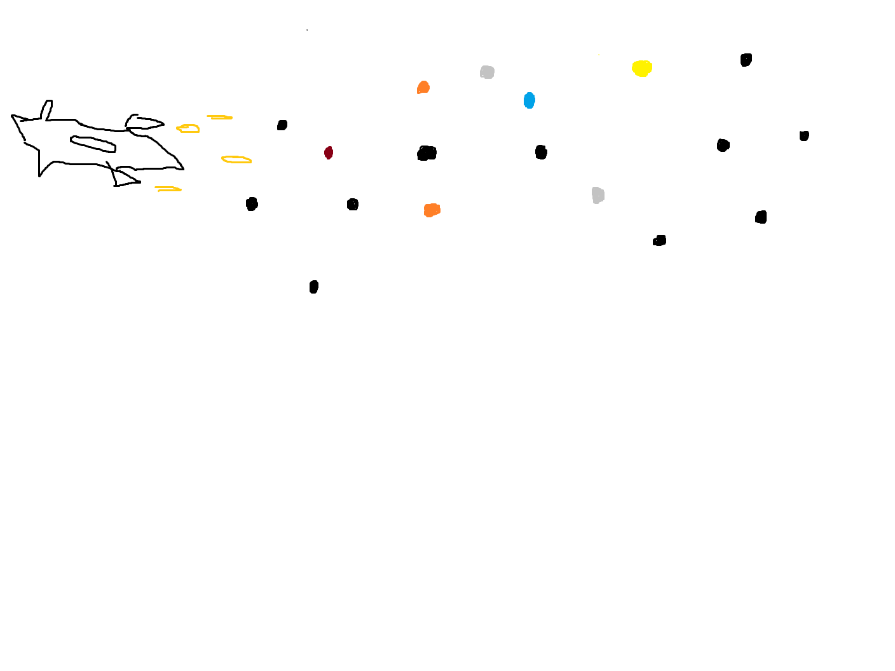

How do you plan to make your game engaging?

By keeping it never ending so that people will play the game until they beat their previous record