* Create a new database called student_management.

**Use student_management**

* Create a collection called students in the student_management database.

**db.createCollection("students")**

1. **Insert at least five student records into the students collection. Each record should have the following fields:**

* **student_id (integer)**
* **name (string)**
* **age (integer)**
* **department (string)**
* **courses (array of strings)**
* **grade (string)**

**db.students.insertMany([**

**{student_id:101,name:"Akshay kumar",age:23,department:"Computer Science",courses:["HTML","DATABASE SYSTEM"],grade:"A"},**

**{student_id:102,name:"Salman khan",age:24,departement:"Information Technology",courses:["Btech","BCOM"],grade:"E"},**

**{student_id:103,name:"Shahid kapoor",age:20,department:"Hotel Manager",courses:["Bcom","BSC"],grade:"A"},**

**{student_id:104,name:"John Abraham",age:19,department:"Computer Science",courses:["DATABASE SYSTEM","BSC"],grade:"A"},**

**{student_id:105,name:"Amir khan",age:24,department:"Computer Science",courses:["PTHON","HTML"],grade:"D"}])**

**// 1st Retrieve all students who are in the "Computer Science" department.**

**db.students.find({department:"Computer Science"})**

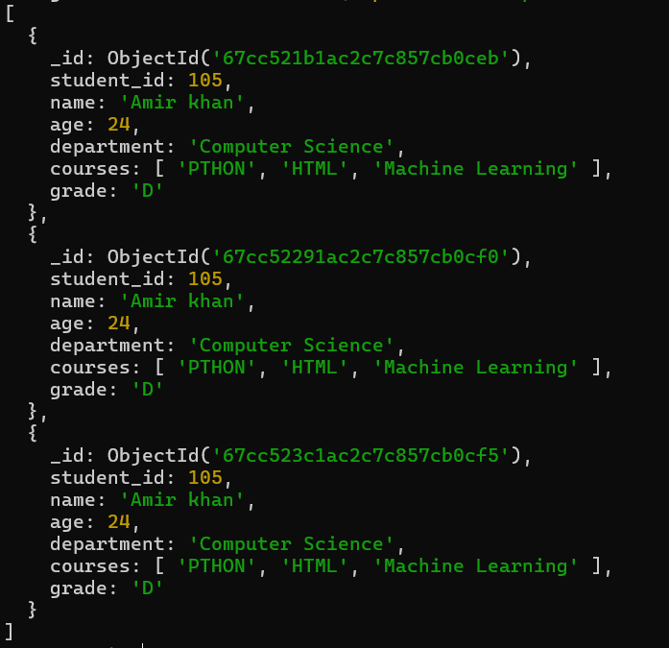

**// 2nd Retrieve students who have an age greater than 21.**

**db.students.find({age:{$gt:21}})**

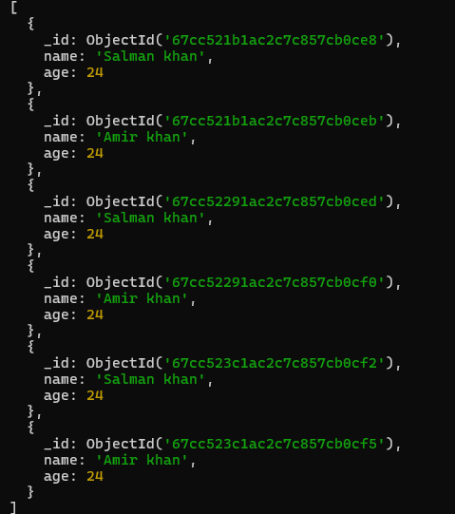

**// 3rd Retrieve students who are taking the "Database Systems" course.**

**db.students.find({courses:"DATABASE SYSTEM"})**

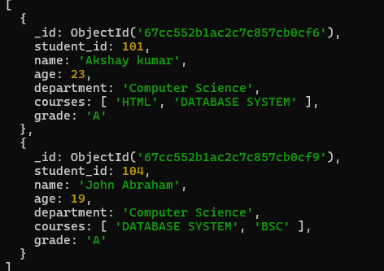

**// 4th Retrieve students with a grade of "A".**

**db.students.find({grade:"A"})**

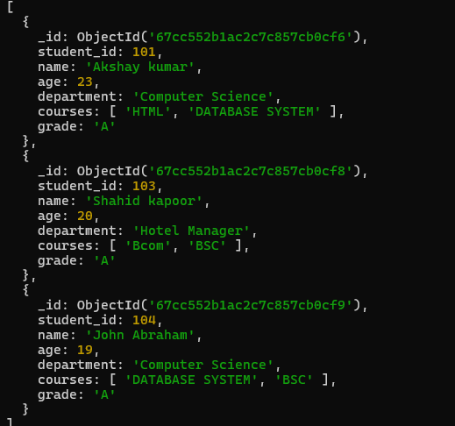

**// 5th Update the age of a student with student_id 101 to 21.**

**db.students.updateOne({student_id:101},{$set:{age:21}})**

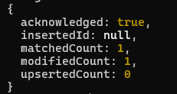

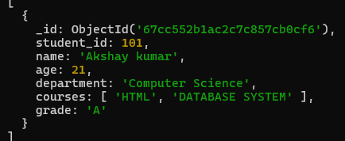

**//6th Add a new course, "Machine Learning", to the courses array for students in the "Computer Science" department.**

**db.students.updateMany({department:"Computer Science"},{$addToSet:{courses:"Machine Learning"}})**

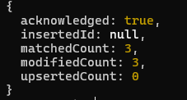

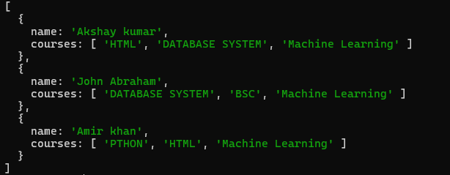

**//7th Delete a student record with student_id 105.**

**db.student.deleteOne({student_id:105})**

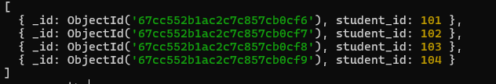

**//8th Delete all students who have a grade lower than "C".**

**db.students.deleteMany({grade:{$lt:"C"}})**

