* Calculate Total Sales for Each Order.



* Calculate Average Order Value for Completed Orders.

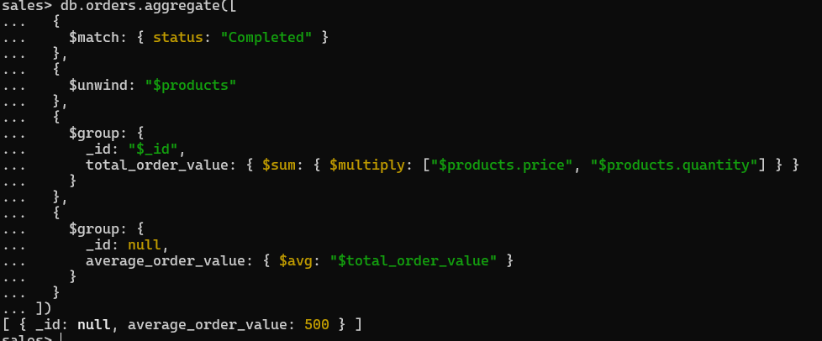

* Find the Maximum Quantity Sold per Product.

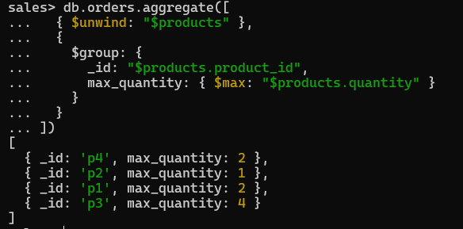

* Find Total Number of Orders for Each Status.

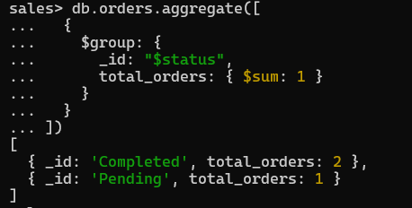

* Calculate Total Quantity of Products Sold Across All Orders.



* Get Minimum and Maximum Order Dates.



* Find Total Sales for Each Customer.

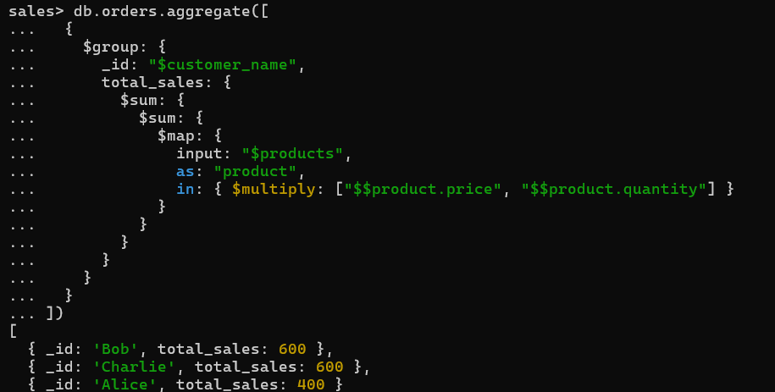

* Calculate the Total Number of Distinct Products Sold.

