Abstract
The cornerstone of this project is to create a DAR system that will convert its functionalities into applications in the areas of research and commercial systems. The system will allow the user to convert a hardcopy text into a digital editable format, hence making the recognition easier and efficient. The system will have its base under some well recognised methods such as image processing, pattern recognition and artificial intelligence with an add-on of a unique technique i.e. natural image processing. The efficient use CNN algorithm would help in reducing the blurriness of the images a recognising the text efficiently. The whole system will be a three step process of creating a digital document from a hardcopy, scanning the digital document and recognising the patterns in the document for successful and error free results.
Keyword: CNN, Artificial neural network, Image processing, Pattern.
1) INTRODUCTION
Document Analysis and Recognition (DAR) system focus at the automatically extracting the information present on paper and transmute it into a digital format. The output expected out of DAR system is in a symbolic form readable by computers. Paper documents have always been the principal Source in contributing to the progress of the humankind and the trend has not changed yet; vast amount of information is still recorded, stored, and shared in paper format. Even if current technology aims to move towards a paperless world, some studies demonstrate that the use of paper as a media for information exchange is still increasing.
Moreover, there are application zones where the reign is still established by paper oriented documents. The most used applications of DAR are related to the processing of office documents (such as invoices, bank documents, business heads, and cheques) thus minmising the forgery of documents. The current availability of inexpensive high-resolution scanning devices, robust computers and OCR packages as an added advantage and can solve simple document recognition tasks for the bulk users. Recent researches are stretching the use of the DAR techniques which can be noticed in the processing of ancient/historical documents in digital libraries, the information extraction from “digital born” documents, such as PDF and HTML, and the analysis of natural images (acquired with mobile phones and digital cameras) containing textual information [1].
The integration of multiple expertise present in computer science such as image processing, pattern recognition, natural language processing, artificial intelligence, and database systems has led to the development of DAR system. DAR applications are particularly suitable for the assimilation of machine learning techniques for several reasons: first, classification algorithms are used at several processing levels, from image pre-processing to character classification; second, large dataset created manually with related images are available and can be used for automatic training of classifiers [1]. DAR system will find its application in both commercial as well as research systems. As a matter of fact, in the coming few decades handwritten character recognition will be frequently used as a standard benchmark for analysing and recognizing documents.
2) PROPOSED SYSTEM
The above mentioned system will find its applications in detecting document forgery, automatic mail sorting and creating digital editable documents from hard copies. The system will be efficient in converting hard copy to digital documents which will be editable to increase the functionality of the system and improvisation in the accuracy of the current system. With certain Updates in future the system will allow the creation of new font styles if the detected font is not available in the existing Google fonts Blurriness of the image will be taken care of for enhanced accuracy and effectiveness. The system will be effective in separating different fonts and making a field of those fonts in the database.
3) METHODS
3.1 Pre-processing
Pre-processing operations in document image analysis converts the input image into an enhanced image more suitable for further processing. Image-to image transformations in DAR is done by four main classes: filtering, geometrical transformations (e.g. skew detection), object boundary detection, and thinning.
3.2 Layout Analysis
Document layout analysis is performed for the segmentation of document image into regions having a correspondent content and to assign some meaning to the regions [1].
The logical layout analysis assigns a logical meaning to each region generating the logical build structure of the document.
3.2.1 Physical Layout Analysis
The main aim of physical layout analysis is extracting regions with uniform features from the document. Segmentation algorithms in image processing can be concluded to three main categories: pixel classification, edge-based segmentation, and region-based segmentation [1].
3.2.2 Logical Layout Analysis
The logical layout analysis assigns a meaning to the regions identified by the physical layout analysis. Examples of features considered are the size of the blocks, their mutual position, and some information on the textual parts such as the predominant font, character size and spacing [1].
3.3 Text Recognition
Text recognition aims to convert an image containing, printed or handwritten text into a format that can be understood by a computer (e.g. ASCII or Unicode). Text reading techniques can be grouped into two main categories (on-line and off-line) on the basis of the input device used [1].
3.4 Software
Our main tool for performing all pre-processing, feature detection, and learning algorithms is the Kaggle library and TensorFlow. This software package includes utilities for every computer vision and Machine learning functionality that we require for this project.
3.5 Data Set
All the training and testing data we use are handwritten characters produced with varied brush sizes and hardness values. The dataset consists of 128x128 grayscale images of the following letters: _, _, _, _, _, _, and _ [3]. There are various images of each letter, and hold-out cross validation is used to separate the data set into training/testing sets and to compare training and generalization error.
In order to reduce variations between images, we implement two different pre-processing
techniques. In the first method, we calculate the centroid, (_x; _y), of the image via moments. These are given by _x = M10 M00 and _y = M01 M00 , where Mpq = X128 x=1 X128 y=1 xp _ yq _ ImageIntensity(x; y):
3.6 Feature Detection
We compare two different types of feature vectors for our learning models. The first is treating the grayscale image as a matrix of pixel values, and then reformatting this matrix into a single row vector. This vector thus encodes the each of the 128 _ 128 pixel values of the image. The second type of feature detection method we use is the Harris operator for detecting corners in an image [3]. We use an abstracted kaggle implementation which assigns a "confidence level" for each of the detected corners, and then returns a vector of the coordinates of the k top scores. In our research, we compare the performance when using 5 corners, 7 corners, and raw pixel values.
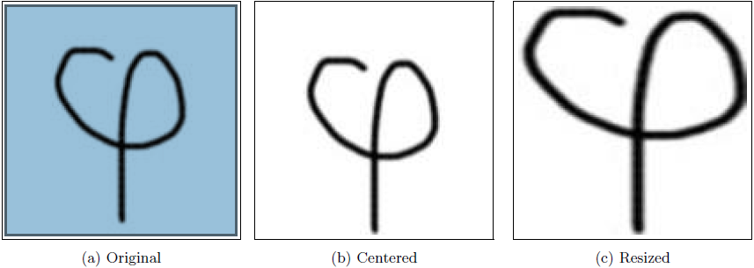
4) Models
We use Two different learning approach in our project: Artificial neural network, Hidden Markov Model. Here we outline each of this approach.

4.1 Artificial Neural Networks

The idea of ANNs is based on the belief that working of human brain by making the right connections, can be imitated using silicon and wires as living neurons and dendrites. ANNs are composed of multiple nodes, which impersonate biological neurons of human brain. The neurons are connected by links and they interact with each other. The nodes can take input data and perform simple operations on the data. The result of these operations is passed to other neurons. The output at each node is called its activation or node value.

The following illustration shows a simple ANN −
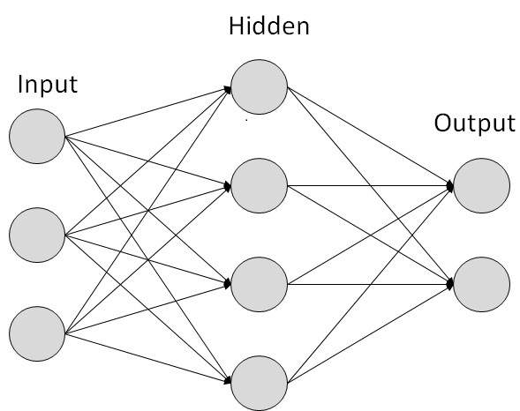

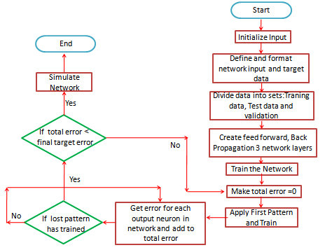

Few imp.code used in our application of above algorithm is illustrated below:
def build(width, height, depth, weightsPath=None):

# initialize the model
model = Sequential()

# first layer CONV => RELU => POOL
model.add(Convolution2D(32, (3, 3), input_shape = (width, height, depth)))
model.add(Activation('relu'))
model.add(MaxPooling2D(pool_size = (2, 2)))

# second layer CONV => RELU => POOL
model.add(Convolution2D(32, (3, 3)))
model.add(Activation('relu'))
model.add(MaxPooling2D(pool_size = (2, 2)))

# third layer of CONV => RELU => POOL
model.add(Convolution2D(64, (3, 3)))
model.add(Activation('relu'))
model.add(MaxPooling2D(pool_size = (2, 2)))

# set of FC => RELU layers
model.add(Flatten())

# number of neurons in FC layer = 128
model.add(Dense(128))
model.add(Activation('relu'))
model.add(Dropout(0.5))

# as number of classes is 36
model.add(Dense(36))
model.add(Activation('softmax'))

# if weightsPath is specified load the weights
if weightsPath is not None:
print('weights loaded')
model.load_weights(weightsPath)
# return model

return model

4.2 Hidden Markov Model

A hidden Markov model is a doubly stochastic process, with an underlying stochastic process that cannot be observed (hence the word hidden), but can be observed through another process that produces a chain of observations [2]. The hidden process consists of a set of states connected to each other by transitions with probabilities, while the observed process consists of a set of outputs or observations, each of which may be emitted by each state according to some output probability density function (PDF) [5-7]. Depending on the nature of this PDF function several kinds of HMMs can be distinguished.

The following illustration shows a simple HMM flowchart−
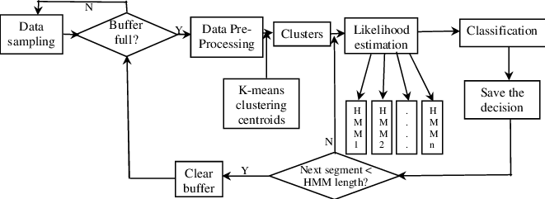
Few imp. code used in our application of above algorithm for training of the data set is illustrated below :
#initialize model
model = Net.build(width = img_width, height = img_height, depth = no_of_channels)
print('building done')
# Compile model
rms = optimizers.RMSprop(lr=0.001, rho=0.9, epsilon=None, decay=0.0)
print('optimizing done')

model.compile(loss='categorical_crossentropy',
optimizer=rms,
metrics=['accuracy'])

print('compiling')

# this is the augmentation configuration used for training
# horizontal_flip = False, as we need to retain Characters
train_datagen = ImageDataGenerator(
featurewise_center=True,
featurewise_std_normalization=True,
rescale=1. / 255,
shear_range=0.1,
zoom_range=0.1,
rotation_range=5,
width_shift_range=0.05,
height_shift_range=0.05,
horizontal_flip=False)
train_generator = train_datagen.flow_from_directory(
train_data_dir,
target_size=(img_width, img_height),
batch_size=batch_size,
class_mode='categorical')

5) COMPARISON
Previous Systems | Our System
The current system is based on structural pattern. | Our system is based on neural pattern recognition.
The error percentage was 6.10 | The error percentage is reduced to 1.0 to 2.3
The older system divides the paragraph into words. | Our system divides the paragraph into characters which increases the accuracy of the system.
The previous system does not allow creation of new scanned fonts. | our system provides the facility to create new fonts.
This feature is not present in the existing system. | Our system provides image de warping which flattens the page image and helps in recognising text easily.
This facility is not available in present system. | The facility of classifying documents after recognising characters is available in our system.

6) RESULT
We found that the best performance came from a combination of centring or resizing, raw pixel value features, and a support vector machine model. Figure below shows our results when using a linear kernel. We were later able to achieve slightly better results using a degree-3 Kaggle kernel, yielding approximately 0.8% generalization error rate when centring the images and using raw pixel values. Other kernel types, such as radial basis function and higher-order polynomials, performed significantly worse due to over-fitting, as shown by a training error of 0% and generalization error of greater than 0.8%.
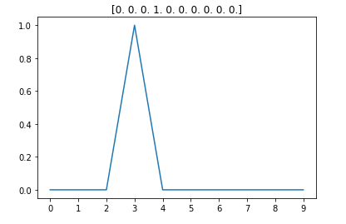

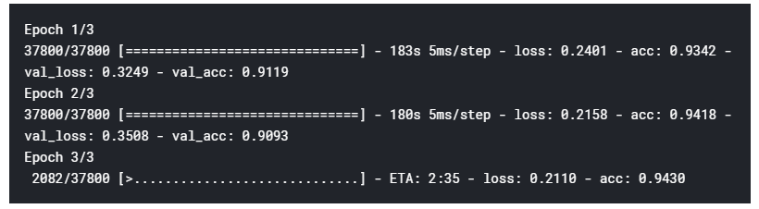
7) CONCLUSION AND FUTURE WORK
Due to the limitation of time, handwritten and printed documents in English and Hindi characters are recognised completely. Hindi character recognition is implemented partially and is not optimized yet. Also, the current segmentation technique used can also detect characters that have clear boundaries. The algorithm and classification technique used, recognizes the characters irrespective of the background quality or patterns. If two consecutive characters were touching each other, they will not be treated as one single character. Moreover, when testing the randomly collected images, the ones that are written really large and thin also have good performance during classification. After scanning and resizing, the image loses lots of pixels during the shrinking process. Therefore to resolve some of the issues mentioned previously the following tasks are recommended:
- Optimize image processing to retain the original features of the image as much as possible no matter the size, thickness, and angle of the character.
- Investigate some reliable segmentation techniques to allow successful separation of characters touching each other. (Might want to consider set a fixed width when searching for individual letters)
- Introduce character recognition for different languages, including English, Mandarin, etc.
- Further using the optimised version of algorithms and database creation techniques which will allow us to recognize the characters and depending upon the boldness of the text it will create the table in the database with columns name as bold text and insert other mentioned text as the database entries.
- Introduce differentiation based on recognized character type which can be used in sorting of physical documents on a particular basis.
- Creation of new fonts if the recognized character font does not matches with the mentioned dataset fonts.

8) REFERENCES
- Introduction to Document Analysis and Recognition Simone Marinai University of Florence Dipartimento di Sistemi e Informatica (DSI) Via S. Marta, 3, I-50139, Firenze, Italy-marinai@dsi.unifi.it.

- Implementation of Character Recognition using Hidden Markov Model Karishma Tyagi, Vedant Rastogi Department of Computer Science & Engineering, IET, Alwar, Rajsthan-273010, U. P., INDIA
- On the Recognition of Handwritten Math Equations Quan Nguyen, Maximillian Wang, Le Cheng Fan December 12, 2014
- Application of Neural Network In Handwriting Recognition Shaohan Xu, Qi Wu, and Siyuan Zhang Stanford University 353 Serra Mall Stanford, CA 94305 USA
- Ko Y, aidya NHV. Location-aided routing (LAR) in mobile ad hoc
networks. Proc. The ACM/IEEE International Conference on Mobile
Computing and Networking, 1998. 66{75}.
- Ma XL, Sun MT, Zhao G, et al. An efficient path pruning algorithm
for geographical routing in wireless networks. IEEE Trans. Vehicuar
Technology, 2008, 57(4): 2474{2488}.
- Kim Y J, Govindan R, Karp B, et al. Geographic routing made
practical. Proc. the 2nd Symposium on Networked Systems Design
and Implementation, 2005. 217{230}.
- Wang, J., Jean, J.: Segmentation of merged characters by neural networks and shortest path. Pattern Recognition 27(5) (1994) 649–658
- You, D., Kim, G.: An approach for locating segmentation points of handwritten digit strings using a neural network. In: Int’l Conference on Document Analysis and Recognition. (2003) 142–146
- LeCun, Y., Bottou, L., Bengio, Y., Haffner, P.: Gradient-based learning applied to document recognition. Proceedings of the IEEE 86(11) (1998) 2278–2324
- Suzuki, M., Uchida, S., Nomura, A.: A ground-truthed mathematical character and symbol image database. In: Int’l Conference on Document Analysis and Recognition. (2005) 675–679
- Marti, U., Bunke, H.: A full english sentence database for off-line handwriting recognition. In: Int’l Conference on Document Analysis and Recognition. (1999) 705–708
- Liu, Cheng-Lin, Kazuki Nakashima, Hiroshi Sako, and Hiromichi Fujisawa. "Handwritten Digit Recognition: Investigation of Normalization and Feature Extraction Techniques.". Pattern Recognition. 37.2 (2004): 265-79. Web
- Ciresan, Dan, Ueli Meier, and Jurgen Schmidhuber. "Multi-column Deep Learning Neural Networks for
- Image Classication.". IEEE Conference on Computer Vision and Pattern Recognition. (2012): 3642-649 IEEE. Web.
- J.Pradeep, E.Srinivasan, and S.Himavathi, Diagonal Based Feature Extraction For Handwritten Character Recognition System Using Neural Network
- O. Matan, J. Bromley, C. J. Burges, J. S. Denker, L. D. Jackel, Y. LeCun, E. P. Pednault, W. D. Satterfield, C. E. Stenard, T. J. Thompson, Reading Handwritten Digits: A Zip Code Recognition System
- Marinai, S., Gori, M., Soda, G.: Artificial neural networks for document analysis and recognition. IEEE Transactions on PAMI 27(1) (2005) 23–35
- Ha, T., Bunke, H.: Image processing methods for document image analysis. In: Handbook of character recognition and document image analysis. World Scientific (1997) 1–47
- Watanabe, T., Luo, Q., Sugie, N.: Structure recognition methods for various types of documents. MVA 6(6) (1993) 163–176

