Game Design Document

Fill up the Following document

1. Write the title of your project.

Ans: Time Ball

1. What is the goal of the game?

Ans: To destroy 288 blocks from 3 levels in the given time.

1. Write a brief story of your game?

Ans: To destroy 288 blocks from the 3 levels. The player has 3 lives to destroy the blocks. The blocks are to be destroyed within a specific time of 500 seconds. The game has 2 types of power-ups, a score increaser which increases the score by 10 and a power-up which gives the user a extra ball to play and the destroy the blocks with. If the player collects the falling heart, a life is lost. If 3 lives are lost the game is over. Also, if the player is not able to finish within the specific time the game ends.

1. Which are the playing characters of this game?

* Playing characters are the ones which respond to the user based on the input from the user
* Cars, monkeys, dinos, wizards etc, are the playing characters in the game.

|  |  |  |
| --- | --- | --- |
| Number | Character Name | What can this character do? |
| 1 | Paddle | It moves its X-position with the mouse and saves the ball from going out of the screen. |
| 2 | Ball | It gets deflected by the paddle and destroys the blocks and helps the player earn points. |

1. Which are the Non Playing Characters of this game?

* Non Playing characters are the ones which don't have an action or a behaviour when the user interacts with the game.
* Hurdles, stones, bananas, coins, etc are non playing characters in the game.

|  |  |  |
| --- | --- | --- |
| Number | Character Name | What can this character do? |
| 1 | Blocks | These help the player earn points and win. |
| 2 | Extra-ball power-up | This gives the player a second ball which can be used to destroy the blocks faster. |
| 3 | Extra-score power-up | This gives the player extra 10 points. |
| 4 | Falling heart | This makes the player lose 1 life. |

Draw your imagination of this game. What does this game look like?

* Draw the game either on your computer or on paper,
* Add images of scenes of the game to show each of the playing and non-playing characters at least once.

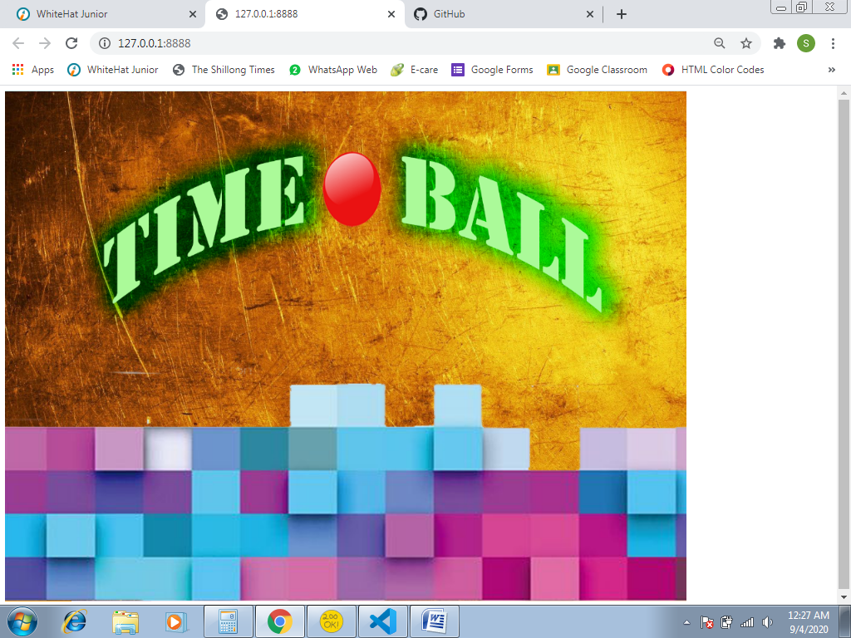

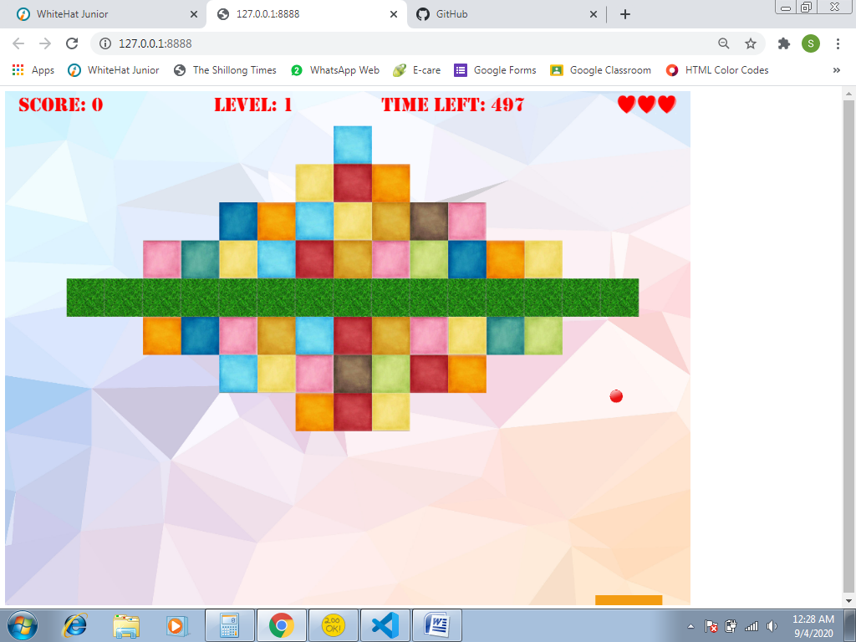

How do you plan to make your game engaging?

Ans: To finish the blocks within the specific time without losing all lives.