**Name: Shriyash Mahadev Gondkar**

**Roll no:618**

**PRN:202201070101**

**Division: F (F1)**

**Assignment 1A**

#Find statistical analysis of Employee Records

f = open("/content/sample_data/emp(10).csv","r")

contents=f.read()

lines=contents.split("\n")

eld=[]; nm=[];design=[];sal=[];

for l in lines:

  words= l.split(",")

  print(words)

  eld.append(int(words[0]))

  nm.append(words[1])

  design.append(words[2])

  sal.append(int(words[3]))

print("Employee IDs:",eld)

print("Employee Names:",nm)

print("Employee DEsignations:",design)

print("Employee salary:",sal)

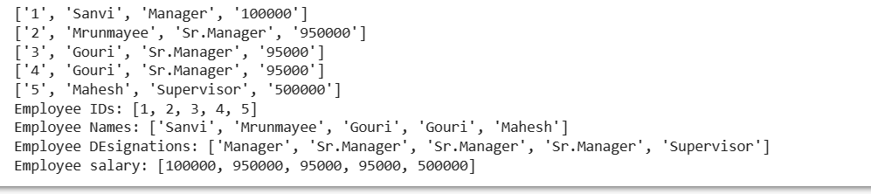

#Max Salary

print("Maximum salary:",max(sal))

#Min Salary

print("Minimum salary:",min(sal))

#Average salary

print("Average salary:",sum(sal)/len(sal))

#Total Salary

print("Total Salary:",sum(sal))

#Employee whose salary is maximum

print("Employee Name whose salary is maximum",nm[sal.index(max(sal))])

#Employee whose Designation is Manager

print("Employee Name whose designation is manager",end="")

for i in range(len(design)):

  if design[i] == "Manager" or design[i]=="manager":

    print(nm[i],end=" ")

#Employee whose salary is 95000

print("Employee Name whose salary is 95000:",nm[sal.index(950000)])

#Employee whose salary is minimum

print("\nEmployee Name whose salary is minimum:",nm[sal.index(min(sal))])

#Employee whose Designation is Sr.Manager

print("Employee Name whose designation is Sr Manager",end=" ")

for i in range(len(design)):

  if design[i]=="Sr.Manager" or design[i] == "Sr.manager":

    print(nm[i], end =" ")

f= 0

#Employee whose salary is 45000

for i in range(len(sal)):

  if sal[i] == 45000:

    print("\nEmployee Name whose salary is 45000 :",nm[i])

    f=1

if(f==0):

  print("\nNo any Employee present whose salary is 45000:",nm[i])

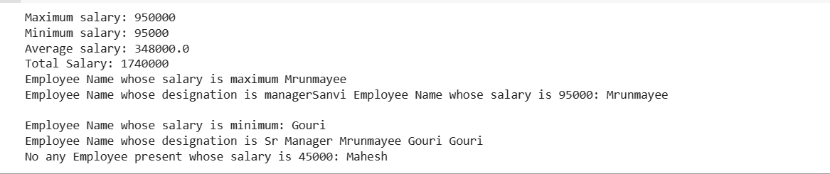

**Assignment 1B :**

**Part 1**

#Code1

f1=open("/content/sample_data/student.csv","r")

f2=open("/content/sample_data/placement.csv","r")

f3=open("/content/sample_data/stud_placement.csv","w")

contents1=f1.read()

contents2=f2.read()

print(contents1)

print(contents2)

nm=[]

package=[]

lines1=contents1.split("\n")

lines2=contents2.split("\n")

lines1.pop()

lines2.pop()

for l1 in lines1:

  words1=l1.split(",")

  for l2 in lines2:

    words2=l2.split(",")

    if(words1[0] == words2[0]):

      l1 = l1 + "," + words2[1] + "," + words2[2] + "\n"

      f3.write(l1)

      nm.append(words1[1])

      package.append(int(words2[2]))

      print(l1)

f1.close()

f2.close()

f3.close()

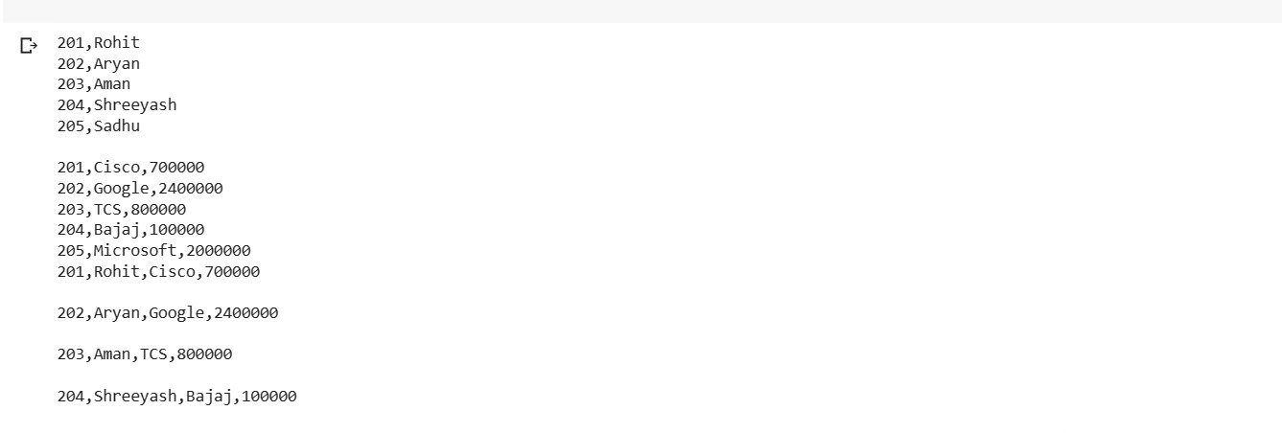

#Code2

f=open("/content/sample_data/stud_placement.csv","r")

contents=f.read()

lines=contents.split("\n")

lines.pop()

sid=[]; nm=[]; company=[]; package=[];

for l in lines:

  words=l.split(",")

  print(words)

  sid.append(int(words[0]))

  nm.append(words[1])

  company.append(words[2])

  package.append(int(words[3]))

print("\nStudent IDs",sid)

print("Student Names",nm)

print("Student Company",company)

print("Student Package",package)

#Max Package

print("\nMaximum Package :",max(package))

#Min Package

print("Minimum Package :",min(package))

#Average Package

print("Average Package :",sum(package)/len(package))

#Total Package

print("Total Package :",sum(package))

#Student whose package is max

print("\nStudent name whose package is maximum : ",nm[package.index(max(package))])

#Student whose company is Google

print("Student name whose company is Google : ",end=",")

for i in range(len(company)):

  if company[i]=="Google":

     print(nm[i],end=" ")

#Student whose package is 2400000

print("\nStudent name whose package is 2400000 : ",nm[package.index(2400000)])

#Student whose package is min

print("Student name whose package is minimum : ",nm[package.index(min(package))])

#Student whose company is Microsoft

print("Student name whose company is Microsoft : ",end=",")

for i in range(len(company)):

  if company[i]=="Microsoft":

    print(nm[i],end=" ")

f=0

#Student whose package is 2000000

for i in range(len(package)):

  if package[i]==2000000:

    print("\nStudent name whose package is 2000000 : ",nm[i])

  f=1

if(f==0):

  print("No any Student present whose package is 2000000")

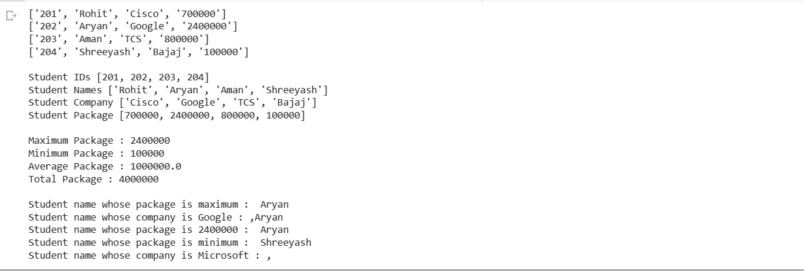

**Part 2:**

import csv

def top_5_emp(d3):

d3.sort(key = lambda x : int(x[5]), reverse = True)

print("Sorted Data : ",d3)

print("\n\nTop 1 Employee",d3[0][1])

print("\n\nTop 2 Employee",d3[1][1])

print("\n\nTop 3 Employee",d3[2][1])

print("\n\nTop 4 Employee",d3[3][1])

print("\n\nTop 5 Employee",d3[4][1])

f1 = open ("/content/drive/MyDrive/Colab Notebooks/EmployeeA.txt","r")

f2 = open ("/content/drive/MyDrive/Colab Notebooks/EmployeeB.txt","r")

f3 = open ("/content/drive/MyDrive/Colab Notebooks/File Merged.csv","w")

d1 = list(csv.reader(f1,delimiter=','))

d2 = list(csv.reader(f2,delimiter=','))

print("\n\n File1 Contents : ",d1)

print("\n\n File2 Contents : ",d2)

d3 = []

for i in range(len(d1)):

  d3.append(d1[i] + d2[i])

print(d3)

cw = csv.writer(f3)

cw.writerows(d3)

top_5_emp(d3)

f1.close()

f2.close()

f3.close()

#Max Salary

print("Maximum Salary : ",max(sal))

#Employee whose Salary is 50000

for i in range(len(sal)):

  if sal[i] == 50000 :

    print("\nEmployee whose Salary is 50000 : ",nm[i])

