Max Marks: 20
Q. No. | Question | Marks
1 | List any two differences between Data and Information. | 1
2 | Draw the schematic block diagram of a computer and explain each component in few words. | 4
3 | Explain software and describe its different types. | 3
4 | Differentiate between Primary and Secondary memory. | 2
5 | Explain what is meant by network topology giving suitable examples. | 2
6 | Match the columns: Options : | 2
 | i. Mouse Input device | 2
 | ii. Printer Output device | 2
 | iii. ROM Primary memory | 2
 | iv. Hard disk Secondary memory | 2
7 | Fill in the blanks  i. Linux is name of an ______ system.  ii. Compiler is a ______ software.  iii. Operating system acts as interface between ______ and ______. | 2
8 | Write a C program to swap two numbers without using a temporary variable | 4
 | OR
 | Write an algorithm to find the largest of two numbers and also draw the flow chart | 4

Q1. List any two differences between Data and Information.
Data | Information
1. Data is raw, unprocessed facts and figures without any context. | 1. Information is processed, organized, and meaningful data.
2. Data alone has no meaning and cannot support decision-making. | 2. Information is useful for making decisions and understanding.

Q2. Draw the schematic block diagram of a computer and explain each component in few words. (4 Marks)
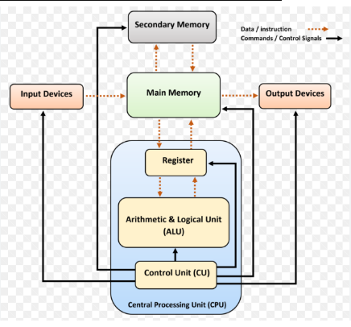
Explanation of Components:
- Input Devices:
Devices like keyboard and mouse that are used to enter data and instructions into the computer.
- CPU (Central Processing Unit):
It is the brain of the computer that processes data and executes instructions. It includes:
  - ALU (Arithmetic Logic Unit): Performs all arithmetic and logical operations.
  - Control Unit (CU): Directs and coordinates all operations of the computer.
- Primary Memory (Main Memory/RAM):
Temporarily stores data and instructions currently in use by the CPU.
- Secondary Memory:
Used for long-term storage of data (e.g., Hard disk, SSD).
- Output Devices:
Devices like monitor and printer that present the processed data to the user.

Q3. Explain software and describe its different types. (3 Marks)
Software is a set of programs, procedures, and related documentation that tells a computer what to do and how to perform specific tasks. Unlike hardware, software is intangible and stored digitally.
Types of Software:
- System Software:
  - This software manages and controls the computer hardware.
  - It acts as a bridge between the hardware and the user.
  - Examples: Operating System (Windows, Linux), Device Drivers, BIOS.
- Application Software:
  - Designed to perform specific tasks for users.
  - It allows users to accomplish goals such as writing documents, browsing the internet, or playing games.
  - Examples: MS Word, Chrome browser, Adobe Photoshop.
- Utility Software:
  - These are specialized programs that help in managing, maintaining, and protecting computer resources.
  - Examples: Antivirus, Disk Cleanup, WinRAR, Backup Software.

Q4. Differentiate between Primary and Secondary memory. (2 Marks)
Primary Memory | Secondary Memory
It is the main memory used by the CPU to store data and instructions currently in use. | It is used for long-term storage of data and programs.
Examples: RAM, ROM | Examples: Hard Disk, SSD, CD/DVD

Q5. Explain what is meant by network topology giving suitable examples. (2 Marks)
Network Topology refers to the physical or logical arrangement of devices (nodes) and how they are connected within a computer network.
Examples of Network Topologies:
- Bus Topology:
  - All devices are connected to a single central cable (backbone).
  - Example: Small office LAN using a single coaxial cable.
- Star Topology:
  - All devices are connected to a central hub or switch.
  - Example: Home Wi-Fi network where devices connect to a central router.
- Ring Topology:
  - Each device connects to exactly two other devices, forming a circular pathway.
  - Example: Some token ring-based local area networks.
- Mesh Topology:
  - Every device is connected to every other device directly.
  - Example: Military or critical systems requiring redundancy.
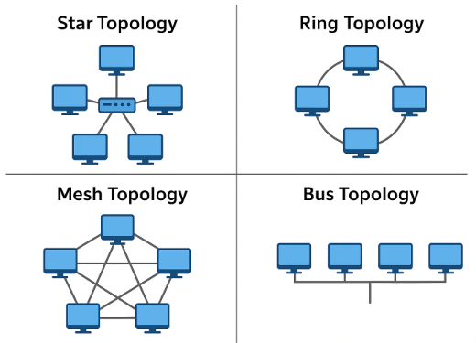

6 | Match the columns: Options : | 2
 | i. Mouse Input device | 2
 | ii. Printer Output device | 2
 | iii. ROM Primary memory | 2
 | iv. Hard disk Secondary memory | 2

Q7. Fill in the blanks (2 Marks)
i. Linux is name of an operating system.
ii. Compiler is a system software.
iii. Operating system acts as interface between hardware and user. ✅

Q8: Write a C program to swap two numbers without using a temporary variable
(4 Marks )
#include <stdio.h>

int main() {
int a, b;

// Input two numbers
printf("Enter two numbers: ");
scanf("%d %d", &a, &b);

// Display before swapping
printf("Before swapping: a = %d, b = %d\n", a, b);

// Swapping without temporary variable using arithmetic operations
a = a + b; // Step 1
b = a - b; // Step 2
a = a - b; // Step 3

// Display after swapping
printf("After swapping: a = %d, b = %d\n", a, b);

return 0;
}

🔹 Sample Input:
Enter two numbers: 10 20

🔹 Sample Output:
Before swapping: a = 10, b = 20
After swapping: a = 20, b = 10

OR

Q8: Write an algorithm to find the largest of two numbers and also draw the flow chart

Algorithm to Find the Largest of Two Numbers:
- Start
- Input two numbers A and B
- If A > B, then
Print "A is largest"
Else
Print "B is largest"
- Stop

