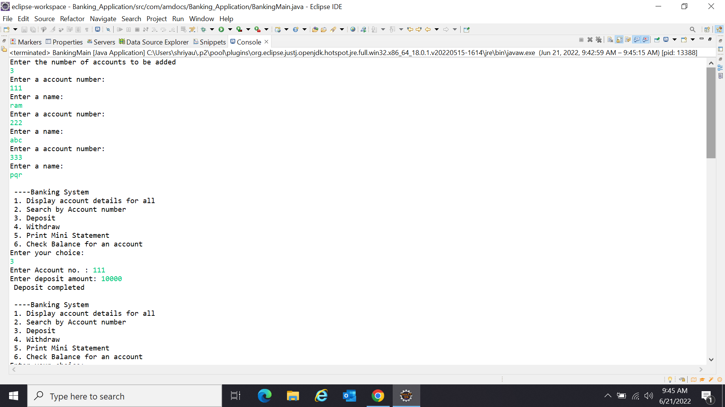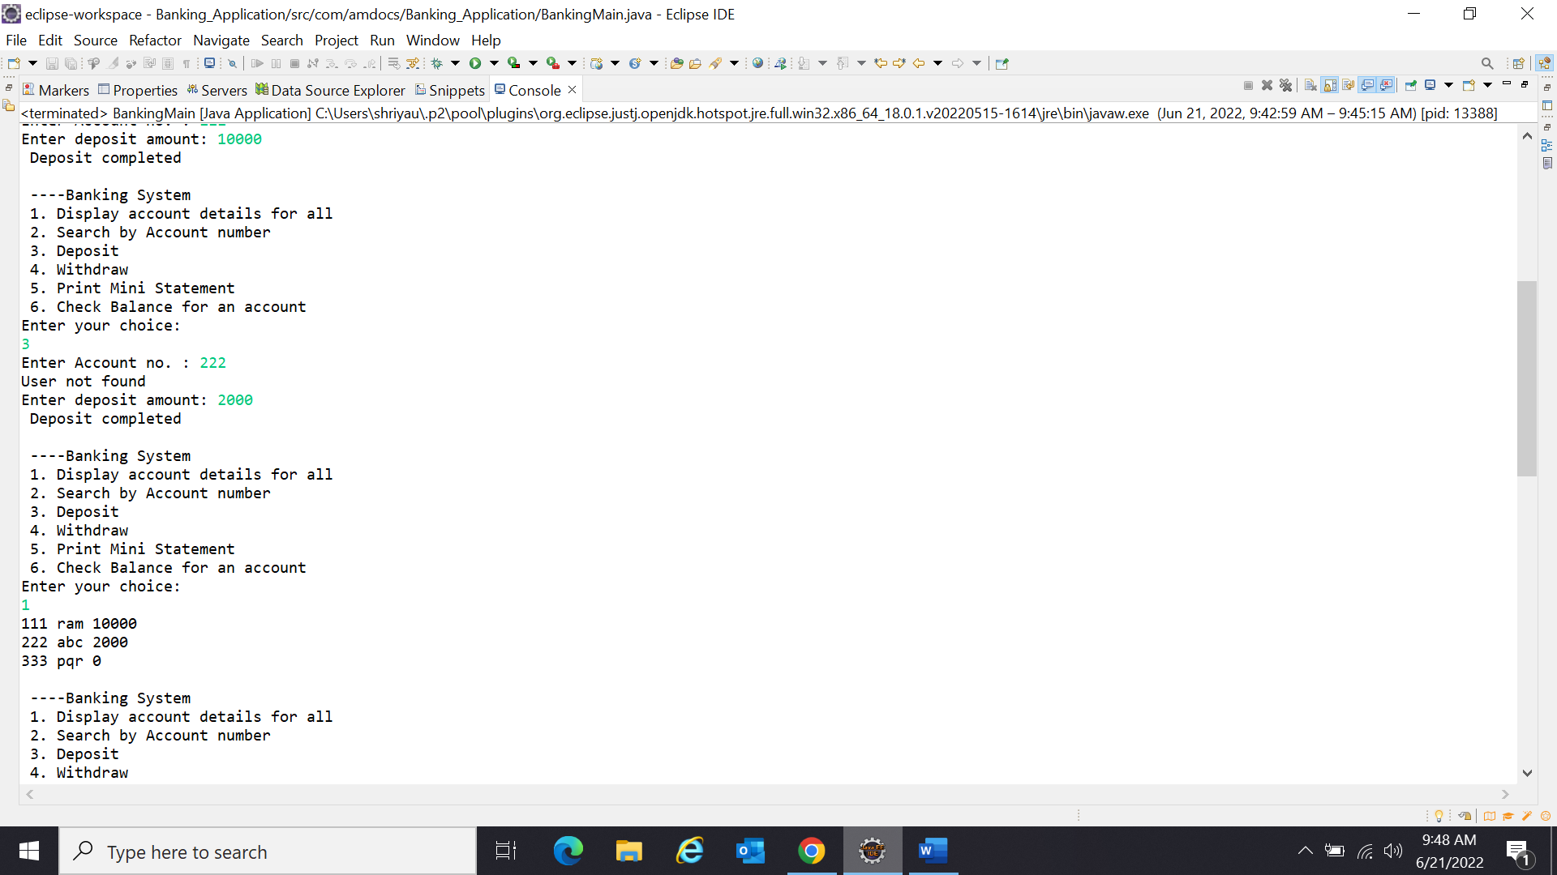

Shriya Umre

Amdocs-Batch 4

194086

Created accounts and deposited money in them

All account numbers, name and balance

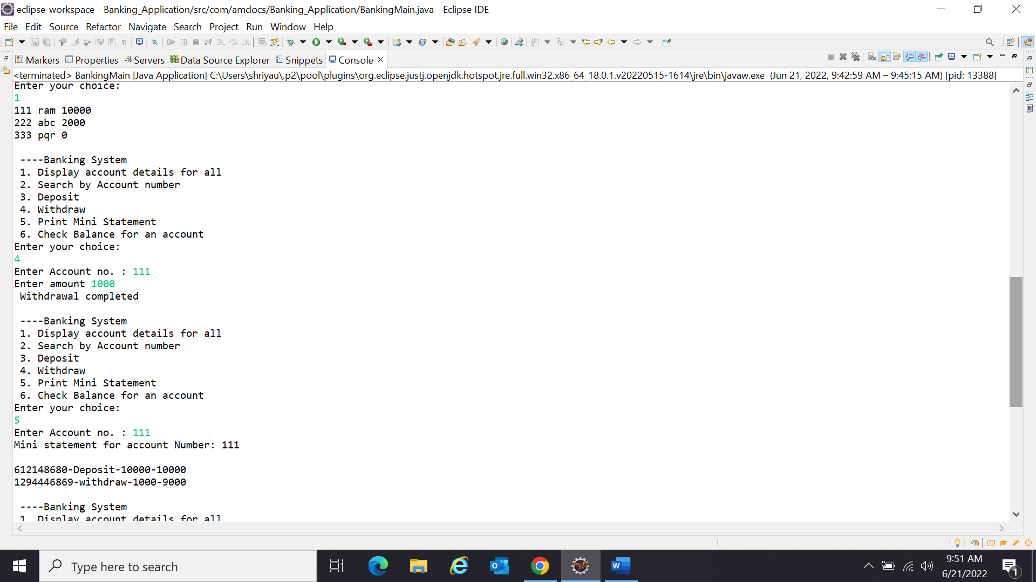

Withdrawal

A mini statement for selected account

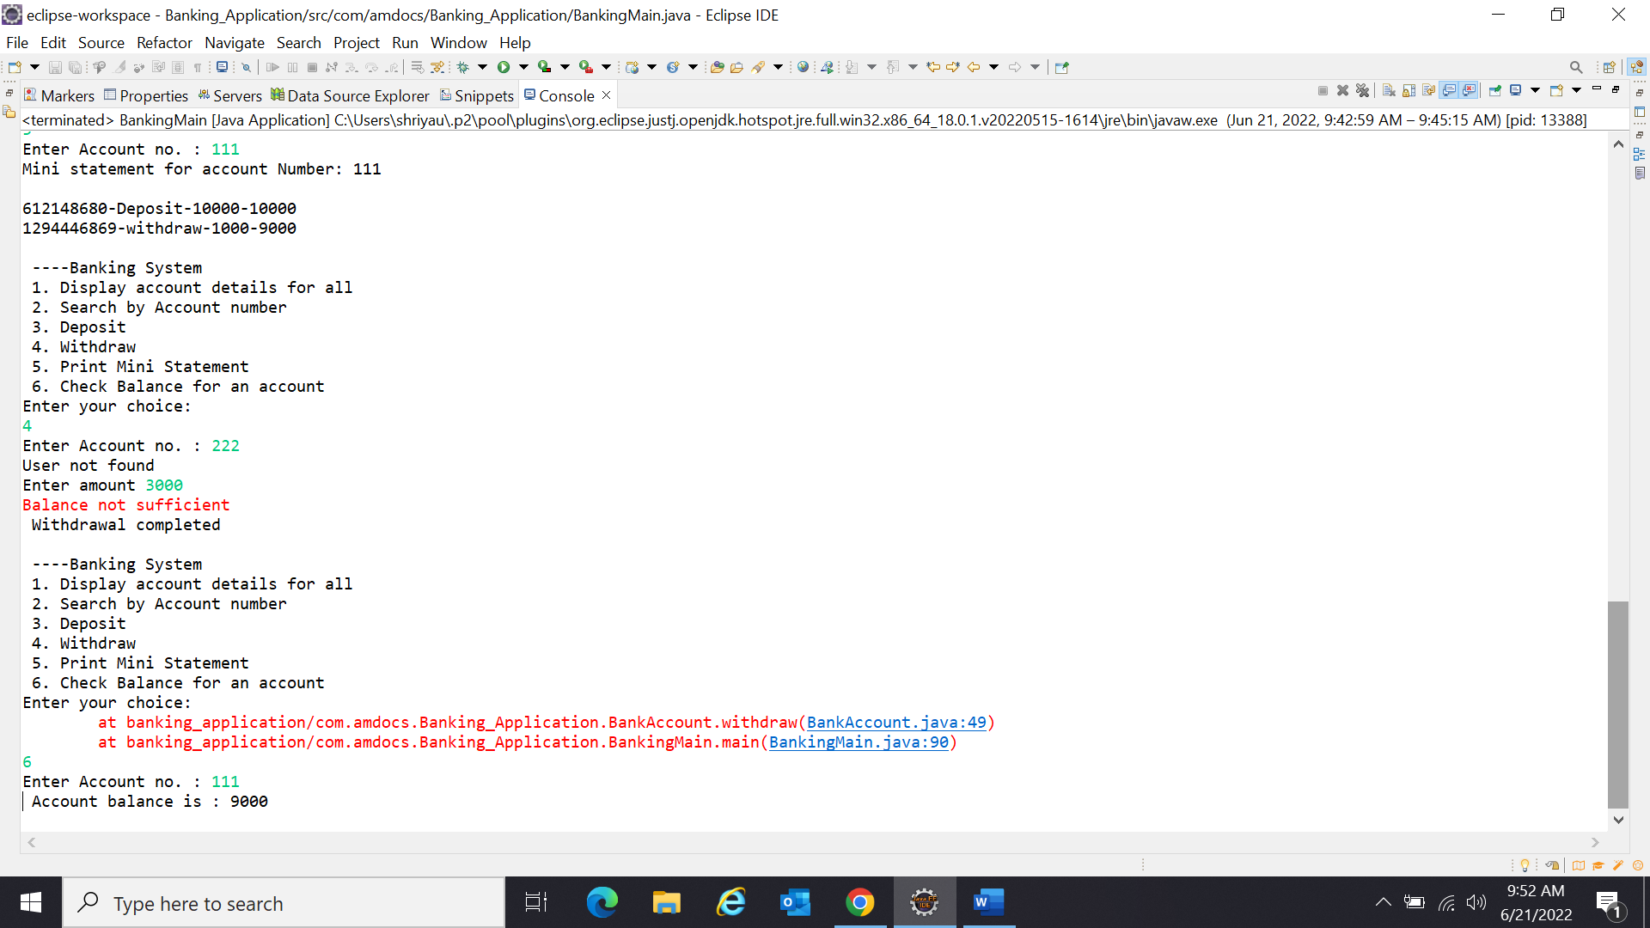

To see account balance

Withdrawal denied to maintain minimum balance 1000

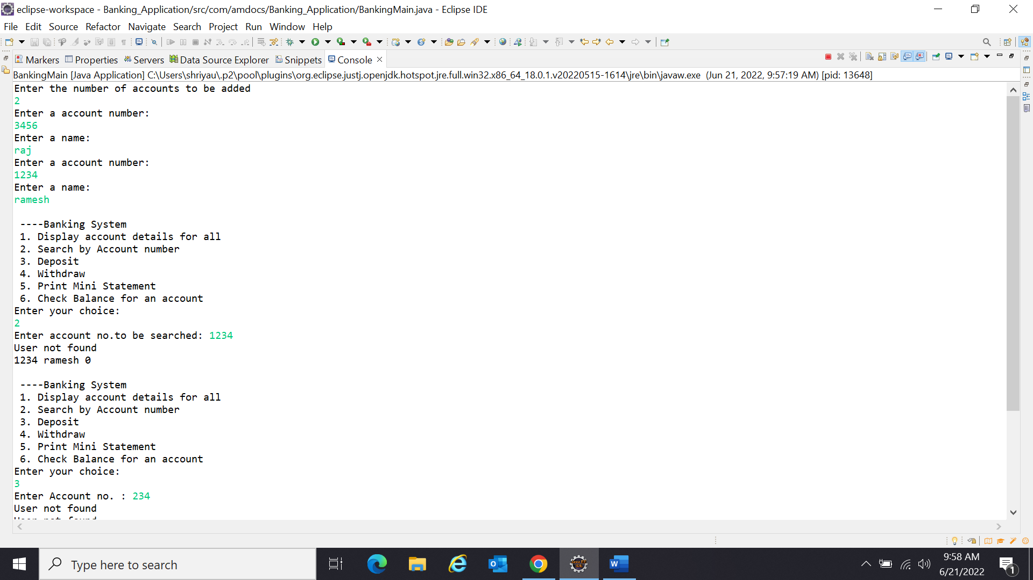

Search details for one account

Error for invalid account number

