

**FUNDAMENTALS OF DATABASE MANAGEMENT SYSTEM**

CIS 8040 TEAM PROJECT FINAL REPORT

**WE - Connect**

Student – Employer Database Management System

Team members

Arun Prasad

Mrunmayee Shukla

Pooja Manvikar

Saurabh Sharma

Shivangi Shroff

**Table of Contents**

Acknowledgement 3

Abstract 4

1. Project Proposal 5

2. Conceptual Diagram 7

Entity Relationship Diagram: 7

Assumptions: 7

3. Logical Design 8

4. Business Case, Functionalities, and Users 9

Business Case: 9

Solutions Offered: 9

Functionalities: 9

Targeted Users: 10

5. Preliminary Implementation 11

Tables Created: 11

Data Creation Queries: 13

6. Data Retrieval 14

Complex queries: 14

• Query 1: 14

• Query 2: 14

• Query 3: 15

7. Challenges Faced 16

8. Project Feasibility 17

Parameters: 17

Project timeline Gantt Chart 17

9. Integration of Visualization 19

Bibliography 21

# **Acknowledgement**

The satisfaction, which accompanies the successful completion of the task, would be incomplete without mentioning people who made it possible and whose constant guidance and encouragement crowned our effort with success.

We express our sincere and hearty gratitude to Dr. *J.J. Po-An Hsieh* for his constant support during the project.

It is our pleasure to express our thanks to all the cohort for their kind help and assistance provided throughout.

# **Abstract**

A database is a collection of related data. A database management system (DBMS) is a collection of programs that enables users to create and maintain a database. DBMS is hence general purpose software that facilitates the process of defining, constructing, manipulating and sharing databases among various users and applications.

The database is implemented in SQL(Structural Query Language) because of the key characteristics of SQL such as data integrity, security, dynamic nature, and avoidance of data redundancy. SQL is one of the most important languages in the present world as it is user friendly, and as is has a highly interactive nature. Thus SQL is chosen as the backend to implement this database.

The main objective behind maintaining such a database is to serve the user requirements as per their specifications so that an interaction is established. Interaction between the user and the software/database is the key factor to success in the real world. Insertion, Joins, Complex queries and display are few operations that enhance the features of this database.

The use of a database management system avoids manual look-ups which are usually error - prone and time-consuming. The use of database makes the data to be stored in an organized manner providing an efficient way to access the records. It also provides security to the data and prevents malicious attacks and provides integrity unlike the traditional data storing techniques which compromises on security.

# 

# **1. Project Proposal**

*Skills assessment:*

Our team members have the following skills: SQL, PHP, Oracle, HTML, CSS, Visio, Star UML

*Tentative meeting days:*

We followed SCRUM methodology; 15 minutes of daily stand up meeting from Monday to Friday to track the project progress.

*Time:*

Between 10 AM to 10:30 AM

*Location:*

RCB, Buckhead

*Business case:*To design a simple database model to have student’s profile compliment with recruiters’ requirements.

*Problems we wish to solve:*

* Ease for employer to find the appropriate candidates
* Increasing the efficiency for the recruiter, with filtering options to get the right candidate
* Central repository for students and employers
* Maintaining the refined and wide data to get the proper results

*Expected users of our DBMS application*

Employers and students

*Establish scope of your project, and assess the feasibility of your proposal*

|  |  |
| --- | --- |
| **Goals** | **Student’s profile compliment with recruiters’ requirements** |
| Deliverables by dates | * 5 pm, Oct 26: Project model, scope, features, team details. * 5pm, Nov 09: Business model and ERD. * 5pm, Nov 16: Conceptual data model + logical data model * 5pm, Nov 30: Presentation of the business model to users. * 5pm, Dec 07: Deployment of final product. |
| Features | * One-click access to recruiters to potential student’s profiles. * Students get easy access to employer’s requirements. * User friendly UI to feed and retrieve data to and from system. |
| Functions | * Allow students to feed their profiles to central database which is accessible to recruiters. * Allow recruiters to apply filters and retrieve student information from database to match their requirements. |
| Deadline | * 5pm, Dec 07: Demonstration of working database model along with all other components. |

*Entities:*

* **Student:** This table will contain student details.
* **Skill:** This table will contain details of all the skills which a student can have
* **SkillSet:** Associative entity with details of which student has which skills.
* **Employer:** Contains the detail of the employer who are going to hire the students
* **Recruit_process:** Contains the information about the recruiting process, which round a student has cleared and the interview process
* **Enrollment:** Associative entity that contains information about which degree the student is enrolled to
* **Degree:** Contains the details of a particular degree, the major and minor of that degree
* **Job_type:** List the type of jobs student is looking for. i.e. Full time , part time, internship
* **Jobs_Targeted:** Associative entity that maps student to type of job he is looking for.
* **Skills_for_job:** Associative entity that specifies what skills are required for a particular type of job

*Responsibility:*

In our teams, each member will be involved in all activities so that overall effective learning is achieved. We have appointed leads for each task who will direct the team for concerned activities.

|  |  |
| --- | --- |
| **Team member name** | **Responsibility** |
| Arun Prasad | Business Model and scope, DB modeling |
| Mrunmayee Shukla | ERD diagrams, front end development |
| Pooja Manvikar | ERD diagrams, front end development |
| Saurabh Sharma | Project model and scope, conceptual model |
| Shivangi Shroff | Data model, database design |

*Deadlines:*

* 5 pm, Oct 26: Project model, scope, features, team details.
* 5 pm, Nov 09: Business model and ERD.
* 5 pm, Nov 16: Conceptual data model + logical data model
* 5 pm, Nov 30: Presentation of the business model to users.
* 5 pm, Dec 07: Deployment of final product.

# **2. Conceptual Diagram**

## **Entity Relationship Diagram:**

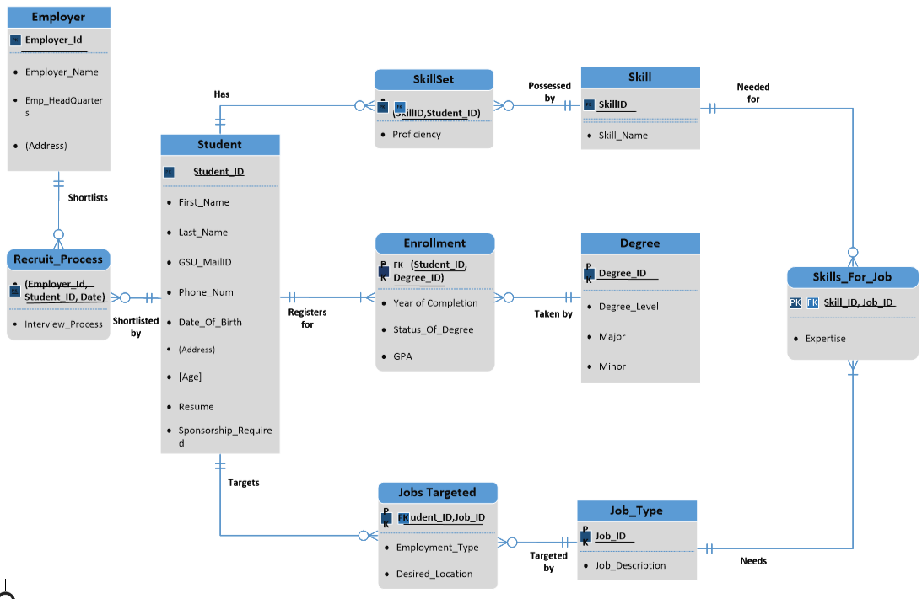

## **Assumptions**:

* Every student may not have any skill
* A course can have no students associated with it
* A skill might be possessed by no student at all
* A student must be enrolled to minimum one course
* This is only for graduate and undergraduate students
* An employer may or may not select any student for an interview process
* A student may or may not target any job type
* A job type may not be targeted by any student

# **3. Logical Design**

Functional Dependency Diagram:

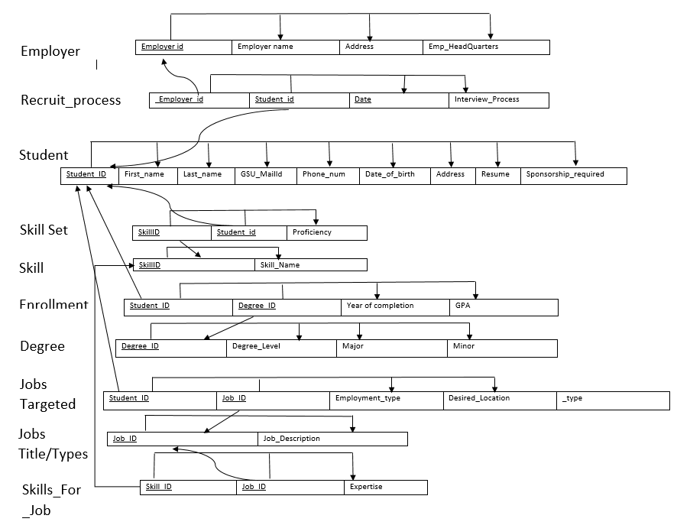

# **4. Business Case, Functionalities, and Users**

## **Business Case:**

Implementation of a simple database model to have student’s profile compliment with recruiters’ requirements to facilitate the following

* Organizations to identify the appropriate students for the recruitment process
* Maintain current and historical data of students based on their skills
* Help students view the varied skills needed for job types that they wish to target

This led to the implementation of **We-Connect**, a Student- Employer Database Management System.

## **Solutions Offered:**

* Varied filtering options to shortlist the suitable candidates suitable for the role
* Central repository for students and employers
* Maintain the refined and extensive data to get appropriate results
* Help increase efficiency of the recruitment system by decreasing delays involved in selecting candidates

## **Functionalities:**

***Employers***

* Easy access to student profiles
* Custom filters such as Degree, Skills, Proficiency, Graduation year to shortlist student profiles
* Recruitment Process Tracking

***Students***

* Interface for profile creation
* Exposure to job opportunities aligned with their interest in an industry
* Accommodate students to select jobs based on their position type
* The visibility of visa sponsorship for each employer

## **Targeted Users:**

***Recruiters***

* Organizations can select students based on the various expertise and interests needed for the recruitment process
* Relative ease in shortlisting candidates based on organizational requirements

***Students***

* Students can update their respective skills and upload a Resume
* Will help understand what skills may be required for the industries that the student is targeting and even shortlist based on the need for sponsorship

# **5. Preliminary Implementation**

## **Tables Created:**

|  |  |
| --- | --- |
| **Tables** | **Constraints** |
|  |  |
|  |  |
|  |  |
|  |  |
|  |  |
|  |  |
|  |  |
|  |  |
|  |  |
|  |  |

## **Data Creation Queries:**

* Insert into **STUDENT** (STUDENT_ID, FNAME,LNAME,GSU_EMAIL,PHONE_NUM,DOB,ADDRESS,AGE,SPONSORSHIP_REQ,RESUME_) values (1000,'Tushar','Agarwal','TAgarwal1@student.gsu.edu',9448611195,to_date('19-NOV-97','DD-MON-RR'),'58,Georgia,US',null,null,null);
* Insert into **DEGREE** (DEGREE_ID,DEGREE_LEVEL,MAJOR,MINOR) values (1,'BS','MIS','Dana analytics');
* Insert into **ENROLLMENT** (DEGREE_ID,STUDENT_ID,YEAR_OF_COMPLETION,GPA) values (2,1011,2015,3.5);
* Insert into **SKILL** (SKILL_ID,SKILL_NAME) values (3,'Programming');
* Insert into **SKILLSET** (SKILL_ID,STUDENT_ID,PROFICIENCY) values (3,1014,1);
* Insert into **JOBS_TARGETED** (STUDENT_ID,JOB_ID,DES_LOCATION,EMPLOYMENT_TYPE) values (1014,3,'New York','Internship');
* Insert into **JOB_TYPE** (JOB_ID,JOB_DESC) values (1,'Data Management');
* Insert into **SKILLS_FOR_JOB** (SKILL_ID,JOB_ID,PROFICIENCY) values (4,3,1);
* Insert into **EMPLOYER** (EMP_ID,EMP_NAME,ADDRESS,EMP_HEADQUARTERS) values (1645,'3 Round Stones, Inc.','Washington,us,20004','DC');

# **6. Data Retrieval**

## **Complex queries:**

* **Query 1:**

*Employee wants details of all the students and the degrees they have earned with skills*

select s.STUDENT_ID , (s.fname || ' '||s.lname) as sSTUDENT_NAME ,e.YEAR_OF_COMPLETION, (d.DEGREE_LEVEL || ','||','||d.major||','|| d.minor) as Degree_desc from student s

inner join enrollment e on s.student_id = e.student_id

inner join degree d on e.DEGREE_ID = d.degree_id

where s.student_id in (select student_id from skillset where skill_id in

(select skill_id from skill where skill_name = 'Programming'));

**Output:**



* **Query 2:**

*Whenever an employer searches for a student from degree then students with GPA greater than or equal to 3.8 should automatically be shortlisted for interview process*

DECLARE

shortlist number (10);

cursor shortlistCursor IS

select e.student_id FROM enrollment e where e.gpa >= 3.8;

Begin

OPEN shortlistCursor;

FETCH shortlistCursor INTO shortlist ;

insert into recruit_process values (1645 , shortlist, SYSDATE,'Interview');

CLOSE shortlistCursor;

End;

**Output:**

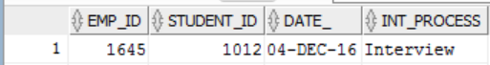

* **Query 3:**

*Display the job type and skills based on the student profile*

select distinct jt.student_id , sj.skill_id , j.job_desc , sk.skill_name as Skill_required_for_job , jt.des_location as desired_location, jt.employment_type from job_type j

left join skills_for_job sj on j.job_id = sj.job_id

inner join skill sk on sj.skill_id = sk.skill_id

inner join skillset ss on sk.skill_id = ss.skill_id

right join jobs_targeted jt on j.job_id= jt.job_id

where jt.student_id = 1014 ;

**Output:**



# **7. Challenges Faced**

* **Undefined goals:** Team members had different perspective for the implementation and it was a tedious task to consider the best ideas and set the goals
* **Ambiguous Contingency Plan:** There were many ‘what-if’ scenarios. The contingencies weren’t identified initially. But we succeeded in identifying the future changes and problems



* **Constraints on the design – limited number of tables:** The constraint of 10 tables were applied on the project implementation and based on our initial design, we had more than 10 entities. We as a team worked upon the design to scale down to 9 entities in the final implementation
* **Data Population:** The task of coming up with innovative and complex queries was intriguing but it was equally a learning process. There were a lot of queries we decided, but ended up implementing 3 most complex queries
* **Knowledge transfer:** As the team had members from different background, it was time consuming to understand the database management system concepts and implementation

# **8. Project Feasibility**

## Parameters:

* Technicalfeasibility**:**We have all the required technical resources at our disposal and the team members are technically sound in the required skills.
* Economic feasibility**:**Our Project does not require any significant cost as all the software are freely available as open source.
* Legal feasibility**:**Not applicable for our project as it is a college project developed for learning.
* Operational feasibility:project plan satisfies the requirements identified in the requirements analysis phase of system development.
* Scheduling feasibility: We tracked our entire project and Created a Gantt chart for the same.

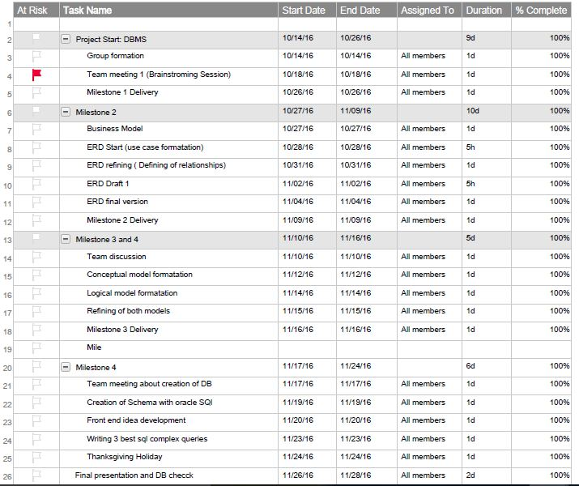Project timeline Gantt Chart

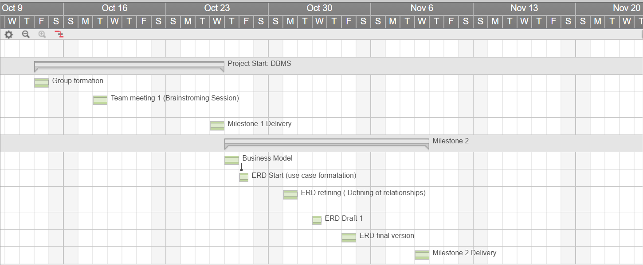

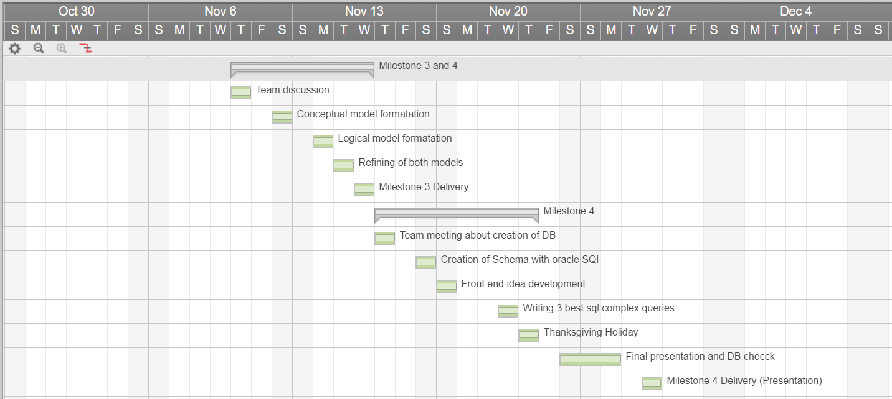

# **9. Integration of Visualization**



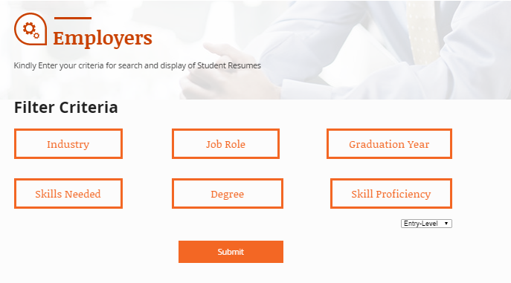

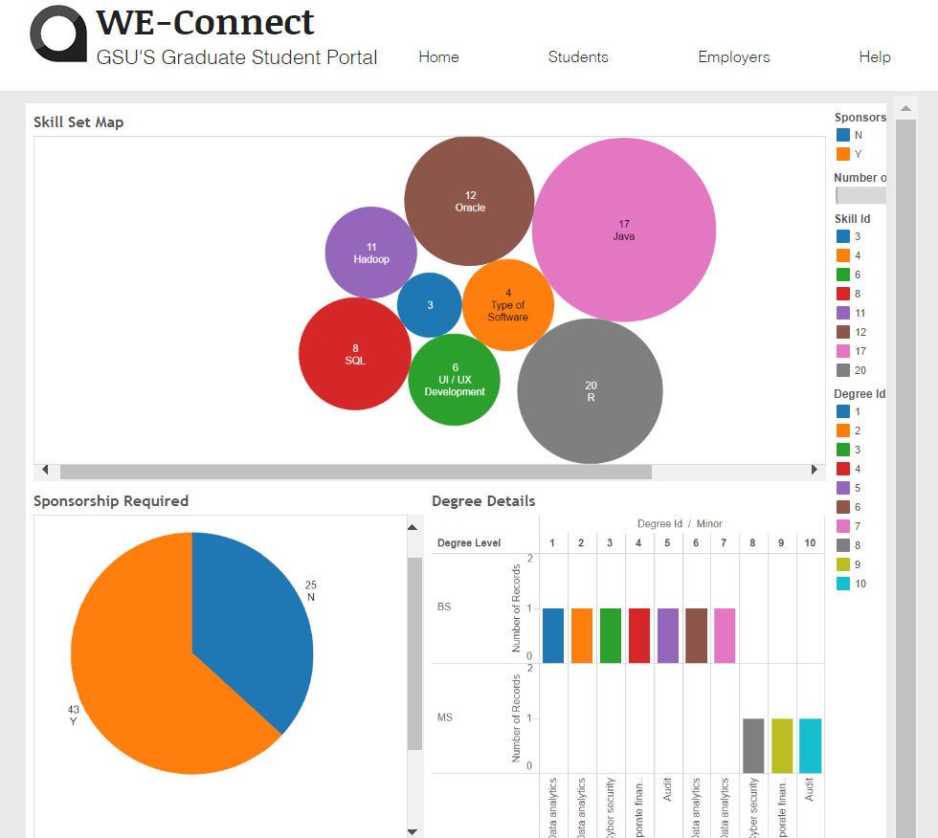

# **Bibliography**

* **Database management system: Pathak, Nirupma; Mumbai [India] : Himalaya Pub. House, 2008**
* **Fuzziness in database management systems: Half a century of developments and future prospects: Kacprzyk Janusz , Zadrożny Sławomir, De Tré Guy; 0165-0114, 15 December 2015 281:300-307**
* **Modern Database Management System: Jeff Hoffer, Ramesh Venkataraman, Heikki Topi: 12th edition**
* <https://ocw.mit.edu/courses/urban-studies-and-planning/11-521-spatial-database-management-and-advanced-geographic-information-systems-spring-2003/lecture-notes/lect4.pdf>
* <http://philip.greenspun.com/sql/complex-queries.html>