Proposal Document for the project

Health Administration System

### Uomna Hesham 211001623

### Shrouk Gbr 211001720

### Farah Fawki 211001836

### Mai Mohammed 211001757

### Nada Atef Salah 211001921

### 

### Supervisor

### Dr. Ahmed Elnokrashy

November 2024

**GitHub:** ........................................................

**Abstract**

The main idea of this project is to study the efficiency and functionality of a Health Administration System (HAS) that streamlines the management of patient records, appointments, and hospital resources. The project focuses on developing a system to simplify administrative tasks, improve communication between patients and healthcare providers, and enhance the overall quality of healthcare services. This system integrates patient registration, appointment scheduling, and medical record management into a single, user-friendly interface. Additionally, it ensures data security and privacy compliance while optimizing resource allocation in healthcare facilities. The project aims to demonstrate how a well-designed HAS can improve operational efficiency and patient satisfaction.

# Introduction

## Background

The healthcare industry is essential for ensuring community well-being. With growing populations and medical advancements, the demand for efficient healthcare services has increased. However, healthcare systems face challenges like managing large patient data, timely service access, and resource optimization. Health administration focuses on organizing services such as patient registration, medical records, and appointments. Many facilities still use outdated processes, causing inefficiencies and errors. Digital Health Administration Systems (HAS) address these issues by automating tasks, streamlining workflows, and improving communication. This project aims to develop a HAS to enhance healthcare management, resource use, and patient experiences.

## Motivation

## Healthcare management often relies on manual processes, leading to inefficiencies, delays, and errors in patient care. These issues reduce patient satisfaction and burden healthcare providers. This project aims to develop a Health Administration System to automate tasks like record-keeping and appointment scheduling, improving efficiency and communication. The motivation is to enhance healthcare services, reduce errors, and create a more organized system for both patients and providers.

#### Academic

#### The successful development of a Health Administration System (HAS) requires knowledge and research across multiple academic fields:

#### Healthcare Management Understanding healthcare workflows such as patient registration, appointment scheduling, and medical record management is critical. Research indicates that inefficiencies in these processes can negatively affect healthcare outcomes (Alharthi et al., 2019). This foundation ensures the system aligns with real-world needs.

#### Information Systems The project involves designing a scalable system using database management and software engineering principles. Studies emphasize the importance of healthcare information systems in improving efficiency and minimizing errors (Sheikh et al., 2015).

#### Data Security and Privacy Ensuring the confidentiality and security of patient data is vital. The system will follow best practices for compliance with standards such as HIPAA, as recommended by Riaz et al. (2020).

#### User Experience Design A user-friendly design is essential for adoption by patients and healthcare staff. Heuristic evaluation principles, as outlined by Nielsen and Molich (1990), guide the creation of an effective interface.

#### Business

Developing a Health Administration System (HAS) addresses key business needs in healthcare by improving efficiency, reducing costs, and enhancing service quality. Manual administrative tasks often cause delays and increased workloads. Automating functions like patient registration and scheduling streamlines operations, reducing errors and saving time. Davis et al. (2019) found that automating administrative processes can improve task completion by over 30%, ensuring smoother operations. Manual systems also contribute to higher costs. Implementing an HAS reduces these by automating tasks and optimizing resource allocation. Jones and Clark (2020) report a 25% cost reduction in organizations using digital solutions. An HAS enhances communication, minimizes wait times, and ensures accurate record-keeping, leading to higher patient satisfaction. Smith et al. (2021) show that patient satisfaction increases with digital tools for managing appointments and records. Finally, healthcare systems must comply with regulations like HIPAA to protect patient privacy. A well-designed HAS includes compliance features to reduce legal risks. Riaz et al. (2020) emphasize that digital systems with built-in compliance mechanisms help avoid regulatory penalties.

## Problem Statement

The primary challenge this project aims to address is the inefficiency of manual administrative processes in healthcare facilities, which result in delays, errors, and increased operational costs. Tasks such as patient registration, appointment scheduling, and medical record management often cause bottlenecks, negatively affecting staff productivity and patient satisfaction. As healthcare services become more complex and patient volumes rise, these inefficiencies become more pronounced. Davis et al. (2019) note that manual administrative processes lead to significant delays and errors, reducing the overall efficiency of healthcare systems. This project seeks to implement a Health Administration System (HAS) that automates these key administrative tasks. By streamlining operations and optimizing resource allocation, the HAS aims to improve operational efficiency and reduce costs. Jones and Clark (2020) highlight that automation can reduce operational costs by 25%, improve productivity, and enhance patient satisfaction.

# Project Description

Write down with a figure the proposed system.

## Objectives

The Health Administration System (HAS) is being developed to address inefficiencies in healthcare administration, streamline operations, and improve patient satisfaction. Manual processes in healthcare, such as patient registration, appointment scheduling, and medical record management, often lead to delays, errors, and increased operational costs (Davis et al., 2019). By automating these tasks, the system aims to reduce these inefficiencies, optimize resource allocation, and enhance workflow efficiency (Jones & Clark, 2020). The goal is to improve the quality of care provided to patients, reduce administrative burdens, and ensure faster, more accurate services.

## Scope

The scope of the Health Administration System (HAS) project focuses on developing a digital solution to automate and streamline key administrative tasks within healthcare facilities. The system will handle patient registration by enabling digital input of patient details, including personal, medical, and insurance information (Davis et al., 2019). It will also facilitate appointment scheduling, allowing patients to book, reschedule, or cancel appointments while ensuring real-time updates to the medical staff's schedules (Jones & Clark, 2020). Additionally, the system will manage medical records, storing patient health data digitally and ensuring easy access for authorized personnel (Riaz et al., 2020). The HAS will provide reporting and analytics features to assist healthcare administrators in tracking appointments, patient visits, resource usage, and overall operational efficiency (Smith et al., 2021). The system will be accessible through a secure web-based interface for both patients and healthcare staff. This project will not involve clinical operations such as diagnosis or treatment but will focus on improving administrative functions within healthcare settings.

* 1. **System Design**
     1. **Web and Mobile App Integration**

The web page and mobile app are integrated through a shared backend system, which acts as a central hub for data exchange between the two platforms. This system uses frameworks like Node.js, Django, or PHP to provide endpoints for data requests and secure user authentication using JWT (JSON Web Tokens). Data is stored in a centralized database, allowing real-time access and updating on both platforms. Synchronization is maintained using WebSockets for instant updates. Cross-platform consistency is achieved by following uniform design guidelines for user interfaces on both platforms. Security measures like end-to-end encryption (SSL/TLS) and role-based access control (RBAC) are applied for data transmission, ensuring a unified experience across both platforms. This integration process ensures a seamless and efficient data exchange between the web and mobile platforms.

* + 1. **System Gaps and Risks**

The Health Administration System aims to provide a seamless user experience, but technical and operational challenges may arise. One key gap is data synchronization issues, where updates made on one platform may not immediately reflect on the other. WebSockets are used to enable real-time updates, ensuring changes are instantly visible on the other. Cross-platform compatibility is another anticipated gap, as designing consistent user interfaces for both web and app can be challenging due to differences in screen size, layout, and design requirements. To mitigate this, unified design principles and usability testing on multiple devices and browsers are recommended. Data security risks, such as unauthorized access or data breaches, are addressed through end-to-end encryption, role-based access control, and authentication mechanisms like JWT tokens. API downtime or system overload can disrupt services, and load balancing and cloud scaling are employed to ensure high availability and scalability. User experience issues may arise if the app or web page is difficult to navigate, and extensive usability testing and feedback sessions will be conducted.

The Health Administration System must manage a number of risks to maintain user satisfaction, security compliance, and system stability. A major risk is the possibility of a data breach, which would violate HIPAA data privacy regulations by exposing private patient information. The system makes use of two-factor authentication, role-based access control, and end-to-end encryption to lessen this. While load balancing and auto-scaling on cloud platforms guarantee high availability during periods of peak usage, system outages remain a risk. Although database backups and redundancy systems are in place to recover data, data loss remains a serious risk. Attackers can obtain unauthorized access by taking advantage of API vulnerabilities, which present another danger. Rate-limiting, OAuth authentication, and API gateways are used by the system to reduce these risks.

* + 1. **System Flow and User Interaction**

The Health Administration System is a user-friendly platform that allows patients, doctors, nurses, and admins to interact with the system through web and mobile platforms. Users log in using credentials, which are verified through a JWT-based authentication system. They then access role-specific features, such as appointment scheduling, medical records, and notes on patient care. Admins oversee system management, generate reports, and manage user permissions. These actions are processed via the Backend API, which validates requests and interacts with the centralized database. WebSockets are used for real-time notifications, ensuring users receive updates immediately, regardless of the platform they are using.

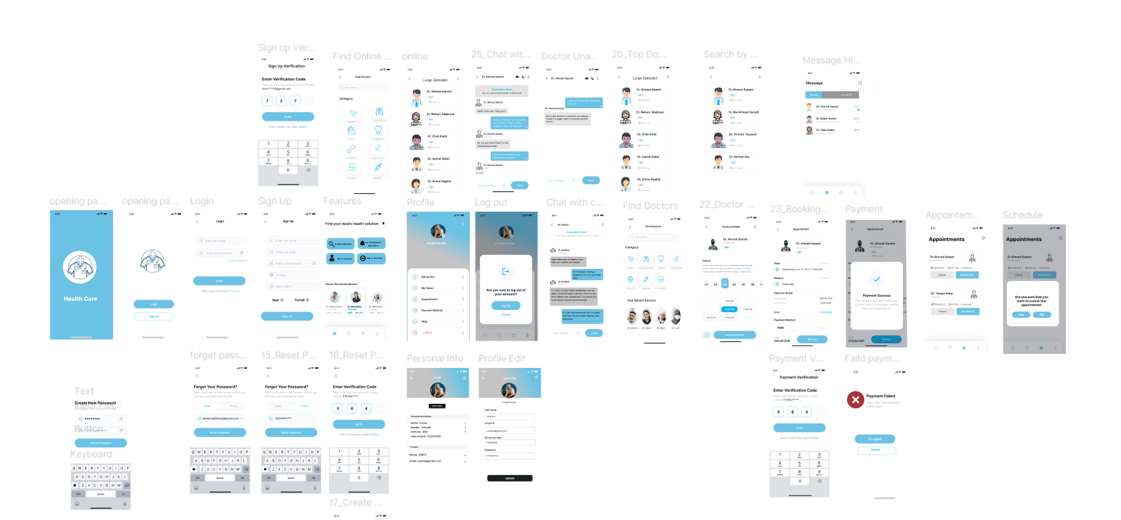

Figure 1

## 2.4 What is new in the Proposed Project?

The innovation or novelty of your project.

# Similar System

## Academic

1. Recommender Systems for Healthcare (Springer, 2021):

* Main Problem Statement: The paper addresses the need for personalized healthcare recommendations using AI to replace static guidelines.
* Researchers' Contributions: It proposes a hybrid system using medical data like EHRs and wearables for accurate recommendations.
* Main Results: Hybrid systems outperformed others in accuracy and improved patient outcomes in case studies.
* Critique: Strong theory but lacks real-world validation and clinical trials.

1. Deep Learning for Medical Image Analysis: A Review:

* Main Problem Statement: Inefficient and inaccurate medical image analysis.
* Researchers' Contributions: Reviewed deep learning techniques for medical image analysis, including image classification, segmentation, and detection.
* Main Results: Highlighted the potential of deep learning to improve the accuracy and efficiency of medical image analysis.
* Critique: The paper could have discussed the ethical implications of using AI for medical diagnosis.
* Figure 2: Medical image analysis

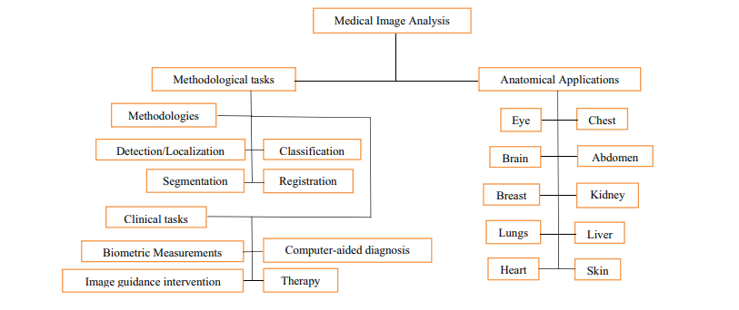

1. IntelliDoctor – AI based Medical Assistant:

* Main Problem Statement: The paper addresses the need for an AI-driven healthcare solution to provide timely and accurate medical diagnostics.
* Researchers' Contributions: The authors created IntelliDoctor, which analyzes health data for diagnosis, utilizes AI for symptom analysis, and tracks user health activities.
* Main Results: IntelliDoctor produces accurate condition predictions and continually improves its diagnostic capabilities through machine learning.
* Critique: The paper lacks sufficient data validation, addresses privacy concerns minimally, and does not effectively cater to complex medical cases or emphasize user education.
* Figure 3: proposed architecture of IntelliDoctor – AI based Medical Assistant

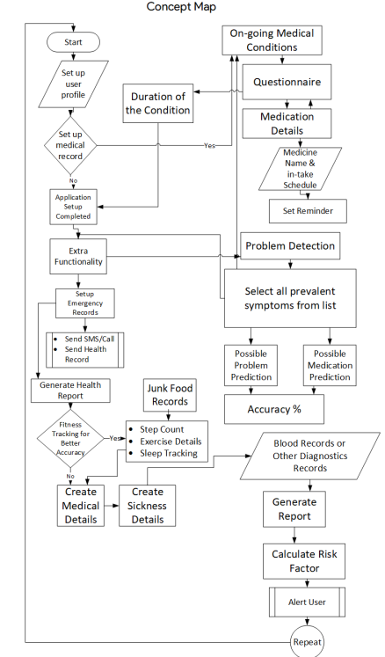

1. Robotic Medical Support ChatBot (RMSCB) system:

* Main Problem Statement: The paper addresses the lack of 24/7 medical facilities in rural areas and the need for timely medical guidance.
* Researchers' Contributions: The researchers developed the RMSCB system, an AI-based chatbot that predicts medical diagnoses and provides solutions autonomously.
* Main Results: The system effectively offers first-aid medication information and reduces the need for immediate physician consultations.
* Critique: The paper lacks comprehensive clinical validation and does not sufficiently address challenges related to data accuracy and user trust.

1. A Review on an Android Application for Medicine Availability and Location Finder:

* Main Problem Statement: The paper addresses the issues related to the lack of accessibility and efficiency in traditional pharmacy services, particularly in the context of online medicine shopping.
* Researchers' Contributions: The authors propose an Android application that helps users find medicine availability and locations of pharmacies, improving access to necessary medications.
* Main Results: The application facilitates easier access to medicines, allowing users to locate pharmacies and get medications delivered, thus enhancing convenience and efficiency.
* Critique: The paper does not adequately address security and privacy concerns associated with online pharmacies and lacks a critical evaluation of the app's effectiveness in real-world scenarios.

1. Advanced Healthcare System Using Artificial Intelligence:

* Main Problem Statement: The work addresses inefficiencies in healthcare systems, particularly focusing on the slow adoption of AI-driven solutions to streamline administrative tasks and improve decision-making in healthcare management.
* Researchers’ Contributions: The authors proposed a healthcare system integrating artificial intelligence and cloud computing to automate tasks like scheduling and data management, ensuring more efficient operations.
* Main Results: The study demonstrated improved task completion times, reduced errors, and enhanced data accessibility compared to traditional methods.
* Critique: While innovative, the system’s reliance on cloud infrastructure may pose challenges related to data privacy and scalability in resource-limited settings.
* Figure 4: Web application front-end process

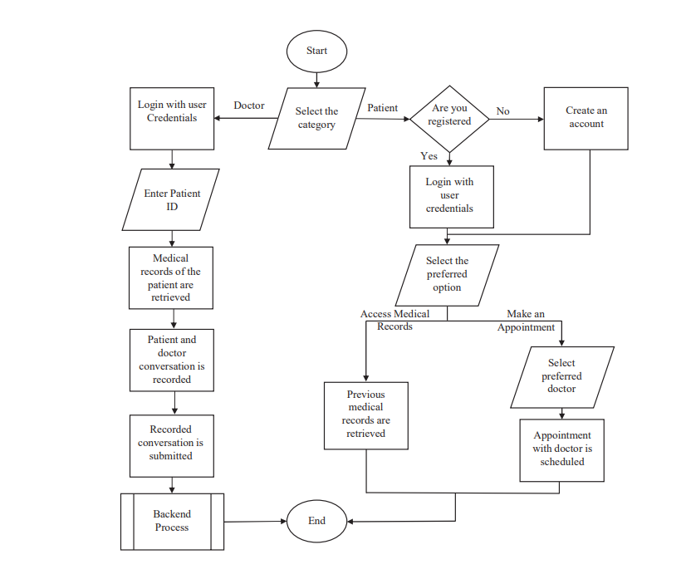

1. A systematic review of chatbots in inclusive healthcare: insights from the last 5 years:

* Main Problem Statement: The paper addresses the insufficient inclusivity of healthcare chatbots, particularly for the elderly and individuals with disabilities.
* Researchers' Contributions: The researchers conducted a systematic review of 21 articles to analyze chatbot accessibility and identify gaps, aiming to promote an "accessibility-by-design" approach.
* Main Results:
  + Increased chatbot use in healthcare but only 15% are inclusive.
  + Most chatbots use text-only communication, which is challenging for some users.
  + Recommendations emphasize natural interaction and simpler language.
* Critique of the Paper:
  + Limited Scope: Only 21 articles reviewed may not be representative.
  + Lack of User Input: No user feedback or case studies included.
  + Implementation Details: More practical steps for recommendations needed.
* Figure 4 illustrates that 15% of chatbots are inclusive, stressing the need for improved design practices
* Figure 5 Applications of Generative AI in Healthcare

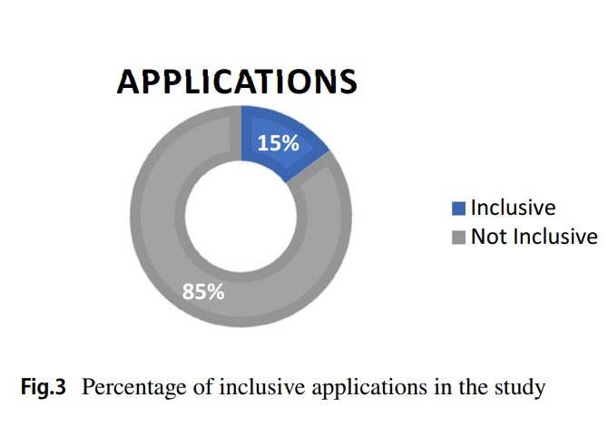

*Figure 5*

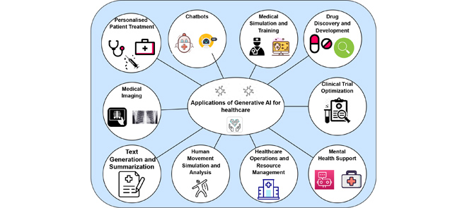

*Figure 6*

## Business Applications

|  |  |  |  |  |
| --- | --- | --- | --- | --- |
| **Feature** | **Health care** | **ChatGPT** | **Google Search** | **Vezeeta** |
| Medical History Tracking | ✔ Allows users to store and access their medical records for personalized recommendations. | ✔ Can store context during sessions but lacks dedicated medical record integration. | ✘ Lacks personalized medical record support. | ✔ Includes medical history tracking. |
| AI Medical Assistant | ✔ Provides accurate and instant medical advice based on AI analysis. | ✔ AI-based responses but lacks medical-specific focus. | ✘ General information only. | ✘ Does not feature AI-based medical assistance. |
| Direct Online Consultation | ✔ Enables users to consult doctors directly through online sessions. | ✘ Not designed for direct doctor consultations. | ✘ No consultation features. | ✔ Connects users with doctors but may lack immediacy. |
| Doctor Appointment Booking | ✔ Allows users to book appointments with specialists easily. | ✘ Not designed for appointment management. | ✘ No booking functionality. | ✔ Focused on booking appointments. |
| Medication & Checkup Reminders | ✔ Sends personalized reminders for medications and regular checkups. | ✘ General reminders only if prompted. | ✘ No reminder functionality. | ✘ No automated medical reminders. |
| Time-Saving Healthcare Solutions | ✔ Reduces waiting time by offering instant AI-powered advice and direct consultations with available doctors. | ✘ Does not prioritize time efficiency for medical services. | ✘ Information retrieval may involve lengthy searches. | ✔ Booking and consultations are available but may include delays. |
| Comprehensive Health Features | ✔ Combines medical history tracking, AI advice, direct consultations, and reminders in a single platform. | ✘ Offers standalone features without integration. | ✘ Focused on generic information. | ✘ Features are fragmented and lack a unified approach. |

# Project Management and Deliverables

## Tasks and Time Plan

**Requirement Gathering and Analysis (**September 2024**)**

* Collect system requirements from stakeholders.
* Define core features (patient management, appointment scheduling).
* Research similar systems for best practices.

**Tools:** Documentation tools (Google Docs)

### **System Design (**October 2024**)**

* Design system architecture and database schema.
* Create user flows and wireframes for web and mobile platforms.
* Finalize tech stack and development tools.

**Tools:** Figma (for wireframes), MySQL Workbench (for database design).

**Front-End Development for Web (**November 2024**)**

* Set up the project structure using React, HTML, CSS, and SCSS.
* Develop core UI components for patient and admin dashboards.
* Implement basic navigation and responsive design.

**Tools:** Visual Studio Code, React, Tailwind/SASS, Bootstrap.

**Back-End Development PHP & SQL (December 2024)**

* Set up server environment and connect to the database.
* Develop APIs for CRUD operations (patients, appointments, reports).

**Tools:** PHP Storm, Postman (API testing).

**Mobile App Development with Flutter (January 2025)**

* Set up the Flutter project structure.
* Create UI components and navigation for mobile interfaces.
* Integrate Firebase or API for backend communication.

**Tools:** Android Studio, Flutter SDK, Dart.

### Integration and Testing Phase 1 (February 2025)

* Integrate front-end, back-end, and mobile app.
* Conduct unit testing for individual modules.
* Fix bugs and address performance issues.

**Tools:** Jest (for React testing), PHP, Flutter testing tools.

### **User Authentication and Authorization (**March 2025**)**

### Finalize and secure role-based access (admin, doctors, nurses, patients).

### **UI/UX Improvements** (April 2025)

* Refine user interface and improve user experience based on feedback.
* Add animations and transitions for web and mobile apps.

**Tools:** React animations, Flutter animations, SCSS for styling.

### **Final Testing and Validation** (May 2025)

* Conduct system-wide testing (functionality, performance, usability).
* Perform stress tests on the database and APIs.
* Validate data security and compliance with regulations.

### **Deployment and Documentation** (June 2025)

* Deploy the web app on a cloud platform.
* Publish the mobile app on Google Play.
* Provide user training and deliver comprehensive documentation.
* Create a project presentation and demo video.

**Tools:** GitHub for version control, Google Docs for documentation.

## Budget and Resource Costs (Grand Total: EGP 200,000)

## 1. Human Resources (EGP 140,000)

## Project Manager: EGP 40,000

## Developers: EGP 60,000

## UI/UX Designer: EGP 15,000

## QA/Testers: EGP 15,000

## Training Staff: EGP 10,000

## 2. Software and Tools (EGP 5,000)

## Development Tools: EGP 2,000

## Project Management Software: EGP 1,500

## Collaboration Tools: EGP 1,000

## Database/Hosting Costs: EGP 500

## 3. Hardware and Infrastructure (EGP 35,000)

## Servers: EGP 15,000

## Laptops/Workstations: EGP 10,000

## Network Equipment: EGP 5,000

## Peripherals: EGP 5,000

## 4. Miscellaneous Costs (EGP 20,000)

## Consultation Fees: EGP 10,000

## Marketing and Awareness: EGP 5,000

## Contingency Fund: EGP 5,000

1. **Supportive Documents**

* users/survey

According to Mansour (2016), this study, carried out via a survey, sought to investigate the ownership and usage of mobile medical apps (MMAs) among patients in Egypt. The results revealed that 65.4% of patients did not utilize MMAs, with most of them being older men working in agriculture or non-government jobs. Conversely, 34.6% of patients were users of MMAs, primarily older, educated males employed as businesspeople or accountants. The majority of MMA users had been using the apps for less than five years, with a moderate number of apps owned and accessed mainly at home or work. The most common types of apps included reminder, healthy life, and general facility information apps. Users spent 1-3 hours daily on these apps, primarily to find information, check materials, and communicate.

# References

# Sai, S., Gaur, A., Sai, R., Chamola, V., Guizani, M., & Rodrigues, J. J. P. C. (2024). *Generative AI for transformative healthcare:* A comprehensive study of emerging models, applications, case studies, and limitations. *IEEE Xplore*

# Zlajpah, L., & Nemec, B. (2002). Kinematic control algorithms for on-line obstacle avoidance for redundant manipulators. *IEEE Xplore*

# Pariyar, A., Kaur, N., & H. R., S. (2023). Enhancing the healthcare system through mobile-based doctor's appointment booking application. *C-ICAS 2023*

# Atherton, H., Eccles, A., Poltawski, L., Dale, J., Campbell, J., & Abel, G. (2024). Investigating patient use and experience of online appointment booking in primary care: Mixed methods study. *BMJ Open*

# Huamaní, E. L., & Romero-Alva, V. (2024). Design of a booking management system, with responsive design web appointments, to reduce time and improve the quality of health care services. *TIU Eprints*

# M. Hussein, P. W., Salim, M., & Ahmed, B. I. (2019). A prototype mobile application for clinic appointment reminder and scheduling system in Erbil City. *TIU Eprints*

# Subhi, A., Jalal, D., & Samal, M. (2023). Doctor appointment system. *LFU Eprint*

# Zhang, X., Yu, P., & Yan, J. (2014). Patients' adoption of the e-appointment scheduling service: A case study in primary healthcare. *ResearchGate*

Savitha, Pavithra, Fayyaz, M., & Sangeetha, K. (2021). Doctor appointment system using cloud. *RSPS Science Hu*

# Alam, M. J. (2017). Smart doctor's appointment and prescription system. *ResearchGate*

# Suhel, S., Parwez, S., Siddique, S., & Fatma, N. (2023). An online mobile-based doctor appointment booking application to enhance the acceptability of healthcare systems. *ResearchGate*

# Jahanshahi, H., Kazmi, S., & Cevik, M. (2021). Auto response generation in online medical chat services. *ResearchGate*.

# Natarajan, S., Harirajkumar, J., Santhosh, S., & Srinith, R. (2024). Online hospital appointment booking. *IEEE Xplore*

AbuHalimeh, A. and Ali, O. (2023) *Comprehensive Review for healthcare data quality challenges in blockchain technology*, *Frontiers in big data*. Available at: https://pmc.ncbi.nlm.nih.gov/articles/PMC10213639/ (Accessed: 10 December 2024).

Bulla, C. and Parushetti, C. (2020) *(PDF) a review of AI based Medical assistant chatbot*, *A Review of AI Based Medical Assistant Chatbot*. Available at: https://www.researchgate.net/publication/342888058_A_Review_of_AI_Based_Medical_Assistant_Chatbot (Accessed: 10 December 2024).

Chakraborty, S., Ghatak, S. and Kumar, A. (2022) *An AI-based medical chatbot model for infectious disease prediction | IEEE Journals & Magazine | IEEE Xplore*. Available at: https://ieeexplore.ieee.org/document/9970731/ (Accessed: 10 December 2024).

Ferreira, D.C. *et al.* (2023) *Patient satisfaction with healthcare services and the techniques used for its assessment: A Systematic Literature Review and a bibliometric analysis*, *Healthcare (Basel, Switzerland)*. Available at: https://pmc.ncbi.nlm.nih.gov/articles/PMC10001171/ (Accessed: 10 December 2024).

Ghodeswar, S. and Gawali, P. (2020) *A Review on an Android Application for Medicine Availability and Location Finder*, *ieeexplore*. Available at: https://ieeexplore.ieee.org/document/9171143 (Accessed: 10 December 2024).

Grassini, E. *et al.* (2024) *A systematic review of Chatbots in Inclusive Healthcare: Insights from the last 5 years - universal access in the information society*, *SpringerLink*. Available at: https://link.springer.com/article/10.1007/s10209-024-01118-x (Accessed: 10 December 2024).

Huang, H. *et al.* (2024) *Construction and application of medication reminder system: Intelligent generation of universal medication schedule - biodata mining*, *SpringerLink*. Available at: https://link.springer.com/article/10.1186/s13040-024-00376-y (Accessed: 10 December 2024).

Ivanova, M. and Ra&#347;, Z.W. (2020) *Recommendation systems in Healthcare*, *SpringerLink*. Available at: https://link.springer.com/chapter/10.1007/978-3-030-66450-3_1 (Accessed: 10 December 2024).

Li, Y. *et al.* (2023) *Chatdoctor: A medical chat model fine-tuned on a large language model meta-ai (llama) using medical domain knowledge*, *Cureus*. Available at: https://pmc.ncbi.nlm.nih.gov/articles/PMC10364849/ (Accessed: 10 December 2024).

Rana, A. and Pandey, N. (2020) *Chatbot for healthcare system using Artificial Intelligence | IEEE conference publication | IEEE xplore*. Available at: https://ieeexplore.ieee.org/abstract/document/9197833 (Accessed: 10 December 2024).

Sanjeev, S. and Ponnekanti, G.S. (2021) *Advanced Healthcare System Using Artificial Intelligence | IEEE conference publication | IEEE xplore*, *ieeexplore*. Available at: https://ieeexplore.ieee.org/document/9377084/ (Accessed: 10 December 2024).

Suganyadevi, S., Seethalakshmi, V. and Balasamy, K. (2021) *A review on deep learning in Medical Image Analysis - International Journal of Multimedia Information Retrieval*, *SpringerLink*. Available at: https://link.springer.com/article/10.1007/s13735-021-00218-1 (Accessed: 10 December 2024).

times, A. wait *et al.* (2024) *A paradigm shift in appointment scheduling: Introducing a Decentralized Integrated Online Booking System*, *Expert Systems with Applications*. Available at: https://www.sciencedirect.com/science/article/abs/pii/S0957417424017032 (Accessed: 10 December 2024).

Wang, X. and Zhang, S. (2020) *Study on the location of private clinics based on K-means Clustering method and an integrated evaluation model | IEEE Journals & Magazine | IEEE Xplore*. Available at: https://ieeexplore.ieee.org/document/8963670/ (Accessed: 10 December 2024).