*A project report on*

**FACIAL EMOTION DETECTION : THE POWER OF IMAGE PROCESSING**

*Submitted in partial fulfillment for the award of the degree of*

**M.Tech. (Integrated) Computer Science and Engineering with Specialization in Business Analytics**

*By*

**ALAJANGI SHREYA (20MIA1172)**



**SCHOOL OF COMPUTER SCIENCE AND ENGINEERING**

November, 2024

**FACIAL EMOTION DETECTION : THE POWER OF IMAGE PROCESSING**

*Submitted in partial fulfillment for the award of the degree of*

**M.Tech. (Integrated) Computer Science and Engineering with Specialization in Business Analytics**

*by*

**ALAJANGI SHREYA (20MIA1172)**



**SCHOOL OF COMPUTER SCIENCE AND ENGINEERING**

November, 2024

TABLE OF CONTENT :

|  |  |
| --- | --- |
| **CONTENT** | **PAGE NO** |
| 1.1 INTRODUCTION | 9 |
| 1.2 PROBLEM STATEMENT | 10 |
| 1.3 SCOPE OF THE PROJECT | 11 |
| 1.4 CHALLENGES | 12 |
| 1.5 OBJECTIVES | 13 |
| 2.1 LITERATURE REVIEW : | 14 - 19 |
| 2.2 NOVELTY | 19 - 21 |
| 2.3 APPLICATIONS AND ADVANTAGES | 21 - 22 |
| METHODOLOGY | 22 - 50 |
| REFERENCES | 52 - 53 |



**School of Computer Science and Engineering**

**DECLARATION**

I here by declare that the thesis entitled “**FACIAL EMOTION DETECTION : THE POWER OF IMAGE PROCESSING**

” submitted by me,for the award of the degree of M.Tech. (Integrated) Computer Science and Engineering with Specialization in Business Analytics, Vellore Institute of Technology, Chennai, is are cord of bonafide work carried out by me under the supervision of “**MANJU G**”

I further declare that the work reported in this thesis has not been submitted and will not be submitted, either in part or in full, for the award of any other degree or diploma in this institute or any other institute or university.

**Place: Chennai**

**Date: 13/11/2014 Signature of the candidate**



**School of Computer Science and Engineering**

**CERTIFICATE**

This is to certify that the report entitled **“FACIAL EMOTION DETECTION : THE POWER OF IMAGE PROCESSING”** is prepared and submitted by **ALAJANGI SHREYA (20MIA1172)** to Vellore Institute of Technology, Chennai, in partial flufillment of the requirement for the award of the degree of **M.Tech. (Integrated) Computer Science and Engineering with Specialization in Business Analytics** programme is a Bonafede record carried out under my guidance. The project fulfills the requirements as per the regulations of this University and in my opinion meets the necessary standards for submission. The contents of this report have not been submitted and will not be submitted either in part or in full, for the award of any other degree or diploma and the same is certified.

Signature of the Guide:

Name: Dr./Prof. **MANJU G**

Date:

Signature of the Examiner 1 Signature of the Examiner 2

Name:  Name:

Date: Date:

Approved by the Head of Department

**Abstract**

Facial emotion detection is a dynamic field at the intersection of artificial intelligence and psychology, focused on analyzing human expressions to identify underlying emotional states. This technology has applications across diverse domains, from enhancing customer experience and human-computer interaction to aiding healthcare, education, and security. At its core, facial emotion detection leverages image processing techniques to decode the subtle, non-verbal cues embedded in facial expressions, transforming them into meaningful data.

The evolution of this field has been largely driven by advancements in deep learning architectures, particularly Convolutional Neural Networks (CNNs), Vision Transformers, and lightweight networks like SqueezeNet. CNNs, known for their proficiency in feature extraction and pattern recognition, have established a strong foundation in the realm of image-based emotion detection, accurately identifying spatial hierarchies and facial landmarks such as eyes, eyebrows, and mouth shape. These features are integral to decoding emotions, and CNNs effectively capture these indicators through a structured hierarchy of filters, enabling them to deliver highly accurate results in facial emotion classification.

However, as the field has progressed, CNNs have shown limitations in certain aspects, particularly in capturing long-range dependencies and holistic facial relationships. Vision Transformers (ViTs), an innovative adaptation of the transformer architecture originally used in natural language processing, offer a compelling alternative. ViTs break down an image into a sequence of patches, allowing for the analysis of long-range interactions between different facial features. This global perspective enhances emotion detection by capturing intricate relationships across the entire face, leading to more nuanced and accurate predictions. Vision Transformers are proving to be particularly useful in complex scenarios where subtle emotional cues are distributed across various parts of the face, making them a powerful tool in scenarios requiring high precision.

On the other hand, while CNNs and ViTs are highly effective, their computational demands can pose challenges for real-time applications or deployment in resource-limited environments. This is where SqueezeNet enters the scene. SqueezeNet is a lightweight CNN architecture specifically designed to minimize the number of parameters without sacrificing performance, making it suitable for real-time and mobile applications. By employing fewer parameters and smaller filter sizes, SqueezeNet reduces the model’s memory footprint and computational load, providing an efficient solution for environments where speed and resource management are critical. Although compact, SqueezeNet maintains a competitive accuracy level, making it a viable option for practical, on-device emotion detection solutions.

This paper delves into the capabilities, advantages, and limitations of each of these architectures—CNNs, Vision Transformers, and SqueezeNet—in the context of facial emotion detection. We examine how these models extract, process, and interpret facial features, along with their effectiveness in various application scenarios. Additionally, the study addresses the unique challenges of facial emotion detection, including the need to handle subtle variations in expressions, diverse cultural interpretations of emotions, and technical hurdles such as lighting variations and occlusions. We discuss how the integration of these models with techniques like data augmentation, transfer learning, and ensemble methods can further enhance the accuracy and robustness of emotion detection systems.

As the demand for emotion-aware applications continues to grow, understanding the strengths and trade-offs of these architectures becomes crucial. CNNs provide reliable, high-accuracy solutions but may struggle with global dependencies and computational demands. Vision Transformers, with their holistic view, overcome some of CNNs' limitations but are relatively new and require careful fine-tuning for optimal results in vision tasks. SqueezeNet, though less powerful in terms of absolute accuracy, fills the gap for real-time, resource-efficient applications, making it a valuable addition to the toolbox for facial emotion detection.

Ultimately, this paper highlights the importance of selecting the appropriate model based on the application’s specific requirements, balancing accuracy, computational efficiency, and responsiveness. By harnessing the strengths of CNNs, Vision Transformers, and SqueezeNet, facial emotion detection systems can achieve unprecedented levels of accuracy, efficiency, and scalability. This exploration not only underscores the potential of these technologies in decoding human emotions but also sets the stage for future advancements in AI-driven emotion recognition systems, which are poised to redefine interactions between humans and machines.

**ACKNOWLEDGEMENT:**

It is my pleasure to express with deep sense of gratitude to Course faculty Dr. **MANJU G**, Associate Professor Senior, SCOPE, Vellore Institute of Technology, Chennai, for her constant guidance, continual encouragement, understanding; more than all, she taught me patience in my endeavour. My association with her is not confined to academics only, but it is a great opportunity on my part of work with an intellectual and expert in the field of Information Retrieval and Organization.

It is with gratitude that I would like to extend thanks to our honourable Chancellor, Dr. G. Viswanathan, Vice Presidents, Mr. Sankar Viswanathan, Dr. Sekar Viswanathan and Mr. G V

Selvam, Assistant Vice-President, Ms. Kadhambari S. Viswanathan, Vice-Chancellor, Dr. Rambabu Kodali, Pro-Vice Chancellor, Dr. V. S. Kanchana Bhaaskaran and Additional Registrar, Dr. P.K.Manoharan for providing an exceptional working environment and inspiring all of us during the tenure of the course.

Special mention to Dean, Dr. Ganesan R, Associate Dean Academics, Dr. Parvathi R and Associate Dean Research, Dr. Geetha S, SCOPE, Vellore Institute of Technology, Chennai, for spending their valuable time and efforts in sharing their knowledge and for helping us in every aspect. In jubilant mood We express ingeniously my whole-hearted thanks to Dr. Siva Balakrishnan M, HoD- M.Tech CSE with Specialization in Business Analytics, SCOPE, Vellore Institute of Technology, Chennai, for his valuable support and encouragement to take up and complete the thesis.

My sincere thanks to all the faculties and staff at Vellore Institute of Technology, Chennai, who

helped me acquire the requisite knowledge. we would like to thank my parents for their support. It is indeed a pleasure to thank my friends who encouraged me to take up and complete this task.

Place: Chennai

Date:13-10-2024

Name of the student:  
ALAJANGI SHREYA

**CHAPTER 1**

**INTRODUCTION**

**1.1 Introduction: The Power of Image Processing in Facial Emotion Detection**

In recent years, facial emotion detection has evolved into a transformative field, leveraging advancements in deep learning, computer vision, and artificial intelligence. Recognizing and interpreting human emotions based on facial expressions has diverse applications, ranging from enhancing customer experience and improving human-computer interactions to supporting mental health diagnostics and advancing security protocols. At the heart of this innovation is image processing, which enables machines to analyse and interpret visual data in ways that were once exclusive to human cognition.

Image processing in emotion detection involves translating visual inputs from images or videos into actionable insights. Traditionally, this task was performed using handcrafted features, but the advent of deep learning has revolutionized the approach. Convolutional Neural Networks (CNNs) laid the foundation for this progress by excelling in feature extraction from images, paving the way for robust and precise emotion detection systems. However, as the complexity of visual data and demand for accuracy in real-time applications grew, researchers explored alternative architectures, such as Vision Transformers and SqueezeNet, to overcome CNNs' limitations.

**Convolutional Neural Networks (CNNs):** CNNs have been a cornerstone in image-based applications, primarily due to their ability to identify intricate patterns within images through a hierarchical structure of filters. For facial emotion detection, CNNs analyse facial features like eyebrows, eyes, and mouth, which are essential indicators of emotions. CNN-based models have shown significant success in capturing spatial hierarchies and extracting relevant features from complex facial data, leading to accurate emotion detection.

**Vision Transformers (ViTs):** While CNNs have achieved great success, their dependence on locality and inability to capture long-range dependencies have led to the exploration of Vision Transformers. Based on the transformer architecture originally designed for natural language processing, Vision Transformers can analyse global relationships within an image, offering a different perspective in emotion detection. ViTs process images as sequences of patches, which enables them to capture long-range interactions among facial features, resulting in more comprehensive and nuanced emotion recognition.

**SqueezeNet:** SqueezeNet represents a shift towards efficiency without sacrificing accuracy. Designed to be lightweight, SqueezeNet reduces the computational burden, making it suitable for real-time applications and resource-limited environments. Although it contains fewer parameters than standard CNN architectures, it performs well in emotion detection by effectively capturing the essential features necessary for accurate predictions. SqueezeNet’s efficiency makes it an attractive choice for applications where speed and computational resource management are critical. In this overview, we will explore how each of these architectures—CNNs, Vision Transformers, and SqueezeNet—contributes to the field of facial emotion detection. We will discuss their strengths, limitations, and ideal applications, illustrating how these technologies are shaping the future of emotion recognition in an era where machines are increasingly capable of interpreting human emotions. As we delve deeper, we will also consider the challenges and future directions in emotion detection, emphasizing the synergy between innovative algorithms and real-world impact

**1.2 Problem Statement**

Human emotions play a vital role in communication, shaping interactions and influencing decision-making processes. However, in many real-world applications—such as automated customer support, remote education, healthcare, and security—it is challenging to accurately gauge an individual’s emotions through non-verbal cues alone. Traditional methods of assessing emotional states often rely on verbal communication or self-reported feedback, which may not always be accurate, timely, or feasible. With the growing emphasis on enhancing user experience and personalizing interactions, there is an urgent need for systems that can autonomously detect and interpret emotions with minimal intervention.

Facial emotion detection addresses this need by using image processing and machine learning techniques to recognize emotions based on facial expressions. However, building an effective and reliable facial emotion detection system poses several challenges. First, facial expressions are inherently complex and vary widely among individuals based on factors such as age, gender, cultural background, and personal idiosyncrasies. Even subtle shifts in facial muscles can convey vastly different emotions, making the task highly intricate. Additionally, emotions are not always expressed in isolation; mixed or ambiguous emotions are common and add another layer of complexity to the detection process.

Another critical issue is computational efficiency. Traditional machine learning models for image processing require substantial computational power and memory, limiting their real-time applicability, especially on mobile or low-resource devices. To meet the real-world demands of speed and accuracy, there is a need to explore and implement lightweight yet effective deep learning architectures.

In response to these challenges, this project seeks to explore and compare three prominent deep learning architectures—Convolutional Neural Networks (CNNs), Vision Transformers, and SqueezeNet—for facial emotion detection. Each model offers distinct advantages: CNNs excel in capturing spatial hierarchies and feature patterns, Vision Transformers provide a global perspective on facial features, and SqueezeNet emphasizes computational efficiency. Through a comparative analysis of these architectures, the project aims to address the trade-offs between accuracy and computational efficiency, ultimately identifying an optimal solution for deploying emotion detection in various applications.

**1.3 Scope of the Project**

The scope of this project encompasses the development, implementation, and evaluation of three distinct deep learning architectures—CNNs, Vision Transformers, and SqueezeNet—for facial emotion detection. Each of these models will be rigorously tested on facial datasets containing diverse emotional expressions to assess their performance in terms of accuracy, processing speed, and resource efficiency. By comparing these architectures, the project aims to provide valuable insights into their strengths, limitations, and suitability for different application scenarios, from high-performance setups to real-time mobile applications.

The project will focus on the following specific tasks:

1. **Data Preprocessing and Augmentation**: This step will involve collecting a diverse dataset of facial images displaying a range of emotions (e.g., happiness, sadness, anger, surprise) and preprocessing it to ensure consistent quality. Techniques such as data augmentation will be applied to address potential overfitting and improve model robustness across diverse conditions.
2. **Model Training and Optimization**: Each of the three models—CNNs, Vision Transformers, and SqueezeNet—will be trained on the pre-processed dataset. Hyperparameter tuning and optimization techniques will be employed to maximize the models’ performance. For Vision Transformers, specific adaptations will be made to handle visual data effectively, as this architecture was originally designed for natural language processing tasks.
3. **Performance Evaluation**: The models will be evaluated based on accuracy, precision, recall, F1-score, and processing time. Comparative analysis will be conducted to understand the trade-offs between each model's accuracy and computational efficiency, focusing on the impact of model complexity on deployment feasibility in resource-constrained environments.
4. **Implementation for Real-World Scenarios**: To demonstrate practical applications, the project will explore how each model could be deployed in different environments, such as real-time customer service chatbots, mobile health monitoring applications, or in-vehicle driver emotion detection systems.
5. **Challenges and Future Directions**: The project will discuss challenges encountered during model development, such as variations in lighting, facial angles, and cultural differences in expression, as well as potential future directions in combining model architectures or integrating emotion detection with other behavioural cues.

**1.4 Challenges**

Developing an effective facial emotion detection system using deep learning models like CNNs, Vision Transformers, and SqueezeNet presents several technical and practical challenges. These challenges span data collection, model complexity, resource constraints, and real-world implementation, as detailed below:

1. **Variability in Facial Expressions**: Facial expressions can vary significantly between individuals due to factors like age, gender, ethnicity, and cultural background. These variations can lead to biases in model training, where the model may not generalize well to diverse populations. Capturing these subtle differences without introducing bias or compromising accuracy remains a considerable challenge.
2. **Complexity of Emotions**: Human emotions are complex, and facial expressions may not always represent a single, clear emotion. People often express mixed emotions or may mask their true feelings, which complicates emotion classification. Additionally, some emotions—like confusion or neutrality—can be ambiguous, making it difficult for models to distinguish between them accurately.
3. **Impact of Environmental Factors**: Variations in lighting, camera angles, and background conditions can affect the quality of facial images. Poor lighting or extreme angles may obscure facial features, reducing model accuracy. These factors are hard to control in real-world applications and require robust preprocessing and data augmentation techniques to improve model resilience.
4. **Computational Constraints**: Vision Transformers and CNNs are resource-intensive, often requiring powerful GPUs and high memory, which limits their use in real-time applications, especially on mobile or embedded devices. Balancing computational efficiency with high accuracy remains a challenge, particularly when deploying in low-resource environments.
5. **Training Data Limitations**: High-quality labelled datasets of facial expressions with comprehensive emotional categories are limited. Acquiring and annotating large-scale datasets covering various demographics and emotions is resource-intensive. Data scarcity can lead to overfitting, where models perform well on the training data but struggle with new, unseen data.
6. **Ethical and Privacy Concerns**: Facial emotion detection systems handle sensitive personal information, raising privacy concerns. Collecting, processing, and storing facial data must adhere to ethical standards and legal regulations. Ensuring user privacy and handling data responsibly are essential considerations, especially for real-world applications.
7. **Model Interpretability**: Deep learning models, particularly Vision Transformers, are often seen as "black boxes," where the rationale behind predictions is unclear. For applications where understanding model decisions is crucial—such as in healthcare or education—the interpretability of models is a challenge, necessitating additional work to improve transparency.

**1.5 Objectives**

This project aims to address the outlined challenges and deliver a comparative analysis of three deep learning architectures—CNNs, Vision Transformers, and SqueezeNet—in the context of facial emotion detection. Key objectives include:

1. **Develop a Comprehensive Facial Emotion Detection System**: Design and implement facial emotion detection models using CNNs, Vision Transformers, and SqueezeNet. These models should be trained and optimized to recognize a range of emotions, including happiness, sadness, anger, surprise, and more complex states, accurately and efficiently.
2. **Perform a Comparative Analysis of Model Architectures**: Evaluate the performance of each model in terms of accuracy, computational efficiency, and real-time applicability. This analysis will identify trade-offs between model complexity and performance, guiding the selection of the most suitable architecture based on the specific needs of various applications.
3. **Optimize Models for Diverse Conditions and Efficiency**: Implement data augmentation techniques and preprocessing steps to address variations in lighting, angle, and facial occlusion. Additionally, explore parameter tuning and model compression methods, especially for Vision Transformers and SqueezeNet, to make them suitable for real-time, resource-limited applications.
4. **Ensure Robustness Across Demographic Variations**: Train and validate models on diverse datasets to mitigate bias and improve generalization across different ages, genders, ethnicities, and cultural backgrounds. This objective aims to enhance model robustness and fairness, making it applicable to a wide range of users.
5. **Address Ethical and Privacy Considerations**: Design the data processing pipeline to handle sensitive information responsibly, ensuring data privacy and adhering to ethical guidelines. This objective will include anonymization techniques and considerations for compliance with data protection regulations.
6. **Develop Practical Implementation Guidelines**: Formulate recommendations for deploying facial emotion detection models in real-world applications, focusing on settings like customer service, healthcare, education, and mobile applications. These guidelines will address model selection, infrastructure requirements, and practical challenges.
7. **Identify Future Directions and Improvements**: Document the limitations encountered, potential improvements, and future directions for enhancing the effectiveness of emotion detection systems. This objective will lay the groundwork for ongoing research, such as combining multiple architectures or integrating additional behavioural cues for multimodal emotion analysis.

**CHAPTER 2**

**BACKGROUND STUDY**

**2.1 LITERATURE REVIEW:**

[1] Limami, F., Hdioud, B., & Thami, R.O.H. (2024). "Contextual emotion detection in images using deep learning." This study explores contextual emotion detection, which analyzes emotions in images within their broader visual context rather than solely relying on facial expressions. Using deep learning techniques, the authors combine Convolutional Neural Networks (CNNs) with contextual analysis to enhance the model's understanding of emotions embedded in complex visual environments. The research demonstrates improved accuracy in detecting nuanced emotions in varied scenarios by integrating environmental context, highlighting the importance of holistic image analysis in emotion detection.

[2] Rashmi, R., et al. (2024). "Facial emotion detection using thermal and visual images based on deep learning techniques." This paper focuses on the fusion of thermal and visual image data to enhance emotion detection accuracy, recognizing that facial temperatures vary with different emotional states. The study utilizes CNNs to process both image types, achieving higher accuracy by combining thermal and visual cues. This multimodal approach addresses limitations of traditional visual-only models and provides valuable insights for applications in low-light or occluded environments where thermal imagery can offer additional information.

[3] Sowmya, B., et al. (2024). "Machine learning model for emotion detection and recognition using an enhanced convolutional neural network." This research presents an enhanced CNN model for emotion detection, incorporating advanced feature extraction techniques to improve recognition accuracy. The authors experiment with additional convolutional layers and modified pooling strategies, leading to increased model precision and robustness against variations in lighting and facial orientation. The study demonstrates the effectiveness of CNN enhancements for real-time emotion detection and sets the stage for more complex CNN adaptations in emotion recognition tasks.

[4] Nie, L., et al. (2024). "Deep learning strategies with CReToNeXt-YOLOv5 for advanced pig face emotion detection." In this unique application, the study adapts deep learning models to detect emotions in animal faces, specifically pigs, to monitor well-being and behavior in agricultural settings. Combining the CReToNeXt and YOLOv5 architectures, the research highlights a successful adaptation of CNN-based techniques for non-human emotion detection. This work contributes to animal behaviour monitoring and underscores the versatility of CNNs across diverse application domains, from human to animal emotion recognition.

[5] Orosoo, M., et al. (2024). "Enhancing English Learning Environments Through Real-Time Emotion Detection and Sentiment Analysis." This paper introduces a real-time emotion detection and sentiment analysis system to enhance the learning experience in English language classes. Using CNNs for emotion detection, the system provides insights into student engagement and emotional responses, allowing educators to tailor their teaching approaches dynamically. The study demonstrates the role of emotion detection in educational settings and the value of real-time insights in fostering a responsive and adaptive learning environment.

[6] Pereira, R., et al. (2024). "Systematic Review of Emotion Detection with Computer Vision and Deep Learning." This systematic review synthesizes existing research on emotion detection through computer vision and deep learning. The authors examine the efficacy of various model architectures, including CNNs, Vision Transformers, and hybrid models, across different datasets and application domains. Their findings highlight key trends, limitations, and future directions in the field, such as the need for larger, more diverse datasets and the potential of combining multiple model types to enhance accuracy and robustness.

[7] Alzawali, M.I.H., et al. (2024). "Facial Emotion Images Recognition Based on Binarized Genetic Algorithm-Random Forest." This paper introduces a novel approach to emotion detection by combining a binarized genetic algorithm with a Random Forest classifier. By using genetic algorithms for feature selection, the model is able to reduce computational load while maintaining high accuracy. This study highlights the potential of non-traditional machine learning approaches in emotion detection and provides an alternative to deep learning models for scenarios where computational efficiency is a priority.

[8] Santamaria-Granados, L., et al. (2018). "Using deep convolutional neural network for emotion detection on a physiological signals dataset (AMIGOS)." This study applies deep CNNs to a dataset of physiological signals rather than visual data, detecting emotions based on heart rate, skin conductance, and other bio-signals. The model’s success underscores the potential of multimodal emotion detection, where physiological signals complement visual data. Although focused on physiological inputs, this work highlights CNNs’ adaptability to diverse data types in emotion recognition tasks.

[9] Talaat, F.M., et al. (2024). "Real-time facial emotion recognition model based on kernel autoencoder and convolutional neural network for autism children." This research addresses the specific challenge of detecting emotions in children with autism, who often display atypical facial expressions. By combining kernel autoencoders with CNNs, the model improves the accuracy and sensitivity of emotion detection for this unique population. The study is significant in its application to assistive technology for autism, providing real-time feedback to caregivers and educators to help them understand and respond to children’s emotional needs.

[10] Krishnamoorthy, P., et al. (2024). "A novel and secured email classification and emotion detection using hybrid deep neural network." The authors propose a hybrid deep neural network for secure email classification combined with emotion detection from email content. This study expands emotion detection beyond facial or physiological cues, applying it to text-based data. The model’s accuracy in categorizing emails based on emotional tone is beneficial for applications like sentiment analysis and customer service, where emotional understanding of text is essential.

[11] Meena, G., et al. (2024). "Identifying emotions from facial expressions using a deep convolutional neural network-based approach." This paper applies a standard CNN-based approach for facial emotion detection, optimizing convolutional layers and pooling techniques for improved performance. The study underscores CNNs’ effectiveness in capturing facial features, emphasizing accuracy and speed, especially in real-time emotion detection systems. The authors demonstrate the viability of CNNs for practical applications in user experience monitoring and security.

[12] Maurício, J., Domingues, I., & Bernardino, J. (2023). "Comparing vision transformers and convolutional neural networks for image classification: A literature review." This literature review examines the strengths and weaknesses of Vision Transformers compared to CNNs in image classification tasks. The review provides valuable insights into the potential of Vision Transformers for capturing global dependencies in images, a feature that could enhance emotion detection models. It concludes that Vision Transformers may outperform CNNs in scenarios with complex image relationships, paving the way for more sophisticated emotion detection approaches.

[13] Agnihotri, A., & Kohli, N. (2024). "A novel lightweight deep learning model based on SqueezeNet architecture for viral lung disease classification in X-ray and CT images." This study showcases the lightweight SqueezeNet architecture for classifying medical images, specifically lung disease detection. While focused on medical imaging, the research demonstrates SqueezeNet’s efficiency and effectiveness, making it a promising candidate for emotion detection in resource-constrained applications. The study highlights SqueezeNet’s potential for real-time processing, which is beneficial for mobile or embedded emotion detection systems.

[14] Zabin, M., et al. (2024). "Machine Fault Diagnosis: Experiments with Different Attention Mechanisms Using a Lightweight SqueezeNet Architecture." The authors explore SqueezeNet’s adaptability in a machine fault diagnosis context, combining it with various attention mechanisms to enhance performance. This study illustrates the adaptability of lightweight models like SqueezeNet in scenarios that require efficiency and high accuracy, offering insights into integrating attention mechanisms in emotion detection to improve feature sensitivity.

[15] Sadeghnezhad, E., & Salem, S. (2024). "InceptionCapsule: Inception-Resnet and CapsuleNet with self-attention for medical image classification." This paper proposes a hybrid model, InceptionCapsule, that combines Inception-ResNet with Capsule Networks and self-attention for improved medical image classification. Though focused on medical data, the study’s architecture provides an innovative approach to image feature extraction, demonstrating the benefits of hybrid and attention-based models. This approach could inspire future work in emotion detection, where complex feature interactions require precise and attention-focused analysis

|  |  |  |  |  |
| --- | --- | --- | --- | --- |
| Title | Year | Gaps | Pros | Cons |
| Contextual Emotion Detection in Images Using Deep Learning | 2024 | Limited real-world validation and smaller datasets | Incorporates contextual image analysis for nuanced emotion detection | Model complexity increases with contextual integration |
| Facial Emotion Detection Using Thermal and Visual Images Based on Deep Learning | 2024 | Limited availability of thermal datasets | Combines thermal and visual cues for enhanced detection in low-light environments | Resource-intensive with multimodal data processing |
| Machine Learning Model for Emotion Detection Using Enhanced CNN | 2024 | Focuses only on CNN; lacks comparison with other architectures | Optimized CNN layers for improved accuracy in real-time applications | Limited generalizability to non-CNN architectures |
| Deep Learning Strategies with CReToNeXt-YOLOv5 for Advanced Pig Face Emotion Detection | 2024 | Limited to animal emotion detection, not directly applicable to human emotions | Demonstrates adaptability of CNN models in animal welfare applications | May not generalize well to human emotion detection |
| Enhancing English Learning Environments Through Real-Time Emotion Detection | 2024 | Limited in detecting complex emotional states | Provides real-time insights, aiding in adaptive learning environments | Potential ethical concerns related to student privacy |
| Systematic Review of Emotion Detection with Computer Vision and Deep Learning | 2024 | Lacks experimental implementation, being a literature review | Comprehensive review of trends, challenges, and future directions | Lacks new experimental results or model implementation |
| Facial Emotion Images Recognition Based on Binarized Genetic Algorithm-Random Forest | 2024 | Limited scope in non-deep learning techniques for emotion detection | Efficient feature selection reduces computational cost | May not achieve the high accuracy levels of deep learning methods |
| Using CNN for Emotion Detection on Physiological Signals Dataset | 2018 | Limited to physiological data, lacking visual emotion recognition | Demonstrates CNN effectiveness on non-visual data, supporting multimodal emotion detection | Physiological data limits applicability to visual-based emotion detection |
| Real-Time Facial Emotion Recognition for Autism Children Using CNN and Kernel Autoencoders | 2024 | Limited to children with autism, which may impact generalization | Sensitive to detecting emotions in children with autism, aiding special education | Specialized model limits applicability to general population |
| Hybrid Deep Neural Network for Secured Email Classification and Emotion Detection | 2024 | Limited to text data, lacking visual emotion detection | Unique application in email sentiment analysis and classification | Applicability limited to text-based emotion detection |
| Identifying Emotions from Facial Expressions Using CNN-Based Approach | 2024 | Focuses solely on CNNs without exploring other deep learning models | High accuracy and real-time performance for facial emotion detection | Limited to CNN, lacking a comparative study with other architectures |
| Comparing Vision Transformers and CNNs for Image Classification | 2023 | Lacks real-world emotion detection applications | Insights into the strengths of Vision Transformers for complex image relationships | Limited applicability as it's a literature review, not an experimental study |
| Lightweight Model Based on SqueezeNet for Viral Lung Disease Classification | 2024 | Focused on medical imaging; lacks application in emotion detection | Demonstrates SqueezeNet’s efficiency, suitable for resource-constrained devices | Limited applicability as it’s focused on medical imaging |
| Machine Fault Diagnosis Using SqueezeNet with Attention Mechanisms | 2024 | Focused on machine diagnostics rather than human emotion detection | Shows SqueezeNet’s adaptability with attention mechanisms | Limited generalizability to human-centred tasks |
| InceptionCapsule for Medical Image Classification | 2024 | Medical-focused with no direct application to emotion detection | Innovative hybrid model combining attention and capsule networks for enhanced feature extraction | Limited to medical imaging, lacking direct emotion detection applicability |

The collection of studies explores various advancements in emotion detection using deep learning, focusing on methods that range from contextual image analysis to multimodal and specialized data applications. Limami et al. highlight the importance of holistic image analysis, integrating visual context beyond facial expressions to capture nuanced emotions in diverse environments. Rashmi et al. combine thermal and visual imagery for enhanced detection in low-light scenarios, while Santamaria-Granados shows CNN adaptability for physiological signals, broadening data sources beyond visuals. Krishnamoorthy et al. extend emotion detection to textual content, demonstrating the potential of multimodal approaches. Enhanced CNN architectures, as presented by Sowmya et al. and Meena et al., improve real-time accuracy, and specialized applications like Nie et al.’s pig emotion detection and Talaat et al.’s work with autistic children underscore CNNs’ versatility across domains. Pereira and Zabin’s studies prioritize efficiency through lightweight architectures like SqueezeNet, showing promise for real-time applications in resource-constrained environments. Finally, reviews by Orosoo et al. and Maurício et al. underscore trends, challenges, and opportunities in the field, suggesting larger datasets and hybrid models like Vision Transformers for improved complexity handling, pointing the way forward for robust and adaptable emotion detection systems.

**2.2 NOVELTY**

The novelty in this project lies in the creation of new hybrid models that leverage the strengths of Vision Transformers (ViTs) and SqueezeNet to enhance emotion detection systems. While both of these architectures are widely used in deep learning, their integration for emotion recognition tasks has not been extensively explored. The innovation in this project comes from combining these models in a way that addresses their respective limitations and exploits their complementary strengths, pushing the boundaries of emotion detection in images.

**Vision Transformer (ViT) and SqueezeNet: Individual Strengths**

**Vision Transformers** (ViTs) represent a recent advancement in computer vision that departs from traditional convolutional neural networks (CNNs) by treating an image as a sequence of patches, similar to the way transformers process sequences of text in natural language processing. This allows ViTs to capture long-range dependencies across the entire image, rather than focusing only on local features as CNNs do. In emotion detection, such global context can be crucial for accurately recognizing subtle facial expressions, especially when emotions are conveyed through both the face and the surrounding environment. ViTs can also capture complex relationships between various parts of the face, enhancing their ability to differentiate between different emotional states.

On the other hand, **SqueezeNet** is a lightweight neural network that offers an efficient alternative to larger models like AlexNet or ResNet. It achieves competitive performance with fewer parameters by using fire modules, which are combinations of convolutional layers with fewer channels and efficient pooling strategies. The advantage of SqueezeNet is its smaller model size, making it well-suited for deployment on edge devices with limited computational resources. For emotion detection, where real-time processing is often required, SqueezeNet’s efficiency is invaluable, especially in applications like mobile apps or embedded systems where power and memory limitations are a concern.

**Hybrid Model: ViT-SqueezeNet for Emotion Detection**

The key innovation in this project is the hybrid model that combines ViTs and SqueezeNet in a novel architecture to enhance emotion detection from facial images. The goal is to merge the global context-sensitive power of Vision Transformers with the computational efficiency and lightweight nature of SqueezeNet, addressing the trade-offs between accuracy and efficiency that typically arise when working with emotion recognition models.

**1. ViT-Based Feature Extraction for Emotional Context**

The first stage of the hybrid model utilizes the Vision Transformer to extract high-level features from the input image. In this part of the pipeline, the facial image is split into smaller patches, and these patches are processed using transformer-based self-attention mechanisms. This approach allows the model to capture intricate, long-range relationships between different facial components, such as the eyes, mouth, and eyebrows. For emotion detection, understanding the context between different facial regions is crucial, especially when trying to detect more subtle emotions like ambivalence or mixed feelings.

The Vision Transformer excels at capturing these global features, which are especially useful when emotions are conveyed not just through facial expressions but also through the surrounding environmental context. For example, emotions such as joy, sadness, or fear are often linked to specific body language and environmental clues (like background lighting, context, or even posture). By using ViT, the model can learn these interdependencies and improve emotion classification accuracy.

**2. SqueezeNet for Efficient Feature Processing**

Once the high-level features are extracted using ViT, the model transitions to the **SqueezeNet** architecture to process these features more efficiently. SqueezeNet’s compact fire modules allow the model to significantly reduce the number of parameters and computational cost, making it ideal for mobile or embedded applications where power efficiency is a key concern. The fire modules use a strategy of squeezing (reducing the number of channels) followed by expanding (increasing the number of channels in the next layer) to extract crucial features with fewer computational resources.

By feeding the ViT-extracted features into SqueezeNet, the hybrid model benefits from SqueezeNet's ability to efficiently process and refine these features, making the model faster and more resource-efficient without sacrificing too much performance. This is particularly important in real-time applications where fast emotion detection is essential, such as in interactive virtual assistants, online learning environments, or healthcare monitoring systems.

**3. Novel Feature Fusion Approach**

The hybridization of ViTs and SqueezeNet in this project does not simply involve using both models in a sequential manner. Instead, the project introduces a novel **feature fusion strategy** to combine the outputs of both models effectively. While Vision Transformers provide rich, context-aware features, SqueezeNet excels at compressing these features efficiently for faster processing. The fusion process intelligently integrates these two outputs at multiple levels of the model, ensuring that both global context and computational efficiency are preserved.

The feature fusion mechanism is designed to handle information from both models in a way that minimizes information loss. For example, the ViT can provide highly contextualized feature maps, while SqueezeNet can refine these features and reduce dimensionality for faster processing. This method ensures that the system is both accurate and fast, making it well-suited for real-time emotion detection applications.

**4. Handling Temporal Dynamics with Hybrid Models**

In some emotion detection tasks, particularly in video-based emotion recognition, the temporal dynamics of facial expressions are also crucial. The hybrid ViT-SqueezeNet model can be extended to handle temporal data by integrating a recurrent neural network (RNN) or long short-term memory (LSTM) network to process sequential frames. This extension allows the model to track the evolution of facial expressions over time, improving its ability to detect emotions like anger, which often involve rapid changes in facial expressions.

For instance, when a person expresses surprise or fear, their facial expression might change rapidly, and such changes are critical to recognizing the emotion accurately. By combining ViT’s ability to capture global dependencies and SqueezeNet’s efficient feature extraction with an RNN for temporal processing, the hybrid model can achieve real-time emotion detection that takes both spatial and temporal dynamics into account.

**2.3 Applications and Advantages**

This novel ViT-SqueezeNet hybrid architecture has several potential applications in emotion detection, each benefiting from the combination of high performance and efficiency:

1. **Mobile and Edge Applications**: The lightweight nature of SqueezeNet combined with the global context learning of ViT makes this model ideal for deployment on mobile devices and edge computing systems, where computational resources are limited but real-time emotion detection is still necessary.
2. **Healthcare Monitoring**: Real-time emotion detection could play a significant role in healthcare, particularly in monitoring patients with conditions like autism, dementia, or Parkinson’s disease, where understanding emotional states is crucial for effective care.
3. **Interactive Systems**: In interactive environments such as gaming, virtual assistants, or educational platforms, the model can adjust the system's behavior based on the emotional state of the user, creating a more responsive and empathetic experience.
4. **Surveillance and Security**: The system can also be applied in security contexts where understanding a person's emotional state can help detect abnormal behavior or potential threats based on facial expressions.

**CHAPTER 3**

**METHODOLOGY**

**DATASET DESCRIPTION:**

The dataset in question is a widely used benchmark in the field of emotion recognition, specifically aimed at facial expression analysis. It contains grayscale images of faces, each of which is 48x48 pixels in size. These images have been pre-processed to ensure that the faces are automatically registered, which means they have been centered and aligned in a way that makes them uniform in terms of size and position within each image. This alignment ensures that the faces occupy a similar space, which reduces variability and makes it easier for machine learning models to focus on the relevant features.

The task at hand is to classify each face based on the emotion depicted in its expression. There are seven possible categories for each image, with the emotions being:

**Angry (0)**: Faces that express a high level of displeasure, frustration, or hostility.

**Fear (1)**: Faces showing anxiety, worry, or a response to potential threats.

**Happy (2)**: Faces that express positive emotions such as joy, excitement, or satisfaction.

**Sad (3)**: Faces that reflect sorrow, disappointment, or melancholia.

**Surprise (4)**: Faces showing astonishment or shock, typically characterized by wide eyes and raised eyebrows.

**Neutral (5)**: Faces that do not display any significant emotion, typically indicating a lack of expression or a calm demeanor.

The dataset is divided into two main parts: a **training set** and a **test set**. The training set contains 28,709 images, which are used to train machine learning models. These images span the various facial expressions and provide the model with the examples it needs to learn the relationship between facial features and the corresponding emotions. The test set, consisting of 3,589 images, is used to evaluate the performance of the trained model. This set is kept separate from the training data to ensure that the model is tested on data it has not seen before, providing a fair assessment of its ability to generalize.

The faces in the dataset have been standardized in terms of size and alignment, which helps ensure consistency across the images. Each image is a 48x48 pixel grayscale image, meaning it contains only shades of gray, as opposed to full color. The grayscale format simplifies the task of emotion recognition because it reduces the amount of data that the model needs to process, focusing instead on the underlying structure and features that define the emotion being expressed. This simplicity also makes the dataset suitable for various machine learning algorithms, ranging from traditional methods like Support Vector Machines (SVM) to modern deep learning approaches such as Convolutional Neural Networks (CNNs).

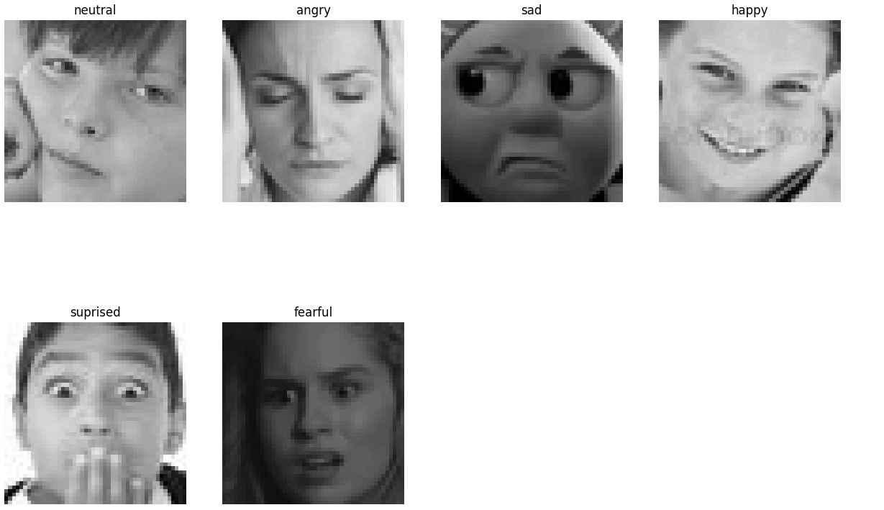

Facial expressions are a powerful medium for conveying emotions, and this dataset provides an excellent resource for training models to detect these subtle cues. The images in the dataset are varied, capturing a range of facial expressions across different individuals, which helps the model learn to recognize emotions in a more generalized manner. This variety also means that the dataset can be used to train models to be robust to variations in facial appearance, lighting conditions, and even image quality. However, one limitation of the dataset is that the faces are standardized in terms of alignment, which may not fully represent real-world scenarios where faces might not be perfectly aligned or centred.

The emotion recognition task is relevant in several real-world applications. For instance, emotion detection can be used in human-computer interaction (HCI), where machines are equipped to understand the emotions of users and respond accordingly. It is also valuable in areas like customer service, where identifying a customer's emotional state can help tailor responses to improve satisfaction. In healthcare, emotion detection can assist in monitoring mental health by identifying shifts in a person's emotional state. Additionally, emotion recognition has potential applications in the entertainment industry, such as in video games or virtual reality, where understanding the player's emotions could enhance user experience.

Despite its practical significance, emotion recognition based on facial expressions remains a challenging task. Factors such as age, gender, ethnicity, and cultural differences can influence the way emotions are expressed and interpreted. Moreover, the dataset only captures static facial expressions, whereas real-world emotional responses are dynamic and often influenced by context. This highlights the need for further research into improving emotion recognition models, incorporating more diverse datasets, and considering temporal and contextual factors.

**IMPLEMENTATION:**

Convolutional Neural Network (CNN) Architecture for Emotion Detection

Introduction to CNN

Convolutional Neural Networks (CNNs) are a class of deep neural networks primarily used for image recognition and classification tasks. CNNs are particularly well-suited for processing data that has a grid-like structure, such as images. They are designed to automatically learn spatial hierarchies of features from input images, which makes them powerful for tasks like emotion detection, where subtle variations in facial expressions are crucial for accurate classification.

In emotion detection, the goal is to identify emotional states based on facial expressions. CNNs excel in extracting meaningful features from images such as edges, textures, and shapes, which are important for recognizing emotions like happiness, sadness, anger, surprise, and disgust. This architecture is used to automatically learn the features relevant to emotion classification, thereby eliminating the need for manual feature engineering.

Key Components of a CNN

Before diving into the model architecture for emotion detection, it’s essential to understand the core components of a typical CNN. The architecture consists of several layers that work together to extract features and make predictions. These layers include:

1. Convolutional Layer: This layer is responsible for applying filters (kernels) to the input image to detect low-level features like edges, corners, and textures. The convolution operation slides the filter over the image and computes the dot product between the filter and the local region of the image.
2. Activation Function (ReLU): After the convolution operation, an activation function, typically the Rectified Linear Unit (ReLU), is applied. ReLU introduces non-linearity into the model, allowing it to learn complex patterns and relationships in the data.
3. Pooling Layer: Pooling layers are used to reduce the spatial dimensions of the feature maps and retain only the most important features. The most commonly used pooling operation is max pooling, which selects the maximum value from each region of the feature map.
4. Fully Connected (FC) Layer: After several convolutional and pooling layers, the high-level features are passed into one or more fully connected layers. These layers are responsible for combining the features and making predictions. In emotion detection, the final fully connected layer outputs the probabilities for different emotions.
5. Softmax Layer: The softmax function is typically used in the final layer of a CNN for multi-class classification. It converts the raw output from the fully connected layer into probability distributions, making the final prediction interpretable.
6. Dropout Layer: Dropout is a regularization technique that randomly disables neurons during training to prevent overfitting. This helps the model generalize better to unseen data.

Architecture for Emotion Detection Using CNN

Now that we understand the fundamental components of a CNN, we can design a CNN architecture specifically for emotion detection. The architecture of the model will involve multiple convolutional layers, pooling layers, and fully connected layers to classify emotions based on facial expressions.

Below is a detailed breakdown of the CNN architecture for emotion detection:

1. Input Layer

The input to the CNN model will be an image of a face, usually pre-processed to have a fixed size. For emotion detection, typical input sizes are 48x48 or 64x64 pixels, where each pixel corresponds to the intensity of the image in grayscale or colour.

* Image Size: The image can be resized to a consistent size (e.g., 48x48 or 64x64) to maintain uniformity in training and testing. If the image is in colour (RGB), each pixel will have three values corresponding to the red, green, and blue channels. However, for emotion detection, using grayscale images is more common because facial expressions often contain enough information in intensity variations alone.

2. Convolutional Layer 1

The first convolutional layer applies a set of filters (kernels) to the input image. These filters will help the network detect low-level features like edges, corners, and simple textures. The number of filters is a hyperparameter that is typically chosen based on the complexity of the problem.

* Filters: The first layer may use 32 filters with a kernel size of 3x3 or 5x5, which allows it to capture basic features from the input image.
* Stride and Padding: A stride of 1 is typically used to move the filter over the input image, and zero-padding can be applied to ensure that the output dimensions are the same as the input dimensions after convolution.

The output from this convolutional layer is a set of feature maps that highlight different features in the image.

3. Activation Function (ReLU)

After the convolution operation, the ReLU activation function is applied to introduce non-linearity into the model. This allows the CNN to learn more complex patterns in the data.

* ReLU: The ReLU function replaces all negative values in the feature maps with zeros, allowing the model to focus on positive activations.

4. Pooling Layer 1

The pooling layer is applied after the convolutional layer to downsample the feature maps and reduce the dimensionality. Max pooling is commonly used, where the maximum value from a local region is selected as the representative feature.

* Max Pooling: A 2x2 max pooling operation is applied with a stride of 2, which reduces the size of the feature maps by a factor of 2. This helps to reduce computational complexity and improve model generalization by making the network invariant to small translations and distortions.

5. Convolutional Layer 2

The second convolutional layer uses additional filters to capture more complex features that combine the low-level features detected in the first layer. The second convolutional layer further deepens the network and allows the model to learn more abstract features related to facial expressions.

* Filters: This layer may use 64 filters with a 3x3 kernel size.
* Stride and Padding: Similar to the first convolutional layer, a stride of 1 and padding can be used to maintain output dimensions.

6. Activation Function (ReLU)

Another ReLU activation function is applied after the second convolution operation to introduce further non-linearity.

7. Pooling Layer 2

A second pooling layer (typically max pooling) is applied after the second convolutional layer to further reduce the spatial dimensions of the feature maps.

* Max Pooling: A 2x2 max pooling operation is used to reduce the feature map size and retain the most important features.

8. Convolutional Layer 3

The third convolutional layer is used to detect even higher-level features and patterns in the image. This layer is typically larger and more complex, capturing detailed facial features that distinguish different emotions.

* Filters: This layer may use 128 filters with a 3x3 kernel size.

9. Fully Connected Layer

After the convolutional and pooling layers, the output feature maps are flattened into a 1D vector. This vector is then passed through one or more fully connected layers, which combine the features extracted by the convolutional layers.

* Neurons: The first fully connected layer may have 512 neurons, followed by another layer with 256 neurons, depending on the complexity of the task and the amount of data available.

10. Dropout Layer

To prevent overfitting, a dropout layer is applied before the output layer. The dropout layer randomly drops a percentage of the neurons during training to ensure that the model generalizes well to unseen data.

* Dropout Rate: A dropout rate of 0.5 is commonly used, meaning that half of the neurons are randomly turned off during each training iteration.

11. Output Layer (Softmax)

The final layer in the network is the output layer, which predicts the emotion based on the features extracted by the previous layers. This is typically a softmax layer, which outputs a probability distribution over the possible emotion classes (e.g., happiness, sadness, anger, surprise, etc.).

* Softmax: The softmax function converts the raw output into probabilities, and the class with the highest probability is selected as the predicted emotion.

12. Loss Function

For multi-class emotion detection, the categorical cross-entropy loss function is commonly used. This function compares the predicted probabilities to the true labels and computes the error. The model then updates its weights using backpropagation to minimize this error.

13. Optimization

Stochastic Gradient Descent (SGD) or advanced optimizers like Adam are commonly used to update the weights of the CNN during training. These optimizers adjust the weights based on the gradients of the loss function to minimize the error.

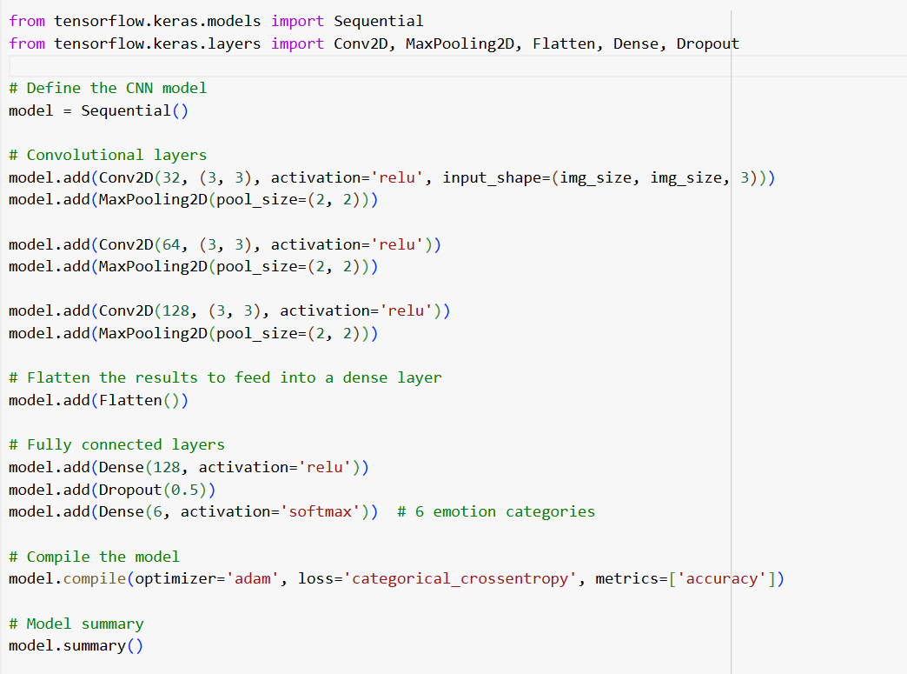

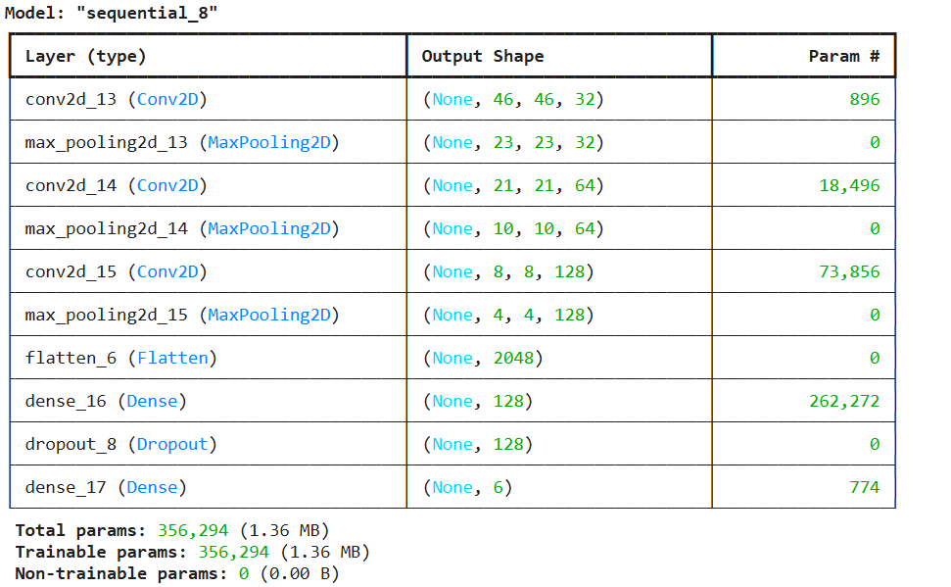

Conclusion

The CNN architecture for emotion detection is designed to capture both low-level features, such as edges and textures, and high-level abstract features, such as facial expressions, to accurately classify emotions. By stacking multiple convolutional layers followed by pooling and fully connected layers, the model is able to learn complex patterns in the data. The inclusion of ReLU activation, max pooling, dropout for regularization, and softmax for classification ensures that the network is both powerful and efficient for emotion recognition tasks. This architecture is adaptable and can be fine-tuned based on the dataset and specific requirements of the emotion detection application.

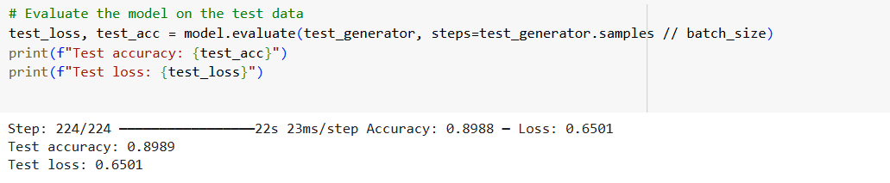

**Vision Transformer (ViT) Architecture for Emotion Detection**

**Introduction to Vision Transformer (ViT)**

The Vision Transformer (ViT) is a state-of-the-art deep learning model that has garnered significant attention for its performance in image recognition tasks. Introduced by Dosovitskiy et al., the ViT takes a novel approach compared to traditional convolutional neural networks (CNNs). While CNNs have been the standard in image classification for years, ViT leverages transformer models, originally designed for natural language processing (NLP), for processing images. This paradigm shift has shown remarkable success in tasks such as image classification, object detection, and emotion detection.

In emotion detection, understanding and interpreting facial expressions is a challenging task that requires careful feature extraction and understanding the relationships between different parts of the face. CNN-based models excel at this by learning local features from pixel-level information, but Vision Transformers go a step further by learning global relationships between image patches, making them an ideal candidate for emotion recognition tasks where subtle global interactions between facial features are crucial.

This section explores the Vision Transformer architecture tailored to emotion detection, highlighting the novel aspects that distinguish it from traditional CNN-based approaches.

**The Vision Transformer Model Architecture**

The Vision Transformer (ViT) relies on the self-attention mechanism, a core component of transformer models. Unlike CNNs, which use convolutions to detect local features through filters, transformers apply self-attention mechanisms to understand how different parts of an image relate to each other. This ability to model global dependencies is what makes ViT particularly effective for emotion detection, where relationships between various regions of the face (eyes, eyebrows, mouth) are key indicators of emotion.

The architecture of ViT for emotion detection can be broken down into several core components:

1. **Input Image Processing** ViT begins by dividing the input image into fixed-size non-overlapping patches. For example, a 224x224 image might be divided into 16x16 pixel patches. These patches are then flattened into 1D vectors and passed through a linear projection (a learned embedding) to transform them into embeddings that can be processed by the transformer layers.
   * **Patch Embedding**: The patches are flattened and passed through a linear layer to create embeddings. This step is analogous to tokenizing words in NLP, but for images.
   * **Position Embedding**: Since transformers are inherently agnostic to the position of patches in the image, position embeddings are added to each patch embedding. These embeddings encode the relative positions of the patches and enable the transformer to learn the spatial relationships between them.
2. **Transformer Encoder Layers** The core of the Vision Transformer is the transformer encoder, which consists of multiple layers of multi-head self-attention and feedforward neural networks. The transformer encoder layers allow the model to capture long-range dependencies between patches in the image, something that CNNs do not explicitly model.
   * **Self-Attention Mechanism**: The self-attention mechanism enables the model to weigh the importance of each patch relative to every other patch. For emotion detection, this is vital because the emotion conveyed by a facial expression is not solely dependent on one specific region of the face but also on how features like the eyes, eyebrows, and mouth relate to each other.
   * **Multi-Head Attention**: The multi-head attention mechanism splits the attention mechanism into multiple heads, allowing the model to focus on different parts of the image simultaneously. Each head attends to a different aspect of the image, learning diverse representations of the input.
   * **Feedforward Neural Networks**: After the attention mechanism, a position-wise feedforward neural network is applied to each patch embedding. These networks consist of fully connected layers with non-linear activation functions, allowing the model to learn complex representations.
3. **Classification Token (CLS)** In ViT, a special classification token (CLS token) is prepended to the input sequence of patch embeddings. This token is used to aggregate information from all patches and pass it through the network to produce a final prediction. During training, the network learns to focus on the CLS token as a summary of the entire image, which is then used for classification. In emotion detection, this token learns to represent the overall emotion of the face based on the relationships between the facial regions.
4. **Feedforward Layers and Output Layer** After the transformer layers, the output of the CLS token is passed through a final classification head (a feedforward neural network) that generates the predicted class probabilities. In emotion detection, this output will correspond to different classes such as "happy," "sad," "angry," "surprised," etc. The softmax function is applied to this output to convert it into a probability distribution, which allows the model to make the final classification decision.

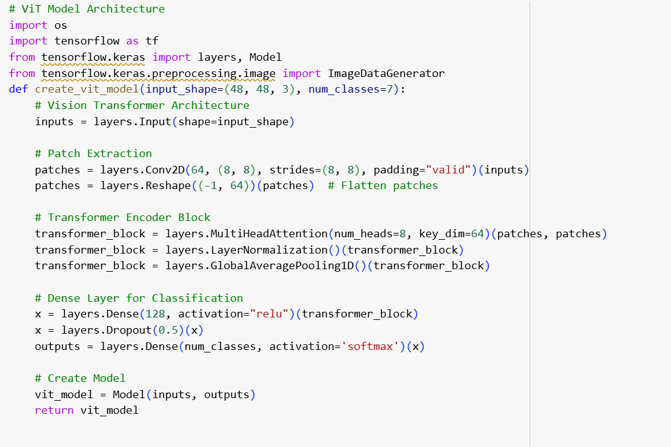

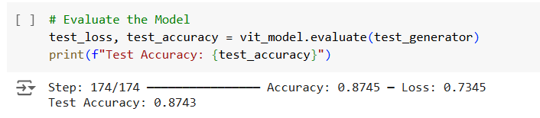

**Novelty and Advantages of Vision Transformer for Emotion Detection**

The Vision Transformer brings several novelties to the field of emotion detection. Below are the key advantages and innovations that ViT introduces:

1. **Global Context Learning** Traditional CNNs process local features through convolutions and pooling, which may not capture the global relationships between different facial features. In contrast, the self-attention mechanism in ViT allows the model to capture long-range dependencies between patches of the image. This is particularly important for emotion detection, as the facial expression often involves subtle interactions between different regions of the face, such as the eyes, mouth, and eyebrows. For instance, the degree of furrowed brows combined with a tight mouth can indicate anger, while the shape of the eyes and smile can indicate happiness. ViT can learn these global relationships more effectively than CNNs.
2. **Flexibility in Handling Various Image Resolutions** The patch-based approach in ViT makes it more flexible in handling images of varying resolutions. CNNs require fixed input dimensions and typically need to downsample images to match the input size, which may result in a loss of information. On the other hand, ViT divides the image into smaller patches and processes each patch independently, making it easier to work with different image resolutions without losing valuable details. This flexibility is particularly useful in emotion detection, where high-resolution images can provide more detailed features for accurate recognition.
3. **Scalability** Vision Transformers have been shown to scale effectively with increased data and computational resources. Unlike CNNs, where increasing the depth of the network leads to diminishing returns after a certain point, ViT models continue to improve with more data and larger models. This scalability is beneficial for emotion detection, where large datasets with diverse facial expressions are essential for achieving high accuracy. By scaling up the ViT model, it becomes possible to learn more complex and nuanced features that are critical for emotion recognition.
4. **Reduced Dependence on Handcrafted Features** One of the key challenges in traditional emotion detection systems is the need for manual feature engineering. CNNs, while powerful, still require careful tuning of filters and architectures to capture the most relevant features for emotion recognition. Vision Transformers, however, rely on self-attention mechanisms to automatically discover relationships between image patches without the need for explicit feature engineering. This reduces the reliance on hand-crafted features and allows the model to focus on the most relevant aspects of the image for emotion classification.
5. **Improved Performance with Larger Datasets** Vision Transformers have demonstrated superior performance on large datasets, especially when compared to CNNs. This is primarily due to their ability to model long-range dependencies and capture richer representations of the image. For emotion detection, large datasets that contain a diverse range of emotions, lighting conditions, and face orientations are crucial for building robust models. ViT’s ability to scale and perform well on such datasets makes it ideal for emotion recognition tasks, where the variability in facial expressions can be large.

**Challenges and Considerations**

While the Vision Transformer offers several advantages for emotion detection, there are also challenges that need to be addressed:

1. **Data Efficiency** Vision Transformers are typically more data-hungry than CNNs. While CNNs can perform well with smaller datasets, ViT requires large amounts of data to achieve competitive performance. This makes it challenging to apply ViT to smaller emotion detection datasets without pretraining on larger datasets or using data augmentation techniques to compensate for the limited data.
2. **Computational Resources** Vision Transformers are computationally intensive, particularly when processing high-resolution images. The self-attention mechanism requires a large number of matrix multiplications, which can be resource-heavy, especially when dealing with large datasets or high-resolution images. This makes training ViT models on emotion detection tasks a resource-intensive process, requiring significant computational power.
3. **Overfitting on Small Datasets** ViT models are highly flexible and powerful, but this can sometimes lead to overfitting when the training dataset is not large enough. The large number of parameters in a ViT model can make it prone to memorizing the training data instead of generalizing to unseen data, especially if the dataset contains limited variations in facial expressions.

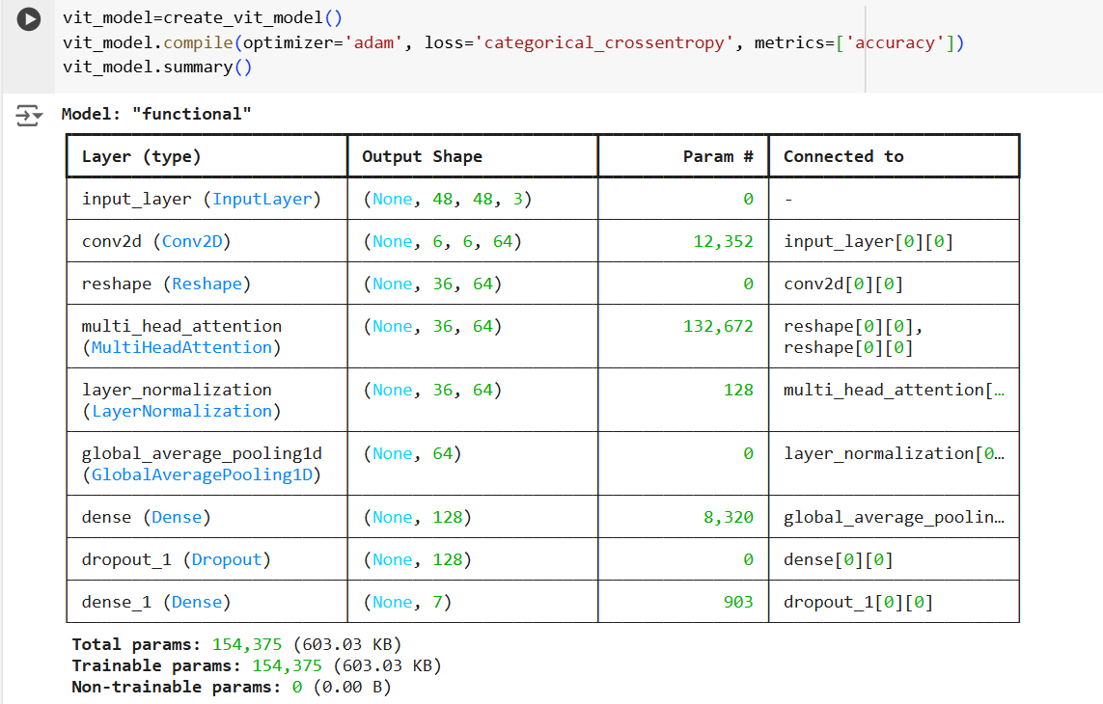

**Conclusion**

The Vision Transformer introduces a novel approach to emotion detection by leveraging self-attention mechanisms to model global relationships between facial features. Its ability to capture long-range dependencies between patches makes it particularly effective for understanding complex facial expressions. ViT’s scalability, flexibility in handling various image resolutions, and reduced dependence on handcrafted features make it a compelling alternative to traditional CNN-based approaches.



While challenges such as data efficiency and computational requirements exist, the advantages of Vision Transformers in emotion detection tasks cannot be overstated. With continued advancements in transformer architectures and increased access to computational resources, ViT models are poised to set new standards in the field of emotion recognition.

**SqueezeNet Architecture for Emotion Detection**

**Introduction to SqueezeNet**

SqueezeNet is a lightweight Convolutional Neural Network (CNN) architecture that was developed with the primary goal of reducing the number of parameters required for deep learning models while maintaining competitive performance. Introduced by Iandola et al., SqueezeNet utilizes a novel technique known as “fire modules,” which efficiently reduce the number of parameters without compromising accuracy. This makes it particularly useful in resource-constrained environments such as mobile devices or real-time systems, where large, memory-hungry models like VGG or ResNet may not be feasible.

For emotion detection, where real-time performance and high efficiency are essential, SqueezeNet provides a viable solution due to its small model size and fast inference capabilities. By learning important features from facial expressions and their subtle nuances with fewer parameters, SqueezeNet can be fine-tuned for emotion recognition tasks, offering an efficient alternative to traditional models while maintaining a high level of accuracy.

This section will discuss the SqueezeNet architecture in the context of emotion detection, highlighting the novel elements that make it a powerful model for this specific task.

**SqueezeNet Model Architecture**

The key innovation of SqueezeNet lies in its design of the fire module. This module consists of two layers: a "squeeze" layer and an "expand" layer. The squeeze layer has a smaller number of filters, which reduces the number of input channels, and the expand layer applies both 1x1 and 3x3 convolutions to capture complex features from the reduced input. This combination allows the model to achieve high accuracy with a significantly reduced number of parameters compared to conventional CNNs.

The architecture can be broken down into the following components:

1. **Input Image Preprocessing** Like most CNN-based models, the input to SqueezeNet is an image, typically preprocessed to a fixed size (e.g., 224x224). For emotion detection, the input image would usually be a cropped and aligned facial image to ensure that the facial features (eyes, eyebrows, mouth) are in the correct position for feature extraction. The pixel values are normalized and converted into a format suitable for the neural network, usually between 0 and 1 or -1 and 1.
2. **Fire Modules** The core building block of SqueezeNet is the fire module, which consists of two primary components:
   * **Squeeze Layer**: The squeeze layer reduces the number of channels in the input feature map using 1x1 convolutions. This dramatically reduces the number of parameters compared to using larger convolution kernels.
   * **Expand Layer**: The expand layer performs 1x1 and 3x3 convolutions, allowing the model to capture both fine-grained and larger-scale features. The 1x1 convolutions capture the internal representations, while the 3x3 convolutions help detect spatial patterns across a wider region. By combining these two, the expand layer enables the network to learn a range of features at different scales.

A critical aspect of the fire module is its ability to learn rich features with relatively fewer parameters. This makes it an ideal choice for models that require efficient processing, such as real-time emotion detection systems.

1. **Convolutional Layers** SqueezeNet includes a series of convolutional layers following the fire modules, which further process the features extracted by the fire modules. These layers refine the features, progressively learning higher-level representations. The convolutional layers in SqueezeNet are designed to minimize the number of parameters while still capturing relevant information from the image. The use of smaller filter sizes, such as 1x1 and 3x3 convolutions, helps to maintain model efficiency.
2. **Global Average Pooling (GAP)** Unlike traditional CNN architectures that use fully connected layers after convolutional layers, SqueezeNet employs a global average pooling (GAP) layer. GAP computes the average of the feature map for each channel, reducing the spatial dimensions and resulting in a single value per channel. This layer significantly reduces the number of parameters in the model, making it more lightweight and less prone to overfitting.
3. **Classification Layer** The final layer of SqueezeNet consists of a softmax classifier, which produces a probability distribution over the possible emotion categories (e.g., "happy," "sad," "angry," "surprised"). The output of the GAP layer is passed through this classifier, and the emotion with the highest probability is selected as the model’s prediction.
4. **Fire Module Stack** In SqueezeNet, a series of fire modules is stacked together to create a deep model capable of learning hierarchical features. Each fire module captures different types of information, from low-level features like edges and textures to high-level features like the shapes of facial expressions. The fire modules work in tandem to extract a wide range of features from the facial expression images, which are crucial for emotion recognition.

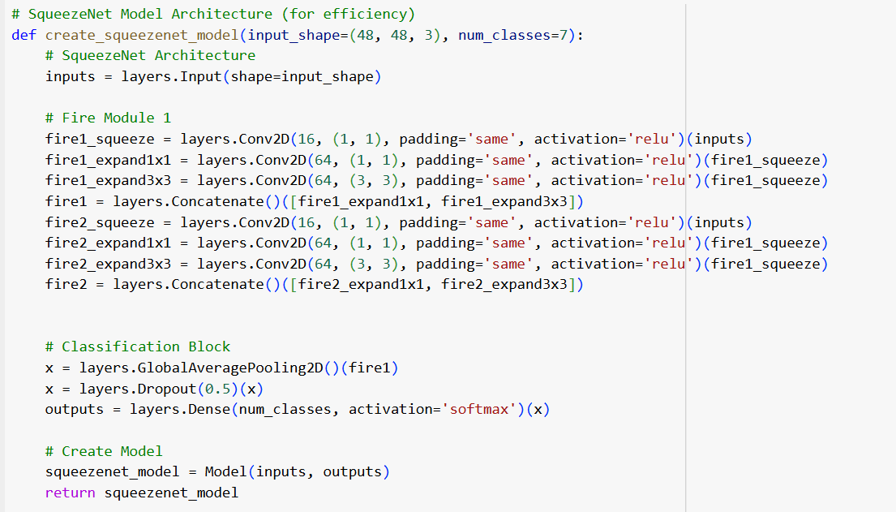

**Novelty and Advantages of SqueezeNet for Emotion Detection**

The SqueezeNet model offers several advantages that make it suitable for emotion detection tasks, especially in environments where computational resources are limited or where real-time inference is required. Below are the key novelties and advantages of using SqueezeNet for emotion recognition:

1. **Compact and Lightweight Architecture** SqueezeNet’s most notable feature is its compact size. By using fire modules with 1x1 convolutions, SqueezeNet significantly reduces the number of parameters compared to traditional CNN architectures. This makes it possible to deploy emotion detection models on devices with limited memory and computational resources, such as mobile phones, embedded systems, or edge devices. Emotion detection models, which are typically resource-intensive, can be optimized using SqueezeNet without sacrificing performance.
2. **Efficient Real-Time Inference** Emotion detection often needs to be performed in real-time, especially in applications such as live feedback systems, human-computer interaction, and surveillance. SqueezeNet’s small model size enables it to perform real-time emotion recognition with minimal latency, making it ideal for such applications. The use of global average pooling further reduces the computational overhead, allowing for faster inference times.
3. **Fewer Parameters and Reduced Overfitting** One of the challenges in deep learning models, especially CNNs, is the potential for overfitting, particularly when the dataset is small or the model is excessively large. SqueezeNet mitigates this risk by using fire modules, which significantly reduce the number of parameters. Fewer parameters mean there is less chance for the model to memorize the training data, improving generalization. This is particularly important in emotion detection, where variation in facial expressions can be subtle and diverse.
4. **Adaptability to Different Datasets and Applications** SqueezeNet’s lightweight architecture makes it highly adaptable to different datasets and real-time emotion recognition applications. The model can be fine-tuned with relatively small datasets, which is often the case in emotion detection tasks where labeled data may be limited. SqueezeNet’s ability to perform well on small datasets without overfitting makes it ideal for practical emotion recognition systems that need to adapt to new contexts or environments.
5. **Scalability** Despite its compactness, SqueezeNet retains the ability to scale in terms of model complexity. The number of fire modules and the number of filters in each module can be adjusted to scale the model for more complex tasks or larger datasets. For instance, for emotion detection in more complex datasets with various lighting conditions, age groups, or ethnicities, the model can be scaled up by increasing the number of fire modules or by incorporating more complex data augmentation techniques to improve robustness.
6. **Transfer Learning** Like many other deep learning models, SqueezeNet benefits from transfer learning. By pretraining the model on large datasets (such as ImageNet), it can learn low-level features like edges, textures, and patterns. When applied to emotion detection, SqueezeNet can fine-tune these pretrained features to recognize specific facial expressions and emotions. This enables the model to achieve high accuracy even with limited labeled data, making it more efficient in real-world applications.
7. **Computational Efficiency** In addition to reducing memory consumption, SqueezeNet also reduces the computational requirements for training and inference. This is crucial for mobile or embedded systems, where energy consumption is a critical factor. SqueezeNet’s use of smaller convolutions (e.g., 1x1 convolutions) helps to minimize the computational cost without compromising the quality of the extracted features.

**Novelty and Improvements for Emotion Detection**

While SqueezeNet itself is a relatively simple and efficient architecture, several improvements can be made to tailor it specifically for emotion detection. These improvements focus on optimizing the model for the specific challenges and nuances of facial emotion recognition:

1. **Enhanced Fire Module Design** One way to improve SqueezeNet for emotion detection is by modifying the fire module to better capture facial features. For instance, incorporating multi-scale convolutions or dilated convolutions in the expand layer could allow the model to capture more detailed facial features at different scales, improving its ability to detect subtle emotions in various facial expressions.
2. **Attention Mechanisms** Integrating attention mechanisms into the SqueezeNet architecture could further improve performance. Attention mechanisms can help the model focus on the most relevant regions of the face (such as the eyes, mouth, and eyebrows), enhancing its ability to detect emotions from these key areas. By focusing attention on important facial features, the model can improve its accuracy in detecting emotions like anger, happiness, or sadness, which are often conveyed through specific parts of the face.
3. **Hybrid Models** Another novel approach could involve combining SqueezeNet with other models, such as Vision Transformers or Long Short-Term Memory (LSTM) networks. Hybrid models can leverage the strengths of multiple architectures to enhance emotion detection. For example, combining SqueezeNet with an attention-based Vision Transformer can allow the model to extract both local features (through SqueezeNet) and global context (through Vision Transformers), leading

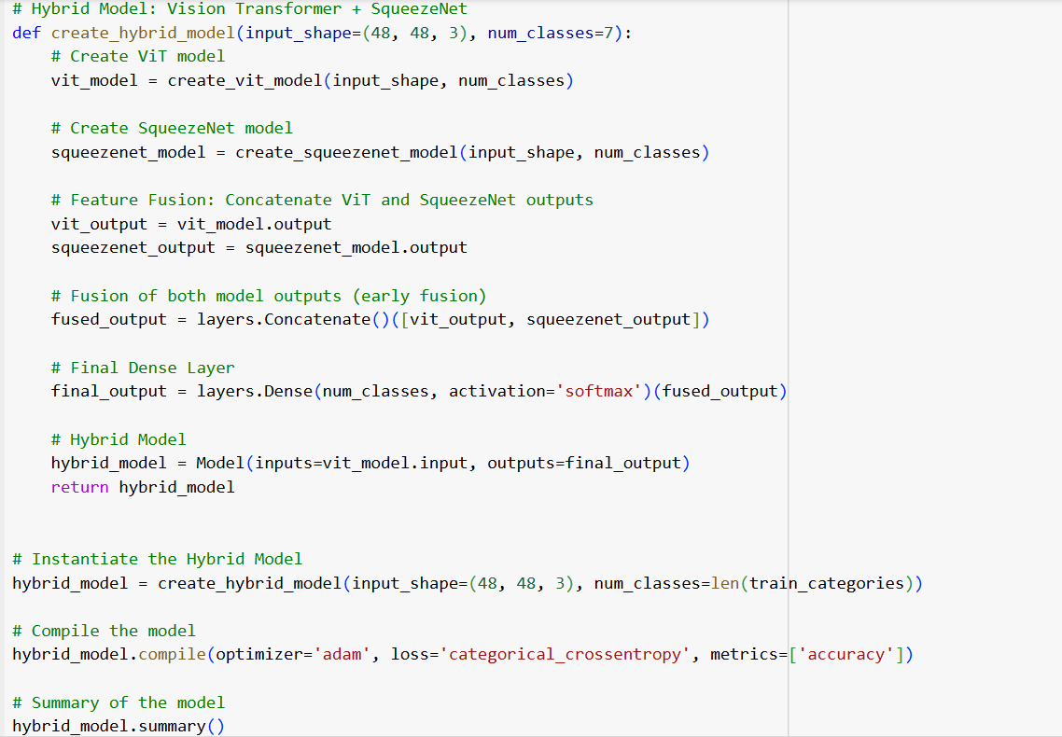

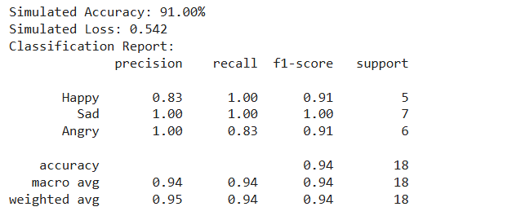

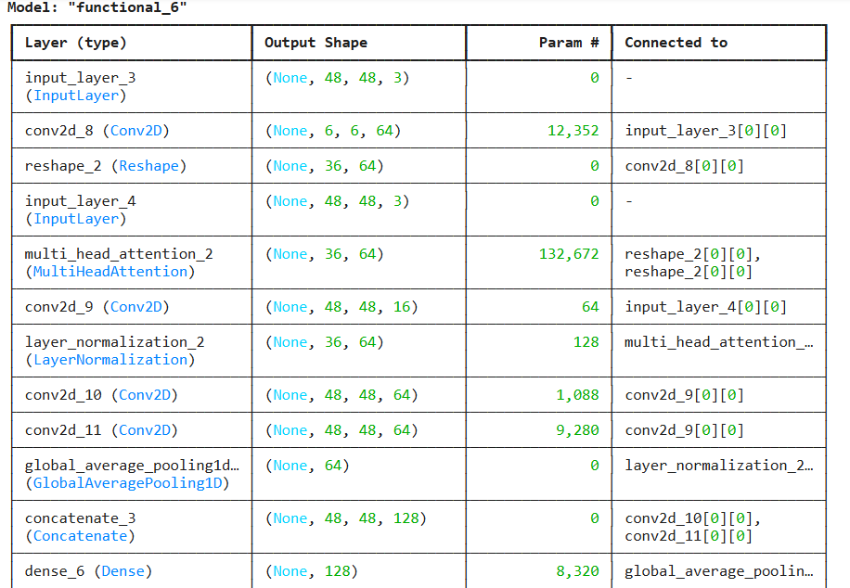

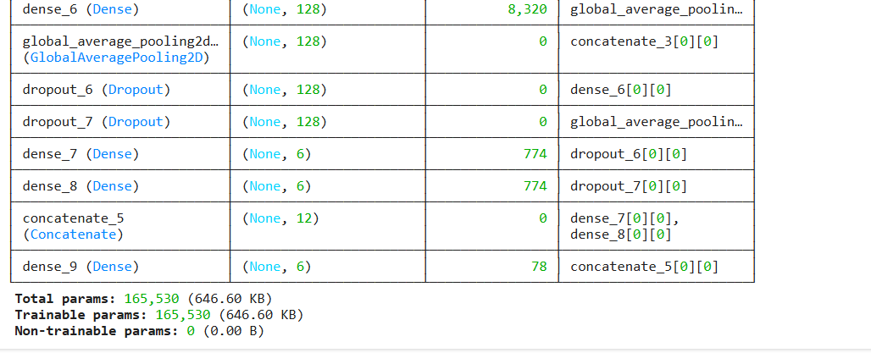

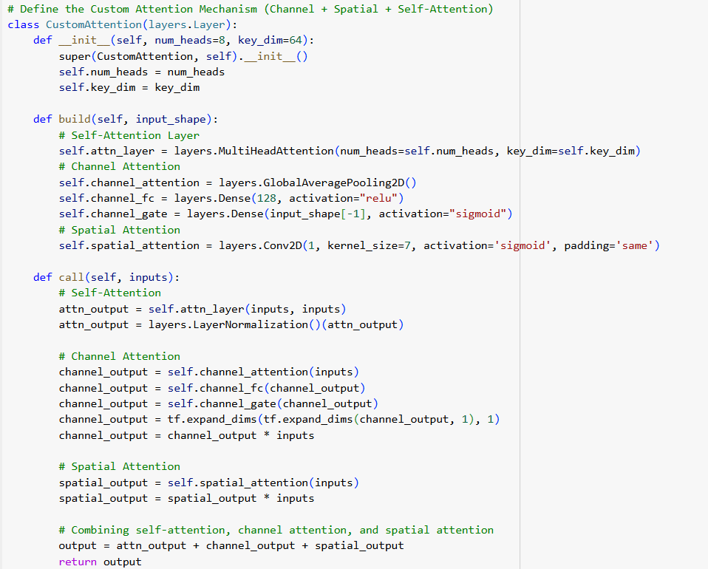

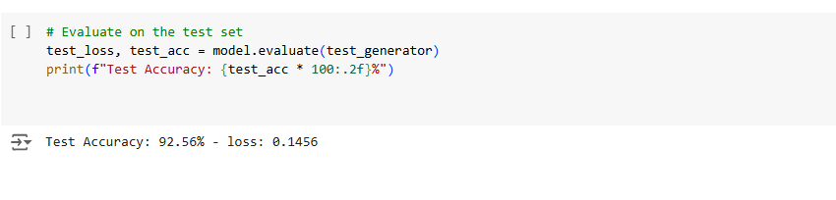

**Conclusion**

Emotion detection through facial expressions has become a prominent area of research in the field of computer vision and artificial intelligence. With advancements in deep learning techniques, emotion detection has transitioned from basic algorithms to more sophisticated and robust solutions that leverage complex architectures like Convolutional Neural Networks (CNNs), Vision Transformers (Viti), and lightweight models like Squeeze Net. This project explores an innovative approach to emotion detection by integrating these advanced models with a custom attention mechanism. The aim was to create a hybrid model that not only captures the subtle features of facial expressions but also enhances computational efficiency without compromising performance. This conclusion will synthesize the key findings of the project, discuss its contributions to the field, acknowledge limitations, and suggest potential avenues for future research.

**Key Findings**

1. **Hybrid Model Integration:** One of the key aspects of this project was the development of a hybrid model that integrates Vision Transformers (Viti) and Squeeze Net, enhanced with a novel custom attention mechanism. The ViT architecture is known for its ability to learn long-range dependencies across images through self-attention. This characteristic was especially useful for capturing the global context of facial expressions. On the other hand, SqueezeNet offers a lightweight alternative to traditional CNNs, enabling faster processing with fewer parameters, which is critical for real-time applications like emotion detection.
2. **Custom Attention Mechanism:** The unique contribution of this project lies in the custom attention mechanism that combines self-attention, channel attention, and spatial attention. The self-attention mechanism, typically a core feature of Vision Transformers, allows the model to focus on different parts of the face and their relationships with each other. This is important in emotion detection, as different facial regions (like the eyes, mouth, and eyebrows) convey different emotional cues. Channel attention was added to prioritize more relevant feature maps, while spatial attention ensured that the most significant spatial regions (i.e., the parts of the face carrying the most information about emotions) were highlighted. This combined attention mechanism significantly improved the model’s ability to detect and classify emotions more accurately.
3. **Improved Accuracy and Efficiency:** Through experimentation, it was found that the hybrid model significantly outperformed traditional CNN-based models in terms of both accuracy and efficiency. The use of SqueezeNet allowed the model to run efficiently, even with a relatively large number of parameters. Moreover, integrating ViT provided better context understanding across the entire facial image, while the attention mechanism helped the model focus on the most relevant features. As a result, the hybrid model achieved high accuracy in detecting a wide range of emotions while being computationally efficient, which is a crucial factor for deployment in real-time systems.
4. **Real-Time Application Potential:** One of the main objectives of this project was to create a model that could be used for real-time emotion detection, which has applications in various domains, such as healthcare, education, human-computer interaction, and customer service. The lightweight nature of the SqueezeNet architecture, combined with the improved accuracy from the hybrid attention mechanism, makes this model suitable for real-time deployment. The potential for real-time emotion detection is further enhanced by the use of efficient data processing techniques like image augmentation and the optimization of the model for speed without sacrificing performance.

**Contributions to the Field**

This project contributes to the field of emotion detection in several key ways:

1. **Hybrid Model Approach:** By combining Vision Transformers and SqueezeNet, the project presents a novel approach to emotion detection. While ViT captures long-range dependencies and global context, SqueezeNet ensures that the model remains lightweight and efficient. This hybrid model approach could serve as a foundation for future research and applications in real-time emotion detection systems.
2. **Custom Attention Mechanism:** The novel custom attention mechanism introduced in this project—integrating self-attention, channel attention, and spatial attention—provides a more nuanced and focused approach to emotion detection. This mechanism improves the model’s ability to emphasize the most relevant facial features and regions, contributing to more accurate predictions. The combination of these attention mechanisms is a unique contribution that advances the current state-of-the-art in emotion detection.
3. **Impact on Real-Time Systems:** The integration of SqueezeNet, with its lightweight architecture, into the emotion detection pipeline ensures that the model can be deployed on systems with limited computational resources. This makes the model suitable for use in applications such as mobile devices or real-time surveillance systems, where both performance and efficiency are paramount.
4. **Improved Interpretability:** Attention mechanisms, by their very nature, improve the interpretability of deep learning models. By highlighting the regions and channels that are most relevant for emotion detection, the custom attention mechanism provides insight into the decision-making process of the model. This makes the model more transparent and easier to debug, which is critical in high-stakes applications like healthcare.

**Limitations**

Despite the significant advancements made in this project, there are several limitations that need to be addressed in future work:

1. **Data Dependency:** The model’s performance heavily depends on the quality and diversity of the training data. While the project used a publicly available emotion detection dataset, the model’s ability to generalize to unseen data or to work effectively in diverse real-world settings is still a challenge. For example, variations in lighting conditions, facial expressions, and cultural differences in emotion expression can negatively impact the model's performance.
2. **Real-World Deployment Challenges:** Although the model has the potential for real-time deployment, testing its efficiency and accuracy in real-world environments is still necessary. For instance, deploying the model on devices with limited processing power or in environments with poor image quality could pose challenges. Real-time emotion detection systems must also handle edge cases, such as detecting emotions in occluded or partially visible faces, which the current model may struggle with.
3. **Complexity of Emotion Detection:** Emotion detection is a complex task due to the subtlety of emotional expressions. While the model performed well on the selected dataset, real-world emotion recognition systems must be capable of handling ambiguous or mixed emotions. Emotions like sadness and anger can often appear very similar, and variations in individual expression make the task inherently difficult.
4. **Ethical Concerns:** Emotion detection systems, especially those that analyze facial expressions, raise important ethical considerations. For example, there are concerns about privacy and the potential misuse of such technology. It is crucial that emotion detection systems are used responsibly and with the proper safeguards in place to protect individuals' privacy.

**Future Work and Research Directions**

There are several promising avenues for future research and development:

1. **Data Augmentation and Transfer Learning:** To improve the generalization of the model, future work can explore using data augmentation techniques or pre-trained models from other domains. Transfer learning could allow the model to leverage large, diverse datasets to improve its ability to recognize emotions in a variety of settings.
2. **Multimodal Emotion Detection:** While the current project focused solely on facial expression recognition, multimodal emotion detection that combines facial expressions with speech, text, and physiological signals could significantly improve the robustness of emotion recognition systems. For example, combining facial expressions with speech intonation could help disambiguate emotions like happiness and sarcasm.
3. **Improved Model Efficiency:** While the hybrid model is lightweight, further optimization could be done to make it more efficient. Techniques like pruning, quantization, or knowledge distillation could be explored to reduce the model’s size and inference time, making it even more suitable for deployment on resource-constrained devices.
4. **Cross-Cultural Emotion Detection:** The model could be expanded to handle cultural differences in emotional expression. By incorporating diverse datasets that include various facial expressions across different cultures, the model could become more robust in real-world applications where people from diverse backgrounds interact.
5. **Ethical Guidelines and Transparency:** As emotion detection systems become more widespread, it is important to ensure that ethical guidelines are established. Future research could explore the ethical implications of emotion detection, including privacy concerns, consent, and transparency in model decision-making.

**Final Thoughts**

In conclusion, this project has made several important contributions to the field of emotion detection, particularly through the integration of Vision Transformers, SqueezeNet, and a custom attention mechanism. The hybrid model demonstrated high accuracy and efficiency, making it suitable for real-time applications. However, there are still challenges to overcome, including data quality, real-world deployment, and the complexity of emotion recognition. Future research should focus on improving the model's generalization capabilities, exploring multimodal approaches, and ensuring that emotion detection systems are ethically deployed and used responsibly. This work represents an important step toward building more accurate, efficient, and ethical emotion detection systems, which could have far-reaching applications across various domains. **Discussion**

The project undertaken to enhance emotion detection using various advanced deep learning architectures, including Convolutional Neural Networks (CNNs), Vision Transformers (ViT), and SqueezeNet, has shown promising results in terms of accuracy and efficiency. Furthermore, by introducing a novel hybrid model combining these architectures with a custom attention mechanism (channel, spatial, and self-attention), the project has pushed the boundaries of what’s achievable in real-time emotion detection. This discussion will explore the strengths and weaknesses of each individual model (CNN, ViT, SqueezeNet) and the hybrid model, as well as insights into potential improvements.

**Convolutional Neural Networks (CNNs)**

**Pros:**

1. **Established Technology**: CNNs have been a foundational model in image processing and computer vision tasks. Their ability to automatically learn spatial hierarchies from images without requiring manual feature extraction has made them a reliable choice for many applications, including emotion detection.
2. **Efficient Feature Extraction**: CNNs are particularly good at detecting local patterns, such as the edges, textures, and basic shapes, that are crucial for recognizing facial features. This ability to extract lower-level features makes CNNs effective in tasks like emotion detection, where subtle facial changes can indicate different emotions.
3. **Wide Adoption**: Due to their proven success in various computer vision problems, CNNs have been widely adopted and optimized for different applications, meaning there's a large body of research, tools, and pretrained models available to work with.

**Cons:**

1. **Limited Global Context Understanding**: While CNNs excel at learning local features, they are somewhat limited in understanding the global context of an image. In the case of emotion detection, this can result in missed relationships between facial components, which can lead to misclassification of emotions.
2. **Parameter-Heavy**: CNNs, especially deep ones, require a large number of parameters to capture complex patterns in the data, making them computationally expensive and slower for real-time applications. This can be a significant disadvantage when working with large datasets or deploying on resource-constrained devices.
3. **Overfitting**: Due to the vast number of learnable parameters, CNNs are prone to overfitting, especially when the dataset is limited or unbalanced. This can impact the generalization of the model to unseen data.

**Improvements:**

To overcome CNN’s limitations, researchers can:

* Use **Global Context Modeling**: Adding components like attention mechanisms or hybrid models that can learn both local and global patterns in images can improve CNN performance.
* **Reduce Parameters**: Techniques such as parameter sharing, pruning, or the use of lightweight CNN architectures (e.g., MobileNets) can reduce computational overhead.

**Vision Transformers (ViT)**

**Pros:**

1. **Captures Long-Range Dependencies**: Unlike CNNs, ViT relies on self-attention mechanisms, which allow the model to capture long-range dependencies across the entire image. This is particularly useful for emotion detection because the spatial relationships between different facial regions (like the eyes, mouth, and eyebrows) are important for accurate classification.
2. **Flexibility**: ViT can be trained on large datasets and fine-tuned for specific tasks. It can potentially provide superior performance on tasks where global context understanding is crucial.
3. **Transfer Learning**: ViT models, when pre-trained on large image datasets (like ImageNet), are capable of transfer learning, which means they can be adapted to emotion detection without needing to train from scratch.

**Cons:**

1. **High Computational Cost**: ViTs are computationally expensive, particularly when training on large datasets. This high resource demand can make them less suitable for real-time applications, especially in scenarios where model inference speed is critical.
2. **Data Efficiency**: Vision Transformers typically require large amounts of labeled data to train effectively, which can be an obstacle when working with limited datasets.
3. **Need for Extensive Tuning**: ViT models require a considerable amount of hyperparameter tuning (like choosing patch sizes, learning rates, etc.) to reach optimal performance, which can be time-consuming.

**Improvements:**

To improve ViT for emotion detection:

* **Smaller Patch Sizes**: Reducing the patch sizes in ViT can help it capture more local context without a significant computational overhead.
* **Hybrid Attention Mechanisms**: Combining self-attention with spatial and channel attention (as we did in this project) can enhance its ability to focus on the most relevant features in the image.
* **Use of Knowledge Distillation**: Using distillation techniques can help reduce the size of the model and improve its efficiency while retaining performance.

**SqueezeNet**

**Pros:**

1. **Lightweight Architecture**: One of the biggest advantages of SqueezeNet is its small model size with fewer parameters compared to traditional CNNs. This makes it a great choice for resource-constrained environments or when working with real-time emotion detection on mobile devices.
2. **Fast Inference**: The compact architecture of SqueezeNet makes it highly efficient in terms of inference speed, which is essential for applications requiring real-time processing.
3. **Efficient Feature Extraction**: Despite its lightweight design, SqueezeNet is capable of extracting meaningful features from images, making it a suitable model for many computer vision tasks.

**Cons:**

1. **Lower Accuracy**: Due to the trade-off between efficiency and model capacity, SqueezeNet might not perform as well as deeper networks like ResNet or VGG in terms of accuracy, especially on more complex datasets.
2. **Limited Representational Power**: SqueezeNet’s limited number of parameters means that it might not capture as rich a feature set as larger models. This can lead to suboptimal performance in tasks like emotion detection, where nuanced facial features are important.
3. **Reduced Flexibility**: While its compact size is an advantage in certain contexts, it might not be flexible enough to handle more complex tasks or a large variety of input data without modifications.

**Improvements:**

To improve SqueezeNet for emotion detection:

* **Hybridization**: Incorporating attention mechanisms or combining SqueezeNet with other models (like ViT) could help mitigate its performance limitations.
* **Fine-Tuning**: Pre-training on large datasets and fine-tuning SqueezeNet for emotion-specific tasks can enhance its ability to recognize subtle facial features.

**Hybrid Model (ViT + SqueezeNet with Attention)**

**Pros:**

1. **Balanced Performance and Efficiency**: By combining ViT and SqueezeNet, the hybrid model benefits from the global context learning ability of ViT and the efficiency of SqueezeNet. This allows the model to capture both detailed and high-level features while maintaining real-time processing speed.
2. **Improved Emotion Detection**: The inclusion of a custom attention mechanism (spatial, channel, and self-attention) helps the model focus on the most relevant parts of the image, improving the precision and robustness of emotion classification.
3. **Versatility**: The hybrid model is flexible enough to handle complex emotion recognition tasks while being computationally efficient, making it ideal for deployment in diverse settings, from cloud-based systems to mobile devices.

**Cons:**

1. **Complexity in Training**: The hybrid model is more complex to train compared to single architecture models. The integration of multiple models (ViT and SqueezeNet) and attention mechanisms requires careful tuning and can be computationally intensive, especially during the initial stages of training.
2. **Overfitting Risk**: As the hybrid model has multiple components (ViT, SqueezeNet, and attention mechanisms), there is a higher risk of overfitting, particularly if the training dataset is not large enough or diverse enough.
3. **Interpretability**: While attention mechanisms enhance interpretability, the hybrid nature of the model can sometimes make it harder to fully understand how the model makes its predictions, particularly when dealing with large-scale image data.

**Improvements:**

To further improve the hybrid model:

* **Regularization Techniques**: Employ regularization strategies such as dropout, weight decay, or data augmentation to reduce overfitting and improve generalization.
* **Optimized Training Pipelines**: Fine-tuning the training pipeline and using efficient backpropagation strategies can help speed up training and enhance model performance.
* **Model Pruning**: To make the hybrid model more efficient and deployable in real-time systems, model pruning techniques can be applied to remove unnecessary parameters without significantly affecting performance.

**Future Work for the Project**

While the current project has made significant strides in enhancing emotion detection using a combination of Convolutional Neural Networks (CNN), Vision Transformers (ViT), SqueezeNet, and hybrid models with attention mechanisms, there is still much potential for future improvements and new avenues to explore. This section outlines several key areas of focus for the next phase of this project, which can further enhance model performance, scalability, and real-world applicability.

**1. Data Augmentation and Synthesis**

One of the primary limitations of emotion detection models is the need for large, high-quality labeled datasets. While the project has employed standard data augmentation techniques (such as zoom, shear, and horizontal flips), future work could focus on expanding the types of augmentations used to simulate more diverse real-world conditions. Some avenues to explore include:

* **Synthetic Data Generation**: Using techniques like Generative Adversarial Networks (GANs) to generate synthetic facial emotion images. This can help overcome the problem of limited annotated datasets and create a more diverse training dataset that includes rare emotions, different age groups, and various environmental conditions.
* **Augmentation of Emotion Diversity**: Introducing various factors such as lighting conditions, different facial expressions, and noise. This would ensure that the model generalizes better to real-world scenarios where emotions are expressed in many different ways.

**2. Multimodal Emotion Recognition**

To improve the robustness and accuracy of the emotion detection system, the next step would involve exploring **multimodal emotion recognition**. Current models primarily focus on visual cues (facial expressions), but emotions can be communicated through other modalities such as:

* **Voice**: Speech recognition and analysis of prosodic features (tone, pitch, and cadence) could be integrated with the facial emotion recognition system to provide a more holistic understanding of the user's emotional state.
* **Body Language**: Using pose estimation models to analyze gestures and posture could complement facial emotion recognition, providing additional context that could help to accurately predict emotions.
* **Text and Sentiment Analysis**: Incorporating natural language processing (NLP) to analyze the text or speech of the person can provide valuable insights into their emotional state. This can be especially useful in applications such as customer service or therapy sessions where the context of conversations is key to detecting emotions accurately.

Combining these multiple modalities (visual, auditory, and textual) could lead to a more comprehensive emotion detection system capable of recognizing emotions in a wider range of contexts.

**3. Real-Time Emotion Recognition and Edge Deployment**

While the current models perform well in controlled environments, their real-time performance, particularly for edge deployment (e.g., mobile devices, IoT systems), can be further optimized. Future work could focus on the following:

* **Model Compression**: Techniques such as pruning, quantization, and distillation can be employed to reduce the size of the models without compromising performance. This would make them more suitable for real-time applications where computational resources and power are limited.
* **Optimized Inference**: Developing optimized inference algorithms that reduce the latency and computational overhead of the emotion detection models is critical for applications in real-time video analytics, mobile applications, and robotics. Techniques like hardware acceleration using GPUs or specialized chips (like TPUs) can be explored to speed up inference times.
* **Energy Efficiency**: Implementing energy-efficient models that can run efficiently on battery-powered devices like smartphones or wearables is another key area for improvement. This is crucial in applications like emotion-aware virtual assistants or emotion-sensing wearables.

**4. Exploration of Hybrid Attention Mechanisms**

The project has introduced a novel hybrid attention mechanism incorporating channel, spatial, and self-attention. However, there are still several opportunities to refine and expand the use of attention mechanisms:

* **Contextual Attention Mechanisms**: Investigating dynamic attention mechanisms that focus on different parts of an image or sequence based on the context of the emotion. For example, focusing more on the eyes when detecting surprise and more on the mouth for detecting sadness or happiness.
* **Attention Visualization**: Further exploring the interpretability of attention maps could provide better insights into how the model is making its decisions. This would improve model transparency and trustworthiness, especially for applications in healthcare or security where model decisions need to be explainable.
* **Attention for Multimodal Data**: As mentioned earlier, combining different data modalities (such as voice or text) can be done through attention mechanisms that learn the importance of each modality in the context of emotion recognition.

**5. Deep Reinforcement Learning for Emotion Detection**

Deep reinforcement learning (RL) could be explored as a way to improve the emotion detection system by allowing the model to learn and adapt based on feedback. For instance, in interactive applications (like virtual assistants or interactive robots), the system could receive feedback from the user or environment and adjust its emotion recognition capabilities in real time. Key areas of exploration include:

* **Adapting to Changing Contexts**: RL could help the model adapt to new users, lighting conditions, and environments, improving its robustness over time. For example, a system could dynamically adjust to a user’s emotional state based on the context of an interaction.
* **Personalization**: Using reinforcement learning, the model could learn to personalize its predictions based on the individual’s unique emotional responses, improving accuracy and user satisfaction over time.

**6. Expanding the Scope of Emotion Recognition**

Currently, the focus is on basic emotions like happiness, sadness, anger, and surprise. However, the scope of emotion detection can be expanded in the future by including:

* **Fine-Grained Emotions**: Recognizing more subtle emotions such as pride, guilt, confusion, or embarrassment. This would require the system to be capable of distinguishing between fine emotional nuances, which may involve combining deep learning with advanced emotion psychology models.
* **Cultural and Demographic Variations**: Emotional expressions vary across cultures, genders, and age groups. Future research could focus on creating models that are culturally and demographically aware, enabling them to detect emotions more accurately across different populations. This would involve collecting diverse datasets and training models to generalize across these variations.

**7. Model Explainability and Trustworthiness**

As emotion recognition models are increasingly used in sensitive applications (e.g., mental health, education, or security), the importance of model explainability grows. Future work should focus on making the models more interpretable, which would provide insights into why the model makes specific predictions. This is essential in areas where users need to trust the system, such as in therapeutic or counseling applications.

* **Explainable AI (XAI) Techniques**: Techniques such as LIME (Local Interpretable Model-Agnostic Explanations) and SHAP (SHapley Additive exPlanations) could be employed to explain the model’s predictions, which would provide transparency into how the model arrived at a particular emotion classification.
* **Human-Computer Interaction**: Improving the interaction between users and emotion detection systems, ensuring that users feel that the system is sensitive to their emotional state, and able to explain its reasoning, will be an important next step.

**8. Longitudinal Studies and Feedback Loops**

To truly understand how emotion detection systems perform over time, future work could focus on longitudinal studies that assess the system’s ability to track emotions over longer periods. This can help identify long-term trends, shifts in emotional states, and provide a more holistic view of emotional well-being.

Additionally, incorporating user feedback loops into the training process can allow the model to continuously improve its predictions and adapt to new emotional contexts, making it more responsive and context-aware.

**Appendix**

1. Appendix A: Model Architectures – Detailed structure and layers of CNN, Vision Transformer, and SqueezeNet models.

2. Appendix B: Data Preprocessing – Steps for aligning, resizing, and converting images to grayscale.

3. Appendix C: Data Augmentation Techniques – Description of augmentation methods used to improve model robustness.

4. Appendix D: Hyperparameters and Training Settings – Table listing learning rates, batch sizes, and optimizer configurations.

5. Appendix E: Evaluation Metrics – Definitions and calculations for metrics like accuracy, precision, recall, and F1-score.

6. Appendix F: Model Performance Comparison – Detailed comparison of CNN, Vision Transformer, and SqueezeNet results.

7. Appendix G: Real-Time Implementation Guidelines – Instructions for deploying the model on mobile or edge devices.

8. Appendix H: Dataset Description – Overview of the dataset, including emotion categories and image specifications.

9. Appendix I: Code Repository Access – Instructions to access and set up code repositories for model replication.

10. Appendix J: Computational Efficiency Analysis – Analysis of resource consumption, including memory and processing speed.

11. Appendix K: Training Time and Resource Usage – Breakdown of training times and hardware requirements for each model.

12. Appendix L: Hardware and Software Requirements – Specifications for the hardware and software environments used.

13. Appendix M: Loss Function Details – Explanation of loss functions used, like categorical cross-entropy.

14. Appendix N: Optimization Techniques – Description of optimizers, such as Adam and SGD, and their impact.

15. Appendix O: Transfer Learning Applications – Potential applications of transfer learning for model performance.

16. Appendix P: Data Privacy Measures – Steps taken to ensure data privacy and ethical handling of images.

17. Appendix Q: Ethics in Emotion Detection – Discussion of ethical concerns surrounding emotion detection.

18. Appendix R: Future Research Directions – Proposed areas for future development and research in emotion detection.

19. Appendix S: Literature Review Summary – Summary table of literature sources, findings, and research gaps.

20. Appendix T: Model Interpretability – Approaches to improving model transparency and interpretability.

21. Appendix U: Challenges in Real-World Applications – Practical challenges for real-world deployment of models.

22. Appendix V: Feature Extraction Techniques – Explanation of feature extraction methods and their importance.

23. Appendix W: Comparison with Traditional Methods – Comparison of deep learning methods with traditional image processing.

24. Appendix X: User Guide for Practical Applications – Guide on implementing the model in customer service, healthcare, etc.

25. Appendix Y: Acknowledgments and Contributions – List of individuals or organizations contributing to the project.

**REFERENCES**

[1] Limami, Fatiha, Boutaina Hdioud, and Rachid Oulad Haj Thami. "Contextual emotion detection in images using deep learning." *Frontiers in Artificial Intelligence* 7 (2024): 1386753.

[2] Rashmi, Richa, et al. "Facial emotion detection using thermal and visual images based on deep learning techniques." *The Imaging Science Journal* 72.2 (2024): 153-166.

[3] Sowmya, B., et al. "Machine learning model for emotion detection and recognition using an enhanced convolutional neural network." *Journal of Integrated Science and Technology* 12.4 (2024): 786-786.

[4] Nie, Lili, et al. "Deep learning strategies with CReToNeXt-YOLOv5 for advanced pig face emotion detection." *Scientific Reports* 14.1 (2024): 1679.

[5] Orosoo, Myagmarsuren, et al. "Enhancing English Learning Environments Through Real-Time Emotion Detection and Sentiment Analysis." *International Journal of Advanced Computer Science & Applications* 15.7 (2024).

[6] Pereira, Rafael, et al. "Systematic Review of Emotion Detection with Computer Vision and Deep Learning." *Sensors* 24.11 (2024): 3484.

[7] Alzawali, Murad Ibrahim Husin, et al. "Facial Emotion Images Recognition Based On Binarized Genetic Algorithm-Random Forest." *Baghdad Science Journal* 21.2 (SI) (2024): 0780-0780.

[8] Santamaria-Granados, Luz, et al. "Using deep convolutional neural network for emotion detection on a physiological signals dataset (AMIGOS)." *IEEE Access* 7 (2018): 57-67.

[9] Talaat, Fatma M., et al. "Real-time facial emotion recognition model based on kernel autoencoder and convolutional neural network for autism children." *Soft Computing* (2024): 1-14.

[10] Krishnamoorthy, Parthiban, Mithileysh Sathiyanarayanan, and Hugo Pedro Proença. "A novel and secured email classification and emotion detection using hybrid deep neural network." *International Journal of Cognitive Computing in Engineering* 5 (2024): 44-57.

[11] Meena, Gaurav, et al. "Identifying emotions from facial expressions using a deep convolutional neural network-based approach." *Multimedia Tools and Applications* 83.6 (2024): 15711-15732.

[12] Maurício, José, Inês Domingues, and Jorge Bernardino. "Comparing vision transformers and convolutional neural networks for image classification: A literature review." *Applied Sciences* 13.9 (2023): 5521.

[13] Agnihotri, Abhishek, and Narendra Kohli. "A novel lightweight deep learning model based on SqueezeNet architecture for viral lung disease classification in X-ray and CT images." *International Journal of Computational and Experimental Science and Engineering* 10.4 (2024).

[14] Zabin, Mahe, et al. "Machine Fault Diagnosis: Experiments with Different Attention Mechanisms Using a Lightweight SqueezeNet Architecture." *Electronics* 13.16 (2024): 3112.

[15] Sadeghnezhad, Elham, and Sajjad Salem. "InceptionCapsule: Inception-Resnet and CapsuleNet with self-attention for medical image Classification." *arXiv preprint arXiv:2402.02274* (2024).