Activity IV - Fundamental of Cryptography
Exercises
- (Encryption and Statistical Analysis) Though encryption is primarily designed to preserve confidentiality and integrity of data, the mechanism itself is vulnerable to brute force (statistical analysis). In other words, the more we see the encrypted data, the easier we can hack it. In this exercise, you are asked to crack the following cipher text. Please provide the decrypted result and explain your strategy in decrypting this text.
Cipher text
PRCSOFQX FP QDR AFOPQ CZSPR LA JFPALOQSKR. QDFP FP ZK LIU BROJZK MOLTROE.
- Count the frequency of letters. List the top three most frequent characters.

- The top three most most frequent characters are
1st P (7)
2nd R, O, F (6)
3rd Q (5)
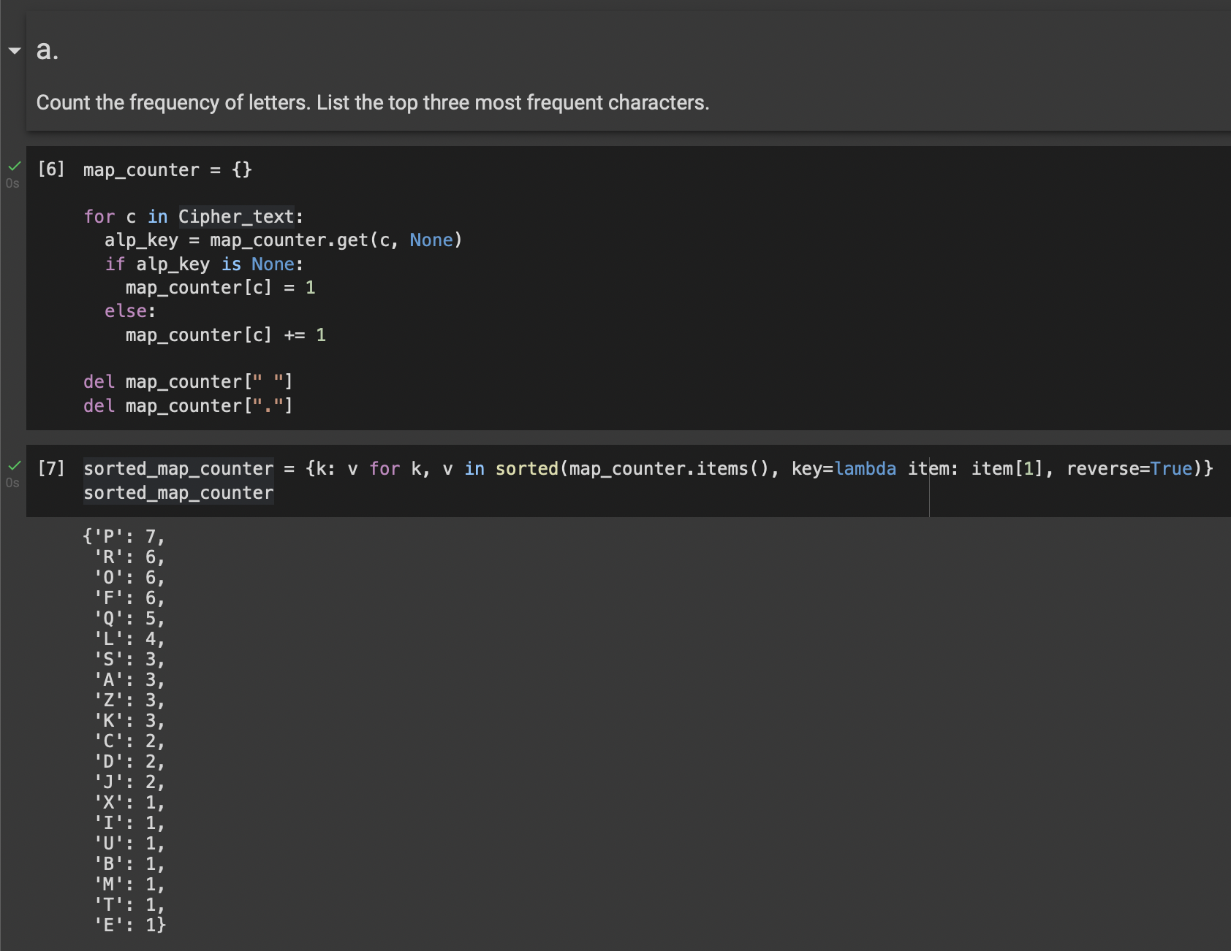

- Knowing that this is English, what are commonly used three-letter words and two-letter words. Does the knowledge give you a hint on cracking the given text?

- Commonly used
Three-letter words: you are the and
Two-letter words: is am in on at
- Yes, the first word I was able to decrypt is “IS” from the original “FP”.
- Cracking the given text. Measure the time that you have taken to crack this message.

- The given text was successfully cracked. Then, we knew it was ..

“SECURITY IS THE FIRST CAUSE OF MISFORTUNE. THIS IS AN OLD GERMAN PROVERB.”

- I took about 1 hour with my colleague to manually crack these sentences.

- Explain your process in hacking such messages.

- We started from guessing low-length words in the given text, which are “FP”, “QDR”, “QDFP”, … in sequence. Then, we took note of the mapping of encrypted alphabets to their original ones.

- After we got the original word of each encrypted word, we replaced the letter at every index of the sentences to the original alphabet of it. Then, we repeated to guess a new word from more information we had freshly accumulated.

- Finally, we got the original sentences of the messages as mentioned above.

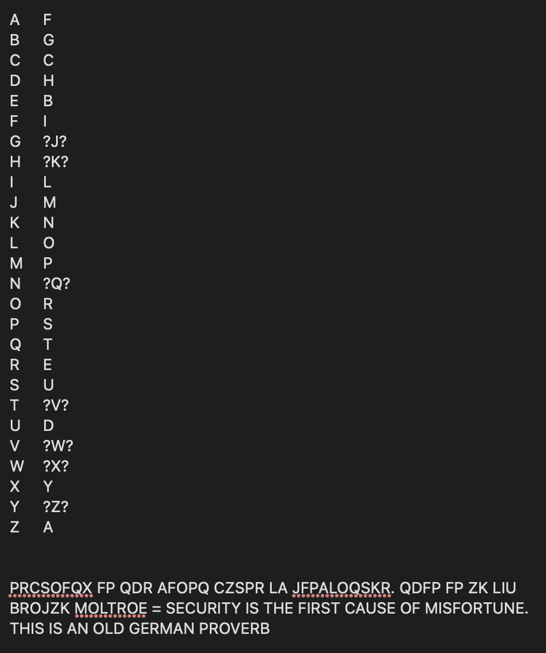

- If you know that the encryption scheme is based on Caesar (Monoalphabetic Substitution) that is commonly used by Caesar for sending messages to Cicero, does it allow you to crack it faster?

- Surely, it could help us not to guess with other types of encryption methods.

- Now, we got the mapping alphabet is ..

ABCDEFGHIJKLMNOPQRSTUVWXYZ

ZECURABDFGHIJKLMNOPQSTVWXY

- Draw a cipher disc of the given text.

- (Draw jaa)

- Create a simple python program for cracking the Caesar cipher text using brute force attack. Explain the design and demonstrate your software. (You may use an English dictionary for validating results.)

- (Mai yark coding)

- (Symmetric Encryption) Vigenère is a complex version of the Caesar cipher. It is a polyalphabetic substitution.

  - Based on the Caesar cipher, explain how it can be used to cipher data.
- Based on the Caesar cipher, the Vigenère can encrypt a letter to more than one letter resulted, depending on the index of the cipher text. The encryption includes ‘Key’ to define the row index of mapping function for each letter, because each letter should be differently encrypted to varied alphabet by the ‘Key’ defined with its position.
  - If a key is the word “CAT”, please analyze the level of security provided by Vigenère compared to that of the Caesar cipher.
- (How laa ?)
  - Create a python program for ciphering data using Vigenère.
- (Mai yark coding)

- (Mode in Block Cipher) Block Cipher is designed to have more randomness in a block. However, an individual block still utilizes the same key. Thus, it is recommended to use a cipher mode with an initial vector, chaining or feedback between blocks. This exercise will show you the weakness of Electronic Code Book mode which does not include any initial vector, chaining or feedback.

  - Find a bitmap image that is larger than 2000x2000 pixels. Note that you may resize any image. To simplify the pattern, we will change it to bitmap (1-bit per pixel) using the portable bitmap format (pbm). In this example, we will use imagemagick for the conversion.

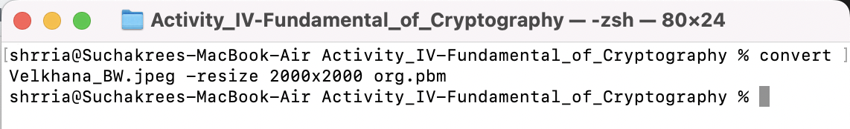

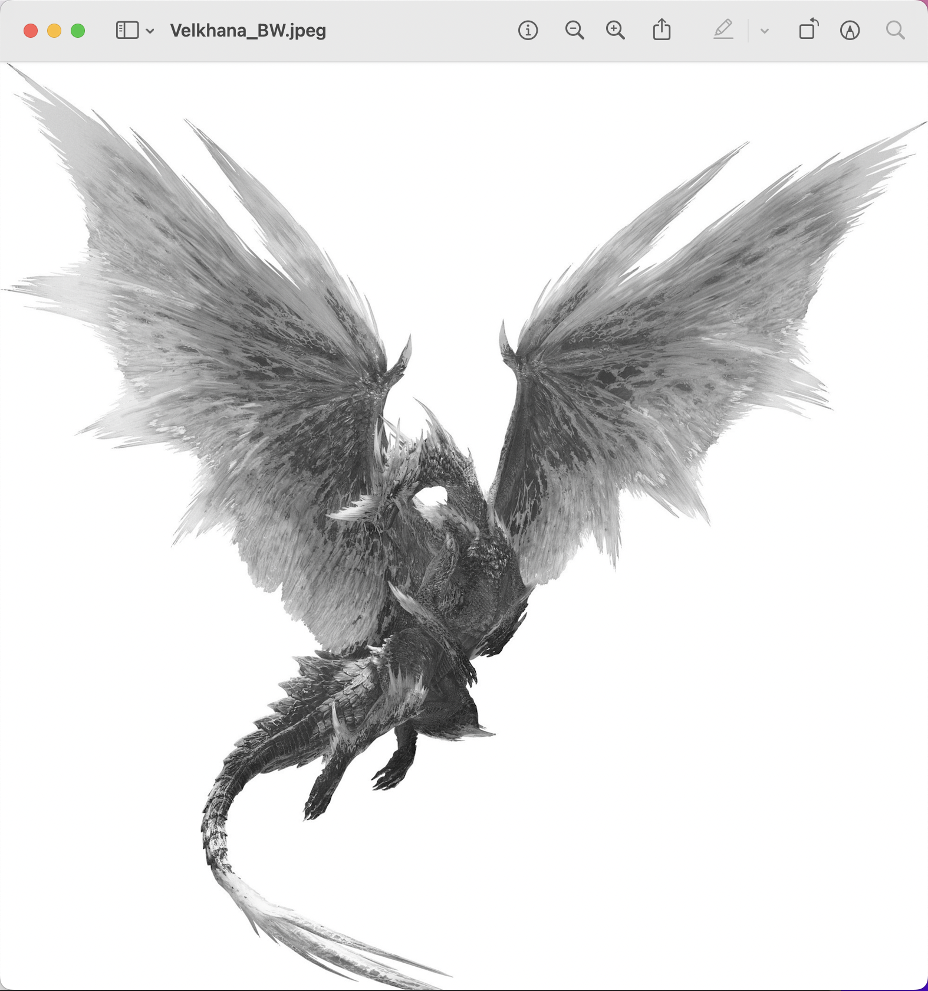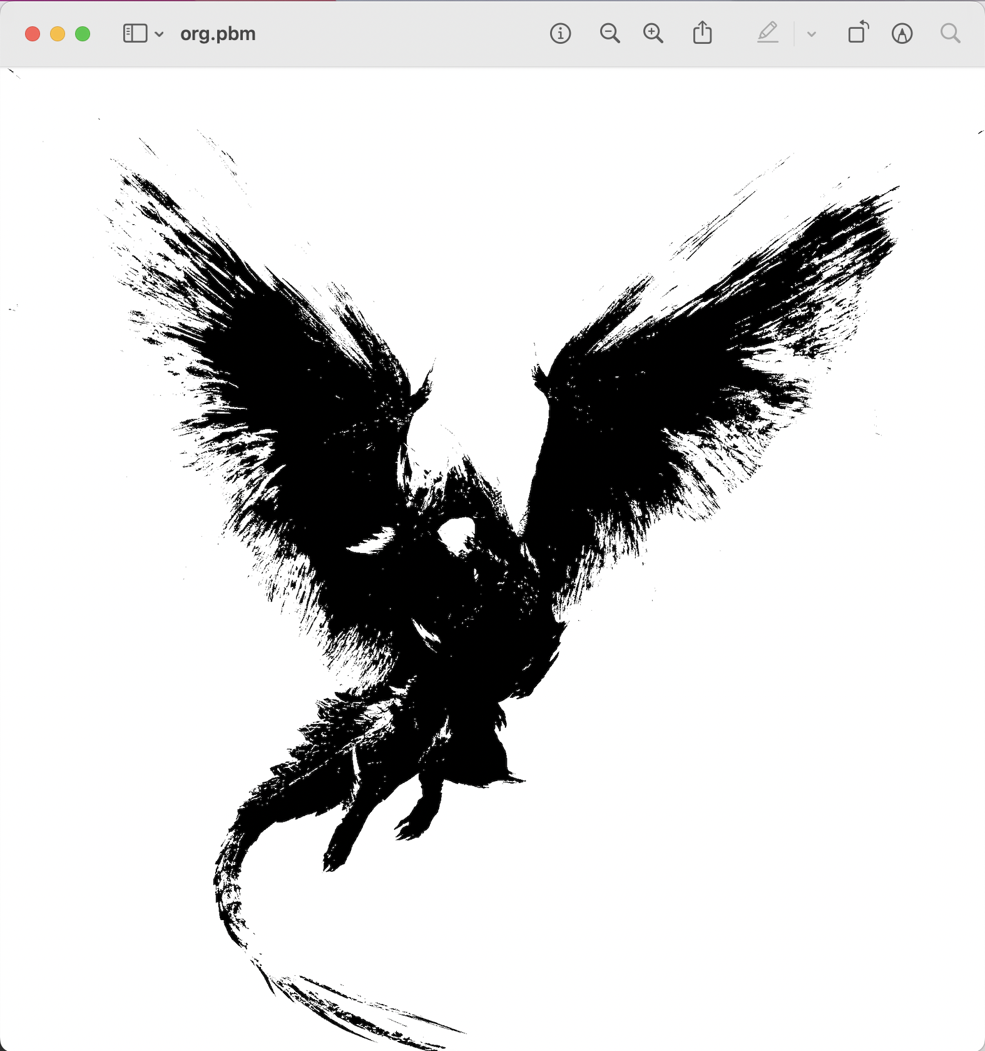

  - The NetPBM format is a naive image format.The first two lines contain a header (format and size in pixel). Depending on the format, the pixels can be represented in either binary and ascii. For our exercise, we prefer binary. However, we first have to take out the header to prevent the encryption from encoding the header. To do so, use your text editor (eg. vi, notepad) to take out the first two lines.

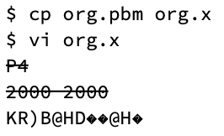

- ss
- Encrypt the file with OpenSSL2 with any block cipher algorithm in ECB mode (no padding and no salt).
$ openssl enc -aes-256-ecb -in org.x -nosalt \
-out enc.x
- Pad the header back and see the result.
$ cp enc.x enc.pbm $ vi enc.pbm
P4
2000 2000 KR)B@HD��@
- You may try it with other modes with IV, chaining, or feedback and compare the result.

