Activity: Recon and Defense (Network Security I)

Part II. Reconnaissance
Q1. Notice the open ports. Does anything look suspicious, i.e., some ports that you are not aware of that are open on the VM or on your notebook?
- VM: There are 2 ports opened which are 22:ssh and 80:http.
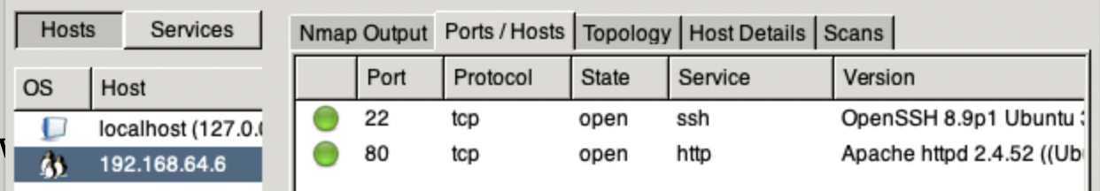
- Localhost: There are 12 ports opened and newly initialized one port 4000 which belongs to ‘nmap’.
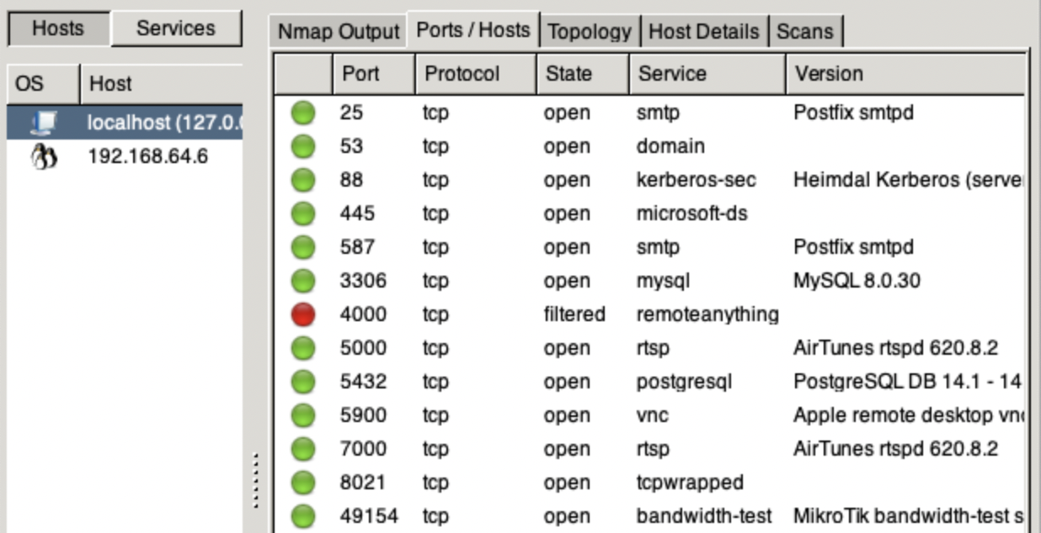
Q2. Look at the information provided by nmap about your OS's. Is the information correct? Why is it or why is it not correct?
- The OS’s information was correct, but not detailed.
VM:
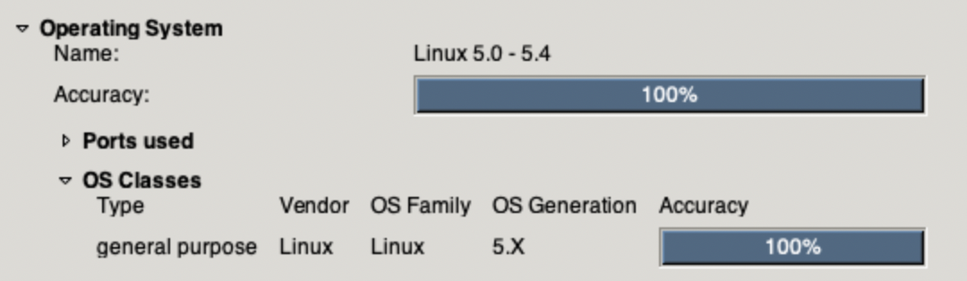
Localhost:
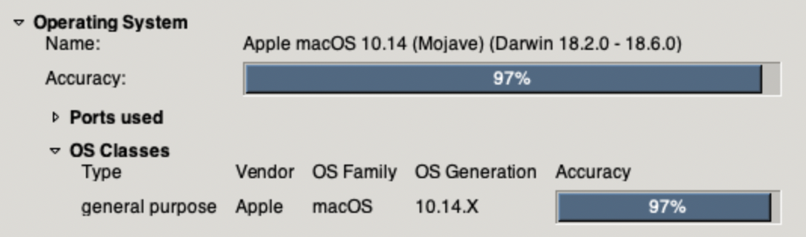

Q3. What do you think about the information you can get using nmap? Scary?
- From the ‘nmap’, we can acknowledge all the opened ports for available services on target, so does a hacker! This is also a sort of environment sniffing to acquire more information of the target before starting an attack.

Q4. Look at the access.log file for the web server in your Linux VM. What IP addresses do you see accessing the Web server? Who owns these IP addresses?
- IP Address: 127.0.0.1 was equal to ‘localhost’ address, in this case, belonged to the VM.
- IP Address: 192.168.64.1 was assigned to my local notebook by the network of the VM.
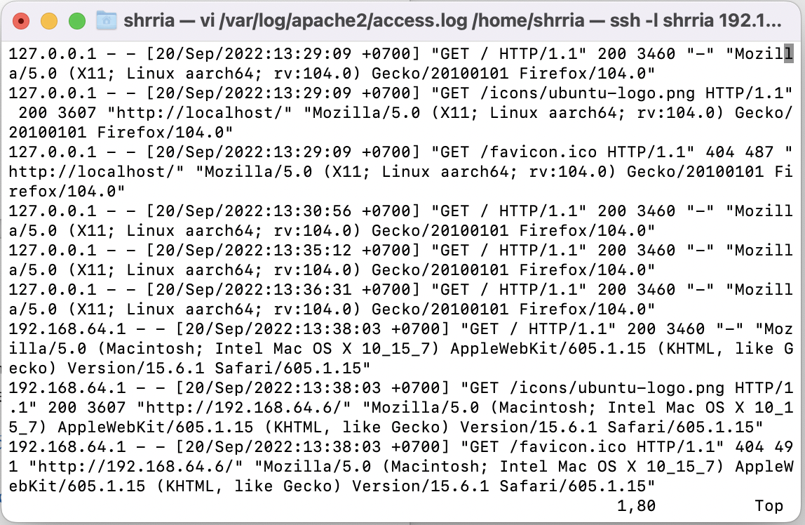

Q5. Find the nmap scan in the Web server log. Copy the lines from the log file that were created because of the nmap scan.
- grep nmap /var/log/apache2/access.log
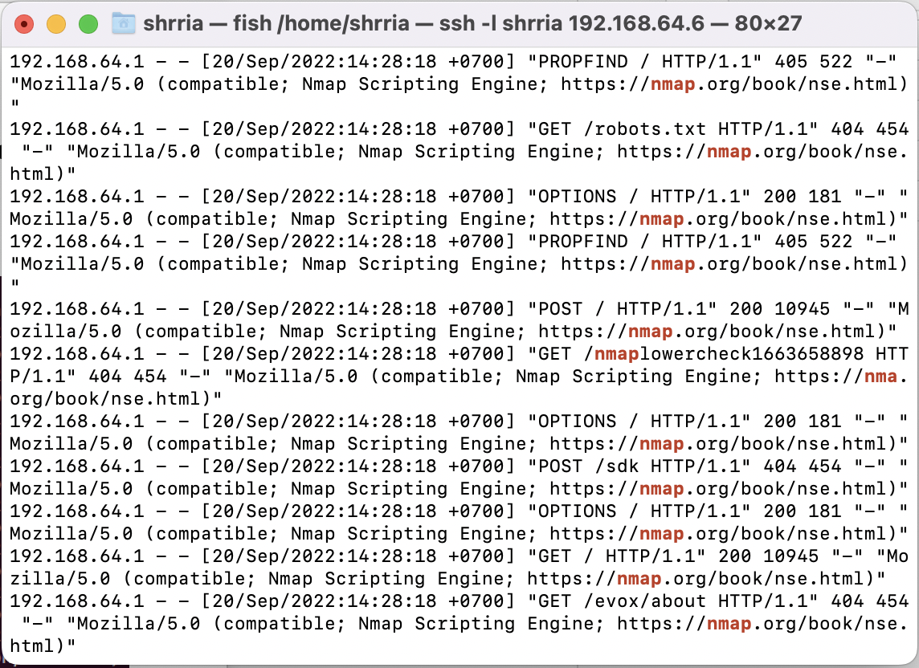

Part III. Defense
Q6. After you successfully install your iptable rule(s), how do the reported results from your new nmap scan compare to your previous scan before using iptables? Look to see if OS detection, port open results, etc. have changed. Something(s) have definitely changed.
- OS information was received with wider range of Linux versions.
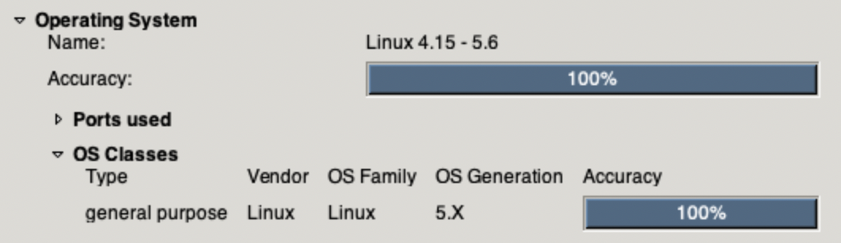
- Ports opened were detected as previous because we left them receiving inputs from anywhere.
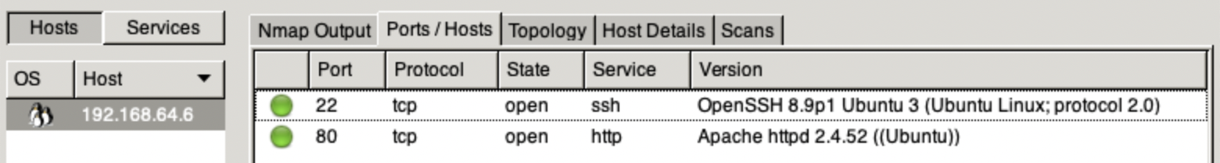

- Also, there was a warning message of OSScan results shown in logging this time!
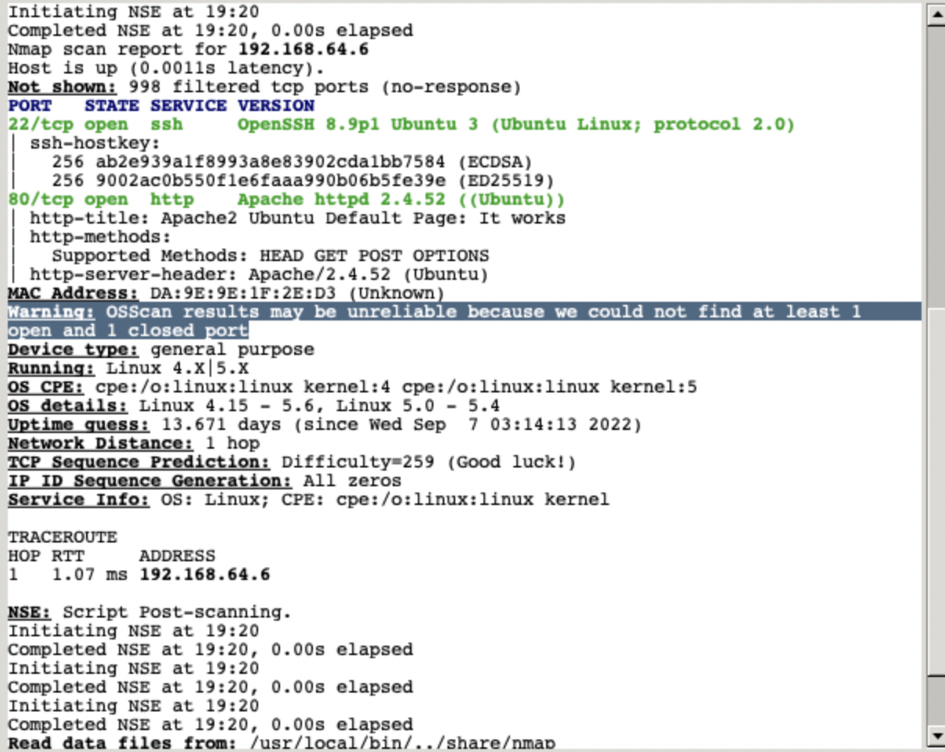

Q7. Notice that nmap can still figure out you have Apache httpd running. Look at the access.log file for the web server in your Linux VM. Are the logs the same as in Part II?
- Yes. The Apache2 logs displayed just the same, even if firewall rules were changed.
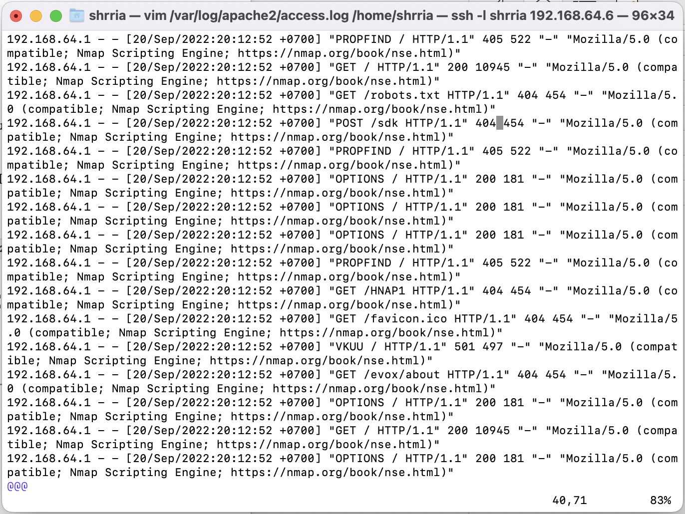

Q8. Explain how you could prevent nmap from reaching the web server while still allowing legitimate clients to get service. Will a firewall be sufficient for this? Or do you need some other device? Please think critically about this.
- Actually, a firewall was not sufficient to prevent nmap from reaching the web server. The DROP action for closed ports could help delay the time of scanning by nmap to make the hackers took longer duration when searching for the opened ports.
- To secure the server from nmap, we need to adopt techniques such as ‘Port Knocking’, ‘Honeypots and Honeynets’, and ‘Reactive Port Scan Detection’.
Q9. What are your firewall rules? Run iptables -L on your VM and enter the output here.
- Output of the command.
