Q1. What is the attacker's IP address?

Q2. What command did you use to run the attack?

Q3. How do you know the attack is successful? Hint: Use the browser on your notebook to access the webpage. What should happen if the attack is successful?
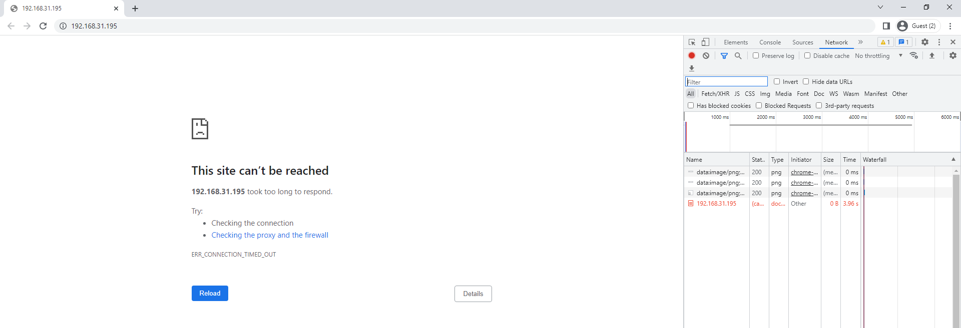

Q4. “netwox” performs the TCP SYN Flood attack using spoofed IP addresses. Give some examples of the spoofed IP addresses you see on the target machine.
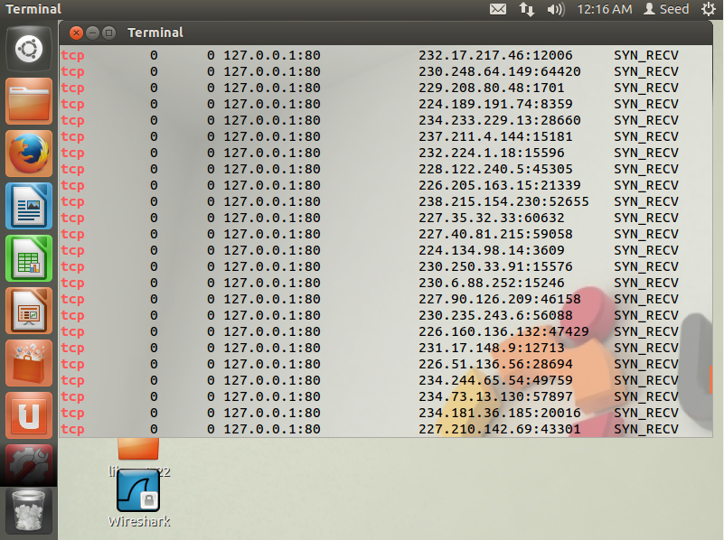

Q5. In the TCP SYN Flood attack, what resource on the server side is exhausted? What is the number of resources available, and how many of those resources get used up in the attack?

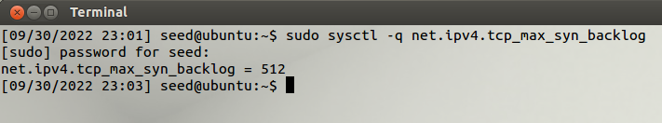

Q6. How do TCP SYN cookies prevent this type of attack?

Q7. For each piece of secret that you steal from the Heartbleed attack, you need to show the screenshots as the proof. Upload a pdf of your screenshots.
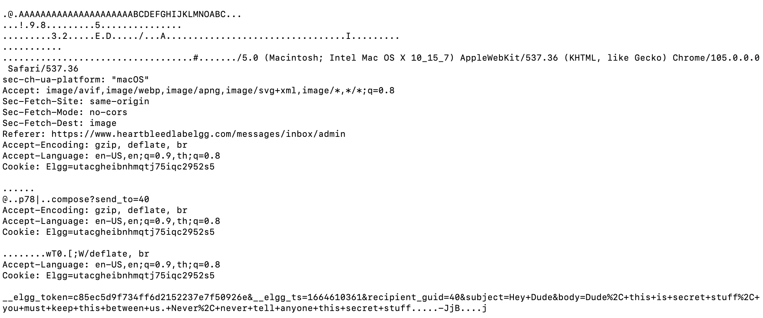

Q8. For the Heartbleed attack, explain how you did the attack, and what your observations are.

Q9: As the length variable decreases, what kind of difference can you observe?
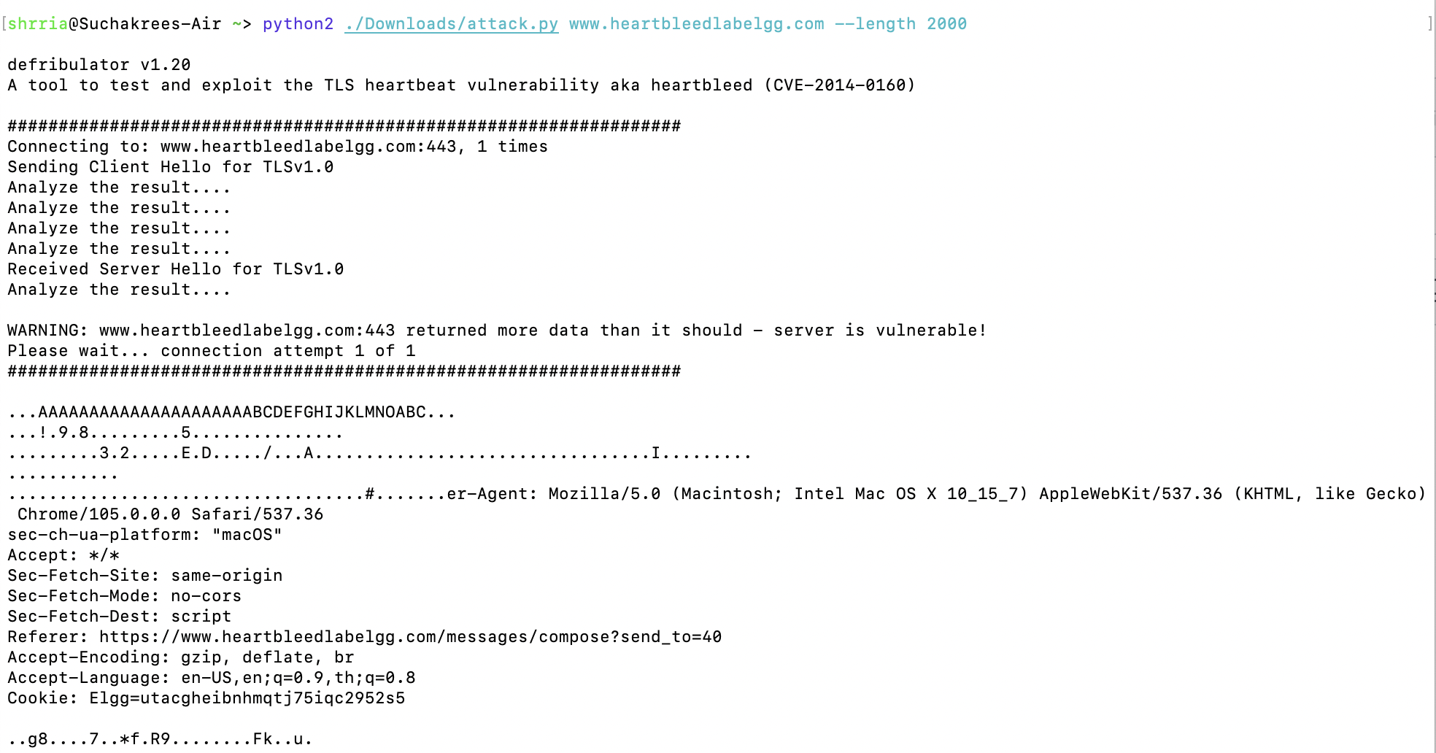
Q10: As the length variable decreases, there is a boundary value for the input length variable. At or below that boundary, the Heartbeat query will receive a response packet without attaching any extra data (which means the request is benign). Please find that boundary length. You may need to try many different length values until the web server sends back the reply without extra data. To help you with this, when the number of returned bytes is smaller than the expected length, the program will print "Server processed malformed Heartbeat, but did not return any extra data." What is the boundary length?

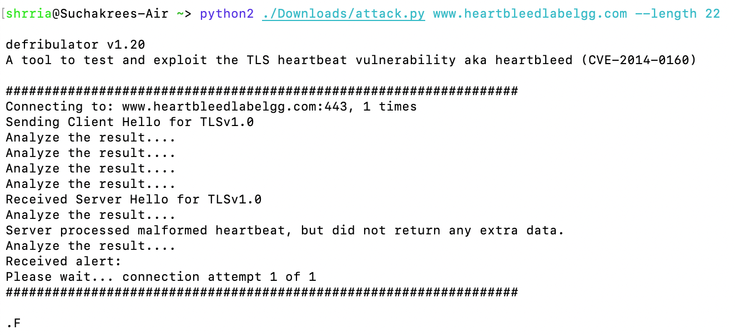

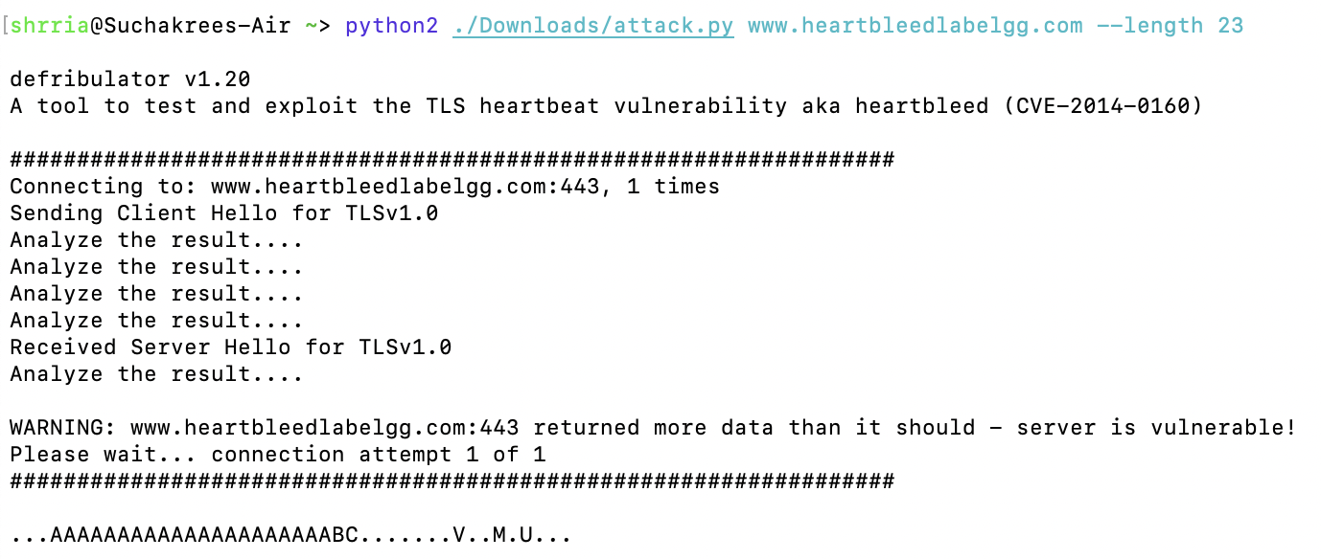

Q11. Try your attack again after you have updated the OpenSSL library. Are you successful at stealing data from the server after the upgrade?

Q12. Please point out the problem from the code and provide a solution to fix the bug (i.e., what modification is needed to fix the bug). You do not need to recompile the code; just describe how you can fix the problem.

Q13. Comment on the following discussions by Alice, Bob, and Eva regarding the fundamental cause of the Heartbleed vulnerability: Alice thinks the fundamental cause is missing the boundary checking during the buffer copy; Bob thinks the cause is missing the user input validation; Eva thinks that we can just delete the length value from the packet to solve everything. Who do you agree and disagree with, and why?

