Activity: Computer Forensics

Part I. File Carving

- Look at the data on the file system (Click on Data Sources and look at the hex values on the right). The file system has no files, but why are we able to find items on the disk image? Explain why the file system has no files but there are items that can be found on the disk image.

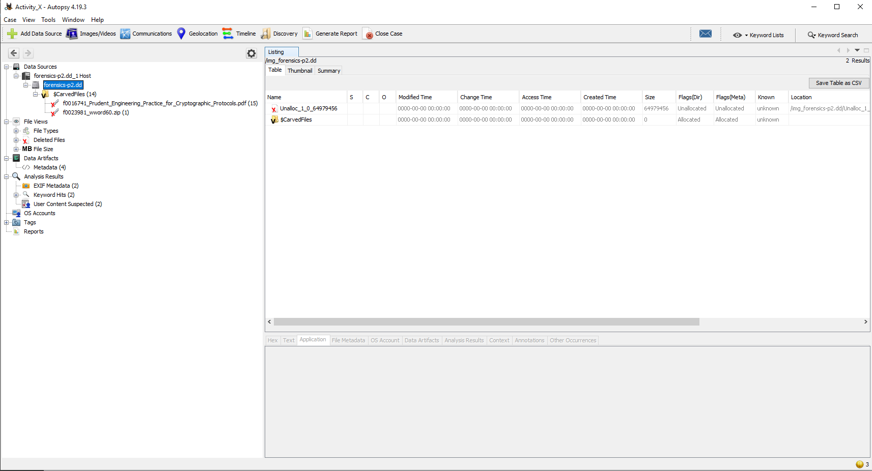

- The files or folders have been marked as unallocated space rather than removed by overwrite those space to “0” or null value when a user commanded to delete them. Still, the files’ content would have remained which could be found without pointer indicated, unless they have been overwritten yet.

- How many objects can you find?
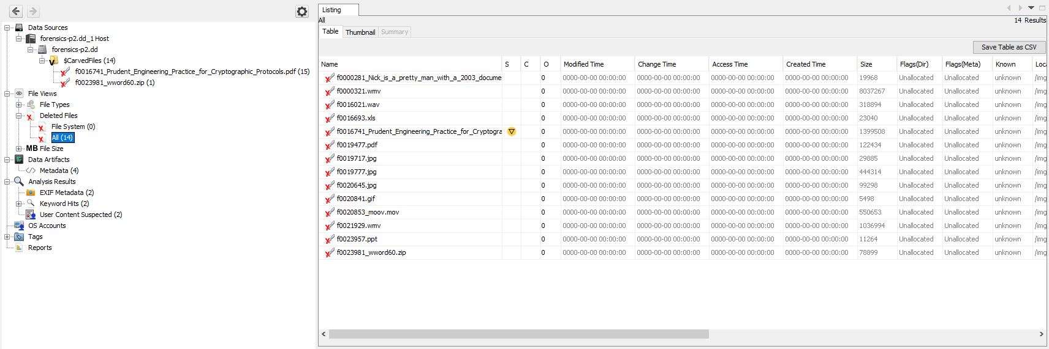

- As said in the document, there were totally 14 objects found deleted from the data source.

- List all the objects here and report on whether or not the content is accessible or damaged/corrupted. Also note which files were actually already deleted.

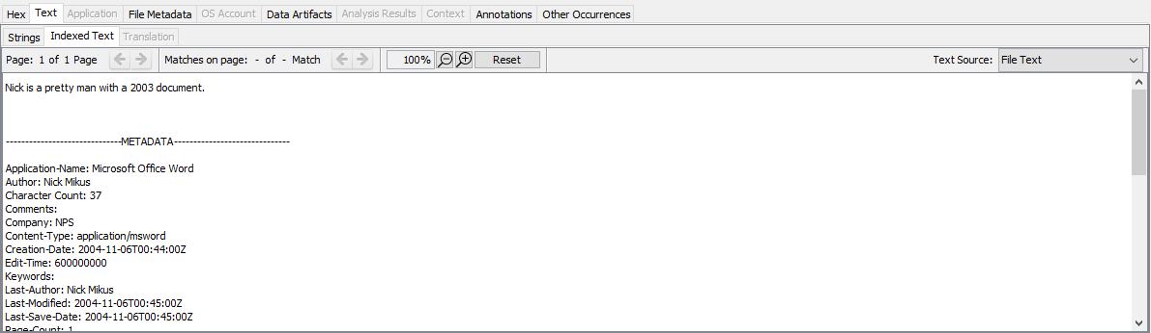
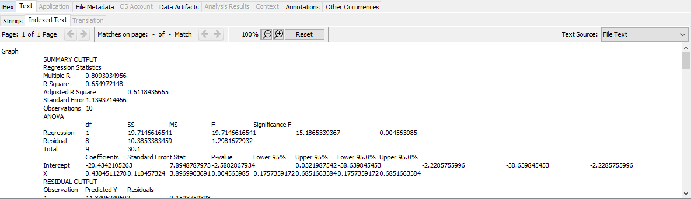
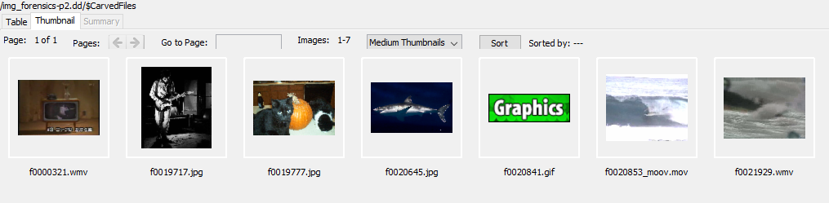
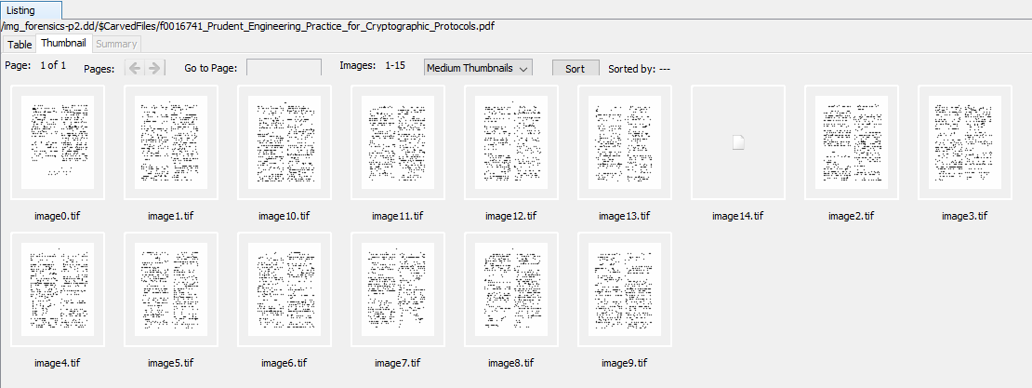
- After access attempts, all 14 files were accessible, even though some was partly corrupted. The files were just unallocated their space, but not removed permanently.

- Think securely: If we want to delete files on a magnetic hard disk and not have them be recovered by any tool, what do we need to do? And how much time do you think you need to wipe a 1TB magnetic hard disk?

- Easily done by overwriting 7 - 35 times on the space where those files were allocated with random bytes.

- For 1TB magnetic hard disk with 100 MB/s writing speed, the files should be completely erased after randomly overwritten 35 times, as the US Government’s official data erasure document issued. The 1TB hard disk should take
(35 times * 1TB * 1024GB/1TB * 1024MB/1GB / 100 MB/s) = 102 hours approximately.

- Will file carving be able to recover deleted files on an SSD? Why or why not?

- Despite of Trim command utilized on SSD, there is a significance process, named ‘Garbage Collection’, which keeps on deleting a block with invalid data whenever a computer is idle. To clarify, the deleted files can be recovered if the Garbage Collection hasn’t been activated yet.
Part II. Investigation

- List all directories that were traversed in ‘RM#2’.

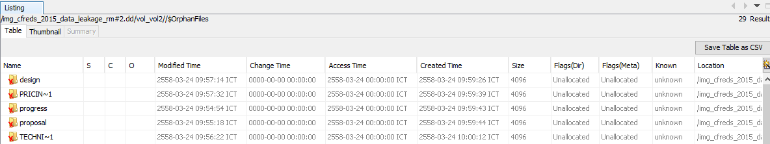

- All the traversed ones were thoroughly contained in a volume 2.

- List all files that were opened in 'RM#2’.

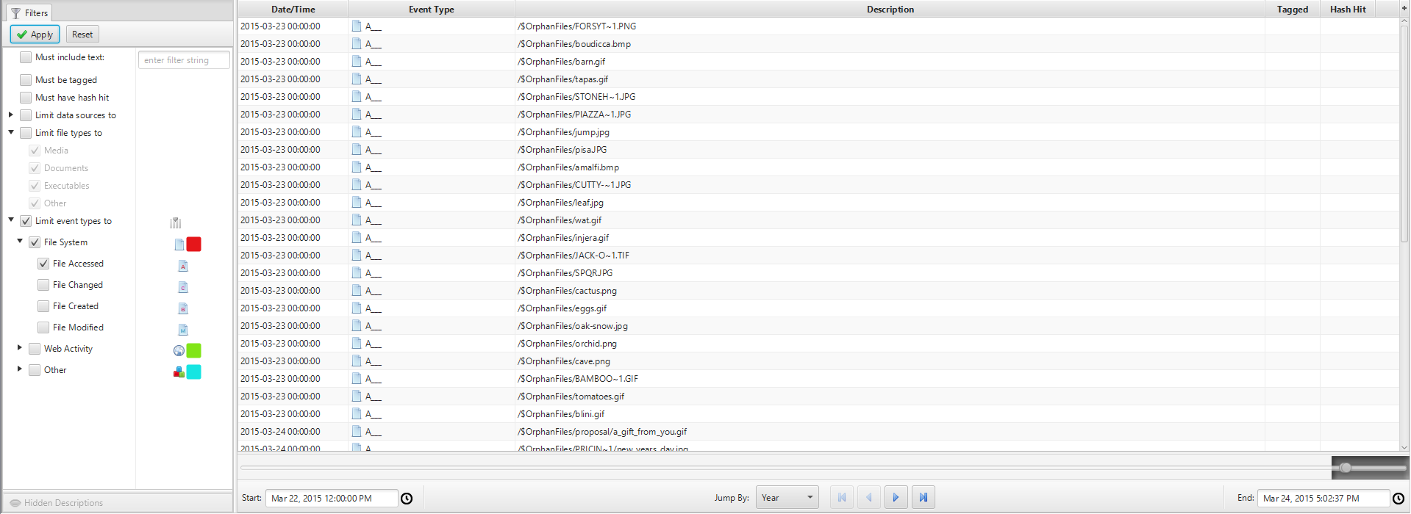
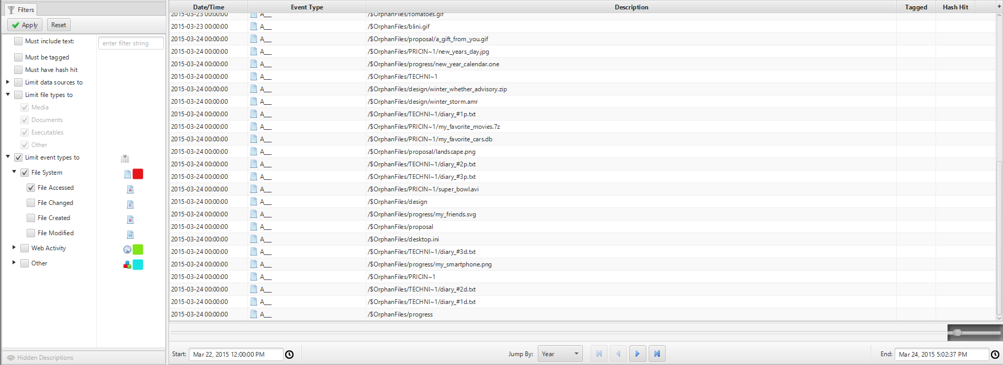

- Display list of files’ events filtered by Access Time.
- Recover deleted files from USB drive ‘RM#2’. What files were you able to recover?

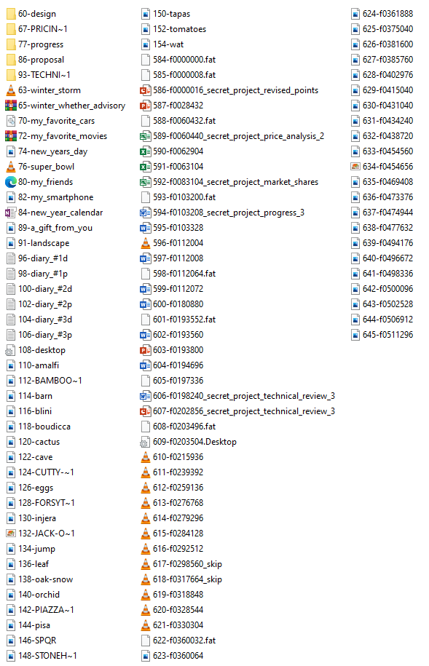

- After extracted, all deleted files were recovered successfully. But some files might be corrupted and not viewable.

- What actions were performed for anti-forensics on USB drive ‘RM#2’?
[Hint: this can be inferred from the results of the above question].

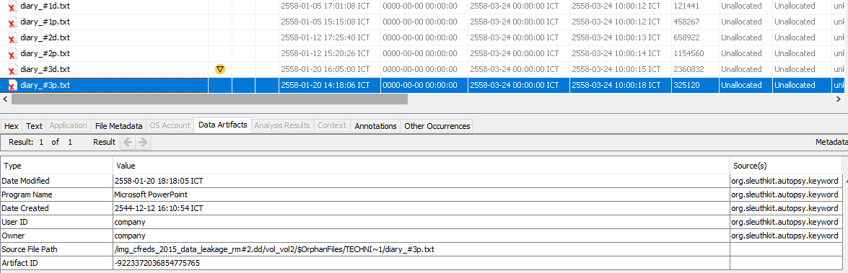

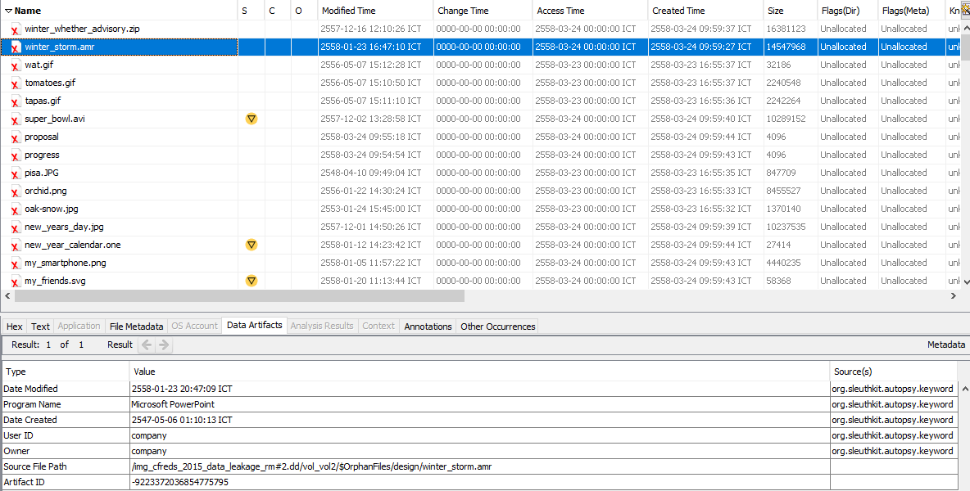

- To prevent digital forensics, many files were renamed with wrong extension types before deleted. Nevertheless, file-types correction could solve the problems, and allowing them all to be readable.

- Recover hidden files from the CD-R ‘RM#3’. What files were you able to recover?

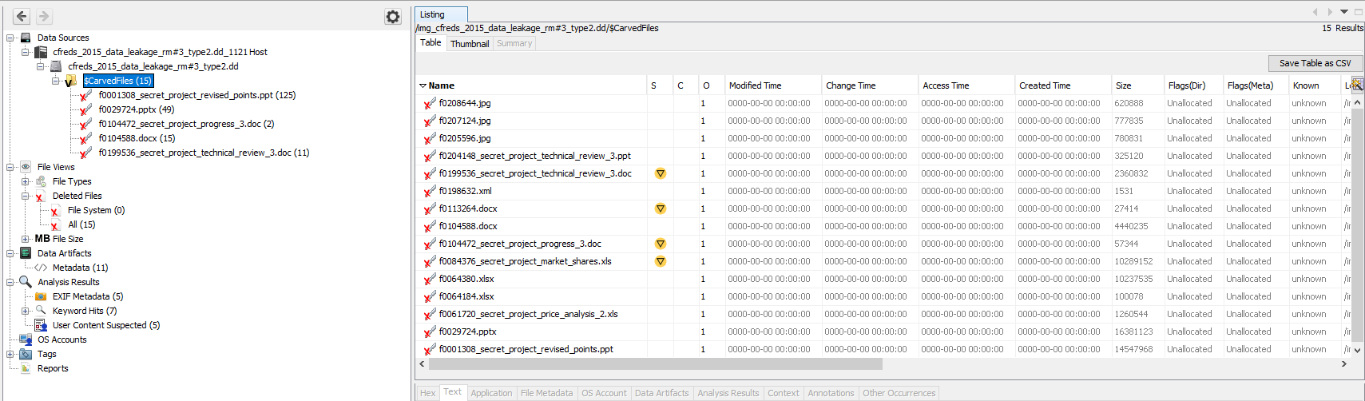

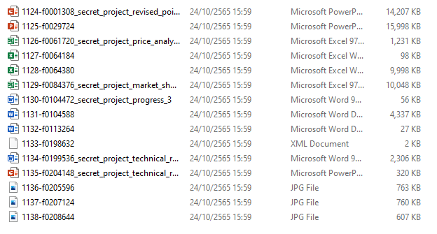

- What actions were performed for anti-forensics on CD-R ‘RM#3’?

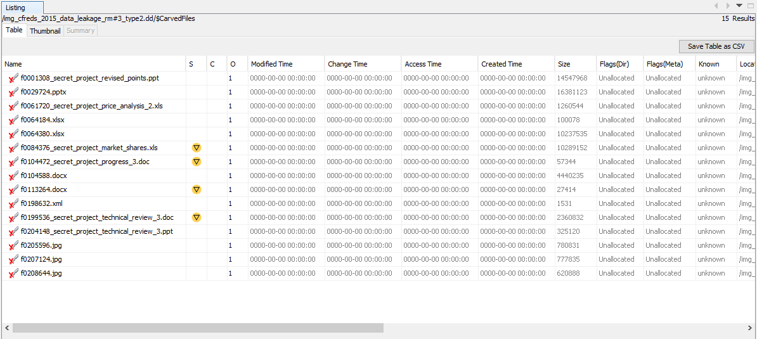

- Properties of all files associated with time were totally removed. But files’ contents were effortlessly accessible.

