Activity V : Public Key Infrastructure

- From the two given openssl commands, what is the difference?
Note: If your operating system does not show any error in the first command, try openssl s_client -connect twitter.com:443 -CApath /dev/null. If the results are still the same, your system is not reliable. You may ignore this exercise.
(Modern versions of Mac OS X will always read CA from keychains. There is no intuitive way to turn it off.)
- The terminal gave the same result for both cases.

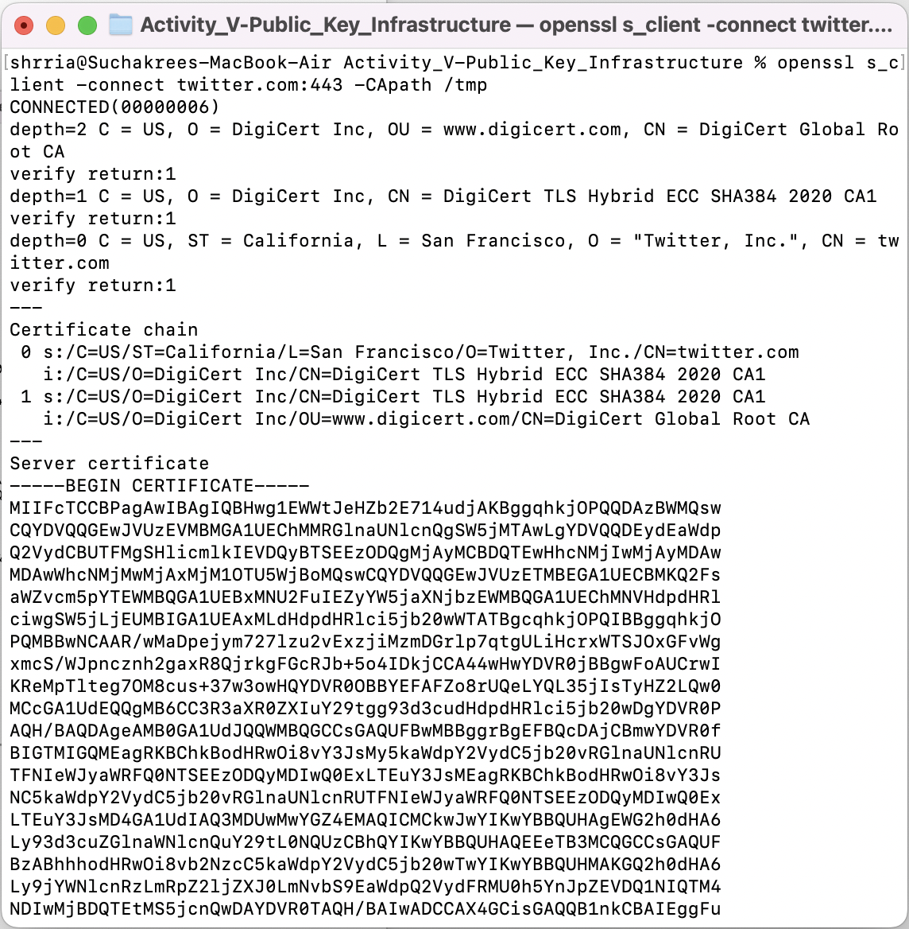
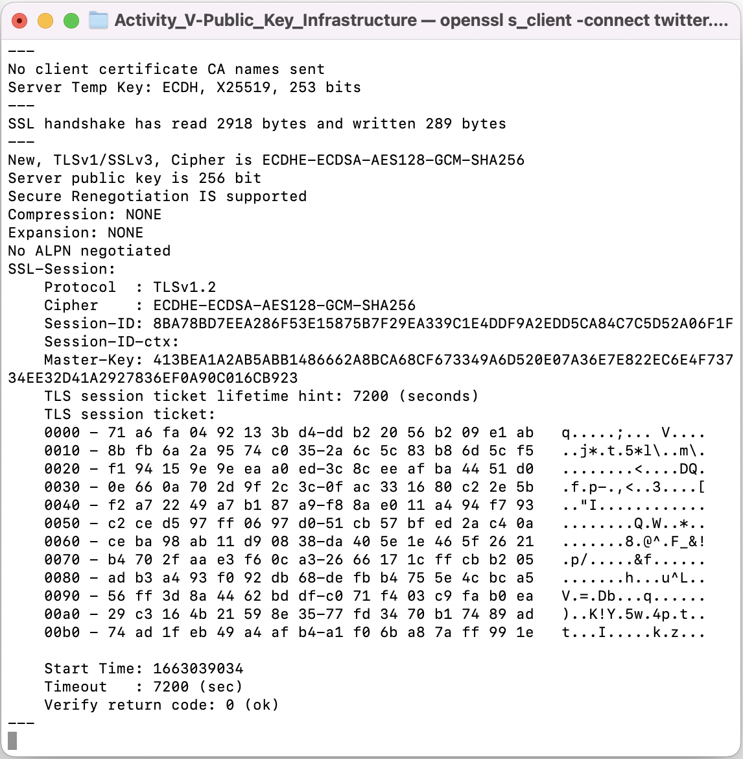

- What does the error (verify error) in the first command mean? Please explain.
- From my device (MacOS), there’s no errors occurred. But there would be such an error message as “Unable to get local issuer certificate” on Windows/Linux OS, because of no files existing at the argument ‘CApath’ we have inputted into the command.

- Copy the server certificate (beginning with -----BEGIN CERTIFICATE----- and ending with -----END CERTIFICATE-----) and store it as twitter_com.cert. Use the command openssl x509 -in twitter_com.cert -text to show a text representation of the certificate content. Briefly explain what is stored in an X.509 certificate (i.e., data in each field).
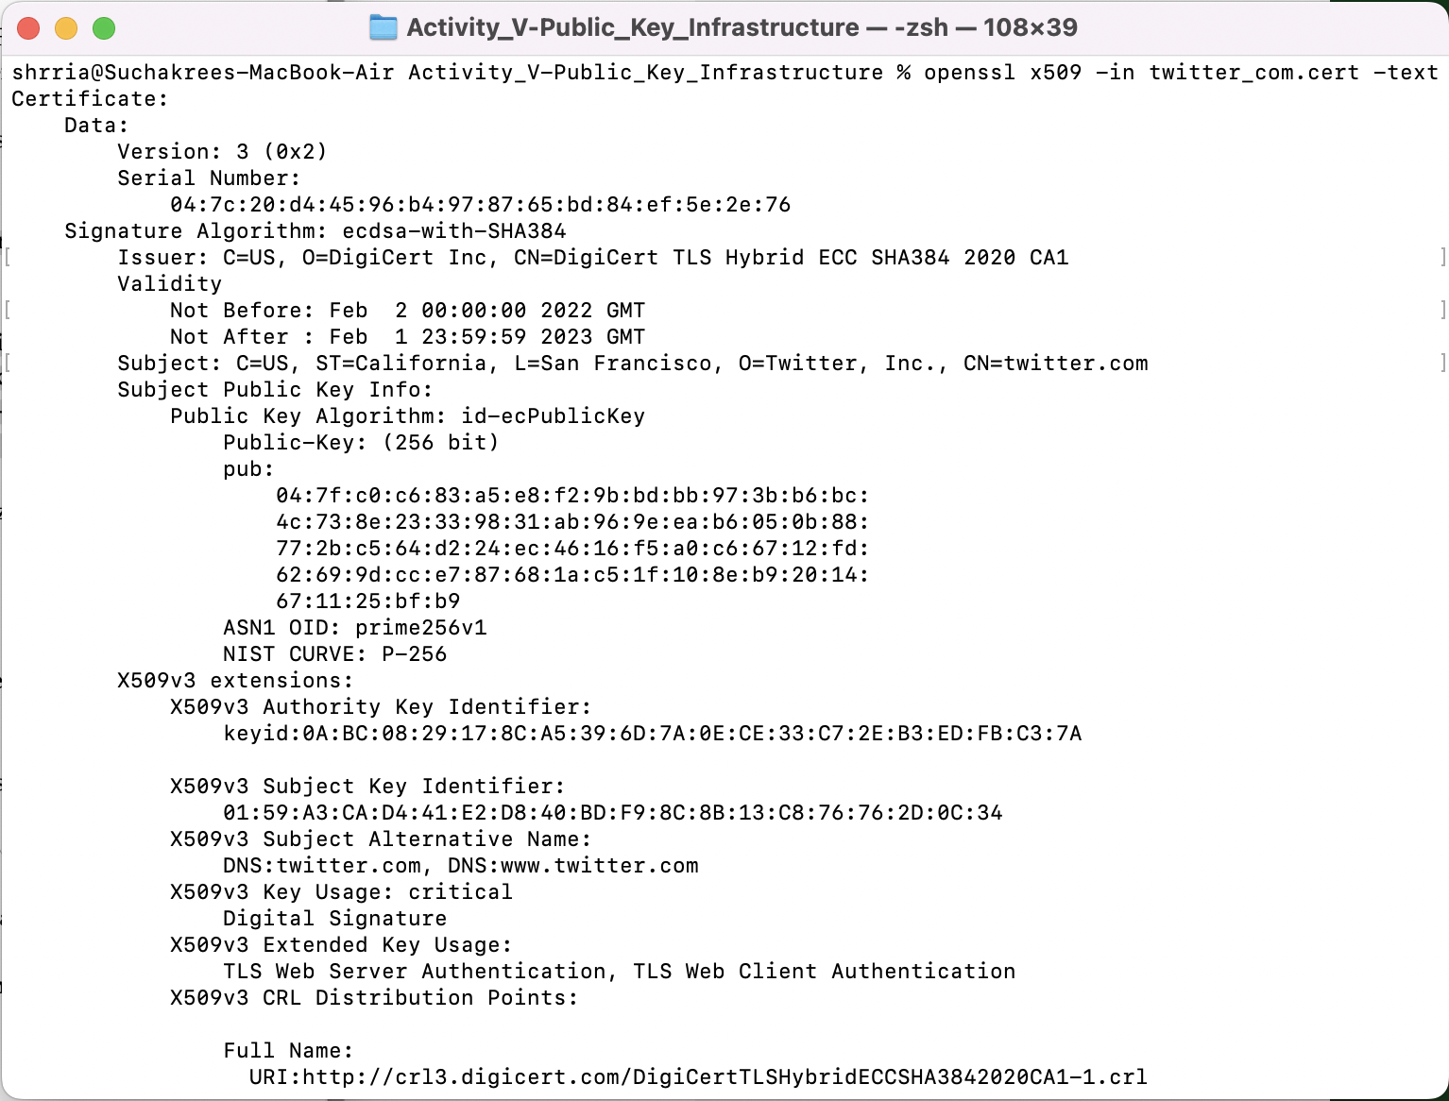
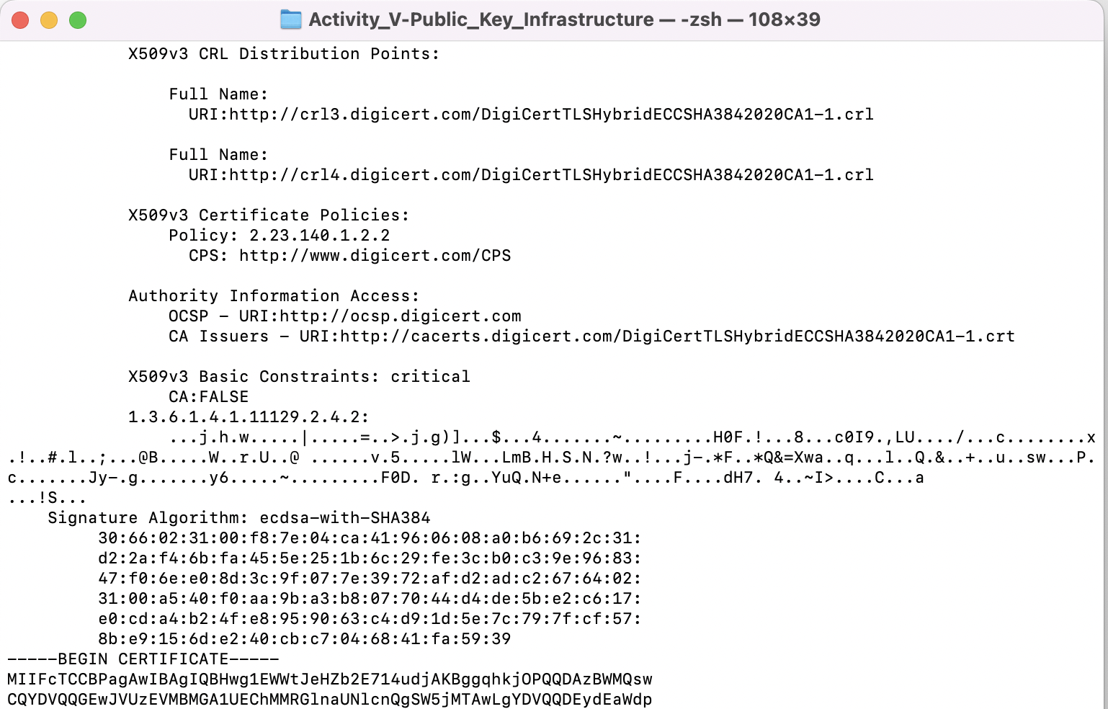
- The command displayed an information of the certification from the given certificate, which stored content fields as followings:
  - Version: Version of the certification
  - Serial Number: a unique key for this website
  - Issuer: Certificate Authority whose certificate and private key are stored inside the cluster
  - Validity: Valid date/Expired date of the certification
  - Subject: Owner of this certificate
  - pub: Public key
  - extensions: Certificate Extensions usage
- From the information in exercise 3, is there an intermediate certificate? If yes, what purpose does it serve?
Hint: Look for an issuer and download the intermediate certificate. You may use the command openssl x509 -inform der -in intermediate.cert -text to show the details of the intermediate certificate. (Note that the -inform der is for reading the DER file. The default file format for x509 is the PEM file.)
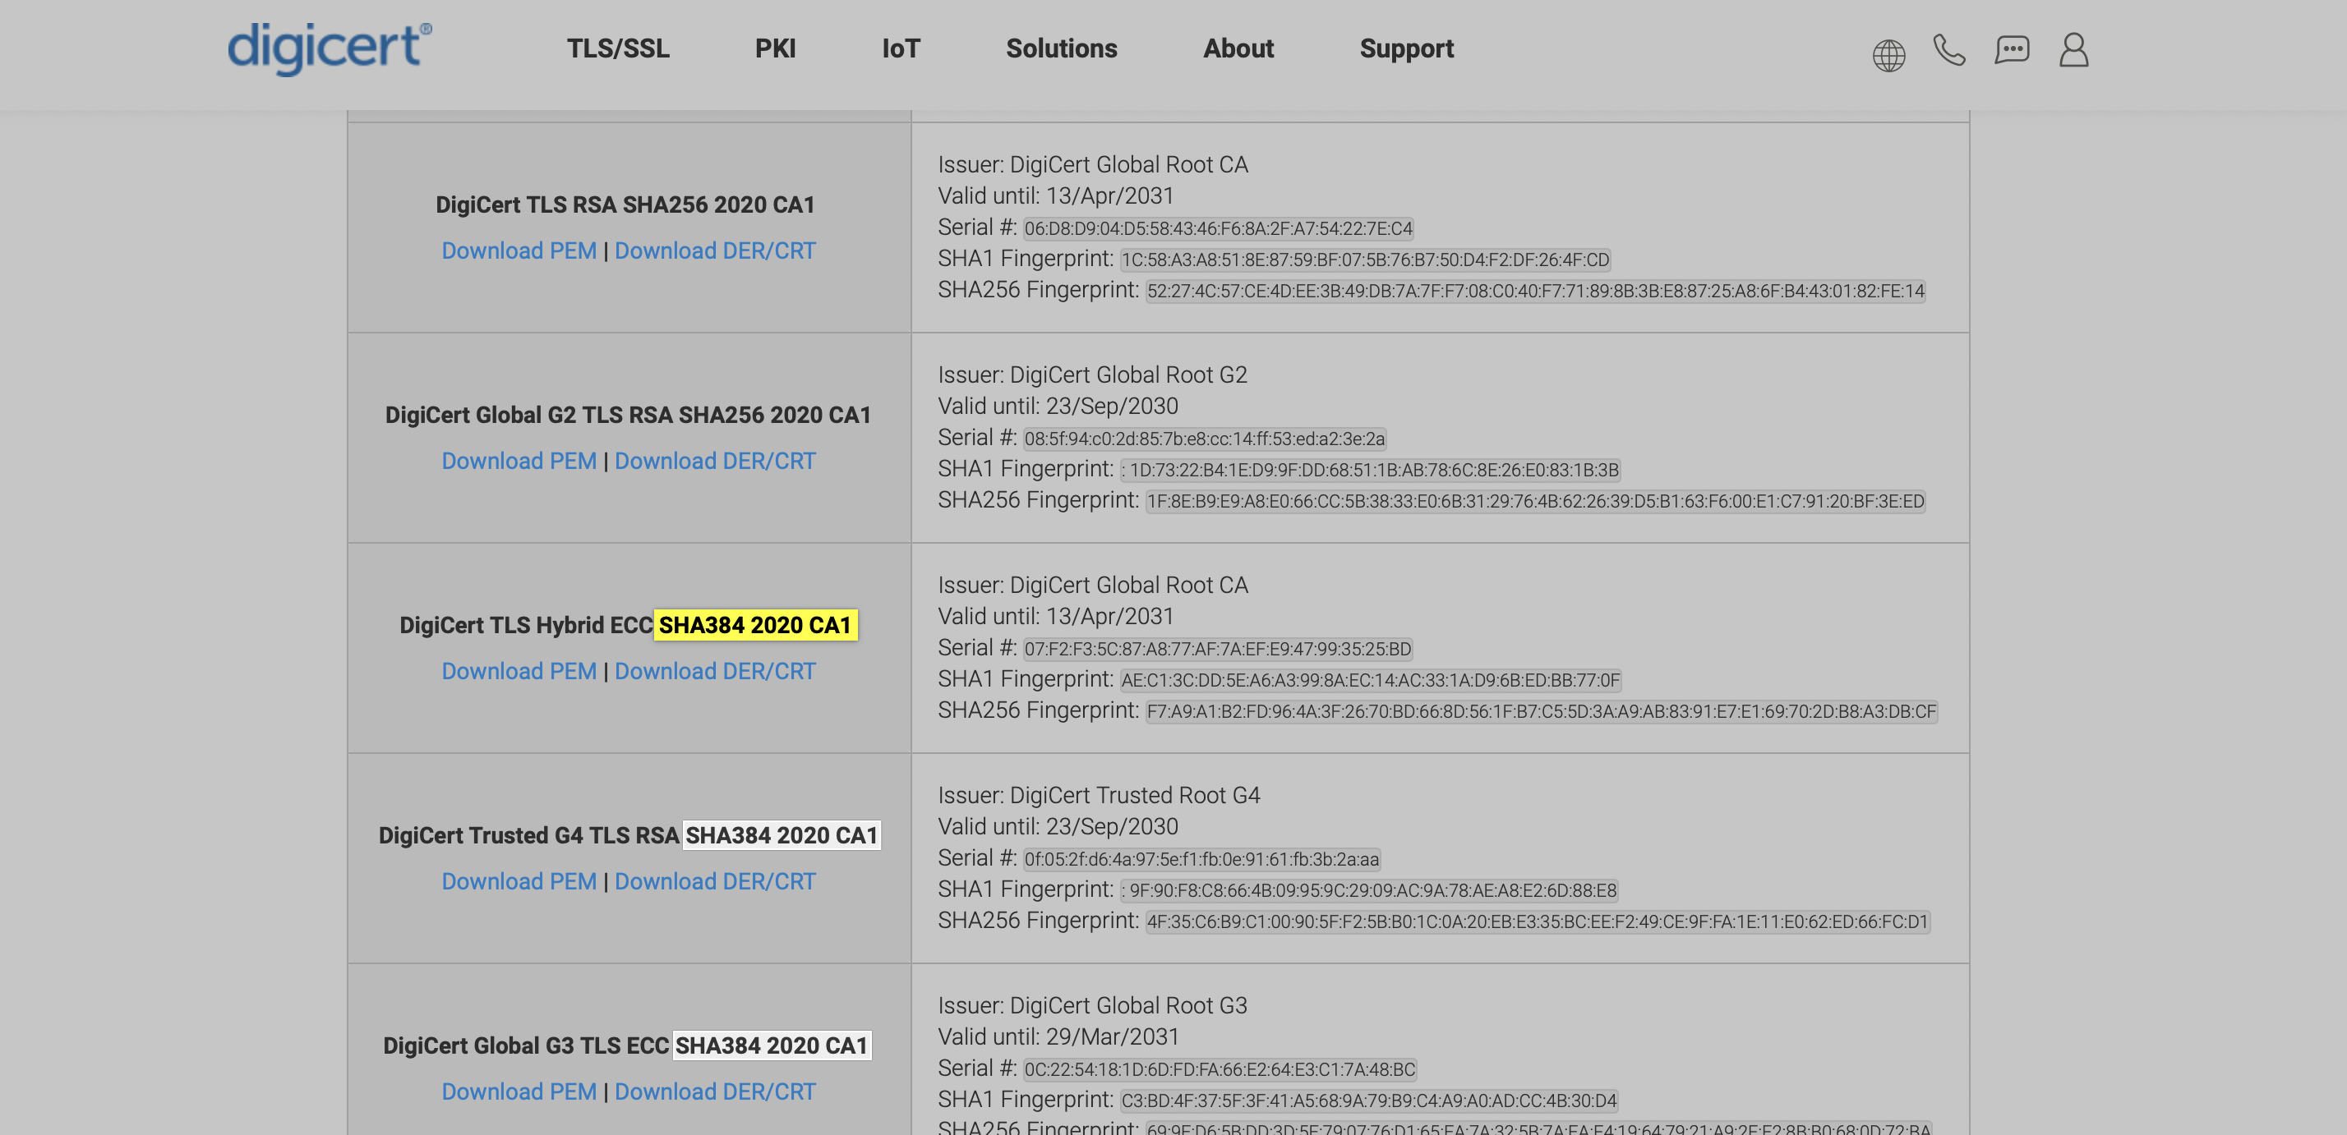
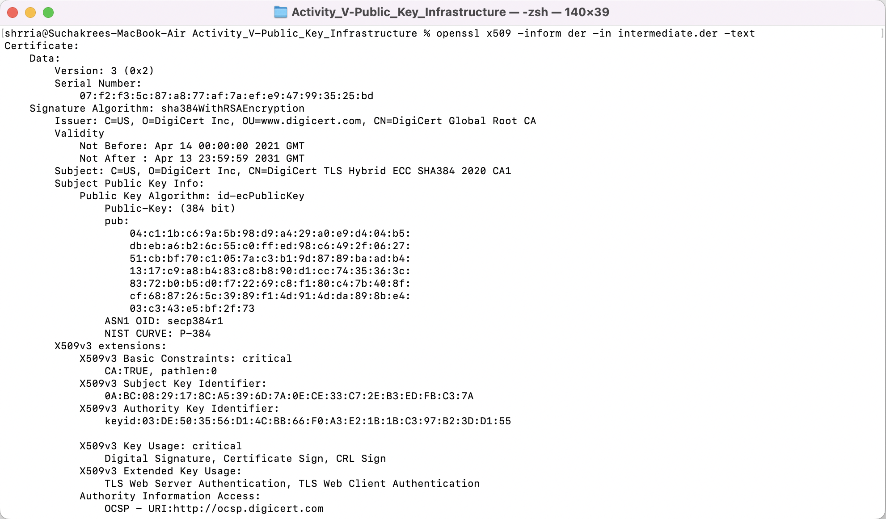
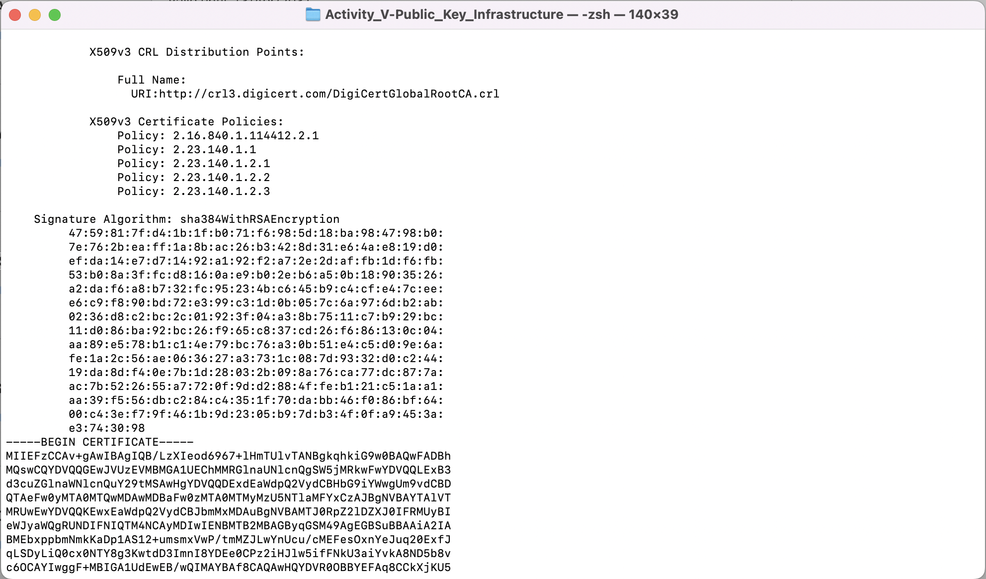
- The intermediate certificate is to ensure that the server certificate, which a user asks for the public key, is reliable with the certificate content and its root CA server in deep.

- Is there an intermediate CA, i.e. is there more than one organization involved in the certification? Say why you think so.
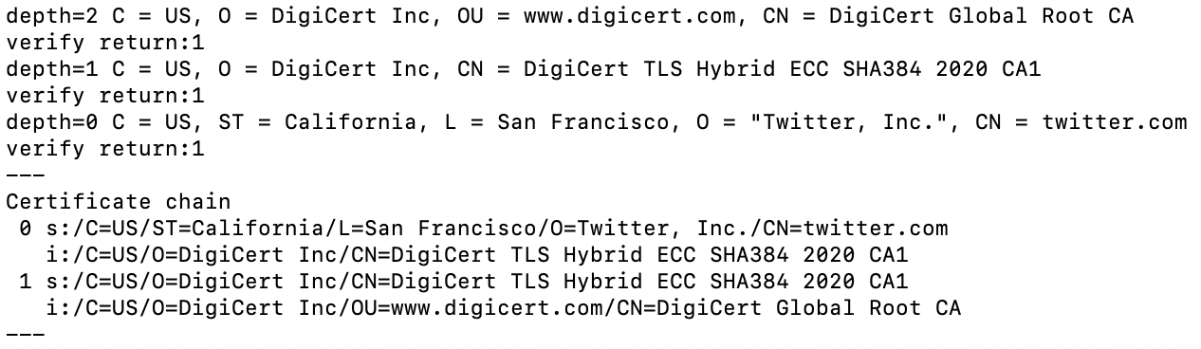
- From the image, we found that there are 2 CAs found in the Certificate chain. The deepest certification was signed by the DigiCert Global Root CA for the intermediate CA to serve leaf nodes in large number.
- From this exercise, we found that DigiCert is only one organization serving for the subject “twitter”.
- On the internet, there are a lot of CA organizations from many countries around the world who act as a trusted third party to store, sign, and issue certificates for public-key owners.
- What is the role of ca-certificates.crt?
- A system file that contains certificates from well-known and trustworthy CAs. When the device sends request to a website and receives a public key of its CA, the file shall be accessed to check an existence of the CA’s certificate to authenticate the subject.

- Explore the ca-certificates.crt. How many certificates are in there? Give the command/method you have used to count.
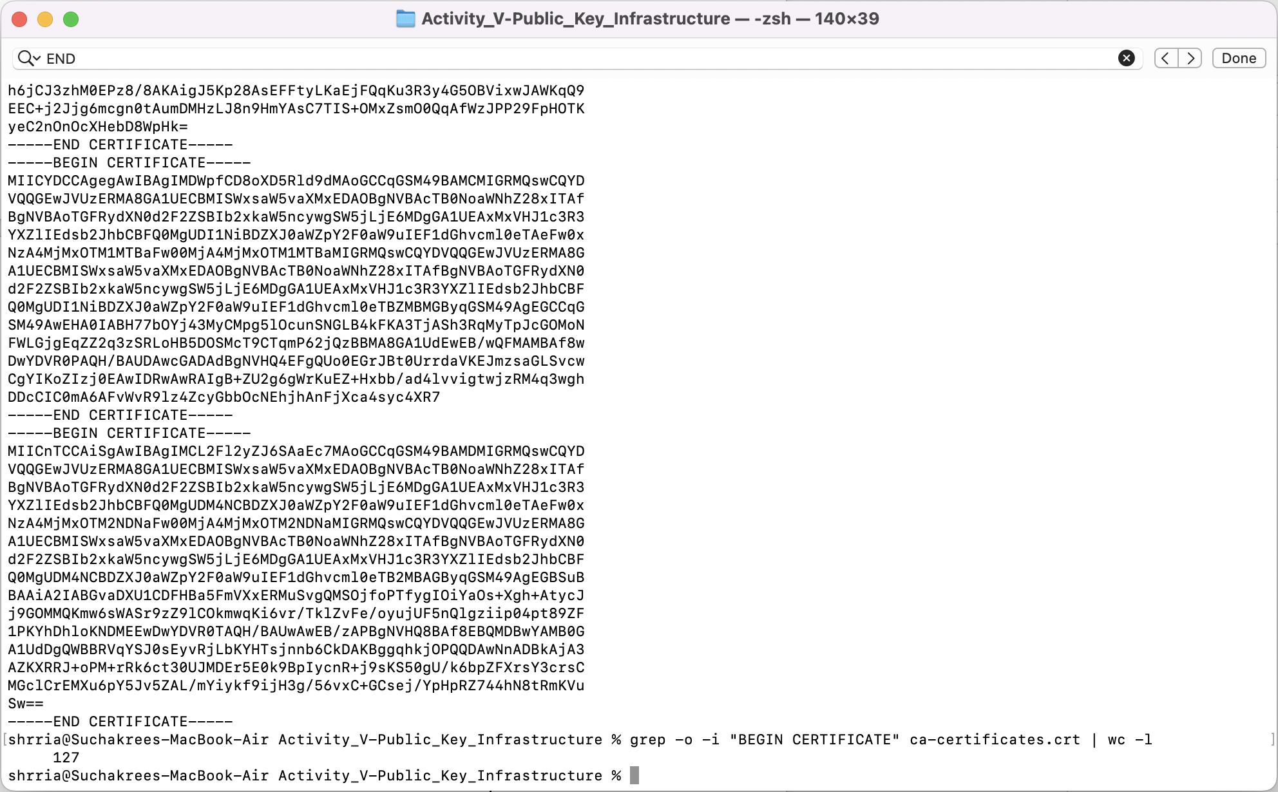
- 127 certificates.
- Extract a root certificate from ca-certificates.crt. Use the openssl command to explore the details. Do you see any Issuer information? Please compare it to the details of twitter’s certificate and the details of the intermediate certificate.
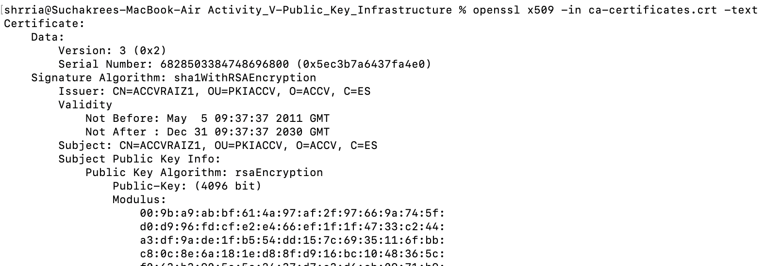
- From the image, the Issuer and Subject for Root CA are the same entity. This is called “Self-Signed Certificate”.

- If the intermediate certificate is not in a PEM format (text readable), use the command to convert a DER file (.crt .cer .der) to PEM file.
openssl x509 -inform der -in certificate.cer -out certificate.pem.
(You need the pem file for exercise 10.)
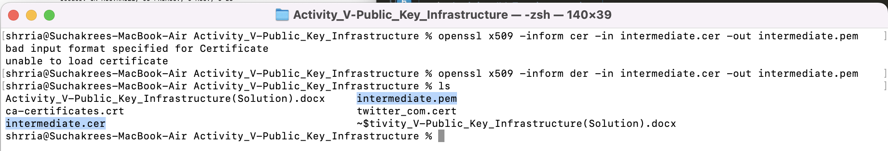
- From the given python code, implement the certificate validation.
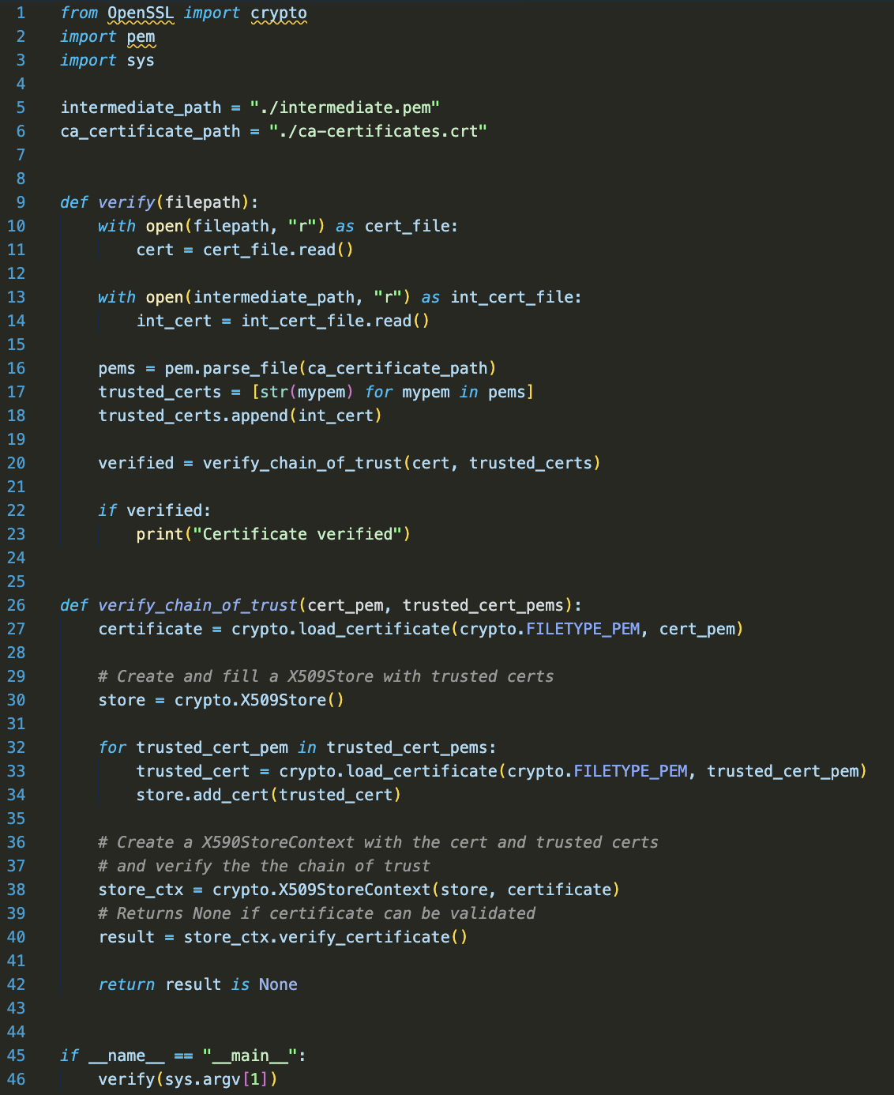
Use your program to verify the certificates of:
Twitter, google, www.chula.ac.th, classdeedee.cloud.cp.eng.chula.ac.th
- Twitter (Verified)
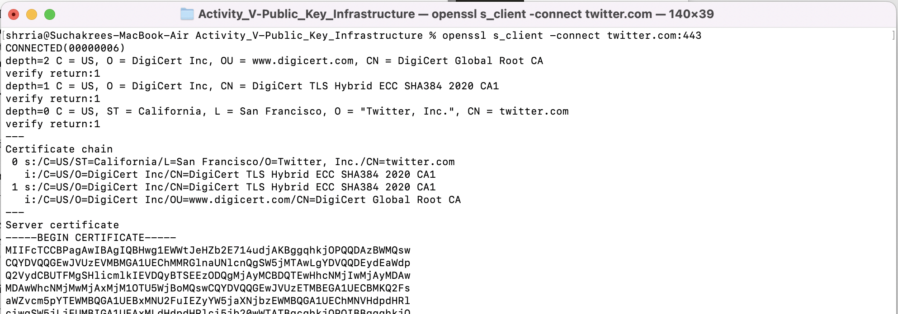
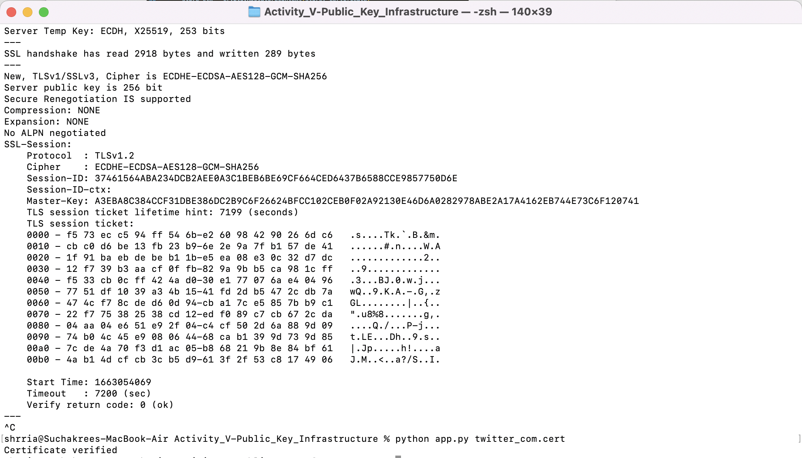

- Google (unable to get local issuer certificate)
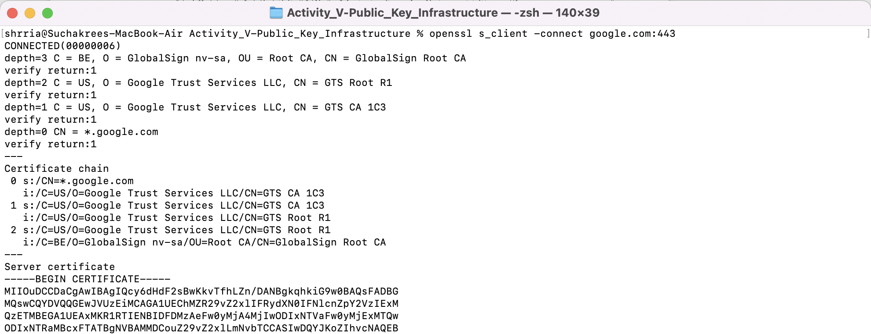
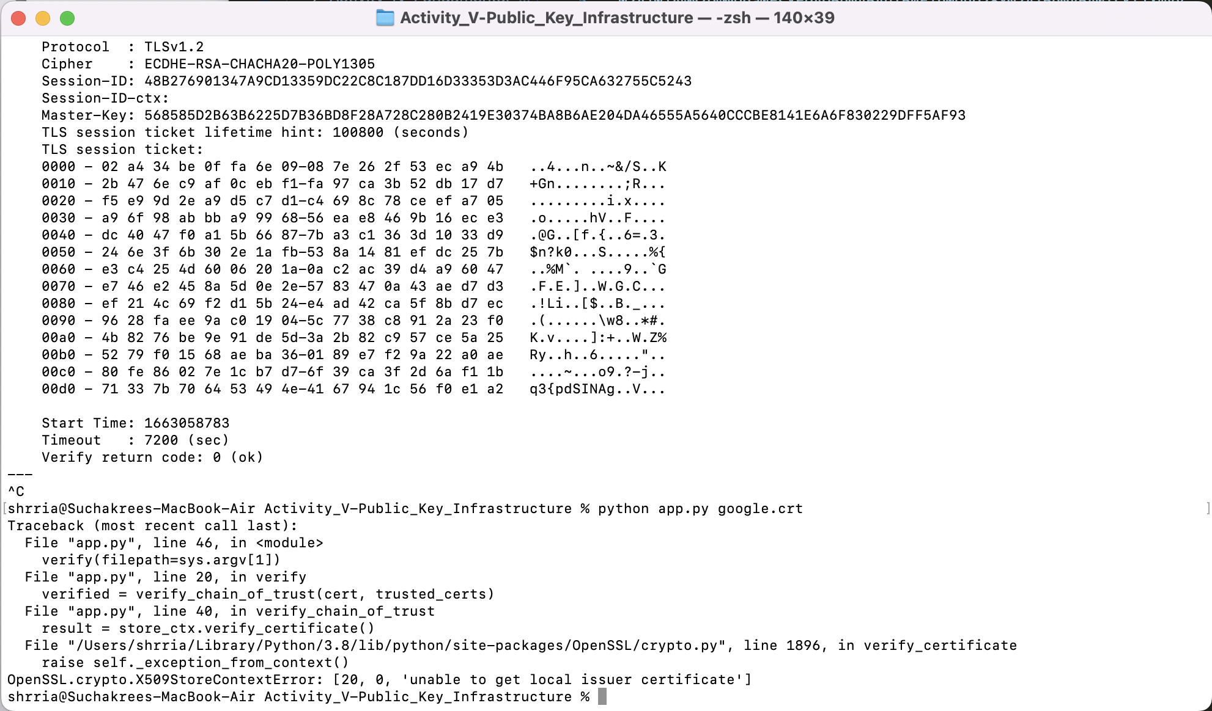
- Chula (unable to get local issuer certificate)
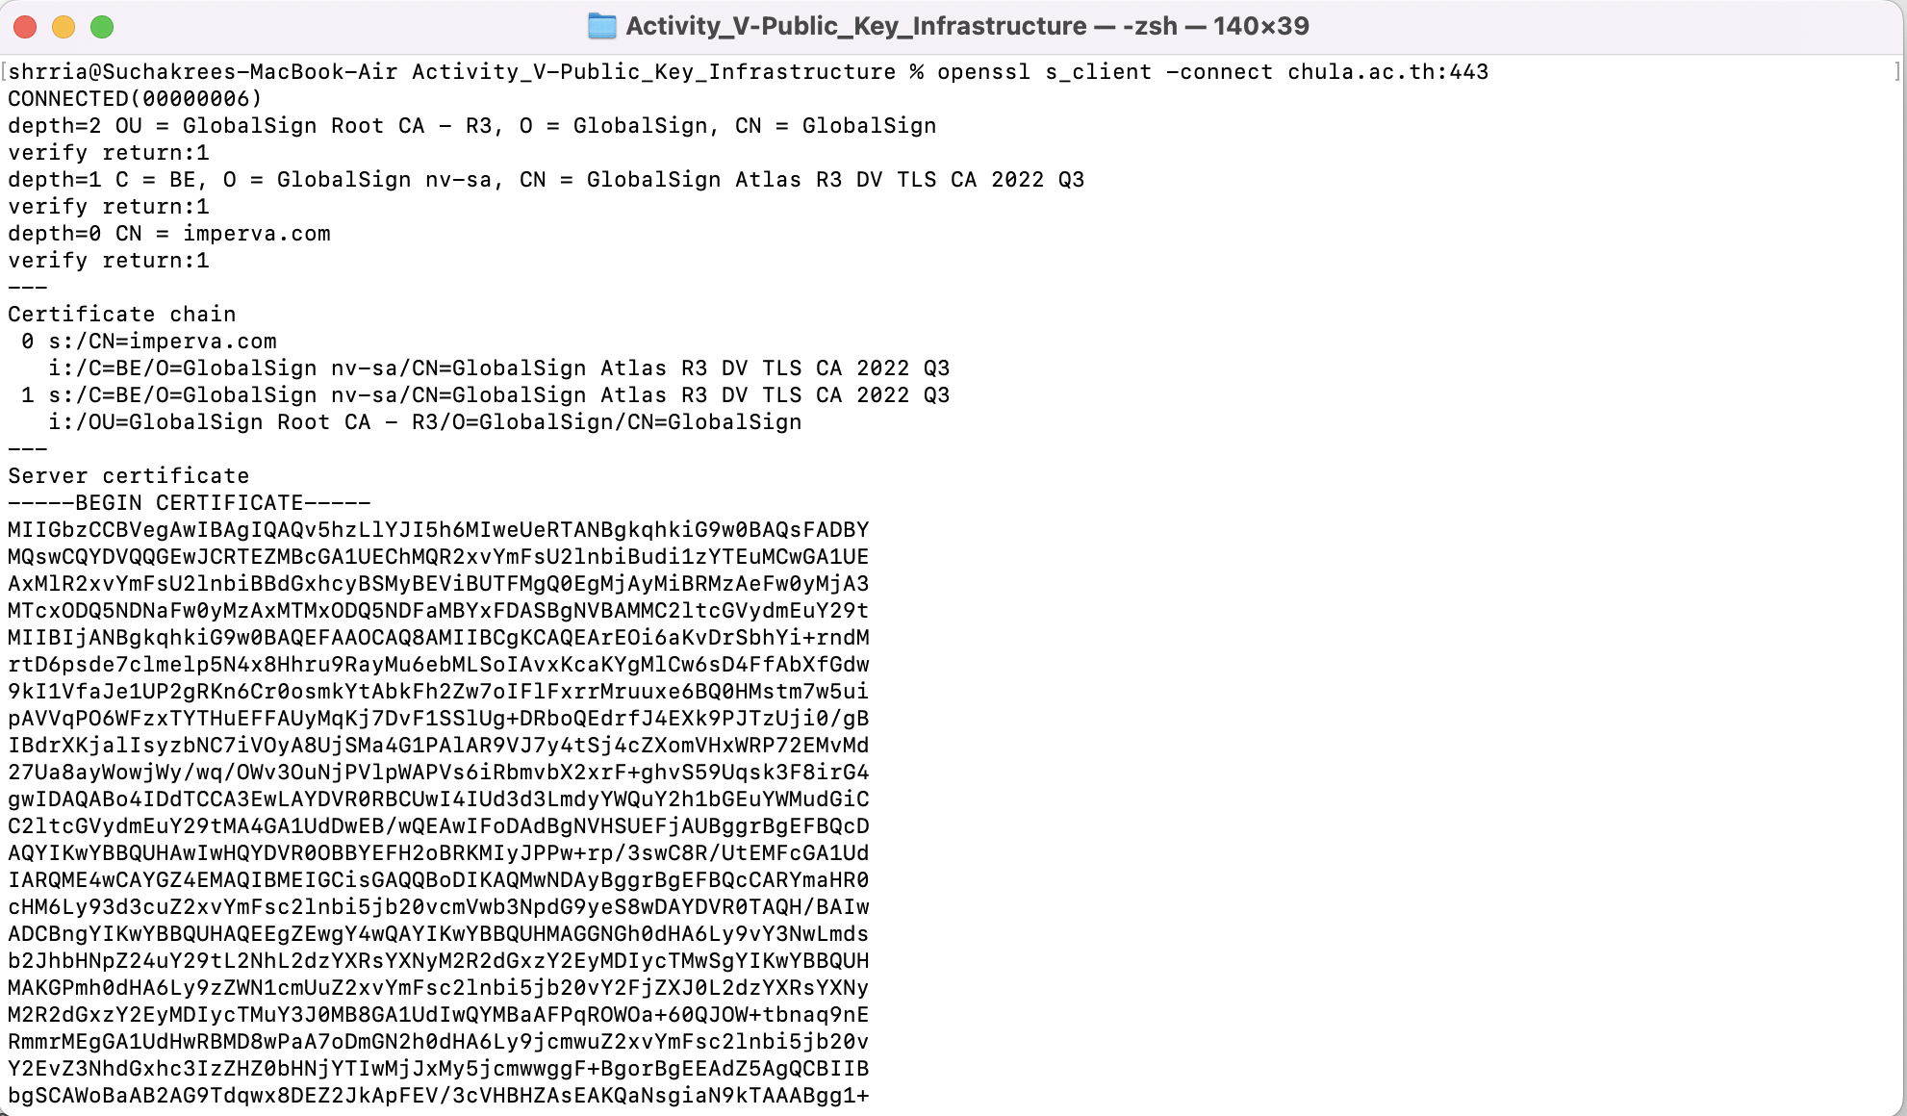
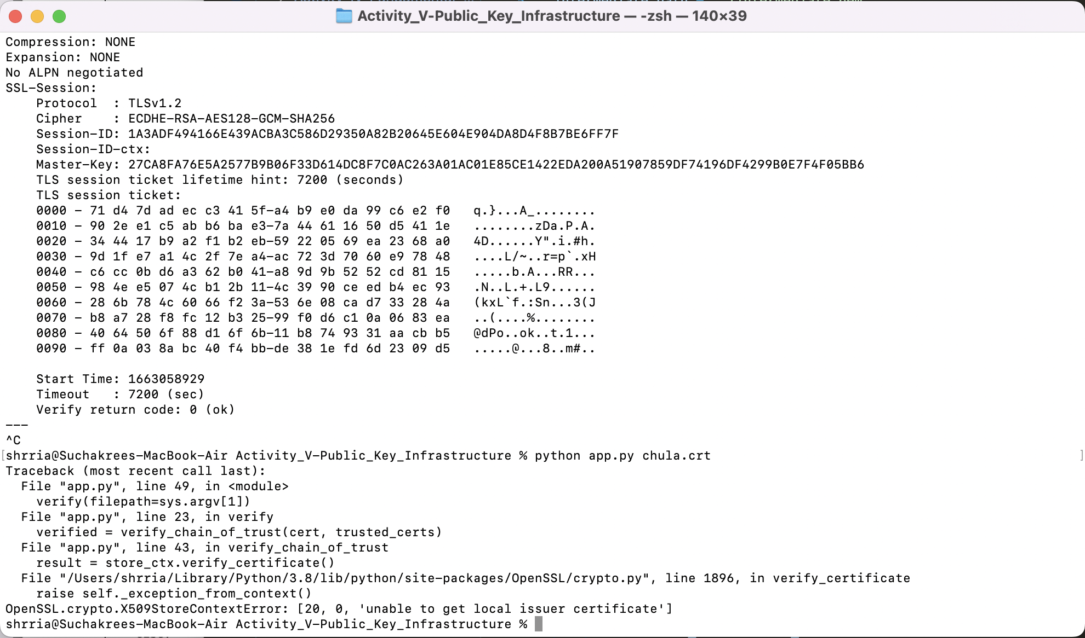

- Classdeedee (self-signed certificate)
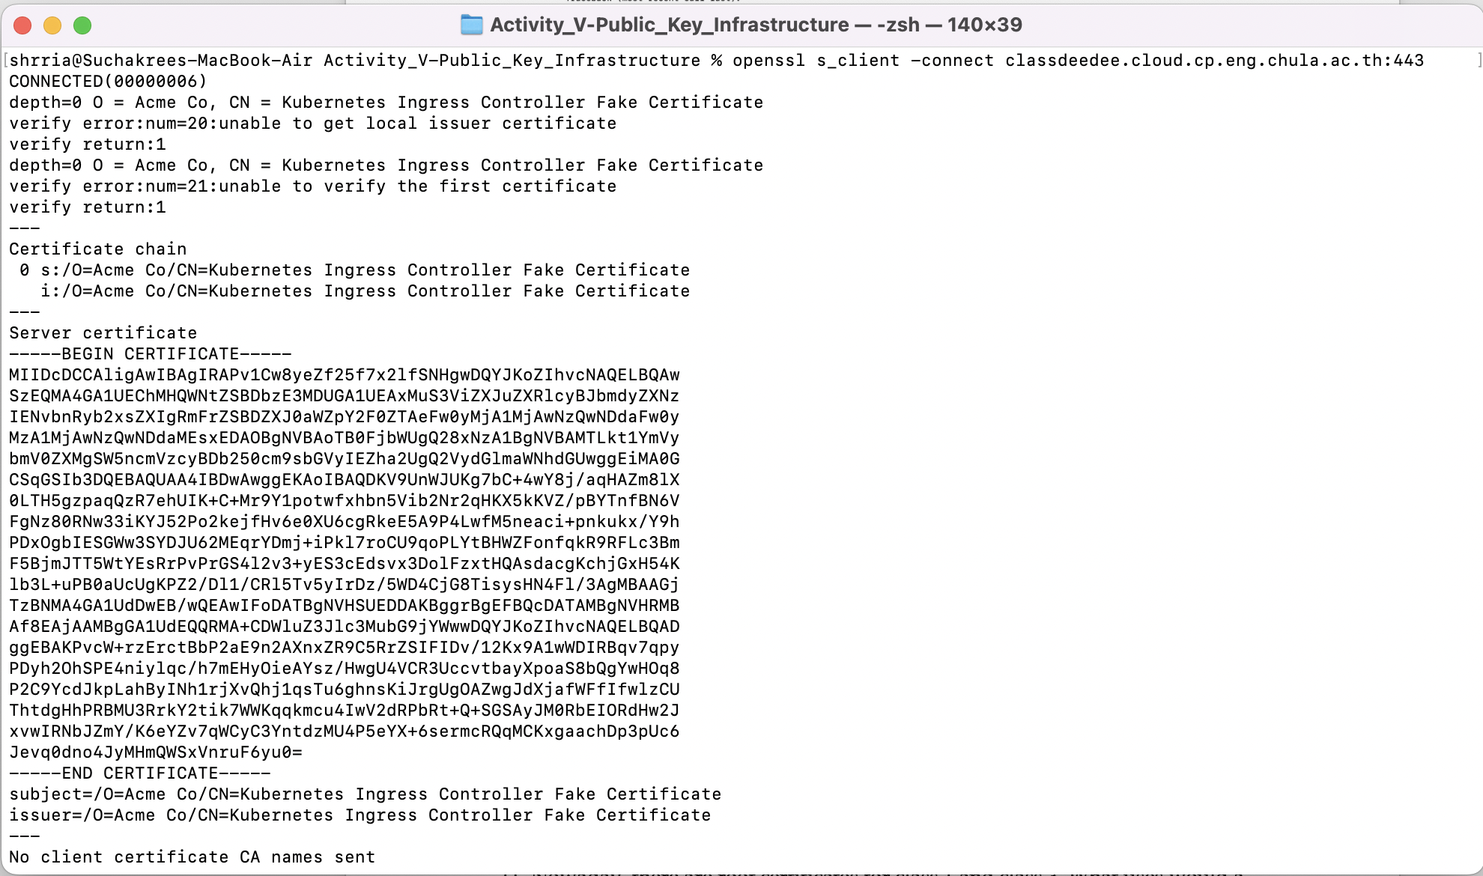
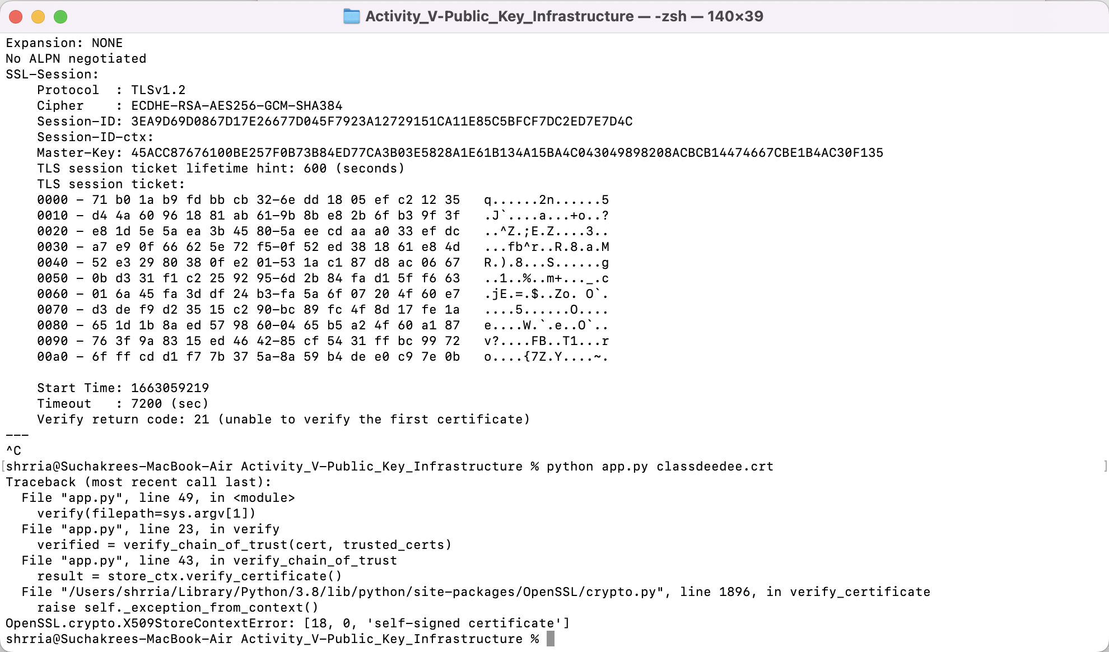
- Nowaday, there are root certificates for class 1 and class 3. What uses would a class 1 signed certificate have that a class 3 doesn't, and vice versa?
- Class 1 signed certificate is a low-level of certificate which allows the owner to self-verify their website with low-security authentication. The class-1 certificate is used for a personal or any website that does not require high level of security.
- Class 3 signed certificate is available for a subject who oversees sensitive information such as banking transaction requests, or any confidential data sent over network.
- Assuming that a Root CA in your root store is hacked and under the control of an attacker, and this is not noticed by anyone for months.
  - What further attacks can the attacker stage? Draw a possible attack setup.
  - When your computer considered the fake CA trustworthy, you could get attacked by the hackers with other tricks leading you to enter the injected-scripted website or download harmful things from their self-signed website that look like a genuine one.
  - In the attack you have described above, can we rely on CRLs or OCSP for protection? Please explain
  - No.
  - CRL (Certificate Revocation List) is the list of certificates which are expired or changed a status to unauthorized from a single CA.
  - OCSP (Online Certificate Status Protocol) is a protocol to acknowledge the status of certificates which issued by a single CA as well.
  - If the attacker has added a Root CA into the root store, both CRL and OCSP were in control of the attacker as well. Because the Root CA is the organization who individually announces the CRL and allows accessibility to view OCSP.
  - To avoid such an attack, a user must remove a Root CA of an attacker from the device and only remain trustful Root CAs and their intermediates.

