Exercise
- Javascript Injection. Your friend has just logged out of ChulaSSO (https://account.it.chula.ac.th/) before leaving his/her computer. You have 2-3 minutes to inject a script to his/her browser so that you can steal his/her username (ChulaId) and password.
For this class, please inject a javascript so that once your friend login (clicks the login button), it will pop up his/her username/password.
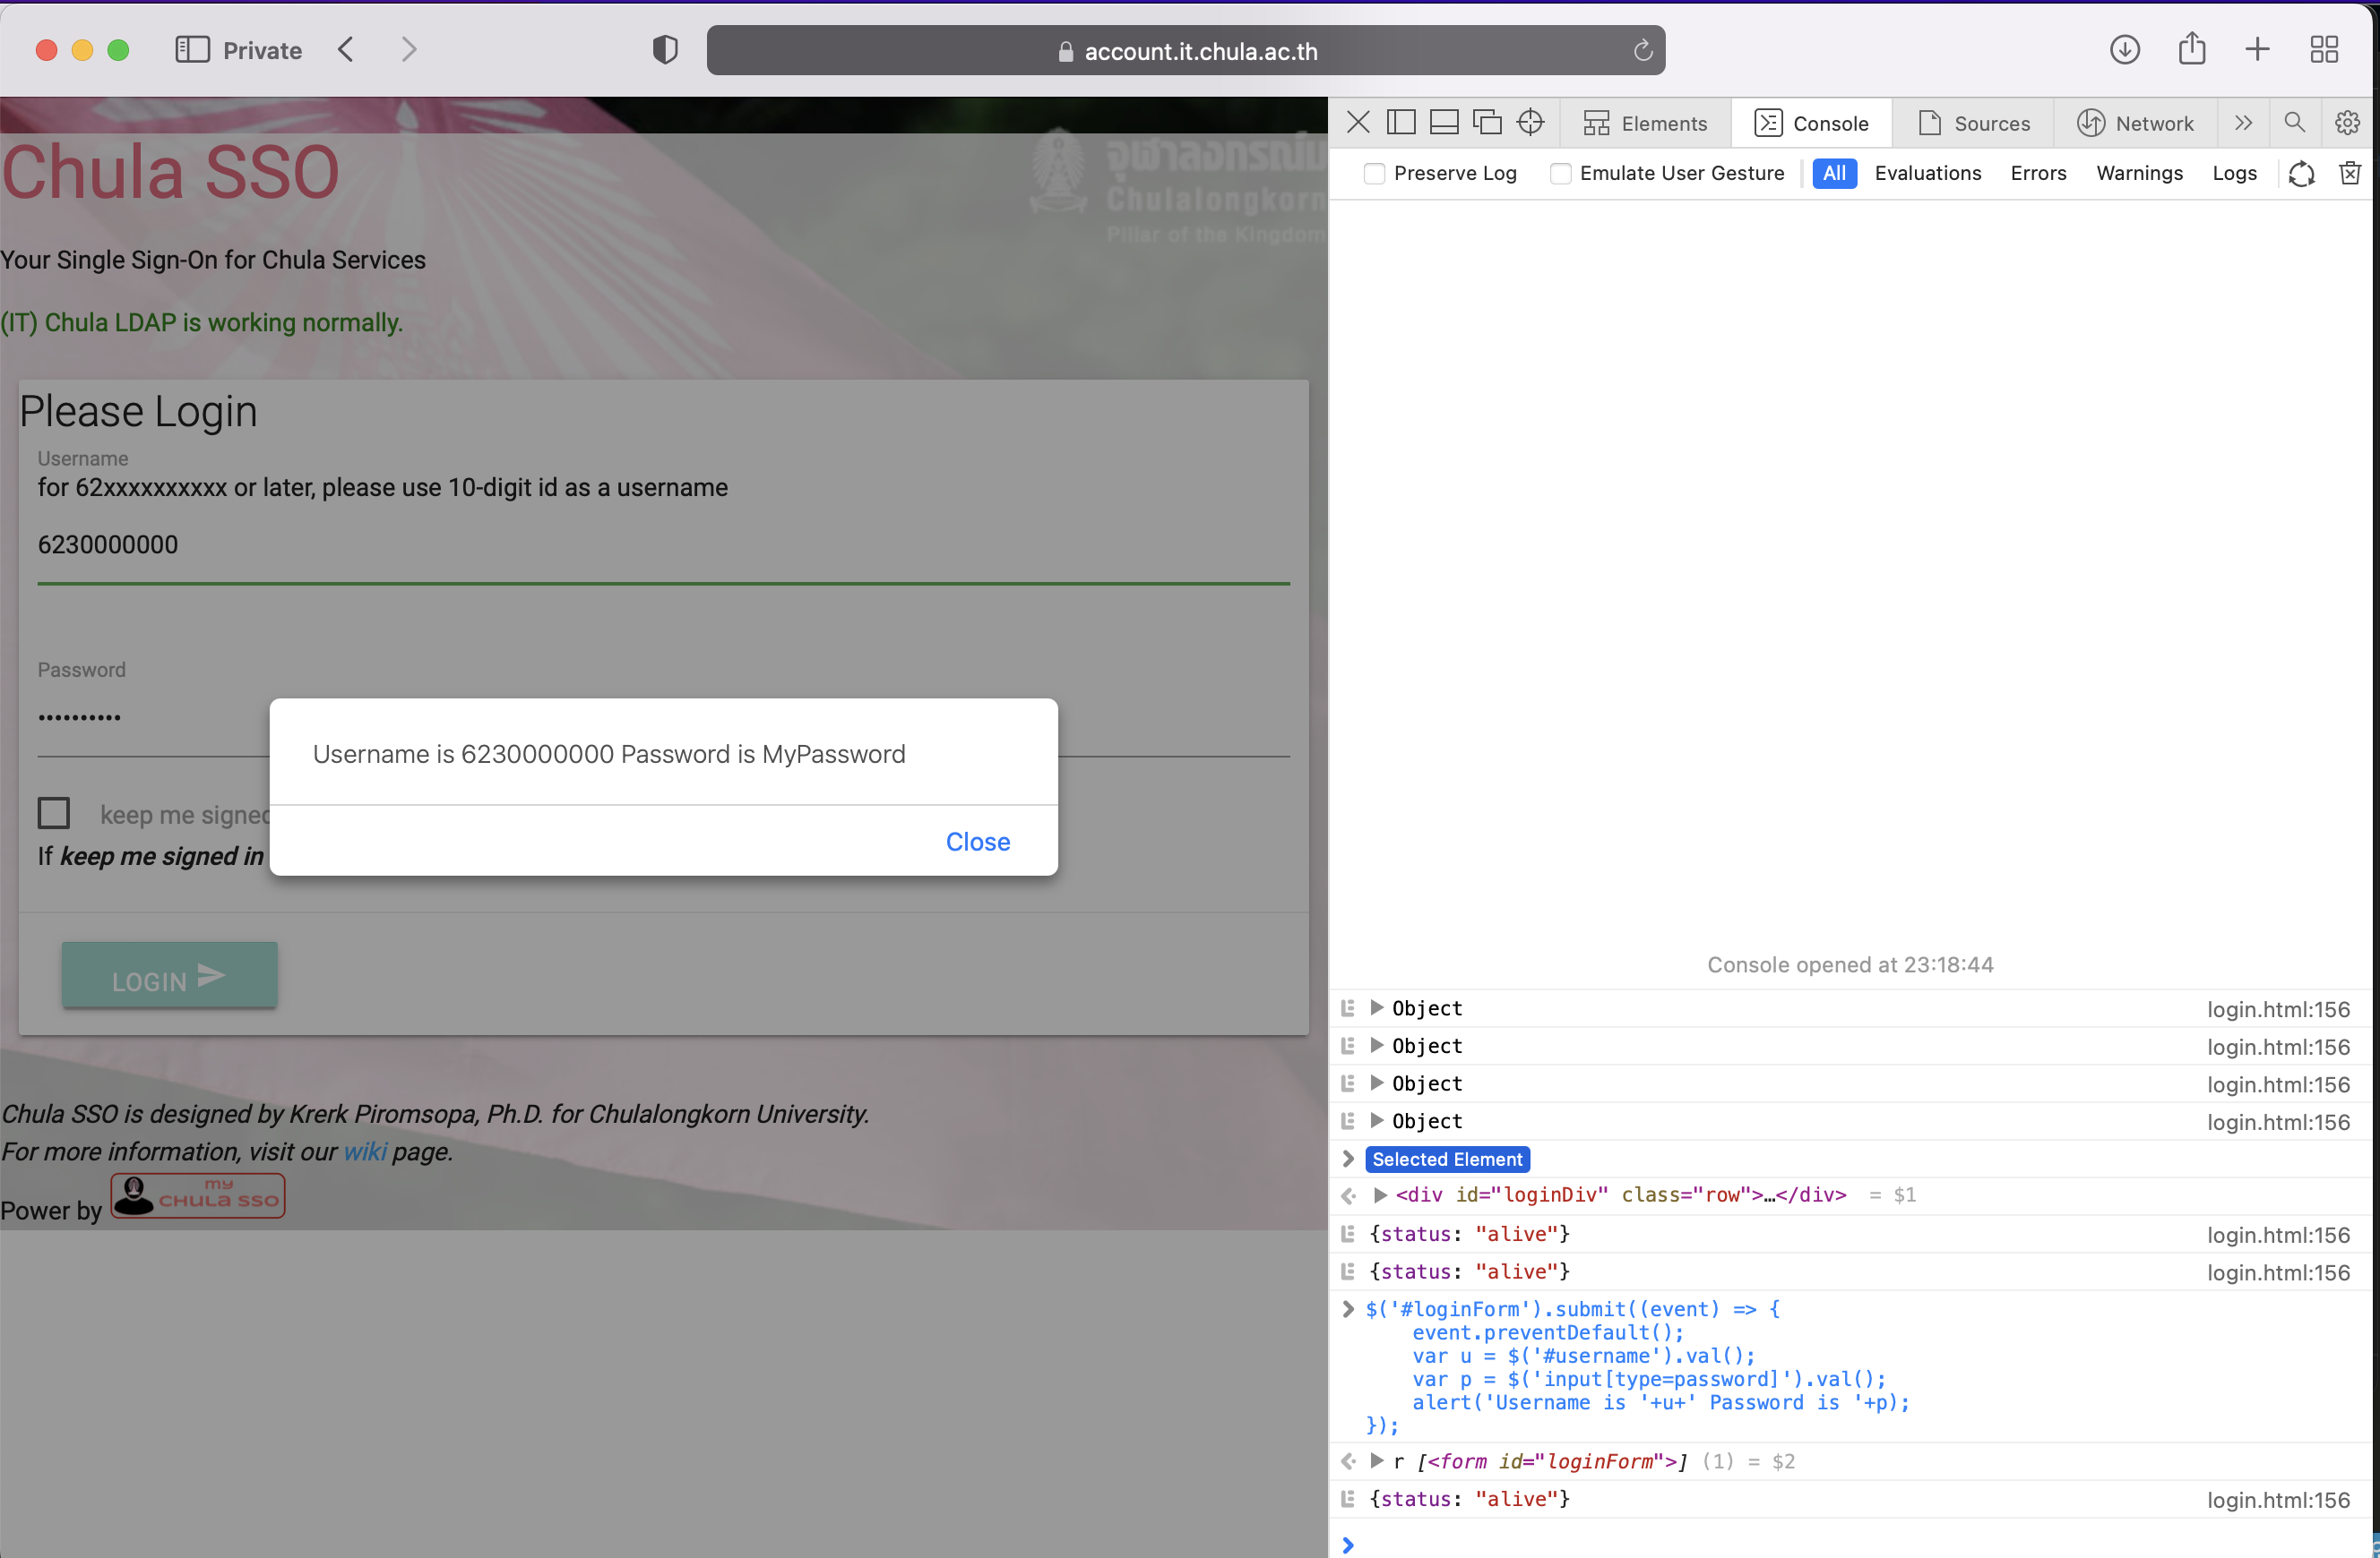

- We will mimic an attack used by several worms for placing a trojan horse into your computer. Please note that it is for demonstration purposes only. Please do not abuse it.
This attack is partly taken from the MSSQL SLAMMER worm that was spread in 2006.
Make a group of two persons. One is a victim. Another is an attacker. Please connect to the same network/WIFI access point. You may share a hotspot from your mobile phone. (Don’t use ChulaWIFI for this.) You may have to turn off your firewall to do this experiment.
- Victim:
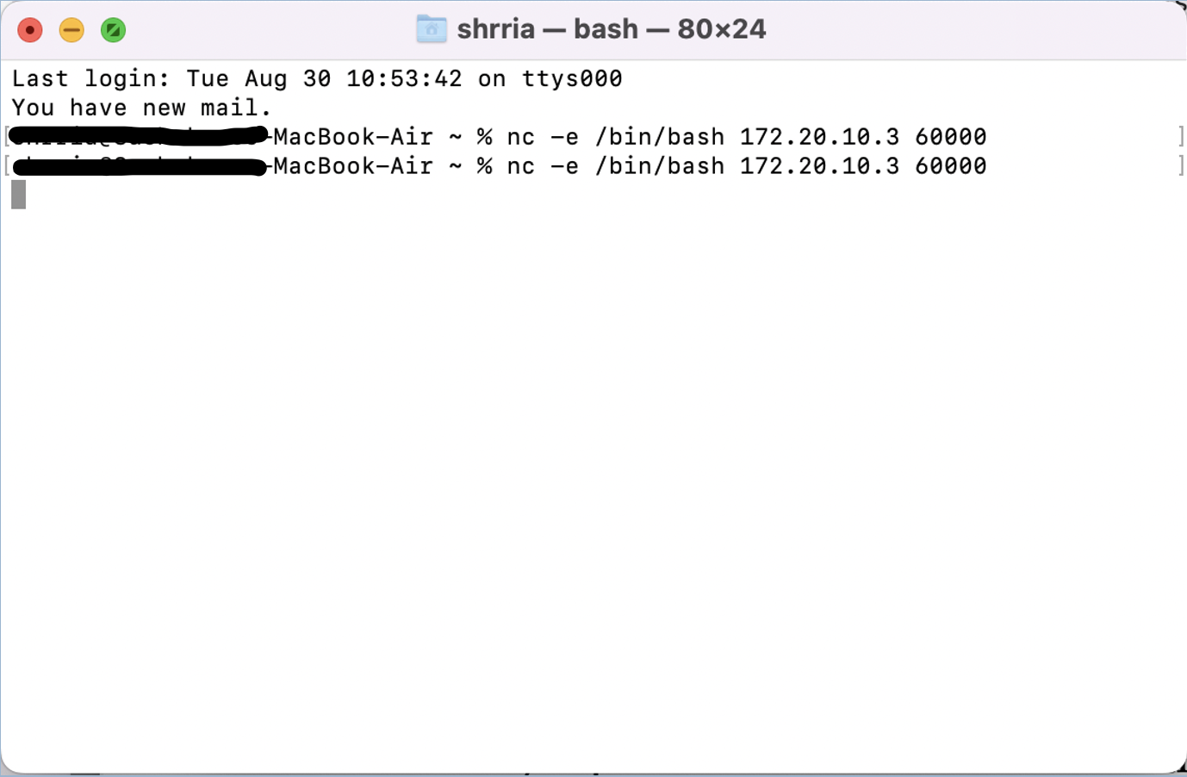

- Hacker:
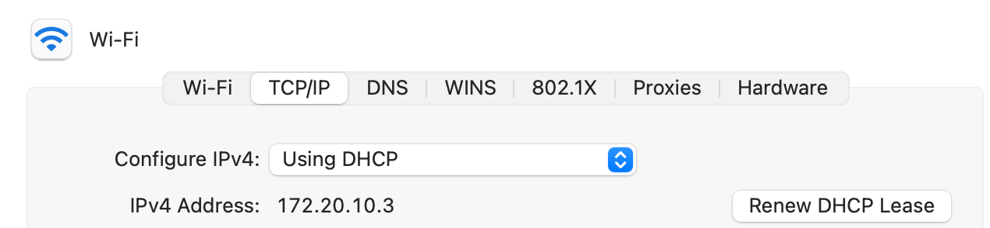
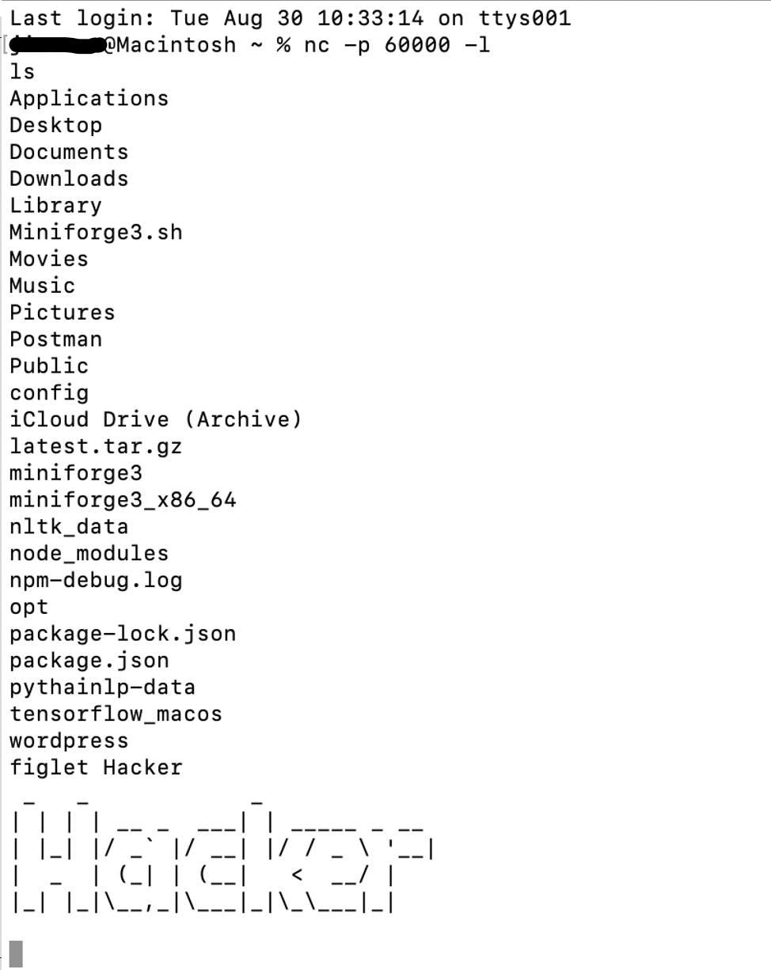

- Write an essay to summarize the lesson that you have learned in this activity.
In particular,
  - explain the worst case scenario that can happen if you leave your computer unattendant.
  - From the first exercise, we have learned that anyone, especially a hacker, could inject JavaScript, sending username, password or any significant information users had entered/submitted to the hacker, into the opened website within 2-3 minutes.

  - explain how a tool like netcat can be used for constructing a trojan horse. As a user, how will you prevent yourself from being a victim to such attacks?
  - From the second exercise, we have tried to remote a computer by opening specific port on it, listening to specific IP Address in the same network. Then, the owner of the specific IP Address was able to input bash command to control the remote computer as its own.
A tool like netcat might be used with bad intentions like a trojan horse, downloaded into computers disguised as a legitimate program.
To prevent yourself from the attacks,
    - Enable firewall on OS
    - Do not download any suspicious software
    - Use a reliable antivirus utility

