Lab-10
Course: Compiler Design Laboratory
SLOT: L23+L24
Name: Shrri Dharshan D R
Reg No: 23BPS1090
OBJECTIVE
To study and implement three-address code representations like Quadruple, Triple, and Indirect Triple for a specific set of statements using a C program.
PROBLEM STATEMENT
Write a C program to implement Quadruple, Triple, and Indirect Triple representations for the following three-address statements.
- S1 := 4 * i
- S2 := a[S1]
- S3 := 4 * i
- S4 := b[S3]
- S5 := S2 * S4
- S6 := prod + S5
- prod := S6
- S7 := i + 1
- i := S7
- if i ≤ 20 goto 1
AIM
To implement Three Address Code representations such as Quadruple, Triple, and Indirect Triple for the given statements using a C program . Also, to study their intermediate code generation in compiler design.
PROCEDURE
1. Start the program.
2. Define the given three-address statements.
3. Construct the Quadruple representation using Operator, Argument1, Argument2, and Result fields.
4. Construct the Triple representation where intermediate results are referred using instruction numbers.
5. Construct the Indirect Triple representation using a pointer table that refers to triple instructions.
6. Display all three representations using formatted output.
7. Compile the program using the C compiler.
8. Execute the program and verify the results.
9. Stop the program.

Question
Implement three address codes of quardable, triple and indirect triple of three address statements using C program in the following statement
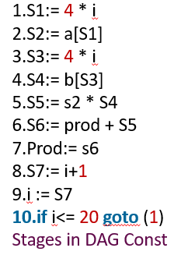

CODE:
#include <stdio.h>

int main() {

// Quadruple Representation
printf("QUADRUPLE REPRESENTATION\n");
printf("Index\tOp\tArg1\tArg2\tResult\n");

printf("1\t*\t4\ti\tS1\n"); // S1 := 4 * i
printf("2\t[]\ta\tS1\tS2\n"); // S2 := a[S1]
printf("3\t*\t4\ti\tS3\n"); // S3 := 4 * i
printf("4\t[]\tb\tS3\tS4\n"); // S4 := b[S3]
printf("5\t*\tS2\tS4\tS5\n"); // S5 := S2 * S4
printf("6\t+\tprod\tS5\tS6\n"); // S6 := prod + S5
printf("7\t:=\tS6\t-\tprod\n"); // prod := S6
printf("8\t+\ti\t1\tS7\n"); // S7 := i + 1
printf("9\t:=\tS7\t-\ti\n"); // i := S7
printf("10\t<=\ti\t20\tgoto 1\n"); // if i <= 20 goto 1

// Triple Representation
printf("\nTRIPLE REPRESENTATION\n");
printf("Index\tOp\tArg1\tArg2\n");

printf("0\t*\t4\ti\n");
printf("1\t[]\ta\t(0)\n");
printf("2\t*\t4\ti\n");
printf("3\t[]\tb\t(2)\n");
printf("4\t*\t(1)\t(3)\n");
printf("5\t+\tprod\t(4)\n");
printf("6\t:=\t(5)\tprod\n");
printf("7\t+\ti\t1\n");
printf("8\t:=\t(7)\ti\n");
printf("9\t<=\ti\t20\n");
printf("goto 0\n");

// Indirect Triple Representation
printf("\nINDIRECT TRIPLE REPRESENTATION\n");
printf("Pointer Table\n");

printf("P0 -> 0\n");
printf("P1 -> 1\n");
printf("P2 -> 2\n");
printf("P3 -> 3\n");
printf("P4 -> 4\n");
printf("P5 -> 5\n");
printf("P6 -> 6\n");
printf("P7 -> 7\n");
printf("P8 -> 8\n");
printf("P9 -> 9\n");

return 0;
}

OUTPUT:
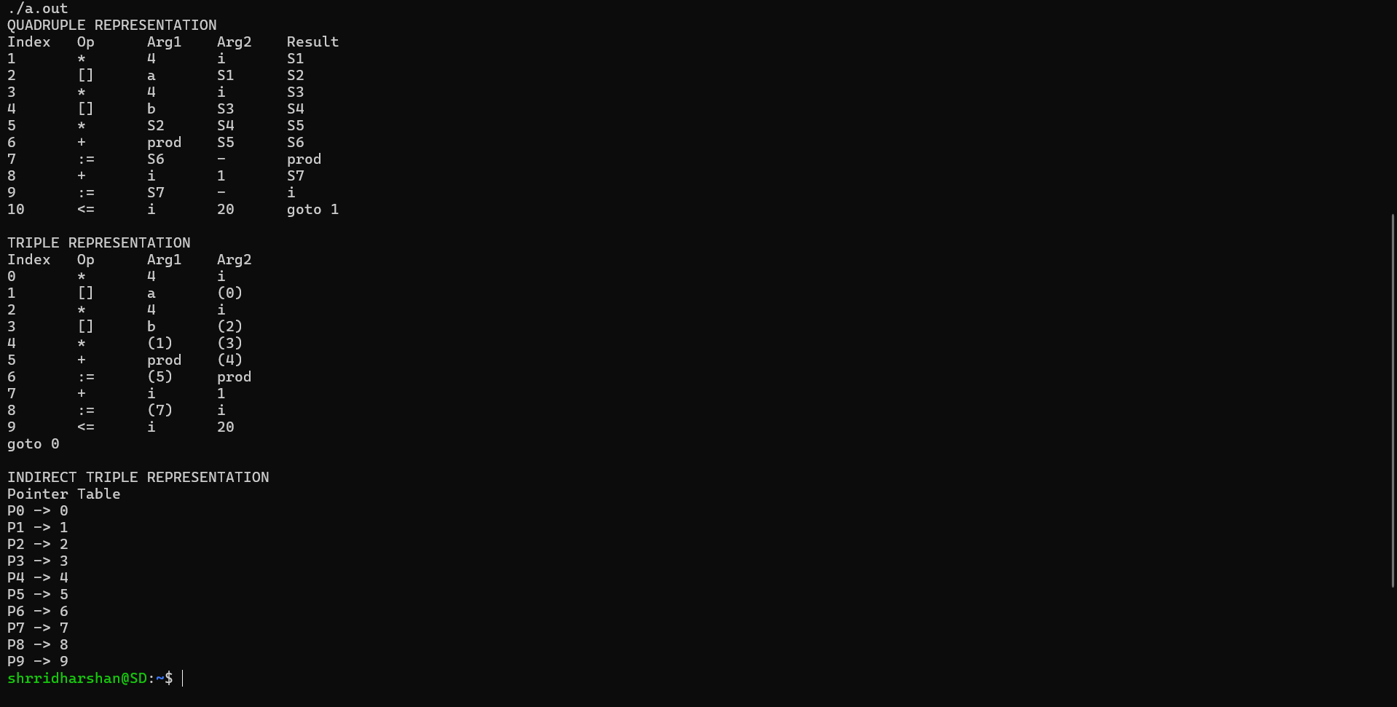

RESULT
The Quadruple, Triple, and Indirect Triple representations for the three-address statements were successfully implemented and run using a C program.

