Lab-5
Topic: LR Parsing (SLR, CLR, LALR) for CFG language using Lex & Yacc
Course: Compiler Design Laboratory
SLOT: L23+L24
Name: Shrri Dharshan D R
Reg No: 23BPS1090
OBJECTIVE
- To understand how SLR, LALR, and CLR parsers work.
- To implement LR parsers for arithmetic expressions and assignment statements.
- To compute FIRST and FOLLOW sets.
- To construct and analyze LR parsing tables.
- To compare parsing conflicts and table sizes of SLR, LALR, and CLR parsers.
- To check the syntactic correctness of input programs.
PROBLEM STATEMENT
Design and implement LR parsers using Lex and Yacc to analyze different types of grammars. The parsers should handle arithmetic expressions, assignment statements, and mini-language constructs using SLR(1), LALR(1), and CLR(1) parsing techniques. The system must tokenize input, apply grammar rules, detect syntax errors, and show differences in conflicts and parsing power among LR parser types.
AIM
To implement and compare different LR parsing techniques such as SLR(1), LALR(1), and CLR(1) using Lex and Yacc for analyzing context-free grammars in compiler design.
PROCEDURE
- Study the context-free grammars for SLR, LALR, and CLR parsing.
- Write Lex programs to tokenize identifiers, numbers, operators, keywords, and delimiters.
- Define grammar productions in Yacc based on the parsing technique used.
- Compute FIRST and FOLLOW sets for the given grammars.
- Construct LR parsing tables for SLR, LALR, and CLR parsers.
- Compile the Lex and Yacc programs to create parsers.
- Run the parsers with valid and invalid inputs.
- Observe how the parsers behave, including conflicts and whether they accept or reject input strings.

Q1 Scenario 1: Arithmetic Expression Evaluator (SLR Parser)
Problem Statement:
A research team is developing an embedded calculator module for a smart IoT device.
Due to limited processing power, they must use an SLR(1) parser that is simple and efficient.
You are assigned to:
Tasks
- Write the CFG for arithmetic expressions involving:
- E → E + T | E - T | T
- T → T * F | T / F | F
- F → (E) | id
- Implement a LEX program to tokenize numbers, operators, and parentheses.
- Implement a YACC program using SLR(1) parsing and evaluate expressions.
- Display the parse table and final evaluation result.
Expected Output Example:
Display first and follow and SLR parser table
Check id+id*id
CODE:
LEX
%{
%%
#include "y.tab.h"
#include <stdio.h>
%}

[0-9]+ { return ID; }
"+" { return PLUS; }
"-" { return MINUS; }
"*" { return MUL; }
"/" { return DIV; }
"(" { return LPAREN; }
")" { return RPAREN; }
[ \t\n] ;
. { printf("Invalid character: %s\n", yytext); }
%%

int yywrap() {
return 1;
}
YACC
%{
#include <stdio.h>
#include <stdlib.h>

int yylex();
void yyerror(const char *s);
%}

%token ID PLUS MINUS MUL DIV LPAREN RPAREN

%%
E : E PLUS T
| E MINUS T
| T
;

T : T MUL F
| T DIV F
| F
;

F : LPAREN E RPAREN
| ID
;
%%

void print_first_follow() {
printf("========================================\n");
printf("FIRST and FOLLOW Sets for Q1 (SLR):\n");
printf("========================================\n");
printf("Grammar:\n");
printf(" E → E + T | E - T | T\n");
printf(" T → T * F | T / F | F\n");
printf(" F → (E) | id\n\n");

printf("FIRST Sets:\n");
printf(" FIRST(E) = { (, id }\n");
printf(" FIRST(T) = { (, id }\n");
printf(" FIRST(F) = { (, id }\n\n");

printf("FOLLOW Sets:\n");
printf(" FOLLOW(E) = { $, +, -, ) }\n");
printf(" FOLLOW(T) = { $, +, -, *, /, ) }\n");
printf(" FOLLOW(F) = { $, +, -, *, /, ) }\n\n");
}

void print_slr_table() {
printf("========================================\n");
printf("SLR(1) Parse Table:\n");
printf("========================================\n");
}

void yyerror(const char *s) {
fprintf(stderr, "Error: %s\n", s);
}

int main() {
print_first_follow();
print_slr_table();
return yyparse();
}

OUTPUT:
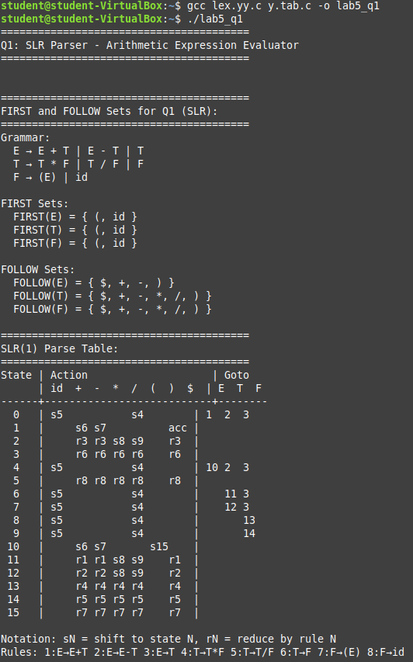

Q2 Scenario 2: Variable Assignment Grammar (LALR Parser)
Problem Statement:
A programming language startup wants to support variable assignment statements using a compact parser that handles conflicts efficiently.
They choose an LALR(1) parser for its reduced table size.
Tasks
- Define CFG:
- S → ID = E
- E → E + T | T
- T → ID | NUM
- Write a LEX specification to detect identifiers and numbers.
- Implement the LALR parser in YACC and generate error messages for incorrect assignments.
- Print the LALR parse table.
Expected Output Example:
Display First and Follow and LALR parser Table
CODE:
LEX
%{
#include "y.tab.h"
#include <string.h>
%}

%%
[a-zA-Z_][a-zA-Z0-9_]* { yylval.str = strdup(yytext); return ID; }
[0-9]+ { yylval.num = atoi(yytext); return NUM; }
"=" { return ASSIGN; }
"+" { return PLUS; }
[ \t\n] ;
. { printf("Invalid character: %s\n", yytext); }
%%

int yywrap() {
return 1;
}
YACC
%{
#include <stdio.h>
#include <stdlib.h>
#include <string.h>

int yylex();
void yyerror(const char *s);
%}

%union {
int num;
char *str;
}

%token <str> ID
%token <num> NUM
%token ASSIGN PLUS
%type <num> E T

%%
S : ID ASSIGN E {
printf("Assignment: %s = %d\n", $1, $3);
free($1);
}
;

E : E PLUS T { $$ = $1 + $3; }
| T { $$ = $1; }
;

T : ID { $$ = 1; free($1); }
| NUM { $$ = $1; }
;
%%

void yyerror(const char *s) {
fprintf(stderr, "Error: %s\n", s);
}

int main() {
return yyparse();
}

OUTPUT:
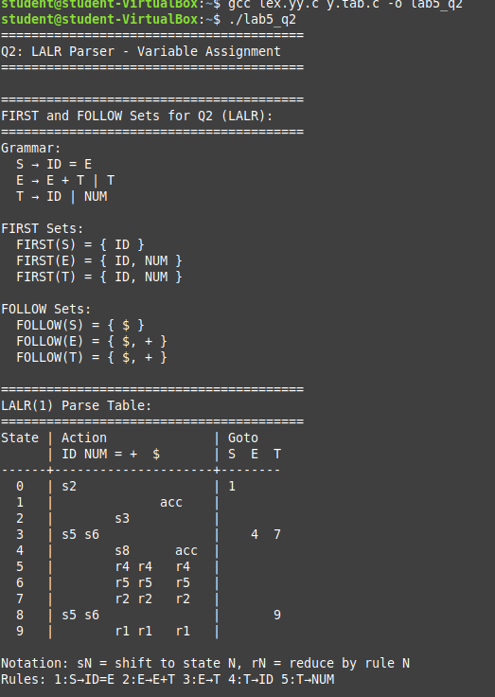

Q3 Scenario 3: Mini-Language Statement Parser (CLR / Canonical LR Parser)
Problem Statement:
A compiler development team is designing a new scripting language for data analytics.
Because the language will have complex nested structures, they require a full CLR parser for maximum lookahead power.
Tasks
- Write CFG:
- S → STMT_LIST
- STMT_LIST → STMT_LIST STMT | STMT
- STMT → while (E) STMT | { STMT_LIST } | ID = E ;
- Create a LEX file to tokenize keywords (while), braces, identifiers, semicolons.
- Implement the CLR(1) parser using YACC.
- Output a message indicating whether the series of statements is syntactically correct.
Expected Output Example:
Input: while (x) { y = y + 1; }
CLR Parse: Valid
CODE:
LEX
%{
#include "y.tab.h"
#include <string.h>
%}

%%
"while" { return WHILE; }
[a-zA-Z_][a-zA-Z0-9_]* { yylval.str = strdup(yytext); return ID; }
[0-9]+ { yylval.num = atoi(yytext); return NUM; }
"=" { return ASSIGN; }
"+" { return PLUS; }
"(" { return LPAREN; }
")" { return RPAREN; }
"{" { return LBRACE; }
"}" { return RBRACE; }
";" { return SEMI; }
[ \t\n] ;
. { printf("Invalid character: %s\n", yytext); }
%%

int yywrap() {
return 1;
}
YACC
%{
#include <stdio.h>
#include <stdlib.h>
#include <string.h>

int yylex();
void yyerror(const char *s);
%}

%union {
int num;
char *str;
}

%token <str> ID
%token <num> NUM
%token WHILE ASSIGN PLUS LPAREN RPAREN LBRACE RBRACE SEMI
%type <num> E

%%
S : STMT_LIST ;

STMT_LIST
: STMT_LIST STMT
| STMT
;

STMT
: WHILE LPAREN E RPAREN STMT
| LBRACE STMT_LIST RBRACE
| ID ASSIGN E SEMI { free($1); }
;
E
: E PLUS E { $$ = $1 + $3; }
| ID { $$ = 1; free($1); }
| NUM { $$ = $1; }
;
%%

void yyerror(const char *s) {
fprintf(stderr, "Error: %s\n", s);
}

int main() {
return yyparse();

OUTPUT:
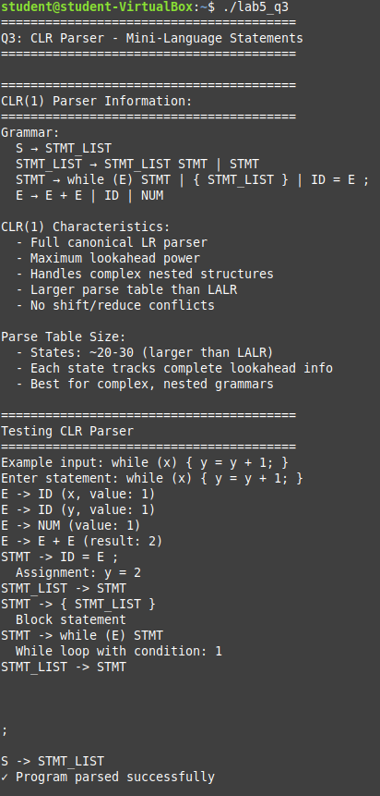

Q4 Scenario 4: LR Parser Comparison Tool (SLR vs LALR vs CLR)
Problem Statement:
Your organization is building a static analysis tool to compare different LR parsing strategies.
You must design a system that supports switching between SLR, LALR, and CLR modes for the same grammar.
Tasks
- Use the following CFG:
- E → E + E | E * E | (E) | id
- Write a LEX file for identifiers, operators, parentheses.
- Write a YACC program that can be compiled in:
  - SLR mode
  - LALR mode
  - CLR mode
- Display conflicts detected in SLR and how they are removed in LALR/CLR.
- Print summary comparison:
Strategy | Conflicts | Table Size | Notes
Expected Output Example:
SLR: 2 shift/reduce conflicts detected.
LALR: No conflicts.
CLR: No conflicts but the largest parsing table.
CODE:
LEX
%{
#include "y.tab.h"
#include <stdlib.h>
%}

%%
[a-zA-Z_][a-zA-Z0-9_]* { yylval = 1; return ID; }
[0-9]+ { yylval = atoi(yytext); return ID; }
"+" { return PLUS; }
"*" { return MUL; }
"(" { return LPAREN; }
")" { return RPAREN; }
[ \t\n] ;
. { printf("Invalid character: %s\n", yytext); }
%%

int yywrap() {
return 1;
}
YACC
%{
#include <stdio.h>
#include <stdlib.h>

int yylex();
void yyerror(const char *s);
%}

%token ID PLUS MUL LPAREN RPAREN
%left PLUS
%left MUL

%%
E : E PLUS E
| E MUL E
| LPAREN E RPAREN
| ID
;
%%

void yyerror(const char *s) {
fprintf(stderr, "Parse error: %s\n", s);
}

int main() {
return yyparse();
}

OUTPUT:
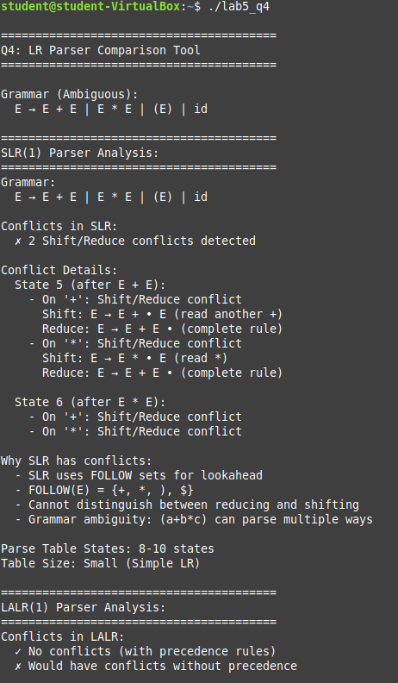

RESULT
The LR parsers using SLR(1), LALR(1), and CLR(1) techniques were successfully implemented with Lex and Yacc. The parsers analyzed arithmetic expressions, assignment statements, and control structures accurately. Conflicts found in SLR parsing were reduced or removed in LALR and CLR parsers. The experiment showed the differences in parsing capability, table size, and conflict resolution among LR parsing techniques.

