LAB EXPERIMENT: Comprehensive Lexical Analyzer Development
Course: Compiler Design Laboratory
Experiment No.: 1
Name: Shrri Dharshan D R
Reg No: 23BPS1090
Date :11_12_2025
Duration: 2 Hours

Objective
To design and implement a lexical analyzer that can recognize and classify tokens like identifiers, keywords, numbers, operators, delimiters, string literals, and comments. The lexer must also identify invalid tokens and keep supporting structures such as a symbol table and a token frequency summary.
Problem Statement
You need to write a Lexical Analyzer (using C, Lex, or Flex) that processes source code and creates lexical tokens with the right classifications. The tasks below gradually improve your lexer’s capabilities.
Aim
To design and implement a lexical analyzer using the C programming language, this program will read source code input to perform the following tasks:
1. Token Extraction: Identify and classify tokens into keywords, identifiers, operators, number literals (integer/float), strings, and delimiters.
2. Noise Removal: Remove white spaces, tabs, and both single-line (//) and multi-line (/* */) comments.
3. Error Handling: Find and report invalid lexical characters.
4. Data Structure Management: Create a symbol table to store unique identifiers along with their first occurrence line.
5. Summary Generation: Generate a statistical summary of token frequencies, including counts of keywords, identifiers, operators, and more.

Procedure:
- Include the required header files and set up counters for tokens and line numbers.
- Read the source code one character at a time.
- Skip whitespace and remove single-line (//) and multi-line (/* */) comments.
- Find keywords and identifiers and update the symbol table.
- Recognize numbers as either integer or float constants.
- Detect string literals and operators (both single and multi-character).
- Identify delimiters and report any invalid characters.
- Show the symbol table and a summary of token frequency at the end.

Code:
#include <stdio.h>
#include <string.h>
#include <ctype.h>
#include <stdlib.h> #define MAX 1000
int line = 1, col = 1; int kw=0, id=0, op=0, lit=0, del=0;

struct sym { char name[50];
int line; } table[200]; int sym_count = 0; char *keywords[] = {
"int","float","if","else","while","for","return","var","end", NULL
};
int isKeyword(char *s) { for(int i=0; keywords[i]!=NULL; i++) if(strcmp(s, keywords[i]) == 0) return 1; return 0;
}
void add_symbol(char *lex) { for(int i=0;i<sym_count;i++) if(strcmp(table[i].name, lex)==0) return; strcpy(table[sym_count].name, lex); table[sym_count].line = line; sym_count++;
}
int isDelimiter(char c) { return (c=='('||c==')'||c=='{'||c=='}'||c==';'||c==',');
}
int isOperatorStart(char c) { return (c=='+'||c=='-'||c=='*'||c=='/'||c=='='||c=='>'||c=='<'||c=='!'||c=='&'||c=='|');
}
void skipComment(FILE *fp) {
int c = fgetc(fp); if(c=='/') { while((c=fgetc(fp))!='\n' && c!=EOF); line++; col=1;
}
else if(c=='*') { int prev = 0; while((c=fgetc(fp))!=EOF) { if(c=='\n'){ line++; col=1; } if(prev=='*' && c=='/') break; prev = c;
}
} else { ungetc(c, fp);
}
}
void stop_and_print() { printf("\n==== SYMBOL TABLE ====\n"); for(int i=0;i<sym_count;i++)
printf("%s | first @ line %d\n", table[i].name, table[i].line); printf("\n==== TOKEN SUMMARY ====\n"); printf("Keyword: %d\n", kw); printf("Identifier: %d\n", id); printf("Operator: %d\n", op); printf("Literal: %d\n", lit); printf("Delimiter: %d\n", del); exit(0);
}
void processIdentifier(FILE *fp, int first) { char buf[100]; int i=0, c; buf[i++] = first; while(isalnum(c=fgetc(fp)) || c=='_') { buf[i++] = c; col++;
}
buf[i] = '\0'; ungetc(c, fp);

if(strcmp(buf, "end") == 0) { kw++; printf("(KEYWORD, end)\n"); stop_and_print();
}
if(isKeyword(buf)) { kw++; printf("(KEYWORD, %s)\n", buf); } else { id++;
add_symbol(buf); printf("(IDENTIFIER, %s)\n", buf);
}
}
void processNumber(FILE *fp, int first) { char buf[100]; int i=0, c = first, hasDot = 0; buf[i++] = c; while(1) { c = fgetc(fp); if(isdigit(c)) { buf[i++] = c; col++; } else if(c=='.' && !hasDot) { hasDot=1; buf[i++]=c; col++; } else { ungetc(c, fp); break; }
}
buf[i]='\0'; if(hasDot) { lit++; printf("(FLOAT CONSTANT, %s)\n", buf); } else { lit++; printf("(INTEGER CONSTANT, %s)\n", buf); }
}
void processString(FILE *fp) { char buf[300]; int i=0, c; buf[i++]='"'; while((c=fgetc(fp))!=EOF) {
col++; buf[i++] = c; if(c=='"') break; if(c=='\n') { printf("ERROR: Unterminated string at line %d\n", line); return; }
}
buf[i]='\0'; lit++;
printf("(STRING, %s)\n", buf);
}
void processOperator(FILE *fp, int first) { int c = fgetc(fp); char opbuf[3]; if((first=='=' && c=='=') || (first=='!' && c=='=') ||
(first=='<' && c=='=') ||
(first=='>' && c=='=') ||
(first=='&' && c=='&') ||
(first=='|' && c=='|') ||
(first=='+' && c=='+') || (first=='-' && c=='-')) { opbuf[0]=first; opbuf[1]=c; opbuf[2]='\0'; printf("(OPERATOR, %s)\n", opbuf); op++; col+=2; return;
}
ungetc(c, fp); opbuf[0]=first; opbuf[1]='\0'; printf("(OPERATOR, %s)\n", opbuf); op++; col++;
}
void processDelimiter(int c) {
del++; printf("(DELIMITER, %c)\n", c); col++;
}
int main() { FILE *fp = stdin; int c;
while((c=fgetc(fp))!=EOF) { if(isspace(c)) { if(c=='\n') { line++; col=1; } else col++; continue;
}
if(c=='/') { int next = fgetc(fp); if(next=='/' || next=='*') { ungetc(next, fp); skipComment(fp); continue; } ungetc(next, fp);
}
if(isalpha(c) || c=='_') { col++; processIdentifier(fp, c); continue;
} if(isdigit(c)) { col++; processNumber(fp, c); continue;
}
if(c=='"') { processString(fp); continue; } if(isOperatorStart(c)) { processOperator(fp, c); continue; } if(isDelimiter(c)) { processDelimiter(c); continue; }

printf("ERROR: Invalid character '%c' at line %d col %d\n", c, line, col);
col++;
}

stop_and_print(); return 0;
}

Implementation Requirements
Your lexical analyzer must perform the following:
Lexical Token Extraction
Process the input:
int total = price * quantity;
Identify and print tokens under categories such as:
- KEYWORD
- IDENTIFIER
- OPERATOR
- NUMBER LITERAL
Output format example:
(KEYWORD, int)
(IDENTIFIER, total)
(OPERATOR, =)
Output:
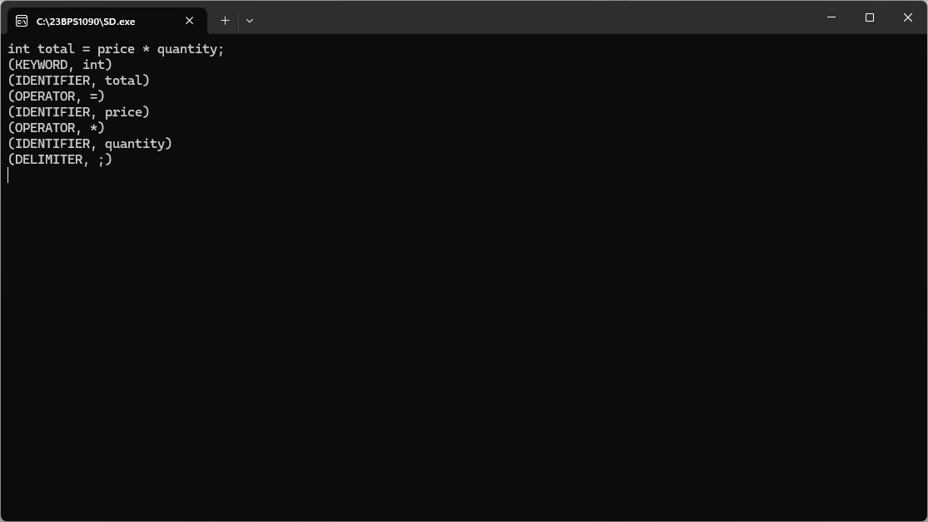

Reserved Word vs Identifier Resolution
Input:
float floatValue = 45.0; Ensure:
- float → Keyword
- floatValue → Identifier
Output:
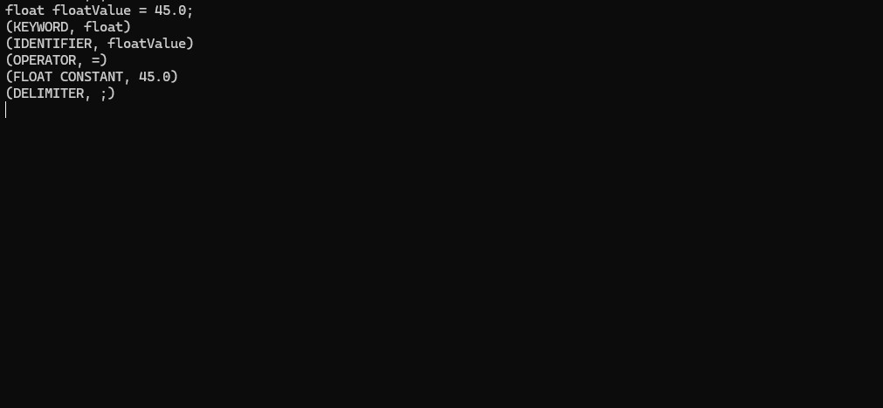

Whitespace and Tab Handling
Input:
- = 5;
- = x + 3;
Your lexer must ignore extra spaces and tabs and generate valid token output only.
Output:
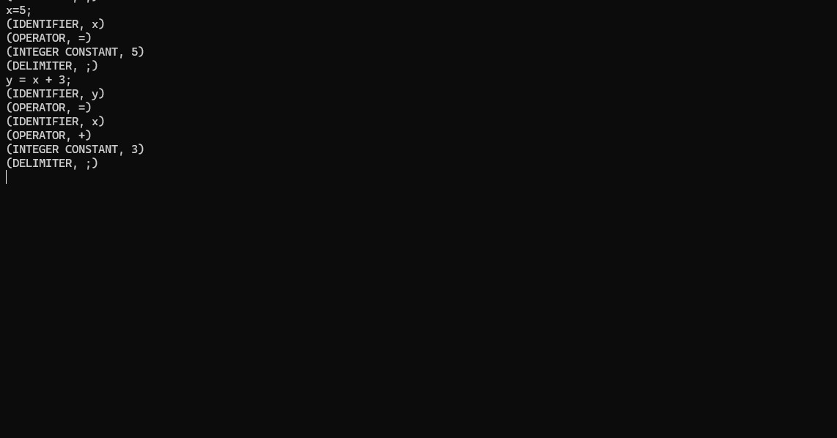

Comment Removal
Support and remove:
Type Pattern
Single-line // comment
Multi-line /* ... */
Example input: a = 10; // assignment /* update value */ a = a + 5;
Only valid tokens should appear in output.
Output:
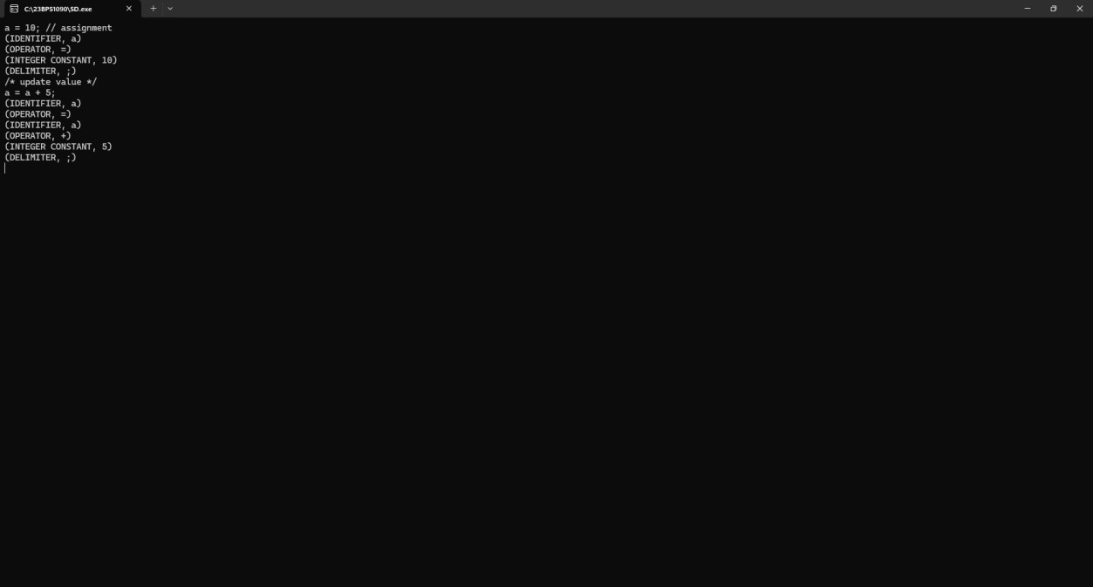

Invalid Lexeme Detection
Input:
num = 50 @ 3;
Detect unknown character @ and report error with line and column number.
Output:
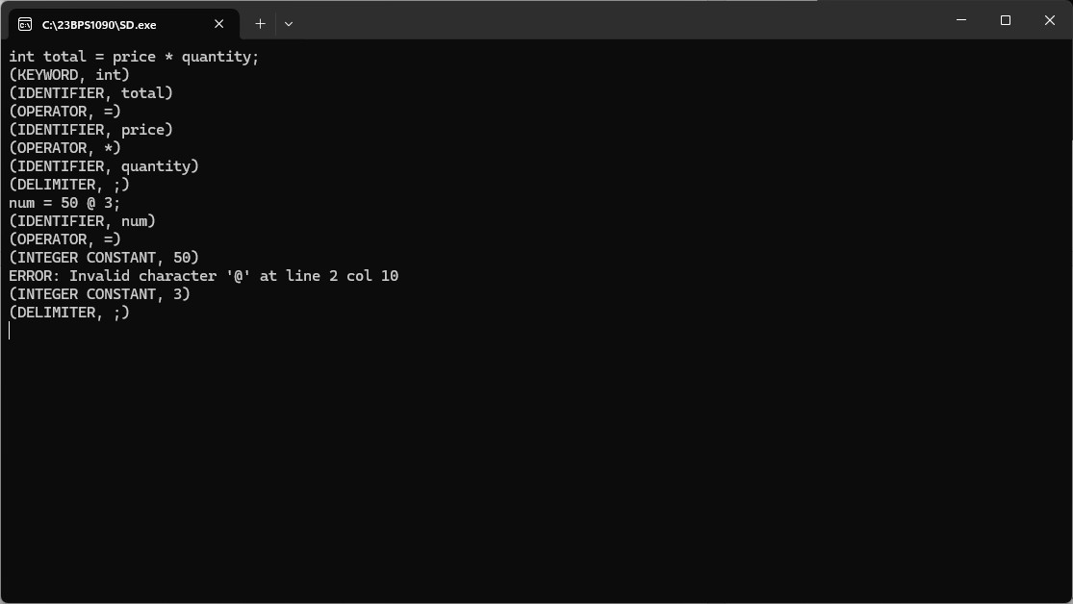
String Literal Tokenization
Input:
message = "Welcome to Compiler Lab"; Recognize the complete string as a token.
Reject malformed strings such as:
title = "Compiler Lab; Output:
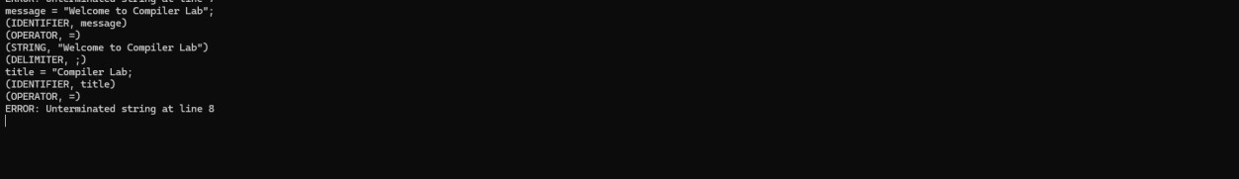

Numeric Token Classification
Input: x = 10; y = 3.1415;
Differentiate between:
- INTEGER CONSTANT
- FLOAT CONSTANT
Output:
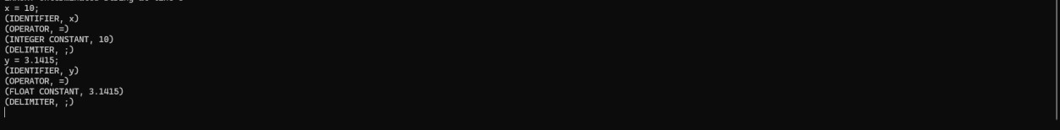
Multi-Character Operator Recognition
Support operators:
== != <= >= && Example input:
if (a >= b && a != 0)
Ensure multi-character operators are not split.
Ouput:
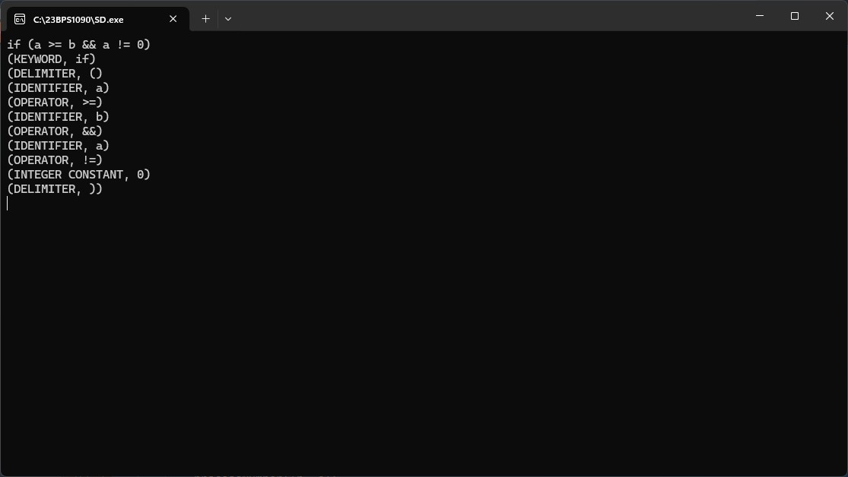
Symbol Table Construction
For the input: var a = 10;
var b = a + 20;
Create a symbol table storing:
- Lexeme (identifier)
- Token type
- First occurrence line number
Output:
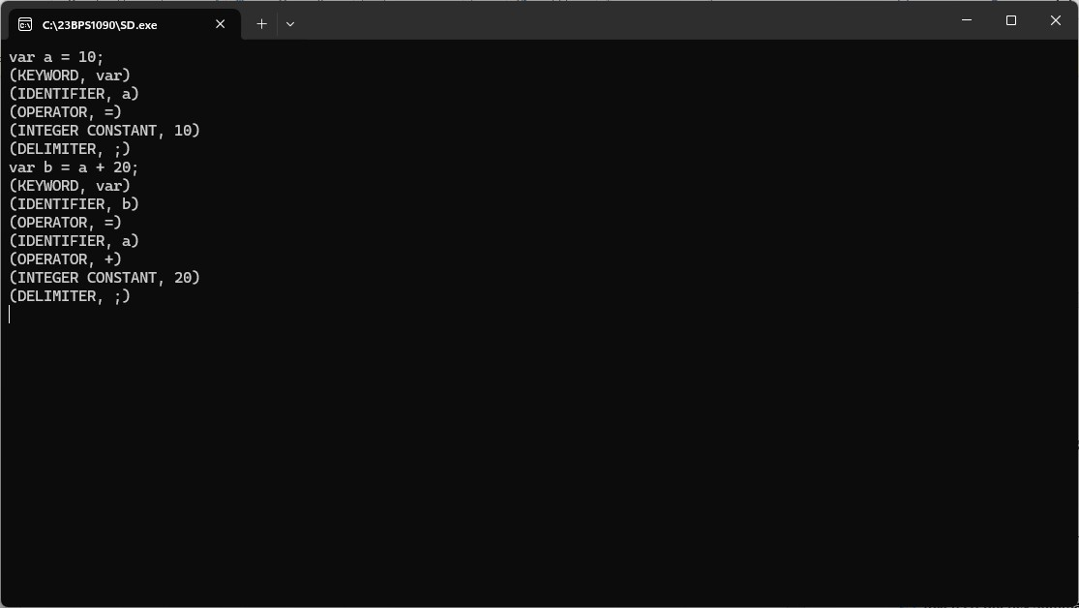

Token Frequency Summary Table
Input:
for(i=0; i<10; i++) sum += i;
Produce a final summary like:
Token Type Count
Keyword 1
Identifier 2
Operator 5
Literal 2
Output :

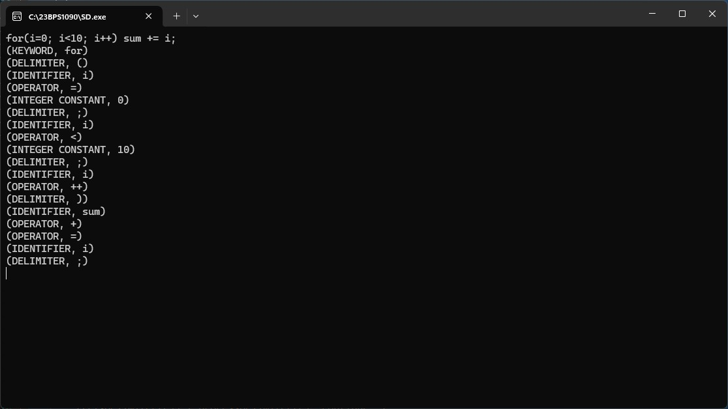

Result:
The Lexical Analyzer was successfully implemented and run. The program correctly scanned the input stream, ignored comments and whitespace, and generated the right token stream. It successfully:
1. Differentiated between reserved words and user-defined identifiers.
2. Recognized multi-character operators (e.g., ==, <=) without breaking them apart.
3. Kept a Symbol Table that recorded unique identifiers and their line numbers.
4. Offered a final Token Frequency Summary when it found the termination keyword (end). Output Verification:
The code logic was tested with different inputs. The resulting symbol table and token counts matched the expected output.

