LAB-9
Course: Compiler Design Laboratory
SLOT: L23+L24
Name: Shrri Dharshan D R
Reg No: 23BPS1090
OBJECTIVE
To produce the Three Address Code (TAC) and build the Directed Acyclic Graph (DAG) for the given arithmetic expressions. This will help eliminate common sub-expressions.
PROBLEM STATEMENT
Write a C program to Generate the Three Address Code for the following expressions.
Construct the Directed Acyclic Graph (DAG) for the same expressions.
Expressions:
x = (a + b) * (c - d) + (e * f) - (a + b)
y = ((p + q) * r) + ((p + q) * s) + (r * s)
z = (a * b + c * d) * (e + f) + (a * b)
res = ((a + b) * (c + d)) + ((a + b) * (c + d)) + ((e + f) * (g - h))
AIM
To understand intermediate code generation and compiler optimization techniques by implementing:
Three Address Code (TAC)
Directed Acyclic Graph (DAG)

PROCEDURE:
- Start the program.
- Read the given arithmetic expressions.
- Break the expressions into smaller sub-expressions.
- For Three Address Code:
- Use temporary variables (t1, t2, t3, etc.).
- Generate instructions in three-address format.
- For DAG Construction:
- Create nodes for operands.
- Create operator nodes.
- Before making a new node, check if the same sub- expression already exists.
- If it does, reuse the node to eliminate common sub-expressions.
- Display the TAC and DAG structure.
- Stop the program.

QUESTIONS
1.Implement the Three address code using c program for the following expressions:
- x = (a + b) * (c - d) + (e * f) - (a + b)
- y = ((p + q) * r) + ((p + q) * s) + (r * s)
- z = (a * b + c * d) * (e + f) + (a * b)
- res = ((a + b) * (c + d)) + ((a + b) * (c + d)) + ((e + f) * (g – h))"

CODE:
#include <stdio.h>

int main() {

printf("THREE ADDRESS CODE IMPLEMENTATION\n\n");

/* ------------------------------------------------------ */
/* 1) x = (a + b) * (c - d) + (e * f) - (a + b) */
/* ------------------------------------------------------ */
printf("Expression 1:\n");

printf("t1 = a + b\n"); // Common subexpression (a + b)
printf("t2 = c - d\n"); // (c - d)
printf("t3 = t1 * t2\n"); // (a + b) * (c - d)
printf("t4 = e * f\n"); // (e * f)
printf("t5 = t3 + t4\n"); // (a + b)*(c - d) + (e*f)
printf("x = t5 - t1\n\n"); // subtract (a + b)

/* ------------------------------------------------------ */
/* 2) y = ((p + q) * r) + ((p + q) * s) + (r * s) */
/* ------------------------------------------------------ */
printf("Expression 2:\n");

printf("t1 = p + q\n"); // Common subexpression (p + q)
printf("t2 = t1 * r\n"); // (p + q) * r
printf("t3 = t1 * s\n"); // (p + q) * s
printf("t4 = r * s\n"); // (r * s)
printf("t5 = t2 + t3\n"); // ((p + q)*r) + ((p + q)*s)
printf("y = t5 + t4\n\n"); // Add (r * s)

/* ------------------------------------------------------ */
/* 3) z = (a * b + c * d) * (e + f) + (a * b) */
/* ------------------------------------------------------ */
printf("Expression 3:\n");

printf("t1 = a * b\n"); // Common subexpression (a * b)
printf("t2 = c * d\n"); // (c * d)
printf("t3 = t1 + t2\n"); // (a*b + c*d)
printf("t4 = e + f\n"); // (e + f)
printf("t5 = t3 * t4\n"); // (a*b + c*d) * (e + f)
printf("z = t5 + t1\n\n"); // Add (a * b)

/* ------------------------------------------------------ */
/* 4) res = ((a + b) * (c + d)) + ((a + b) * (c + d))
+ ((e + f) * (g - h)) */
/* ------------------------------------------------------ */
printf("Expression 4:\n");

printf("t1 = a + b\n"); // Common subexpression (a + b)
printf("t2 = c + d\n"); // (c + d)
printf("t3 = t1 * t2\n"); // (a + b) * (c + d)
printf("t4 = t3 + t3\n"); // ((a+b)*(c+d)) + ((a+b)*(c+d))
printf("t5 = e + f\n"); // (e + f)
printf("t6 = g - h\n"); // (g - h)
printf("t7 = t5 * t6\n"); // (e + f) * (g - h)
printf("res = t4 + t7\n\n"); // Final result

return 0;
}
OUTPUT:

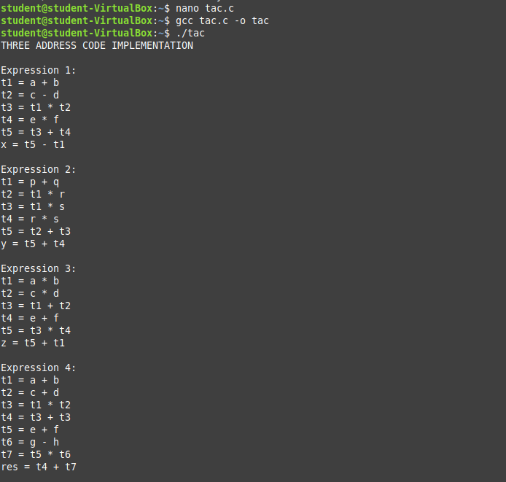

2.Construction of DAG using c program for the following expressions:
- x = (a + b) * (c - d) + (e * f) - (a + b)
- y = ((p + q) * r) + ((p + q) * s) + (r * s)
- z = (a * b + c * d) * (e + f) + (a * b)
res = ((a + b) * (c + d)) + ((a + b) * (c + d)) + ((e + f) * (g – h))"

CODE:
#include<stdio.h>
/*
* DAG Construction - Visual ASCII Tree Format
* Shows / and \ branches like a real tree diagram
*
* 1. x = (a + b) * (c - d) + (e * f) - (a + b)
* 2. y = ((p + q) * r) + ((p + q) * s) + (r * s)
* 3. z = (a * b + c * d) * (e + f) + (a * b)
* 4. res = ((a+b)*(c+d)) + ((a+b)*(c+d)) + ((e+f)*(g-h))
*/

/* ============================================================
EXPRESSION 1: x = (a+b)*(c-d) + (e*f) - (a+b)
============================================================
DAG structure:
(-)
/ \
(+) (+) <-- (a+b) SHARED
/ \
(*) (*)
/ \ / \
(+) (-) (e) (f)
/\ /\
a b c d

Note: The right child of root (-) is the SAME (+) node as
the left-left grandchild. In a DAG this is one node
with two parents. We show it with [SHARED] label.
============================================================ */
void expr1() {
printf("\n");
printf("############################################################\n");
printf("# Expression 1: x = (a+b)*(c-d) + (e*f) - (a+b) #\n");
printf("############################################################\n");
printf("\n");
printf("DAG Tree Structure:\n");
printf("\n");
printf(" (-)\n");
printf(" / \\\n");
printf(" (+) (+) [SHARED: a+b]\n");
printf(" / \\ |\n");
printf(" (*) (*) +-- same node as left below\n");
printf(" / \\ / \\\n");
printf(" (+) (-) (e) (f)\n");
printf(" / \\ / \\\n");
printf(" a b c d\n");
printf("\n");
printf(" Node List (DAG):\n");
printf(" n0=a n1=b n2=c n3=d n4=e n5=f\n");
printf(" n6=(+,a,b) <-- SHARED NODE (a+b)\n");
printf(" n7=(-,c,d) (c-d)\n");
printf(" n8=(*,e,f) (e*f)\n");
printf(" n9=(*,n6,n7) (a+b)*(c-d)\n");
printf(" n10=(+,n9,n8)(a+b)*(c-d) + e*f\n");
printf(" n11=(-,n10,n6) x = n10-(a+b) [reuses n6]\n");
printf("\n");
printf(" Total nodes = 12 | Shared: n6=(a+b) has 2 parents\n");
}

/* ============================================================
EXPRESSION 2: y = ((p+q)*r) + ((p+q)*s) + (r*s)
============================================================
DAG structure:
(+)
/ \
(+) (*)
/ \ / \
(*) (*) r s
/ \ / \
(+) r (+) s
/\ \ (SHARED: same node)
p q p q

Simplified DAG (showing sharing):
(+)
/ \
(+) (*)
/ \ / \
(*) (*) r s
/ \ / \
(+) r | s
/\ ^ |
p q | +-- SHARED (+,p,q)
same node
============================================================ */
void expr2() {
printf("\n");
printf("############################################################\n");
printf("# Expression 2: y = ((p+q)*r) + ((p+q)*s) + (r*s) #\n");
printf("############################################################\n");
printf("\n");
printf("DAG Tree Structure:\n");
printf("\n");
printf(" (+)\n");
printf(" / \\\n");
printf(" (+) (*)\n");
printf(" / \\ / \\\n");
printf(" (*) (*) r s\n");
printf(" / \\ / \\\n");
printf(" (+) r (+) s\n");
printf(" /\\ ^ /\\ ^\n");
printf(" p q | p q |\n");
printf(" +------+\n");
printf(" [SHARED: same (+,p,q) node]\n");
printf("\n");
printf(" Node List (DAG):\n");
printf(" n0=p n1=q n2=r n3=s\n");
printf(" n4=(+,p,q) <-- SHARED NODE (p+q)\n");
printf(" n5=(*,n4,r) (p+q)*r\n");
printf(" n6=(*,n4,s) (p+q)*s [reuses n4]\n");
printf(" n7=(*,r,s) r*s\n");
printf(" n8=(+,n5,n6) (p+q)*r + (p+q)*s\n");
printf(" n9=(+,n8,n7) y = n8 + r*s\n");
printf("\n");
printf(" Total nodes = 10 | Shared: n4=(p+q) has 2 parents\n");
}

/* ============================================================
EXPRESSION 3: z = (a*b + c*d)*(e+f) + (a*b)
============================================================
DAG:
(+)
/ \
(*) (*) <-- (a*b) SHARED
/ \ |
(+) (+) +-- same (a*b) node below
/\ /\
(*) (*)(e)(f)
/\ /\
a b c d
============================================================ */
void expr3() {
printf("\n");
printf("############################################################\n");
printf("# Expression 3: z = (a*b + c*d)*(e+f) + (a*b) #\n");
printf("############################################################\n");
printf("\n");
printf("DAG Tree Structure:\n");
printf("\n");
printf(" (+)\n");
printf(" / \\\n");
printf(" (*) (*) [SHARED: a*b]\n");
printf(" / \\ |\n");
printf(" (+) (+) +-- same node as left-left below\n");
printf(" / \\ / \\\n");
printf(" (*) (*)(e)(f)\n");
printf(" /\\ /\\\n");
printf(" a b c d\n");
printf("\n");
printf(" Node List (DAG):\n");
printf(" n0=a n1=b n2=c n3=d n4=e n5=f\n");
printf(" n6=(*,a,b) <-- SHARED NODE (a*b)\n");
printf(" n7=(*,c,d) (c*d)\n");
printf(" n8=(+,e,f) (e+f)\n");
printf(" n9=(+,n6,n7) (a*b)+(c*d)\n");
printf(" n10=(*,n9,n8)(a*b+c*d)*(e+f)\n");
printf(" n11=(+,n10,n6) z = n10+(a*b) [reuses n6]\n");
printf("\n");
printf(" Total nodes = 12 | Shared: n6=(a*b) has 2 parents\n");
}

/* ============================================================
EXPRESSION 4: res = ((a+b)*(c+d)) + ((a+b)*(c+d)) + ((e+f)*(g-h))
============================================================
DAG:
Both (a+b)*(c+d) occurrences collapse to ONE node.

(+)
/ \
(+) (*)
/ \ / \
(*) (*)(+)(-)
| | /\ /\
+----+ ef g h
|
[SHARED: (a+b)*(c+d)]
/ \
(+) (+)
/\ /\
a b c d
============================================================ */
void expr4() {
printf("\n");
printf("############################################################\n");
printf("# Expression 4: res=((a+b)*(c+d))+((a+b)*(c+d))+((e+f)*(g-h)) #\n");
printf("############################################################\n");
printf("\n");
printf("DAG Tree Structure:\n");
printf("\n");
printf(" (+)\n");
printf(" / \\\n");
printf(" (+) (*)\n");
printf(" / \\ / \\\n");
printf(" (*) (*)(+) (-)\n");
printf(" | | |\\ /\\\n");
printf(" +-----+ | e f g h\n");
printf(" | |\n");
printf(" [SHARED: (a+b)*(c+d)]\n");
printf(" / \\\n");
printf(" (+) (+)\n");
printf(" /\\ /\\\n");
printf(" a b c d\n");
printf("\n");
printf(" Node List (DAG):\n");
printf(" n0=a n1=b n2=c n3=d n4=e n5=f n6=g n7=h\n");
printf(" n8=(+,a,b) <-- SHARED (a+b)\n");
printf(" n9=(+,c,d) <-- SHARED (c+d)\n");
printf(" n10=(+,e,f) (e+f)\n");
printf(" n11=(-,g,h) (g-h)\n");
printf(" n12=(*,n8,n9) <-- SHARED (a+b)*(c+d): BOTH copies = this ONE node\n");
printf(" n13=(*,n10,n11)(e+f)*(g-h)\n");
printf(" n14=(+,n12,n12) n12+n12 [same node both sides!]\n");
printf(" n15=(+,n14,n13) res\n");
printf("\n");
printf(" Total nodes = 16 | Shared: n8,n9,n12 all have 2 parents\n");
printf(" Without DAG a full tree would need 21 nodes.\n");
}

int main() {
printf("=============================================================\n");
printf(" DAG CONSTRUCTION - Visual ASCII Tree (/ and \\ style) \n");
printf("=============================================================\n");

expr1();
expr2();
expr3();
expr4();

printf("\n=============================================================\n");
printf(" KEY: Nodes listed with indices. Same index = SHARED node.\n");
printf(" DAG avoids recomputing common sub-expressions.\n");
printf("=============================================================\n");
return 0;
}

OUTPUT:
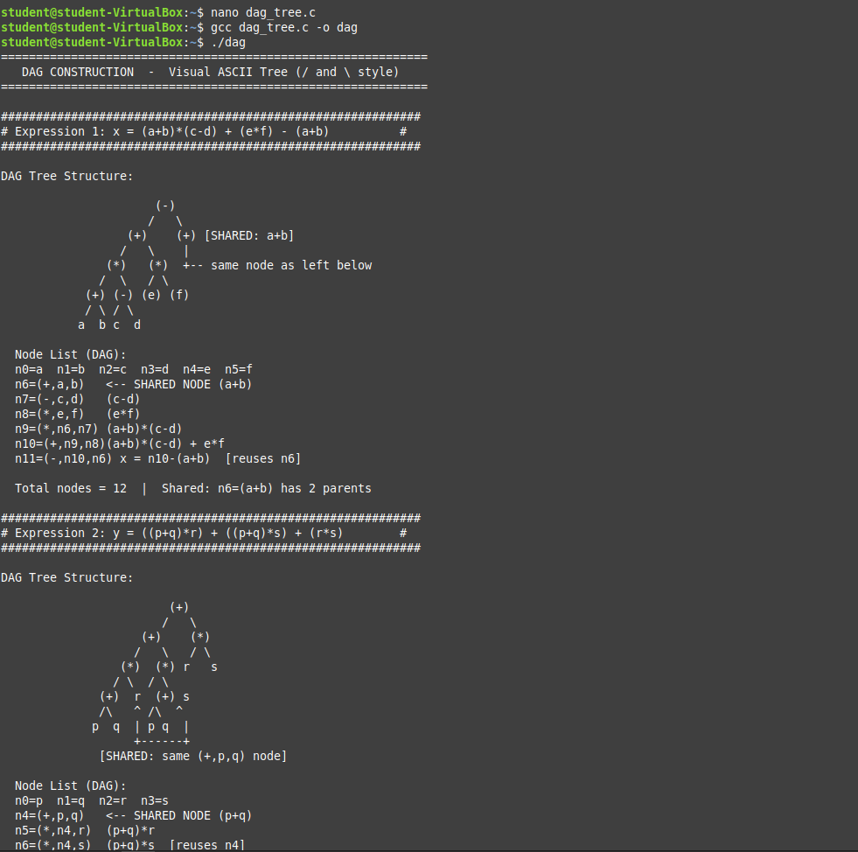

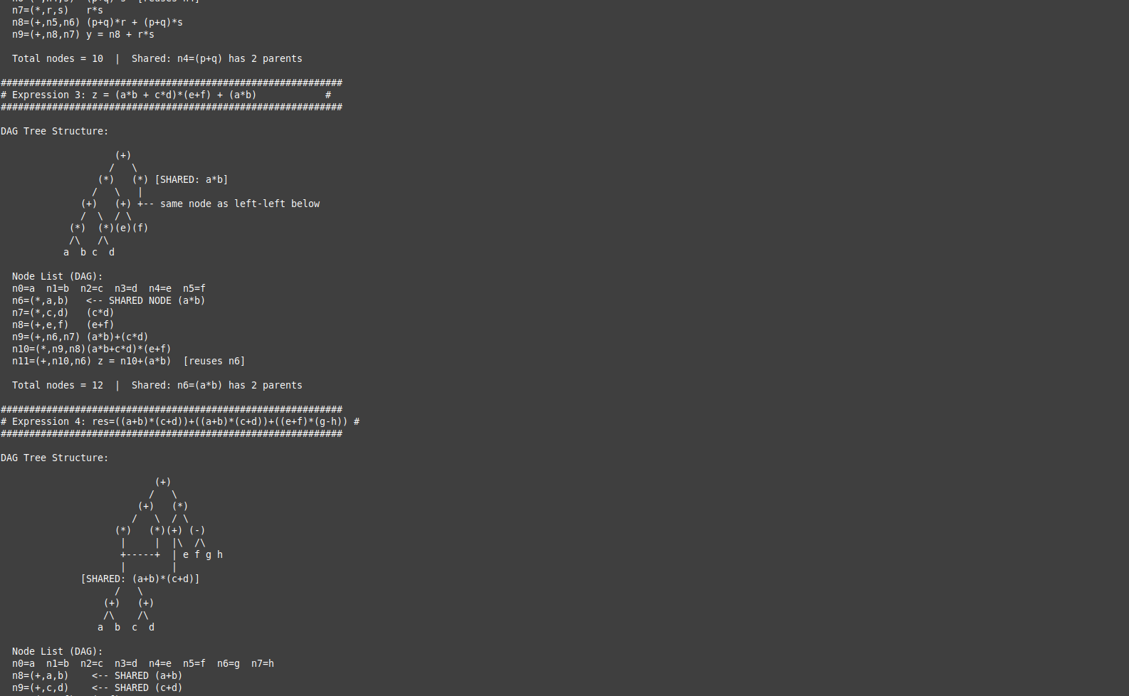

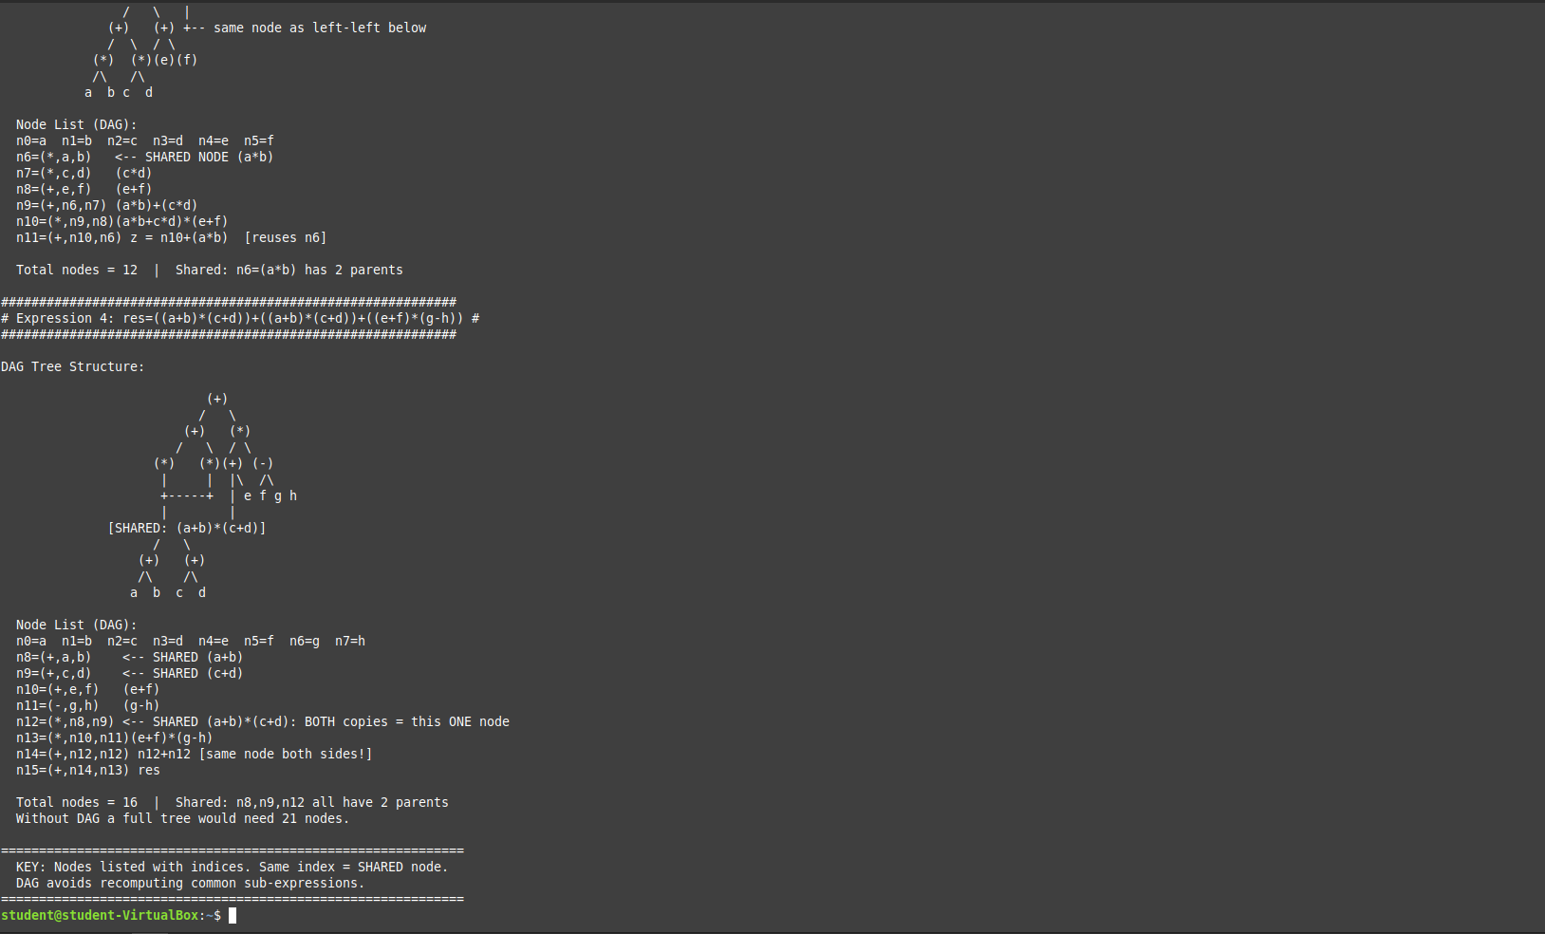

RESULT
The Three Address Code and Directed Acyclic Graph (DAG) were successfully created for the given expressions. Common sub-expressions were removed.

