RIKI DARLING LIBRARY
Book | Author | ISBN | Image
5 GALAXY - SHORT NOVELS | H. L. GOLF | No ISBN | No Image
A FINE FLEECE - KNITTING WITH HANDSPUN YARN | LISA LLOYD | 978-0-307-34683-4 | 
A HANDBOOK FOR SPINNERS – ANGORA | ERICA LYNNE | 0-934026-75-0 | 
A NO-LATHE SAXONY-STYLE SPINNING WHEEL CONSTRUCTION MANUAL | RICHARD & MYRNA SCHNEIDER | 0-936984-05-8 | 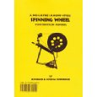
A NOVEL - SPINNERS | ANTHONY MCCARTEN | 0-688-16303-3 | 
A NOVEL - WOMEN OF THE SILK | GAIL TSUKIYAMA | 0-312-09943-6 | 
A PICTORIAL GUIDE TO AMERICAN SPINNING WHEELS | DAVID PENNINGTON & MICHAEL TAYLOR | 0-915836-01-7 | 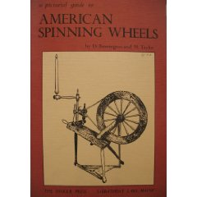
A SMALL UPRIGHT SPINNING WHEEL CONSTRUCTION MANUAL | RICHARD & MYRNA SCHNEIDER | 0-93694-06-6 | 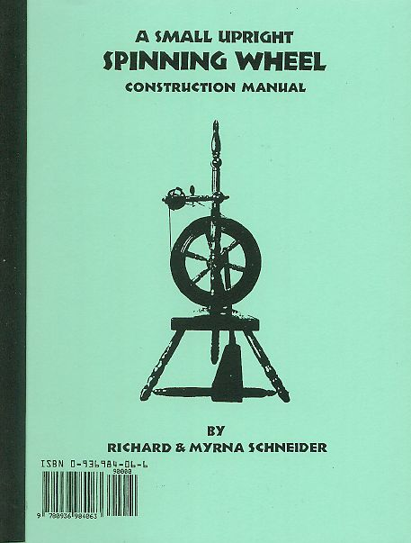
A SYMPHONY FOR THE SHEEP | C. M. MILLEN | 0-395-76503-X | 
A WEAVER'S GARDEN | RITA BUCHANAN | 486407128 | 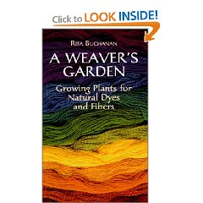
ANGORA GOATS THE NORTHERN WAY | SUSAN BLACK DRUMMOND | No ISBN | 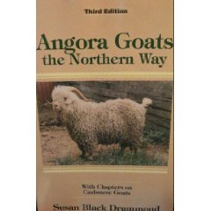
ANNIE AND THE OLD ONE | MISKA MILES | 0-316-57120-2 | 
BABY AFGHANS TO KNIT & CROCHET | LEISURE ARTS, LEAFLET 64 | LEAFLET | 
BACK TO BASICS - DROP SHOULDER SWEATERS - SIZES 32 TO 40 | LEISURE ARTS, LEAFLET 2287 | LEAFLET | 
BEAUTIFUL SHEEP | KATHRYN DUNN | 0-312-38512-9 | 
BELLWETHER | CONNIE WILLIS | 0-553-56296-7 | 
BEYOND THE FOUR CORNERS OF THE - A NAVAJO WOMAN'S JOURNEY | EMILY BENEDEK | 0-8061-3083-0 | 
BIG COTTON | STEPHEN YAFA | 0-670-03367-7 | 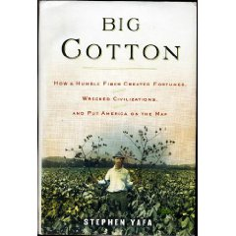
BODY & SOUL - A MASTERPIECE THEATRE PRESENTATION | KRISTIN SCOTT THOMAS | 2-DISC SET | 
C. N. COTTON AND HIS NAVAJO BLANKETS | LESTER L. WILLIAM, M.D. | 0-936755-09-1 | No Image
CAPRINE COLORS - COLORING BOOK | JOSEPH MILLER | No ISBN | No Image
CHARLIE NEEDS A CLOAK | TOMIE DEPAOLA | 0-671-66467-0 | 
CLASSIC EARRING DESIGNS | NOLA MAY | 0-943604-43-5 | 
CLASSIC VESTS | BRUNSWICK, VOLUME 905 | LEAFLET | No Image
COLOR IN SPINNING | DEB MENZ | 1-931499-82-9 | 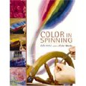
COLORS - THE STORY OF DYES AND PIGMENTS | FRANCOIS DELAMARE & BERNARD GUINEAU | 0-8109-2872-8 | 
COLORWORKS - THE CRAFTER'S GUIDE TO COLOR | DEB MENZ | 1-931499-47-0 | 
COMPLETELY ANGORA | SHARON KILFOYLE & LESLIE B SAMSON | No ISBN | 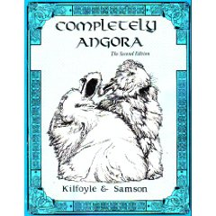
CONTEMPORARY NAVAJO WEAVING - THOUGHTS THAT COUNT | ANN LANE HEDLUND | 0-89734-118-X | 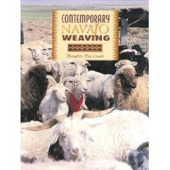
CRIME IN CORN WEATHER - A NOVEL | MARY MEIGS ATWATER | 0-934026-84-X | 
CROCHETING TABLECLOTHS & PLACEMENTS | FLORENCE WEINSTEIN | 0-486-20659-9 | 
CROCHETS FOR BABIES, INFANTS & TODDLERS | COLUMBIA-MINERVA, BOOK 778 | BOOKLET | 
DAUGHTER OF THE LOOM - A NOVEL | TRACIE PETERSON & JUDITH MILLER | 0-7642-2688-6 | 
DAUGHTERS OF COPPER WOMAN | ANNE CAMERON | 1-55017-245-X | 
DESIGNER KNITTING | NINA SHUTTLEWOOD & JANET BIGGS | 0-668-06446-3 | No Image
DESIGNING FOR WEAVING - A STUDY GUIDE FOR DRAFTING, DESIGN AND COLOR | CAROL S. KURTZ | 0-934026-21-1 | 
DEZBA WOMAN OF THE DESERET - LIFE AMONG THE NAVAJO INDIANS | GLADYS A REICHARD | 87380-057-5 | 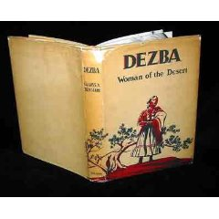
DO IT IN WOOL - 365 DAYS A YEAR, 24 HOURS A DAY , 7 DAYS A WEEK | THE AMERICAN WOOL COUNCIL | No ISBN | No Image
DYEING WITH NATURAL MATERIALS | LAS ARANAS SPNNERS & WEAVERS GUILD, INC | No ISBN | No Image
DYEING WITH NATURAL MATERIALS | LAS ARANAS SPNNERS & WEAVERS GUILD, INC | No ISBN | No Image
FASHIONS FROM THE LOOM | BETTY J. BEARD | 0-934026-03-3 | 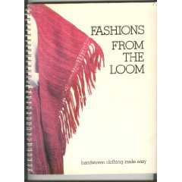
FELTING BY HAND | ANNE EINSET VICKREY | 0-9619053-5-2 | 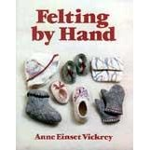
FIBER PREPARATION AND MULTICOLOR BLENDING TECHNIQUES | DEB MENZ | VIDEO CASSETTE | 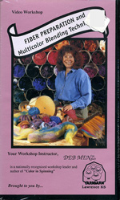
FIBERARTS | SEPTEMBER/OCTOBER 1986 | MAGAZINE | No Image
FIBERARTS | NOVEMBER/DECEMBER 1979 | MAGAZINE | No Image
FIBERARTS | JANUARY/FEBRUARY 1989 | MAGAZINE | No Image
FIBERARTS | NOVEMBER/DECEMBER 1989 | MAGAZINE | No Image
FIBERARTS | SEPTEMBER/OCTOBER 1989 | MAGAZINE | No Image
FIBERARTS | NOVEMBER/DECEMBER 1987 | MAGAZINE | No Image
FIBERARTS | SUMMER 1989 | MAGAZINE | No Image
FIBERARTS | MARCH/APRIL 1989 | MAGAZINE | No Image
FIBERARTS | 1988 | MAGAZINE | No Image
FIBERARTS | MAY/JUNE 1987 | MAGAZINE | No Image
FIBERARTS | SEPTEMBER/OCTOBER 1987 | MAGAZINE | No Image
FIBERARTS | NOVEMBER/DECEMBER 1988 | MAGAZINE | No Image
FIBERARTS | 1988 | MAGAZINE | No Image
FIBERLINE MAGAZINE | MICHIGAN FIBER FESTIVAL INC., VOL. 9, ISSUE 1 | MAGAZINE | No Image
FIBRE FACTS | BETTE HOCHBERG | 0-9600990-6-9 | 
FLEECEWEAVING - THE FLEECE, MORDANTS, DYEING, LOOMS AND MORE | CAROL LEE - THE SHEEP SHED STUDIO | No ISBN | 
FORCES OF CHANGE - A NEW VIEW OF NATURE | THE SMITHSONIAN INSTITUTION | 0-7922-7596-9 | 
FUNDAMENTALS OF FELTMAKING - ENLARGED EDITION | PATRICIA SPARK | 0-916658-48-1 | No Image
GENUINE NAVAJO RUG: HOW TO TELL | NOEL BENNETT | 0-910584-55-9 | No Image
GOATS, SHEEP, AND HOW THEY LIVE | MARIE M JENKINS | 0-8234-0317-3 | 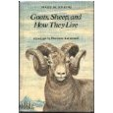
H. L. JAMES RUGS AND POSTS | H.L. JAMES | 0-88740-134-1 | 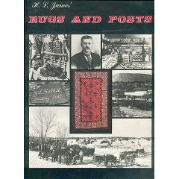
HALF FOR YOU | MEYER AZAAD | 0-87614-016-9 | No Image
HAND SPINNING COTTON | OLIVE & HARRY LINDER | 0-915113-02-3 | No Image
HANDBOOK OF TIMESAVING TABLES FOR WEAVERS, SPINNERS & DYERS | BETTIE G. ROTH & CHRIS SCHULZ | No ISBN | No Image
HANDMADE | SEPTEMBER/OCTOBER 1983 | MAGAZINE | No Image
HANDMADE | ISSUE NO. 3 1986 | MAGAZINE | No Image
HANDS ON SPINNING | LEE RAVEN | 0-934026-27-0 | 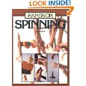
HANDS ON SPINNING | LEE RAVEN | 0-934926-27-0
HANDSPINDLES | BETTE HOCHBERG | 0-9600990-4-2 | 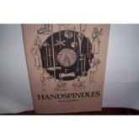
HANDSPINING ART & TECHINQUE | ALLEN FANNIN | 0-671-61036-8 | 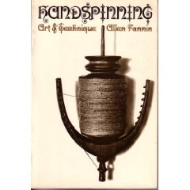
HANDSPINNERS GUIDE TO SELLING | PAULA SIMMONS | 0-914718-45-2 | 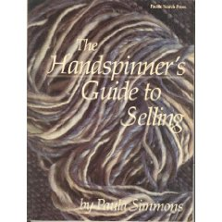
HANDSPINNER'S HANDBOOK | BETTE HOCHBERG | 0-9600990-5-0
HANDSPINNER'S WORKBOOK: FANCY YARNS | MABEL ROSS | 0-9507292-5-6 | 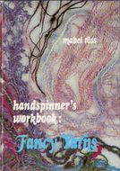
HANDSPINNING - ADVANCED TECHNIQUES | MABEL ROSS | VIDEO CASSETTE | 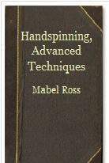
HANDWOVEN | NOVEMBER/DECEMBER 1983 | MAGAZINE | No Image
HANDWOVEN | SEPTEMBER/OCTOBER 1989 | MAGAZINE | No Image
HANDWOVEN | SEPTMEBER 1981 | MAGAZINE | No Image
HANDWOVEN | JANUARY/FEBRUARY 1985 | MAGAZINE | No Image
HANDWOVEN | MAY 1981 | MAGAZINE | No Image
HANDWOVEN | MARCH/APRIL 1989 | MAGAZINE | No Image
HANDWOVEN | SEPTEMBER 1982 | MAGAZINE | No Image
HANDWOVEN | MARCH 1982 | MAGAZINE | No Image
HANDWOVEN | JANUARY/FEBRUARY 1984 | MAGAZINE | No Image
HANDWOVEN | MAY/JUNE 1994 | MAGAZINE | No Image
HEARTS AND BONES | MARGARET LAWRENCE | 380788799 | 
HIDDEN IN PLAIN VIEW: A SECRET STORY OF QUILT AND THE UNDERGROUND RAILROAD | JACQUELINE L. TOBIN & RAYMOND G DOBARD, Ph.D. | 0-385-49767-9 | 
IKAT TECHNIQUE | JACKIE BATTENFIELD | 0-442-20595-3 | 
INDIGO TEXTILES - TECHNIQUE AND HISTORY | GOSTA SANDBERG | 0-937274-40-2 | 
INDIGO, MADDER & MARIGOLD - A PORTFOLIO OF COLORS FROM NATURAL DYES | TRUDY VAN STRALEN | 934026866 | 
INTERWEAVE | VOL. VI, # 1, WINTER 1980-81 | MAGAZINE | No Image
INTERWEAVE | VOL. V, #2, SPRING 1980 | MAGAZINE | No Image
IS YOUR MAMA A LLAMA? | DEBORAH GUARINO | 0-590-41387-2 | 
JAMES GRANT SCOTTISH TARTANS IN FULL COLOR | JAMES GRANT | 0-486-27046-7 | 
JEWELRY - A CREATIVE CRAFT FOR YOUR LEISURE HOURS | SUE SIMMONS | 0-525-70430-2 | 
JEWLERY - THE SMITHSONIAN ILLUSTRATED LIBRARY OF ANTIQUES | MARIE-LOUISE D'OTRANGE MASTAI | No ISBN | 
KNIT LIT | LINDA ROGHAAR & MOLLY WOLF | 0-609-80824-9 | 
KNIT LIT THE THIRD | LINDA ROGHAAR & MOLLY WOLF | 1-4000-9760-6 | 
KNITTER'S ISSUE 14 | SPRING 1989 | MAGAZINE | No Image
KNITTER'S ISSUE 4 | SPRING/SUMMER 1986 | MAGAZINE | No Image
KNITTING BAZAAR | JO SHARP | 1-56158-364-2 | 
KNITTING FOR REAL PEOPLE | FERNE GELLER CONE | 0-934026-47-5 | 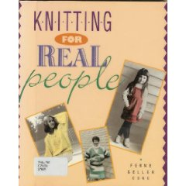
KNITTING STYLISH STITCHES - TECHNIQUES, PATTERNS & DIAGRAMS | LYRIC BOOKS LIMITED | 0-7111-0082-9 | 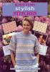
KNITTING-WORK: WEB OF MANY TEXTURES | RUTH PARTINGTON | No ISBN | 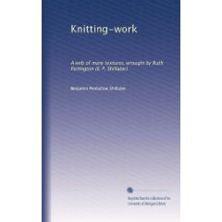
LAMBS OF GOD - A NOVEL | MARELE DAY | 1-57322-079-5 | 
LEARN TO SPIN - ASHFORD INSTRUCTION BOOKLET | ASHFORD | No ISBN | 
LEARN TO SPIN AND ASSEMBLING INSTRUCTIONS | ASHFORD | LEAFLET | No Image
LEARNING TO WARP | DEBORAH CHANDLER | 1-883010-04-7 | 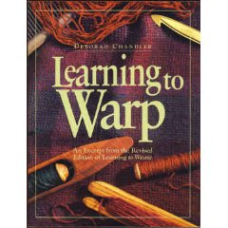
LEARNING TO WEAVE | DEBORAH CHANDLER | 0-934026-15-7 | 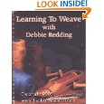
MAGLIA - A NEW BOOK OF CLASSIC AND UNIQUE DESIGNS | KERRY FERGUSON | No ISBN | No Image
MARY MEIGS ATWATER RECIPE BOOK (ON CD) | MARY MEIGS ATWATER WEAVERS GUILD | CD | 
MARY MEIGS ATWATER RECIPE BOOK (ON CD) | MARY MEIGS ATWATER WEAVERS GUILD | CD
MCCALL'S NEEDLEWORK TREASURY - A LEARN & MAKE BOOK | BY THE EDITORS OF MCCALL'S NEEDLEWORK & CRAFTS MAGAZINE | No ISBN | 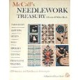
MERINO HANDSPINNING DYEING & WORKING WITH MERINO & SUPERFINE WOOLS | MARGARET STOVE | 0-934026-71-8 | 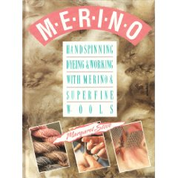
MONOGRAMS AND CIPHERS | A. A. TURBAYNE | 0-486-22182-2 | 
MOVING TARGET - A NOVEL | ELIZABETH LOWELL | 0-06-103107-0 | 
NATIONAL ANGORA RABBIT BREEDERS CLUB GUIDEBOOK | AMANDA RICHARDSON & PEGGY MOSES & ALICE PANKO & LINDA LEWIS & DAVID LEWIS | No ISBN | No Image
NATIONAL AUDUBON SOCIETY FIELD GUIDE TO NORTH AMERICAN MUSHROOMS | GARH H LINCOFF | 0-394-51992-2 | 
NATIONAL GEOGRAPHIC VOL. 161 NO. 5 | MAY 1982 | No ISBN | No Image
NATIONAL GEOGRAPHIC VOL. 200 NO. 6 | DECEMBER 2001 | No ISBN | No Image
NAVAJO AND HOPI WEAVING TECHNIQUES | MARY PENDLETON | 0-02-595500-4 | 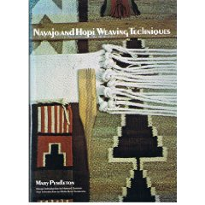
NAVAJO HOPI DYES | BILL RIESKE | 1-883736-08-0 | 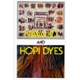
NAVAJO TEXTILES - THE WILLIAM RANDOLPH HEARST COLLECTIONS | NANCY J. BLOMBERG | 0-8165-1078-4 | 
NAVAJO WEAVING NAVAJO WAYS | HARRIET KOENIG & SEYMOUR H. KOENIG | 0-915171-03-1 | No Image
NAVAJO WEAVING TODAY | NANCY N. SCHIFFER | 0-88740-319-0 | 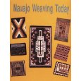
NEW PATHWAYS FOR SOCK KNITTERS - BOOK ONE | CAT BORDHI | 978-0-9708869-6-5 | 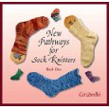
NORTH AMERICAN DYE PLANTS | ANNE BLISS | 0-934026-89-0 | 
NOTES ON DOUBLE KNITTING | BEVERLY ROYCE | 0-942018-06-0 | 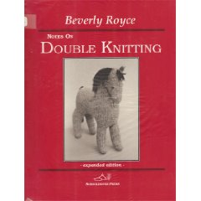
PATOLAS AND RESIST-DYED FABRICS OF INDIA | HEMA KARKARIA | 0-944142-09-5 | 
PATTERNS AND SOURCES OF NAVAJO WEAVING | BILL HARMSEN | 0-9601322-2-8 | No Image
PELLE'S NEW SUIT | ELSA BESKOW | 863155847 | 
PERSONAL FOOTPRINTS FOR INSOUCIANT SOCK KNITTERS | CAT BORDHI | 978-0-9708869-2-7 | 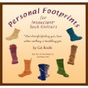
QUICK CROCHET AFGHANS | LEISURE ARTS, LEAFLET 431 | LEAFLET | 
RABBITS - A COMPLETE PET OWNER'S MANUAL | HELGA FRIZSCHE | 0-8120-2615-2 | 
RAISING SHEEP THE MODERN WAY | PAULA SIMMONS | 0-88266-529-4 | 
RAY MANLEY'S THE FINE ART OF NAVAJO WEAVING | STEVE GETZWILLER | 931418089 | 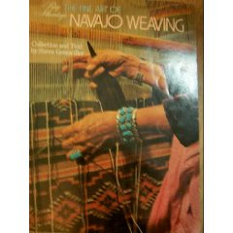
REFLECTIONS OF THE WEAVER'S WORLD | ANN LANE HEDLUND | 295-97231-9 | No Image
RESPECT THE SPINDLE | ABBY FRANQUEMONT | 978-1-59668-155-2 | 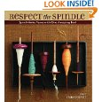
SAMMY'S SHAWL - A STUDY OF SPINNING & WEAVING IN THE GREASE | CAROL LEE - THE SHEEP SHED STUDIO | No ISBN | 
SCANDINAVIAN-STYLE FELTMAKING - A THREE-DEMENSIONAL APPROACH TO HATS, BOOTS, MITTENS AND OTHER USEFUL OBJECTS | PATRICIA SPARK | 0-916658-50-3 | No Image
SHADOW AND SILK | ANN MAXWELL | 0-8217-7311-9 | 
SHADOW SPINNER | SUSAN FLETCHER | 0-439-13753-5 | 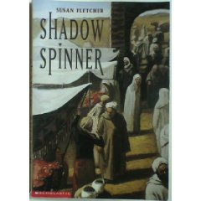
SHADOW WALK | JANE WATERHOUSE | 0-380-78879-9 | 
SHEAR SPIRIT - TEN FIBER FARMS, TWENTY PATTERNS, AND MILES OF YARN | JOAN TAPPER | 978-0-307-39403-3 | 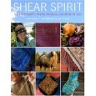
SHEEP IN A SHOP | NANCY SHAW | 0-395-70672-6 | 
SHUTTLE SPINDLE & DYEPOT | WINTER 1973 | MAGAZINE | No Image
SHUTTLE SPINDLE & DYEPOT | SUMMER 1974 | MAGAZINE | No Image
SHUTTLE SPINDLE & DYEPOT | FALL 1976 | MAGAZINE | No Image
SHUTTLE SPINDLE & DYEPOT | SPRING 1975 | MAGAZINE | No Image
SHUTTLE SPINDLE & DYEPOT | SPRING 1977 | MAGAZINE | No Image
SHUTTLE SPINDLE & DYEPOT | WINTER 1976 | MAGAZINE | No Image
SHUTTLE SPINDLE & DYEPOT | SPRING 1976 | MAGAZINE | No Image
SLIPPERS! 9 STYLES TO KNIT & CROCHET FOR WOMEN AND CHILDREN | LEISURE ARTS, LEAFLET 356 | LEAFLET | 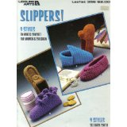
SOFT PEOPLE THE ART OF DOLLCRAFTING | LORETTA POMPILIO | 0-89594-013-2 | No Image
SOLDIER HOLLOW CLASSIC SHEEPDOG CHAMPIONSHIP | SEPTEMBER 3, 4, 5, & 6, 2004 | MAGAZINE | No Image
SPIN SPAN SPUN - FACT AND FOLKLORE FOR SPINNERS & WEAVERS | BETTE HOCHBERG | 0-9600990-3-4 | 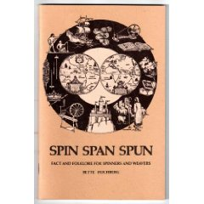
SPINDLE SPINNING FROM NOVICE TO EXPERT | CONNIE DELANEY | 0-9660952-0-0 | 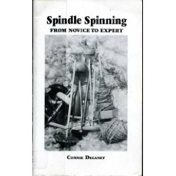
SPINNERS - A NOVEL | DONNA JO NAPOLI & RICHARD TCHEN | 0-525-46065-9 | 
SPINNING DESIGNER YARNS | DIANE VARNEY | 0-934026-29-7 | 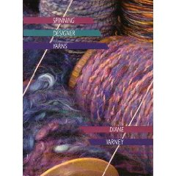
SPINNING FOR SOFTNESS & SPEED | PAULA SIMMONS | 0-914842-87-0 | 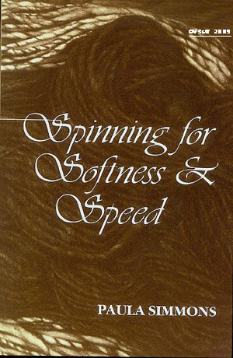
SPINNING WHEEL STORIES | LOUISA M ALCOTT | No ISBN | 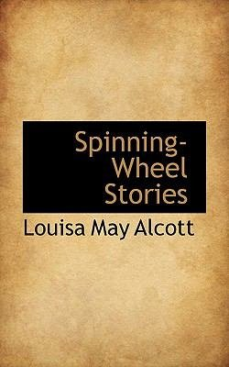
SPINNING WOOL - BEYOND THE BASICS | ANNE FIELD | 0-908704-275 | 
SPIN-OFF | FALL 1992 | MAGAZINE | No Image
SPIN-OFF | SUMMER 1992 | MAGAZINE | No Image
SPIN-OFF | SPRING 1992 | MAGAZINE | No Image
SPIN-OFF | WINTER 1991 | MAGAZINE | No Image
SPIN-OFF | FALL 1991 | MAGAZINE | No Image
SPIN-OFF | SUMMER 1991 | MAGAZINE | No Image
SPIN-OFF | SPRING 1991 | MAGAZINE | No Image
SPIN-OFF | WINTER 1990 | MAGAZINE | No Image
SPIN-OFF | FALL 1990 | MAGAZINE | No Image
SPIN-OFF | SUMMER 1990 | MAGAZINE | No Image
SPIN-OFF | SPRING 1990 | MAGAZINE | No Image
SPIN-OFF | SUMMER 1989 | MAGAZINE | No Image
SPIN-OFF | SPRING 1989 | MAGAZINE | No Image
SPIN-OFF | SUMMER 1988 | MAGAZINE | No Image
SPIN-OFF | SUMMER 2002 | MAGAZINE | No Image
SPIN-OFF | SPRING 2002 | MAGAZINE | No Image
SPIN-OFF | WINTER 2001 | MAGAZINE | No Image
SPIN-OFF | FALL 2001 | MAGAZINE | No Image
SPIN-OFF | SUMMER 2001 | MAGAZINE | No Image
SPIN-OFF | SPRING 2001 | MAGAZINE | No Image
SPIN-OFF | FALL 2000 | MAGAZINE | No Image
SPIN-OFF | SUMMER 2000 | MAGAZINE | No Image
SPIN-OFF | SPRING 2000 | MAGAZINE | No Image
SPIN-OFF | WINTER 1999 | MAGAZINE | No Image
SPIN-OFF | SUMMER 1999 | MAGAZINE | No Image
SPIN-OFF | SPRING 1999 | MAGAZINE | No Image
SPIN-OFF | FALL 1998 | MAGAZINE | No Image
SPIN-OFF | SUMMER 1998 | MAGAZINE | No Image
SPIN-OFF | SUMMER 1997 | MAGAZINE | No Image
SPIN-OFF | SPRING 1998 | MAGAZINE | No Image
SPIN-OFF | WINTER 1997 | MAGAZINE | No Image
SPIN-OFF | FALL 1997 | MAGAZINE | No Image
SPIN-OFF | SPRING 1997 | MAGAZINE | No Image
SPIN-OFF | WINTER 1996 | MAGAZINE | No Image
SPIN-OFF | FALL 1996 | MAGAZINE | No Image
SPIN-OFF | SUMMER 1996 | MAGAZINE | No Image
SPIN-OFF | SPRING 1996 | MAGAZINE | No Image
SPIN-OFF | WINTER 1995 | MAGAZINE | No Image
SPIN-OFF | FALL 1995 | MAGAZINE | No Image
SPIN-OFF | SUMMER 1995 | MAGAZINE | No Image
SPIN-OFF | SPRING 1995 | MAGAZINE | No Image
SPIN-OFF | WINTER 1994 | MAGAZINE | No Image
SPIN-OFF | FALL 1994 | MAGAZINE | No Image
SPIN-OFF | SUMMER 1994 | MAGAZINE | No Image
SPIN-OFF | SPRING 1994 | MAGAZINE | No Image
SPIN-OFF | WINTER 1993 | MAGAZINE | No Image
SPIN-OFF | FALL 1993 | MAGAZINE | No Image
SPIN-OFF | SUMMER 1993 | MAGAZINE | No Image
SPIN-OFF | SPRING 1993 | MAGAZINE | No Image
SPIN-OFF 1997 INDEX |  | LEAFLET | No Image
SPIN-OFF 1997 INDEX |  | LEAFLET | No Image
SPIN-OFF 2001 INDEX |  | LEAFLET | No Image
SPIN-OFF 2002 INDEX |  | LEAFLET | No Image
SPIN-OFF 2003 INDEX |  | LEAFLET | No Image
STEP BY STEP SPINNING & DYEING | EUNICE SVINICKI | 0-307-42015-9 | 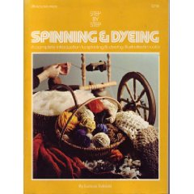
SUZY'S FIX-A-KNIT HOLES #1 | SUZY HERBERT | VIDEO CASSETTE | No Image
SWEATER DESIGN IN PLAIN ENGLISH | MAGGIE RIGHETTI | 0-312-05164-6 | 
SYLVIA'S FARM - THE JOURNAL OF AN IMPROBABLE SHEPHERD | SYLVIA JORRIN | 0-965-50178-7 | 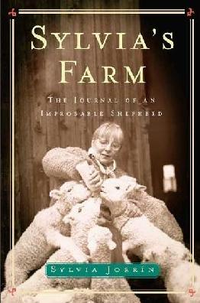
SYNTHETIC DYES FOR NATURAL FIBERS | LINDA KNUTSON | 0-934026-23-8 | 
SYNTHETIC DYES FOR NATURAL FIBERS | LINDA KNUTSON | 0-934026-23-8
TENSION AND HARMONY: THE NAVAJO RUG | STEPHEN TRIMBLE | No ISBN | 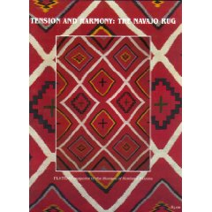
TEXTILES - SEVENTH EDITION | SARA J. KADOLPH & ANNA L. LANGFORD & NORMA HOLLEN & JANE SADDLER | 0-02-36161-6 | No Image
TEXTILES - THIRD EDITION | NORMA HOLLEN & JANE SADDLER | No ISBN | No Image
THE ALDEN AMOS BIG BOOK OF HANDSPINNING | ALDEN AMOS | 1-883010-88-8 | 
THE ART AND CRAFT OF HANDWEAVING | LILI BLUMENAU | No ISBN | 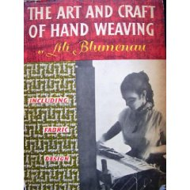
THE ART AND CRAFT OF NATURAL DYEING - TRADITIONAL RECIPES FOR MODERN USE | J. N. LILES | 0-87049-670-0 | 
THE ART OF THE LOOM - WEAVING SPINNING & DYEING ACRSS THE WORLD | ANN HECHT | 0-8478-1147-6 | 
THE ARTS OF THE NORTH AMERICAN INDIAN - NATIVE TRADITIONS IN EVOLUTION | EDWIN L. WADE | 0-933920-56-3 | 
THE ASHFORD BOOK OF DYEING | ANN MILNER | 0-908912-25-0 | 
THE BARN AT THE END OF THE WORLD - THE APPRENTICESHIP OR A QUAKER, BUDDHIST SHEPHERD | MARY ROSE O'REILLEY | 1-57131-237-4 | 
THE BLACK SHEEP - A NOVEL | HONORE DE BALZAC | 0-14-044237-5 | 
THE BOOK OF LOOMS | ERIC BROUDY | 0-87451-649-8 | 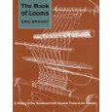
THE CARE & FEEDING OF SPINNING WHEELS - A BUYER'S GUIDE & OWNER'S MANUAL | KAREN PAULI | 0-934026-04-1 | 
THE CRAFT OF CHAIR SEAT WEAVING | GEORGE STERNS | 0-934026-56-4 | 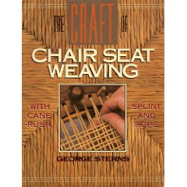
THE DURANGO COLLECTION - THREE CENTURIES OF NAVAJO WEAVING | AN EXHIBIT PRESENTED BY THE UTAH MUSEUM OF NATURAL HISTORY | No ISBN | No Image
THE EMPEROR PENGUIN'S NEW CLOTHES | JANET PERLMAN | 0-590-31257-X | 
THE ESSENTIALS OF HANDSPINNING | MABEL ROSS | 0-9507292-0-5 | 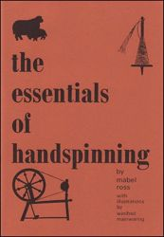
THE FOXFIRE BOOK 1 | ELIOT WIGGINTON | 0-385-07353-4 | 
THE FOXFIRE BOOK 2 | ELIOT WIGGINTON | 0-385-02267-0 | 
THE FOXFIRE BOOK 3 | ELIOT WIGGINTON | 0-385-02272-7 | 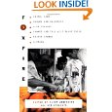
THE GOAT IN THE RUG | GERALDINE | 0-689-71418-1 | 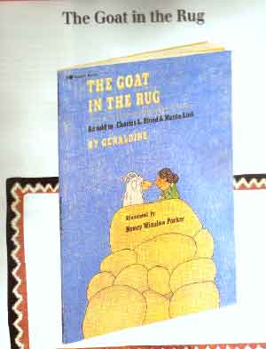
THE GOOD HOUSEKEEPING ILLUSTRATED BOOK OF NEEDLECRAFTS | CECELIA K TOTH | 0-688-12639-1 | 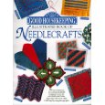
THE GREAT AFGHAN BOOK | AMERICAN SCHOOL OF NEEDLEWORK | 0-930748-19-0 | 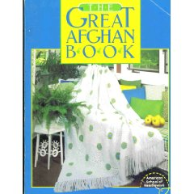
THE INTENTIONAL SPINNER- A HOLITIC APPROACH TO MAKING YARN | JUDITH MACKENZIE MCCUIN | 978-1-59668-080-7 | 
THE JOY OF KNITTING | LISA R MYERS | 0-7624-1060-4 | 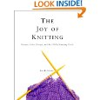
THE JOY OF SPINNING | MARILYN KLUGER | 0-671-24213-X | 
THE KNITTER'S BOOK OF WOOL - THE ULTIMATE GUIDE TO UNDERSTANDING, USING & LOVING THIS MOST FABULOUS FIBER | CLARA PARKES | 978-0-307-35217-0 | 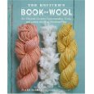
THE KNITTING GODDESS - FINDING THE HEART AND SOUL OF KNITTING THROUGH INSTRUCTION, PROJECTS AND STORIES | DEBORAH BERGMAN | 0-7868-6611-X | 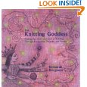
THE KNITTING SUTRA | SUSAN GORDON LYDON | 0-06-251202-1 | 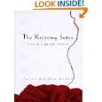
THE LAUGUAGE OF THREADS - A NOVEL | GAIL TSUKIYAMA | 0-312-26756-8 | 
THE LOVING STITCH - A HISTORY OF KNITTING AND SPINNING IN NEW ZEALAND | HEATHER NICHOLSON | 1-86940-188-3 | 
THE NAVAJO AND HIS BLANKET | U.S. HOLLISTER | 0-87380-097-4 | 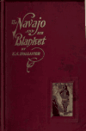
THE PRAIRIE WOOL COMPANION | ISSUE 10 | MAGAZINE | No Image
THE PRAIRIE WOOL COMPANION | ISSUE 13 | MAGAZINE | No Image
THE PRAIRIE WOOL COMPANION | ISSUE 14 | MAGAZINE | No Image
THE PROFESSOR KNITS A SHROUD | WIRT VAN ARSDALE | No ISBN | 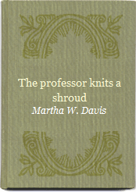
THE RED TENT - A NOVEL | ANITA DIAMANT | 0-312-19551-6 | 
THE SASHA KAGAN SWEATER BOOK | DORLING KINDERSLEY LIMITED | 1-871854-04-0 | 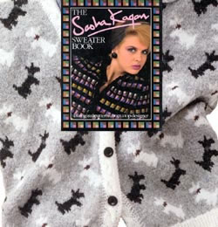
THE SHEEP BOOK | RON PARKER | 0-345-31574-X | 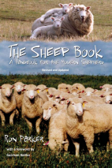
THE SOCK BOOK, 5 SOCK PATTERNS TO KNIT | JEAN LAMPE, BOOKLET #9731 | BOOKLET | No Image
THE SPIN-OFF INDEX AND RESOURCE DIRECTORY | 1977-2000 | MAGAZINE | No Image
THE STUDIO LIBRARY OF DECORATIVE ART CLASSIC TEXTILE DESIGNS | M. DUPONT-AUBERVILLE | 1-85170-278-4 | No Image
THE TAPESTRIES - A NOVEL | KIEN NGUYEN | 316735604 | 
THE TEXTILE DESIGN BOOK | KARIN JERSTORP & EVA KOHLMARK | 0-937274-83-6 | 
THE TEXTILE MUSEUM JOURNAL 1997-1998 | THE TEXTILE MUSEUM, WASHINGTON D.C. | No ISBN | 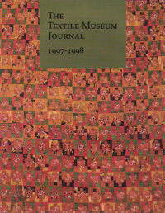
THE TEXTILE MUSEUM JOURNAL 1999-2000 (VOLUME 38 & 39) | THE TEXTILE MUSEUM, WASHINGTON D.C. | No ISBN | 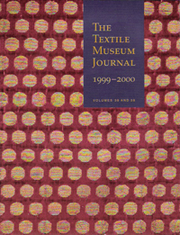
THE TREASURY OF DECORATIVE ART - AFRICAN TEXTILES | CHRISTOPHER SPRING | 0-99521-162-8 | 
THE TWISTED SISTERS SOCK WORKBOOK | LYNNE VOGEL | 1-931499-16-0 | 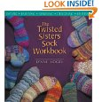
THE WEAVING, SPINNING, AND DYEING BOOK | RACHEL BROWN | 0-394-71595-0 | 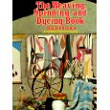
THE WOOLLY TIMES | FALL 2001 | MAGAZINE | No Image
THE WOOLLY TIMES | SUMMER 2000 | MAGAZINE | No Image
THREE WEAVERS | JOAN POTTER LOVELESS | 0-8263-1318-3 | 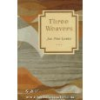
TURNING TO ONE ANOTHER - SIMPLE CONVERSATIONS TO RESTORE HOPE TO THE FUTURE | MARGARET J WHEATLEY | 1-57675-145-7 | 
TURNING WOOL INTO A COTTAGE INDUSTRY | PAULA SIMMONS | 0-88266-685-1 | 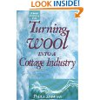
WEAVER'S | SPRING 1989 | MAGAZINE | No Image
WEAVER'S | SPRING 1988 | MAGAZINE | No Image
WEAVER'S | FALL 1988 | MAGAZINE | No Image
WEAVER'S | WINTER 1989 | MAGAZINE | No Image
WEAVER'S | SUMMER 1988 | MAGAZINE | No Image
WEAVING A WORLD - TEXTILES AND THE NAVAJO WAY OF SEEING | ROSEANN S. WILLINK & PAUL G. ZOLBROD | 0-89013-307-7 | 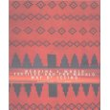
WEAVING PROFITS | JAMES DILLEHAY | 0-9629923-9-9 | 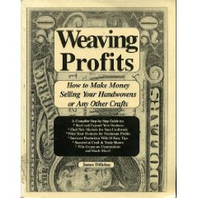
WHAT'S IN THE POT? - A NATURAL DYEING VIDEO WORKSHOP | CAROL LEE - THE SHEEP SHED STUDIO | VIDEO CASSETTE | 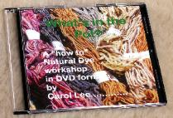
WHERE DO SHEEP LIKE TO SLEEP? | NANCY PARENT | 1-57657-676-0 | No Image
WHILE OTHER PEOPLE SLEEP | MARCIA MULLER | 0-446-60721-5 | 
WILD FIBERS | NOVA NESTRICK | MAGAZINE | No Image
WILD FIBERS | WINTER 2007 | MAGAZINE | No Image
WILD FIBERS | SUMMER 2008 | MAGAZINE | No Image
WILD FIBERS | FALL 2008 | MAGAZINE | No Image
WILD FIBERS | FALL 2006 | MAGAZINE | No Image
WILD FIBERS | SUMMER 2006 | MAGAZINE | No Image
WOOL CLIPS | FALL 1999, NO. 1 | LEAFLET | No Image
WOOL CLIPS | FALL 1999, NO. 2 | LEAFLET | No Image
WOOL CLIPS | FALL 1999, NO. 3 | LEAFLET | No Image
WORKING WITH THE WOOL - HOW TO WEAVE A NAVAJO RUG | NOEL BENNETT & TAINA BIGHORSE | 0-87358-084-2 | 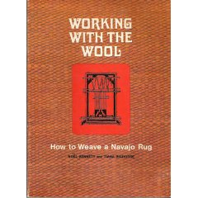
YOU KNIT UNIQUE - INSPIRATION AND INFORMATION FOR THE ORIGINAL KNITTER | LEE ANDERSEN | 0473002906 | 
YOUR HANDSPINNING | ELSIE G. DAVENPORT | No ISBN | 