**Install AWS CLI in local using below command**

* sudo apt-get update
* curl "https://awscli.amazonaws.com/awscli-exe-linux-x86_64.zip" -o "awscliv2.zip"
* unzip awscliv2.zip
* sudo ./aws/install
* aws –version
* aws s3 ls – to verify that aws CLI installed properly and able to access s3.

**Install terraform in local using below commands**

* wget https://releases.hashicorp.com/terraform/1.0.7/terraform_1.0.7_linux_amd64.zip
* unzip terraform_1.0.7_linux_amd64.zip
* sudo mv terraform /usr/local/bin/
* terraform --version

Created terraform directory – mkdir terraform

**Created provider.tf and connected it with s3 bucket using below mentioned code**

terraform {

required_providers {

aws = {

source = "hashicorp/aws"

version = "4.32.0"

}

}

backend "s3" {

bucket = "courseassignment3"

key = "path/to/my/terraform.tfstate"

region = "us-east-1"

}

}

provider "aws" {

# Configuration options

region = "us-east-1"

}

**Created vpc.tf and sg.tf file using below mentioned code**

module "vpc" {

source = "terraform-aws-modules/vpc/aws"

name = "project3"

cidr = "10.0.0.0/16"

azs = ["us-east-1a", "us-east-1b"]

private_subnets = ["10.0.1.0/24", "10.0.2.0/24"]

public_subnets = ["10.0.101.0/24", "10.0.102.0/24"]

enable_nat_gateway = true

enable_vpn_gateway = true

enable_dns_hostnames = true

enable_dns_support = true

tags = {

Terraform = "true"

Environment = "dev"

}

}

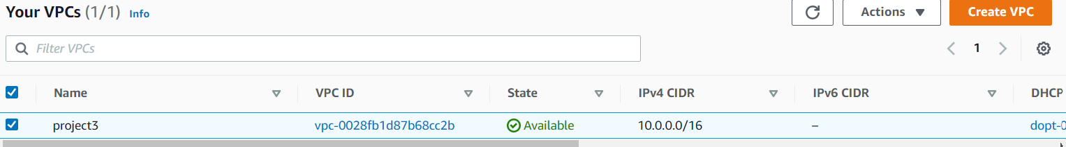

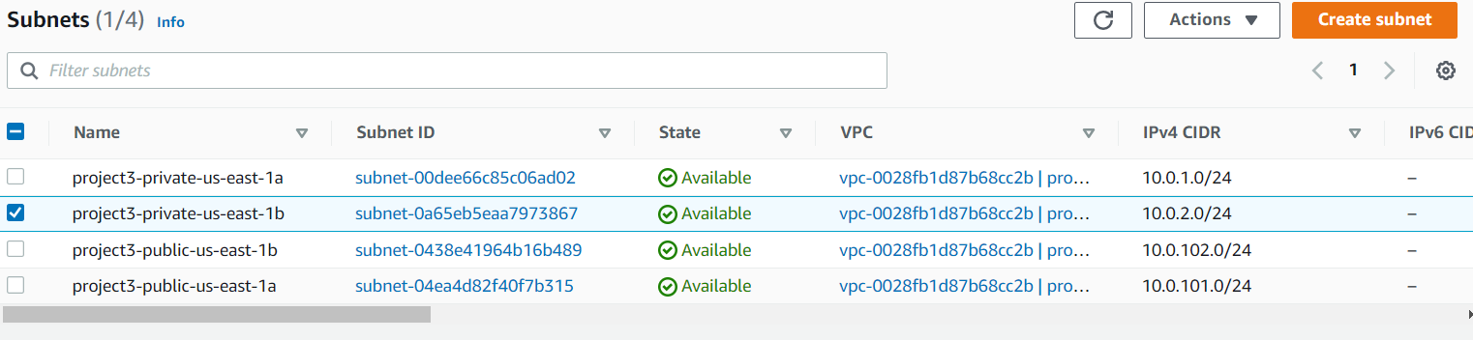



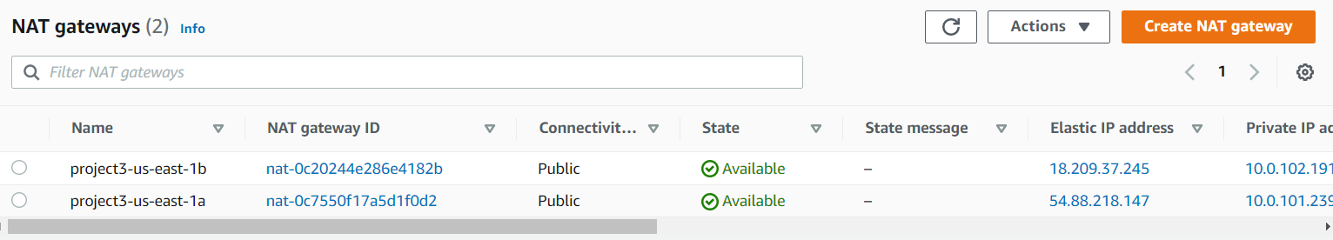

module "web_server_sg" {

source = "terraform-aws-modules/security-group/aws//modules/http-80"

name = "web-server"

description = "Security group for web-server with HTTP ports open within VPC"

vpc_id = "vpc-0028fb1d87b68cc2b"

ingress_cidr_blocks = ["10.10.0.0/16"]

}

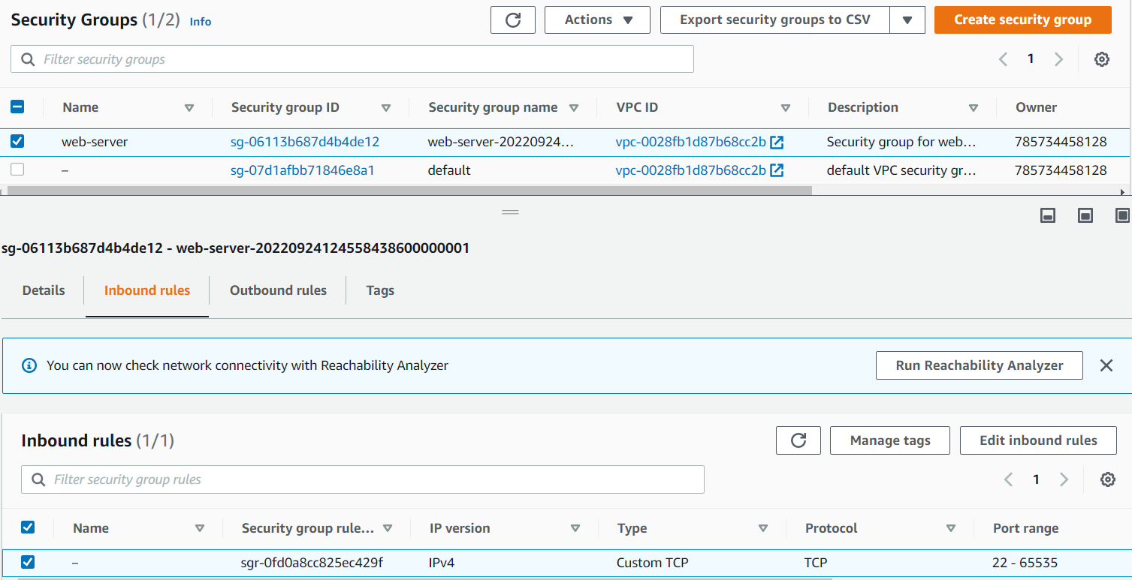

**Created ec2public.tf and ec2private.tf file using below mentioned code**

module "ec2_instance" {

source = "terraform-aws-modules/ec2-instance/aws"

version = "~> 3.0"

name = "**bastion**"

ami = "ami-08c40ec9ead489470"

instance_type = "t2.micro"

key_name = "key2"

monitoring = true

vpc_security_group_ids = ["sg-06113b687d4b4de12"]

subnet_id = "subnet-0438e41964b16b489"

}

module "ec2_instance1" {

source = "terraform-aws-modules/ec2-instance/aws"

version = "~> 3.0"

name = "**jenkins_server**"

ami = "ami-08c40ec9ead489470"

instance_type = "t2.micro"

key_name = "key2"

monitoring = true

vpc_security_group_ids = ["sg-06113b687d4b4de12"]

subnet_id = "subnet-00dee66c85c06ad02"

}

module "ec2_instance2" {

source = "terraform-aws-modules/ec2-instance/aws"

version = "~> 3.0"

name = "**app_server**"

ami = "ami-08c40ec9ead489470"

instance_type = "t2.micro"

key_name = "key2"

monitoring = true

vpc_security_group_ids = ["sg-06113b687d4b4de12"]

subnet_id = "subnet-0a65eb5eaa7973867"

}

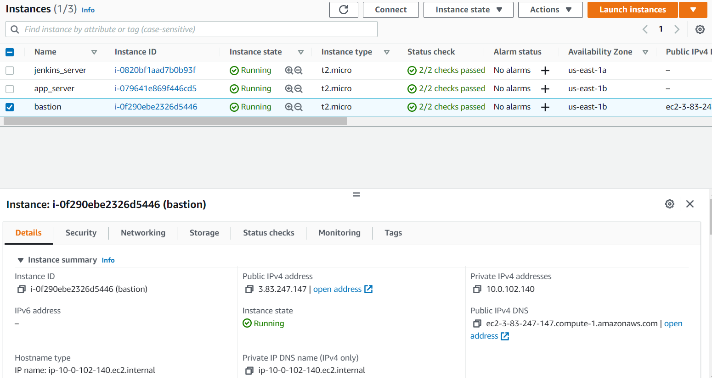

**Connection established from bastion server to Jenkins and app server shown in below images.**

