Installing Ansible on bastion machine using below commands

* sudo apt-add-repository ppa:ansible/ansible
* sudo apt update
* sudo apt install ansible

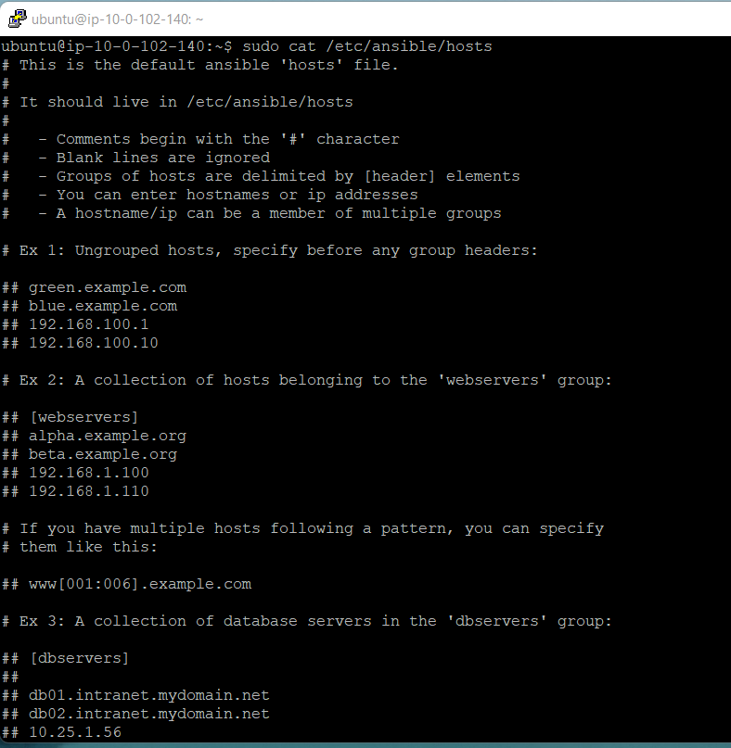

**Created 2 files inventory and playbook.yaml and code mentioned below for both the files.**

**nano inventory**

10.0.1.128 ansible_ssh_user=ubuntu ansible_ssh_private_key_file="/home/ubuntu/AwsKeyPair"

10.0.2.176 ansible_ssh_user=ubuntu ansible_ssh_private_key_file="/home/ubuntu/AwsKeyPair"

**Playbook.yaml**

- name: add docker repository to apt

apt_repository:

repo: deb https://download.docker.com/linux/ubuntu bionic stable

state: present

- name: install docker

apt:

name: "{{item}}"

state: latest

update_cache: yes

loop:

- docker-ce

- docker-ce-cli

- containerd.io

- name: check docker is active

service:

name: docker

state: started

enabled: yes

- name: Ensure group "docker" exists

ansible.builtin.group:

name: docker

state: present

- name: adding ubuntu to docker group

user:

name: ubuntu

groups: docker

append: yes

- name: Install docker-compose

get_url:

url: https://github.com/docker/compose/releases/download/1.29.2/docker-compose-Linux-x86_64

dest: /usr/local/bin/docker-compose

mode: 'u+x,g+x'

- name: Change file ownership, group and permissions

ansible.builtin.file:

path: /usr/local/bin/docker-compose

owner: ubuntu

group: ubuntu

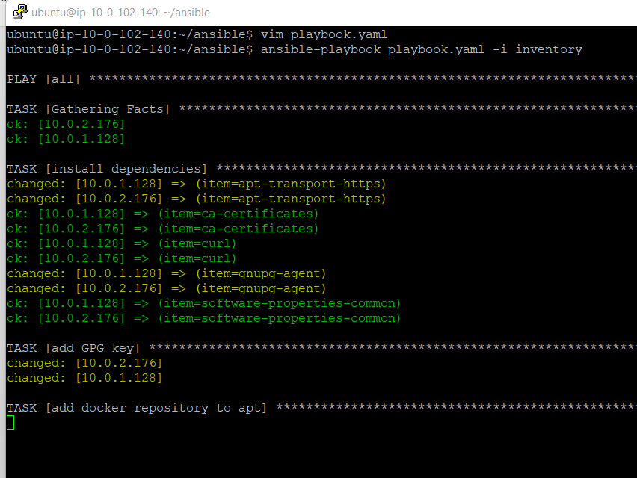

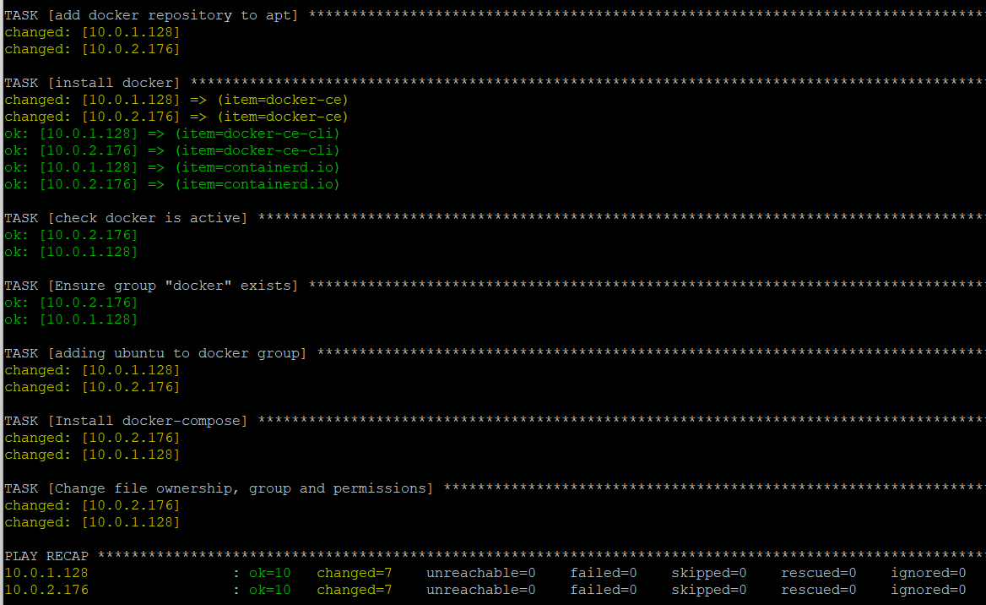

**Install Jenkins in Jenkins instance manually with docker using below commands:**

* docker pull jenkins/Jenkins
* docker run -itd -p 8080:8080 -p 50000:50000 --env JENKINS_OPTS="--prefix=/jenkins" -v jenkins_home:/var/jenkins_home jenkins/Jenkins
* docker ps

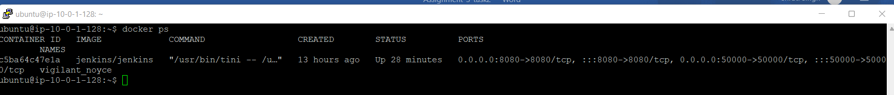

**Create ALB and target group and assigned to ALB for Jenkins instance as shown below images:**

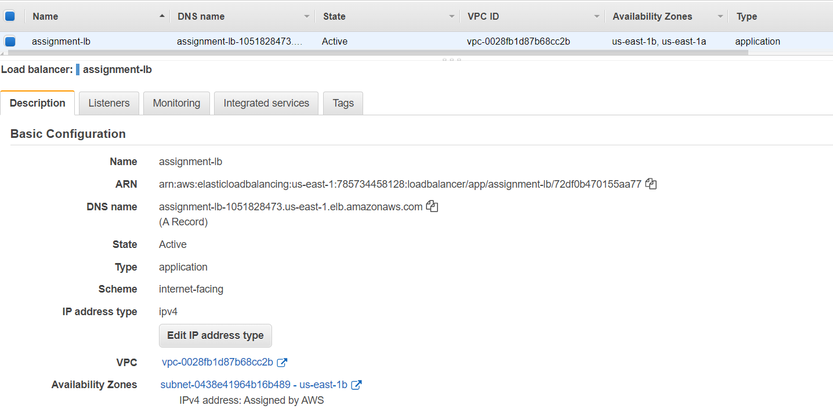

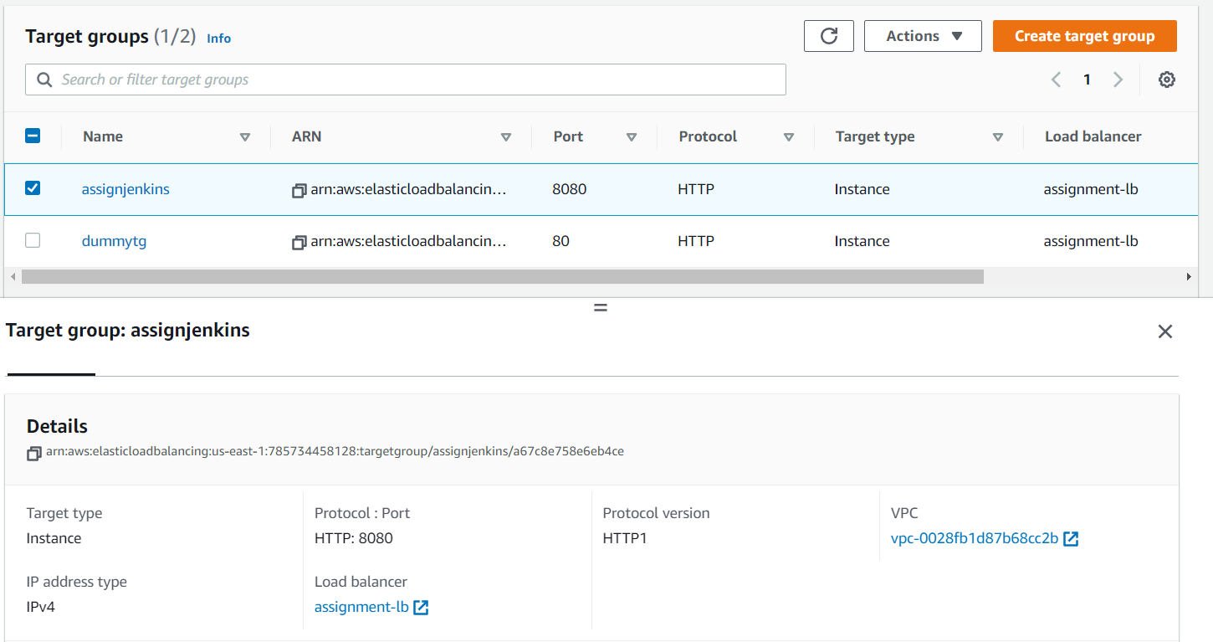

**And Run Jenkins page with ALB DNS successfully.**

