Delivery Feedback Low Level Design
Engineering handoff • Published version 3 • 11 September 2026
This design describes the private delivery dashboard for Outside (KAN), Autopsy (AUT) and Share My Bread (SMB). Jira supplies current facts; deterministic rules produce risks, pending decisions and tradeoffs. The code is published, but unattended reporting remains gated by supported owner authentication.
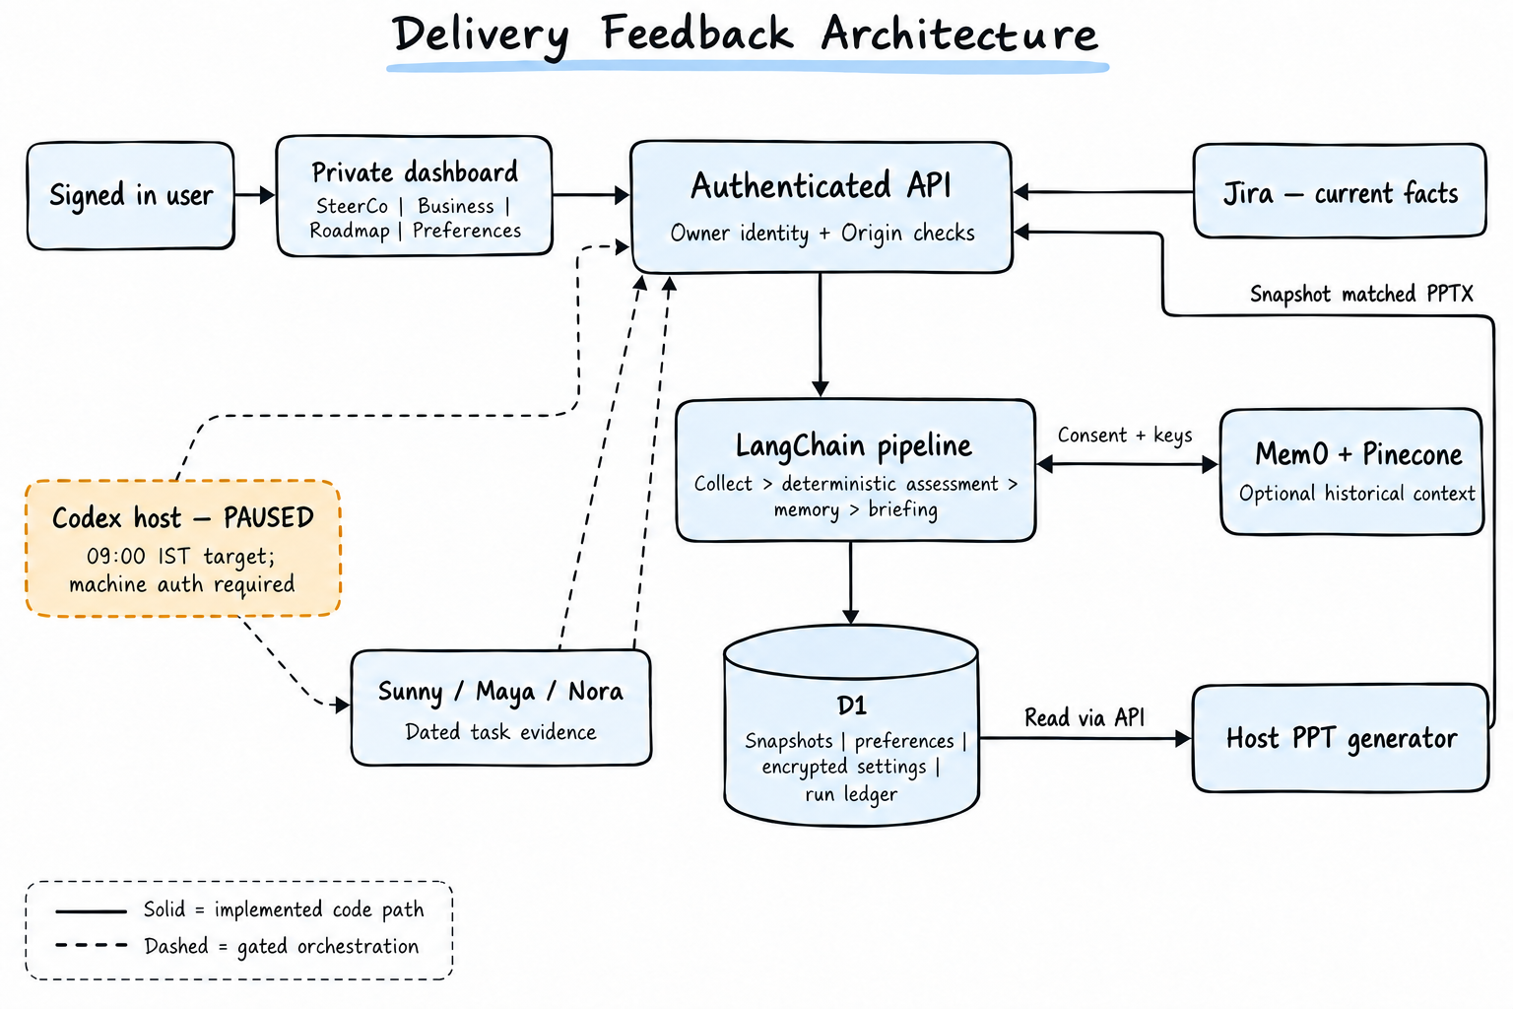
Figure 1 Handwritten style logical architecture. Provider traffic runs through backend connectors. The PPT generator reads the snapshot through the API and uploads its result to the API; it has no direct D1 access. Solid paths describe implemented code, not verified provider availability.

Implementation boundary
Implemented: authenticated dashboard and APIs, LangChain sequence, D1 persistence, optional memory connectors and snapshot matched PPT download. Gated: unattended agent collection, daily notification and automatic report generation. Jira timeline writeback is not implemented. Aliases identify configured tasks, not proof of running agents.
Source baseline: ff4e6ac98d096ca8a28ec52dbe2e1746731ff9e5. Existing ARCHITECTURE.md still describes version 2; publication was verified as version 3. No new Jira retrieval was performed for this design.

Components and request flow
Module | Responsibility
app/dashboard.tsx | Four tabs; load saved snapshot on mount; explicit Refresh Jira action. No polling or focus revalidation.
app/steerco.tsx and lib/steerco.ts | Infographic agenda, three agent cards, risks, planning gaps, decisions and tradeoffs from the same snapshot.
app/api/[...path]/route.ts | Authenticate owner, validate writes, coordinate pipeline, store snapshots and artifacts, manage run claims.
lib/jira.ts | Paginated scoped JQL, issue normalization, active sprint discovery and provider timeouts.
lib/pipeline.ts | RunnableSequence: collect → assess → consented memory retrieval/write → briefing.
lib/delivery-manager.ts | Evidence reconciliation, dependency and decision rules, exact daily and weekly comparisons.
lib/snapshot-store.ts | Merge bundled baseline/archive with owner D1 history; retrieve exact comparison windows.
reports/create-steerco.mjs | Host-side PPTX authoring; presentation-edition.ts enforces snapshot matching at download.

Manual refresh sequence
1. Browser POSTs /api/refresh. API verifies signed-in owner, exact Origin and JSON content type, then obtains an owner refresh lock.
2. Backend decrypts settings and retrieves all three projects. JQL uses project in (AUT, KAN, SMB); current sprint queries additionally use sprint in openSprints(). Inaccessible projects or incomplete pagination fail the refresh.
3. Pipeline normalizes Jira data, attaches dated agent evidence and computes the report. Mem0/Pinecone execute only with consent and keys. The API saves the resulting snapshot and returns it to the browser.
4. Dashboard updates its state and reloads saved history. A Jira failure preserves the previous report. Memory failures add warnings without discarding successful Jira retrieval.

Deterministic assessment decision
LangChain is orchestration, not an LLM decision maker. Provider secrets stay in backend closures, not runnable inputs. Jira text is data, never executable instructions. Agent claim conflicts are compared against Jira; alias changes do not change issue ownership.

API and persistence contracts
Endpoint | Contract
GET /api/dashboard | Returns snapshot, history summaries and daily/weekly comparison objects. Does not retrieve fresh Jira.
GET /api/briefing | Returns snapshotId, asOf, briefing and delivery assessment.
POST /api/refresh | Retrieves Jira using saved credentials; returns saved snapshot and briefing.
POST /api/run-manager | Accepts {agentEvidence:[…]}; retrieves Jira and runs the same pipeline.
POST /api/ingest | Accepts validated scoped Snapshot plus agent evidence; assesses and stores it.
GET and POST /api/preferences | Read state; write {preferences,revision}. Stale revision returns 409.
GET and POST /api/settings | Read masked configuration; write validated owner-encrypted credentials. Blank keys preserve existing values.
POST /api/claim and /api/finish | Claim due window atomically; finish with {runId,status,detail}.
GET and POST /api/presentation | GET selects ?snapshotId=…; POST accepts {snapshotId,base64}. No matching deck returns 409.

D1 schema
Table and key | Stored fields
snapshots • id | user_id, fetched_at, payload JSON. Index on (user_id, fetched_at).
integrations • user_id | encrypted settings envelope, updated.
preferences • user_id | payload JSON, revision integer, updated.
refresh_locks • user_id | until_ms integer.
report_runs • id | user_id, slot, status, updated, detail. Run id is owner plus slot.
report_artifacts • user_id | snapshot_id, base64 payload, updated. One current uploaded deck per owner.

Security operations and acceptance

Trust boundaries
All APIs require signed-in identity. Writes also require exact APP_ORIGIN and application/json. Settings use AES-256-GCM with a random 12-byte IV and owner identity as authenticated additional data. VAULT_KEY remains a server secret. Browser reads receive configured flags, not API tokens.
Jira tenant is fixed; Pinecone hostnames are validated. Provider requests reject redirects and time out after 20 seconds. JSON bodies are bounded to 16,384 bytes, or 1,500,000 for ingestion and presentation. API responses use no-store. No issue text is executed and no Jira mutations are performed.

Scheduling and recovery
Preferences support daily, weekdays or weekly, whole-hour times in Asia/Kolkata, default 09:00. The target host checks twice hourly. /api/claim uses atomic insertion or recovery of failed/one-hour-stale running slots; /api/finish only updates the owner’s running record. A refresh lock lasts ten minutes with a fifteen-second cooldown after completion.
The host must collect task evidence, run the manager, generate and upload a snapshot-matched PPT, notify the user and only then complete the run. Supported unattended owner identity is still required. Perimeter bearer access is insufficient; browser cookies and identity spoofing must not be used. Enabled preferences alone do not prove the host automation is active.

Known limitations and engineering decisions
Freshness: the browser fetches on mount or manual refresh only. Long-open tabs can remain stale; no automatic Jira sync is implied by a deployment. Add focus revalidation and visible sync state as a follow-on fix.
Artifacts: the PPT is generated on the host, not per click in the Worker. A fresh snapshot can have no matching PPT until generation completes. Uploaded files are checked for size, base64 and ZIP prefix, not full OOXML integrity; add package validation before treating uploads as trusted presentations.
Isolation: D1 reads are owner-scoped, but bundled baseline/archive are included for every authenticated owner. Keep the Site owner-private; remove or owner-bind fixtures before sharing. Snapshot IDs are global primary keys; owner-prefixed IDs would avoid cross-owner ingest collisions.
Reporting: absent budget inputs mean an unresolved planning dependency, not proven overspend. Record counts include parent/child issues and are not percent-delivered. Sample roadmap dates stay separate from Jira commitments. No retention purge, delivery SLO or verified backup recovery procedure is defined in this implementation.

Release acceptance
Existing tests cover rules, evidence schemas, schedule math, security and snapshot-matched export selection. Complete signed-in production validation for refresh → persisted report → matching PPT download. Then verify owner isolation, provider-failure retention, claim retry and duplicate-notification behavior before activating the 09:00 schedule.
Code references: app/api/[...path]/route.ts; lib/{jira,pipeline,security,preferences,snapshot-store,delivery-manager,presentation-edition}.ts; drizzle/0000–0002 migrations; tests/*.test.ts. Diagram generated with the built-in image tool; schematic labels are clarified by the contracts above.

