I have added LSTM algorithm as extension and below is the accuracy and MSE (mean square error) of all algorithms

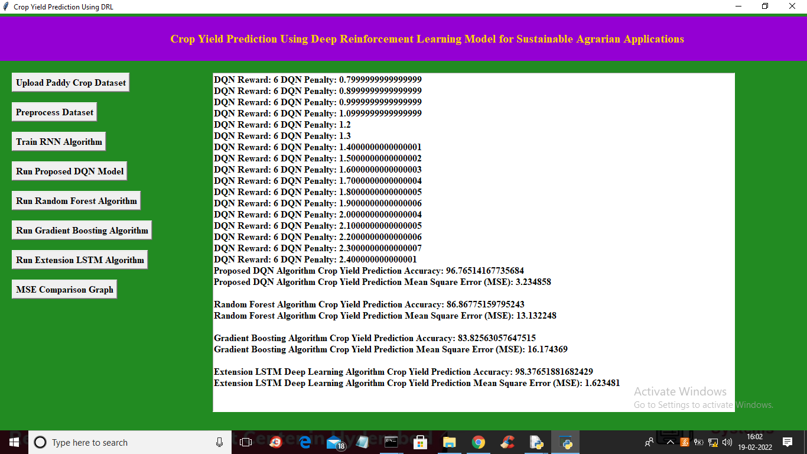

In above screen we can see accuracy and MSE of all algorithms and in last algorithm LSTM we got high accuracy as 98.37& and MSE as 1.62 and in all algorithms LSTM is better and below is the MSE error graph for all algorithms

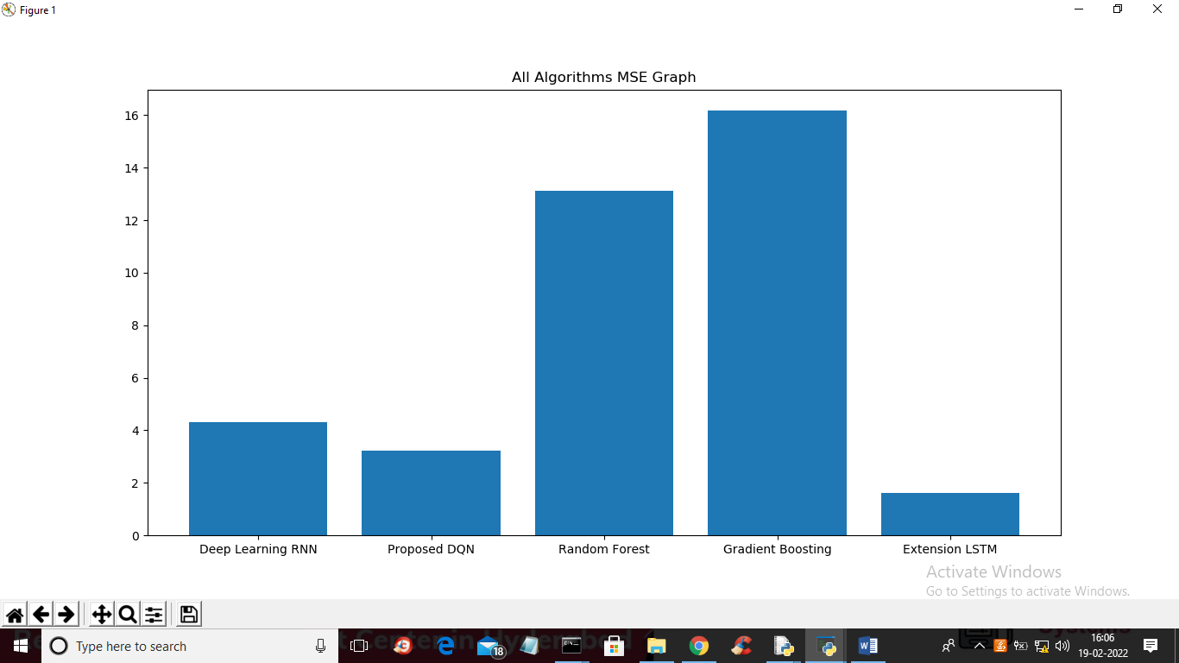

In above graph x-axis represents algorithm names and y-axis represents MSE error and in all algorithms LSTM has got less MSE value which means LSTM is better than all

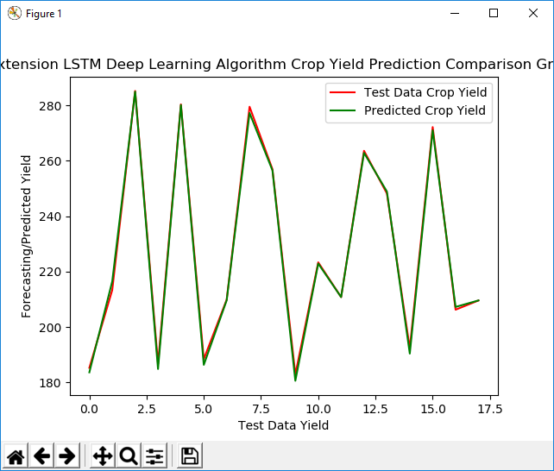

In above LSTM extension we can see both green and red lines completely overlap so actual data and predicted data perfectly matched