**KPI’S:**

select * from bank_loan_data

--Total Loan application

select COUNT(id) as Total_Loan_Application from bank_loan_data

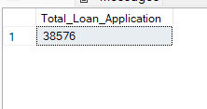

-----the Month-to-Date (MTD) Loan Applications--------latest--

select COUNT(id) as MTD_Loan_Applications from bank_loan_data

where Month(issue_date)=12 AND YEAR(issue_date)=2021

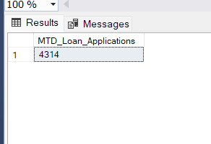

select COUNT(id) as PMTD_Loan_Applications from bank_loan_data

where Month(issue_date)=11 AND YEAR(issue_date)=2021

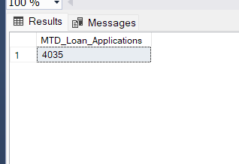

--------------Total Funded Amount--------------------------

select sum(loan_amount) as MTD_Total_Funded_Amount from bank_loan_data

where Month(issue_date)=12 AND YEAR(issue_date)=2021

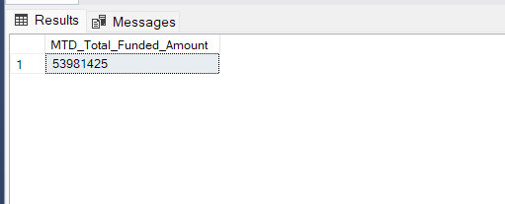

select sum(loan_amount) as MTD_Total_Funded_Amount from bank_loan_data

where Month(issue_date)=11 AND YEAR(issue_date)=2021

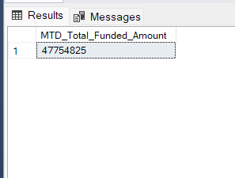

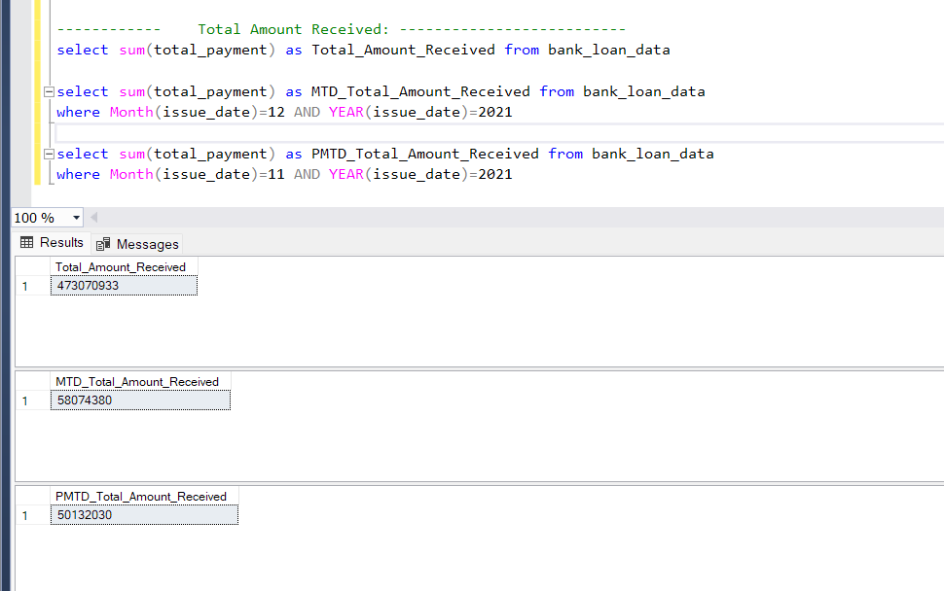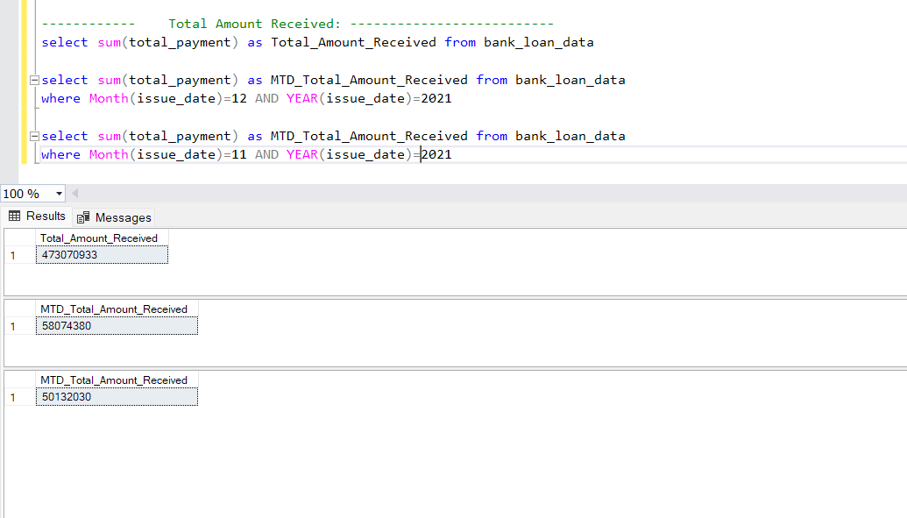

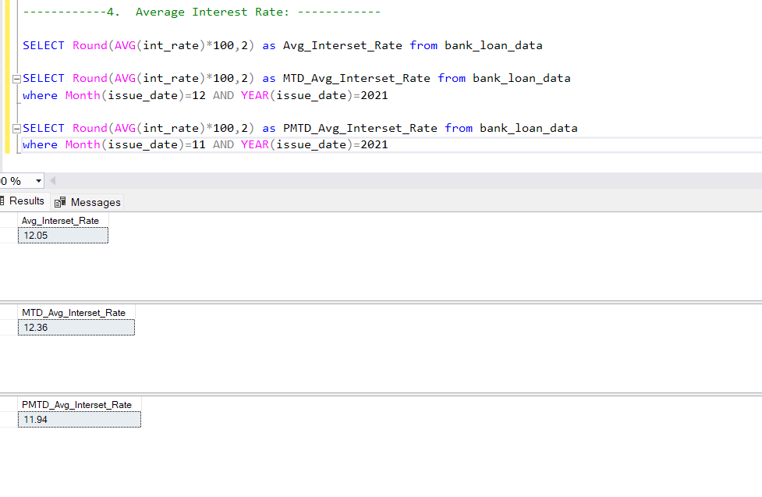

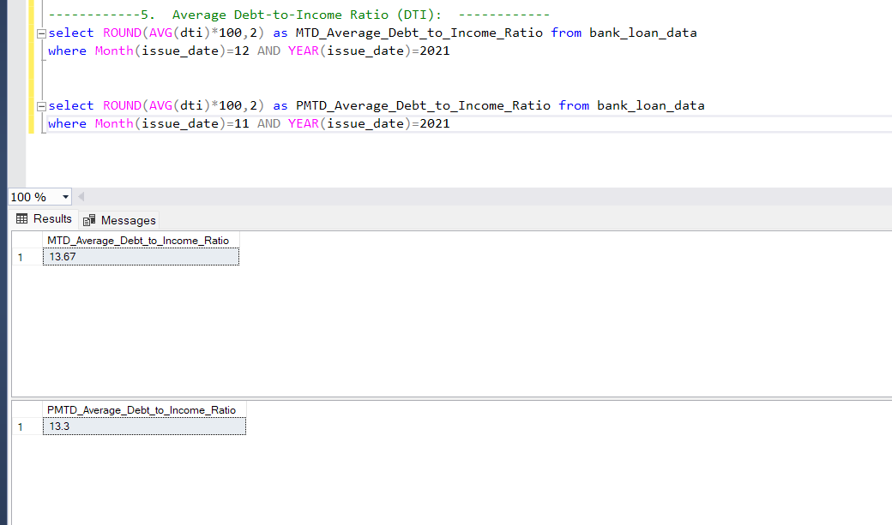

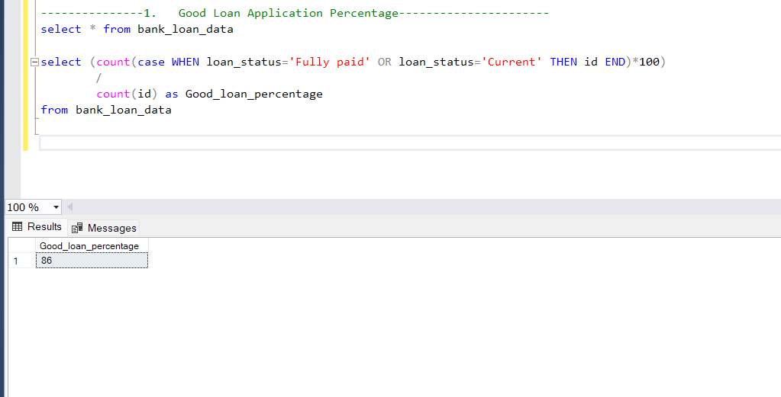

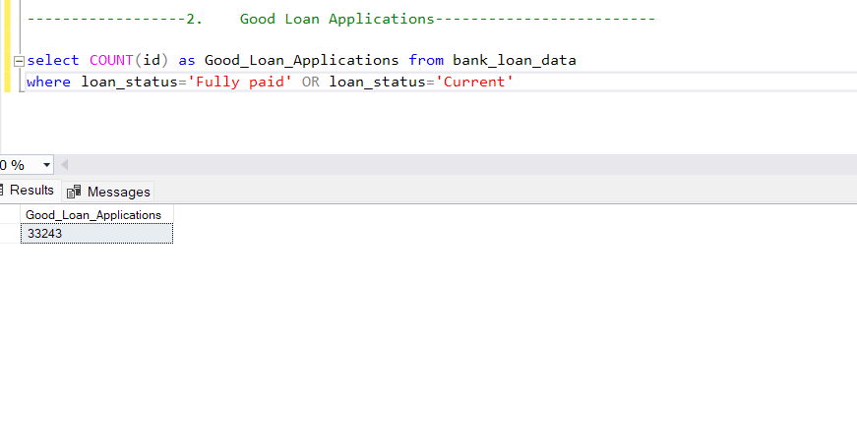

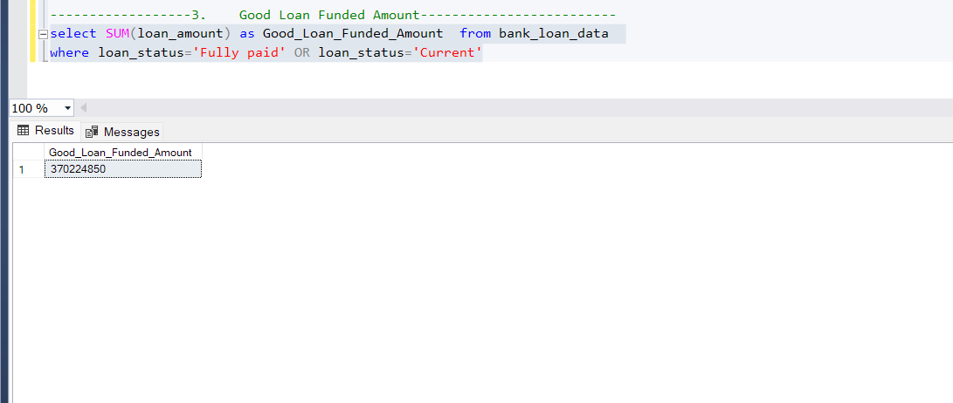

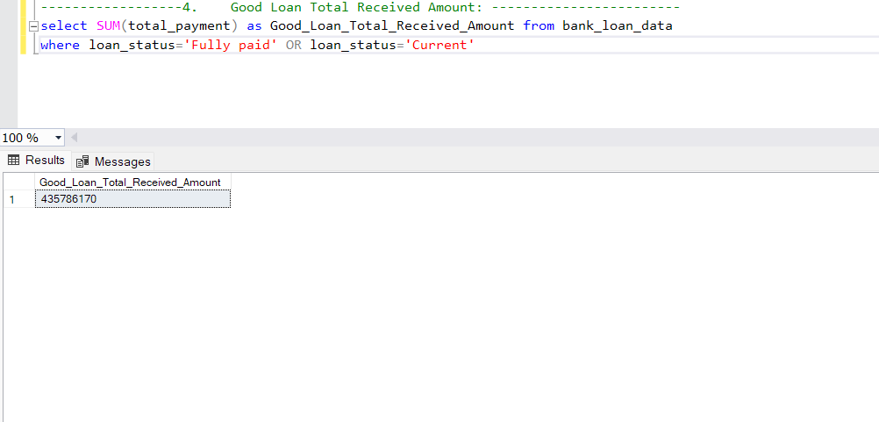

-----------------------------Bad Loan KPIs----------------------------------

-----------1. Bad Loan Application Percentage---------------------

select (count(case WHEN loan_status='Charged off' THEN id END)*100)

/

count(id) as Bad_loan_percentage

from bank_loan_data

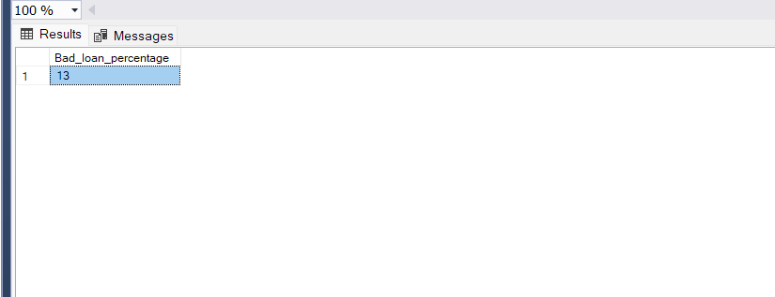

-----------2 Bad Loan Application ---------------------

select COUNT(id) as Bad_Loan_Application

from bank_loan_data

where loan_status='Charged off'

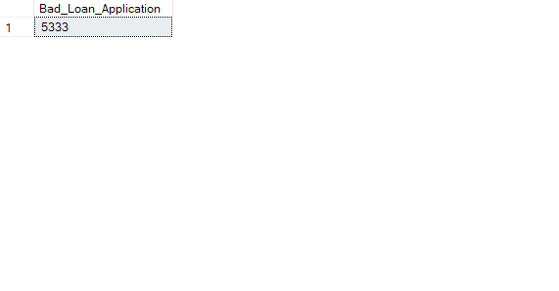

---------------------4. Bad Loan Total Received Amount: ---------------------

select SUM(total_payment) as Bad_Loan_Total_Received_Amount

from bank_loan_data

where loan_status='Charged off'

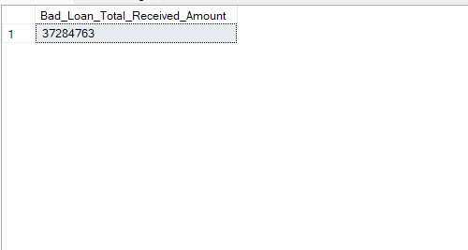

select

loan_status,

count(id) as Total_Loan_Applications,

sum(loan_amount) as Total_Funded_Amount,

sum(total_payment) as Total_Amount_Received,

AVG(int_rate *100) as Average_Interest_Rate,

AVG(dti *100) as Average_Debt_to_Income_Ratio

from bank_loan_data

Group by loan_status

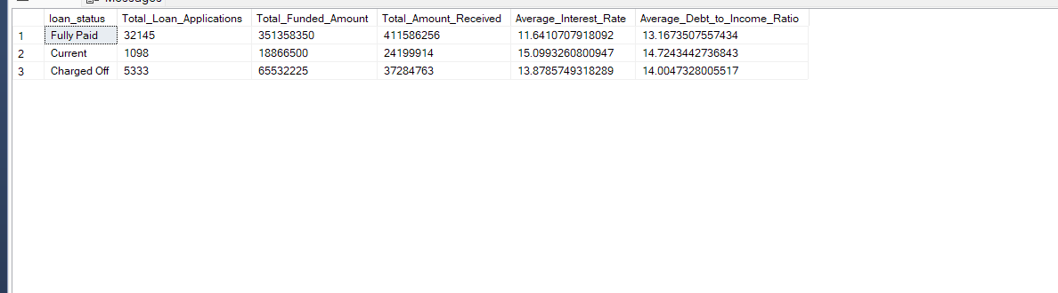

select loan_status,

sum(loan_amount) as MTD_Total_Funded_Amount,

sum(total_payment) as MTD_Total_Amount_Received

from bank_loan_data

where MONTH(issue_date)=12

Group by loan_status

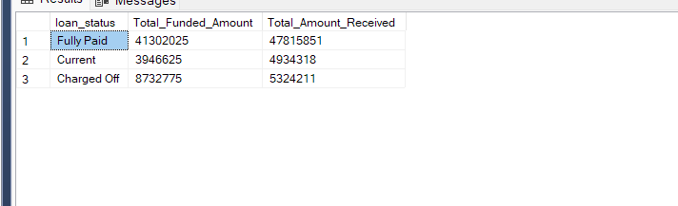

-----------------------------OverView------------------

---------Monthly Trends by Issue Date --------------------------

select

MONTH(issue_date) as Month_Number,

DATENAME(MONTH, issue_date) as Month_Name,

COUNT(id) as Total_Loan_Application ,

SUM(loan_amount) as Total_Funded_Amount,

sum(total_payment) as Total_Amount_Received

from bank_loan_data

GROUP BY MONTH(issue_date) ,DATENAME(MONTH, issue_date)

ORDER BY MONTH(issue_date)

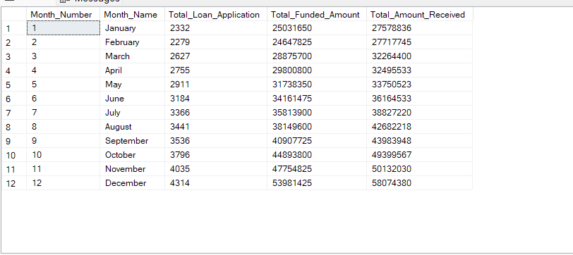

---------Regional Analysis by State --------------------------

select

address_state ,

COUNT(id) as Total_Loan_Application ,

SUM(loan_amount) as Total_Funded_Amount,

sum(total_payment) as Total_Amount_Received

from bank_loan_data

GROUP BY address_state

order by COUNT(id) DESC

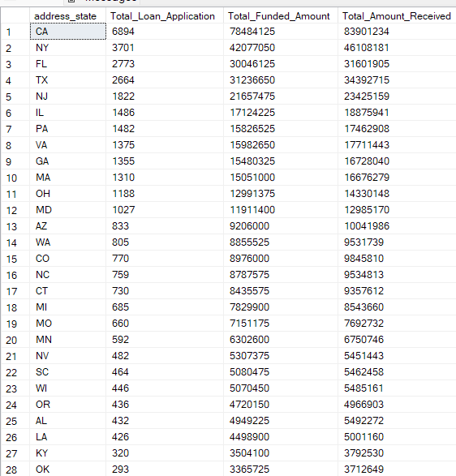

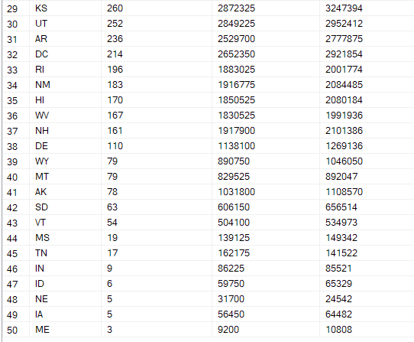

---------------------------------3. Loan Term Analysis --------------------

Select

term ,

COUNT(id) as Total_Loan_Application ,

SUM(loan_amount) as Total_Funded_Amount,

sum(total_payment) as Total_Amount_Received

from bank_loan_data

GROUP BY term

order by COUNT(id) DESC

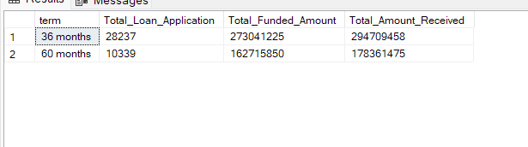

---------------------------------4..Employee Length Analysis --------------------

Select

emp_length ,

COUNT(id) as Total_Loan_Application ,

SUM(loan_amount) as Total_Funded_Amount,

sum(total_payment) as Total_Amount_Received

from bank_loan_data

GROUP BY emp_length

order by emp_length

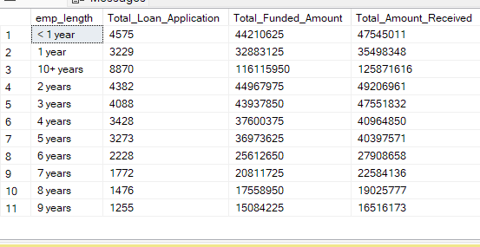

---------------------------------5.Loan Purpose Breakdown --------------------

Select

purpose ,

COUNT(id) as Total_Loan_Application ,

SUM(loan_amount) as Total_Funded_Amount,

sum(total_payment) as Total_Amount_Received

from bank_loan_data

GROUP BY purpose

order by COUNT(id) DESC

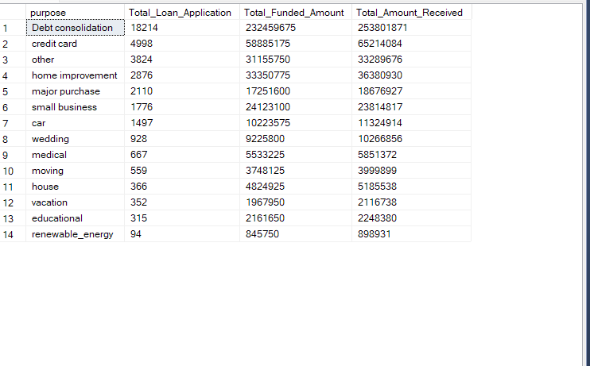

---------------------------------6.Home Ownership Analysis --------------------

Select

home_ownership ,

COUNT(id) as Total_Loan_Application ,

SUM(loan_amount) as Total_Funded_Amount,

sum(total_payment) as Total_Amount_Received

from bank_loan_data

GROUP BY home_ownership

order by COUNT(id) DESC

