**1. SQL Queries:**

----Total Sales Amount by Product Category---------

------- Write a SQL query to calculate the total sales amount by product category for the year.----------------

select p.ProductCategory,Round(SUM(s.SaleAmount),2) As TotalSalesAmount

from sales s

INNER JOIN produts p ON s.ProductID= p.ProductID

where YEAR(s.SaleDate)=2023

group by p.ProductCategory

order by TotalSalesAmount DESC

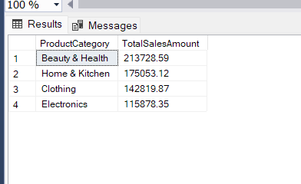

-----------------------------Top 3 Performing Stores-------------------------------------------------------

-------Write a SQL query to find the top 3 performing stores in terms of sales amount----------------------

select TOP 3 StoreName,TotalSalesAmount

from (

select st.StoreName,Round(SUM(S.SaleAmount),2) AS TotalSalesAmount

from sales S

Inner Join stores st ON s.StoreID=st.StoreID

where YEAR(S.SaleDate)=2023

group by st.StoreName ) AS TopStores

order by TotalSalesAmount DESC

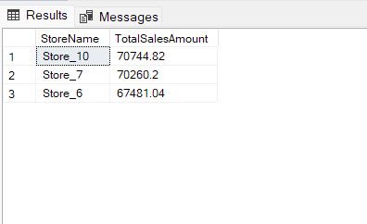

----------------------------------Employee with the Highest Sales in Each Store:------

-----------Identify the employee with the highest sales in each store-------------------------------

select st.StoreName,CONCAT(e.FirstName,' ',e.LastName) AS EmployeeName, Round(MAX(s.SaleAmount),2) as HigestSales

from sales s

inner Join stores st ON s.StoreID=st.StoreID

inner join employees e ON S.StoreID=e.StoreID

WHERE YEAR(s.SaleDate) = 2023

GROUP BY st.StoreName,e.FirstName,e.LastName

order by HigestSales DESC

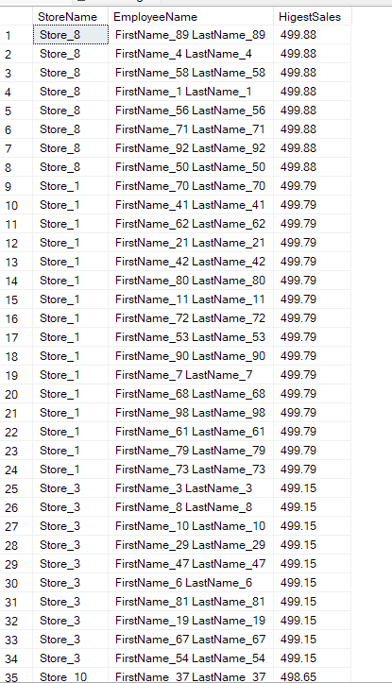………………………………

**2. Data Analysis & RCA:**

-------------------------------------Calculate Monthly Sales---------

------------- Analyze the monthly sales data to identify any declining trends in any product category or store.

select YEAR(SaleDate) as SaleYear,MONTH(SaleDate) as SaleMonth,ProductCategory,StoreName,round(SUM(SaleAmount),2) as MonthlySalesAmount

FROM sales s

Inner Join produts p ON s.ProductID = p.ProductID

Inner join stores st ON s.StoreID = st.StoreID

group by YEAR(SaleDate),MONTH(SaleDate),ProductCategory,StoreName

order by SaleYear,SaleMonth, ProductCategory,StoreName

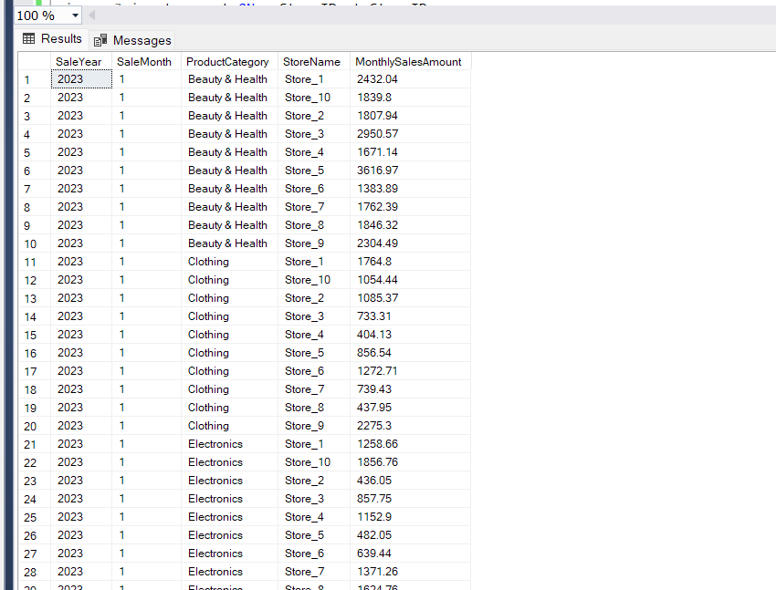…….

-----Data related to sales, products, stores, and employees. We'll look at trends and patterns over time--------

SELECT S.SaleDate,P.ProductCategory, SUM(S.QuantitySold) AS TotalQuantitySold,Round(SUM(S.SaleAmount),2) AS TotalSaleAmount

FROM Sales S

JOIN produts P ON S.ProductID = P.ProductID

GROUP BY S.SaleDate,P.ProductCategory

ORDER BY S.SaleDate

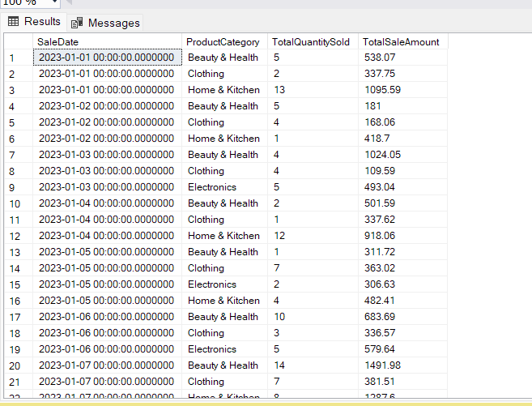

-------------employee turnover-----------

select YEAR(HireDate) as HireYear , COUNT(*) as TotalEmployee

from employees

group by YEAR(HireDate)

order By HireYear

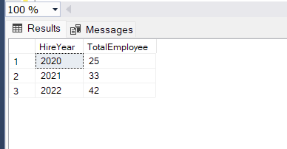

----Product Availability----

SELECT ProductCategory, COUNT(*) AS TotalProducts

FROM produts

group by ProductCategory

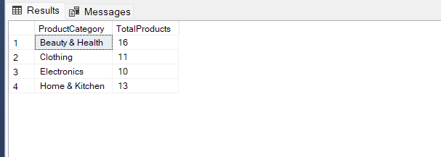

**Actionable insights based on your analysis:**

**Beauty & Health, Home & Kitchen makes maximum sales**

**Store_10,Store_7,Store_6 makes maximum sales amount**

**Store_8** Employee FirstName_89 LastName_89 makes Highest Sales in Store

