CUSTOMER SEGMENTATION USING K-MEANS CLUSTERING
Submitted By
Shrushti Mohate
Internship Domain
Machine Learning Internship
Organization
Syntecxhub

Objective
The objective of this project is to perform customer segmentation using Machine Learning techniques. The project helps in identifying different groups of customers based on their annual income and spending score. This analysis can help businesses improve marketing strategies and customer targeting.

Dataset Used

Dataset Name: Mall Customers Dataset
The dataset contains customer information such as:
- Customer ID
- Gender
- Age
- Annual Income
- Spending Score

Tools & Technologies Used
- Python
- Google Colab
- Pandas
- NumPy
- Matplotlib
- Scikit-learn
- K-Means Clustering Algorithm

Project Steps
1. Data Loading
The dataset was loaded into Google Colab using Pandas.
2. Data Cleaning
The dataset was checked for missing values and cleaned before analysis.
3. Feature Selection
Important features selected:
- Annual Income
- Spending Score
4. Data Scaling
The selected data was scaled using StandardScaler.
5. Elbow Method
The Elbow Method was used to determine the optimal number of clusters.
6. K-Means Clustering
K-Means clustering algorithm was applied to group customers into different segments.
7. Data Visualization
Graphs and scatter plots were created to visualize customer clusters.

Results
The customers were successfully divided into different clusters based on their income and spending patterns.
The project identified:
- High income & high spending customers
- High income & low spending customers
- Low income & high spending customers
- Average customers

These insights can help businesses create better marketing strategies and personalized offers.
Conclusion
Customer segmentation is an important Machine Learning application in business analytics. Using K-Means clustering, customers were grouped effectively according to their behavior and spending habits.

This project improved understanding of:
- Data preprocessing
- Clustering techniques
- Data visualization
- Machine Learning workflows

- Dataset Preview
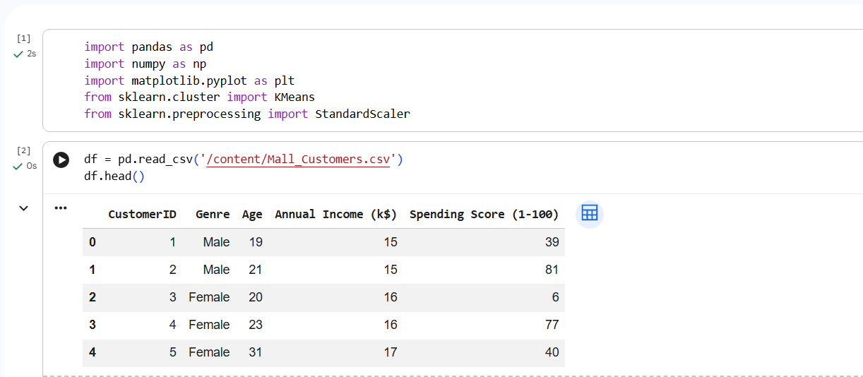
- Elbow Method Graph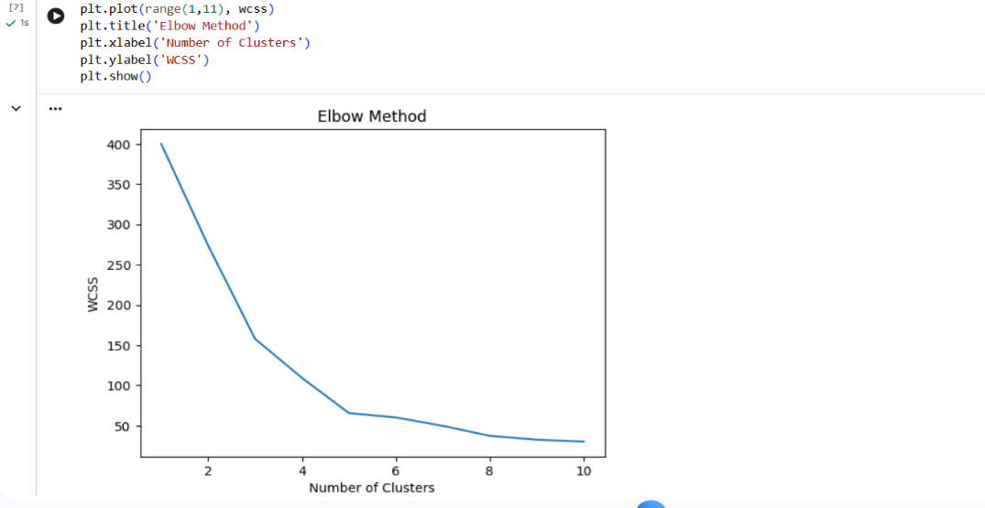
- Customer Segmentation Graph
