Computer Networks (CN)
“Network Analysis using Wireshark”

The best way to learn wireshark is to try it out! We’ll assume that your computer is connected to the Internet via a wired Ethernet interface. If you use a laptop that only has wireless connection, this will also be fine with the following experiments. Do the following:
- Start up your favorite web browser, which will display your selected homepage.
- If you are using a proxy (especially a host-based one), disable it if possible to examine uncached network traffic.
- Also better to clear browser cache, cookies if you have previously displayed this page.
- Disable anti-virus protection software before your own IP address will show up in captured data.
- Start up the Wireshark software, look like following figure
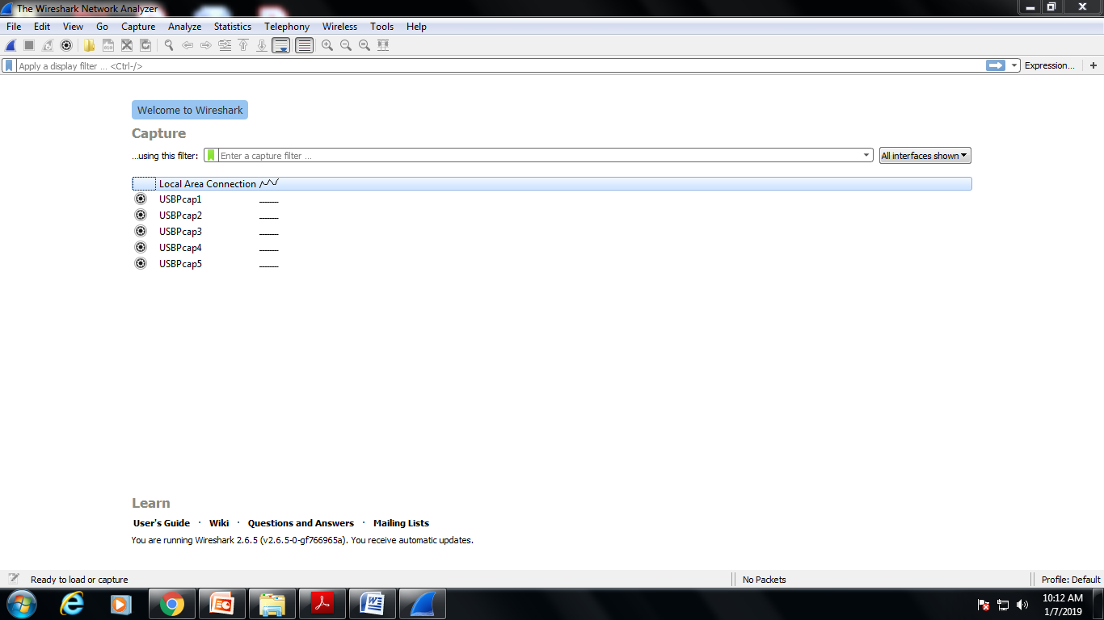

- To begin packet capture, select the Capture pull down menu and select Options. This will cause the “Wireshark: Capture Options” window to be displayed
- You can use most of the default values in this window. The network interfaces (i.e., the physical connections) that your computer has to the network will be shown in the Interface pull down menu at the top of the Capture Options window. In case your computer has more than one active network interface (e.g., if you have both a wireless and a wired Ethernet connection), you will need to select an interface that is being used to send and receive packets (mostly likely the wired interface). After selecting the network interface (or using the default interface chosen by Wireshark), click Start. Packet capture will now begin - all live packets being sent/received from/by your computer are now being captured by Wireshark!
- Once you begin packet capture, a packet capture summary window will appear. This window summarizes the number of packets of various types that are being captured, and (importantly!) contains the Stop button that will allow you to stop packet capture. Don’t stop packet capture yet.
- While Wireshark is running, enter the URL: http://gtu.ac.in
and have that page displayed in your browser. In order to display this page, your browser will contact the HTTP server at http://gtu.ac.in and exchange HTTP messages with the server in order to download this page. The Ethernet frames containing these HTTP messages will be captured by Wireshark.
- After your browser has displayed the web page, stop Wireshark packet capture by selecting stop in the Wireshark capture window. This will cause the Wireshark capture window to disappear and the main Wireshark window to display all packets captured since you began packet capture. You now have live packet data that contains all protocol messages exchanged between your computer and other network entities! The HTTP message exchanges with the http://gtu.ac.in should appear somewhere in the listing of packets captured. But there will be many other types of packets displayed as well. Even though the only action you took was to download a web page, there were evidently many other protocols running on your computer that are unseen by the user.
- Type in “http” (without the quotes, and in lower case – all protocol names are in lower case in Wireshark) into the display filter specification window at the top of the main Wireshark window. Then select Apply (to the right of where you entered “http”). This will cause only HTTP message to be displayed in the packet-listing window.
- Select the first http message shown in the packet-listing window. This should be the HTTP GET message that was sent from your computer to the www.gtu.ac.in HTTP server or www.google.com HTTP server or any other server. When you select the HTTP GET message, the Ethernet frame, IP datagram, TCP segment, and HTTP message header information will be displayed in the packet-header window. Maximize the amount information displayed about the HTTP protocol.
- Type in http into the display filter, select “Apply” in the filter toolbar. This will cause only HTTP message to be displayed in the packet-listing window. Add the filter ip.src == <your IP address> || ip.dst == <your IP address> to filter out traffic that is going to or from your computer. This will keep other people’s traffic private and get rid of lots of HTTP exchanges from other computers that you don’t care about. Filters are combined with C operators. For example, if your IP address is 169.1.19.87, then your filter should be http && (ip.src == 169.1.19.87 || ip.dst == 169.1.19.87). You can also use a more English-like term to describe the same operators. For instance, ip.src eq 169.1.19.87 or ip.dst eq 169.1.19.87.

- The capture time of each packet is quite important, so is displayed in the packet listing area as the second column. By default, this time is "number of seconds since the beginning of capture." However, you have control over what is displayed. Explore the View ➙ Time Display Format menu to see display formats as well as precision choices. Also of interest is the ability to change the time reference so that all times are displayed relative to the capture time of a chosen packet. First, chose a packet from the display list by clicking on it. Then, go to the Edit ➙ Set/Unset Time Reference, which will toggle your choice to use the chosen packet as the reference.

- Color coding: Wireshark uses colors to identify the types of particular packets in the user interface. You will see packet highlighted in green, blue and black. By default Green is TCP traffic, dark blue is DNS traffic, light blue is UDP traffic and black identifies TCP packets with problem.
Experiment:

- List up to IO different protocols that appear in the protocol column in the unfiltered packet-listing window.
- How long did it take from when the HTTP GET message was sent until the HTTP OK reply was received? (By default, the value of the Time column in the packet listing window is the amount of time, in seconds, since Wireshark tracing began. To display the Time field in time-of-day format, select the Wireshark View pull down menu, then select Time Display Format, then select Time-of-day. For now you don’t need to understand HTTP GET and OK, but reading the textbook may be helpful if you are curious on how they work.).
- What is the Internet address of the www.google.com? What is the Internet address of your computer? Include a screenshot and describe where you got the data to answer this question.
- Provide a screenshot showing http protocol only with Wireshark running on your computer.
- How many packets did you capture (total of all protocols, not just HTTP)? Now, use display filters to determine how many packets contain your ip address (hint: Use ip.addr instead of the clumsy ip.src or ip.dst format). What is this filter you used? Now, reverse the filter to determine how many packets don’t contain your ip address.

HTTP Conditional GET/Response Interaction

- We know that most web browsers perform object caching and thus perform the conditional GET when retrieving HTTP objects. Before performing the steps below, make sure that your browser’s cache is empty.
- Start up your web browser, and make sure your browser’s cache is cleared.
- Start up the Wireshark packet sniffer, and make sure that “http” is in the displayfilter, so that only captured HTTP messages will be displayed in the packet-list pane.
- Enter the following URL into your browser:
http://gaia.cs.umass.edu/wireshark-labs/HTTP-wireshark-file2.html
Your browser should display a very simple HTML file.
- Quickly enter the same URL into your browser again (or simply select the refresh button on your browser).
- Stop Wireshark packet capture.

Answer the following questions. Please explain how you can find the answers.
- Inspect the contents of the first HTTP GET request from your browser to the server. Is there an “IF-MODIFIED-SINCE” header line in the HTTP GET message? Why or why not?
- Inspect the contents of the server response. Has the server explicitly returned the contents of the file? How can you tell? (Hint: Search for http response if it is 1/1 then you can say server explicitly returned the contents of the file)
- Now inspect the contents of the second HTTP GET request from your browser to the server. Is there an “IF-MODIFIED-SINCE:” header line in the HTTP GET message? If so, what information follows the “IF-MODIFIED-SINCE:” header line?
- What is the HTTP status code and phrase returned from the server in response to this second HTTP GET? Has the server explicitly returned the contents of the file? Explain. (Hint: The status code and phrase returned from the server is HTTP/1.1 304 Not Modified. The server didn’t return the contents of the file since the browser loaded it from its cache (cookies))
- Which packet in the trace contains the status code and phrase associated with the response to the HTTP GET request? What is the status code and phrase in the response?

