

PRESENTED BY: Shrusti Patel
Roll No :12
Subject :104 Web development & operation
Class :M.SC.CS sem-1
Home Assignment -1

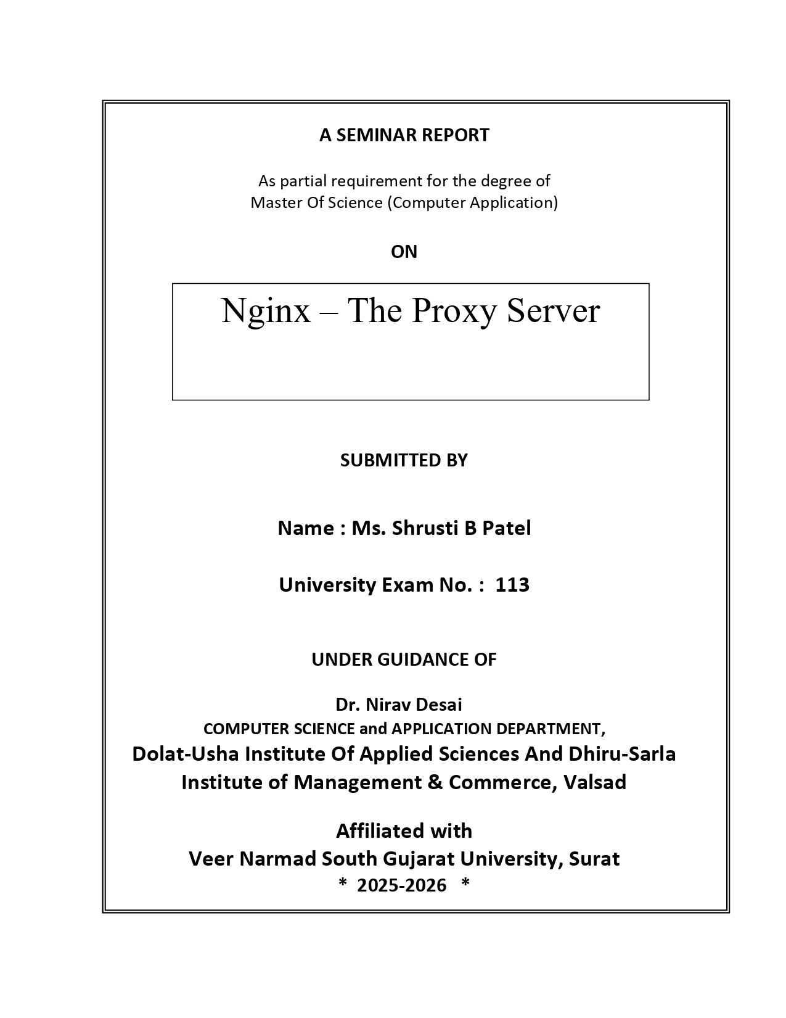



Sr .no | I INDEX | Page . no
1 | Introduction to Nginx & Common Use Cases
2 | Company Background
3 | Core Capabilities of Nginx
4 | Installation Steps
5 | Advantages & Disadvantages of Nginx
6 | Learning Resources & Course Certifications
7 | Conclusion

Introduction to Nginx

- What is Nginx?
At its core, Nginx is a powerful and flexible open-source software that plays multiple roles in modern web infrastructure:
- Web Server:
Serves static files (HTML, CSS, JS, images) and works with backend applications (PHP, Python, Node.js) to deliver dynamic content.
- Reverse Proxy:
Forwards client requests to backend servers, hides server details, adds security, and improves performance.
- Load Balancer:
Distributes incoming traffic across multiple backend servers, ensuring reliability, scalability, and fault tolerance.
- Caching Server:
Stores frequently accessed content (like images or web pages) to reduce server load and deliver faster responses.
- Mail Proxy:
Supports email services such as IMAP, POP3, and SMTP, providing secure and efficient email handling.
- High Concurrency Handling:
Designed to solve the C10k problem, Nginx can handle tens of thousands of simultaneous client connections efficiently with minimal resource consumption

- Common Use Cases of Nginx

- Website Hosting: Nginx efficiently serves static files like HTML, CSS, and images, and can also handle dynamic content generated by backend applications, making websites fast and reliable.
- API Gateway: It can manage and route API requests in a microservices architecture, directing traffic to the appropriate service while handling authentication and rate limiting.
- Reverse Proxy: Nginx acts as a middle layer between clients and backend servers, enhancing security, hiding server details, and managing client requests efficiently.
- Load Balancing: It distributes incoming traffic across multiple servers, ensuring no single server gets overloaded, which improves reliability and performance under high traffic.
- Content Delivery: Nginx can cache frequently accessed resources, reducing server load, and handle SSL/TLS termination to improve website speed and security.

- Company Background

- Founder: Nginx was developed by Igor Sysoev to address the need for a high-performance web server.
- First Public Release: It was released in 2004, introducing efficient handling of multiple connections simultaneously.
- Adoption: Quickly gained popularity because of its speed, scalability, and ability to serve millions of concurrent users.
- Nginx, Inc.: Formed in 2011 to provide professional support and enterprise-level features for businesses.
- Acquisition: In 2019, Nginx, Inc. was acquired by F5 Networks for $670 million, expanding its commercial reach.
- Today: Powers top companies like TikTok, Airbnb, Netflix, WordPress, and GitHub, making it a key part of modern web infrastructure.

- Core Capabilities of Nginx

- Web Server: Nginx serves static files like HTML, CSS, JavaScript, and images, and can also work with backend servers to handle dynamic content efficiently.
- Reverse Proxy: It sits between clients and servers, forwarding requests securely while hiding backend details and improving performance.
- Load Balancer: Nginx distributes incoming traffic across multiple servers, ensuring better performance and reliability during high load.
- HTTP Cache: Frequently requested content is stored temporarily, reducing server load and improving response times for users.
- Mail Proxy: Supports email protocols such as IMAP, POP3, and SMTP, enabling secure and efficient mail handling.
- Scalability & Reliability: Its event-driven architecture allows Nginx to manage thousands of simultaneous connections without slowing down.

Installing Nginx: Windows

- Download Nginx:
- Visit the Nginx Downloads page.

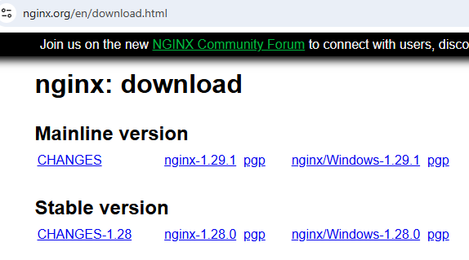

- Download the latest Windows .zip package (e.g., nginx-1.29.1.zip).
- Extract the Files:

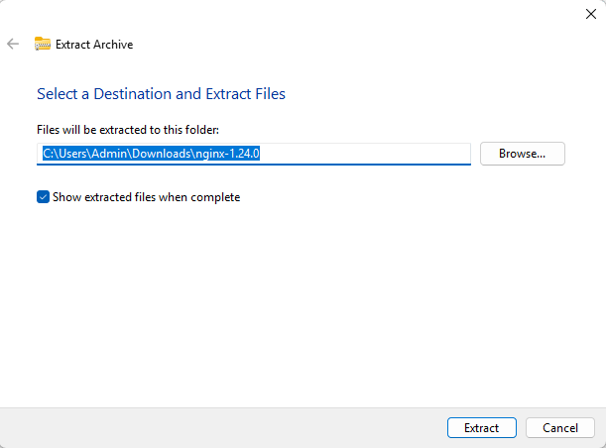

- Unzip the downloaded file to a directory, such as C:\nginx.
- Start Nginx:
- Open Command Prompt (Win + R, type cmd, press Enter).
- Navigate to the Nginx directory:

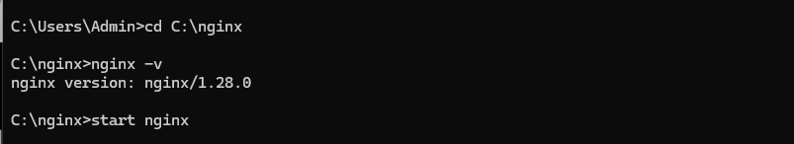

- Open a Web Browser: Launch Chrome, Edge, Firefox, or any browser.
- Enter URL: Type http://localhost in the address bar and press Enter.
- View Nginx Page: If Nginx is installed and running, the Nginx Welcome Page will appear, confirming the installation is successful.

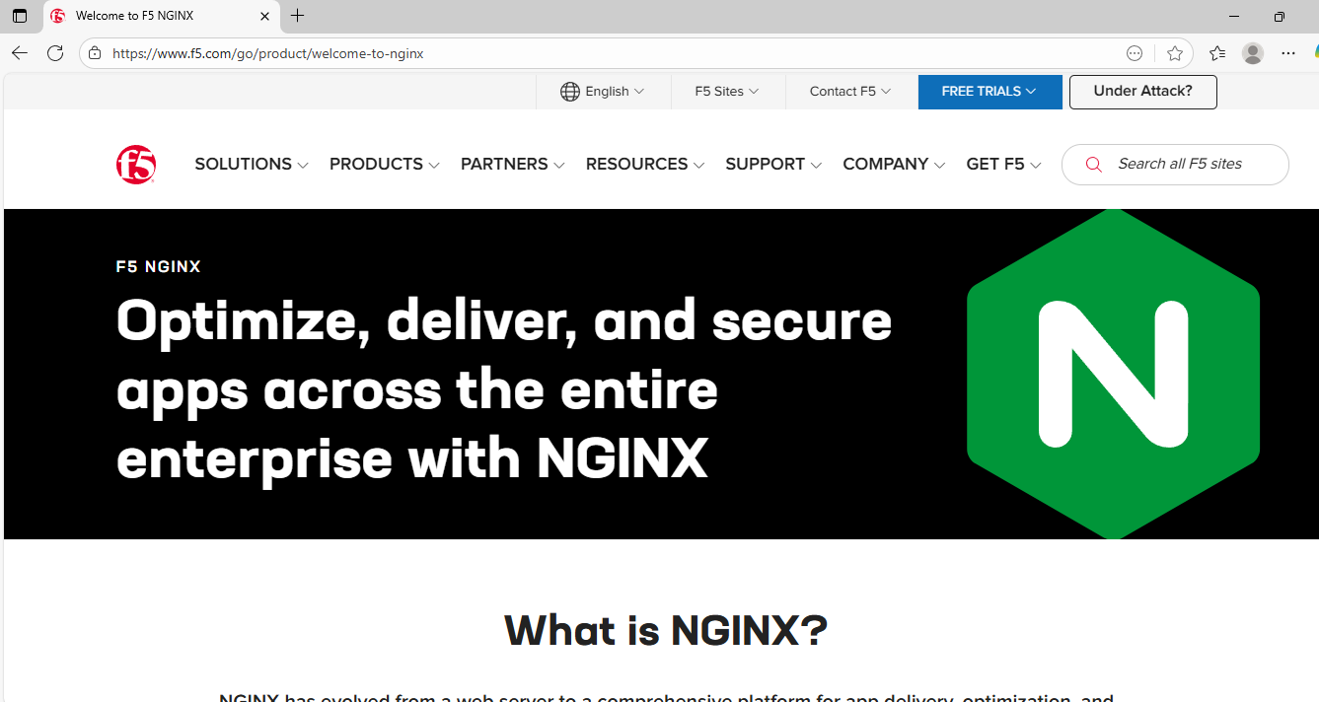

- Advantages of Nginx

- High Performance – Nginx can handle thousands of concurrent connections without slowing down. Its event-driven architecture allows it to serve many users efficiently, making it faster than traditional web servers.
- Reverse Proxy & Load Balancing – Nginx can act as a gateway between clients and servers, distributing traffic across multiple servers. This improves reliability, scalability, and uptime for websites and applications.
- Low Resource Usage – Nginx uses very little CPU and memory, even under heavy traffic. This makes it ideal for high-traffic websites and servers with limited resources.
- Security Features – Nginx provides built-in SSL/TLS support, access controls, and protection against attacks like DDoS. It helps secure websites and applications from common vulnerabilities.
- Flexible Web Serving – Nginx can serve static files quickly and work with dynamic content through backend servers like PHP, Python, or Node.js. This flexibility makes it suitable for many types of web applications.
- Reverse Proxy for Applications – Nginx efficiently manages requests to web applications and APIs, acting as a middle layer to optimize performance, cache responses, and improve reliability.
- Disadvantages of Nginx
- Hard to Set Up for New Users – Nginx uses a unique configuration syntax that is different from other web servers. Beginners may find it confusing to write and understand configuration files. Unlike Apache, it doesn’t use .htaccess for per-directory rules, so setting up basic sites may require more effort and learning.
- Limited Support for .htaccess – Nginx does not support .htaccess files, which are commonly used in Apache for directory-level configurations. This means all configuration changes must be done in the main configuration file, making it less flexible for users who want quick per-directory adjustments.
- Fewer Modules Compared to Apache – Nginx has fewer built-in modules, so some advanced features are not available out-of-the-box. Users may need to compile third-party modules manually, which can be complex and time-consuming.
- Difficult to Customize at First – Customizing Nginx for specific needs or performance tuning requires in-depth knowledge of its configuration and architecture. Beginners may struggle to set up advanced features like caching, load balancing, or security rules correctly.

- Video Tutorials and Certification for Nginx

- Video Tutorials for Learning Nginx
- NGINX Official Tutorials
Explore the official NGINX YouTube playlist, which offers comprehensive tutorials on various NGINX features and configurations.
📺Watch here
- Complete NGINX Training | NGINX WebServer
This crash course covers NGINX as a web server, reverse proxy, and load balancer, providing hands-on experience.
📺Watch here
- Become an NGINX Expert | Full Crash Course
An in-depth crash course designed to master every feature of NGINX, including Docker integration.
📺Watch here

Certification Programs for Nginx
- F5 NGINX Administrator Certification
F5 offers an official certification path for NGINX administrators, including the NGINX Administrator Accelerator self-directed training.
📄 Learn more
- NGINX Core Training by Westcon-Comstor Academy
An 8-hour course providing foundational knowledge to administer, configure, and manage NGINX using best practices.
📄 Explore the course
- NGINX Web Server Administration by Koenig Solutions
A comprehensive training program covering installation, configuration, security, and performance optimization for NGINX.
📄 Check out the course
- NGINX Fundamentals: High Performance Servers from Scratch (Udemy)
A top-rated Udemy course that teaches installation, configuration, optimization, and performance tuning of NGINX from scratch. Certificate of completion included.
📄View course
- NGINX Bootcamp: From Basics to Advanced Mastery (Udemy)
Bootcamp-style course covering everything from beginner to advanced NGINX topics, including reverse proxy, load balancing, and SSL. Certificate of completion included.
📄View course

Conclusion on Nginx
Nginx is a powerful, high-performance web server that is widely used for modern web applications. Its ability to handle thousands of concurrent connections with low resource usage makes it a preferred choice over traditional servers like Apache. With features such as reverse proxy, load balancing, and strong security options, Nginx provides both speed and reliability for businesses of all sizes. While it can be challenging for beginners due to its unique configuration style and limited .htaccess support, the performance benefits and flexibility outweigh these drawbacks. Overall, Nginx is an excellent solution for scalable, secure, and efficient web hosting and application delivery.

