Contents

ABSTRACT 3

Chapter 1-Introduction 4
1.1Block Diagram Of An Assembler 4
1.2 Capabilities and tasks of an Assembbler 5
1.3 Aim and Description of the Project 5
1.4 Existing System 5
1.5 Proposed System 6

Chapter 2-Theory and fundamentals 7
2.1 8086 microprocessor 7
2.1.1 Registers In 8086 7
2.1.2 Addressing Modes In 8086: 7
2.1.3 Instruction format: 8
2.2 Types of Assemblers 8
2.2.1 Two-Pass Assembler: 8

Chapter 3-Design and Implementations 10
3.1 System Requirements 10
3.1.1 Hardware Requirements: 10
3.1.2 Software Requirements: 10
3.2 Functional Requirements: 10
3.2.1 Input Specifications 10
3.2.2 Output Specification 10
3.3 Data structures 10
3.3.1 Operation code table (OPTAB) 11
3.3.2 Symbol table (SYMTAB) 11
3.4 Flowchart 12
3.4.1 Pass 1: 12
3.4.2 Pass 2 13
3.5 Data Flow diagram 13
3.5.1 Level 0 13
3.5.2 Level 1 14
3.5.3 Level 2 15

Chapter 4-Conclusions 16
4.1 LIMITATIONS 16
4.2 FURTHER ENHANCEMENTS 16

Chapter 5-BIBLIOGRAPHY 17

Chapter 6-APPENDICES 18
Appendix A : Snapshots 18
Appendix B: Source Code Listing 22

List of Figures

Fig 1.1-Block diagram of an assembler 5

Fig 3.1-Pass-1 Flowchart 13

Fig 3.2-Pass-2 flowchart 14

Fig 3.3-Level 0 DFD 15

Fig 3.4-Level 1 DFD 15

Fig 3.5-Level 2 DFD 16

ABSTRACT

An assembler is system software which converts an assembly level language program into a machine level language program.
An assembly language is a low level programming language for a computer system. It is specific to a certain computer system. Hence it is a machine dependent in nature.
Assembly languages are close to a one to one correspondence between symbolic instructions and executable machine codes. Assembly languages also include directives to the assembler, directives to the linker, directives for organizing data space, and macros. Macros can be used to combine several assembly language instructions into a high level language-like construct (as well as other purposes). There are cases where a symbolic instruction is translated into more than one machine instruction. But in general, symbolic assembly language instructions correspond to individual executable machine instructions.
High level languages are abstract. Typically a single high level instruction is translated into several (sometimes dozens or in rare cases even hundreds) executable machine language instructions. Some early high level languages had a close correspondence between high level instructions and machine language instructions. Modern object oriented programming languages are highly abstract.
Assembly language is much harder to program than high level languages. The programmer must pay attention to far more detail and must have an intimate knowledge of the processor in use. But high quality hand crafted assembly language programs can run much faster and use much less memory and other resources than a similar program written in a high level language. Speed increases of two to 20 times faster are fairly common, and increases of hundreds of times faster are occasionally possible
High level programming languages are much easier for less skilled programmers to work in and for semi-technical managers to supervise. And high level languages allow faster development times than work in assembly language, even with highly skilled programmers. Development time increases of 10 to 100 times faster are fairly common. Programs written in high level languages (especially object oriented programming languages) are much easier and less expensive to maintain than similar programs written in assembly language (and for a successful software project, the vast majority of the work and expense is in maintenance, not initial development).

Chapter 1-Introduction

A microprocessor works upon the hardware embedded in it. It accepts instructions to generate suitable output desired by programmer. These instructions exist natively in binary form-i.e., in a pattern of 0’s and 1’s.Every type of instruction that can be handled by microprocessor has a unique code- a sequence of binary numbers. Thus for every operation serviceable by the microprocessor, a suitable binary stream has to be supplied. This is the fastest way to perform an operation on a microprocessor, because the microprocessor understands the only language of binary digits. Hence there is no translation required of the input.
Speed may be achievable in this procedure, but it is very inefficient form of a programmer’s point of view as it is a tedious procedure,error prone and leads to unrecognizable language. Due to these inconveniences; which are very serious; the microprocessor manufacturers supply an instruction set along with the chip. The instruction set consists of English language equivalents of the instruction.But these opcodes and operands are not interpreted by microprocessor. It needs that the instructions are in the binary form.
An assembler does the job of converting these mnemonics to a machine understandable format.An assembler is a program that accepts assembly language program as input and produces its equivalent machine code.An assembly language is a low level programming language for the system.

1.1Block Diagram Of An Assembler

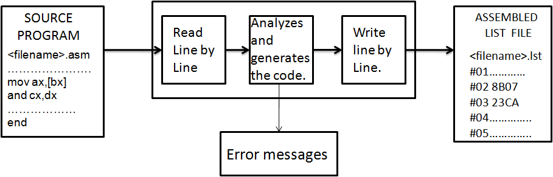

Fig 1.1-Block diagram of an assembler

Assembling is a translating process in which source program in assembly language will be translated in to object module containing only machine codes and data. Assembler also recognizes the symbol definition and symbol reference, Computes the values for the expression and use them while generating machine codes. An assembler can handle Assembler Directives and Decode Assembly language instructions.
When coded in assembly language, the program has to go through three phases of modification before finally appearing as a machine code. The three phases are as shown in the Fig . The first type of course is to type user program and save in suitable format.Next step is to assemble the mnemonics and to convert them to machine code. This step is taken care by the assembler. The assembler converts all the information in the text file to its machine format. This form of an intermediate file, which is directly not executable, is called the object code.

1.2 Capabilities and tasks of an Assembbler

An Assembler is capable of the following:
- Generates machine code that can be loaded and executed.
- Providing syntax errors.
- Provide symbolic labels for representation of constants and address.
- Access to all the machine’s resources by the assembled program.
- Run time locations of program and memory.

Task of an Assembler
The major task of an assembler is to translate the given assembly language program to its machine language program. Other tasks of assembler are:
- Checking each line of the source input i.e. check whether the input line is instruction, assembler directive or comment etc
- Processing Assembler Directive.
- Recognizing symbol definitions.
- Flagging Errors for undefined symbols, invalid symbols etc....
- Recognizing addressing modes.
- Evaluating expressions during assembling time.

1.3 Aim and Description of the Project

The main aim of our project is to convert an assembly level program in 8086 to its
equivalent opcode, only if the instructions used in the program use only the instructions,
which are designed in the project.

1.4 Existing System
The features and designs of an assembler depends upon the source language it translates and the machine language it produces. As far as existing system is concerned, we will consider the assembly language programming using MASM.MASM reads the source program as its input and produces an object program in 2 passes. A 2 pass assembler is one that goes through the source file two times. It does so that the addresses of any forward declaration which it encounters during the first pass are resolved during the second pass. If the declaration is not resolved an error is flagged. MASM accepts the file name only with extension.asm.MASM contains directives and operations of 8086 microprocessors.

1.5 Proposed System
The Proposed system is designed to consider most of the assembler features in a limited fashion.The features implemented in this design are 1 byte, 2 byte, 3 byte instructions, register-register and register and register to memory instruction formats. it also performs specific task for the assembler directives as indicated in the module. Parsing is done for each instruction to determine the type and addressing modes of the operands .Jmp instruction is also include which supports only near jump.

Chapter 2-Theory and fundamentals

8086 microprocessor
8086Microprocessor was developed by Intel Corporation in 1978. It is a 16 bit microprocessor, implemented in N - channel, depletion load, silicon gate technology (HMOS), and packaged in a 40 pin dual inline package.8086 can be divided into 2 subunits: Bus Interface Unit (BIU) and Execution Unit (EU).BIU is concerned interfacing of 8086 with memory. I t has an instruction queue which can store up to 6 instruction.EU performs the execution of the instructions. It has a set of registers to store data values and a flag register to store status of various flags. ALU performs arithmetic and logic functions.

2.1.1 Registers In 8086
8086 supports both 16-bit and 8- bit registers.
The various 16-bit registers supported are:
1. Segment registers - ES, CS, SS, DS.
2. General purpose registers - AX, BX, CX, and DX.
3. Index registers - SI, DI.
4. Pointer register - SP, BP.
Various 8- bit registers supported are:
AL, AH, BL, BH, CL , CH, DL, DH.

2.1.2 Addressing Modes In 8086:
The different ways that a processor can access data are referred to as addressing modes. There are 12 basic addressing modes in 8086 .This can be classified into 5 categories:
1. Addressing modes for accessing immediate and register data (register and immediate modes).
2. Modes for accessing data in memory.
3. Addressing modes for accessing I/O ports (I/O modes).
4. Relative addressing mode.
5. Implied addressing mode.
Memory modes can further be classified into the following types:
1. Direct addressing mode.
2. Register addressing mode.
3. Based addressing mode.
4. Indexed addressing mode.
5. Based indexed addressing mode.
6. String addressing mode.

2.1.3 Instruction format:
Label Field | Operand field | Operand 1 | Delimiter | Operand 2

Label: | MOV | AX | , | BX

Types of Assemblers
There are options available while designing an Assembler. They are One-Pass Assembler ,Two-Pass Assembler , Multi-Pass Assembler

2.2.1. Two-Pass Assembler:
A two Pass Assembler scans the source code twice, once during first pass and the other during the second pass. During the first pass, all the symbols defined in the code are stored in the symbol table (SYMTAB) and memory is allocated for the instructions. During the second pass the machine codes are loaded into the memory allocated for each instructions.
Operations performed in pass1:
Ø Checks to see if the instructions are legal in the current assembly mode.
Ø Allocates space for instructions and storage areas that are requested.
Ø Assigns addresses to all statements the program, using a location counter.
Ø Builds a symbol table, also called cross reference table, and makes an entry in this table for every symbol it encounters in the label field of a statement.
Ø Save the values (addresses) assigned to all labels in the symbol table, for use in pass2.
Ø It also processes the assembler directives.

At the end of the first pass, all the necessary space has been allocated and each symbol defined in the program has been associated with a location counter in the symbol table (.sym file). When there are no more statements to be read, the second pass starts at the beginning of the program.

Operations performed in pass2:
Ø Examines the operands for symbolic references to storage locations and resolves these symbolic references using information in the symbol table.
Ø Ensures that no instructions contain an invalid instruction form.
Ø Translates source statements into machine code and constants, thus filling the allocated space with object code.
Ø Performs processing of assembler directives not done during pass 1.
Ø Write the object program to destination .obj file.
Ø It keeps track of errors and displays appropriate messages if the same occurs.
If an error is found in the first pass, the assembly process terminates and does not continue to the second pass. If this occurs the assembly listing only contains errors and warnings generated during the first pass of the assembler.
If only warnings are generated in the first pass, the assembly process continues to the second pass. The assembler listing contains errors and warnings generated during the second pass of the assembler. Any warnings generated during the first pass do not appear in the assembler listing

Chapter 3-Design and Implementations

3.1 System Requirements

3.1.1 Hardware Requirements:
-INTEL 80x86 or above processors
-Minimum 1MB hard disk
-800x600 screen resolution

3.1.2 Software Requirements:
-Linux Operating System.
-Linux or Unix based c++ compiler
-Text Editor

3.2 Functional Requirements:

3.2.1 Input Specifications
1) The labels in the source program, if present must begin on a new line. The opcode field should be separated from the label field by a colon followed by \n.. If no label is present, the opcode may begin on a new line.
2) Labels should satisfy the following requirements. The first character must be an alphabet or numbers (a-zA-Z0-9) and each of the remaining characters can be alphabets or Numbers. Label names should not match with keywords or reserved words (opcode and assembler directives).
3) The opcode field must be from the instruction set supported or from one of the assembler directives (Pseudo instructions).
4) An instruction operand may be either a symbol, which appears as a label in the program or a number (only HEXADECIMAL ) that represents an immediate operand or an INTEL 8086 register.
5) The source program may or may not contain distinct labels.

3.2.2 Output Specification
1) The assembly listing should show each source program statement, together object code generated. This describes the form and contents of the desired output.
2) The object program should not be generated if any assembly errors are reported. This specifies the conditions under which the output is generated.

3.3 Data structures
Two major internal data structures are used in the assembling process:

3.3.1 Operation code table (OPTAB)
It is used to store the mnemonic operation code and its machine language equivalent. The information stored in this table is predefined when the assembler itself is written, rather than being loaded into the table at execution time. This is a static table in the sense that the values in this table are not modified during assembling process. During Pass 1, this table is used to look up and validate operation cues in the source program. In Pass 2, it is used to translate the operation codes to machine language.

3.3.2 Symbol table (SYMTAB)
It is used to store name, address, and other attributes associated with different labels used in the source program. This is a dynamic table, that is, values are entered into the table during assembling process, and its length cannot be predicated. During pass 1 of the assembler, labels are entered into this table as they are encountered in the source program, along with their assigned addresses using the value of the location counter at the instance it is encountered. During pass 2, symbols used as operands are looked up in this table to obtain the addresses to be inserted I the assembled instructions. This table acts as an input to the second pass.

3.4 Flowchart

3.4.1 Pass 1:

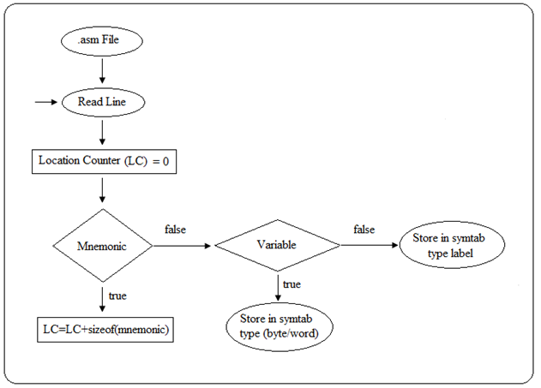

Fig3.1-Pass-1 Flowchart

3.4.2 Pass 2
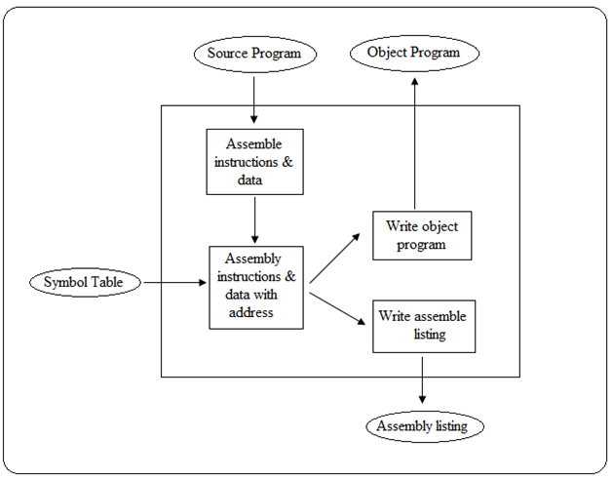

Fig 3.2-Pass-2 flowchart

3.5 Data Flow diagram
A data flow diagram is a representation of the movement of information between storage and processing steps within a software system.it is also called as bubble chart.It is a heirarchial graphical model of a system that shows the different processing activities of functions that the system performs and the data interchanged among these functions.Each function is considered as a processing station that consumes some input data and produces some output data.A DFD model uses a very limited number of primitive symbols to represent the functions performed by a system and the data flow among these.
Imporatnce:
- Simple to understand and use
- Represents various sub-functions
- It is an abstract model
It is represented in three levels:

3.5.1 Level 0
This level shows overall content of system and its operating environement and shows the whole system as just one process.It does not ususally show data stores unless owned by external system.
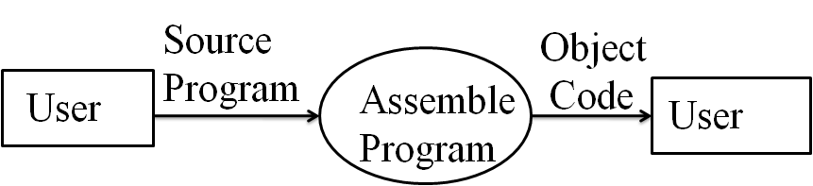

Fig 3.3-Level 0 DFD

3.5.2 Level 1

This level shows all processes at first level of processing,data stores and data flows between them .Purpose of this level id to show major high level processes of the system and their interaction.

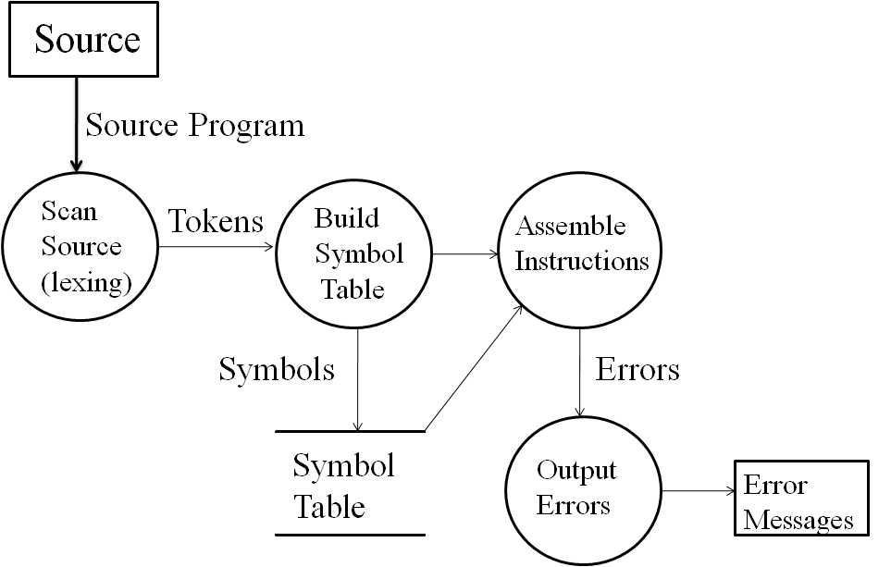

Fig 3.4-Level 1 DFD

3.5.3 Level 2
This level is decomposition of process shown in level one diagram .Together they wholly and completely describe current process and perform full capacity of this parent process.

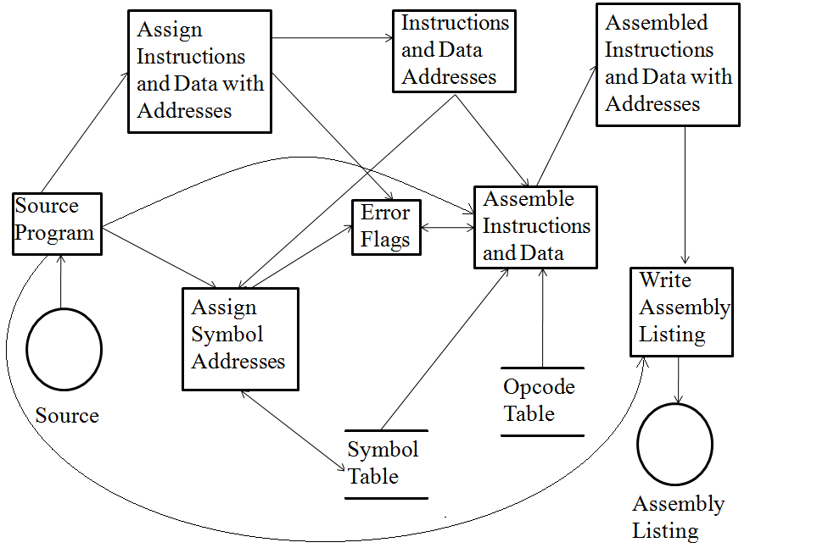

Fig 3.5-Level 2 DFD

Chapter 4-Conclusions
This Project was an effort at learning the development of a system software which are the building blocks of programming. As we go through this project we come to understand the processes going on “behind the scenes” like how the object code is generated for the given source program in the assembly language and how the entries are made into the symbol table etc.
Although a lot of effort has been put in building this system software, there might be deficiencies. To the best of our knowledge this system takes care of most of the conditions that may occur at runtime environment.
To make the best of the designed system, the user has to work on the system and to train himself this would help the user in better understanding of the system and in turn increases the users’ efficiencies and skills in using the system.
This Project is developed such that anybody who has the basic idea about the assembly language can easily manage. There might be minor changes in the proposed system from time to time to update the changes.

4.1 LIMITATIONS

- This assembler does not support the complete instruction set of 8086’
- Procedures have not been implemented.
- The assembly listing has been produced to be user friendly and cannot be directly loaded and run.

4.2 FURTHER ENHANCEMENTS

- The assembler can be upgraded in the future to include the following features
- Ability to handle all the remaining instructions along with their addressing modes.
- Ability to handle macros and procedures.
- Generate a full fledged object program that can be directly linked and executed by a linker.

Chapter 5-BIBLIOGRAPHY

1) The Intel Microprocessors, PHI Publications, Sixth Edition, 2004,
Barry.B.Brey

2) System Software, Pearson Education, Third Edition, 2004,
Leland L.Beck

3) Advanced Microprocessors and Peripherals, Tata McGraw-Hill, 004,A.K.Ray and K.M.Burchandi

4) Webpages referred:

- http://www.cs.man.ac.uk/~pjj?cs211/yacc/yacc.html

- http://www.tldp.org/HOWTO/Lex-YACC-HOWTO.html

- http://epaperpress.com/lexandyacc/

- http://pltplp.net/lex-yacc

- http://www.sourceforge.net

- http://www.emu8086.com/

- http://en.wikipedia.org/wiki/x86_assembly_language

Chapter 6-APPENDICES

Appendix A : Snapshots
- Run 1
  - Input File

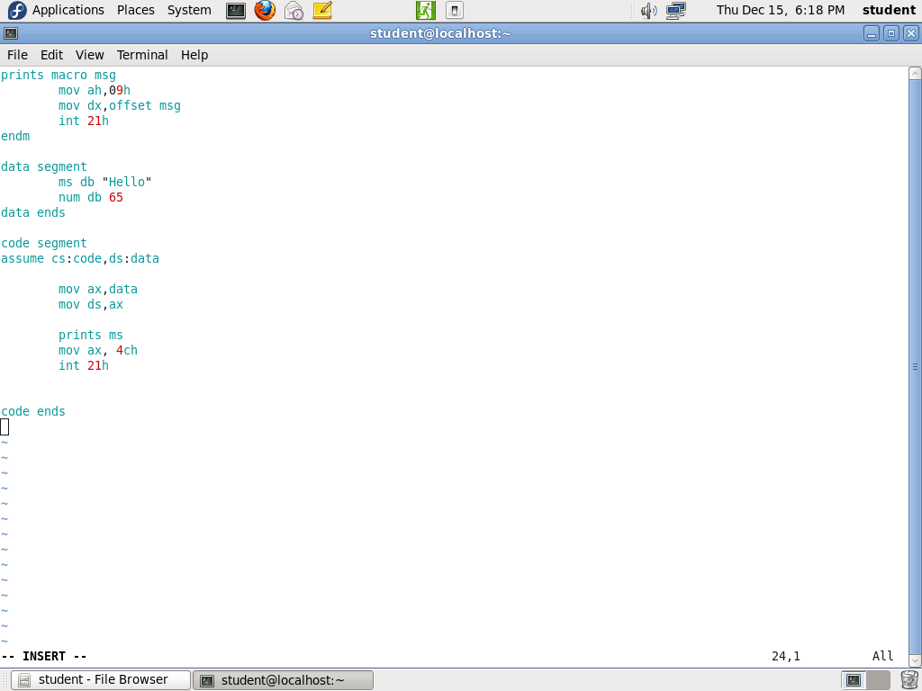

  - Terminal Output
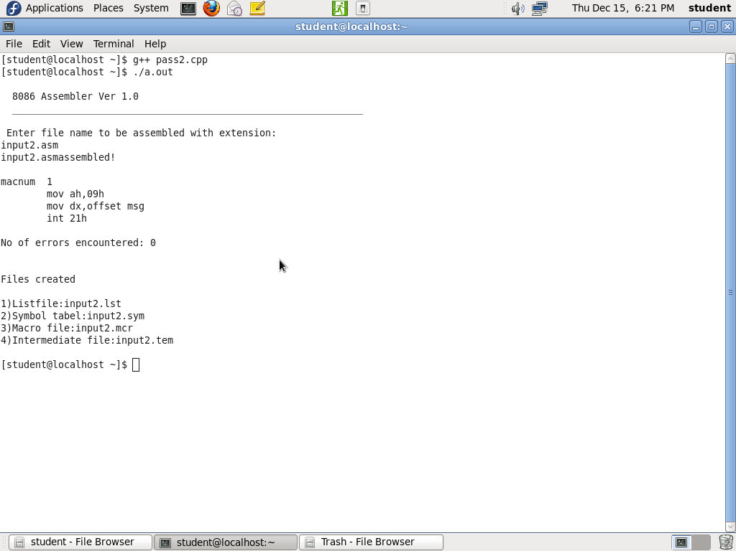

1.3 Output Files Created
1.3.1 input2.lst
LIST FILE: input2.lst for input2.asm

1 0000
2 0000
3 0000
4 0000
5 0000
6 0000
7 0000 data segment
8 0000 00 ms db Hello
9 0001 41 num db 65
10 0002 data ends
11 0000
12 0000 00 00 00 00 00 00 00 00 00 00 00 00 00 00
code segment
13 0000 assume cs : code , ds : data
14 0000
15 0000 B8 00 00 mov ax , data
16 0003 8E D8 mov ds , ax
17 0005
18 0005 B4 09 mov ah , 09h
19 0007 BA 00 00 mov dx , offset 0
20 0010 CD 21 int 21h
21 0012 B8 04 00 mov ax , 4ch
22 0015 CD 21 int 21h
23 0017
24 0017
25 0017 code ends
26 0017

*********User defined variables and types.**********

prints Macro

ms Data Byte

num Data Byte

Number of lines = 27

Number of errors = 0

1.3.2 input2.sym
name addr type size value
data 0 0 0 0
ms 0 1 1 0
num 1 1 1 0

1.3.3 input2.mcr
Macro name = prints
mov ah,09h
mov dx,offset msg
int 21h
endm

1.3.4 input2.tem

- 0000
- 0000
- 0000
- 0000
- 0000
- 0000
- 7 0000 datasegment
- 8 0000 msdbHello
- 9 0001 numdb65
- 10 0002 dataends
- 0000
- 12 0000 codesegment
- 13 0000 assumecs:code,ds:data
- 0000
- 15 0000 movax,data
- 16 0003 movds,ax
- 0005
- 18 0005 movah,09h
- 19 0007 movdx,offset0
- 20 000A int21h
- 21 000C movax,4ch
- 22 000F int21h
- 0011
- 0011
- 25 0011 codeends
- 0011

Appendix B: Source Code Listing

1.Source code for macro.cpp
// MACROPROCESSOR: For Macro Detection and Expansion Also Removes Comments
//#include<conio.h>
#include<string>
#include<stdio.h>
#include<cctype>
#include<iostream>
#include<string.h>
using namespace std;
int macnum=0;
int errnum=0;
char asmbuf[80];
FILE *source,*temp,*mfp;
char macrofname[20];
unsigned int userDefinedIndex;

class userDefinedVar {
public:
char varName[100];
char varType[100];
} ud[20];

int linenum=0;

class mactab{
public:
char name[10];
int name_size;
char arglist[5][10];
long startptr;
long endptr;
}mac[5];
void while_Null(int& a)
{
while(asmbuf[a]==' ')
a++;
}
void while_Char_Present(int& a)
{
while(isalnum(asmbuf[a]) || asmbuf[a]=='\'' || asmbuf[a]=='+' || asmbuf[a]=='[' || asmbuf[a]=='_' || asmbuf[a]==']')
{
if(asmbuf[a]==';')return;
a++;
}
}
int charcheck(char buffer[],int &ii,int &i)
{
if(asmbuf[i]==',')
{
return 1;
}
while(isalnum(asmbuf[i]) || asmbuf[i]=='\'' || asmbuf[i]=='+' || asmbuf[i]=='[' || asmbuf[i]=='_' || asmbuf[i]==']')
{
buffer[ii++] = asmbuf[i++];
buffer[ii]='\0';
if(asmbuf[i]==';')return 0;
else;
}
buffer[ii]='\0';
if(asmbuf[i]==',')
{
return 1;
}
return 0;
}
nt macropro(const char* Fname)
{
static char charin[80];
static char newbuf[5][10];
source=fopen(Fname,"rb");
mfp = fopen (macrofname, "wb");
temp=fopen("tempbuf.asm","wb");

while(!feof(source)){

++linenum;
strcpy(asmbuf," ");
fgets(asmbuf,80,source);

int i=0;

while_Null(i); int i1=i;
while_Char_Present(i); int i2=i;
while_Null(i); int i3=i;

int j=0;
if(asmbuf[i1]==';'){fputs("\n",temp);}//do nothing;

else if((strncmp(asmbuf+i3,"macro",5)==0) )//&& (asmbuf[i3+5]==' '|| asmbuf[i3+5]=='\t'))
{
fputs("\n",temp);
for(int ii=i1; ii<i2; ii++,j++)
{
mac[macnum].name[j]=asmbuf[ii];
mac[macnum].name_size=j+1;
}
if(macnum!=0)
{
for(i=0;i<macnum;i++)
{
if( strcmp(mac[macnum].name , mac[i].name)==0 )
{
cout<<"\n\nERROR:Line "<<linenum<<" Redeclaration of macro not allowed"<<endl;
errnum++;
}
}
}
int argcount=0;
for(i=i3+5;i<80;i++)
{
int ii=0;
while_Null(i);
if(i>=80)break;
if(asmbuf[i]=='\0')break;
charcheck(mac[macnum].arglist[argcount],ii,i);
if(ii>1) ++argcount;
if(i>=80)break;
if(asmbuf[i]=='\0')break;

}

i=0;
mac[macnum].startptr=ftell(source);
long curpos;

fprintf (mfp, "\n\nMacro name = %s\n\n", mac[macnum].name );
while(!feof(source))
{

fgets(asmbuf,80,source);
fprintf (mfp, "\n%s", asmbuf);
++linenum;
i=0;
while_Null(i);
int i1=i;
if(asmbuf[i1]==';'){continue;}//do nothing;
else
if(strncmp(asmbuf+i1,"endm",4)==0)
{
fputs("\n",temp);
mac[macnum].endptr=curpos;
break;
}
else
{
curpos=ftell(source);
fputs("\n",temp);
}

}//while ends
++macnum;

}//if check for macro ends
else
fputs(asmbuf,temp);
}//feof(source) ends

fclose(temp);
fclose(source);
fclose(mfp);
source=fopen("tempbuf.asm","rb");
temp=fopen("tempbuf2.asm","wb");
FILE *initsource=fopen(Fname,"rb");
printf("\nmacnum %d\n",macnum);
while(!feof(source)){
int mac_size;
strcpy(charin," ");
fgets(asmbuf,80,source);
int i=0;
int called=0;
int macronum;
while_Null(i);int i1=i;
for(int p=0;p<macnum;p++)
{
if((strncmp(asmbuf+i1,mac[p].name,mac[p].name_size)==0))
{
mac_size=mac[p].name_size;
called=1;
macronum=p;
}
}
if(called==1)
{
int j=0;
for(i=i1+mac_size;i<80;i++)
{
int ii=0;
while_Null(i);
if(i>=80)break;
if(asmbuf[i]=='\0')break;
if(asmbuf[i] != '\t'&& asmbuf[i] != ' '&& asmbuf[i] != ',')
{
while(isalnum(asmbuf[i]))
{
newbuf[j][ii++] = asmbuf[i++];
newbuf[j][ii]='\0';
if(asmbuf[i]=='\0')break;
else;
}
}
newbuf[j][ii]='\0';
if(ii>1) j++;
if(i>=80)break;
if(asmbuf[i]=='\0')break;
}//end for(i=i1+mac_size;i<80;i++)

fseek(initsource,mac[macronum].startptr,0);
strcpy(charin,"\0");
while(ftell(initsource)<mac[macronum].endptr)
{
fgets(asmbuf,80,initsource);//fgets(asmbuf,80,initsource);
fputs(asmbuf,stdout);
char buffer[20];
strcpy(charin,"\0");
for(i=0;i<80;i++)
{
int ii=0, comma=0;
int flag=-1;
while_Null(i);
if(i>=80)break;
if(asmbuf[i]=='\0')break;
comma=charcheck(buffer,ii,i);

buffer[ii]='\0';
flag=-1;
for(int jj=0;jj<5;jj++)
{
if(strcmp(mac[macronum].arglist[jj],buffer)==0)
flag=jj;
}
if(flag!=-1)
strcat(charin,newbuf[flag]);
else
strcat(charin,buffer);

if(comma==1)
strcat(charin,",");
else
strcat(charin," ");

if(ii>1) j++;
if(i>=80)break;
if(asmbuf[i]=='\0')break;
}//end for(i=0;i<80;i++)
strcat(charin,"\n");
fputs(charin,temp);
}//end while(ftell)

}//end if(called)
else fputs(asmbuf,temp);
}//end while(!feof(source))

for (int i = 0; i < macnum; ++i)
{
strcpy (ud[userDefinedIndex].varName , mac[i].name);
strcpy (ud[userDefinedIndex++].varType , "Macro");
}
fclose(source);
fclose(temp);
fclose(initsource);
return 0;
}

Source Code for Pass 1
// PASS 1 of Assembler...

#include "iostream"
#include <stdio.h>
#include <ctype.h>
#include <stdlib.h>
#include <math.h>
#include <string.h>
using namespace std;
#include "Macropro.cpp"
int toknum=0;
int symnum=0;
int locctr=0;
int dlocctr=0;
int relocatable;
int reloc[5];
int maxlines;
int flag1,flag2,flag3;
char elem[20];
char token[20][40];

FILE *curf, *objmem,*intermediate;

// Instruction Operand Flags
void itoa(int value,char* result,int base)
{
//to check the base is valid
if(base<2 || base>36)
{
*result='\0';
}
char* ptr=result,*ptr1=result,tmp_char;
int tmp_value;
do
{
tmp_value=value;
value/=base;
*ptr++="Zyxwvutsrqponmlkjihgfedcba9876543210123456789abcdefghijklmnopqrstuvwxyz"[35+(tmp_value-value*base)];
}while(value);
if(tmp_value<0) *ptr++='-';
*ptr--='\0';
while(ptr1<ptr)
{
tmp_char=*ptr;
*ptr--=*ptr1;
*ptr1++=tmp_char;
}
}

class flags{
public:
unsigned int reg8;
unsigned int reg16;
unsigned int seg;
unsigned int mem;

};

//Line structure to store info about each line
class lines{
public:
int wordnum;
unsigned int loc;
int is_instruc;
int mod;
char dispval[20];
unsigned int disp;
unsigned int imm;
unsigned int var;
unsigned int index;
unsigned int base;
unsigned int d;
unsigned int w;
char word[20][40];
flags op1,op2;
};

//class lineinfo lines;
lines Line[50];

//Classification of Instructions
char type1[41][8]={"aaa","aad","aam","aas","cbw","clc","cld","cli","cmc","cmpsb","cmpsw","cwd","daa","das","hlt","int3","iret","into","lahf","lock","lodsb","lodsw","movsb","movsw","nop","popf","pushf","rep","repe","repne","ret","sahf","scasb","scasw","stc","std","sti","stosb","stosw","wait","xlat"};
char type2[36][8]={"jo","jno","jb","jnae","jae","jnb","je","jz","jne","jnz","jbe","jna","ja","jnbe","js","jns","jp","jpe","jnp","jpo","jl","jnge","jge","jnl","jle","jng","jg","jnle","jcxz","loop","loope","loopz","loopne","loopnz","jmp","call"};
char type3[2][6]={"push","pop"};
char type4[2][5]={"neg","not"};
char type5[2][5]={"dec","inc"};
char type6[4][6]={"div","idiv","mul","imul"};
char type7[5]={"int"};
char type8[9][6]={"adc","add","and","cmp","or","sbb","sub","test","xor"};
char type9[8][5]={"rcl","rcr","rol","ror","sal","sar","shl","shr"};
char type10[2][5]={"in","out"};
char type11[6]={"xchg"};
char type12[3][5]={"lds","lea","les"};
char type13[5]={"mov"};

//The Symbol Table
class symtab{
public:
char name[20];
unsigned int addr;
unsigned int size;
unsigned int value;
int type; //0=label, 1=symbol(db), 2=symbol(dw), 4=const(equ)
}symEntry[20];

//Function for Entry into Symbol table
void entSymtab(char *entry,int typ,int siz,int val)
{
strcpy(symEntry[symnum].name,entry);
symEntry[symnum].addr=locctr;
symEntry[symnum].type=typ;
symEntry[symnum].size=siz;
symEntry[symnum].value=val;
symnum++;
}

//Global function to issue Error messages and
//update error count
void errmsg()
{
cout<<"\n\nERROR: Line "<<linenum<<" ";
errnum++;
}

void dectohex(int decival,char resulta[])
{
char hexconv[16]={'0','1','2','3','4','5','6','7','8','9','A','B','C','D','E','F'};
if(decival<16)
{
resulta[3]=hexconv[decival];
}
else
{
if(decival<256)
{
int rema;
int tempa;
tempa=decival/16;
rema=decival%16;
resulta[2]=hexconv[tempa];
resulta[3]=hexconv[rema];
}
}
}

void interf(int line)
{
char resulta[5]={'0','0','0','0','\0'};
char putin[40];
fprintf(intermediate,"\n %4d ",line);
dectohex(Line[line].loc,resulta);
fprintf(intermediate,"%s ",resulta);
strcpy(putin,"\0");
for(int p=0;p<Line[line].wordnum;p++)
{
strcat(putin,Line[line].word[p]);
}
fprintf(intermediate,"\t\t\t\t");
fprintf(intermediate," %s",putin);
}

//Function converts a hex value to decimal
int hextodec(char elem[5])
{
int p,count=0,iter=0;
int value=0;
int final=0;
p=strlen(elem)-2;
while(isalnum(elem[p]) && p>-1)
{
count=(int)pow(16,iter);
if(elem[p]=='0')
{
value=0;
}
if(elem[p]=='1')
{
value=1;
}
if(elem[p]=='2')
{
value=2;
}
if(elem[p]=='3')
{
value=3;
}
if(elem[p]=='4')
{
value=4;
}
if(elem[p]=='5')
{
value=5;
}
if(elem[p]=='6')
{
value=6;
}
if(elem[p]=='7')
{
value=7;
}
if(elem[p]=='8')
{
value=8;
}
if(elem[p]=='9')
{
value=9;
}
if(elem[p]=='a')
{
value=10;
}
if(elem[p]=='b')
{
value=11;
}
if(elem[p]=='c')
{
value=12;
}
if(elem[p]=='d')
{
value=13;
}
if(elem[p]=='e')
{
value=14;
}
if(elem[p]=='f')
{
value=15;
}
final=final+value*count;

p--;
iter++;
}
return final;
}

//Binary to Decimal
int bintodec(char elem[5])
{
int p,count=0,iter=0;
int value=0;
int final=0;
p=strlen(elem)-2;
while(isalnum(elem[p]) && p>-1)
{
count=(int)pow(2,iter);
if(elem[p]=='0')
{
value=0;
}
if(elem[p]=='1')
{
value=1;
}

final=final+value*count;

p--;
iter++;
}
return final;
}

//Check if First token is a valid instruction
int isValidInstruction(char tok[10])
{
int i;

for(i=0;i<41;++i)
{
if(!strcmp(type1[i],tok))
{
return 1;
}
}
for(i=0;i<36;++i)
{
if(!strcmp(type2[i],tok))
{
return 2;
}
}
for(i=0;i<2;++i)
{
if(!strcmp(type3[i],tok))
{
return 3;
}
}
for(i=0;i<2;++i)
{
if(!strcmp(type4[i],tok))
{

return 4;
}
}
for(i=0;i<2;++i)
{
if(!strcmp(type5[i],tok))
{

return 5;
}
}
for(i=0;i<4;++i)
{
if(!strcmp(type6[i],tok))
{

return 6;
}
}
if(!strcmp(type7,tok))
{

return 7;
}
for(i=0;i<9;++i)
{
if(!strcmp(type8[i],tok))
{

return 8;
}
}
for(i=0;i<8;++i)
{
if(!strcmp(type9[i],tok))
{

return 9;
}
}
for(i=0;i<2;++i)
{
if(!strcmp(type10[i],tok))
{

return 10;
}
}
if(!strcmp(type11,tok))
{

return 11;
}

for(i=0;i<3;++i)
{
if(!strcmp(type12[i],tok))
{

return 12;
}
}

if(!strcmp(type13,tok))
{
return 13;
}
return 0;
}

// Classify / Identify Line
int check()
{
if(isValidInstruction(token[0]))return 0;

if((strcmp(token[0],"end")==0)||(strcmp(token[0],"loop")==0)||(strcmp(token[0],"assume")==0)||(strcmp(token[0],"code")==0)||(strcmp(token[0],"data")==0))
return 5;
if(!strcmp(token[1],"equ"))
{ entSymtab(token[0],4,0,atoi(token[2]));return 4;}
else if(!strcmp(token[1],"endp"))return 5;
else if(strcmp(token[1],":")==0 || !strcmp(token[1],"proc")) {
entSymtab(token[0],0,0,0);

if (strcmp (token[1], ":") == 0) {
strcpy (ud[userDefinedIndex].varName, token[0]);
strcpy (ud[userDefinedIndex++].varType, "Label");
}

else if (strcmp (token[1], "proc") == 0) {
strcpy (ud[userDefinedIndex].varName, token[0]);
strcpy (ud[userDefinedIndex++].varType, "Procedure");
}

return 4;
} //Label
for(int i=0;i<symnum;i++){
if(strcmp(token[0],symEntry[i].name)==0)
{
errmsg();cout<<symEntry[i].name<<" already exists";
return -1;
}
}
if(!strcmp(token[1],"db") || !strcmp(token[1],"dw"))
return 1;
if(!strcmp(token[0]," ") || !strcmp(token[0]," ") || !strcmp(token[0],"\0"))
return 5;
errmsg();cout<<"Illegal Symbol/Instruction";
return 5;
}

// Tokenize/split line into tokens
void tokenize()
{
toknum=0;
for(register int i=0;i<80;i++)
{
starting:
int ii=0;
while_Null(i); //if space is encountered

if(i>=80)break;
if(asmbuf[i]=='\0') return;
if(asmbuf[i]==',')
{
i++;
strcpy(token[toknum],",");
toknum++;
continue;
}
if(asmbuf[i]==':')
{
i++;
strcpy(token[toknum],":");
toknum++;
continue;
}
while(isalnum(asmbuf[i]) || asmbuf[i]=='\'' || asmbuf[i]=='+' || asmbuf[i]=='[' || asmbuf[i]=='_' || asmbuf[i]==']')
{
token[toknum][ii]='\0';
if(asmbuf[i]=='[')
{
while(asmbuf[i]!=']')
{
if(asmbuf[i]==' ')i++;
token[toknum][ii]=asmbuf[i];
i++; ii++;token[toknum][ii]='\0';
}
token[toknum][ii]=']';
i++; ii++;token[toknum][ii]='\0';
break;
}

if(asmbuf[i]=='\'')
{
while(asmbuf[i]!='$')
{
token[toknum][ii]=asmbuf[i];
i++; ii++;token[toknum][ii]='\0';
}
token[toknum][ii]='$';
i++; ii++;
token[toknum][ii]='\'';
i++; ii++;token[toknum][ii]='\0';
break;
}

if(asmbuf[i]=='(')
{
i++;
while(asmbuf[i]!=')')
{
if(asmbuf[i]==' ')i++;
token[toknum][ii]=asmbuf[i];
i++; ii++;token[toknum][ii]='\0';
}
i++; ii++;token[toknum][ii]='\0';
break;
}

token[toknum][ii++] = asmbuf[i++];
token[toknum][ii]='\0';
if(asmbuf[i]=='\0')return;

}
token[toknum][ii]='\0';

if(asmbuf[i]==',')
{
toknum++;
i++;
strcpy(token[toknum],",");
toknum++;
goto starting;
}
if(asmbuf[i]==':')
{
toknum++;
i++;
strcpy(token[toknum],":");
toknum++;
goto starting;
}
if(ii>1)
toknum++;
if(i>=80)break;
if(asmbuf[i]=='\0')return;
}
}

//To check if paarameter is a Register

int isreg(char a[5])
{
if(!(strcmp(a,"al")) || !(strcmp(a,"bl"))|| !(strcmp(a,"cl"))|| !(strcmp(a,"dl")))
return 1;
else if(!(strcmp(a,"ah")) || !(strcmp(a,"bh"))|| !(strcmp(a,"ch"))|| !(strcmp(a,"dh")))
return 1;
else if(!(strcmp(a,"ax")) || !(strcmp(a,"bx"))|| !(strcmp(a,"cx"))|| !(strcmp(a,"dx")))
return 2;
if(!(strcmp(a,"sp")) || !(strcmp(a,"bp")))
return 3;
else if(!(strcmp(a,"si"))|| !(strcmp(a,"di")))
return 4;
else if(!strcmp(a,"cs"))return 5;
else if(!strcmp(a,"ds"))return 6;
else if(!strcmp(a,"es"))return 7;
else if(!strcmp(a,"ss"))return 8;
else return 0;
}

int dbsiz( int n)
{
if(n>0 && n<=8)n=1;
else if(n>8 && n<=16)n=2;
else if(n>16 && n<=32)n=3;
else if(n>32 && n<=64)n=4;
return n;
}

void inparenth(int flag,char buf[20],int &i)
{
int code=0;
// Try doing it. --i;
if(flag!=3)
{
if(!strcmp(buf,"bx"))
{
if(flag==1)
locctr+=2;
Line[linenum].base=1;
}
else if(!strcmp(buf,"bp"))
{
if(flag==1)
locctr+=2;
Line[linenum].base=2;
}//base reg
else if(!strcmp(buf,"si"))
{
if(flag==1)
locctr+=2;
Line[linenum].index=1;
}
else if(!strcmp(buf,"di"))
{
if(flag==1)
locctr+=2;
Line[linenum].index=2;
}//index reg
code=1;
}

if(!isalpha(buf[0]))
{
if(buf[i]=='h')
{
if(strlen(buf)<=3)locctr+=2;//immediate 8
else locctr+=2;
Line[linenum].disp=1;//immediate 16
}
else if(buf[i]=='b')
{
if(strlen(buf)<=9)locctr+=2;//immediate 8
else locctr+=2;
Line[linenum].disp=1;//immediate 16
}
else if(atoi(buf)>255)
{
locctr+=2;//cout<<"ERROR: Line "<<linenum<<" : Constant too large";
}

else if(atoi(buf)<255 && atoi(buf)>0)
{
locctr+=2;
Line[linenum].disp=1;
}//imm8
code=1;
}
else if(code==0)
{

errmsg();
cout<<"Undefined Symbol(s) ";
}
}

void splitparenth(char buf1[20],char buf2[20],char buf3[20],int &i1,int &i2,int &i3,int &i)
{
while(elem[i]!=']')
{
flag1=1;
if(elem[i]=='+')
{
i++;
flag2=1;
while(elem[i]!=']')
{
if(elem[i]=='+')
{
i++;
flag3=1;
while(elem[i]!=']' && elem[i]!='+')
{
buf3[i3++]=elem[i++];
buf3[i3]='\0';
}
return;
}

buf2[i2++]=elem[i++];
buf2[i2]='\0';
}
return;
}

buf1[i1++]=elem[i++];
buf1[i1]='\0';
}
return;
}

// If token is not Register function Identifies if it is memory or
// immediate and sets mod reg disp imm and other fields . . .

void tokType(char element[20],int typ)
{
strcpy(elem,element);
register int i=0,i1=0,i2=0,i3=0,ii=0;
int k=0;//iii=0;
flag1=0;flag2=0;flag3=0;
char buf[20],buf1[20],buf2[20],buf3[20];

if(!strcmp(elem,"data"))
{
if(isreg(token[1]))
locctr+=3;

Line[linenum].imm=1;

relocatable++;
reloc[relocatable]=locctr;
return;
}

for(k=0;k<symnum;k++)//mem
{
if(strcmp(elem,symEntry[k].name)==0)
{
if(symEntry[k].type==4)
{
locctr+=4;
itoa(symEntry[k].value, (token[3]),10);
itoa(symEntry[k].value, Line[linenum].word[3],10);
itoa(symEntry[k].value, elem,10);
break;
}

Line[linenum].mod=0;
Line[linenum].var=1;

if(typ==1)
{
if(symEntry[k].type==2)
Line[linenum].w=1;
if(!isreg(token[3]) && isalpha(token[3][0]))
{
errmsg();
cout<<"Illegal operand types";
return;
}
if(symEntry[k].type==1 && isreg(token[3])>1)
{
errmsg();
cout<<"Operand type mismatch";
return;
}
if(symEntry[k].type==2 && isreg(token[3])==1)
{
errmsg();
cout<<"Operand type mismatch";
return;
}

Line[linenum].op1.mem=1;

if(isreg(token[3]))
{
locctr+=4;
}
else
{
if(symEntry[k].type==2)
{
Line[linenum].w=1;
}
locctr+=5 ;
}
return;
}

if(typ==3)
{
if(!isreg(token[1]))
{
errmsg();
cout<<"Illegal operand types";
return;
}

if(symEntry[k].type==1 && isreg(token[1])>1)
{
errmsg();
cout<<"Operand type mismatch";
return;
}
if(symEntry[k].type==2 && isreg(token[1])==1)
{
errmsg();
cout<<"Operand type mismatch";
return;
}
Line[linenum].op2.mem=1;
Line[linenum].var=1;

locctr+=4;

if(symEntry[k].type==2)
Line[linenum].w=1;
return;
}

//return;
}
//mem ref in symtab
}

if(typ==3)
{
if(strcmp(elem,"offset")==0)
{
int p=0;
Line[linenum].imm=1;

for(k=0;k<symnum;k++)//mem
{
if(strcmp(token[4],symEntry[k].name)==0)
{
p=1;
if(Line[linenum].op1.reg8==1)
{
locctr+=2;
}
else
{
locctr+=3;
}

itoa(symEntry[k].addr,token[4],10);
itoa(symEntry[k].addr,Line[linenum].word[4],10);

return;//break;
}
}
if(p==0)
{
errmsg();
cout<<"Undefined Symbol"<<endl;
return;
}

}

else if(elem[i]=='[')//mem
{
i++;
Line[linenum].op2.mem=1;
splitparenth(buf1,buf2,buf3,i1,i2,i3,i);

}

if(flag3==1)
{
inparenth(3,buf3,i3);

}

if(flag2==1)
{
inparenth(2,buf2,i2);
}

if(flag1==1)
{
Line[linenum].w=1;
Line[linenum].op2.mem=1;
inparenth(1,buf1,i1);
}

else if(!isalpha(elem[0]) && typ==3)// && !flag1 && !flag2 && !flag3) //immediate
{
strcpy(buf,elem);
ii=strlen(elem)-1;

for(k=0;k<symnum;k++)//mem
{
if(strcmp(token[1],symEntry[k].name)==0)
{

if(buf[ii]=='h')
{

if(hextodec(buf)<=255)//immediate 8
{
Line[linenum].imm=1;
}

else
{
Line[linenum].imm=2;
locctr+=1;
}

}

else if(buf[ii]=='b')
{
if(bintodec(buf)<=255)
{
Line[linenum].imm=1;
}
else
{
Line[linenum].imm=2;
locctr+=1;
}
}

else if(atoi(buf)<=255)
{
Line[linenum].imm=1;
}

else
{
Line[linenum].imm=2;
locctr+=1;
}
return;
}
}

if(!strcmp(token[0],"mov")) //mov...
{
if(isreg(token[1])) //|| Line[linenum].w==1)
{
locctr+=1;
}

if(buf[ii]=='h')
{
if(hextodec(buf)<=255)//immediate 8
{
if(Line[linenum].op1.reg8==1)
locctr+=1;
else
locctr+=2;
Line[linenum].imm=1;
}

else
{
locctr+=2;//immediate 16
Line[linenum].imm=2;
}
}

else if(buf[ii]=='b')
{
if(strlen(buf)<=9)
{
if(Line[linenum].op1.reg8==1) locctr+=1;
else locctr+=2;//immediate 8
Line[linenum].imm=1;
}
else
{
locctr+=2;//immediate 16
Line[linenum].imm=2;
}
}

else if(atoi(buf)<=255)
{
if(Line[linenum].op1.reg8==1)
locctr+=1;
else
locctr+=2;
Line[linenum].imm=1;
}

else
{
locctr+=2;
Line[linenum].imm=2;
}
}

else //not mov ...
{

if(isreg(token[1])) //|| Line[linenum].w==1)
{
locctr+=2;
Line[linenum].imm=1;
}

if(buf[ii]=='h')
{

if(strlen(buf)<=3)//immediate 8
{
locctr+=1;
Line[linenum].imm=1;
}

else
{
locctr+=2;//immediate 16
Line[linenum].imm=2;
}
}

else if(buf[ii]=='b')
{
if(strlen(buf)<=9)
{

locctr+=1;//immediate 8
Line[linenum].imm=1;
}
else
{
locctr+=2;//immediate 16
Line[linenum].imm=2;
}
}

else if(atoi(buf)<=255)
{

locctr+=1;
Line[linenum].imm=1;

}

else
{
locctr+=2;
Line[linenum].imm=2;
}
}
}

else
{
errmsg();
cout<<"Illegal/Undefined Symbol(s) ";
}
}

else if(typ==1)
{
if(strcmp(elem,"offset")==0)
{
errmsg();
cout<<" Illegal immediate "<<endl;
}

else if(elem[i]=='[')//mem
{
i++;Line[linenum].op1.mem=1;
splitparenth(buf1,buf2,buf3,i1,i2,i3,i);
}

if(flag3==1)
{
inparenth(3,buf3,i3);
}

if(flag2==1)
{
inparenth(2,buf2,i2);
}

if(flag1==1)
{
Line[linenum].w=1;
Line[linenum].op1.mem=1;
inparenth(1,buf1,i1);
}

else
{
errmsg();
cout<<"Illegal/Undefined Symbol(s) ";
}
}

else
{
errmsg();
cout<<"Illegal/Undefined Symbol(s) ";
}

if(!strcmp(token[3],"offset"))
Line[linenum].imm=2;
if(flag1==1 && flag2==1 && flag3==1)
Line[linenum].mod=2;
else if(flag1==1 && flag2==1 &&flag3==0 && Line[linenum].disp==1)
Line[linenum].mod=2;
else if(flag1==1 && flag2==1 &&flag3==0 && Line[linenum].disp==0)
Line[linenum].mod=0;
else if(flag1==1 && flag2==0 &&flag3==0)
Line[linenum].mod=0;

i=0;ii=0;
if(Line[linenum].disp==1)
{
if(!isalpha(buf1[0]))
while(!isalpha(buf1[i])){ Line[linenum].dispval[ii++]=buf1[i++];}
else if(!isalpha(buf2[0]))
while(!isalpha(buf2[i])){ Line[linenum].dispval[ii++]=buf2[i++];}
else if(!isalpha(buf3[0]))
while(!isalpha(buf3[i])){ Line[linenum].dispval[ii++]=buf3[i++];}
}

}

int handleMAX(int cod)
{
if(isreg(token[1])==5)
{
errmsg();
cout<<"Invalid Operand in instruction";
return 0;//exit(0);
}

else if(isreg(token[1])==1 && (isreg(token[3])==2 || isreg(token[1])==3 || isreg(token[3])==4))
{
errmsg();
cout<<"Operand types do not match...";
return 0;//exit(0);
}
else if(isreg(token[3])==1 && (isreg(token[3])==2 || isreg(token[1])==3 || isreg(token[3])==4))
{
errmsg();
cout<<"Operand types do not match...";
return 0;//exit(0);
}

else if(isreg(token[3])==1 && isreg(token[1])==1)
{
locctr+=2;
Line[linenum].op1.reg8=1;
Line[linenum].op2.reg8=1;

Line[linenum].mod=3;

return 1;
}

else if(isreg(token[1]) && !isreg(token[3]))
{
Line[linenum].d=1;

if(isreg(token[1])==1)
{
Line[linenum].op1.reg8=1;
tokType(token[3],3);
}

else
{
Line[linenum].w=1;

if(isreg(token[1])==5 || isreg(token[1])==6)
{
Line[linenum].op1.seg=1;
}
Line[linenum].op1.reg16=1;
tokType(token[3],3);
}
return 1;

}

else if(isreg(token[3]) && !isreg(token[1]))
{
Line[linenum].d=0;
if(isreg(token[3])==1)
{
Line[linenum].op2.reg8=1;
tokType(token[1],1);
}
else
{
Line[linenum].w=1;

if(isreg(token[3])==5 || isreg(token[3])==6)
{
Line[linenum].op2.seg=1;
}
Line[linenum].op2.reg16=1;
tokType(token[1],1);
}
return 1;
}

else if(isreg(token[1])!=0 && isreg(token[3])!=0 && isreg(token[1])!=1 && isreg(token[3])!=1)
{
locctr+=2;
if(cod==1)
{
if(isreg(token[1])==5 || isreg(token[1])==6)
{
Line[linenum].op1.seg=1;
}
if(isreg(token[3])==5 || isreg(token[3])==6)
{
Line[linenum].op2.seg=1;
}
}
Line[linenum].op1.reg16=1;
Line[linenum].op2.reg16=1;
Line[linenum].w=1;
Line[linenum].mod=3;
return 1;
}

else
{
tokType(token[3],3);
tokType(token[1],1);
Line[linenum].op1.mem=1;
return 1;
}

errmsg();
return 0;
}

void handleNoop()
{
locctr+=1;
if(!strcmp(token[0],"aad") || !strcmp(token[0],"aam"))
locctr+=1;
}

void handleJump()
{
for(int k=0;k<symnum;k++)
{
if(!strcmp(token[1],symEntry[k].name) && symEntry[k].type==0)
{
locctr+=2;
Line[linenum].var=1;
}
}
if(!(Line[linenum].var==1))
{
if(!strcmp(token[0],"jmp") || !strcmp(token[0],"call"))
locctr+=3;
else
locctr+=2;
}
}

void handlePushPop()
{
if(isreg(token[1])==1)
{
errmsg();
cout<<"Illegal size\n";
}
else if(!strcmp(token[1],"cs"))locctr+=1;
else if(!strcmp(token[1],"ds"))locctr+=1;
else if(!strcmp(token[1],"es"))locctr+=1;
else if(!strcmp(token[1],"ss"))locctr+=1;
else if(isreg(token[1])>1) locctr+=1;
else tokType(token[1],1);
}

void handleNegNot()
{
tokType(token[1],3);
}

void handleDecInc()
{
if(isreg(token[1])>1)
{
Line[linenum].w=1;
locctr+=1;
return;
}

tokType(token[1],3);
}

void handleMulDiv()
{
if(isreg(token[1])==0)
tokType(token[1],1);
else
{
if(isreg(token[1])==1)
{
Line[linenum].op2.reg8=1;
}

else if(isreg(token[1])>1)
{
if(isreg(token[1])==5 || isreg(token[1])==6)

{
Line[linenum].op2.seg=1;
}

Line[linenum].op2.reg16=1;
Line[linenum].w=1;
}

locctr+=2;

}

}

void handleInt()
{
locctr+=2;
}

void handleRotShift()
{
if(!strcmp(token[3],"1") || !strcmp(token[3],"cl"))
{
if(isreg(token[1])==1)
{
Line[linenum].op1.reg8=1;
locctr+=2;
}
else if(isreg(token[1])>1)
{
Line[linenum].op1.reg16=1;
locctr+=2;
}
else
{
Line[linenum].op1.mem=1;
tokType(token[1],1);
}
return;
}

else //immediate
{
Line[linenum].imm=1;
char buf[20];
strcpy(buf,token[3]);

if(isreg(token[1])==1)
{
Line[linenum].op1.reg8=1;
locctr+=atoi(token[3])*2;

}
else if(isreg(token[1])>1)
{
Line[linenum].op1.reg16=1;
locctr+=atoi(token[3])*2;

}

else if(isreg(token[1])==1 && atoi(token[3])>8)
{
errmsg();
cout<<"Count out of range";
}

else if(atoi(token[3])<=8)
{
Line[linenum].op1.mem=1;
for(int i=0;i<atoi(token[3]);i++)
{
tokType(token[1],1);
locctr+=1;
}
}
else
{
errmsg();
cout<<" Count out of range";
}
}

}

void handleInOut()
{
if(!strcmp(token[0],"in"))
{
if(!strcmp(token[1],"al")||!strcmp(token[1],"ax"))
{
if(isreg(token[1])==1)Line[linenum].op1.reg8=1;
else Line[linenum].op1.reg16=1;
if(isreg(token[3]))
{
if(!strcmp(token[3],"dx"))
{
locctr+=1;
Line[linenum].op2.reg16=1;
}
else
{
errmsg();
cout<<" Only dx expected Line "<<linenum<<endl;
}
}
else
{
locctr+=2;
Line[linenum].imm=1;
}
}
else
{
errmsg();
cout <<" Only al or ax allowed Line "<<endl;
}
}

else if(!strcmp(token[0],"out"))
{

if(!strcmp(token[3],"al")||!strcmp(token[3],"ax"))
{
if(isreg(token[1])==1)Line[linenum].op2.reg8=1;
else Line[linenum].op2.reg16=1;

if(isreg(token[1]))
{
if(!strcmp(token[1],"dx"))
{
locctr+=1;
Line[linenum].op1.reg16=1;
}
else
{
errmsg();
cout<<" Only dx expected Line "<<endl;
}
}
else
{
locctr+=2;
Line[linenum].imm=1;
}
}

else
{
errmsg();
cout <<" Only al or ax allowed Line "<<linenum;
}
}

}

int handleLoad()
{
if(isreg(token[1])>1 && isreg(token[3])==0)
{

if(isreg(token[1])==1)
{
Line[linenum].op1.reg8=1;
tokType(token[3],3);
}

else
{
Line[linenum].w=1;
tokType(token[3],3);
}
return 1;

}

else if(isreg(token[3])>1 && isreg(token[1])==0)
{
if(isreg(token[3])==1)
{
Line[linenum].op2.reg8=1;
tokType(token[1],1);
}
else
{
Line[linenum].w=1;
tokType(token[1],1);
}
return 1;
}

errmsg();

locctr+=1;
return 0;

}

void decideinstruc(int flag)
{

switch(flag)
{
case 1:
handleNoop();
break;

case 2:
handleJump();
break;

case 3:
handlePushPop();
break;

case 4:
handleNegNot();
break;

case 5:
handleDecInc();
break;

case 6:
handleMulDiv();
break;

case 7:
handleInt();
break;

case 8:
handleMAX(2);//ArithLogic
break;

case 9:
handleRotShift();
break;

case 10:
handleInOut();
break;

case 11:
handleMAX(3);//xchg
break;

case 12:
handleLoad();
break;

case 13:
handleMAX(1);//mov
break;
}
}

void decideother(int flag)
{
switch(flag)
{
case 1:
//Unknown Label.......

if(strcmp(token[1],"db")==0)
{
strcpy (ud[userDefinedIndex].varName, token[0]);
strcpy (ud[userDefinedIndex++].varType, "Data Byte");

if(token[2][0]=='\'')
{
entSymtab(token[0],1,strlen(token[2])-2,0);
locctr+=(strlen(token[2])-2);
}

else if(!strncmp(token[3],"dup",3))//strncmp(token[3],"dup",3)==0)
{
entSymtab(token[0],1,atoi(token[2]),0);
locctr+=atoi(token[2]);

if(!strcmp(token[4],"?"))
{
strcpy(token[4],"00");
strcpy(Line[linenum].word[4],"00");
}
}

else if(toknum<4)
{
entSymtab(token[0],1,1,0);
locctr+=1;
}

else if(!strcmp(token[3],","))
{
int j=0,i;
for(i=2;i<=toknum;i+=2,j++)
;
entSymtab(token[0],1,j,0);
for(i=2;i<=toknum;i+=2) {
locctr+=1;
}

}

}

else if(strcmp(token[1],"dw")==0)
{
strcpy (ud[userDefinedIndex].varName, token[0]);
strcpy (ud[userDefinedIndex++].varType, "Data Word");
if(!strncmp(token[3],"dup",3))
{
entSymtab(token[0],2,dbsiz(atoi(token[2])),0 );
locctr+=2*atoi(token[2]);
}
else if(toknum<4)
{
entSymtab(token[0],2,1,0);
locctr+=2;
}
else if(!strcmp(token[3],","))
{
int j=0,i;
for(i=2;i<=toknum;i+=2,j++);

entSymtab(token[0],2,j,0);

for(i=2;i<=toknum;i+=2)
{
locctr+=2;
}
}
}
break;

default:
break;

}
}

void resettokens()
{
for(int i=0;i<20;i++)
strcpy(token[i],"\0");
}

void setlineinfo()
{
Line[linenum].wordnum=toknum;
Line[linenum].mod=10;// >5
Line[linenum].d=10;
Line[linenum].loc=locctr;
Line[linenum].is_instruc=0;
strcpy(Line[linenum].dispval,"\0");

for(int i=0;i<20;i++)
strcpy(Line[linenum].word[i],"\0");

for(int i=0;i<toknum;i++)
strcpy(Line[linenum].word[i],token[i]);

Line[linenum].op1.reg8=0;
Line[linenum].op1.reg16=0;
Line[linenum].disp=0;
Line[linenum].op1.seg=0;
Line[linenum].op1.mem=0;
Line[linenum].imm=0;
Line[linenum].var=0;
Line[linenum].index=0;
Line[linenum].base=0;
Line[linenum].op2.reg8=0;
Line[linenum].op2.reg16=0;
Line[linenum].op2.seg=0;
Line[linenum].op2.mem=0;
Line[linenum].w=0;

}

void addzeros()
{
fputc(0x00,objmem);
fputc(0x00,objmem);
}

int pass1(const char *listname)
{
register int i;
locctr=0;
linenum=0;
toknum=0;

curf=fopen("tempbuf2.asm","rb");

while(!feof(curf))
{
int flag;
fgets(asmbuf,80,curf);linenum++;
resettokens();
tokenize();
setlineinfo();
flag=-1;
if(strcmp(token[0],"data")==0 && strcmp(token[1],"segment")==0)
{
entSymtab(token[0],0,0,0);
while(!(!(strcmp(token[0],"data")) && !(strcmp(token[1],"ends"))))
{
resettokens();
flag=-1;
fgets(asmbuf,80,curf);linenum++;
tokenize();
setlineinfo();
flag=check();

decideother(flag);

if(feof(curf)){errmsg();cout<<" End of data segment not found\n";exit(0);}
}
resettokens();
dlocctr=locctr;
locctr=0;
}

flag=check();
if(flag==0)
{
Line[linenum].is_instruc=1;
flag=isValidInstruction(token[0]);
decideinstruc(flag);
}

}//(!feof)

maxlines=linenum;

int extra;

if(dlocctr%16!=0)
{
if(dlocctr<16)
extra=16-dlocctr;
else
{
extra=dlocctr%16;
extra=16-extra;
}

}
else extra=0;

int t=dlocctr+extra+locctr;

int s=t/512;
int lmod=(t)/512+2;

int m=dlocctr%16;
m=(extra+dlocctr)/16;

int seg;
if(dlocctr%16 != 0)
seg=dlocctr/16+1;
else seg=dlocctr/16 ;

fputc(0x4d,objmem);
fputc(0x5a,objmem);

fputc(t,objmem);//t
fputc(s,objmem);

fputc(lmod,objmem);//lmod
fputc(0x00,objmem);

fputc(relocatable,objmem);//6
fputc(0x00,objmem);//7

fputc(0x20,objmem);
fputc(0x00,objmem);

addzeros();//0a //0b

fputc(0xff,objmem);
fputc(0xff,objmem);

addzeros();//0e //0f

addzeros();//10 //11

addzeros();

addzeros();

fputc(m,objmem);//16
fputc(0x00,objmem);//17

fputc(0x3e,objmem);
fputc(0x00,objmem);

addzeros();//ia //ib

for(i=0;i<6;i++)
{
fputc(0x00,objmem);
}

fputs("by SUMIassm",objmem);

for(i=0;i<12;i++) {
fputc(0x00,objmem);
}

for(i=0;i<relocatable;i++) {
fputc(reloc[i]+1,objmem);
fputc(0x00,objmem);
fputc(seg,objmem);
fputc(0x00,objmem);
}

for(i=0;i<512-(62+4*relocatable);i++)
{
fputc(0x00,objmem);
}

fclose(curf);
for(int pp=1;pp<maxlines;pp++)
{
interf(pp);
}
return 0;
}

3.Source code for Pass2

// PASS 2 of Assembler...
#include <iostream>
#include <stdio.h>
#include <ctype.h>
#include <stdlib.h>
#include <math.h>
#include <string.h>
#include "pass1.cpp"
//#include<conio.h>
unsigned char hexcode[6];
int opno;
FILE *lstf,*symbf;

int il;
class optable{
public:
char name[10];
unsigned char opcode1;
};

class optable optab[]=
{
"aaa",0x37,
"aad",0xD5,"aam",0xD4,
"aas",0x3F,"cbw",0x98,
"clc",0xF8,"cld",0xFC,
"cli",0xFA,"cmc",0xF5,
"cmpsb",0xA6,"cmpsw",0xA7,
"cwd", 0x99,"daa", 0x27,
"das", 0x2F,"hlt", 0xF4,
"int3", 0xcc,"iret", 0xCF,
"into", 0xCE,"lahf", 0x9F,
"lock", 0xF0,"lodsb",0xAC,
"lodsw", 0xAD,"leave",0xc9,
"movsb", 0xA4,"movsw", 0xA5,
"nop", 0x90,"popf", 0x9D,
"pushf", 0x9C,"rep", 0xF3,
"repz" , 0xF3,"repe", 0xF3,
"repnz", 0xF2,"repne", 0xF2,
"ret", 0xc3,"retf",0xca,
"sahf", 0x9E,"scasb", 0xAE,
"scasw", 0xAF,"stc", 0xF9,
"std", 0xFD,"sti", 0xFB,
"stosb", 0xAA,"stosw",0xAB,
"wait", 0x9B,"xlat", 0xD7,
"jo", 0x70,"jno", 0x71,
"jb", 0x71,"jnae", 0x72,
"jae", 0x73,"jnb", 0x73,
"je", 0x74, "jz", 0x74,
"jne", 0x75,"jnz", 0x75,
"jbe", 0x76,"jna", 0x76,
"ja", 0x77,"jnbe", 0x77,
"js", 0x78,"jns", 0x79,
"jp", 0x7A, "jpe", 0x7A,
"jnp", 0x7B,"jpo", 0x7B,
"jl", 0x7C,"jnge", 0x7C,
"jge", 0x7D,"jnl", 0x7D,
"jle", 0x7E,"jng", 0x7E,
"jg", 0x7F,"jnle", 0x7F,
"jcxz", 0xE3,"loop", 0xE2,
"loope", 0xE1, "loopz", 0xE1,
"loopne" ,0xE0, "loopnz",0xE0,
"jmp", 0xEb, "call", 0xE8,
"push", 0x06,"pop", 0x07,
"neg", 0xF6,"not", 0xF6,
"dec", 0xFE,"inc", 0xFE,
"div", 0xF6,"idiv", 0xF6,
"mul", 0xF6,"imul", 0xF6,
"adc", 0x14,"add", 0x04,
"and", 0x24,"cmp", 0x3C,
"or", 0x0C,"sbb", 0x1C,
"sub", 0x2C,"test", 0xA8,
"xor", 0x34,"rcl",0xD0,
"rcr",0xD0,"rol",0xD0,
"ror",0xD0,"sal", 0xD0,
"sar", 0xD0,"shl", 0xD0,
"shr", 0xD0,"in", 0xec,
"out", 0xee,"xchg",0x86,
"lds", 0xc5,"lea", 0x8d,
"les",0xc4
};

//Search Optab for opcode and set opno
void seaOpt(int a,int b)
{
for(register int i=a;i<b;i++)
{
if(!strcmp(Line[il].word[0],optab[i].name))
{
opno=i;
return;
}
}
}

void sfputc(int ch,FILE *fptr)
{
fprintf(lstf,"%02X ",int(ch));
fputc(ch,objmem);
}

//Get register value
int regval(char reg1[5])
{
if(strcmp(reg1,"al")==0){return 0;}
else if(strcmp(reg1,"cl")==0){return 1;}
else if(strcmp(reg1,"dl")==0){return 2;}
else if(strcmp(reg1,"bl")==0){return 3;}
else if(strcmp(reg1,"ah")==0){return 4;}
else if(strcmp(reg1,"ch")==0){return 5;}
else if(strcmp(reg1,"dh")==0){return 6;}
else if(strcmp(reg1,"bh")==0){return 7;}

else if(strcmp(reg1,"ax")==0){return 0;}
else if(strcmp(reg1,"cx")==0){return 1;}
else if(strcmp(reg1,"dx")==0){return 2;}
else if(strcmp(reg1,"bx")==0){return 3;}
else if(strcmp(reg1,"sp")==0){return 4;}
else if(strcmp(reg1,"bp")==0){return 5;}
else if(strcmp(reg1,"si")==0){return 6;}
else if(strcmp(reg1,"di")==0){return 7;}

else if(strcmp(reg1,"es")==0){return 0;}
else if(strcmp(reg1,"cs")==0){return 1;}
else if(strcmp(reg1,"ss")==0){return 2;}
else if(strcmp(reg1,"ds")==0){return 3;}
else return -1;
}
//Component function for Encoding Instructions
void coding(int code)
{
int hex;

if(Line[il].mod==3)//mode 3 (reg,reg)
{
hexcode[1]= hexcode[1]|(Line[il].mod<<6);
hexcode[1]= hexcode[1]|(regval(Line[il].word[1])<<3);
hexcode[1]= hexcode[1]|(regval(Line[il].word[3]));
}

if(Line[il].mod==0 || Line[il].mod==2 || Line[il].mod==1)//modes 0 and 2
{
if(Line[il].mod==1)
hexcode[1]=hexcode[1]|64;
else if(Line[il].mod==2)
hexcode[1]=hexcode[1]|128;
else if(Line[il].mod==0)
hexcode[1]=hexcode[1]|0;

if(code==1)
{
if(Line[il].op1.reg8==1)
hexcode[1]= hexcode[1]|(regval(Line[il].word[1])<<3);
if(Line[il].op2.reg8==1)
hexcode[1]= hexcode[1]|(regval(Line[il].word[3])<<3);
if(Line[il].op1.reg16==1)
hexcode[1]= hexcode[1]|(regval(Line[il].word[1])<<3);
if(Line[il].op2.reg16==1)
hexcode[1]= hexcode[1]|(regval(Line[il].word[3])<<3);
else
hexcode[1]= hexcode[1]|0;
}

if(Line[il].index)
{
if(Line[il].base)
{
if(Line[il].base==1 && Line[il].index==1)
hex=0x00;
else if(Line[il].base==1 && Line[il].index==2)
hex=0x01;
else if(Line[il].base==2 && Line[il].index==1)
hex=0x02;
else if(Line[il].base==2 && Line[il].index==2)
hex=0x03;
}//both si/di and bx/bp

else
{
if(Line[il].index==1)
hex=0x04;
else if(Line[il].index==2)
hex=0x05;
}//only index
}

else if(Line[il].base)
{
if(Line[il].base==1)
hex=0x06;
if(Line[il].base==2)
hex=0x07;
}//was for only base

if(Line[il].var==1)
{
for(int k=0;k<symnum;k++)//memory reference...
{
if(strcmp(Line[il].word[3],symEntry[k].name)==0 || strcmp(Line[il].word[1],symEntry[k].name)==0)
{
hex=0x06;
hexcode[2]=symEntry[k].addr;
hexcode[3]=symEntry[k].addr/256;

}
}
}

hexcode[1]=hexcode[1]+hex;

}

if(!strcmp(Line[il].word[3],"data"))//if mov xx,data
{
hexcode[4]=0x00;
hexcode[5]=0x00;
}

if(Line[il].disp==1) //[si di bx etc. +disp]...
{
hexcode[2]=atoi(Line[il].dispval);
hexcode[3]=0x00;
}
}

void encodemov()
{
if(Line[il].op1.seg)//seg reg cs/ds etc.
{
hexcode[0]=hexcode[0]|0x8e;
coding(1);
sfputc(hexcode[0],objmem);
sfputc(hexcode[1],objmem);
return;
}

else if(Line[il].op2.seg)
{
hexcode[0]=hexcode[0]|0x8c;
coding(1);
sfputc(hexcode[0],objmem);
sfputc(hexcode[1],objmem);
return;
}

else if(Line[il].imm)//immediate separate case
{
if(!strcmp(Line[il].word[3],"data"))
{
if(Line[il].op1.reg16)
{
hexcode[0]=hexcode[0]|0xb8;
hexcode[0]=hexcode[0]+regval(Line[il].word[1]);
}
coding(1);
sfputc(hexcode[0],objmem);
sfputc(hexcode[4],objmem);
sfputc(hexcode[5],objmem);

return;
}

if(!strcmp(Line[il].word[3],"offset"))
{
hexcode[4]=atoi(Line[il].word[4]);
hexcode[5]=atoi(Line[il].word[4])/256;
}
else
{
if(Line[il].word[3][strlen(Line[il].word[3])-1]=='h')
{
if(hextodec(Line[il].word[3])>255)
hexcode[5]=(hextodec(Line[il].word[3])/256);
hexcode[4]=hextodec(Line[il].word[3]);
}
else
{
if(Line[il].word[3][0]=='\'')
hexcode[4]=Line[il].word[3][1];
else
hexcode[4]=atoi(Line[il].word[3]);
hexcode[5]=atoi(Line[il].word[3])/256;
}
}

if(Line[il].op1.mem && !Line[il].op1.reg8 &&!Line[il].op1.reg16)
{

//if(Line[il].w==1)
hexcode[0]=hexcode[0]|0xc7;
//else
// hexcode[0]=hexcode[0]|0xc6;

coding(1);
hexcode[1]=hexcode[1]|0;
sfputc(hexcode[0],objmem);
sfputc(hexcode[1],objmem);

if(Line[il].disp==1 || Line[il].var==1)
{
sfputc(hexcode[2],objmem);
sfputc(hexcode[3],objmem);
}

sfputc(hexcode[4],objmem);
if(Line[il].imm>1 || Line[il].w)//Line[il].var==0)
sfputc(hexcode[5],objmem);
return;
}

else if(Line[il].op1.reg8)
{
hexcode[0]=hexcode[0]|0xb0;
hexcode[0]=hexcode[0]+regval(Line[il].word[1]);
sfputc(hexcode[0],objmem);
sfputc(hexcode[4],objmem);
}
else if(Line[il].op1.reg16)
{
hexcode[0]=hexcode[0]|0xb8;
hexcode[0]=hexcode[0]+regval(Line[il].word[1]);
sfputc(hexcode[0],objmem);
if(!strcmp(Line[il].word[3],"offset"))
{
sfputc(atoi(Line[il].word[4]),objmem);
}
else
{
sfputc(atoi(Line[il].word[3]),objmem);
}
sfputc(hexcode[5],objmem);
}

return;
}//immediate ends

else if(Line[il].op1.reg8==1 && Line[il].op2.reg8==1)
{
hexcode[0]=hexcode[0]|0x8a;
coding(1);
sfputc(hexcode[0],objmem);
sfputc(hexcode[1],objmem);
return;
}

else if(Line[il].op1.reg16==1 && Line[il].op2.reg16==1)
{
hexcode[0]=hexcode[0]|0x8b;
coding(1);
sfputc(hexcode[0],objmem);
sfputc(hexcode[1],objmem);
return;
}//both regs...

//one reg one mem...
else if(Line[il].op1.reg16==1 || Line[il].op2.reg16==1|| Line[il].op1.mem || Line[il].op2.mem)
{

if(Line[il].op1.reg8==1 && Line[il].op2.mem==1)
{
hexcode[0]=hexcode[0]|0x8a;

}
else if(Line[il].op1.reg16==1 && Line[il].op2.mem==1)
{
hexcode[0]=hexcode[0]|0x8b;

}
else if(Line[il].op2.reg8==1 && Line[il].op1.mem==1)
{
hexcode[0]=hexcode[0]|0x88;

}
else if(Line[il].op2.reg16==1 && Line[il].op1.mem==1)
{
hexcode[0]=hexcode[0]|0x89;

}

coding(1);
sfputc(hexcode[0],objmem);
sfputc(hexcode[1],objmem);
if(Line[il].disp || Line[il].var)
{
sfputc(hexcode[2],objmem);
sfputc(hexcode[3],objmem);
}
}
}

void encodearith()
{

if(Line[il].imm)//immediate separate case
{

if(!strcmp(Line[il].word[3],"offset"))
{
hexcode[4]=atoi(Line[il].word[4]);
hexcode[5]=atoi(Line[il].word[4])/256;
}
else
{
if(Line[il].word[3][strlen(Line[il].word[3])-1]=='h')
{
if(hextodec(Line[il].word[3])>255)
hexcode[5]=(hextodec(Line[il].word[3])/256);
hexcode[4]=hextodec(Line[il].word[3]);
}
else
{
if(Line[il].word[3][0]=='\'')
hexcode[4]=Line[il].word[3][1];
else
hexcode[4]=atoi(Line[il].word[3]);

hexcode[5]=atoi(Line[il].word[3])/256;
}
}

if(Line[il].w==1)
{
if(Line[il].imm==1)
hexcode[0]=hexcode[0]|(0x83);/////
else if(Line[il].imm==2)
hexcode[0]=hexcode[0]|(0x81);/////
}

else
hexcode[0]=hexcode[0]|0x80;

if(!strcmp(Line[il].word[0],"adc"))
hexcode[1]=hexcode[1]|16;
if(!strcmp(Line[il].word[0],"add"))
hexcode[1]=hexcode[1]|0;
if(!strcmp(Line[il].word[0],"and"))
hexcode[1]=hexcode[1]|32;
if(!strcmp(Line[il].word[0],"cmp"))
hexcode[1]=hexcode[1]|56;
if(!strcmp(Line[il].word[0],"or"))
hexcode[1]=hexcode[1]|8;
if(!strcmp(Line[il].word[0],"sbb"))
hexcode[1]=hexcode[1]|24;
if(!strcmp(Line[il].word[0],"sub"))
hexcode[1]=hexcode[1]|40;
if(!strcmp(Line[il].word[0],"test"))
hexcode[1]=hexcode[1]|0;
if(!strcmp(Line[il].word[0],"xor"))
hexcode[1]=hexcode[1]|48;

if(Line[il].op1.mem)
{
coding(1);
sfputc(hexcode[0],objmem);
sfputc(hexcode[1],objmem);
if(Line[il].disp || Line[il].var)
{
sfputc(hexcode[2],objmem);
sfputc(hexcode[3],objmem);
}
sfputc(hexcode[4],objmem);
if(Line[il].imm==2)
sfputc(hexcode[5],objmem);
return;
}

if(Line[il].op1.reg8)
{
hexcode[1]=hexcode[1]|192;
hexcode[1]=hexcode[1]|regval(Line[il].word[1]);
sfputc(hexcode[0],objmem);
sfputc(hexcode[1],objmem);
sfputc(hexcode[4],objmem);
}
else if(Line[il].op1.reg16)
{
hexcode[1]=hexcode[1]|192;
hexcode[1]=hexcode[1]|regval(Line[il].word[1]);
sfputc(hexcode[0],objmem);
sfputc(hexcode[1],objmem);
sfputc(hexcode[4],objmem);
if(Line[il].imm>1)
sfputc(hexcode[5],objmem);

}

return;
}// <--- end of immediate...

//one reg one mem...
else if(Line[il].op1.reg16==1 || Line[il].op2.reg16==1|| Line[il].op1.mem || Line[il].op2.mem
|| Line[il].op1.reg8==1 || Line[il].op2.reg8==1)
{

if(Line[il].op1.reg8==1)// && Line[il].op2.mem==1)
{
hexcode[0]=hexcode[0]|(optab[opno].opcode1-2);

}
else if(Line[il].op1.reg16==1)// && Line[il].op2.mem==1)
{
hexcode[0]=hexcode[0]|(optab[opno].opcode1-1);

}
else if(Line[il].op2.reg8==1)// && Line[il].op1.mem==1)
{
hexcode[0]=hexcode[0]|(optab[opno].opcode1-4);

}
else if(Line[il].op2.reg16==1)// && Line[il].op1.mem==1)
{
hexcode[0]=hexcode[0]|(optab[opno].opcode1-3);

}

coding(1);

if((Line[il].op1.reg8==1 && Line[il].op2.reg8==1) || (Line[il].op1.reg16==1 && Line[il].op2.reg16==1))
{
sfputc(hexcode[0],objmem);
sfputc(hexcode[1],objmem);
}
else
{
sfputc(hexcode[0],objmem);
sfputc(hexcode[1],objmem);
if(Line[il].disp || Line[il].var)
{
sfputc(hexcode[2],objmem);
sfputc(hexcode[3],objmem);
}
}
}

}

void encoderotshift()
{
int i=0;
if(atoi(Line[il].word[3])==1)
{

if(Line[il].op1.reg8)
{
coding(1);
hexcode[0]=(optab[opno].opcode1);
hexcode[1]=hexcode[1]|192;
}
else if(Line[il].op1.reg16)
{
coding(1);
hexcode[0]=(optab[opno].opcode1|1);
hexcode[1]=hexcode[1]|192;
}
else if(Line[il].op1.mem && Line[il].w)
{
coding(1);
hexcode[0]=(optab[opno].opcode1|1);
}
else if(Line[il].op1.mem && Line[il].w==0)
{
coding(1);
hexcode[0]=(optab[opno].opcode1);
}
}

if(!strcmp(Line[il].word[3],"cl"))
{

if(Line[il].op1.reg8)
{
coding(1);
hexcode[0]=(optab[opno].opcode1|2);
hexcode[1]=hexcode[1]|192;

}
else if(Line[il].op1.reg16)
{
coding(1);
hexcode[0]=(optab[opno].opcode1|3);
hexcode[1]=hexcode[1]|192;

}
else if(Line[il].op1.mem && Line[il].w)
{
coding(1);
hexcode[0]=(optab[opno].opcode1|3);
}
else if(Line[il].op1.mem && Line[il].w==0)
{
coding(1);
hexcode[0]=(optab[opno].opcode1|2);
}
}

else if(atoi(Line[il].word[3])>1)//immediate
{

if(Line[il].op1.reg8)
{
coding(1);
hexcode[0]=(optab[opno].opcode1|0);
hexcode[1]=hexcode[1]|192;

}
else if(Line[il].op1.reg16)
{
coding(1);
hexcode[0]=(optab[opno].opcode1|1);
hexcode[1]=hexcode[1]|192;

}
else if(Line[il].op1.mem && Line[il].w)
{
coding(1);
hexcode[0]=(optab[opno].opcode1|1);
}
else if(Line[il].op1.mem && Line[il].w==0)
{
coding(1);
hexcode[0]=(optab[opno].opcode1|0);
}
}

if(isreg(Line[il].word[1]))
{

if(Line[il].op1.reg8==1)
hexcode[1]=hexcode[1]|(regval(Line[il].word[1])|0);

if(Line[il].op1.reg16==1)
hexcode[1]=hexcode[1]|(regval(Line[il].word[1])|0);

}

if(!strcmp(Line[il].word[0],"rcl"))
hexcode[1]=hexcode[1]|16;
if(!strcmp(Line[il].word[0],"rcr"))
hexcode[1]=hexcode[1]|24;
if(!strcmp(Line[il].word[0],"rol"))
hexcode[1]=hexcode[1]|0;
if(!strcmp(Line[il].word[0],"ror"))
hexcode[1]=hexcode[1]|8;
if(!strcmp(Line[il].word[0],"sal"))
hexcode[1]=hexcode[1]|32;
if(!strcmp(Line[il].word[0],"sar"))
hexcode[1]=hexcode[1]|56;
if(!strcmp(Line[il].word[0],"shl"))
hexcode[1]=hexcode[1]|32;
if(!strcmp(Line[il].word[0],"shr"))
hexcode[1]=hexcode[1]|40;

if(atoi(Line[il].word[3])>1 && strcmp(Line[il].word[3],"cl"))
{
for(i=0;i<atoi(Line[il].word[3]);i++)
{
sfputc(hexcode[0],objmem);
sfputc(hexcode[1],objmem);// hexcode [ 1 ] . . .
if(Line[il].disp || Line[il].var)
{
sfputc(hexcode[2],objmem);
sfputc(hexcode[3],objmem);
}

}
return;
}

else
{
sfputc(hexcode[0],objmem);
sfputc(hexcode[1],objmem);// hexcode [ 1 ] . . .

if(Line[il].disp || Line[il].var)
{
sfputc(hexcode[2],objmem);
sfputc(hexcode[3],objmem);
}
}
}

void encodeinout()
{

if(!strcmp(optab[opno].name,"in"))
{
if(strcmp(Line[il].word[1],"al"))
{
if(strcmp(Line[il].word[3],"dx"))
sfputc(0xee,objmem);
}

else if(strcmp(Line[il].word[1],"ax"))
{
if(strcmp(Line[il].word[3],"dx"))
sfputc(0xef,objmem);
}

else if(Line[il].imm)
{
if(strcmp(Line[il].word[1],"al"))
{
sfputc(0xe6,objmem);
sfputc(atoi(Line[il].word[3]),objmem);
}
else if(strcmp(Line[il].word[1],"ax"))
{
sfputc(0xe7,objmem);
sfputc(atoi(Line[il].word[3]),objmem);
if(Line[il].imm==2)
sfputc(atoi(Line[il].word[3])/256,objmem);
}

}

}

else if(!strcmp(optab[opno].name,"out"))
{
if(strcmp(Line[il].word[3],"al"))
{
if(strcmp(Line[il].word[1],"dx"))
sfputc(0xee,objmem);
}

else if(strcmp(Line[il].word[3],"ax"))
{
if(strcmp(Line[il].word[1],"dx"))
sfputc(0xef,objmem);
}

else if(Line[il].imm)
{
if(strcmp(Line[il].word[3],"al"))
{
sfputc(0xe6,objmem);
sfputc(atoi(Line[il].word[1]),objmem);
}
else if(strcmp(Line[il].word[3],"ax"))
{
sfputc(0xe7,objmem);
sfputc(atoi(Line[il].word[1]),objmem);
if(Line[il].imm==2)
sfputc(atoi(Line[il].word[1])/256,objmem);
}
}
}
}

void encodexchg()
{

if(Line[il].op1.reg8==1)// && Line[il].op2.mem==1)
{
hexcode[0]=hexcode[0]|(0x86);

}
else if(Line[il].op1.reg16==1)// && Line[il].op2.mem==1)
{
hexcode[0]=hexcode[0]|(0x87);

}
else if(Line[il].op2.reg8==1)// && Line[il].op1.mem==1)
{
hexcode[0]=hexcode[0]|(0x86);

}
else if(Line[il].op2.reg16==1)// && Line[il].op1.mem==1)
{
hexcode[0]=hexcode[0]|(0x87);

}

if((Line[il].op1.reg8==1 && Line[il].op2.reg8==1) ||
(Line[il].op1.reg16==1 && Line[il].op2.reg16==1))
{
//Line[il].mod=3;
coding(1);
sfputc(hexcode[0],objmem);
sfputc(hexcode[1],objmem);
}
else
{
coding(1);
sfputc(hexcode[0],objmem);
sfputc(hexcode[1],objmem);
if(Line[il].disp || Line[il].var)
{
sfputc(hexcode[2],objmem);
sfputc(hexcode[3],objmem);
}
}
}

void encodeload()
{
coding(1);
hexcode[0]=hexcode[0]|optab[opno].opcode1;

sfputc(hexcode[0],objmem);
sfputc(hexcode[1],objmem);
if(Line[il].disp)
{
sfputc(hexcode[2],objmem);
sfputc(hexcode[3],objmem);
}
}

// Add / Append extra bytes to data segment to fill a paragraph
void paragraph()
{
int extra;
if(dlocctr%16!=0)
{
if(dlocctr<16)
extra=16-dlocctr;
else
{
extra=dlocctr%16;
extra=16-extra;
}

for(int i=0;i<extra;i++)
sfputc(0x00,objmem);
}
}

//Encode Instructions : based on a case structure
void encode(int flag)
{

register int i;
char r_m=0;
for(int j=0;j<6;j++)
hexcode[j]=0;

seaOpt(0,114);

switch(flag)
{

case 1:

// 0 operand instructions
sfputc(optab[opno].opcode1,objmem);

if(!strcmp(Line[il].word[0],"aad") || !strcmp(Line[il].word[0],"aam"))
sfputc(0x0a,objmem);

if(Line[il].word[1][0]!=' ')
{
for(i=0;i<110;i++)
{
if(!strcmp(Line[il].word[1],optab[i].name))
{
cout<<Line[il].word[1];
sfputc(optab[i].opcode1,objmem);
break;
}
}
}

break;

case 2:

//jmp call etc.

sfputc(optab[opno].opcode1,objmem);
for(i=0;i<symnum;i++)
{
if(!strcmp(symEntry[i].name,Line[il].word[1]))
{
unsigned char offset;
if(symEntry[i].addr>Line[il].loc)
{
offset=symEntry[i].addr-(Line[il].loc+2);
if(!strcmp(Line[il].word[0],"call"))
offset=offset-1;
sfputc(offset,objmem);
if(!strcmp(Line[il].word[0],"jmp"))
sfputc(0x90,objmem);

}
else
{
if(!strcmp(Line[il].word[0],"jmp"))// || !strcmp(Line[il].word[0],"loop"))
offset=symEntry[i].addr-(Line[il].loc+2);
else
offset=symEntry[i].addr-(Line[il].loc+2);

sfputc(offset,objmem);

}
}
}

if(!strcmp(Line[il].word[0],"call"))
sfputc(0x00,objmem);

break;

case 3: // push pop...

if(!strcmp(Line[il].word[0],"push"))
{
if(!strcmp(Line[il].word[1],"cs"))sfputc(0x0e,objmem);
else if(!strcmp(Line[il].word[1],"ds"))sfputc(0x1e,objmem);
else if(!strcmp(Line[il].word[1],"es"))sfputc(0x06,objmem);
else if(!strcmp(Line[il].word[1],"ss"))sfputc(0x16,objmem);
else if(isreg(Line[il].word[1]) )
{
char hex=0x50;
hex=hex+regval(Line[il].word[1]);
sfputc(hex,objmem);
}
}
else if(!strcmp(Line[il].word[0],"pop"))
{
if(!strcmp(Line[il].word[1],"ds"))sfputc(0x1f,objmem);
else if(!strcmp(Line[il].word[1],"es"))sfputc(0x07,objmem);
else if(!strcmp(Line[il].word[1],"ss"))sfputc(0x17,objmem);
else if(isreg(Line[il].word[1]) )
{
char hex=0x58;
hex=hex+regval(Line[il].word[1]);
sfputc(hex,objmem);
}
}

break;

case 4://neg not

if(isreg(Line[il].word[1])==1)
{int p=3;sfputc(0xf6,objmem); r_m=r_m|(p<<6);}
else if(isreg(Line[il].word[1]))
{int p=3;sfputc(0xf7,objmem); r_m=r_m|(p<<6);}
else if(Line[il].op1.mem && !Line[il].w)
sfputc(0xf6,objmem);
else if(Line[il].op1.mem && Line[il].w)
sfputc(0xf7,objmem);
if(!strcmp(Line[il].word[0],"neg"))
{
int p=3;
r_m=r_m|p<<3;
r_m=r_m|regval(Line[il].word[1]);
sfputc(r_m,objmem);
}

else if(!strcmp(Line[il].word[0],"not"))
{
int p=2;
r_m=r_m|p<<3;
r_m=r_m|regval(Line[il].word[1]);
sfputc(r_m,objmem);

}

break;

case 5:
//dec inc

for(i=0;i<6;i++)
hexcode[i]='\0';
if(!strcmp(Line[il].word[0],"dec"))
{
if(isreg(Line[il].word[1]))
{
sfputc(0x48+regval(Line[il].word[1]),objmem);
return;
}

coding(0);
if(Line[il].w==0)
sfputc(0xfe,objmem);
else
sfputc(0xff,objmem);

hexcode[1]=hexcode[1]|8;

sfputc(hexcode[1],objmem);
if(Line[il].disp==1)
{
sfputc(hexcode[2],objmem);
sfputc(hexcode[3],objmem);
}
}

else if(!strcmp(Line[il].word[0],"inc"))
{
if(isreg(Line[il].word[1]))
{
sfputc(0x40+regval(Line[il].word[1]),objmem);
return;
}

coding(0);
if(Line[il].w==0)
sfputc(0xfe,objmem);
else
sfputc(0xff,objmem);

hexcode[1]=hexcode[1]|0;

sfputc(hexcode[1],objmem);
if(Line[il].disp==1)
{
sfputc(hexcode[2],objmem);
sfputc(hexcode[3],objmem);
}
}

break;

case 6:
// Mul Div. . .

if(Line[il].w == 1)
{
hexcode[0]=optab[opno].opcode1|1;
}
else
hexcode[0]=optab[opno].opcode1;
sfputc(hexcode[0],objmem);

if(!strcmp(Line[il].word[0],"mul"))
hexcode[1]=hexcode[1]=32;

if(!strcmp(Line[il].word[0],"div"))
hexcode[1]=hexcode[1]=48;

if(!strcmp(Line[il].word[0],"imul"))
hexcode[1]=hexcode[1]=40;

if(!strcmp(Line[il].word[0],"idiv"))
hexcode[1]=hexcode[1]=56;

if(isreg(Line[il].word[1]))
{
hexcode[1]=hexcode[1]|192;
hexcode[1]=hexcode[1]|regval(Line[il].word[1]);
sfputc(hexcode[1],objmem);
}
else
{
coding(1);
sfputc(hexcode[1],objmem);
}

if(Line[il].disp==1 || Line[il].var) // By default disp is always 16 bit
{
sfputc(hexcode[2],objmem);
sfputc(hexcode[3],objmem);
}

break;

case 7:
// int
sfputc(0xcd,objmem);
sfputc(hextodec(Line[il].word[1]),objmem);
break;

case 8:
//ArithmeticLogical();
encodearith();
break;

case 9:
encoderotshift();
break;

case 10:
encodeinout();
break;

case 11:
encodexchg();
break;

case 12:
encodeload();
break;

case 13:
// mov
encodemov();
break;
}
}

//Encode Data Segment portion
void encodeother()
{

if(!strcmp(Line[il].word[1],"db") || !strcmp(Line[il].word[1],"dw"))
{

for(int i=0;i<=symnum;i++)
{
if(!strcmp(Line[il].word[0],symEntry[i].name))
{
if(Line[il].word[2][0]=='\'')
{
int t=1;
while(Line[il].word[2][t] != '\'')
{
sfputc(Line[il].word[2][t++],objmem);
}
}

else if (Line[il].wordnum==3)
{
sfputc(atoi(Line[il].word[2]),objmem);
if(!strcmp(Line[il].word[1],"dw"))//word --> xx 00
{
sfputc(0x00,objmem);
}

}
else if(!strncmp(Line[il].word[3],"dup",3))
{
if(!strcmp(Line[il].word[1],"dw"))
{
for(i=0;i<atoi(Line[il].word[2]);i++)
{
sfputc(atoi(Line[il].word[4]),objmem);
sfputc(0x00,objmem);
}

}
else if(!strcmp(Line[il].word[1],"db"))
{
for(i=0;i<atoi(Line[il].word[2]);i++)
{
sfputc(atoi(Line[il].word[4]),objmem);
}
}
}

else
{
int count=0;
while(count<(Line[il].wordnum-1))//symEntry[i].size)
{
count+=2;
sfputc(atoi(Line[il].word[count]),objmem);
if(!strcmp(Line[il].word[1],"dw"))
sfputc(atoi(Line[il].word[count])/256,objmem);
}
}
}
}
}
}

//Enter into Listing file
void Listing(int line)
{
fprintf(lstf,"\n %4d ",line);
fprintf(lstf,"%04d ",Line[line].loc);
}

int main(int argc,char *argv[])
{
char fname[20],symbname[20],listname[20],execname[20],inter[20];
char outstr[40],outsymb[400];

cout<<"\n 8086 Assembler Ver 1.0";
cout<<"\n _____________________________________________________________\n";
cout<<"\n Enter file name to be assembled with extension:\n";
cin>>fname;
system("clear");
/*if(argc<2)
{
//cout<<"\nParameters missing...";
///cout<<"\nPlease type 'start.exe' followed by filename with .asm extension";
//cout<<"\n\nFORMAT:\n"<<"\n start.exe filename.asm \n";
exit(0);
}
else
strcpy(fname,argv[1]);*/

for(unsigned int i=0;i<strlen(fname);i++)
{
fname[i]=tolower(fname[i]);
}
strcpy(inter,fname);
strcpy(execname,fname);
strcpy(symbname,fname);
strcpy(listname,fname);
strcpy(macrofname,fname);
int r=strlen(fname)-4;
if(fname[r]=='.' && fname[r+1]=='a' && fname[r+2]=='s' && fname[r+3]=='m')
{
execname[r++]='.';
execname[r++]='e';
execname[r++]='x';
execname[r++]='e';

r=strlen(fname)-4;
listname[r++]='.';
listname[r++]='l';
listname[r++]='s';
listname[r++]='t';

r=strlen(fname)-4;
inter[r++]='.';
inter[r++]='t';
inter[r++]='e';
inter[r++]='m';

r=strlen(fname)-4;
macrofname[r++]='.';
macrofname[r++]='m';
macrofname[r++]='c';
macrofname[r++]='r';

r=strlen(fname)-4;
symbname[r++]='.';
symbname[r++]='s';
symbname[r++]='y';
symbname[r++]='m';
}

/*else
{
cout<<"\nERROR: Unknown Format...";
cout<<"\nPlease type 'state.exe' followed by filename with .asm extension";
cout<<"\n\nFORMAT:\n"<<"\n state.exe xxx.asm \n";
exit(0);

}*/
cout<<fname<< "assembled!\n";
if((objmem=fopen(fname,"r"))==NULL)
{
cout<<"\n\nERROR: No such file exists\n";
return 1;
}
fclose(objmem);

macropro(fname);//Send to Macro processor...

objmem=fopen(listname,"wb");
lstf=fopen(listname,"wb");
symbf=fopen(symbname,"wb");
intermediate=fopen(inter,"wb");
pass1(listname);//Send for Pass 1...
linenum=0;
toknum=0;
fprintf(symbf,"name \t addr \t type \t size \t value\n");
for(int k=0;k<symnum;k++)
{
strcpy(outsymb,"\0");
strcat(outsymb,symEntry[k].name);
strcat(outsymb,"\0");

fprintf(symbf,"%s",outsymb);
fprintf(symbf,"\t %d",symEntry[k].addr);
fprintf(symbf,"\t %d",symEntry[k].type);

fprintf(symbf,"\t %d",symEntry[k].size);
fprintf(symbf,"\t %d",symEntry[k].value);
fprintf(symbf,"\n");
}
fclose(symbf);

if(errnum<1)//If no error from Pass 1 go into Pass 2...
{
//fprintf(lstf," Sumi Assembler Ver DCH-67");
fprintf(lstf,"\n LIST FILE: %s for %s \n\n",listname,fname);
for(il=1;il<maxlines;il++)
{
Listing(il);

if(strcmp(Line[il].word[0],"code")==0 && strcmp(Line[il].word[1],"segment")==0)
{
paragraph();
}

if(Line[il].is_instruc==1)
{
int type=isValidInstruction(Line[il].word[0]);
encode(type);
}
else if(Line[il].word[0][0]!=' ')
{
encodeother();
}

strcpy(outstr,"\0");
for(int p=0;p<Line[il].wordnum;p++)
{
strcat(outstr,Line[il].word[p]);
strcat(outstr," ");
}
fprintf(lstf,"\t\t\t");
fprintf(lstf,"%s",outstr);

for(int ci=0;ci<6;ci++)
hexcode[ci]=0;
}
unlink("tempbuf.asm");
unlink("tempbuf2.asm");
}
cout<<"\nNo of errors encountered: "<<errnum<<endl;
if(errnum<1)
cout<<"\n\nFiles created\n\n1)Listfile:"<<listname<<"\n2)Symbol tabel:"<<symbname<<"\n3)Macro file:"<<macrofname<<"\n4)Intermediate file:"<<inter<<"\n\n";
else cout<<listname<<" could not be created...\n\n";
fclose(objmem);
fprintf (lstf, "\n\n*********%s", "User defined variables and types.**********\n");
for (int i =0; i < userDefinedIndex; i++)//++i
{
fprintf (lstf, "\n%-20s%s\n", ud[i].varName , ud[i].varType );
}
fprintf (lstf, "\n\nNumber of lines = %d\n\n", maxlines);
fprintf (lstf, "\n\nNumber of errors = %d\n\n", errnum);
fclose(lstf);
fclose(intermediate);
//getch();
return 0;
}//end main

