R. V. COLLEGE OF ENGINEERING

DEPARTMENT OF COMPUTER SCIENCE AND ENGINEERING

(Autonomous Institution Affiliated to VTU)
Bangalore – 560 059


Operating Systems Assignment

“Peterson’s Algorithm”

By

SHRUTHI R
1RV09CS101

Contents

1.INTRODUCTION 3

1.1 The Critical-Section Problem 3

1.2 Solution to Critical-Section Problem 3

1.3 Peterson's algorithm . 4

1.3.1 Peterson’s Solution: 4

1.3.2 Peterson’s Algorithm: 4

2. Implementation of Peterson’s Algorithm(in C) 6

3. Snapshots of Output: 9

4. Conclusion: 11

5. References 12

INTRODUCTION

1.1 The Critical-Section Problem

- n processes all competing to use some shared data
- Each process has a code segment, called critical section, in
which the shared data is accessed.
- Problem – ensure that when one process is executing in its
critical section, no other process is allowed to execute in its
critical section.
- Structure of process Pi
repeat

entry section

critical section

exit section

remainder section

until false;

1.2 Solution to Critical-Section Problem

1. Mutual Exclusion: If process Pi is executing in its critical section, then no other processes can be executing in their critical sections.
2. Progress: If no process is executing in its critical section and there exist some processes that wish to enter their critical section, then the selection of the processes that will enter the critical section next cannot be postponed indeﬁnitely.
3. Bounded Waiting: A bound must exist on the number of times that other processes are allowed to enter their critical sections after a process has made a request to enter its critical section and before that request is granted.
- Assume that each process executes at a nonzero speed.
- No assumption concerning relative speed of the n
processes.

1.3 Peterson's algorithm (also known as Peterson's solution) is a concurrent programming algorithm for mutual exclusion that allows two processes to share a single-use resource without conflict, using only shared memory for communication. It was formulated by Gary L. Peterson in 1981.While Peterson's original formulation worked with only two processes, the algorithm can be generalized for more than two.

1.3.1 Peterson’s Solution:

- Two process solution
- Assume that the LOAD and STORE instructions are atomic; that is, cannot be interrupted.
- The two processes share two variables:
  - int turn;
  - Boolean flag[2]
- The variable turn indicates whose turn it is to enter the critical section.
- The flag array is used to indicate if a process is ready to enter the critical section. flag[i] = true implies that process P_{i} is ready!

1.3.2 Peterson’s Algorithm:

//flag[2] is boolean , and turn is an integer initialized as follows
flag[0] = false;
flag[1] = false;
turn;

//first process denoted by P0
{
flag[0] = true;
turn = 1;
while (flag[1] == true && turn == 1)
{
//busy wait
}
//critical section
…
//end of critical section
flag[0] = false;

//remainder section
}
//second process denoted by P1
{
flag[1] = true;
turn = 0;
while (flag[0] == true && turn == 1)
{
//busy wait
}
//critical section
…
//end of critical section
flag[1] = false;

//remainder section
}
The algorithm uses two variables, flag and turn. A interested[n] value of true indicates that the process wants to enter the critical section. The variable turn holds the ID of the process whose turn it is. Entrance to the critical section is granted for process P0 if P1 does not want to enter its critical section or if P1 has given priority to P0 by setting turn to 0.
The algorithm does satisfy the three essential criteria to solve the critical section problem. The three criteria are mutual exclusion, progress, and bounded waiting.

Mutual exclusion:P0 and P1 can never be in the critical section at the same time: If P0 is in its critical section, then either interested[1] is false (meaning P1 has left its critical section) or turn is 0 (meaning P1 is just now trying to enter the critical section, but graciously waiting). In both cases, P1 cannot be in critical section when P0 is in critical section.

Progress:Progress is defined as the following: if no process is executing in its critical section and some processes wish to enter their critical sections, then only those processes that are not executing in their remainder sections can participate in making the decision as to which process will enter its critical section next. This selection cannot be postponed indefinitely. A process cannot immediately re-enter the critical section if the other process has set its flag to say that it would like to enter its critical section.

Bounded waiting:Bounded waiting means that "there exists a bound or limit on the number of times that other processes are allowed to enter their critical sections after a process has made a request to enter its critical section and before that request is granted".In Peterson's Algorithm, a process will not wait longer than one turn for entrance to the critical section: After giving priority to the other process, this process will run to completion and set its flag to 0, thereby allowing the other process to enter the critical section.

2. Implementation of Peterson’s Algorithm(in C)

#include<stdio.h>
#include<stdlib.h>
#include<conio.h>

void file_access(int n)
{
FILE *fptr;
char c = ' ';
switch(n)
{
case 1: fptr = fopen("resource.txt","r");
if(fptr == NULL)
{
printf("\nERROR:File doesn't exist");
return;
}
while((c = fgetc(fptr))!=EOF)
{
printf("%c",c);
}
fclose(fptr);
break;
case 0: fptr = fopen("resource.txt","a+");
if(fptr == NULL)
{
printf("\nERROR:File doesn't exist");
return;
}
printf("\nEnter text to be written into file,press z to terminate\n");
scanf("%c",&c);

while(c != 'z')
{
fprintf(fptr,"%c",c);
scanf("%c",&c);
}
fclose(fptr);
break;
}
return;
}

void new_process(int process_num)
{
int n,r;
switch(process_num)
{
case 1:printf("\n--------------------------------------");
printf("\nEntry in Critical Section of Process 1");
printf("\n\nContents of File resource.txt");
file_access(1);
printf("\n\nExit from Critical Section of Process 1");
printf("\n---------------------------------------\n");
break;
case 0:printf("\n--------------------------------------");
printf("\nEntry in Critical Section of Process 2");
printf("\n\nWrite into File resource.txt\n");
file_access(0);
printf("\n\nExit from Critical Section of Process 2");
printf("\n---------------------------------------\n");
break;
}

}

main()
{
int turn,select,loopv;
int flag[2]={0,0};
int i=1,j=2;
i=rand();
if(i==0)
j=1;
else
{ j=0;i=1;}

do
{
printf("\nProcess 1:Read and display a file named resource.txt\n\nProcess 2:Write into a file named resource.txt");
printf("\n\nEnter the Process to run first ");
scanf("%d",&select);

//Peterson's Algorithm

flag[i]=1;
turn=j;
while(flag[j] && turn == j )
{
//check to see if the flag is set for the other process,
//if yes then execute that process first
printf("\nPlease Wait till the current process completes\n");
new_process(j);
flag[j]=0;
//this executes the other process and clears the flag
//allowing the selected process to execute
};
//critical section
{
new_process(i); //Run the process selected
}

flag[i]=0; //clear the flag allowing the next process to execute
//remainder section
{
new_process(j);
flag[j]=0;
printf("\nDo you want to continue? Press 1 to Continue 0 to Exit: ");
scanf("%d",&loopv);
i=i+j;
j=i-j;
i=i-j;
}

}while(loopv);
}

3. Snapshots of Output:

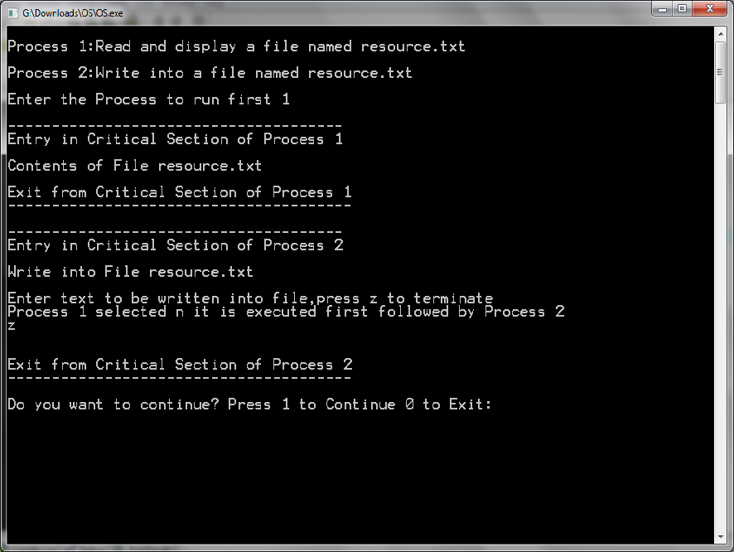

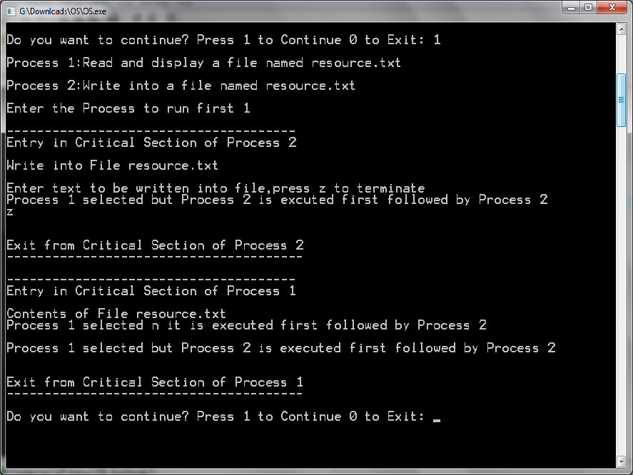
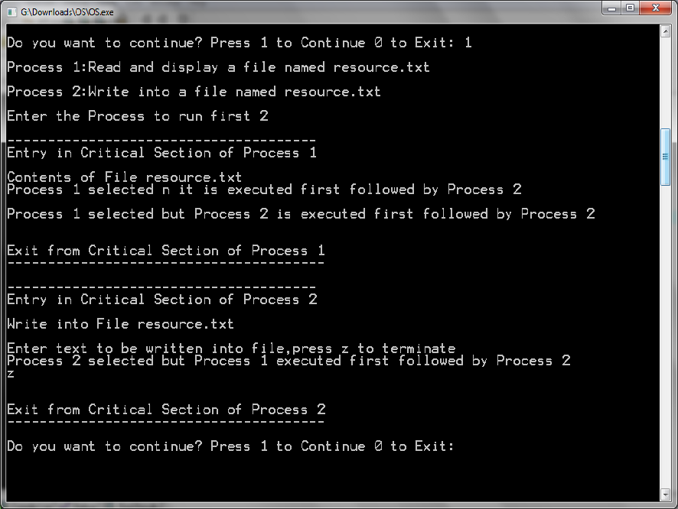

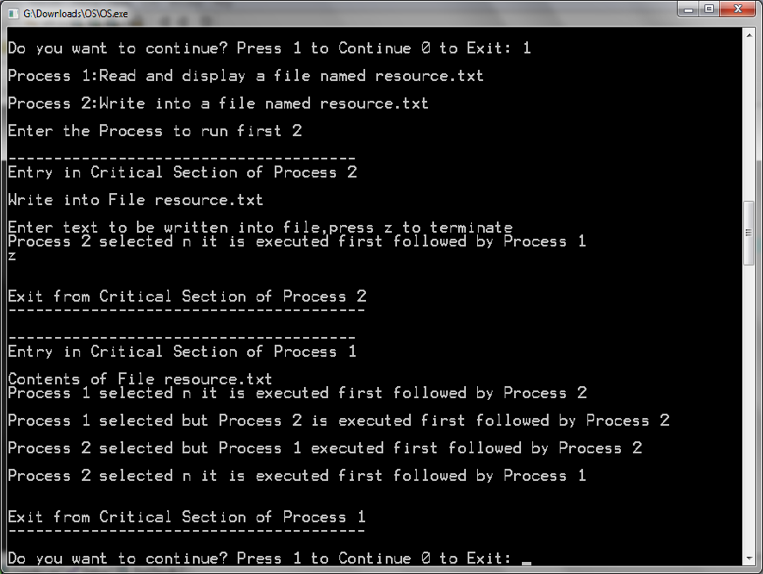

4. Conclusion:
s
When working at the hardware level, Peterson's algorithm is typically not needed to achieve atomic access. Some processors have special instructions, like test-and-set or compare-and-swap, that, by locking the memory bus, can be used to provide mutual exclusion in SMP systems.
Most modern CPUs reorder memory accesses to improve execution efficiency (see memory ordering for types of reordering allowed). Such processors invariably give some way to force ordering in a stream of memory accesses, typically through a memory barrier instruction. Implementation of Peterson's and related algorithms on processors which reorder memory accesses generally requires use of such operations to work correctly to keep sequential operations from happening in an incorrect order. Note that reordering of memory accesses can happen even on processors that don't reorder instructions (such as the PowerPC processor in the Xbox 360).
Most such CPUs also have some sort of guaranteed atomic operation, such as XCHG on x86 processors and Load-Link/Store-Conditional on Alpha, MIPS, PowerPC, and other architectures. These instructions are intended to provide a way to build synchronization primitives more efficiently than can be done with pure shared memory approaches.

5. References
- Operating System Concepts Sixth edition by Silberchatz Galvin Gagne
- http://en.wikipedia.org/wiki/Peterson's_algorithm
- http://informatik.unibas.ch/lehre/ws05/cs201/_Downloads/cs201-L14c-2up.pdf
- http://www.cs.jhu.edu/~yairamir/cs418/os3/sld006.htm
- http://web.sau.edu/lilliskevinm/csci410/2008Spring/slides/Ch07/09_algorithm3.htm

