ECEN 5803 MASTERING EMBEDDED

SYSTEMS ARCHITECTURE

PROJECT #2 MODULE 1

Team: Tharuni Gelli, Shruthi Thallapally, Aysvarya Gopinath

***1. Follow the directions in VisualStudioInstallationGuide1.pdf to install Visual Studio on your PC. You will need to configure the installation so that it can compile code for your ARM target processor.***

The installation images of visual studio are below:

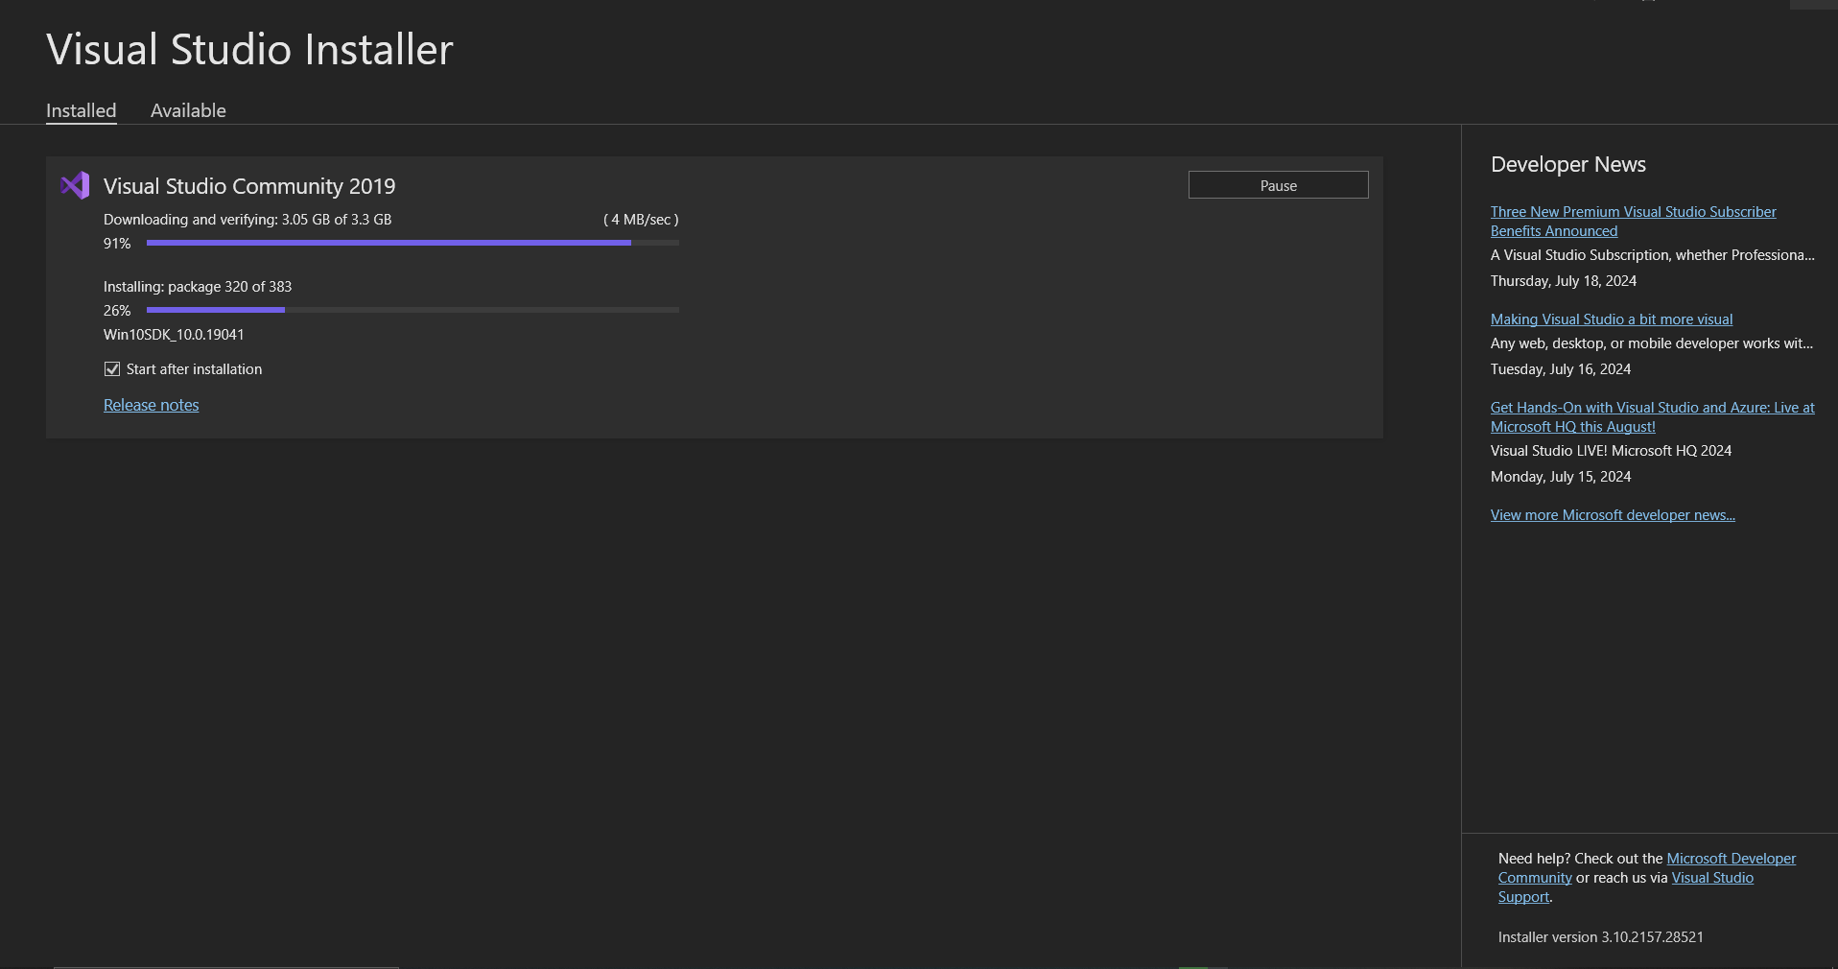

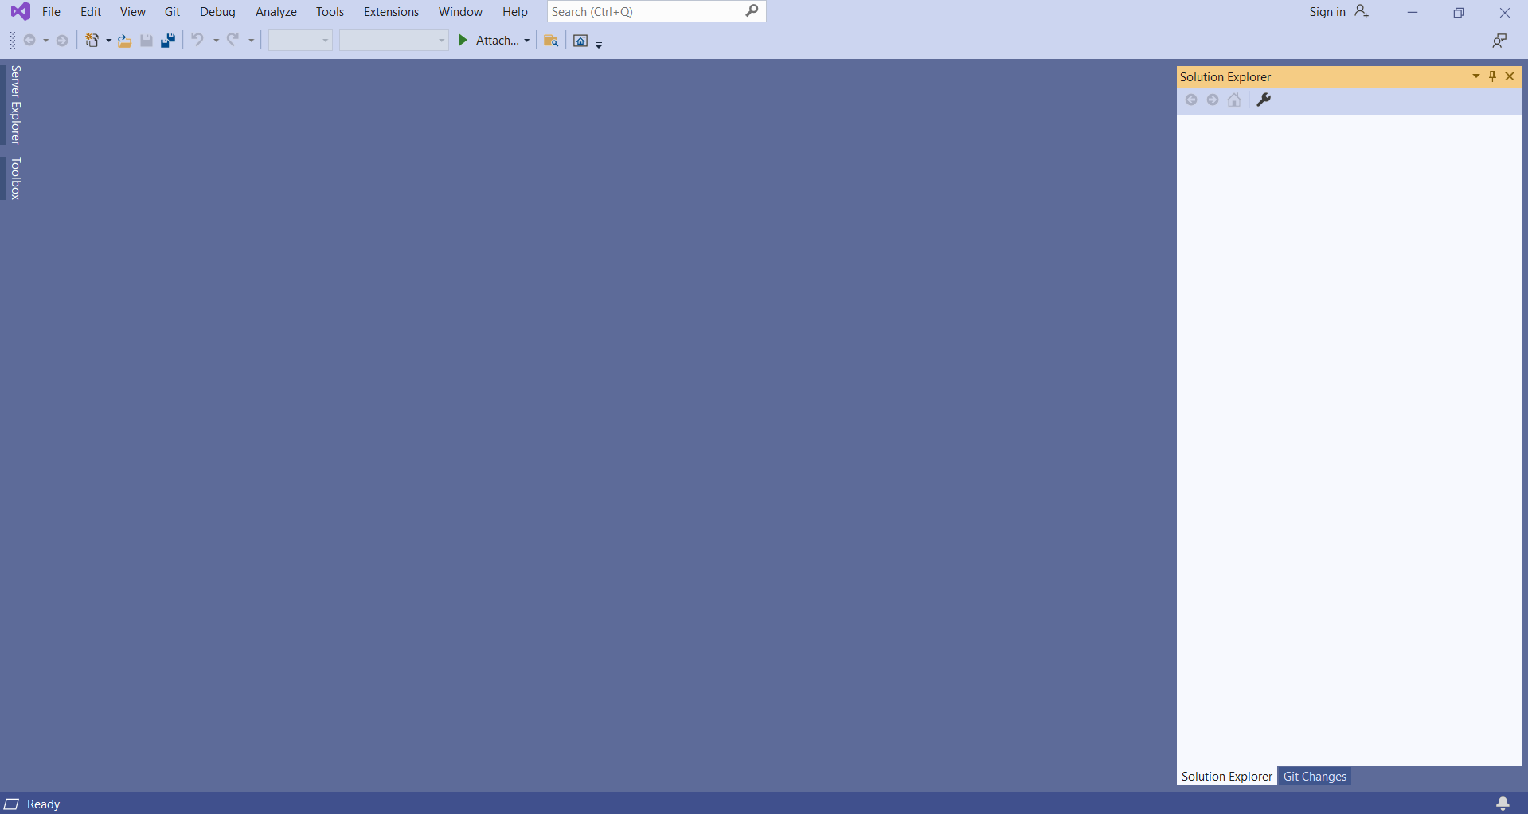

After installing the necessary tools, it jumps to the default operating screen of visual studio.

It can be seen that we have configured the tool for debugging ARM processors.

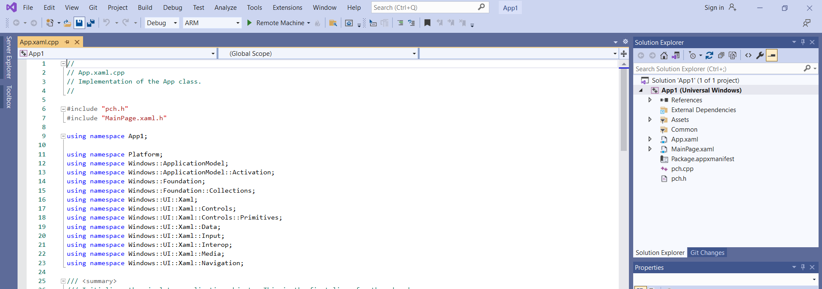

Thus the Visual studio was successfully installed and configured to compile code for ARM processor.

***2) Code development for Windows 10 IoT Core***

The windows 10 IOT core dashboard was installed and the OS was flashed in the Raspberry pi 3. The installation images are below:

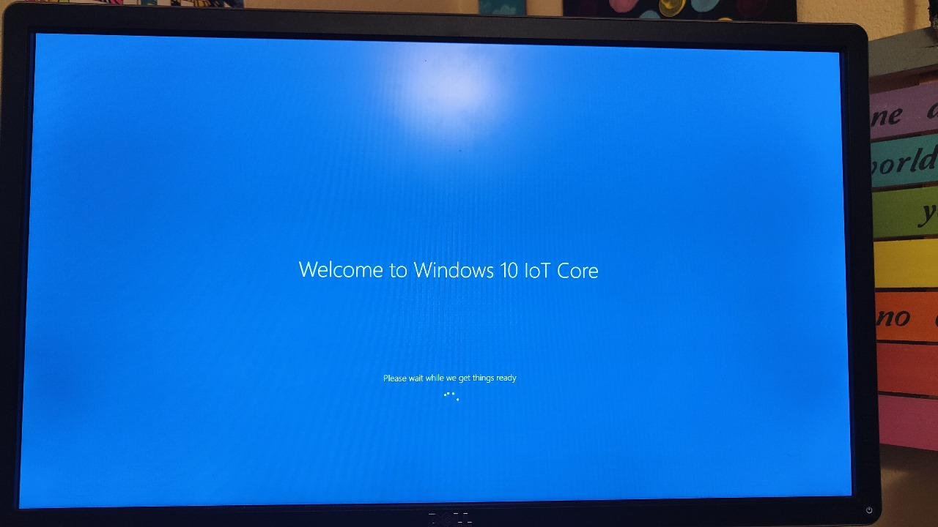

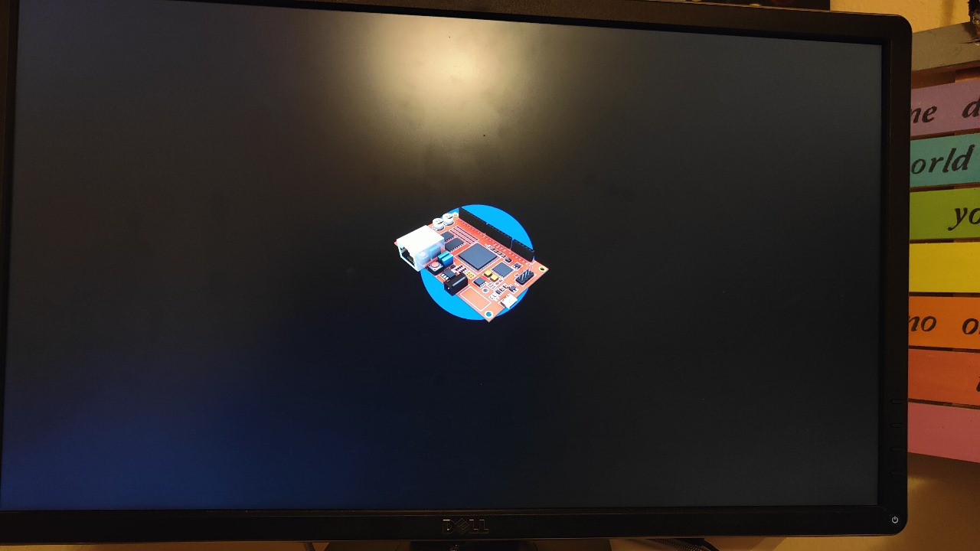

The network information of the connected Raspberry Pi 3 along with the IP address is displayed below.

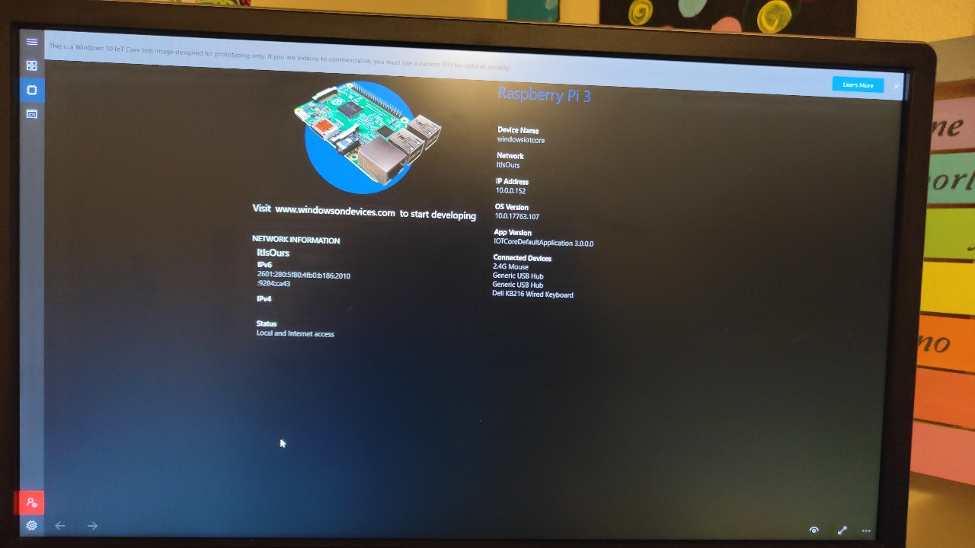

Windows 10 IoT (Internet of Things) is a special edition of the Windows 10 operating system optimized for use on embedded systems and IoT devices.Windows 10 IOT core can be integrated with Visual studio to be used as a deploying , development and debugging tool.Thus the code can be created in visual studio and run on the Rpi 3.The raspberry pi can be connected to the development laptop/desktop using wifi, ethernet or remotely connecting using the R pi’s IP address.