**CSE 5306 Lab # 1 An Instant Messaging System**

Implemented a Messaging System which allows the users to connect with each other and send messages between them.

Technology used: **PYTHON**

IDE: PyCharm

When one client is connected to other client, both the clients connected clients cannot receive messages from other clients.

Server.py is executed first, later client.py is executed and is prompted to enter the username. Once the username is entered, the client has to enter the recipient name he has to connect with. Once the connection is made, messages can be sent between them.

If the client has no messages to receive from any other client then the server send “no messages” to the client

Client1 logins in and send message to the recipient.

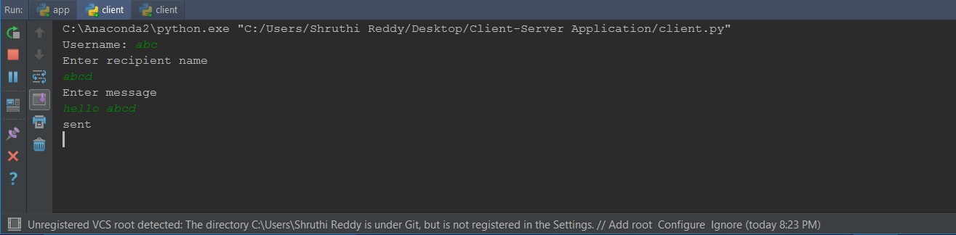

Server receives the message from the sender client and sends it to the specific receiver

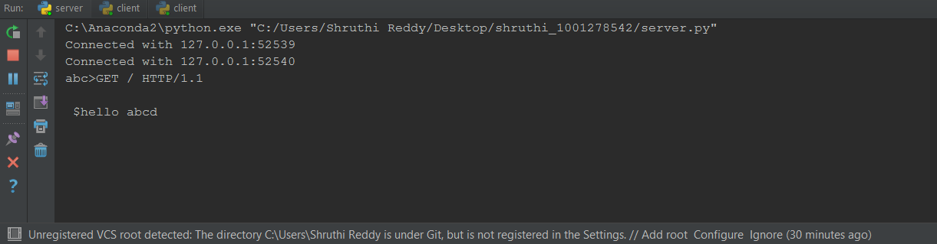

Client2 logins in and enter the client with whom he want to connect and receive messages from the client1 if sent any.

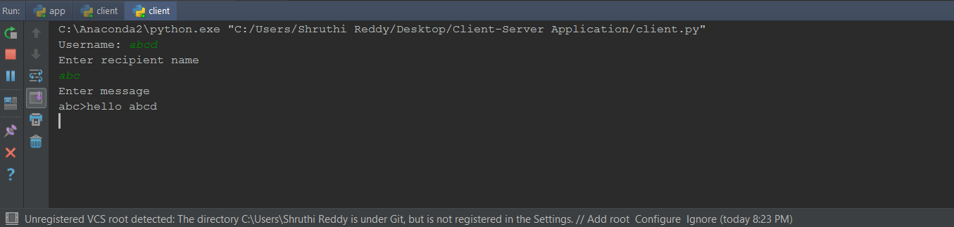

When Client3 logins and tries to connect and send message to Client1 or Client2. The request is rejected.

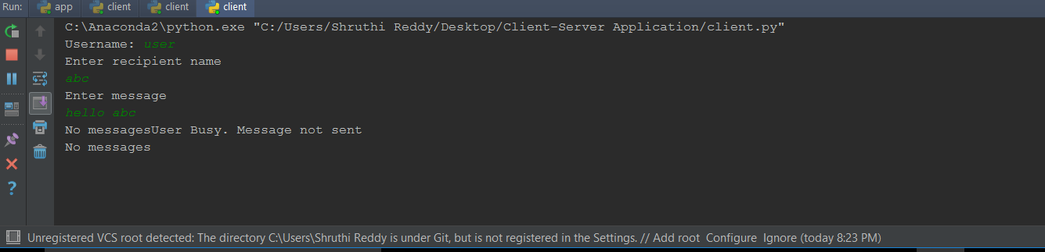

**REFERENCES:**

<https://docs.python.org/2/library/socket.html>

http://www.bogotobogo.com/python/python_network_programming_tcp_server_client_chat_server_chat_client_select.php