Coding Challenge: Farm Yield Optimization
The Tasks Write SQL queries to answer the following questions. Provide the queries and the resulting tables.
- Productivity & Performance
• Identify the top 3 most productive plots based on average yield per harvest. Show the plot_name, crop_type, and average_yield_kg.
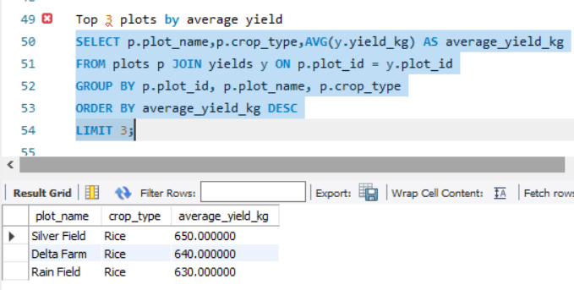
• Calculate the total water consumption for each plot and rank them from highest to lowest. Show plot_name and total_water_liters.
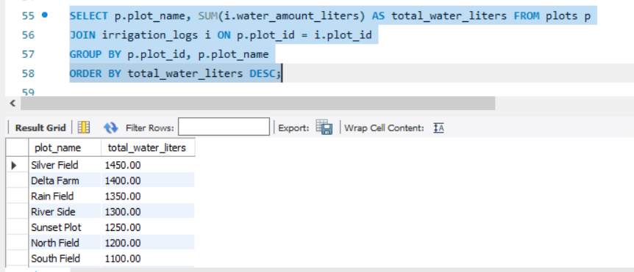
- Yield & Environmental Analysis
• Determine the average yield for each crop type under different weather conditions. The output should have crop_type, weather_condition, and average_yield_kg.
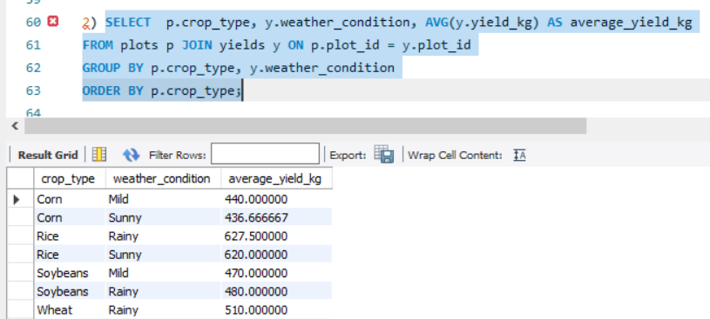
• Find the highest-yielding plot for each soil type. Show the soil_type, plot_name, and highest_yield_kg.
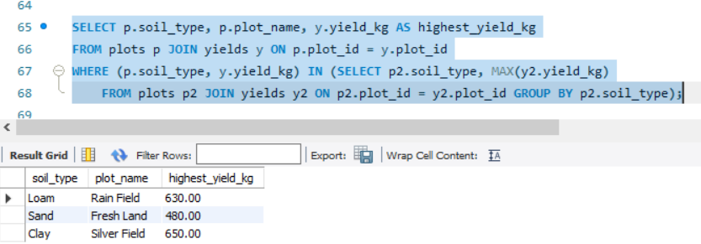

- Farmer & Resource Management
• Identify the farmer who manages the plots with the lowest average water consumption. Show the first_name, last_name, and their plots' average_water_liters_per_plot.
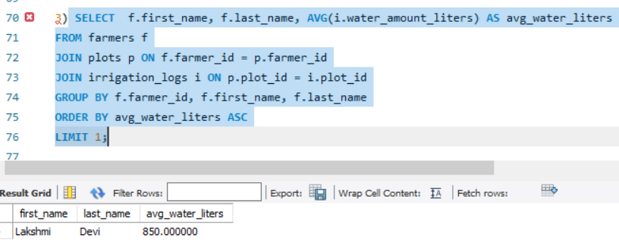
• Calculate the number of harvests per month for the last 12 months. Show the month and the number of harvests.
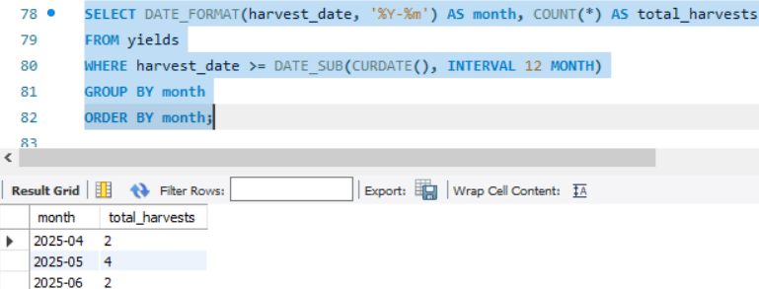
- Advanced Analysis (Bonus)
• Find plots that have a below-average yield for their specific crop type but an aboveaverage water consumption compared to all other plots with the same crop. List the plot_name, crop_type, yield_kg, and water_amount_liters.
