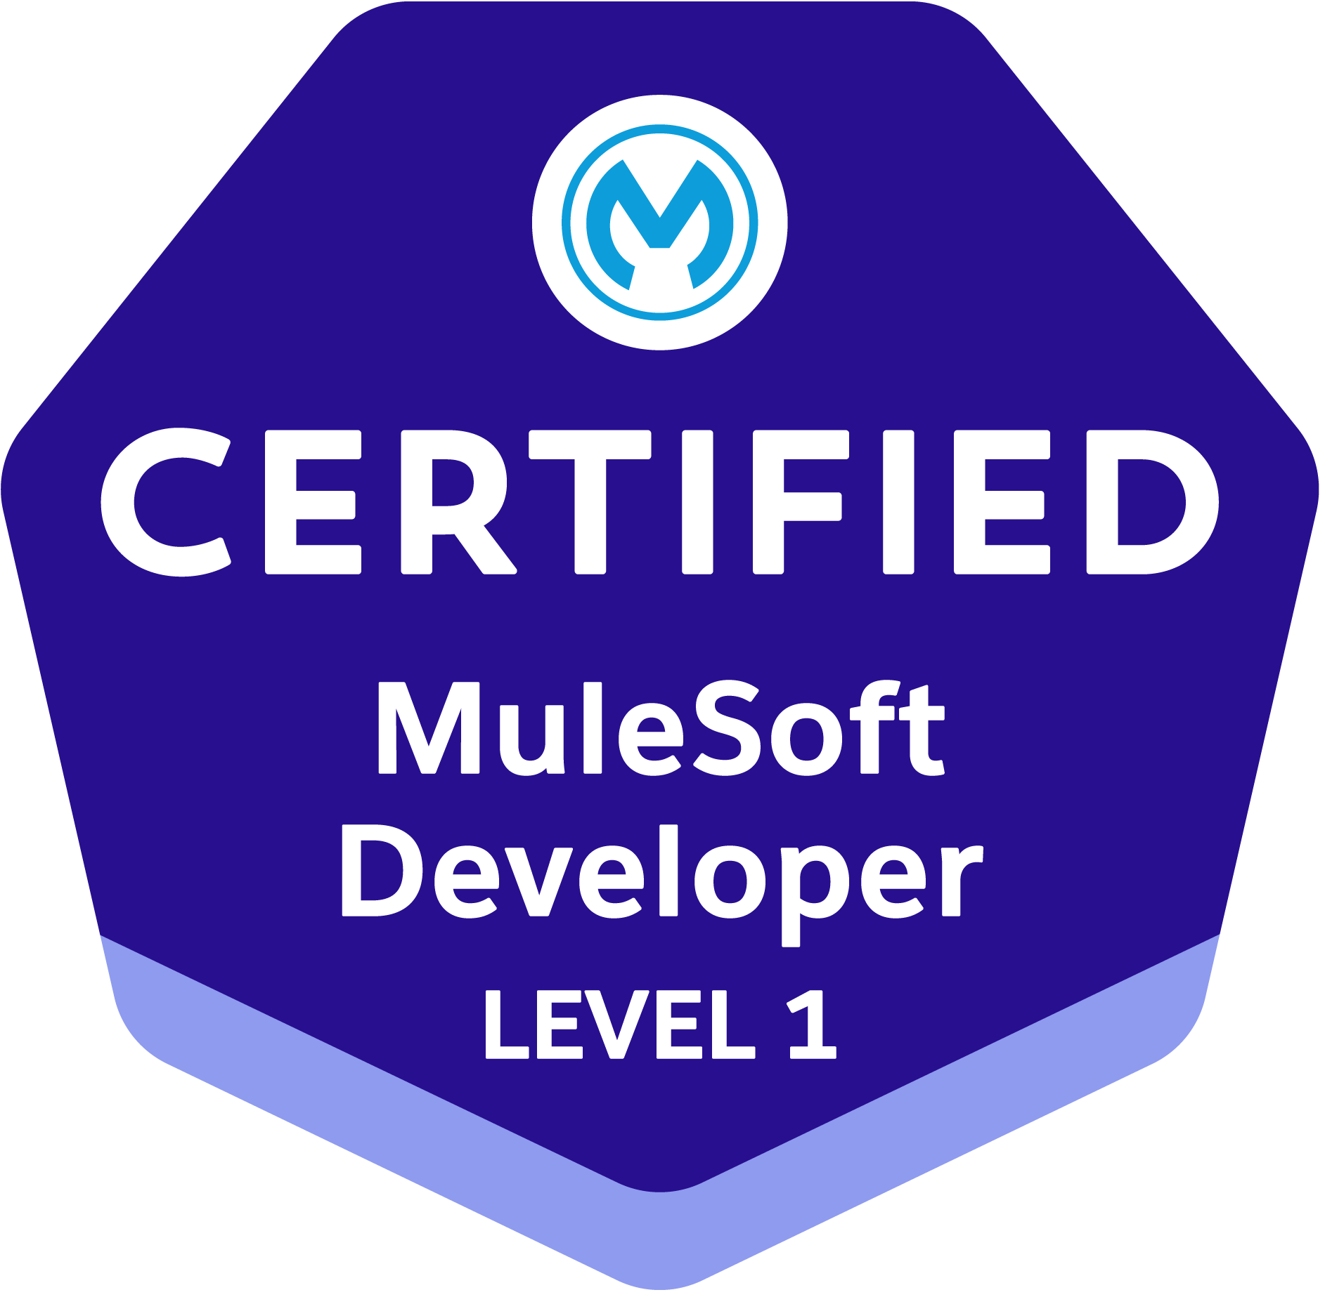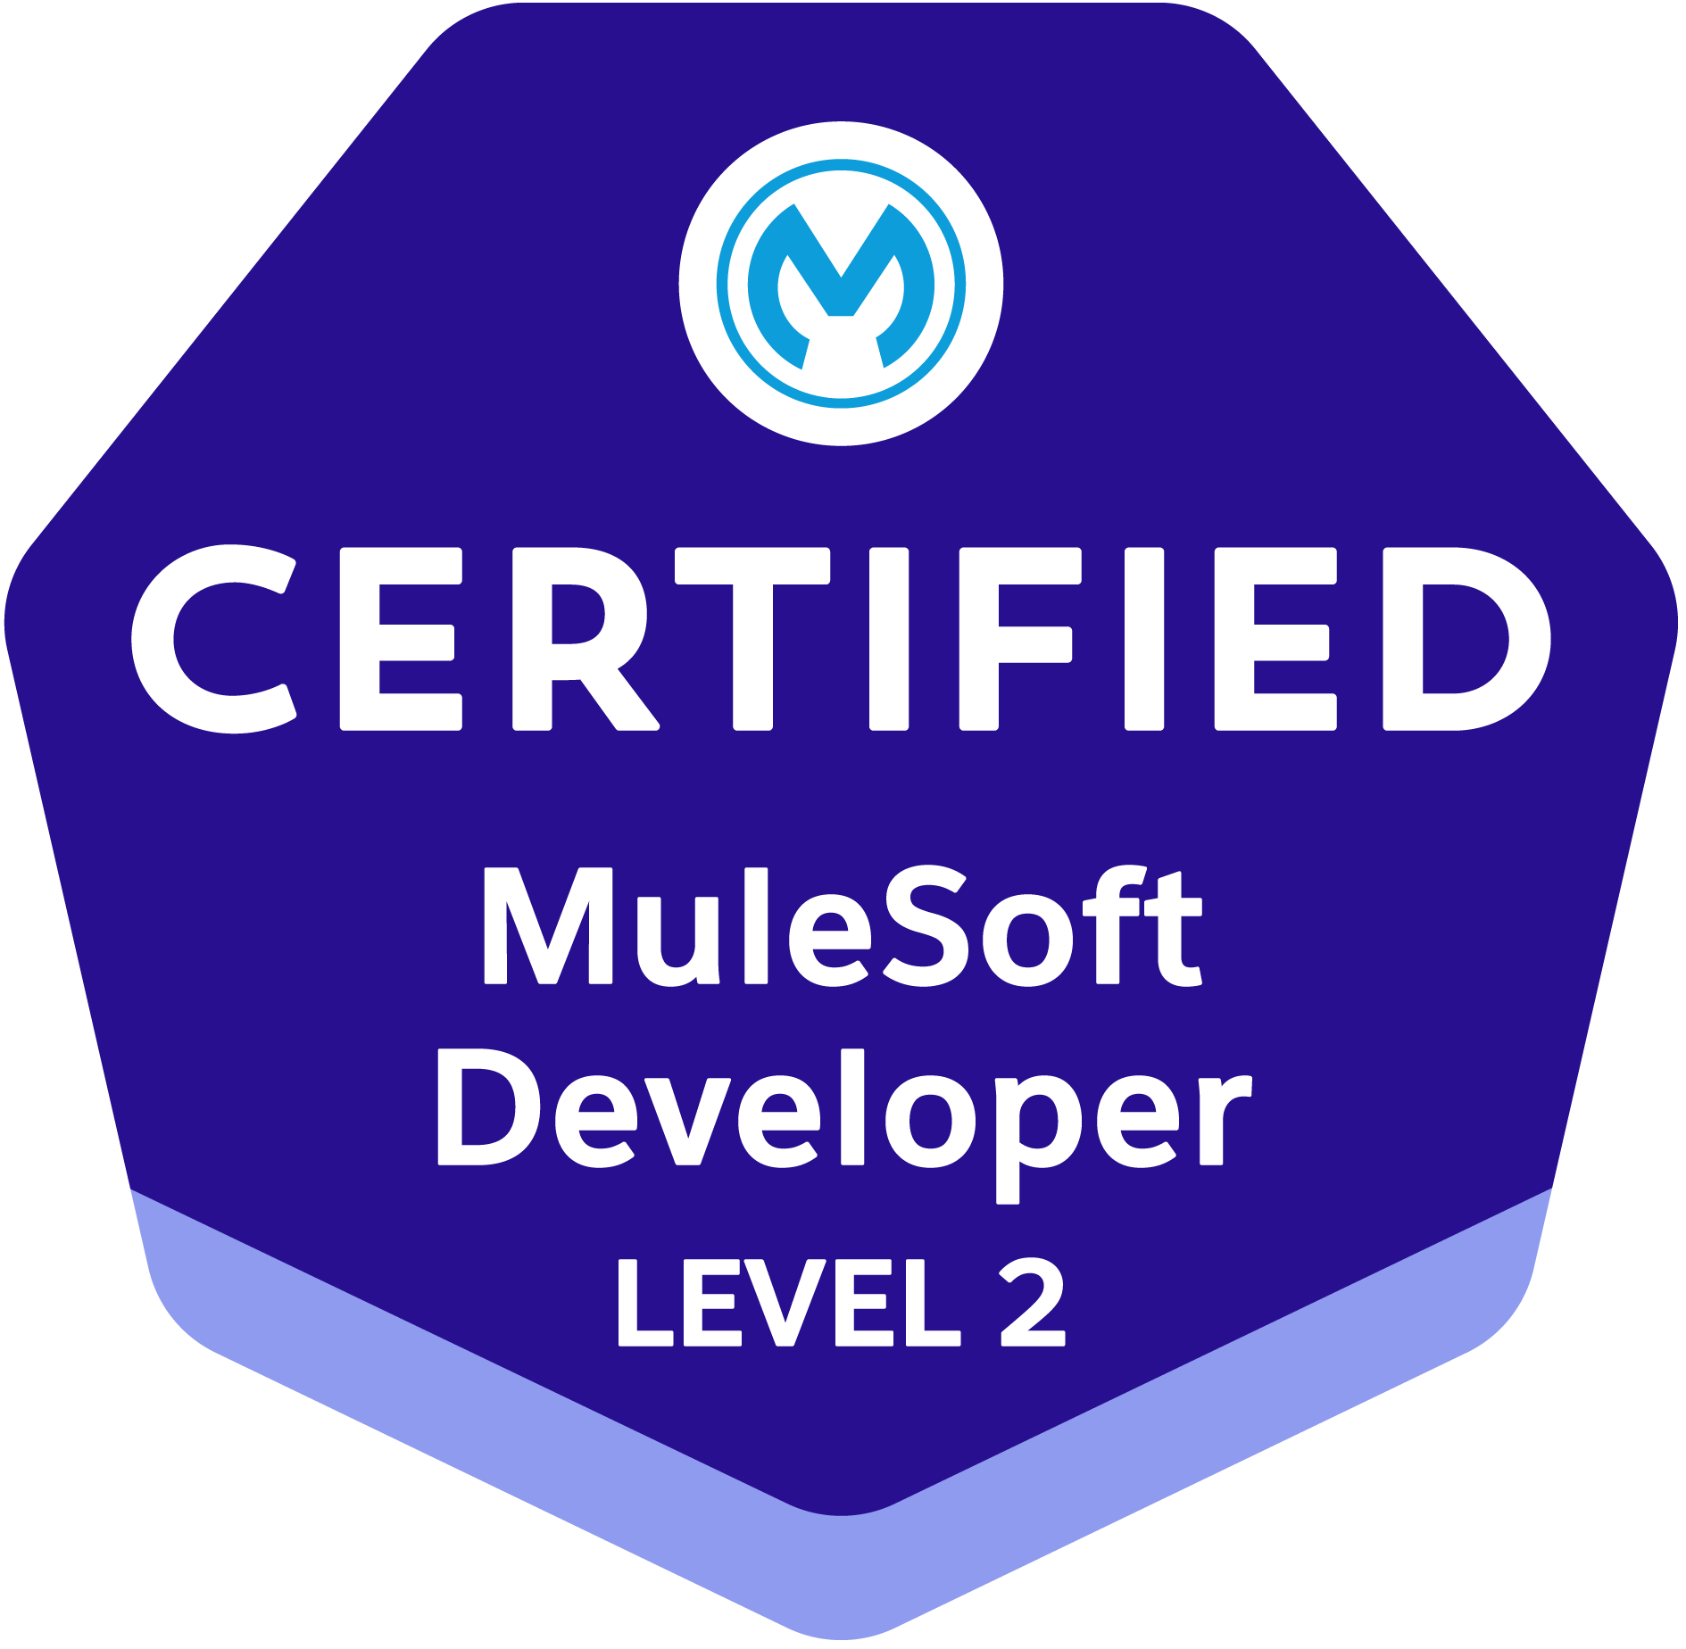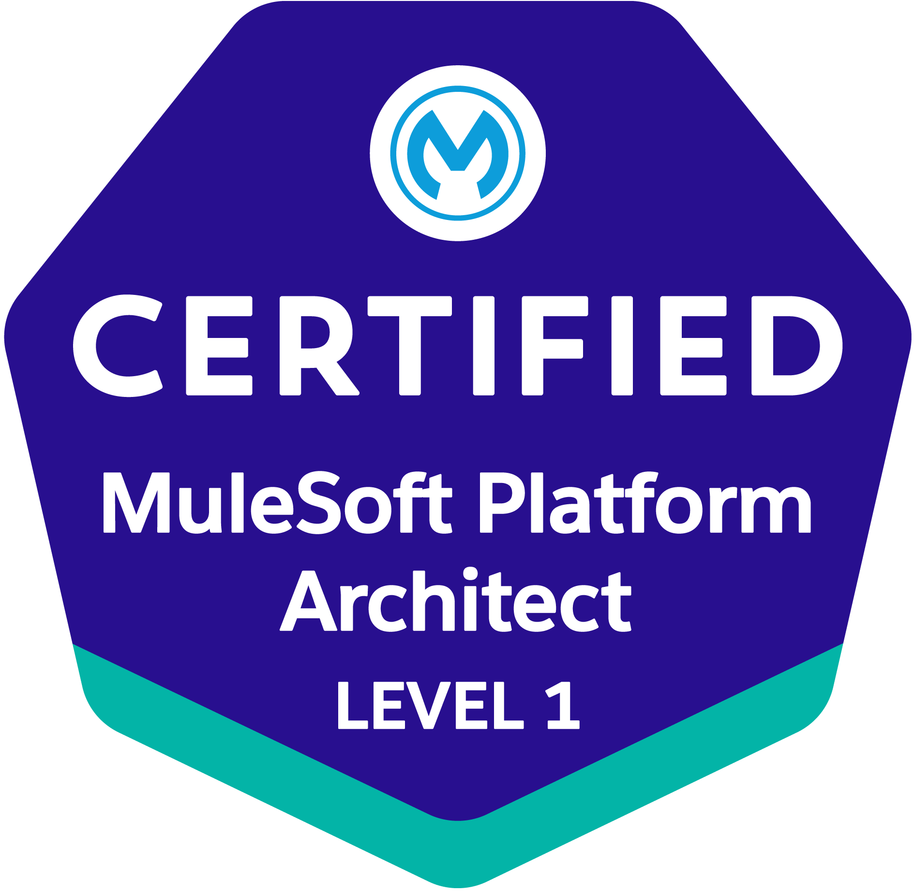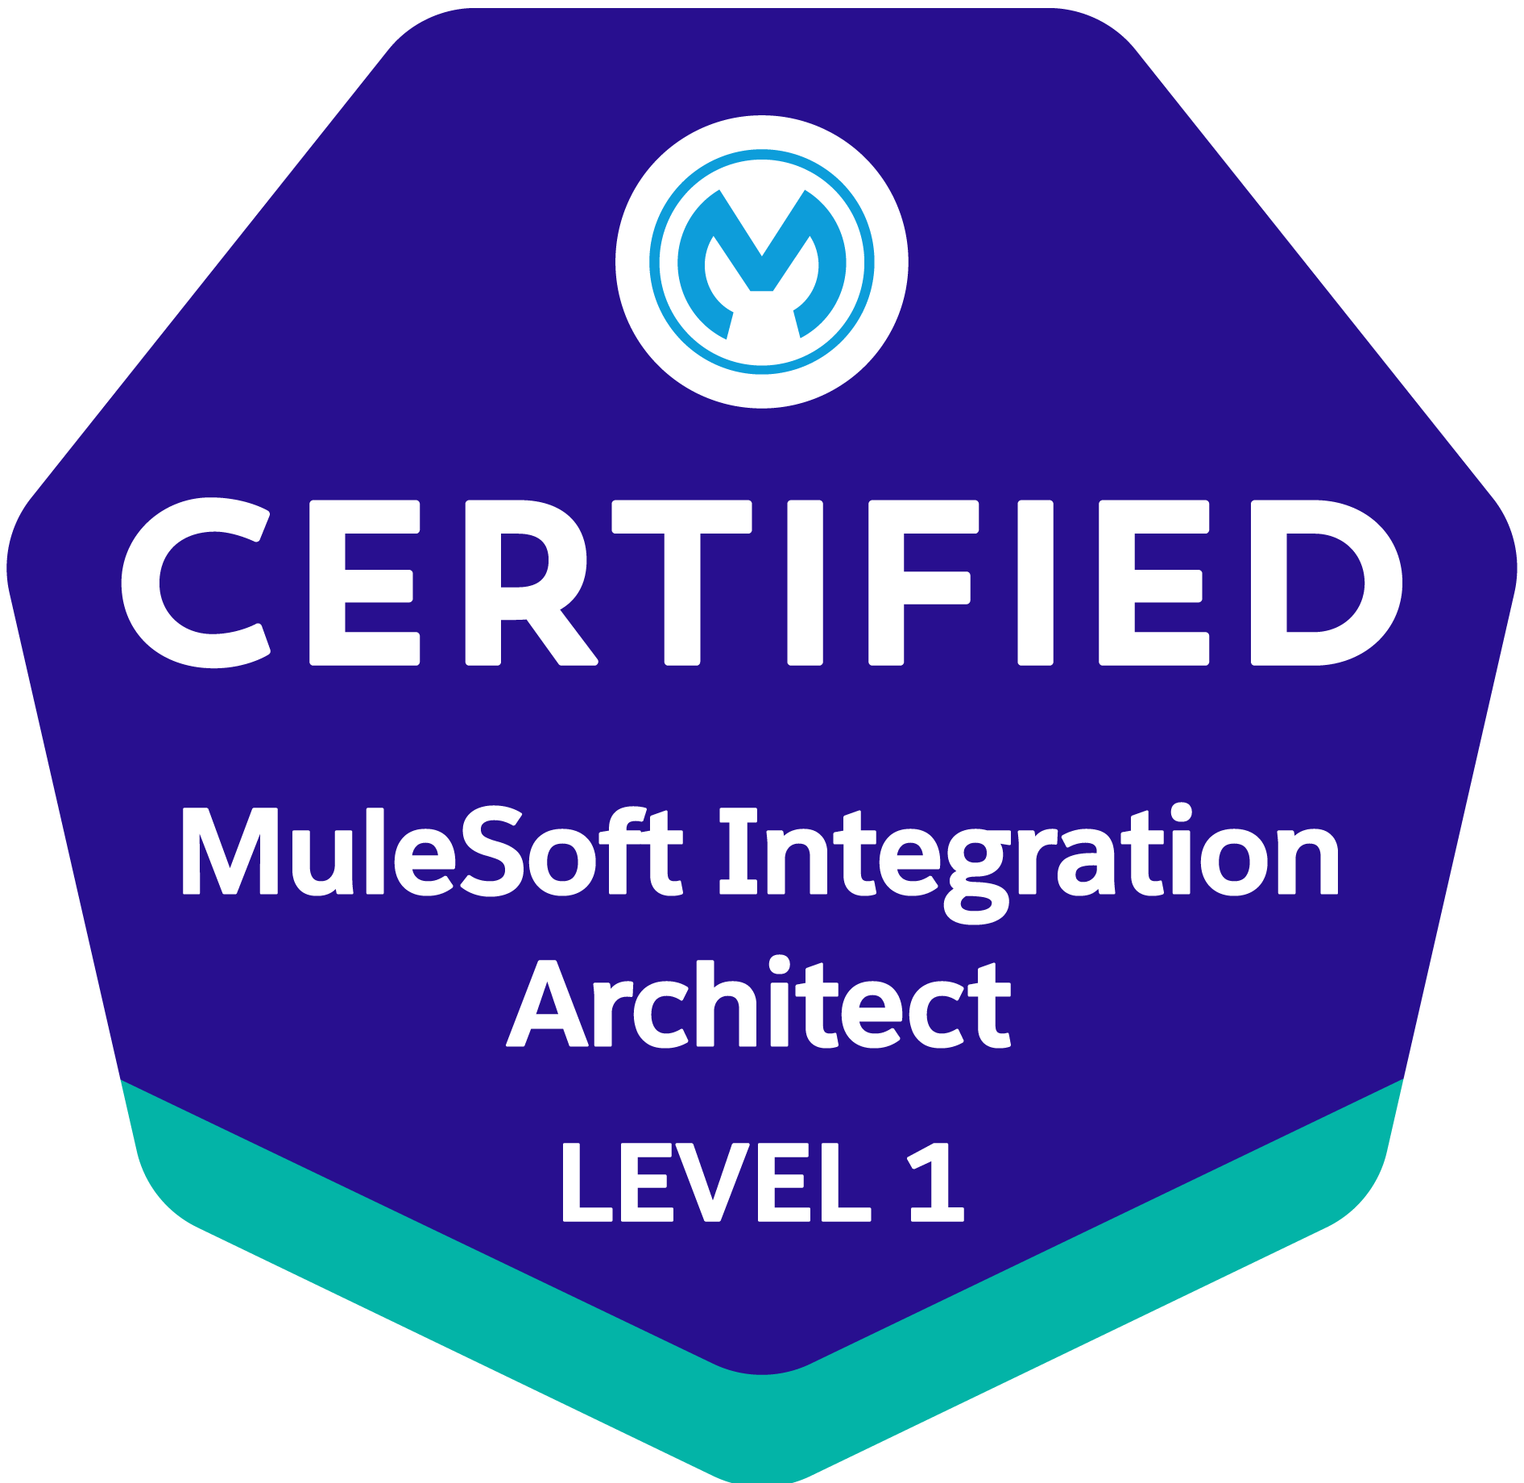

VENKATA RAMANA
Senior MuleSoft Developer
Email: tvramanamule4@gmail.com
Contact no: +91-9347692834.
_______________________________________________________________

CAREER OBJECTIVE:
A skilled, talented and dedicated IT professional with experience in MuleSoft Applications and recruitment looking for a challenging position to utilize my knowledge of designing, developing, implementing, low-cost solutions and reducing organization cost.
PROFESSIONAL SUMMARY:
- Overall 8+ years of experience in all aspects of Software Development Life Cycle (SDLC) including requirements analysis, design specification, code development, code integration, testing, Support and deployment.
- Having 7+ years of experience in Mule 3.x and 4.X Designing, Developing and deploying Mule Applications.
- Experience in Monitoring, Quick Defect Fixing and Maintain complete Anypoint Platform Activities in SRE.
- Experience in Thru Platform.
- Experience in AWS and SQL Database.
- Experience in Both Cloud and on-prem runtimes.
- Experience in creating Interface as per the business requirement
- Experience in Mule soft Enterprise security like securing the API with External OAuth provider 2.0, Basic authentication, JWT, Encryption, secure Placeholder etc.
- Experiences in Data weave Language 1.0, 2.0 for mapping and complex Transforming Data across Mule.
- Experience in Routers, Components, Transformers, Flow Controls, Connectors, Scopes, filters, Exceptions handling In Mule.
- Having experience on Git and Azure Devops.
- Hands on experience in mule expression language (MEL).
- Experience in creating jar files and uploading artifacts in Nexus repository using maven.
- Experience in creating SOAP Web Services and REST API’s using RAML (Restful API Modeling Language).
- Experience in configuring and Creating Maven based projects in Mule ESB.
- Good hands-on experience in Supporting Large Applications and working on Design Specifications.
- Consistent team player with problem solving skills with a can-do attitude.
- Ability to learn and use new systems and paradigms quickly.
- Having knowledge of creating Architecture Designs for API implementation.
- Experience in creating Design Documents (FSD and LLD).
- Worked on Error handler with On-continue, on-propagate.
- “Mule Soft Certified Platform & Integration Architect - MCPA & MCIA Level 1”
- “Mule Soft Certified Developer - Mule 4 MCD Level 1 & Level 2”

EDUCATION QUALIFICATION:

S.No | Year | Course | Insitute | Grade
1 | 2015 | M.Tech | Vignan Institute of Technology and Science from J.N.T.U.H | 82% with First Class with Distinction
2 | 2013 | B.Tech | Samskruti College of Engineering and Technology from J.N.T.U.H | 76% with First Class with Distinction
3 | 2009 | Diploma | J.N.GOVT. POLYTECHNIC, Ramanthapur, Hyderabad-13 from State Board of Technical Education | 65% with First Class
4 | 2006 | SSC | Z.P.H.S from State Board of Secondary Education | 65% with First Class

TECHNICAL SKILLS:
Languages : C, C++, Java
Tools : Mule Soft, Splunk, Anypoint Studio, Salesforce, PostgreSQL
Message Brokers : Active MQ, Anypoint MQ, Amazon SNS
DevOps tools : Oracle DB, MySQL and Azure
Servers : Mule standalone Server, Cloud Hub
Testing Tools : Soap UI, Postman
Operating Systems : Windows98, 2000, XP, Windows 7,8,10

EMPLOYMENT DETAILS:

- Working in Wipro 2023 March to till date.
- Worked in InvenioLSI 2022 Jan to 2023 Feb.

PROJECTS
Summary of Engagements

Project #1: National Gas SRE (Platform Engineering)
Designation: Senior MuleSoft Developer
Description: Monitoring for MuleSoft Anypoint and Thru Platform.
Role: Need to work on monitoring, quick defect fixing and platform activities of multiple API’s in Anypoint and Thru Platform.
Responsibilities:
- Analyzing and fixing the defect raised by user and monitoring the applications in Anypoint and Thru Platform.
- Maintain the complete activities in Platform.
- Generating the reports of API’s.
- Enhancing the schema Data in Salesforce and Maximo System.
- Enhancing the RAML files on API designer and deploying them to Cloud Hub.
- Development of mule flows in the system, process and experience layers.
- Enhancing data mappings using Data Weave and MEL expressions.
- Enhancing the Thru endpoints configurations.
- Enhancing the Thru flows and bound configurations.
- Used Git services through Azure Devops.
- Participate in design discussions and SRE leader Team Meetings.

Project #2: DAM (Digital Asset Mangement)
Designation: Senior MuleSoft Developer
Description: New API Implementations for Mule Soft.
Role: Need to work on new development requirement of multiple APIs for each Interface.
Responsibilities:
- Understand the business requirements by going through business requirements documentation and working according to it.
- Designing the RAML files on API designer and deploying them to Cloud Hub.
- Creating and enhancing the schema Data in Salesforce and Maximo System.
- Development of mule flows in the system, process and experience layers.
- Create Restful APIs using HTTP connector.
- Implement data mappings using Data Weave and MEL expressions.
- Used Git services through Azure Devops.
- Participate in design discussions and sprint planning.
- Participate in 24X7 production support effort after application go-live.

Project #3: National Gas CIS
Designation: Senior MuleSoft Developer
Description: Migration services for Mule Soft.
Role: Need to work on migration related tasks to replace existing source system.
Responsibilities:
- Understand the business requirements by going through business requirements documentation and working according to it.
- Coordinate with program managers to explain what tasks were possible for the system to achieve their desired output.
- Designing the RAML files on API designer and deploying them to Cloud Hub.
- Development of mule flows in the system, process and experience layers.
- Create Restful APIs using HTTP connector.
- Implement data mappings using Data Weave and MEL expressions.
- Used Git services through Azure Devops.
- Participate in design discussions and sprint planning.
- Participate in 24X7 production support effort after application go-live.

Project #4: Informa TandF (Retail MANAGEMENT)
Designation: MuleSoft Consultant
Description: Managerial services for Mule Soft.
Role: Need to work on change request and troubleshooting the issue, need to work on root cause and solution.
Responsibilities:
- Understand the business requirements by going through business requirements documentation and working according to it.
- Coordinate with program managers to explain what tasks were possible for the system to achieve their desired output.
- Designing the RAML files on API designer and deploying them to Cloud Hub.
- Creating eBooks seller’s buckets and secret manager in AWS.
- Creating and enhancing the schema Data in PostgreSQL Database.
- Development of mule flows in the system, process and experience layers.
- Create Restful APIs using HTTP connector.
- Implement data mappings using Data Weave and MEL expressions.
- Used Git services through GitHub Actions.
- Participate in design discussions and sprint planning.
- Participate in 24X7 production support effort after application go-live.

Project #5: FTA (Federal Tax Authority)
Designation: MuleSoft Developer
Description: Managerial services for Mule Soft.
Role: Need to work on change request and troubleshooting the issue, need to work on root cause and solution.
Responsibilities:
- Contributing and taking part software and architectural development activities
- Developing well-designed, efficient, and testable code
- Conducting software analysis, programming, testing, and debugging
- Troubleshooting and resolving the reported issues and replying to queries in a timely manner
- Preparing and producing releases of software components
- Improve the code quality by implementing best practices

Name | Venkata Ramana
Date of Birth | 25-08-1991
Languages | English, Hindi, Telugu

