**About the Data**

We have a data that has following information,

1. Product Attributes
2. Customer and Product rating
3. Product Price information
4. Competitor Price information
5. Date and Day
6. Information on seasonality

**Understanding Data**

**Basic Statistics**

* 1. Idea of what the data looks like, types of variables, their ranges and any missing values

**Exploratory Data Analysis**

**Histogram plot to illustrate the distribution of various features**

* **qty (Quantity)**: The distribution is right-skewed, indicating that most transactions involve lower quantities, but there are some instances of very high quantities.
* **total_price**: Also right-skewed, suggesting that most transactions have lower total prices, with fewer high-value transactions.
* **freight_price**: Shows a relatively normal distribution with a peak around 20-30. This suggests most freight prices fall within this range.
* **unit**_**price**: The unit price has a multimodal distribution with several peaks, indicating different price bands for products.
* **product_weight_g**: Most products are lightweight (under 2000 grams), with fewer heavier items.
* **product**_**score**: The product scores cluster around 3.6 to 4.4, indicating generally good product ratings.
* **customers**: Distribution indicates that most transactions involve a smaller number of customers, with fewer involving large numbers of customers.
* **holiday**: Most transactions occur on non-holidays, with fewer on holidays.
* **month**: Distribution shows seasonality, with peaks in certain months indicating higher transaction volumes.
* **comp_1 ,comp_2 and comp_3**: Shows a right-skewed distribution, indicating most competitor prices are lower, with fewer higher prices.

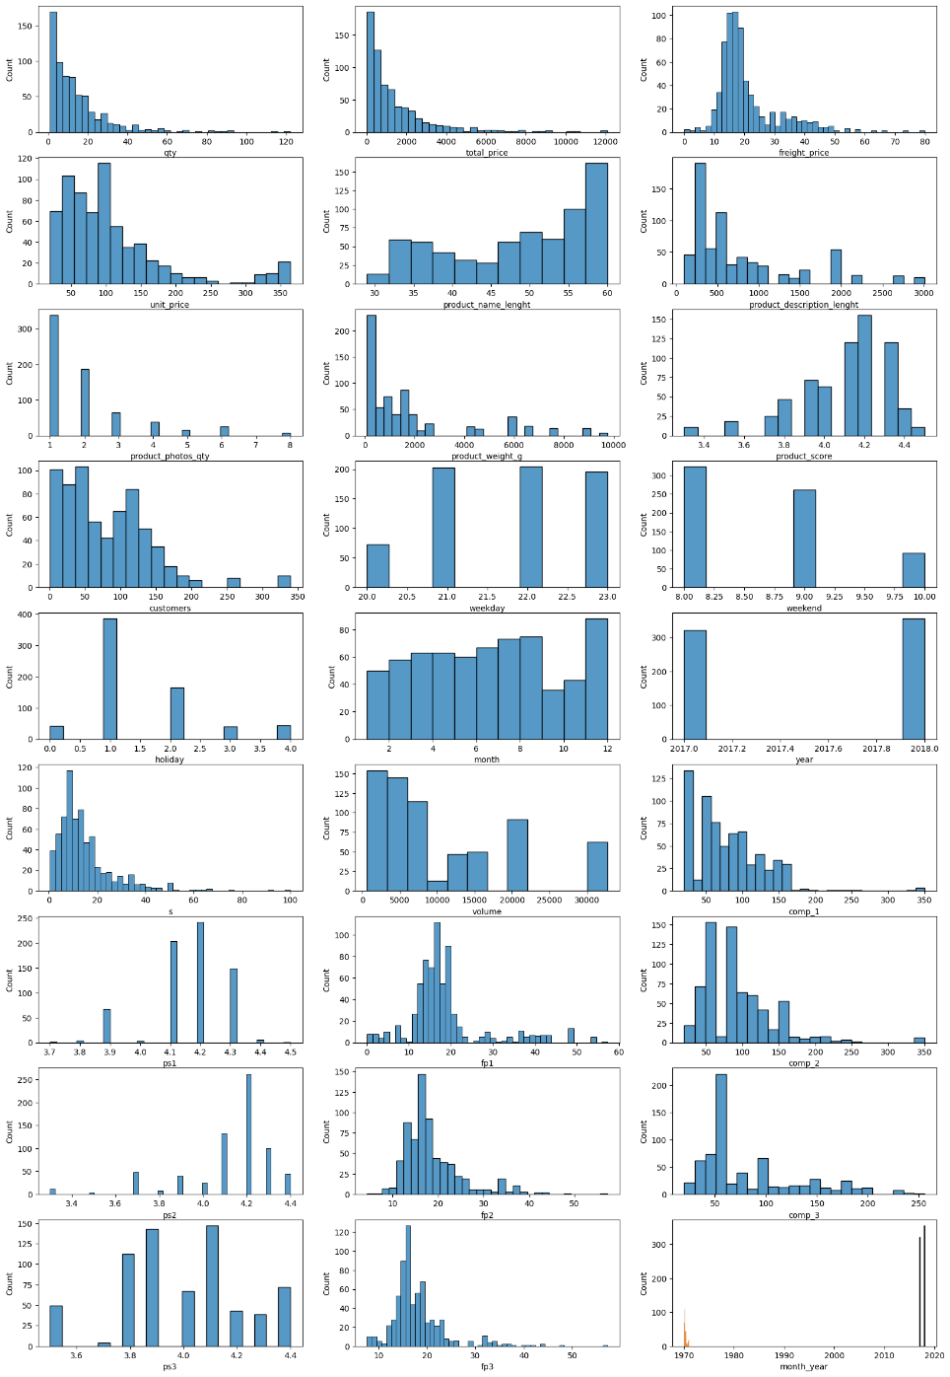

**Understanding categories with high value transactions**

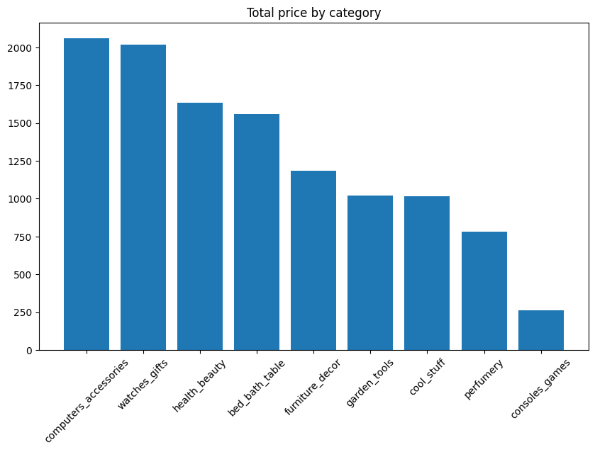

**Understanding unit price of the product categories**

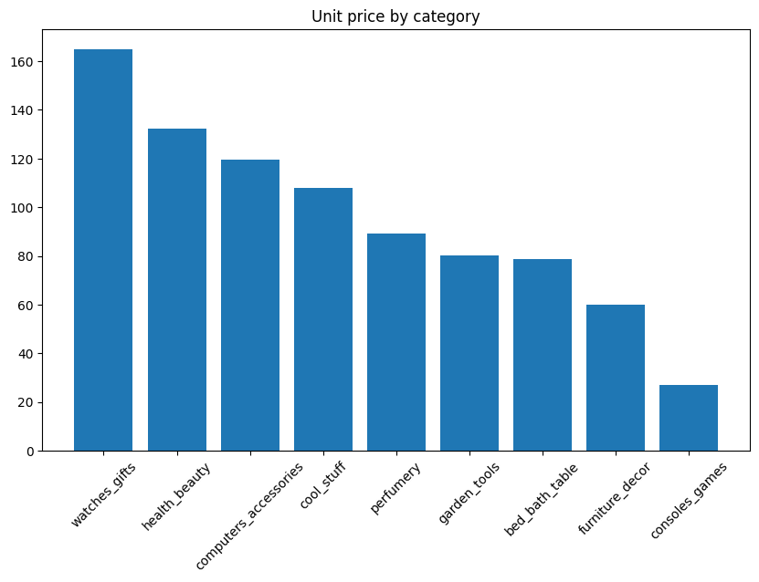

**Comparing with competitors product pricing**

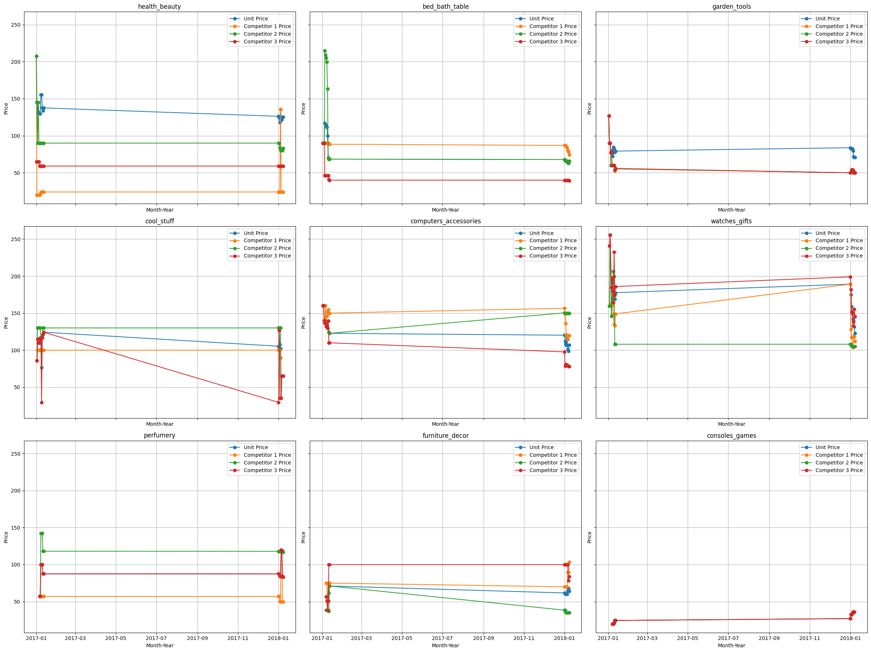

Interpretations:

1. Health Beauty: The unit price is relatively stable but higher than competitor prices. Competitor 1 and 2 prices are close to each other, with Competitor 3 slightly lower.

2. Bed Bath Table: Unit price drops significantly over time, aligning closer to competitor prices.

3. Garden Tools: The unit price is higher than competitor prices, which are relatively stable.

4. Cool Stuff: The unit price is stable, whereas Competitor 3 price drops significantly over time.

5. Computers Accessories: The unit price trends upwards, while competitor prices remain relatively stable.

6. Watches Gifts: The unit price increases over time, surpassing competitor prices which also show an increasing trend.

Strategic Actions that can be taken in future for Product Pricing:

1. Freight Cost Analysis:

* Dive deeper into categories with variability to understand underlying causes (e.g., supplier changes, fuel costs).
* Analyze whether changes in freight prices correlate with changes in sales or customer satisfaction.

1. Benchmarking Against Competitors:

* Regularly benchmark your freight prices against competitors to ensure competitiveness.
* Consider strategic adjustments during periods of competitor price changes to capture market share.

1. Optimization Opportunities:

* For categories with significant freight cost increases, explore logistics optimization, such as bulk shipping, better packaging, or alternate shipping methods.
* Implement technology or partnerships to gain more control over shipping and freight costs.

1. Forecasting Future Prices:

* Use historical trends to forecast future freight prices and incorporate these forecasts into pricing strategies and budget planning.

**Comparing the freight price amongst competitors**

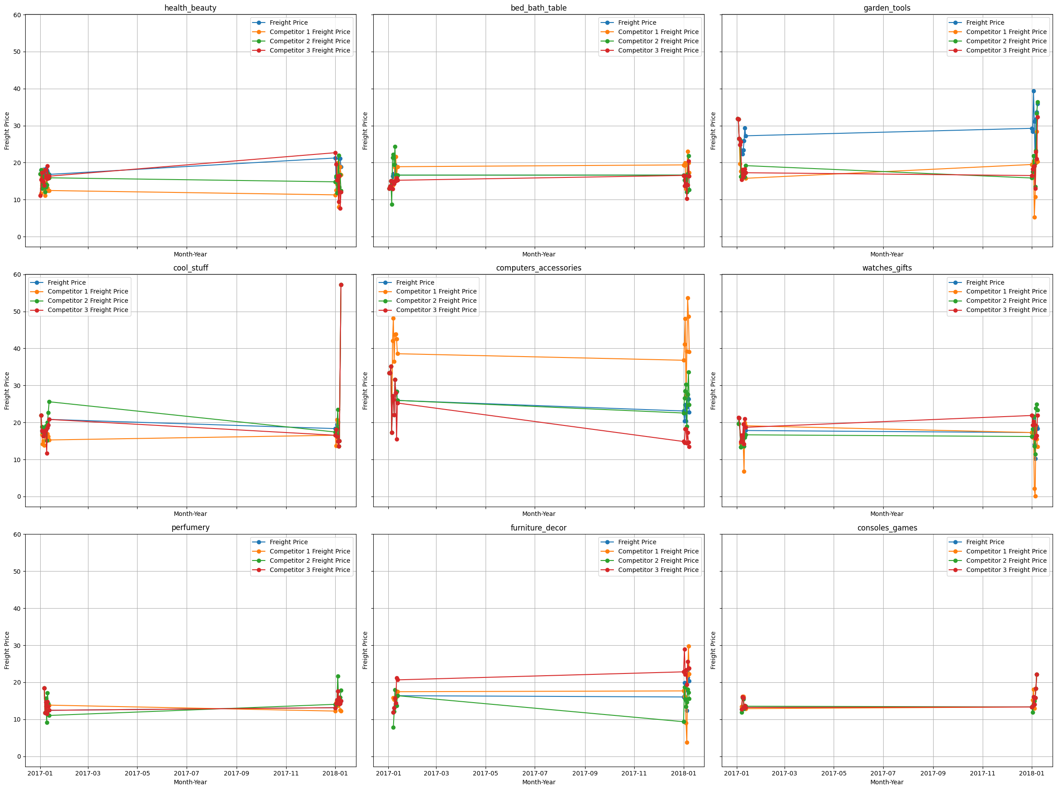

Interpretations:

* There is a notable alignment in the freight prices of the competitors across most product categories, indicating possible market-wide freight cost structures.
* In categories like cool_stuff and computers_accessories, there's more variability, suggesting potential pricing strategies or market conditions affecting freight costs differently.

**Comparing the product rating among the competitors**

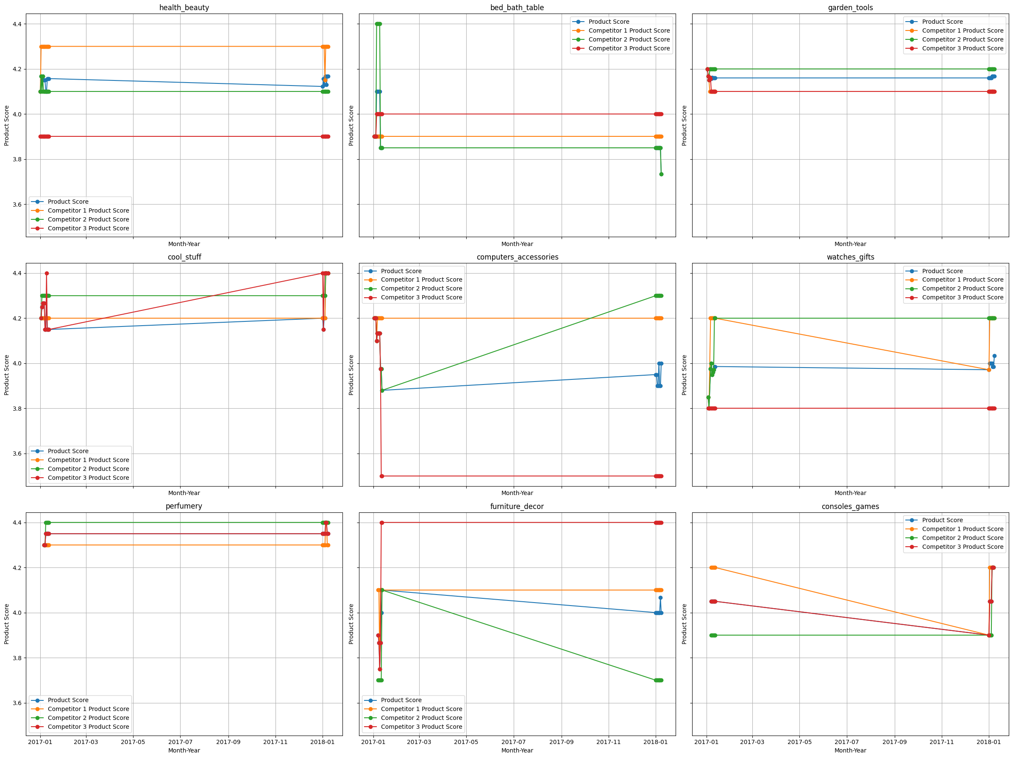

Interpretations:

* Bed, Bath & Table: There is a significant drop in product scores around the middle of the period, followed by stabilization.
* Cool Stuff: There is a gradual increase in your product score, while competitors' scores remain relatively stable.
* Computers & Accessories: Significant variability in product scores, especially for Competitor 1 and Competitor 3. Your scores show a slight increase towards the end.
* Watches & Gifts: Product scores show a notable decline for Competitor 2 and Competitor 3, while your scores remain stable.
* Furniture & Decor: There is a sharp decline in product scores for Competitor 1 and Competitor 2, while your scores remain relatively stable.
* Consoles & Games: Significant drop in product scores for all competitors towards the end of the period.

**Competitor Comparison:**

Categories like bed_bath_table, computers_accessories, and consoles_games show more variability, suggesting potential issues with product quality or changes in consumer perception.

**Implications for Product Strategy:**

* **Quality Consistency**: Stable scores in categories like **health_beauty** and **perfumery** indicate strong product consistency, which is crucial for maintaining consumer trust.
* **Quality Improvement Opportunities**: Categories with declining scores (e.g., **bed_bath_table**, **computers_accessories**) may need quality improvements or better customer feedback management.
* **Competitive Positioning**: Understanding where competitors are losing ground (e.g., **watches_gifts, furniture_decor**) can provide opportunities to capitalize on their weaknesses by highlighting your product strengths.

**Next Steps for Strategic Actions to improve Product Score:**

1. **Quality Assurance and Improvement:**

* **Monitor and Improve: Regularly monitor product scores and identify areas for quality improvement, especially in categories showing variability.**

1. **Benchmarking and Market Positioning:**

* **Competitive Analysis: Continuously benchmark against competitors to understand relative positioning in terms of product quality.**
* **Marketing Emphasis: Highlight categories where your product scores are stable or improving in marketing campaigns to attract quality-conscious consumers.**

1. **Targeted Quality Initiatives:**

* **Product-Specific Strategies: For categories like computers_accessories and consoles_games, where there is significant score variability, conduct deep dives to understand root causes and implement targeted quality initiatives.**

1. **Long-Term Trends and Forecasting:**

* **Historical Analysis: Use historical product score trends to forecast future scores and proactively address potential quality issues.**

**Customer Insights on Product Groups**

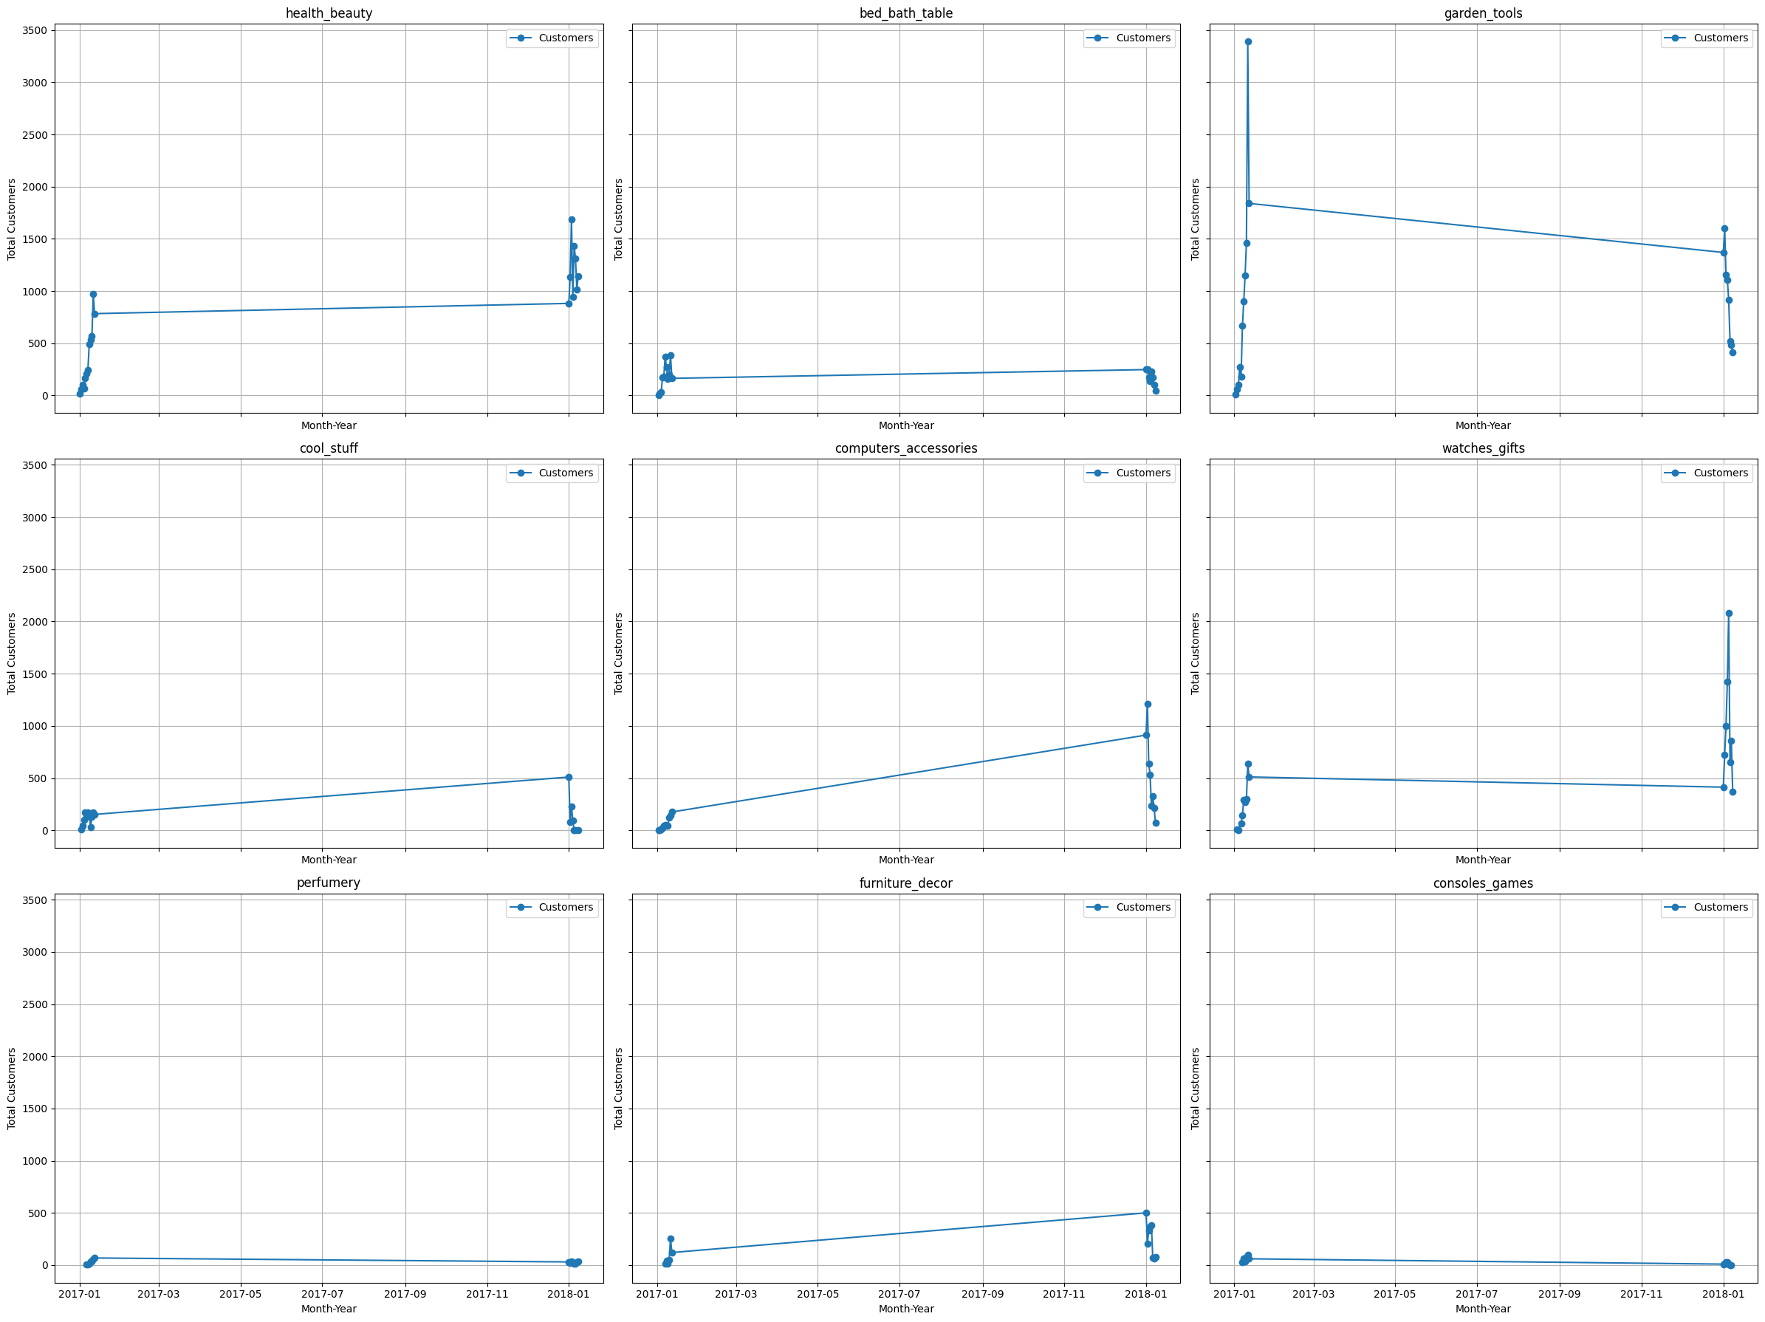

Interpretation:

* Health Beauty: There is a noticeable increase in customers towards the end of the time period.
* Bed Bath Table: The customer count is relatively stable with slight fluctuations.
* Garden Tools: There is a decrease in customers towards the end of the time period.
* Cool Stuff: Shows a gradual increase in customers over time.
* Computers Accessories: The customer count increases steadily over the period.
* Watches Gifts: A sharp increase in customers towards the end of the period.
* Perfumery: The customer count remains low with minor increases.
* Furniture Decor: Shows a stable trend with slight increases.

**Heatmap Plot to understand the relationship between variables**

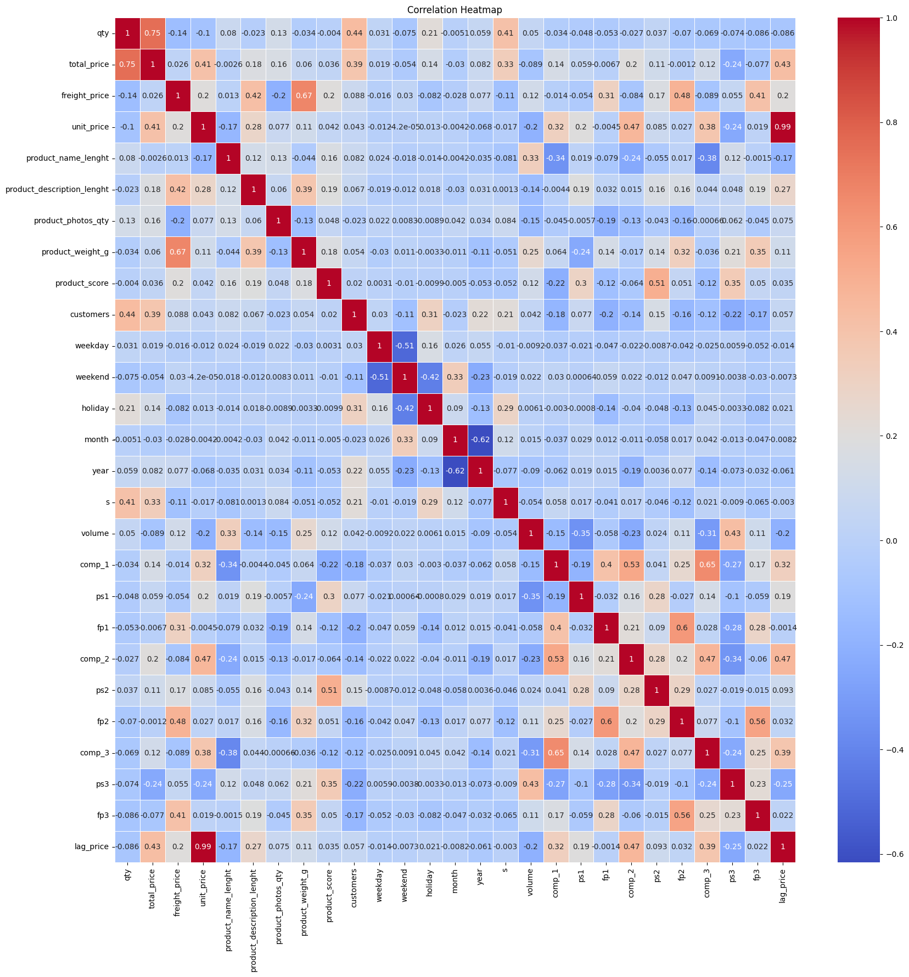

Interpretations:

1. Product and Pricing Strategy: The strong correlation between total price and quantity suggests that volume sales are critical. Ensuring competitive pricing and promotions to boost quantity sold can significantly impact revenue.

2. Competitor Analysis: Understanding the close correlation between competitors' prices can help in anticipating market moves and adjusting pricing strategies accordingly.

3. Freight Cost Management: Given the strong relationship between product weight and freight price, optimizing packaging and logistics for weight efficiency can reduce shipping costs.

4. Seasonality and Consumer Behavior: The differences in behavior between weekends and weekdays highlight the need for tailored marketing strategies and inventory management to capitalize on these variations.

5. Price Stability: The near-perfect correlation between lag price and unit price suggests a stable pricing environment. Exploring the reasons for price stability can reveal insights into market dynamics and pricing power.