
Department of Computer Science and Engineering
ALGORITHMIC PROBLEM-SOLVING HACKATHON (APSH 2026)
PROJECT DOCUMENTATION
Date: 03-10-2026 | Venue: 3rd Floor, A & B Blocks
Field | Details
Project Title | College Timetable Generator
Team Name / Team No. | 2
Year / Semester / Section | II Year B.Tech / I Sem / A
Algorithm Paradigm Used | Greedy / Backtracking / Graph
Programming Language / Tools | Python, Flask, HTML/CSS/JS, SQLite
Faculty Mentor | Edukondalu
Team Members
S.No | Name of the Student | Roll No. | Role
1 | Pragna Sree Allu | 25MVCSMR0071 | Team Lead
2 | B.Shruthi | 25MVCSMR0010 | Team Member
3 | B.Indu | 25MVCSMR0013 | Team Member
4 | R.Lekha Reddy | 25MVCSMR0072 | Team Member

1. Problem Statement
The College Timetable Generator aims to automatically generate a conflict-free timetable for a college. The
system must assign subjects to student batches, faculty members, rooms and available time slots while avoiding
scheduling conflicts. APSH2026_Project_Documentation_…
Inputs:
- Student batches
- Subjects
- Faculty members
- Classrooms
- Available time slots
Outputs:
- A complete conflict-free college timetable
- Batch-wise, faculty-wise and room-wise timetable views
Constraints:
- A student batch must not have two classes at the same time.
- A faculty member must not be assigned to two classes at the same time.
- A room must not be assigned to two classes at the same time.
- Classes must be assigned only to available resources and time slots.

2. Objectives
- Demonstrate the selected DAA algorithms and compare their behavior where more than one approach is provided.
- Present the final result clearly so that users can understand the solution produced by the algorithm.

3. Proposed Approach
We use Graph Coloring, Greedy, and Backtracking as the main algorithmic approaches for timetable generation. Graph Coloring is suitable for representing conflicts between classes, while Greedy helps make quick feasible scheduling choices. Backtracking is used to undo a choice when it leads to a conflict or prevents a complete timetable. These approaches suit the problem because timetable generation involves multiple constraints such as batch, faculty and room clashes. An alternative approach could be using only a Greedy algorithm, but it may not always find a complete valid solution. Therefore, combining these approaches provides better conflict handling and recovery.
4. Algorithm / Pseudocode
Step-by-Step Algorithm
Step 1: Read the batches, subjects, faculty, rooms and available time slots.
Step 2: Create class records for every batch-subject combination.
Step 3: Identify conflicts between classes.
Step 4: Construct a conflict graph.
Step 5: Apply Graph Coloring to model the scheduling conflicts.
Step 6: Use the Greedy algorithm to select feasible time slots and rooms.
Step 7: Check whether the assignment violates any batch, faculty or room constraint.
Step 8: If a valid assignment is found, store it.
Step 9: If the assignment causes a problem, use Backtracking to undo the previous choice.
Step 10: Continue until all classes are assigned.
Step 11: Store the final master timetable.
Step 12: Display filtered views for students, faculty and rooms.
Flowchart
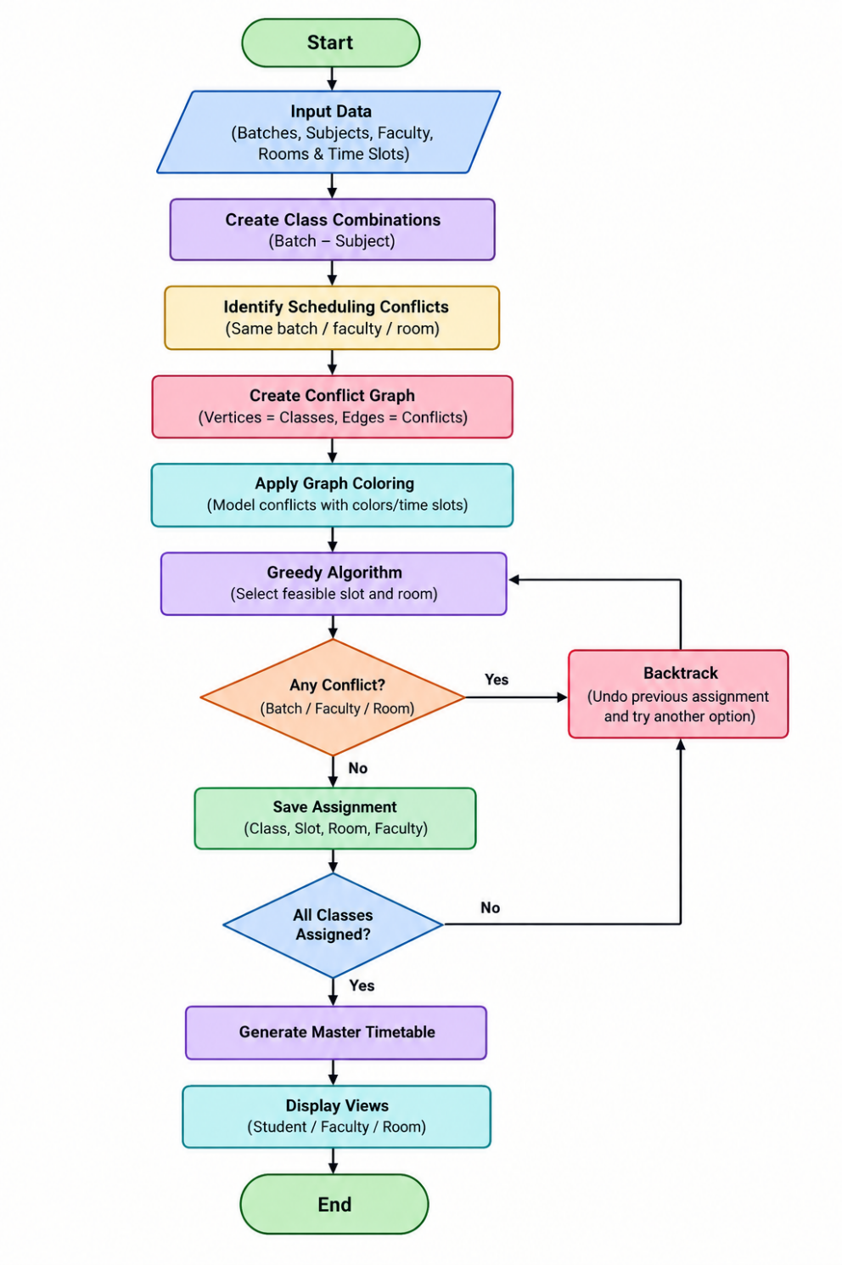
5. Complexity Analysis
Complexity | Best Case | Average Case | Worst Case
Time | O(n) | Depends on conflicts and choices | O(n!) for exhaustive backtracking in the worst case
Space | O(n) | O(n+e) | O(n + e) plus recursion stack
Where:
- n = number of classes/vertices
- e = number of conflict edges
Justification
- Graph construction requires checking relationships between classes and therefore depends on the number of classes and conflicts.
- The Greedy algorithm generally makes fast local decisions.
- Backtracking may explore many possible assignments when constraints are tight. Therefore, its worst-case running time can become exponential/factorial depending on the exact formulation and search order.
- The space is mainly required for storing classes, conflicts, timetable assignments and the recursion stack.
6. Implementation
The application is implemented as a web-based system.
Frontend
- HTML – webpage structure
- CSS – styling and layout
- JavaScript – filtering and user interaction
Backend
- Python – core programming language
- Flask – connects the backend algorithms with the web interface
Database
- SQLite – stores timetable information.
Main Modules
1. Data Module
Stores batches, subjects, faculty, rooms and time slots.
2. Conflict Graph Module
Creates the graph by identifying conflicts between classes.
3. Graph Coloring Module
Represents scheduling conflicts and assigns available resources/time slots.
4. Greedy Module
Makes locally feasible scheduling decisions.
5. Backtracking Module
Reverses previous choices when they prevent a valid complete timetable.
6. Conflict Detection Module
Checks:
- Batch clashes
- Faculty clashes
- Room clashes
7. Timetable Display Module
Displays:
- Master timetable
- Student timetable
- Faculty timetable
- Room timetable

7. Results and Test Cases
Test Case 1 – Valid Timetable Generation
Input: Student batches, subjects, faculty, classrooms and available time slots.
Expected Output: Complete conflict-free timetable.
Observed Output: 100% valid schedule with 0 conflicts.
Figure 1: Dashboard showing 100% valid conflict-free timetable.
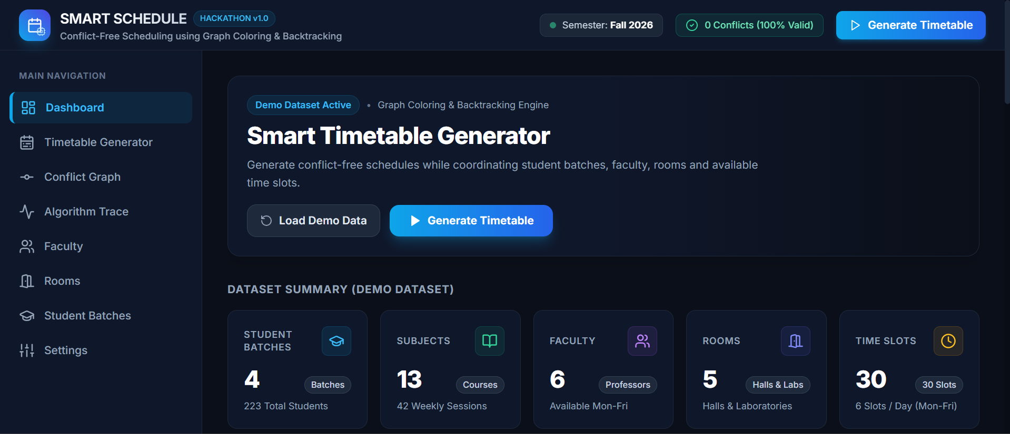
Test Case 2 – Student-Batch Conflict
Input: Multiple classes belonging to student batches.
Expected Output: No two classes of the same batch should overlap.
Observed Output: All displayed batches show 0 collisions.
Figure 2: Student-batch conflict validation.
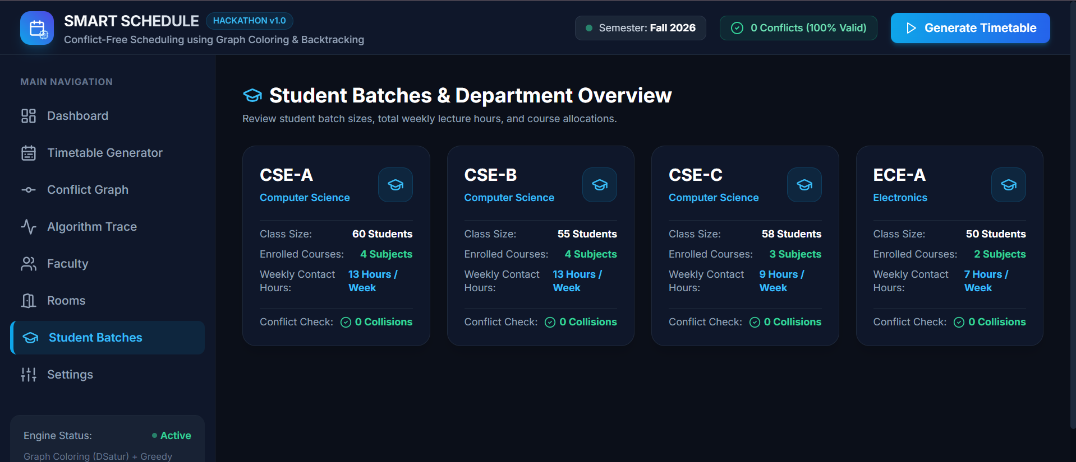

Test Case 3 – Faculty Conflict
Input: Faculty members assigned to multiple classes.
Expected Output: A faculty member should not be assigned to two classes at the same time.
Observed Output: Faculty schedule shows 0 conflicts.
Figure 3: Faculty-wise timetable and conflict status.
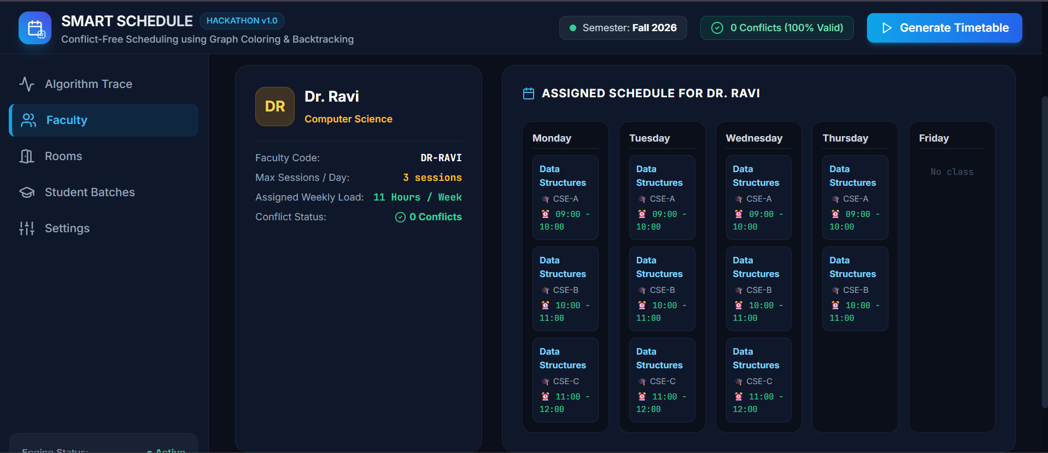
Test Case 4 – Room Conflict
Input: Classrooms and scheduled classes.
Expected Output: A room should not be double-booked.
Observed Output: All rooms show 0 Double-Bookings.
Figure 4: Room utilization and double-booking validation.
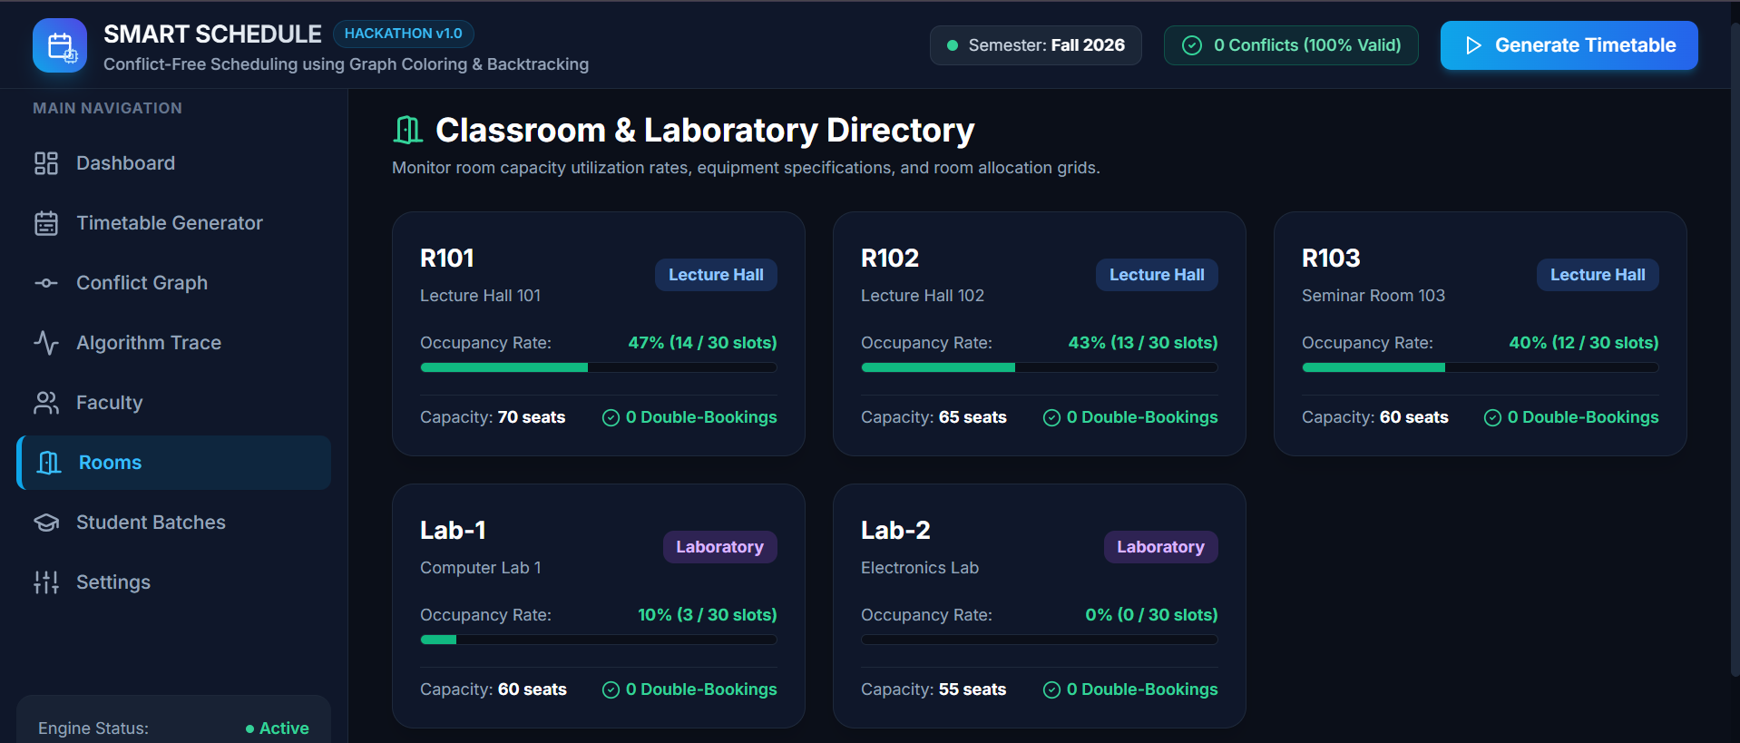

Test Case 5 – Timetable Views / Algorithm
Input: Scheduling relationships between classes.
Expected Output: Conflicting classes should be represented as edges in the graph.
Observed Output: The system displays 307 total edges, including 142 faculty-only edges and 165 batch-only edges.
Figure 5: Conflict graph visualization.
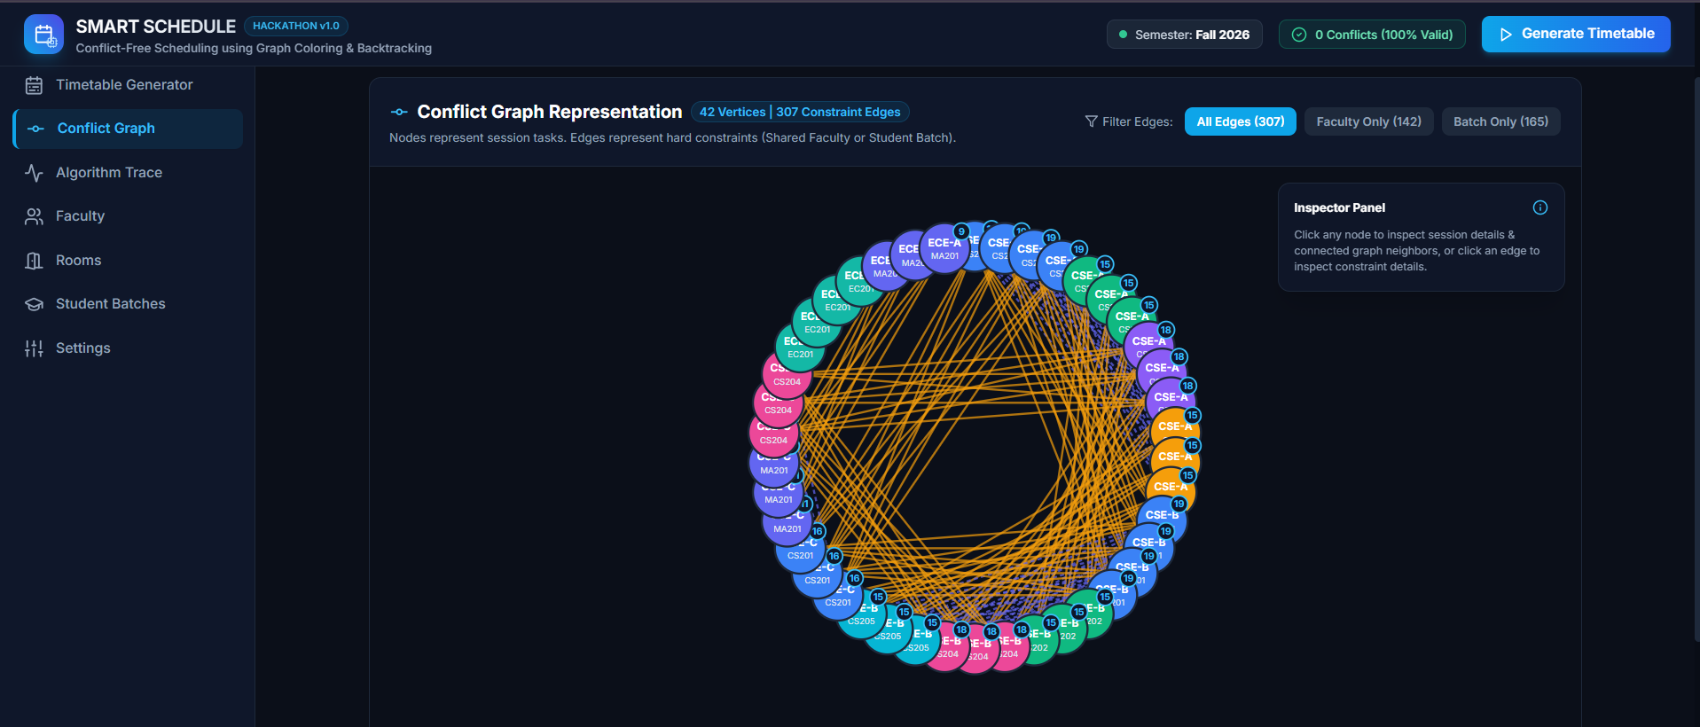

8. Conclusion and Future Scope
The College Timetable Generator provides an algorithm-based solution for creating a conflict-free college timetable. The system uses Graph Coloring to represent conflicts, Greedy to make feasible scheduling choices, and Backtracking to handle unsuccessful assignments. It considers student batches, subjects, faculty, rooms and time slots while avoiding major clashes. The generated master timetable can also be viewed separately for students, faculty and rooms. Overall, the project demonstrates the practical application of Design and Analysis of Algorithms to solve a real-world scheduling problem. APSH2026_Project_Documentation_…
Future Scope
- Add faculty availability and preferences.
- Consider room capacity and room type.
- Support laboratory and practical sessions.
- Extend the system for multiple departments and semesters.
- Add automatic timetable rescheduling when changes occur.
- Provide PDF and Excel export of generated timetables.
- Add user login and authentication for administrators and faculty.
- Deploy the application on a cloud platform for online access.

9. References
- T. H. Cormen, C. E. Leiserson, R. L. Rivest and C. Stein, Introduction to Algorithms, 4th ed., MIT Press, 2022.
- APSH 2026, Algorithmic Problem-Solving Hackathon – Project Problem Statements, Department of Computer Science and Engineering, 2026.
- Python Software Foundation, Python Documentation.
- Pallets, Flask Documentation.
- SQLite, SQLite Documentation.
- Mozilla Developer Network, HTML, CSS and JavaScript Documentation.

