
Department of Computer Science and Engineering
ALGORITHMIC PROBLEM-SOLVING HACKATHON (APSH 2026)
PROJECT DOCUMENTATION
Date: 10-10-2026 | Venue: 3rd Floor, A & B Blocks
Field | Details
Project Title | Online Complaint Tracking
Team Name / Team No. | 2
Year / Semester / Section | II Year B.Tech / I Sem / A
Algorithm Paradigm Used | MERN Stack (MongoDB, Express.js, React.js, Node.js), HTML, CSS, and JavaScript.
Programming Language / Tools | JavaScript, HTML, CSS, React.js, Node.js, Express.js, MongoDB, Visual Studio Code, and GitHub.
Faculty Mentor | Edukondalu
Team Members
S.No | Name of the Student | Roll No. | Role
1 | Pragna Sree Allu | 25MVCSMR0071 | Team Lead
2 | B.Shruthi | 25MVCSMR0010 | Team Member
3 | B.Indu | 25MVCSMR0013 | Team Member
4 | R.Lekha Reddy | 25MVCSMR0072 | Team Member

1. Problem Statement
Develop a MERN-based Online Complaint Tracking System that allows users to submit complaints online and track their status. The system should store complaint details, including user information, complaint category, submission date, and status, in a MongoDB database. Administrators should be able to view complaints and update their status to improve complaint management and transparency.
Inputs:
- User details (for identification and login).
- Complaint title and description.
- Complaint category.
- Complaint submission date.
- Complaint ID for tracking existing complaints.
Outputs:
- Successful complaint submission confirmation.
- Unique complaint ID.
- List of complaints submitted by the user.
- Current complaint status: Pending, In Progress, or Resolved.
- Administrator dashboard displaying complaint details and status.
- Updated status when the administrator processes a complaint.
Constraints:
- The application must use the MERN stack: MongoDB, Express.js, React.js, and Node.js.
- Complaint records must be stored and retrieved from MongoDB.
- Users should be able to view only their own complaints.
- Only authorized administrators should be allowed to update complaint statuses.
- Required fields must be validated before submitting a complaint.
- The system should prevent unauthorized access and maintain accurate complaint records.
- The interface should be simple, responsive, and easy to use.

2. Objectives
- Demonstrate MERN Stack development by building a complete web application.
- Implement CRUD operations and REST APIs using MongoDB, Node.js, and Express.js.
- Develop an interactive frontend using React.js with authentication and role-based access.
- Display complaint details, tracking status, and project results clearly through a user-friendly interface.

3. Proposed Approach
The proposed system, SafeTrack, uses a rule-based algorithmic approach combined with CRUD operations and a priority-based workflow to manage and track complaints efficiently. The system is developed using the MERN stack: MongoDB, Express.js, React.js, and Node.js.
Algorithm Design Paradigm
I. Rule-Based Approach
The system applies predefined rules to validate complaint details, identify complaint categories, assign priority levels, and flag urgent or overdue complaints. For example, complaints marked as emergencies can be flagged for immediate attention.
II. CRUD-Based Data Management
The system uses Create, Read, Update, and Delete operations to register complaints, retrieve complaint details, update complaint statuses, and manage records according to user permissions.
III. Priority-Based Processing
Complaints are categorized by their urgency. High-priority complaints are highlighted for authorized administrators, while other complaints follow the regular tracking workflow. Status changes are recorded to maintain a complaint history.
Why This Approach Suits the Problem
- Simple and efficient: Rule-based processing is easy to implement, understand, and test.
- Consistent decisions: Predefined rules apply the same priority criteria to similar cases.
- Easy maintenance: Rules and complaint categories can be updated as requirements change.
- Secure management: Authentication and role-based access control restrict sensitive complaint information.
- Scalable design: REST APIs and MongoDB support structured complaint management as the number of users and complaints grows.
Alternatives Considered
- Manual complaint management: Simple to start with, but tracking, prioritization, and status updates can become difficult as complaint volume increases.
- A traditional relational database: SQL databases could also manage complaint records, but MongoDB was selected for the proposed MERN-based implementation.
- AI or machine-learning-based classification: AI could classify complaint descriptions automatically, but it requires appropriate integration, evaluation, and safeguards. Rule-based classification provides a simpler baseline.
- First-in, first-out (FIFO) processing: Processing complaints only in arrival order is straightforward, but urgent complaints may need attention before older, lower-priority cases.
4. Algorithm / Pseudocode
Step-by-Step Algorithm
Step 1: Start the application.
Step 2: Allow the user to register or log in using valid credentials.
Step 3: Display the user dashboard after successful authentication.
Step 4: Allow the user to submit a complaint by entering the title, description, category, and optional incident location or evidence.
Step 5: Validate the complaint details. If required information is missing or invalid, display an error message and request correction.
Step 6: Generate a unique complaint ID and store the complaint in the MongoDB database with the initial status set to Pending.
Step 7: Check the complaint category and predefined priority rules. Flag urgent complaints for authorized staff review.
Step 8: Allow the user to track the complaint using its unique ID and view the latest available status.
Step 9: Allow authorized administrators to review complaints and update their status to In Progress or Resolved.
Step 10: Record status changes in the complaint history and notify the user if a notification service is configured.
Step 11: For emergencies, display appropriate safety guidance and a direct emergency call option. Do not claim that police have been notified unless an authorized integration confirms successful submission.
Step 12: Continue accepting and managing complaints until the user logs out or exits the application.
Flowchart
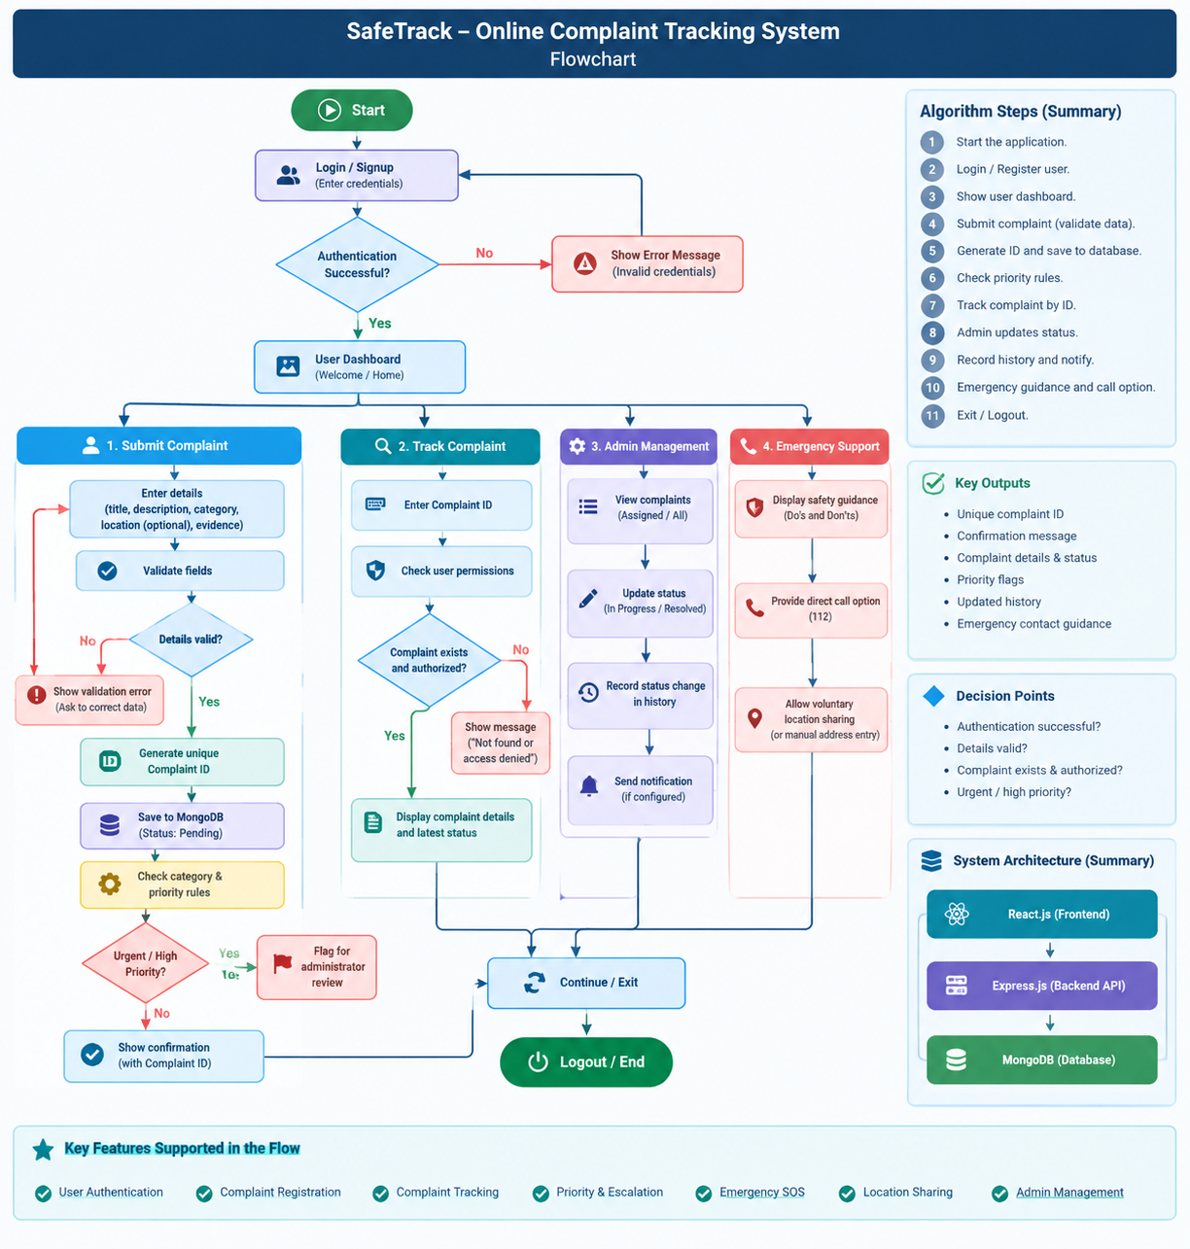

5. Complexity Analysis
Complexity | Best Case | Average Case | Worst Case
Time | O(1) | O(1) | O(n)
Space | O(1) | O(n) | O(n)
Justification:
- Time Complexity: Complaint registration, tracking by an indexed complaint ID, and priority checking generally take O(1) time. Displaying all complaints takes O(n) time in the worst case.
- Space Complexity: A single operation may use O(1) extra space, while storing or retrieving all n complaints requires O(n) space.
Here, n represents the total number of complaints.

6. Implementation
The SafeTrack – Online Complaint Tracking System is designed to help users register complaints, track their status, and access emergency support. The system uses a modular architecture in which each module performs a specific function
Main Modules and Functions
- User Authentication Module: Allows users to register, log in, and access authorized features securely.
- Complaint Registration Module: Collects complaint details such as title, description, category, location, and supporting evidence. A unique complaint ID is generated for tracking.
- Complaint Tracking Module: Allows users to check complaint details and current status using the complaint ID.
- Admin Management Module: Enables administrators to view complaints, assign priorities, and update complaint statuses such as Pending, In Progress, and Resolved.
- Emergency SOS Module: Provides emergency guidance and a direct call option for India's emergency number 112.
- Priority and Escalation Module: Uses predefined rules to identify urgent complaints and flag them for administrative review.
- Notification and History Module: Maintains complaint status history and supports notifications when configured.
- Location and Evidence Module: Allows users to optionally share their location and upload supporting evidence, subject to permissions and implementation.
Data Structures Used
- Objects: Store individual user and complaint details as key-value pairs.
- Arrays: Store collections of complaints, notifications, and status history for display and processing.
- JSON: Transfers structured data between the frontend and backend through APIs.
- MongoDB Documents and Collections: Store user accounts, complaints, status history, and related records.
- Database Indexes: Support efficient searches using unique complaint IDs and user identifiers.

Tools and Technologies
Tool / Technology | Purpose
React.js | Builds the user interface
Node.js | Runs the backend application
Express.js | Creates REST APIs and handles requests
MongoDB | Stores complaints and user data
Mongoose | Defines models and interacts with MongoDB
JavaScript / TypeScript | Implements application logic
HTML and CSS | Structures and styles web pages
JWT and bcrypt | Support authentication and password security
Visual Studio Code | Development environment
Git and GitHub | Version control and source-code management
Working Procedure
- The user registers or logs in.
- The user submits a complaint through the registration form.
- The backend validates the information and stores the complaint in MongoDB.
- The system generates a unique complaint ID and assigns an initial status.
- The user tracks the complaint using that ID.
- The administrator reviews the complaint and updates its status.
- The system records status changes and displays updates to the user.
- Emergency guidance is available when required.

7. Results and Test Cases
Test Case 1: User Login
Input:
- Username/Email: shruthi65343@gamil.com
- Password: *************

Output:
- Login successful.
- User is redirected to the dashboard.

Figure 7.1: User Login Test Case Screenshot
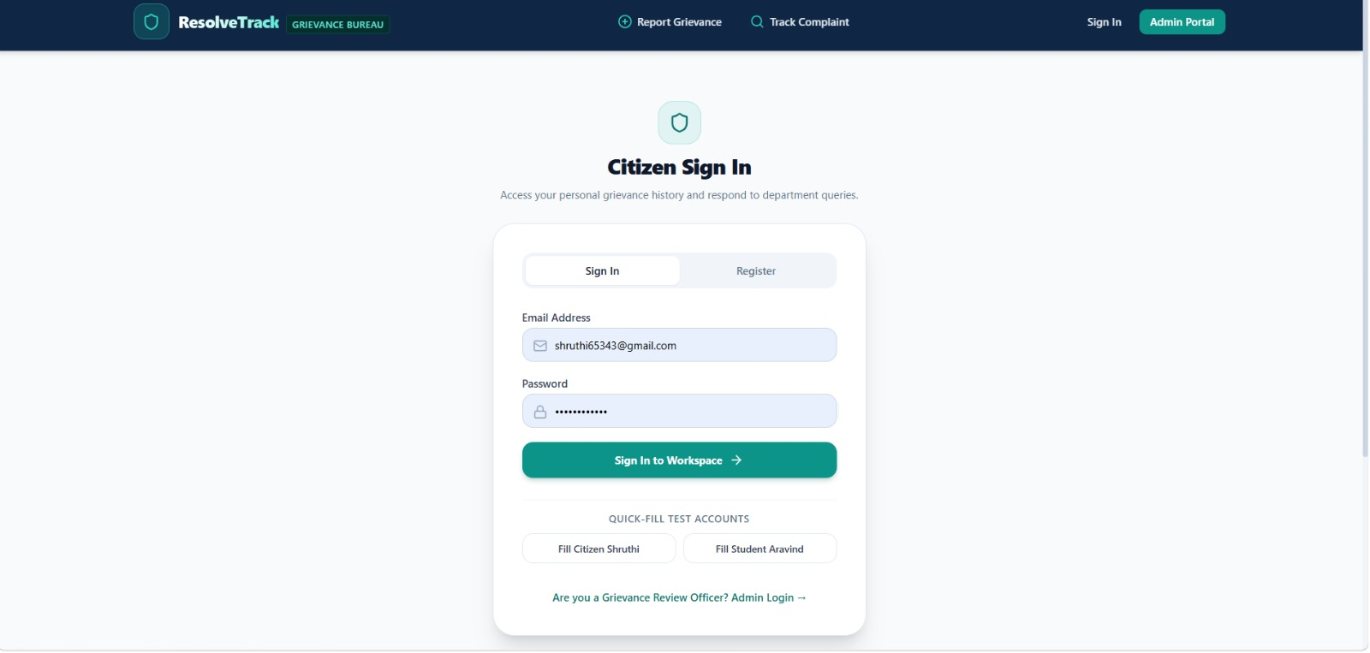
Test Case 2: Complaint Submission
Input:
- Complaint Title: Girl-Safety
- Category: Harrasment and Public Safety
- Description: I went for exam on that day my parents are busy so i went alone and while coming from exam center ,one group of boys chased me i felt uncomfortable so can you please help me
Output:
- Complaint submitted successfully.
- A unique complaint ID is generated.
Figure 7.2: Complaint Submission Test Case Screenshot
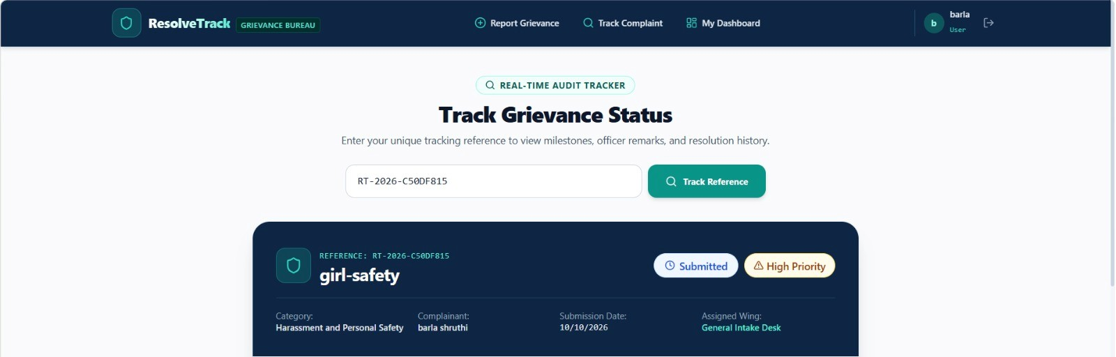
Test Case 3: Complaint Tracking
Input:
- Complaint ID: RTC-2026-C50DF815 (Example)
Output:
- Complaint details are displayed.
- Current status: Pending.
Figure 7.3: Complaint Tracking Test Case Screenshot
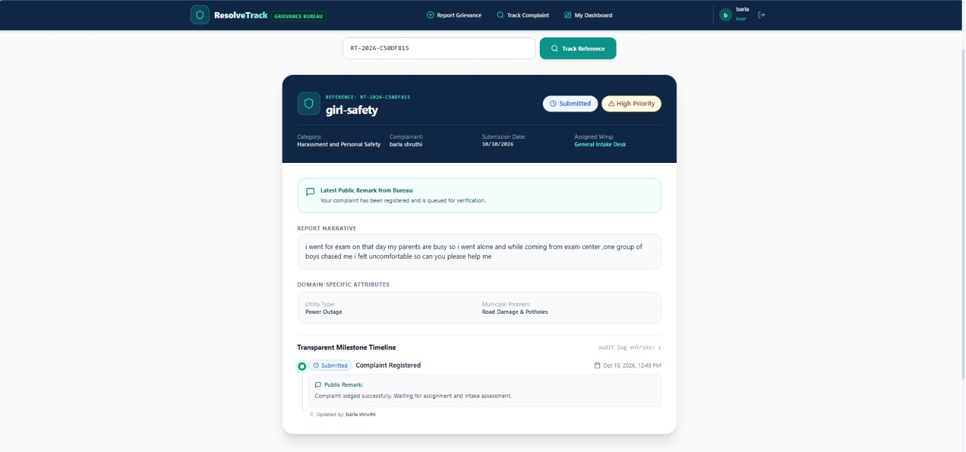
Test Case 4: Complaint Status Update
Input:
- Complaint ID: RTC-2026-C50DF815 (Example)
- Updated Status: Resolved
Output:
- Complaint status is updated successfully.
- The updated status is displayed to the user.
Figure 7.4: Complaint Status Update Test Case Screenshot
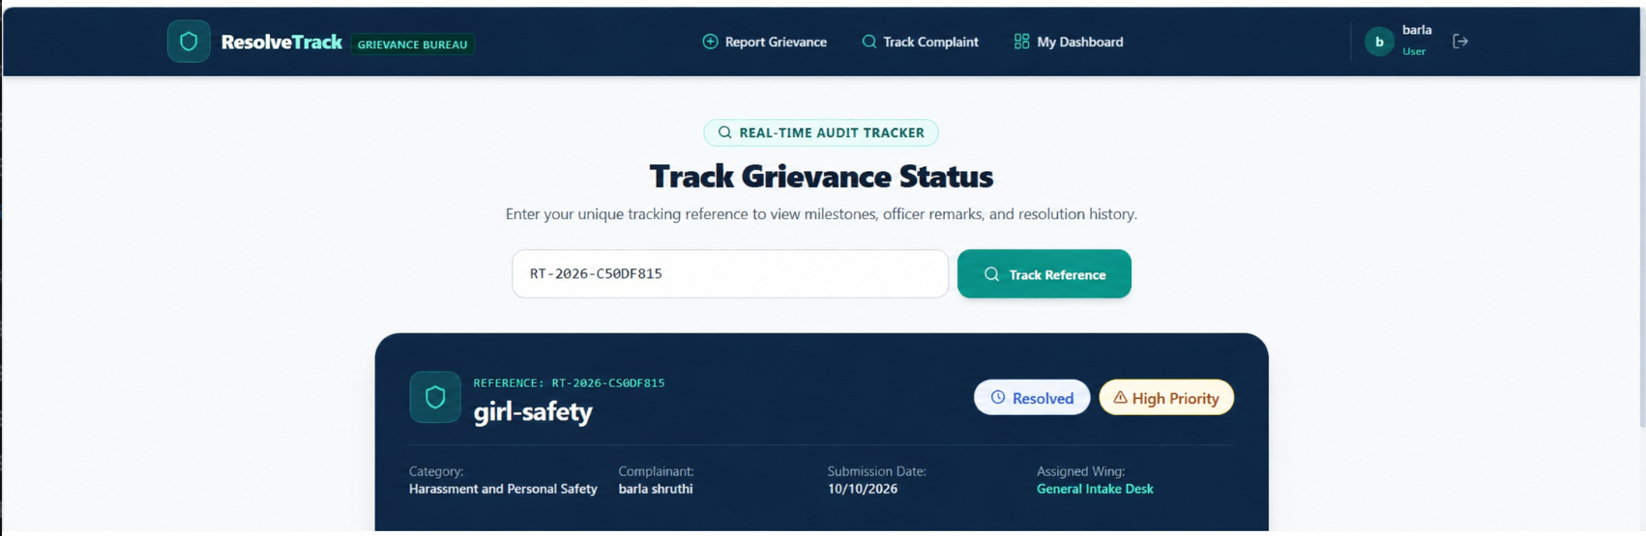

8. Conclusion and Future Scope
Conclusion
SafeTrack – Smart Online Complaint Tracking and Emergency Escalation System is designed to make complaint registration and tracking easier, faster, and more transparent. It provides a centralized platform where users can submit complaints, receive a unique complaint ID, and monitor complaint status. The administrator can review complaints, assign priorities, and update their progress.
The system uses the MERN stack, consisting of MongoDB, Express.js, React.js, and Node.js. Features such as priority-based processing, complaint history, optional location sharing, and emergency guidance aim to improve accessibility and accountability.
Overall, SafeTrack aims to reduce manual effort, improve complaint management, and provide users with a convenient way to follow up on their complaints.
Future Scope
The system can be improved in the following ways:
- AI-Based Classification: Automatically categorize complaints and identify urgent cases using machine learning.
- Real-Time Notifications: Send SMS, email, or push notifications whenever complaint statuses change.
- Multilingual Support: Provide the interface in English, Telugu, Hindi, and other regional languages.
- Mobile Application: Develop an Android and iOS application for easier access.
- Advanced Analytics: Generate reports and dashboards to identify common complaint types and response-time trends.
- Duplicate Complaint Detection: Identify similar complaints to reduce repeated submissions.
- Secure Evidence Management: Improve the secure storage and access control of uploaded images and documents.
- Authorized Emergency Integration: Integrate with official emergency or complaint-management services where permission and supported APIs are available.
- Scalability and Performance: Improve database indexing, caching, and deployment infrastructure to support more users.
- Feedback System: Allow users to rate the resolution process and provide suggestions.

9. References
- MongoDB, “MongoDB Documentation.” [Online]. Available: https://www.mongodb.com/docs/
- Meta, “React Documentation.” [Online]. Available: https://react.dev/
- OpenJS Foundation, “Node.js Documentation.” [Online]. Available: https://nodejs.org/docs/
- OpenJS Foundation, “Express.js Documentation.” [Online]. Available: https://expressjs.com/
- OWASP Foundation, “Password Storage Cheat Sheet.” [Online]. Available: https://cheatsheetseries.owasp.org/cheatsheets/Password_Storage_Cheat_Sheet.html
- M. Jones, J. Bradley, and N. Sakimura, “JSON Web Token (JWT),” RFC 7519, IETF, May 2015. [Online]. Available: https://www.rfc-editor.org/rfc/rfc7519
- OWASP Foundation, “REST Security Cheat Sheet.” [Online]. Available: https://cheatsheetseries.owasp.org/cheatsheets/REST_Security_Cheat_Sheet.html
- Mozilla, “HTTP Overview,” MDN Web Docs. [Online]. Available: https://developer.mozilla.org/en-US/docs/Web/HTTP/Overview

