AI-ASSISTED CODING ASSIGNMENT 10
Shruthi Addagudi | 2303A52133 | Batch 37

Problem Statement 1: AI-Assisted Bug Detection
A Python function was written to calculate the factorial of a number. However, the function produces incorrect output due to a logical error. The task is to test the function, identify the bug using AI assistance, correct it, and compare the AI fix with a manual fix.
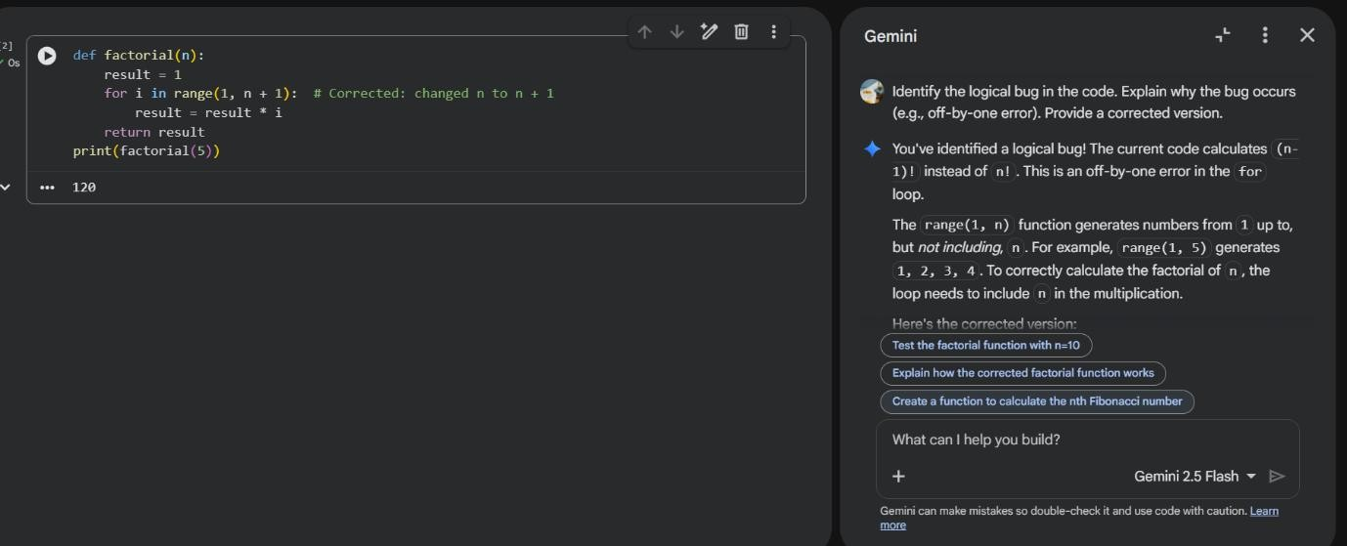
Step 1: Code Execution and Testing
When testing factorial(5), the output returned was 24 instead of 120, indicating a logical issue in the loop implementation.
Step 2: AI Analysis
Identified Bug:
The function contains an off-by-one error in the loop range.
Explanation:
The loop uses range(1, n), which excludes n. Therefore, the final multiplication step is skipped.
AI Suggested Correction:
Change loop to range(1, n + 1) and handle negative numbers properly.

Step 3: Manual Fix
The manual fix involved modifying the loop range to include n and optionally adding input validation for negative numbers.

Step 4: Comparison
Aspect AI Fix Manual Fix
Off-by-one correction Yes Yes
Negative input handling Included Sometimes missed
Zero handling Included Included
Error messages Added Optional
AI provided a production-ready solution.

Test Results
After correction, factorial(5) correctly returns 120.

Problem Statement 2: Improving Readability & Documentation
Problem Description
The function performs arithmetic operations but is poorly structured, lacks documentation, and does not handle errors properly.

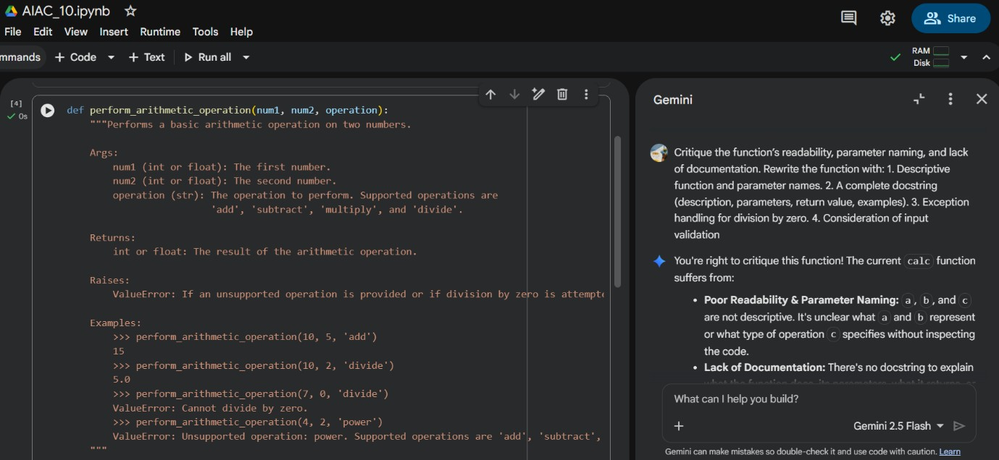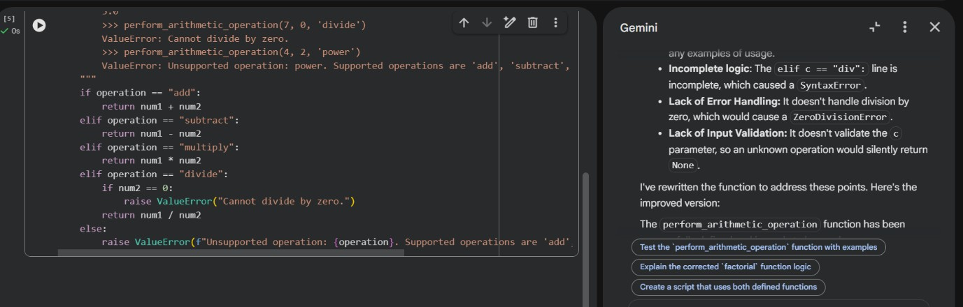

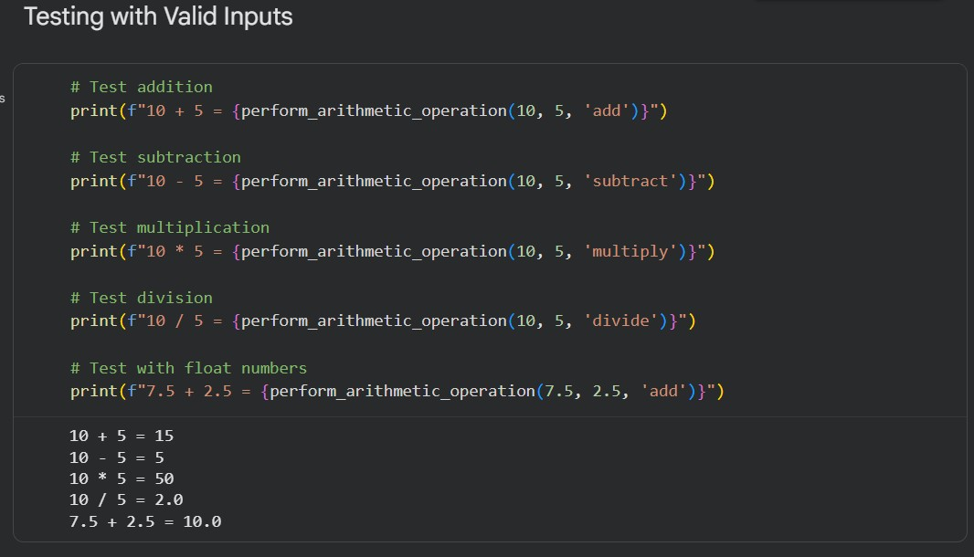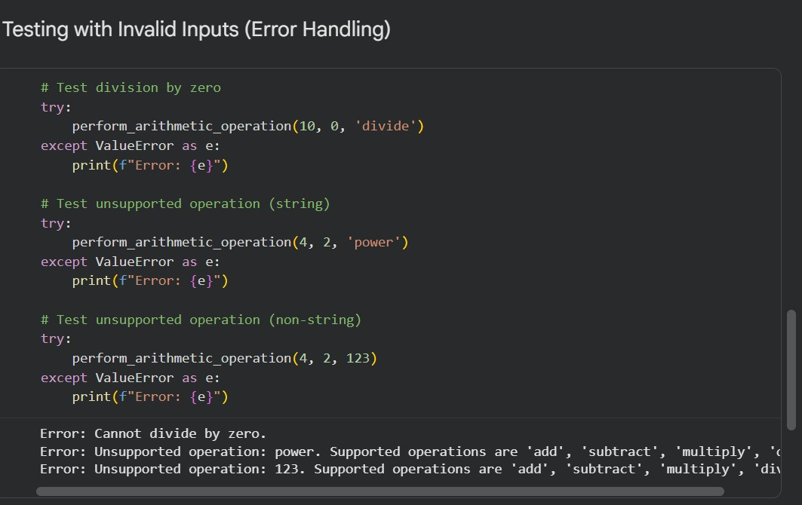

Step 1: Code Execution and Testing
The function works for valid inputs but fails for:
- Division by zero
- Invalid operation string
- Incorrect input types

Step 2: AI Analysis
Issues Identified:
- Poor function name (calc)
- Non-descriptive parameters (a, b, c)
- No docstring
- No error handling
- No input validation
AI Improvements Suggested:
- Use descriptive names
- Add complete docstring
- Add input validation
- Handle division by zero
- Raise meaningful exceptions

Step 3: Manual Fix
Manual improvements included renaming variables and adding basic error handling.

Step 4: Comparison
Feature Original Improved
Readability Poor | High
Documentation None | Complete
Error Handling None | Proper exceptions
Maintainability Low | High

Test Results
The improved function correctly:
- Performs valid operations
- Raises ZeroDivisionError for division by zero
- Raises ValueError for invalid operations
- Raises TypeError for invalid input types

Problem Statement 3: Enforcing Coding Standards (PEP8)
Problem Description
The function checks whether a number is prime but violates PEP8 coding standards.
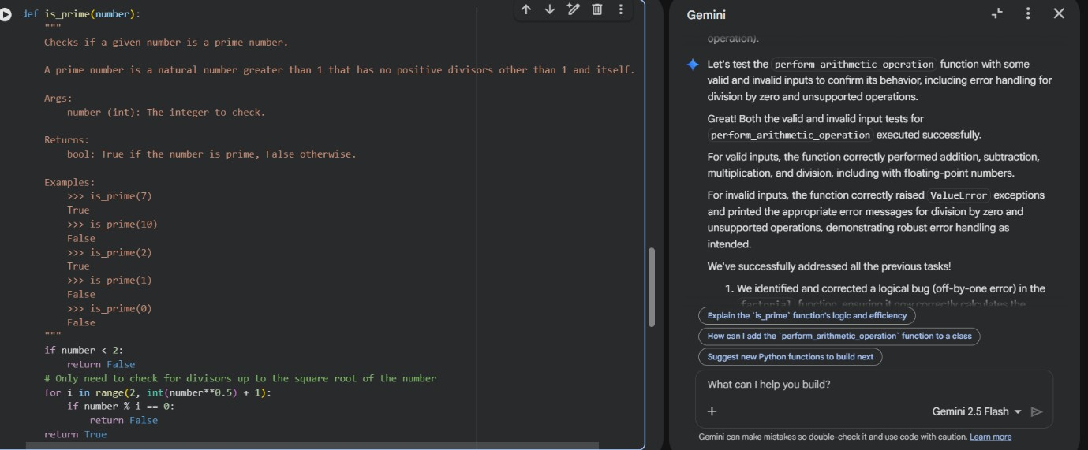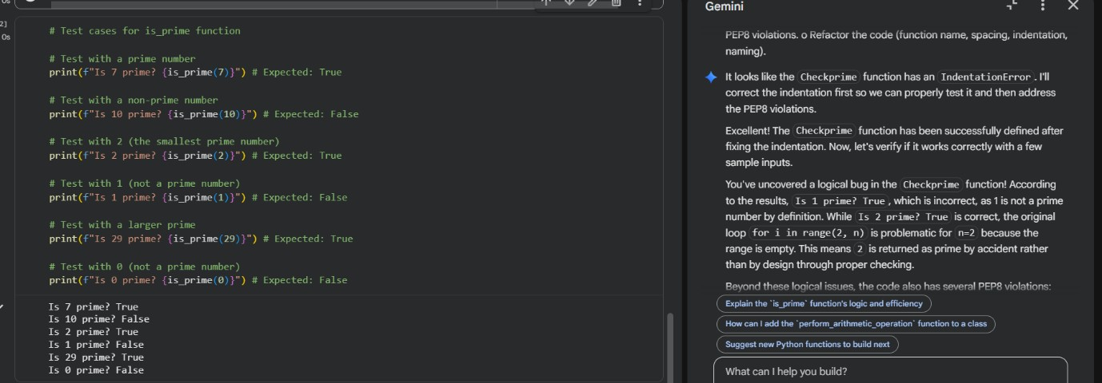

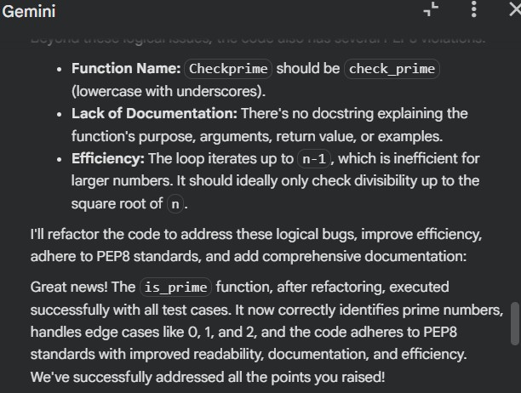

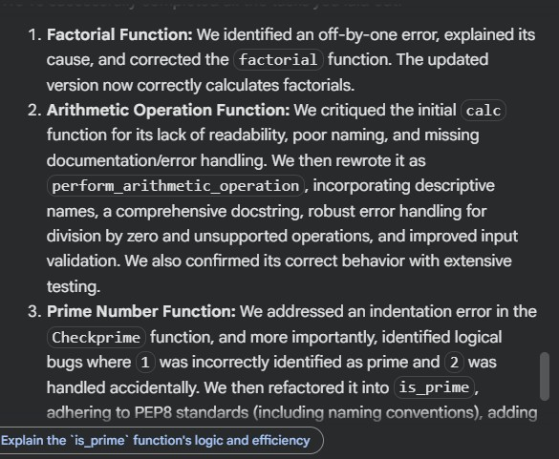

Step 1: Function Testing
The function works correctly for positive numbers greater than 1. However, it incorrectly returns True for numbers less than 2.

Step 2: AI PEP8 Review
Violations Identified:
- Function name not in snake_case (Checkprime)
- Missing spaces
- No docstring
- No validation for n < 2
Refactoring Suggestions:
- Rename to check_prime
- Add docstring
- Add condition for numbers less than 2
- Improve formatting

Step 3: Applying Changes
After applying AI suggestions, the function became PEP8 compliant and handled edge cases properly.

Step 4: AI in Code Reviews
Automated AI reviews help:
- Detect style violations instantly
- Ensure consistency across large codebases
- Reduce manual reviewer workload
- Improve overall code quality
AI speeds up code reviews but should assist human reviewers, not replace them.

Problem Statement 4: AI as a Code Reviewer in Real Projects
Problem Description
A function processes a list and doubles even numbers. The task is to review readability, edge cases, and improve reusability.
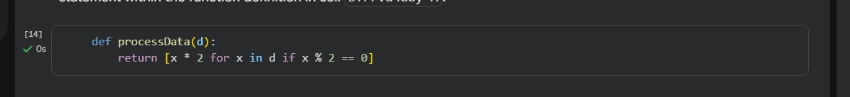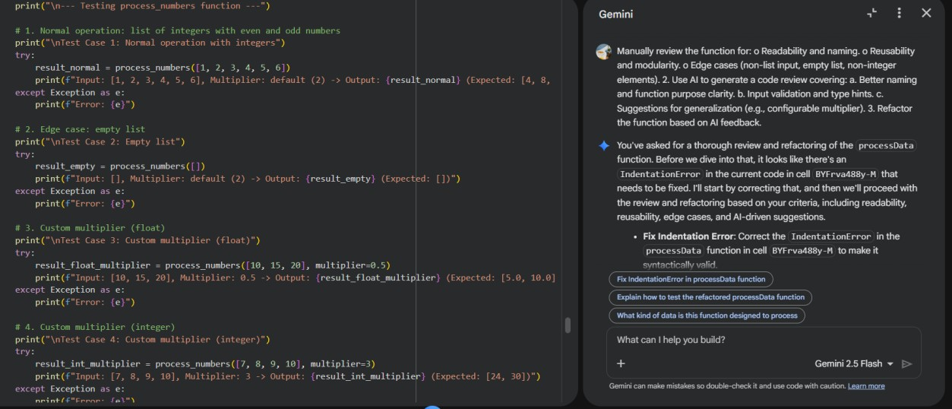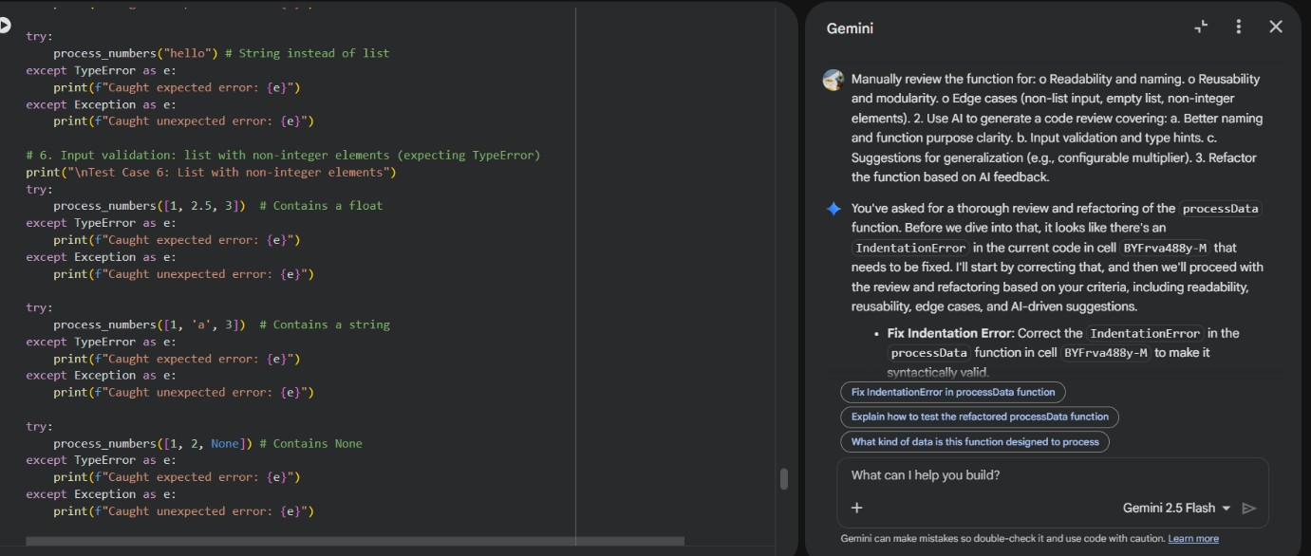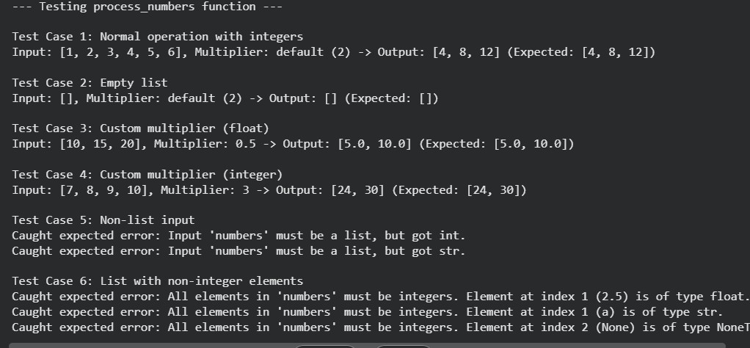
Step 1: Manual Review
Issues identified:
- Poor naming (processData, d)
- No input validation
- No type hints
- Not reusable
- No documentation

Step 2: AI Code Review Suggestions
AI recommended:
- Rename function to reflect purpose clearly
- Add type hints
- Add input validation
- Handle non-list inputs
- Generalize multiplier value

Step 3: Refactoring
The improved version includes:
- Proper naming
- Type hints
- Validation
- Cleaner structure
- Better maintainability

Step 4: Reflection
AI should be used as a supporting reviewer.
It improves speed and consistency, but human reviewers understand:
- Business logic
- Architecture decisions
- Project context
AI enhances productivity but should not replace human judgment.

Problem Statement 5: AI-Assisted Performance Optimization
Problem Description
A function calculates sum of squares but is slow for very large datasets.
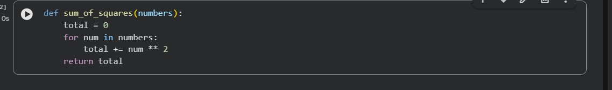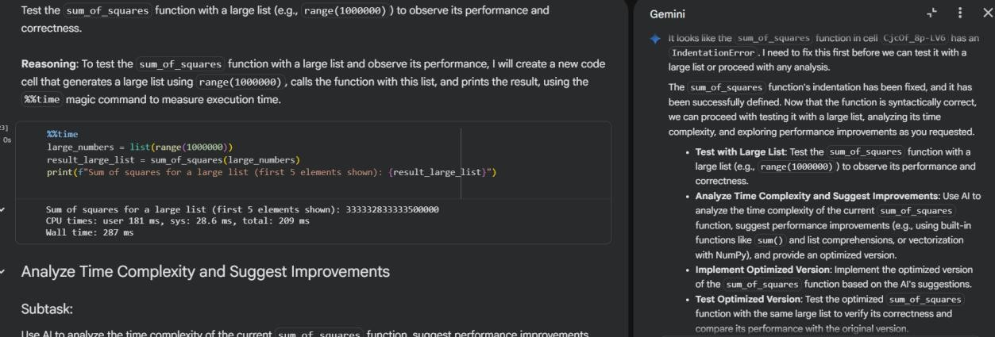
Step 1: Testing
Testing with range(1000000) shows noticeable execution time.

Step 2: AI Performance Analysis
Time Complexity:
O(n)
AI Suggestions:
- Use built-in sum() function
- Use generator expressions
- Consider NumPy for vectorization (for very large datasets)

Step 3: Optimized Version
The optimized function uses:
- Generator expression
- Built-in sum()
This reduces Python loop overhead and improves performance.

Step 4: Performance Comparison
Version Speed Readability
Original Loop Slower Medium
Optimized Faster High

Step 5: Trade-Off Discussion
- Built-in functions improve performance.
- NumPy improves speed significantly but it adds dependency.
- Readability should not be sacrificed unnecessarily.
- Optimization is important only when performance becomes a bottleneck.

