e10/14/24, 12:23 PM irispetalsepal.ipynb - Colab

import pandas as pd import numpy as np

import seaborn as sns z

import matplotlib.pyplot as plt

%matplotlib inline

data=pd.read_csv('/content/Iris_Dataset.csv')

data

**Id SepalLengthCm SepalWidthCm PetalLengthCm PetalWidthCm variety**

**0** 1 5.1 3.5 1.4 0.2 Iris-setosa

**1** 2 4.9 3.0 1.4 0.2 Iris-setk,osa

**2** 3 4.7 3.2 1.3 0.2 Iris-setosa

**3** 4 4.6 3.1 1.5 0.2 Iris-setosa=

**4** 5 5.0 3.6 1.4 0.2 Iris-setosa

**...** ... ... ... ... ... ...

**145** 146 6.7 3.0 5.2 2.3 Iris-virginica

**146** 147 6.3 2.5 5.0 1.9 Iris-viirginica

**147** 148 6.5 3.0 5.2 2.0 Iris-virginica

**148** 149 6.2 3.4 5.4 2.3 Iris-virginica

**149** 150 5.9 3.0 5.1 1.8 Iris-virginica

150 rows × 6 columns

data.info() i

<class 'pandas.core.frame.DataFrame'>

RangeIndex: 150 entries, 0 to 149

Data columns (total 6 columns):

# Column Non-Null Count Dtype

--- ------ -------------- -----

0 Id 150 non-null int64

1 SepalLengthCm 150 non-null float64

2 SepalWidthCm 150 non-null float64

3 PetalLengthCm 150 non-null float64

4 PetalWidthCm 150 non-null float64

5 variety 150 non-null object

dtypes: float64(4), int64(1), object(1)

memory usage: 7.2+ KB

l

**Id SepalLengthCm SepalWidthCm PetalLengthCm PetalWidthCm**

**count** 150.000000 150.000000 150.000000 150.000000 150.000000

**mean** 75.500000 5.843333 3.054000 3.758667 1.198667

**std** 43.445368 0.828066 0.433594 1.764420 0.763161

**min** 1.000000 4.300000 2.000000 1.000000 0.100000

**25%** 38.250000 5.100000 2.800000 1.600000 0.300000

**50%** 75.500000 5.800000 3.000000 4.350000 1.300000

**75%** 112.750000 6.400000 3.300000 5.100000 1.800000

**max** 150 000000 7 900000 4 400000 6 900000 2 500000

data.value_counts('variety')

**count**

**Varie ty**

**Iris-setosa** 50

**Iris-versicolor** 50

**Iris-virginica** 50

https://colab.research.google.com/drive/1Tqx5IOXjHro7-CLF16NYNKyRMTEo1INN#printMode=true 1/5

10/14/24, 12:23 PM irispetalsepal.ipynb - Colab

sns.countplot(x='variety',data=data,)

plt.show()

dummies=pd.get_dummies(data.variety)

FinalDataset=pd.concat([pd.get_dummies(data.variety),data.iloc[:,[0,1,2,3]]],axis=1)

FinalDataset.head()

**Iris-setosa Iris-versicolor Iris-virginica Id SepalLengthCm SepalWidthCm PetalLengthCm 0** True False False 1 5.1 3.5 1.4 **1** True False False 2 4.9 3.0 1.4 **2** True False False 3 4.7 3.2 1.3 **3** True False False 4 4.6 3.1 1.5 **4** True False False 5 5 0 3 6 1 4

sns.scatterplot(x='SepalLengthCm',y='SepalWidthCm',hue='variety',data=data)

<Axes: xlabel='SepalLengthCm', ylabel='SepalWidthCm'>

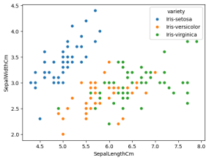

sns.scatterplot(x='PetalLengthCm',y='PetalWidthCm',hue='variety',data=data,)

https://colab.research.google.com/drive/1Tqx5IOXjHro7-CLF16NYNKyRMTEo1INN#printMode=true 2/5

10/14/24, 12:23 PM irispetalsepal.ipynb - Colab

<Axes: xlabel='PetalLengthCm', ylabel='PetalWidthCm'>

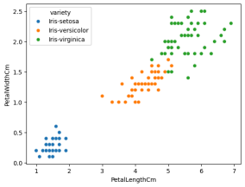

sns.pairplot(data,hue='variety',height=3);

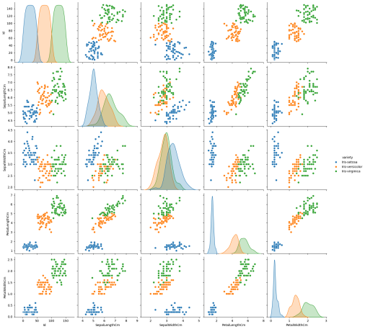https://colab.research.google.com/drive/1Tqx5IOXjHro7-CLF16NYNKyRMTEo1INN#printMode=true 3/5

10/14/24, 12:23 PM irispetalsepal.ipynb - Colab plt.show()

sns.FacetGrid(data,hue='variety',height=5).map(sns.histplot,'PetalLengthCm').add_legend(); plt.show();

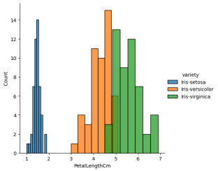

sns.FacetGrid(data,hue='variety',height=5).map(sns.histplot,'PetalWidthCm').add_legend(); plt.show();

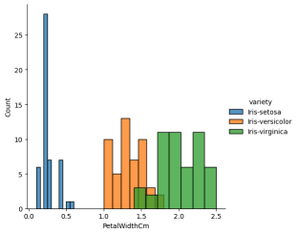

sns.FacetGrid(data,hue='variety',height=5).map(sns.histplot,'SepalLengthCm').add_legend(); plt.show();

https://colab.research.google.com/drive/1Tqx5IOXjHro7-CLF16NYNKyRMTEo1INN#printMode=true 4/5

10/14/24, 12:23 PM irispetalsepal.ipynb - Colab

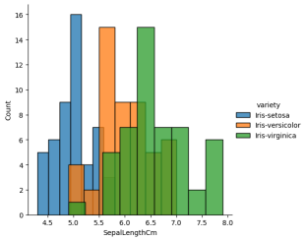

sns.FacetGrid(data,hue='variety',height=5).map(sns.histplot,'SepalWidthCm').add_legend();

plt.show();

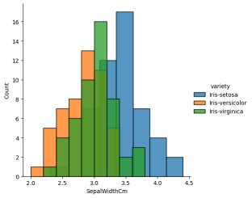

https://colab.research.google.com/drive/1Tqx5IOXjHro7-CLF16NYNKyRMTEo1INN#printMode=true 5/5