**Solution a:**

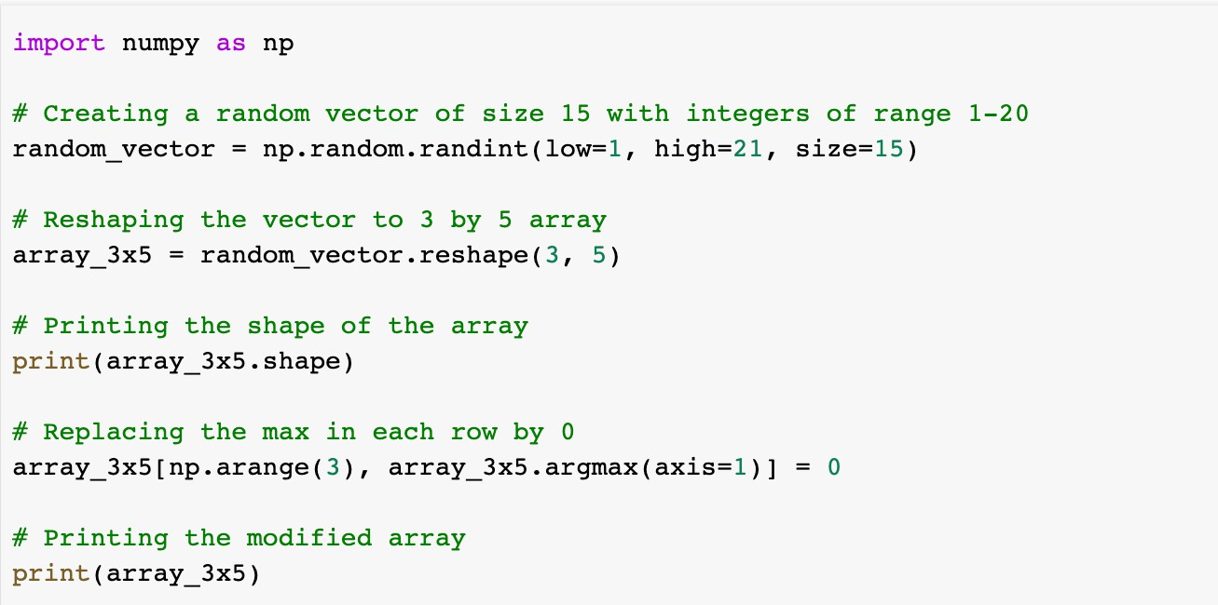

**Output:**

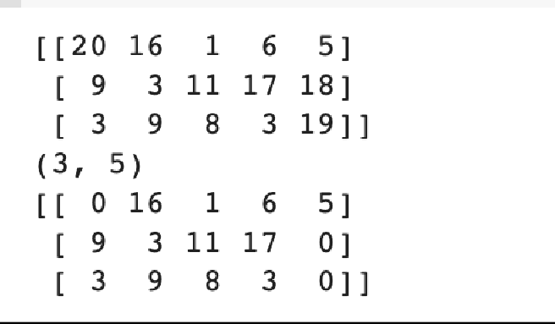

**Explanation:**

Firstly created a random vector using np.random.randint. Used ‘reshape’ method to reshape the vector to 3 by 5 array. The ‘shape’ attribute is used to know the shape of vector. To determine the index of the largest member in each row of the array, use the argmax method. The maximum element is set to 0 by combining the index of the maximum element for each row with the array of indices for the rows created by the np.arange(3) function.

**Output:**

Firstly created a random vector using np.random.randint. It will create a 4x3 mtarix and by using shape, type, and dtype functions we can print the shape, type and data type of the matrix as shown in the output.

**Solution b:**

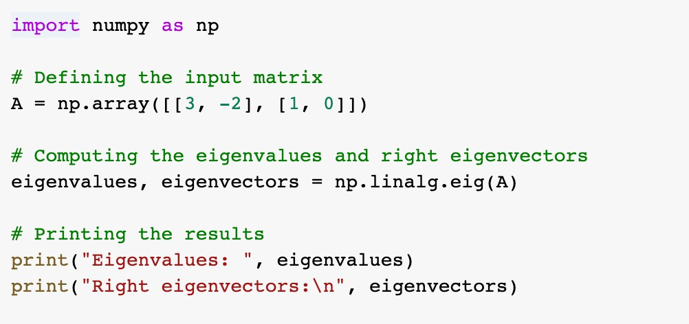

**Output:**

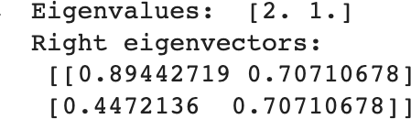

**Explanation:**

Input matrix is defined. Then used ‘np.linalg.eig’ function used to compute the eigenvalues and right eigenvectors. Finally printed the values by calling them.

**Solution c:**

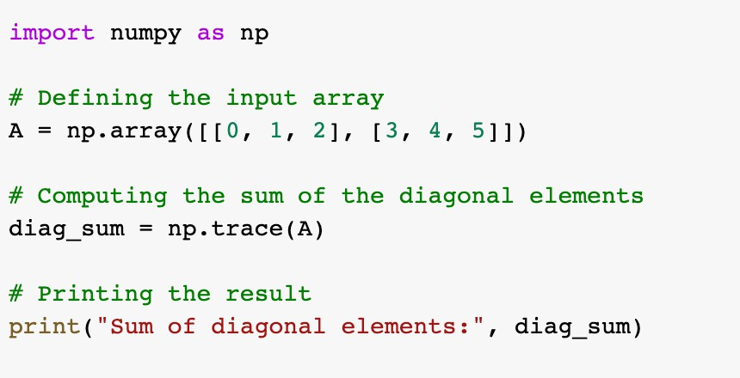

**Output:**

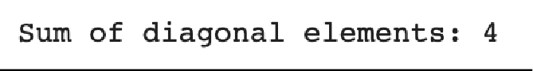

**Explanation:**

Defined an input array. The function ‘np.trace’ is used to compute the sum of diagonal elements and is being stored in diag_sum.

**Solution d:**

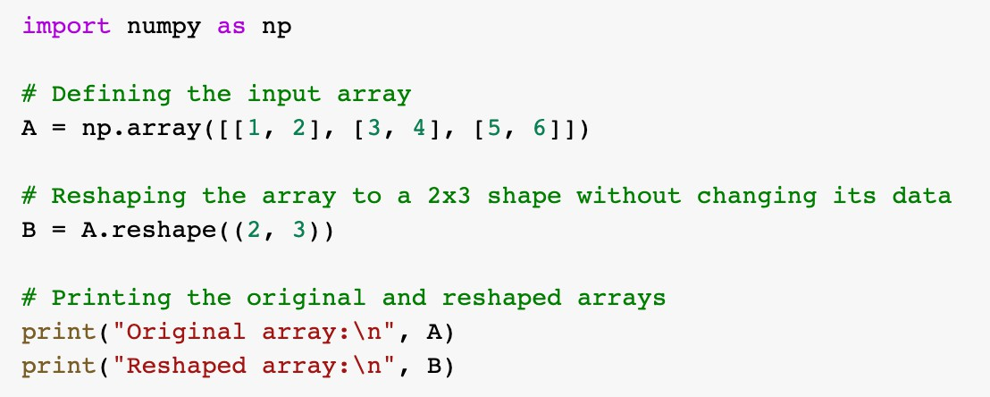

**Output:**

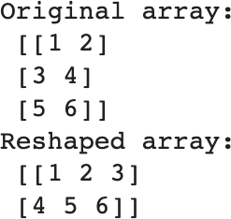

**Explanation:**

Defined an input array. Used ‘reshape’ function to reshape the array without changing the data then printed the reshaped arrays

**Video Link:**

[**https://drive.google.com/file/d/1oa5EkI6LHrR1YE7uLqMyfSvZzgzFWlVi/view?usp=drive_link**](https://drive.google.com/file/d/1oa5EkI6LHrR1YE7uLqMyfSvZzgzFWlVi/view?usp=drive_link)

**GitHub Link:**

[**https://github.com/shruthikatkam26/MachinelearningICP3.git**](https://github.com/shruthikatkam26/MachinelearningICP3.git)