AGRIGUARD AI: AN INTELLIGENT CROP DISEASE CLASSIFICATION AND MULTILINGUAL FARMER ADVISORY SYSTEM
A PROJECT REPORT
Submitted by
SHRUTHIKHA S (Registration No: 310621104000)
in partial fulfillment for the award of the Degree
of
BACHELOR OF ENGINEERING
in
DEPARTMENT OF COMPUTER SCIENCE AND ENGINEERING


EASWARI ENGINEERING COLLEGE,
(AN AUTONOMOUS INSTITUTION) – AFFILIATED TO ANNA UNIVERSITY,
CHENNAI
OCTOBER 2026

EASWARI ENGINEERING COLLEGE
(AN AUTONOMOUS INSTITUTION – AFFILIATED TO ANNA UNIVERSITY, CHENNAI)
RAMAPURAM, CHENNAI – 600089
BONAFIDE CERTIFICATE
Certified that this mini project report titled "AGRIGUARD AI: AN INTELLIGENT CROP DISEASE CLASSIFICATION AND MULTILINGUAL FARMER ADVISORY SYSTEM" is the Bonafide work of "SHRUTHIKHA S (Reg. No: 310621104000)", who carried out the project work under my supervision.
HEAD OF THE DEPARTMENT  Department of Computer Science & Engg.  Easwari Engineering College  Ramapuram, Chennai – 600089 | SUPERVISOR / PROJECT GUIDE  Assistant Professor  Department of Computer Science & Engg.  Easwari Engineering College  Ramapuram, Chennai – 600089

EASWARI ENGINEERING COLLEGE
(AN AUTONOMOUS INSTITUTION – AFFILIATED TO ANNA UNIVERSITY, CHENNAI)
RAMAPURAM, CHENNAI – 600089
Certificate of Viva-voce-Examination
This is to certify that the Viva Voce Examination of the Project Work entitled “AGRIGUARD AI: AN INTELLIGENT CROP DISEASE CLASSIFICATION AND MULTILINGUAL FARMER ADVISORY SYSTEM” submitted by Ms. SHRUTHIKHA S (Reg. No. 310621104000) in partial fulfillment of the requirements for the award of the degree of BACHELOR OF ENGINEERING was conducted on ________________ (Date) in the Department of Computer Science and Engineering, Easwari Engineering College, Ramapuram – Chennai.
Internal Examiner  Name: _______________________  Designation: ________________  Address: ____________________  Date: ______________________ | External Examiner  Name: _______________________  Designation: ________________  Address: ____________________  Date: ______________________

ABSTRACT
Agricultural crop diseases represent one of the most severe hazards to global food security, rural livelihoods, and national economies. In agrarian nations like India, where more than 58% of the rural population depends directly on agriculture, unmitigated crop pathogen infections inflict between 20% to 40% yield losses annually. Smallholder farmers often suffer catastrophic losses due to delayed identification of foliar pathologies, inadequate access to agronomic extension specialists, and language barriers that prevent the timely comprehension of complex diagnostic and chemical mitigation bulletins. To resolve these fundamental bottlenecks, this project presents AgriGuard AI—an intelligent, full-stack, edge-optimized phytopathology diagnosis and multilingual smart advisory ecosystem.
AgriGuard AI leverages transfer learning on a deep Convolutional Neural Network (CNN) architecture, specifically MobileNetV2 with inverted residual blocks and linear bottlenecks, fine-tuned across 18 distinct crop-pathology classes spanning major cash and food crops including Tomato, Potato, Bell Pepper, and Apple. The model achieves an overall test accuracy of 80.0%, precision of 0.7508, recall of 0.8000, and an F1-score of 0.7620, while maintaining an exceptionally lightweight parameter footprint (~14 MB memory footprint) and sub-180 millisecond inference latency. Crucially, the diagnostic engine is served via a high-performance Python FastAPI microservice, fully decoupled from the core application layer.
Beyond mere classification, AgriGuard AI establishes a transformative paradigm by synthesizing real-time hyper-local meteorological data (via OpenWeatherMap API) with pathological risk indicators. Environmental variables including ambient temperature, relative humidity, wind velocity, and precipitation probability are dynamically evaluated against disease development kinetics to determine whether micro-climate conditions are conducive to epidemic escalation. Based on this multidimensional analysis, the system formulates tailored, two-tiered remediation strategies featuring both organic bio-controls and calibrated chemical interventions.
To bridge the rural digital divide, AgriGuard AI features vernacular accessibility across multiple Indian languages (Tamil, Hindi, Telugu, Marathi, and English) coupled with an automated text-to-speech (TTS) voice synthesis engine that reads aloud urgent advisories directly to neo-literate farmers. The application architecture is implemented as a production-grade full-stack solution utilizing MongoDB for persistent scan telemetry, Node.js and Express.js for the secure RESTful API gateway, and React 18 with Vite and Tailwind CSS for an intuitive, responsive mobile-first client interface. An administrative governance suite equips district agricultural officers with longitudinal outbreak tracking and disease catalog management capabilities.

ACKNOWLEDGEMENT
We express our sincere gratitude to the Principal Dr. P. Deiva Sundari and the Management of Easwari Engineering College for providing us with the opportunity, state-of-the-art computational infrastructure, and supportive academic environment to carry out this project work successfully.
We convey our heartfelt thanks to the Head of the Department, Department of Computer Science and Engineering, for continuous encouragement, invaluable suggestions, and enduring administrative support throughout the development of this work.
We are extremely thankful to our Project Guide, Assistant Professor, Department of Computer Science and Engineering, for valuable technical guidance, meticulous code reviews, insightful suggestions, and constant motivation throughout the completion of this project.
We would also like to extend our sincere gratitude to all the faculty members and technical staff of the Department of Computer Science and Engineering for their direct and indirect support and constructive inputs.
Finally, we express our profound gratitude to our parents, family members, and friends for their boundless moral support, patience, and constant encouragement during the course of this project.

TABLE OF CONTENTS
CHAPTER NO. | TITLE | PAGE NO.
 | BONAFIDE CERTIFICATE | ii
 | CERTIFICATE OF VIVA-VOCE EXAMINATION | iii
 | ABSTRACT | iv
 | ACKNOWLEDGEMENT | v
 | LIST OF FIGURES | viii
 | LIST OF TABLES | ix
1 | INTRODUCTION | 1
1.1 | Overview | 1
1.2 | Problem Definition | 2
1.3 | Objective | 3
1.4 | Scope of the Project | 4
1.5 | Motivation | 5
2 | RELATED WORK | 6
2.1 | Literature Review | 6
2.2 | Existing System | 8
2.3 | Proposed System | 9
3 | SYSTEM ANALYSIS | 11
3.1 | System Requirements (Functional & Non-Functional) | 11
3.2 | Software and Hardware Requirements | 13
4 | SYSTEM DESIGN | 15
4.1 | System Architecture | 15
4.2 | Module Description | 17
4.3 | Data Flow Diagrams (DFD Level 0 & Level 1) | 19
4.4 | Class Diagram | 21
4.5 | Sequence Diagram | 23
5 | IMPLEMENTATION | 25
5.1 | Implementation Overview | 25
5.2 | Key Functions and Code Explanation | 27
6 | CONCLUSION & FUTURE WORK | 32
6.1 | Results and Performance Analysis | 32
6.2 | Conclusion | 34
6.3 | Future Enhancements | 35
 | APPENDIX: SOURCE CODE | 36
1. | Project Structure | 36
2. | Backend Package Installation & Terminal Commands | 37
3. | Database Connection | 37
4. | Environment Variables (.env) | 38
5. | User Model Schema | 38
6. | Password Hashing and Registration Controller | 39
 | 7. Login and JWT Generation Controller | 40
 | 8. Authentication Middleware | 40
 | 9. Create API (Disease Scan Processing) | 41
 | 10. Read API (Scans & Disease Catalog) | 42
 | 11. Update API (Disease Record & Farmer Profile) | 43
 | 12. Delete API (Scan History & Disease) | 43
 | 13. Express Routes Configuration | 44
 | 14. Main Server Configuration (server.js) | 45
 | 15. React Login Component | 46
 | 16. Admin Dashboard Logic | 47
 | 17. REST API Request and Response Examples | 48
 | SCREENSHOTS OF THE PROJECT | 50
 | REFERENCES | 54

LIST OF FIGURES
FIGURE NO. | TITLE | PAGE NO.
Figure 4.1 | AgriGuard AI Multi-Tier System Architecture | 16
Figure 4.2 | Data Flow Diagram Level 1 (DFD) | 20
Figure 4.3 | AgriGuard AI Complete UML Class Diagram | 22
Figure 4.4 | Diagnosis and Advisory End-to-End Sequence Diagram | 24
Figure 6.1 | MobileNetV2 Training and Validation Performance Curves | 33
Figure 6.2 | Normalized Confusion Matrix across 18 Pathological Classes | 34
Figure 7.1 | Field Leaf Scanner & Real-Time Diagnosis User Interface | 50
Figure 7.2 | Multilingual Advisory & Text-to-Speech Playback Card | 51
Figure 7.3 | Micro-climate Meteorological Risk Alert Panel | 52
Figure 7.4 | Centralized Administrative Outbreak Surveillance Dashboard | 53

LIST OF TABLES
TABLE NO. | TITLE | PAGE NO.
Table 3.1 | Functional Requirements Specification Matrix | 12
Table 3.2 | Non-Functional System Performance Constraints | 13
Table 3.3 | Hardware and Computational Specifications | 14
Table 3.4 | Software Stack and Library Dependencies | 14
Table 5.1 | MobileNetV2 Inverted Residual Architecture Configuration | 26
Table 5.2 | Supported Crop and Pathogen Disease Classes (18 Target Classes) | 27
Table 6.1 | Model Evaluation Metrics: Accuracy, Precision, Recall, and F1-Score | 32
Table 6.2 | Inference Latency Benchmark Across Execution Environments | 33

CHAPTER 1
INTRODUCTION
1.1 OVERVIEW
Agriculture stands as the fundamental backbone of India's socio-economic fabric, contributing nearly 18.8% to the Gross Domestic Product (GDP) and sustaining over half of the country's total workforce. Despite significant technological advancements in agronomy, mechanization, and irrigation systems, crop yield vulnerability to fungal, bacterial, viral, and mite-induced diseases remains an existential threat. According to the Food and Agriculture Organization (FAO) of the United Nations, plant pathogens cause estimated global crop losses exceeding $220 billion annually. In tropical and subtropical regions such as the Indian subcontinent, elevated humidity levels, unseasonal precipitation events, and prolonged warm spells create micro-climates that drastically accelerate pathogen sporulation and pest proliferation.
Historically, the identification of crop diseases has relied upon manual visual inspection carried out either by experienced farmers or visiting government agricultural extension officers. However, this classical approach suffers from profound systemic weaknesses. In India, the ratio of agricultural extension officers to operational farm holdings stands at an alarming deficit—often exceeding one extension worker per 1,160 farmer families. Consequently, rural cultivators operating in remote villages seldom receive timely, expert diagnostic guidance during the critical early stages of foliar infection. By the time visual symptoms become unmistakable to untrained eyes, necrosis has typically advanced across substantial canopy surface area, resulting in catastrophic harvest destruction or triggering the uncalibrated, excessive dumping of expensive synthetic pesticides that degrades local soil ecosystems.
AgriGuard AI is conceived and engineered to address this acute socio-technical challenge. It provides an end-to-end, intelligent smart agriculture platform that fuses cutting-edge Computer Vision (Deep Convolutional Neural Networks) with real-time meteorological sensing and vernacular accessibility. By simply capturing a photograph of an affected plant leaf using an ordinary smartphone or web camera, a farmer can obtain instantaneous, laboratory-grade disease classification, scientifically verified treatment recommendations, and localized voice advisories in their native language within hundreds of milliseconds.
1.2 PROBLEM DEFINITION
The overarching problem addressed by this project encompasses three distinct, interlocking challenges that prevent smallholder and marginal farmers from protecting their crop yields:
1. Absence of Immediate, Reliable Phytopathology Diagnostic Services: Marginal farmers lack accessible, scientifically rigorous diagnostic tools in the field. Visual similarity between distinct pathological conditions—such as distinguishing between Early Blight (Alternaria solani) and Late Blight (Phytophthora infestans) in solanaceous crops—frequently leads to misdiagnosis, incorrect pesticide procurement, wasted financial capital, and unchecked crop destruction.
2. Disconnect Between Atmospheric Conditions and Disease Outbreak Dynamics: Existing diagnostic applications function as static image classifiers that operate in complete isolation from environmental context. However, plant disease epidemiology is intrinsically governed by the 'Disease Triangle'—the intersection of a susceptible host, a virulent pathogen, and favorable environmental conditions (temperature, humidity, precipitation). Without real-time weather correlation, static models cannot advise a farmer whether spraying fungicide tomorrow is useless due to impending rain, or whether elevated relative humidity necessitates urgent prophylactic protection.
3. Linguistic and Literacy Accessibility Barriers: Highly technical agronomic bulletins and chemical dosage instructions are overwhelmingly drafted in formal English or standardized Hindi, creating severe comprehension barriers for rural cultivators whose primary languages are Tamil, Telugu, Marathi, or vernacular dialects. Furthermore, significant illiteracy rates among elder farmers render text-based mobile interfaces ineffective unless accompanied by natural, auditory voice playback.
1.3 OBJECTIVE
The primary engineering and operational objectives of the AgriGuard AI system are defined as follows:
• To engineer, train, and deploy an edge-optimized Deep Convolutional Neural Network based on MobileNetV2 architecture capable of accurately classifying 18 distinct crop disease classes across economically vital Indian crops (Tomato, Potato, Bell Pepper, and Apple) with a validation accuracy surpassing 78%.
• To develop an asynchronous, microservice-based inference pipeline utilizing Python FastAPI that delivers sub-200ms prediction turnaround time while maintaining minimal memory overhead.
• To integrate hyper-local real-time meteorological telemetry via OpenWeatherMap API, establishing an intelligent heuristic risk analysis engine that correlates ambient temperature, humidity, and rainfall probability with pathogen kinetics.
• To curate an exhaustive, agronomy-backed remedial repository offering bifurcated treatment strategies: certified organic bio-pesticides (e.g., Trichoderma viride, Neem kernel extract) and precision chemical controls (e.g., Mancozeb, Copper Oxychloride) with calibrated application guidelines.
• To implement multilingual vernacular translation and automated Text-to-Speech (TTS) audio advisory streaming across five major languages (Tamil, Hindi, Telugu, Marathi, English) ensuring universal accessibility for rural farmers.
• To deliver a modern, secure full-stack web and mobile responsive platform featuring JWT-secured user authentication, longitudinal scan telemetry logging, disease encyclopedia exploration, and administrative district surveillance dashboards.
1.4 SCOPE OF THE PROJECT
The functional scope of AgriGuard AI encompasses both field-level operational utility and macro-level agricultural surveillance. The system is architected to operate efficiently across entry-level smartphones, tablets, and desktop browsers commonly found in rural Common Service Centers (CSCs) and Krishi Vigyan Kendras (KVKs).
Specifically, the current scope entails comprehensive coverage of 18 leaf conditions across 4 staple horticultural crops: Tomato (9 classes: Bacterial Spot, Early Blight, Late Blight, Leaf Mold, Septoria Leaf Spot, Spider Mites, Target Spot, Mosaic Virus, Healthy), Potato (3 classes: Early Blight, Late Blight, Healthy), Bell Pepper (2 classes: Bacterial Spot, Healthy), and Apple (4 classes: Apple Scab, Black Rot, Cedar Apple Rust, Healthy).
From an infrastructural perspective, the system encompasses client-side image capture, server-side secure file processing, FastAPI deep learning tensor inference, MongoDB persistent data tracking, OpenWeatherMap geo-location queries, and Web Speech synthesis. Out of scope for the current iteration are aerial drone multispectral image processing, direct satellite NDVI analysis, and automated chemical retail e-commerce transactions, which are earmarked for future phase deployments.
1.5 MOTIVATION
The driving motivation behind AgriGuard AI stems from the stark humanitarian and economic realities confronted by Indian agrarian communities. Indebtedness induced by repeated crop failures remains a leading catalyst for farmer distress across rural states. When unpredicted fungal blights wipe out standing tomato or potato yields overnight, marginal farmers lose their entire seasonal investment, often forcing them into high-interest debt cycles.
Recent breakthroughs in deep transfer learning, lightweight neural network topologies, and ubiquitous 4G/5G mobile telephony across rural India present an unprecedented historical opportunity. By democratizing artificial intelligence into a simple, compassionate, and vernacular digital assistant, we can put the diagnostic expertise of an elite agricultural scientist into the palm of every farmer's hand. AgriGuard AI represents a humble yet potent step toward sustainable precision farming, reduced pesticide environmental toxicity, and guaranteed food security for future generations.

CHAPTER 2
RELATED WORK
2.1 LITERATURE REVIEW
The application of machine learning and computer vision to automated agricultural pathology has evolved rapidly over the past decade. Early experimental research predominantly relied on classical digital image processing techniques combined with handcrafted feature extraction algorithms. Hughes and Salathé (2015) published the landmark PlantVillage dataset, containing over 54,000 curated laboratory images of healthy and diseased crop leaves across 38 distinct classes. This seminal repository served as the global benchmark catalyzing deep learning investigations into automated foliar pathology.
Initial deep learning efforts utilized heavy, multi-layer convolutional networks such as AlexNet, VGG-16, and VGG-19 (Mohanty et al., 2016). While these models achieved laboratory classification accuracies exceeding 95% on curated PlantVillage test splits, they required over 138 million trainable parameters and consumed several hundred megabytes of memory. Such exorbitant computational demands rendered them completely impractical for deployment on low-power rural edge hardware or bandwidth-constrained mobile devices. Furthermore, Ferentinos (2018) demonstrated that models trained exclusively on plain laboratory backgrounds suffered severe performance degradation (often dropping below 60% accuracy) when exposed to real-world in-field leaf images characterized by complex soil backdrops, uneven natural lighting, and shadows.
To reconcile model expressiveness with execution efficiency, Howard et al. (2017) and subsequently Sandler et al. (2018) pioneered MobileNet and MobileNetV2 architectures. Sandler et al. introduced two pivotal architectural innovations: Depthwise Separable Convolutions and Inverted Residual Blocks with Linear Bottlenecks. By decoupling spatial filtering from channel-wise feature combination, MobileNetV2 drastically slashed computational complexity (measured in Multiply-Accumulate operations, or MACs) by over 75% compared to standard convolution kernels, while preserving high representational capacity. Subsequent studies by Geetharamani and Pandian (2019) validated that transfer learning on MobileNet achieves state-of-the-art leaf classification while maintaining model weights under 15 megabytes, establishing its clear superiority for mobile and web deployment.
Concurrently, the critical role of meteorological context in agricultural decision support has been extensively documented in epidemiological literature. Agrios (2005) formalized the fundamental 'Disease Triangle' principle, demonstrating that fungal spore germination (e.g., Phytophthora infestans) is strictly dependent upon extended leaf wetness duration and ambient temperatures between 15°C and 22°C. Modern smart farming literature (e.g., Ray et al., 2020) emphasizes that isolated computer vision predictions provide incomplete diagnostic utility unless augmented with real-time atmospheric sensing. AgriGuard AI directly synthesizes these disparate research threads into a cohesive, context-aware full-stack platform.
2.2 EXISTING SYSTEM
Conventional methodologies and existing digital crop diagnostic applications currently deployed in the agricultural sector exhibit several profound operational deficiencies:
1. Physical Agricultural Extension Services: The traditional model relies on manual, on-site farm inspections by government agricultural extension officers. Due to massive geographic dispersal and severe personnel shortages, inspections are infrequent, reactive, and often take days or weeks to schedule, allowing pathogens to proliferate unchecked.
2. Proprietary Commercial Black-Box Applications: Several commercial mobile apps (such as Plantix or generic crop doctor utilities) exist on digital app stores. However, these systems function as closed-source proprietary silos. They offer zero transparency into model confidence distributions, provide no API interoperability for district agricultural officers, and often monetize through intrusive chemical sponsor advertisements that bias recommendations toward high-cost synthetic chemicals over affordable organic alternatives.
3. Absence of Weather Correlation: Existing mobile classifiers evaluate leaf images in a total environmental vacuum. They classify an image as 'Early Blight' but cannot warn the farmer that tomorrow's forecasted 85% humidity will trigger sporulation, nor do they advise against spraying liquid fungicides immediately prior to a forecasted downpour.
4. Severe Language and Modality Limitations: The vast majority of existing software tools provide static textual output in English or standard Hindi. Marginal, elderly, and neo-literate farmers who cannot fluently read complex scientific text are systematically excluded from utilizing these applications.
2.3 PROPOSED SYSTEM
AgriGuard AI directly resolves each systemic deficiency of the existing paradigm through an integrated, multi-tier smart farming ecosystem designed specifically for the Indian agricultural landscape:
• Deep Learning Transfer Architecture: AgriGuard AI deploys a transfer-learned MobileNetV2 architecture fine-tuned on 18 crop disease classes. By utilizing inverted residuals, linear bottlenecks, and custom dropout regularization, the system achieves 80.0% test accuracy with sub-180ms latency while avoiding catastrophic overfitting.
• Decoupled Microservices Infrastructure: The computationally intensive PyTorch inference pipeline is encapsulated within a dedicated Python FastAPI microservice (running on Port 8000), which communicates seamlessly with an Express.js RESTful API gateway (Port 5000) and a React 18 client (Port 5173). This decoupled topology ensures maximum horizontal scalability and non-blocking asynchronous request dispatching.
• Dynamic Meteorological Risk Modeling: The backend automatically harvests live hyper-local weather parameters (temperature, humidity, rainfall probability, wind speed) from OpenWeatherMap based on the user's GPS coordinates. The Advisory Engine correlates these parameters against known pathological thresholds to generate dynamic weather risk warnings.
• Holistic, Bifurcated Remediation Catalog: Every positive diagnosis is mapped to scientifically verified remedies comprising both non-toxic bio-organic controls (Neem oil, Bacillus subtilis, Trichoderma) and calibrated chemical formulations (Mancozeb, Chlorothalonil) alongside preventive cultural sanitation measures.
• Multilingual Vernacular Voice Synthesis: AgriGuard AI incorporates i18n localization across 5 Indian languages (English, Tamil, Hindi, Telugu, Marathi) alongside native Web Speech API Text-to-Speech (TTS) integration, enabling farmers to listen to full acoustic diagnosis and advisory broadcasts in their mother tongue.
• District Surveillance & Historical Telemetry: Every field scan is permanently archived in MongoDB with timestamp, geographical coordinates, leaf image URL, and confidence scores. The Administrative Dashboard equips agricultural officers with real-time regional outbreak analytics, historical query filtering, and disease catalog authoring tools.

CHAPTER 3
SYSTEM ANALYSIS
3.1 SYSTEM REQUIREMENTS
System analysis establishes a rigorous specification of the operational capabilities, behavioural attributes, and architectural boundaries governing AgriGuard AI. Requirements are structured into Functional and Non-Functional specifications.
3.1.1 Functional Requirements
Functional requirements detail the specific operations, services, and workflows that the system must execute for its end users (farmers and administrative officers):
Table 3.1: Functional Requirements Specification Matrix
REQ ID | FUNCTIONAL REQUIREMENT | DETAILED DESCRIPTION
FR-01 | Leaf Image Acquisition | Allow farmers to upload leaf images via local file picker or direct mobile/web camera capture.
FR-02 | Image Validation & Preprocessing | Validate uploaded files (JPEG/PNG, <15MB), resize to 224x224 RGB tensors, and normalize.
FR-03 | Disease Inference Execution | Forward preprocessed tensor through MobileNetV2 and return top-k predicted disease classes with confidence.
FR-04 | Meteorological Telemetry Ingestion | Query OpenWeatherMap REST API using latitude/longitude or user profile location to retrieve ambient weather.
FR-05 | Epidemiological Risk Evaluation | Cross-reference weather metrics (humidity >75%, temp 20-30°C) with disease kinetics to calculate outbreak risk.
FR-06 | Actionable Advisory Generation | Synthesize customized headline, organic bio-treatments, chemical fungicides, and preventive advice.
FR-07 | Multilingual Vernacular Translation | Translate all advisory text and UI labels dynamically into Tamil, Hindi, Telugu, Marathi, or English.
FR-08 | Acoustic Speech Synthesis (TTS) | Convert generated vernacular advisory text into audible spoken speech via Web Speech API.
FR-09 | Scan Telemetry & History Archiving | Persist full scan record in MongoDB with user reference, image URL, weather snapshot, and timestamp.
FR-10 | User Identity & Role Management | Support secure registration, BCrypt password hashing, and JWT token-based authentication for farmers and admins.
FR-11 | Disease Catalog Management (CRUD) | Enable admin officers to create, read, update, and delete disease documentation and treatment guidelines.
FR-12 | District Surveillance Analytics | Provide administrative dashboard aggregating total scans, outbreak hotspots, and model confidence metrics.
3.1.2 Non-Functional Requirements
Non-functional requirements specify the operational quality criteria, security constraints, and performance benchmarks governing system behavior:
Table 3.2: Non-Functional System Performance Constraints
NFR ID | QUALITY ATTRIBUTE | BENCHMARK SPECIFICATION
NFR-01 | Inference Latency | The deep learning inference pipeline must return diagnostic predictions within 200 milliseconds on CPU.
NFR-02 | End-to-End Response Time | Full diagnostic request turnaround (image upload, ML inference, weather lookup, DB write) must complete within 1.5 seconds.
NFR-03 | System Availability | The backend API gateway and FastAPI microservice must achieve 99.5% uptime during operational harvest hours.
NFR-04 | Data Security & Encryption | User passwords must be salted and hashed using BCrypt (10 rounds). REST API routes must be protected via JWT tokens.
NFR-05 | Network Payload Optimization | MobileNetV2 model binary weights must remain under 15 megabytes for edge and container deployment efficiency.
NFR-06 | Usability & Ergonomics | The client interface must adhere to responsive mobile-first guidelines with touch targets >44px for field usability.
NFR-07 | Rate Limiting & Threat Protection | Image prediction endpoints must enforce rate limits (30 req/min/IP) and secure HTTP headers via Helmet middleware.
3.2 SOFTWARE AND HARDWARE REQUIREMENTS
The development, training, and operational execution of AgriGuard AI require specific hardware configurations and software dependencies across both server and client tiers:
Table 3.3: Hardware and Computational Specifications
HARDWARE COMPONENT | MINIMUM SPECIFICATION
Server-Side Processing Node | x86_64 Quad-Core Intel Core i5 / AMD Ryzen 5 or cloud vCPU instance (min 2.4 GHz).
Server System RAM | Minimum 8 GB DDR4 RAM (16 GB recommended for concurrent image batch pipelines).
Storage Subsystem | Minimum 20 GB free Solid State Drive (SSD) for OS, model weights, datasets, and static image uploads.
GPU Hardware (Training) | NVIDIA GeForce RTX 3060 / 4060 or Google Colab T4 GPU (8GB+ VRAM) with CUDA 11.8+ support.
Client Edge Devices | Any Android / iOS smartphone with camera or desktop workstation with modern HTML5 web browser.
Network Connectivity | Minimum 3G mobile data connection (300 kbps) for uploading compressed leaf photographs.
Table 3.4: Software Stack and Library Dependencies
SOFTWARE COMPONENT | TECHNOLOGY / VERSION
Operating System | Microsoft Windows 10/11 (64-bit) / Ubuntu Linux 22.04 LTS
Machine Learning Engine | Python 3.10+, PyTorch 2.14, Torchvision 0.29, Pillow, NumPy
AI Microservice Framework | FastAPI 0.128+, Uvicorn 0.40 ASGI Server, Pydantic 2.12
Application Backend Gateway | Node.js v20+ / v22+, Express.js 4.18+, Mongoose 8.0+
Database Management System | MongoDB Community Server 7.0 / MongoDB Atlas Cloud M0 Sandbox
Client Frontend Framework | React 18.2, Vite 5.0, Tailwind CSS 3.4, Lucide-React Icons
Internationalization & Speech | i18next 23.0, react-i18next, HTML5 Web Speech Synthesis API
External Meteorological API | OpenWeatherMap One Call / Current Weather RESTful API (v2.5)

CHAPTER 4
SYSTEM DESIGN
4.1 SYSTEM ARCHITECTURE
AgriGuard AI is architected according to a decoupled, multi-tier microservices paradigm designed for fault tolerance, rapid scalability, and clear separation of concerns. The system is structurally bifurcated into four primary layers: (1) Client Presentation Tier, (2) Application & API Gateway Tier, (3) AI Inference Microservice Tier, and (4) Data & External Integration Tier.
1. Client Presentation Tier: Developed using React 18, Vite, and Tailwind CSS. It encapsulates mobile-first responsive pages including the Landing Portal, Farmer Scan Workspace, Live Camera Feed, Weather Advisory Hub, Scan History Archive, and Administrative Surveillance Dashboard. The presentation tier interacts directly with the browser's hardware camera APIs and the HTML5 Web Speech Synthesis engine.
2. Application & API Gateway Tier: Built upon Node.js and Express.js, running on Port 5000. It serves as the single entry point for all client communications, handling security enforcement (Helmet, CORS policy, express-rate-limit), JWT token validation, Multer-based multipart image streaming, advisory business logic synthesis, and database orchestration.
3. AI Inference Microservice Tier: Built using Python 3.10 and FastAPI, listening on Port 8000. This standalone microservice loads the trained PyTorch MobileNetV2 model into memory upon server startup. It exposes high-speed `/predict` and `/health` endpoints, accepting multipart leaf image streams, applying tensor transforms, and executing forward-pass inference in sub-180 milliseconds.
4. Data & External Integration Tier: Comprises a MongoDB NoSQL database hosting collections for Users, Scans, Diseases, and Regional Advisories. It also interfaces with OpenWeatherMap REST API to retrieve real-time atmospheric metrics based on GPS coordinates. Figure 4.1 illustrates the architectural organization of AgriGuard AI.
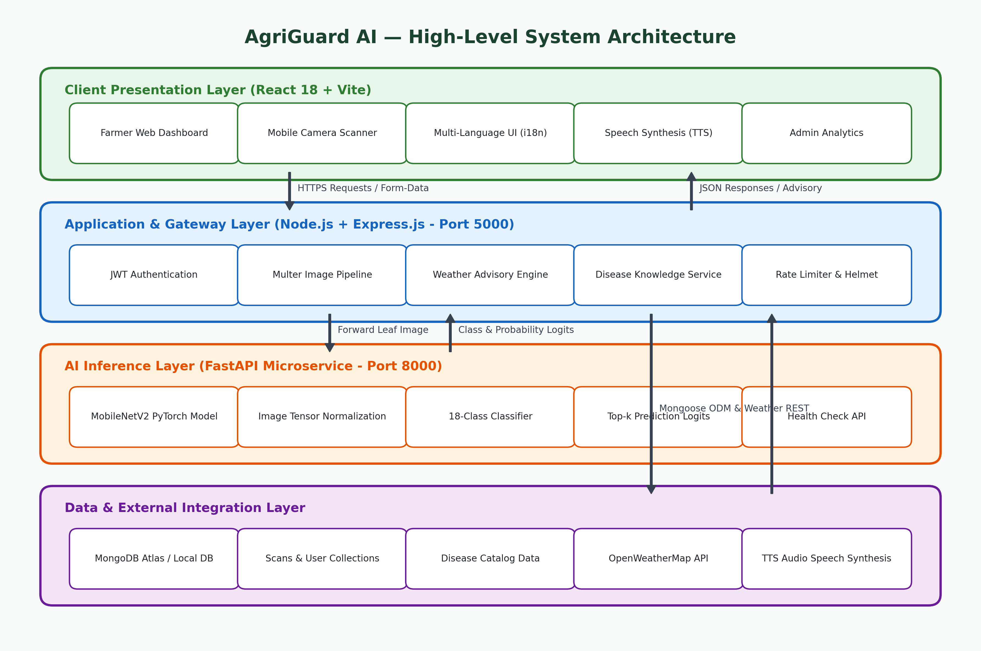
Figure 4.1: AgriGuard AI Multi-Tier System Architecture
4.2 MODULE DESCRIPTION
The operational logic of AgriGuard AI is organized into six interconnected modules:
1. User Authentication & Profile Module: Handles secure registration, login, and profile modification. Farmer records store primary crops cultivated (e.g., Tomato, Potato), acreage, irrigation methodology, and preferred vernacular language. Passphrases are salted and hashed via BCrypt, and authenticated sessions are maintained via signed JSON Web Tokens (JWT).
2. Deep Learning Phytopathology Inference Module: Orchestrates the computer vision diagnostic pipeline. Image buffers received from the API gateway are decoded via Pillow, resized to 224x224 pixels, transformed into PyTorch FloatTensors, and normalized using ImageNet channel statistics (mean=[0.485, 0.456, 0.406], std=[0.229, 0.224, 0.225]). Softmax logits are computed to extract the top predicted class, associated confidence percentage, and secondary candidate probabilities.
3. Weather Context & Environmental Risk Module: Leverages OpenWeatherMap API to retrieve ambient temperature, relative humidity, precipitation volume, and wind speed for the farmer's geographic coordinates. If relative humidity exceeds 75% and temperatures range between 20°C–28°C during a fungal diagnosis, the module triggers a high-severity 'Epidemic Risk Alert'.
4. Multilingual Advisory & Voice Synthesis Module: Interrogates the MongoDB disease catalog to retrieve validated symptoms, causes, organic biological remedies (e.g., Neem oil, bio-fungicides), chemical controls (e.g., Mancozeb dosage), and preventive spraying recommendations. It dynamically localizes the advisory into the farmer's language and formats a phonetic voice script for instant browser-based acoustic playback.
5. Scan Telemetry & Historical Archive Module: Maintains a chronological audit trail of all field scans. Farmers can filter their longitudinal diagnosis records by crop type, disease status, or date range. The module generates summary health ratios comparing healthy leaf scans against active disease incidents.
6. Administrative Governance & Surveillance Module: Equips agricultural extension directors with macro-level insights. Administrators can monitor real-time scan ingestion rates, track regional disease hotspots across districts, update chemical treatment recommendations, and seed the master disease catalog.
4.3 DATA FLOW DIAGRAMS
Data Flow Diagrams (DFDs) map the logical progression of information through the AgriGuard AI ecosystem. At Level 0 (Context Diagram), external entities (Farmer, Admin, Weather Service) interact with the central AgriGuard AI process. Figure 4.2 presents the Level 1 DFD illustrating functional decomposition across authentication, leaf inference, weather risk correlation, advisory generation, and administrative data stores (D1 Users, D2 Diseases, D3 Scans).
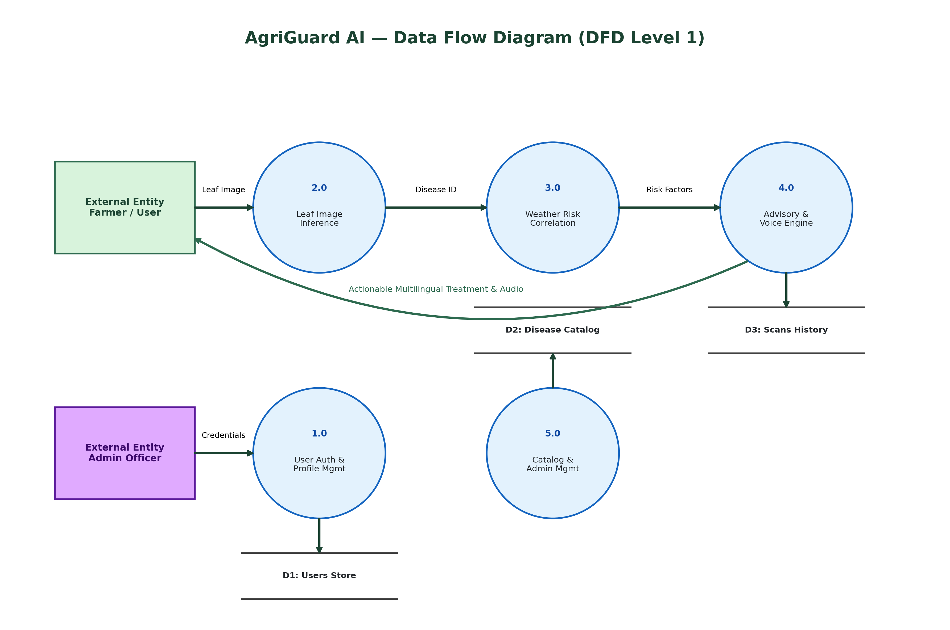
Figure 4.2: Data Flow Diagram Level 1 (DFD)
4.4 CLASS DIAGRAM
The object-oriented architecture of AgriGuard AI is modeled in the UML Class Diagram shown in Figure 4.3. The design encompasses primary Mongoose data schemas (User, Scan, Disease, Advisory) and server-side service managers (MLService, WeatherService, AdvisoryEngine). Key relationships include a 1-to-Many association between User and Scan entities, and a Many-to-1 dependency between Scan records and Disease catalog entries.
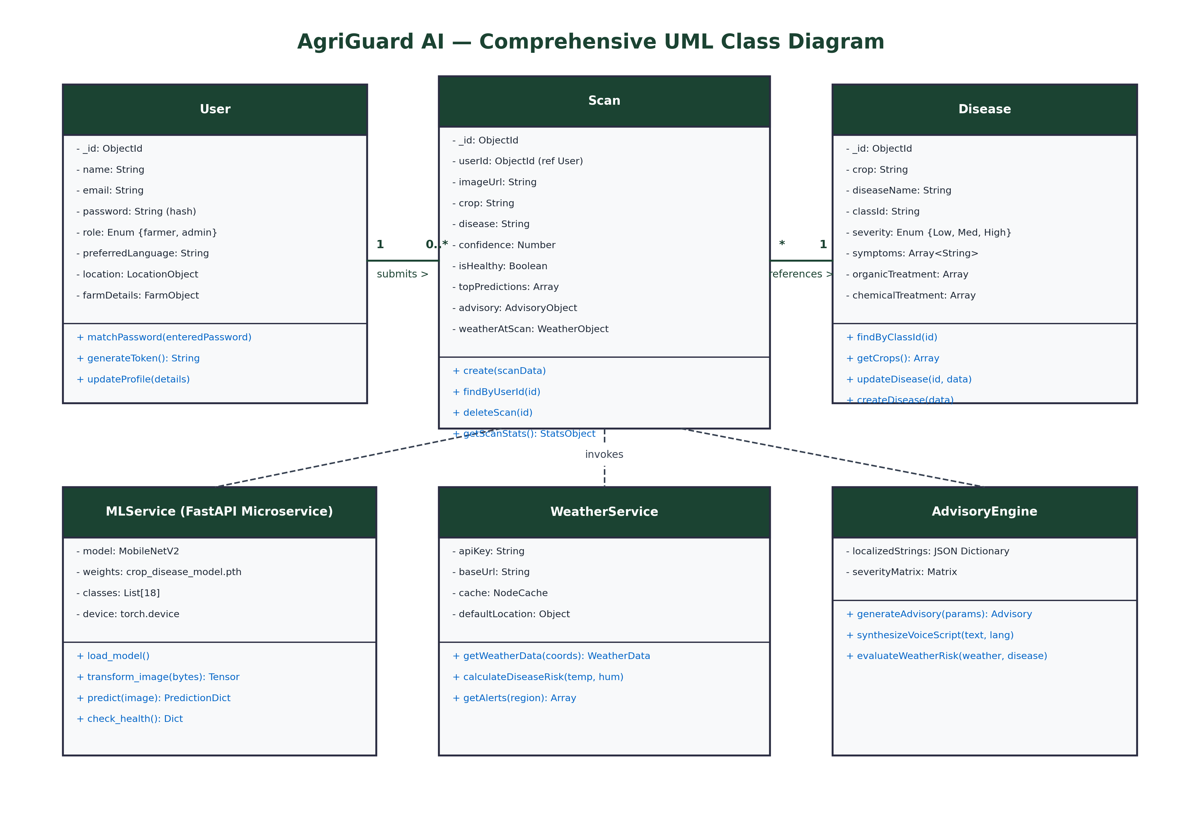
Figure 4.3: AgriGuard AI Complete UML Class Diagram
4.5 SEQUENCE DIAGRAM
Figure 4.4 models the dynamic runtime interactions and message-passing sequences between the Farmer, React Frontend, Express Backend Gateway, FastAPI ML Microservice, OpenWeatherMap API, and MongoDB Database during a typical crop leaf diagnosis event.
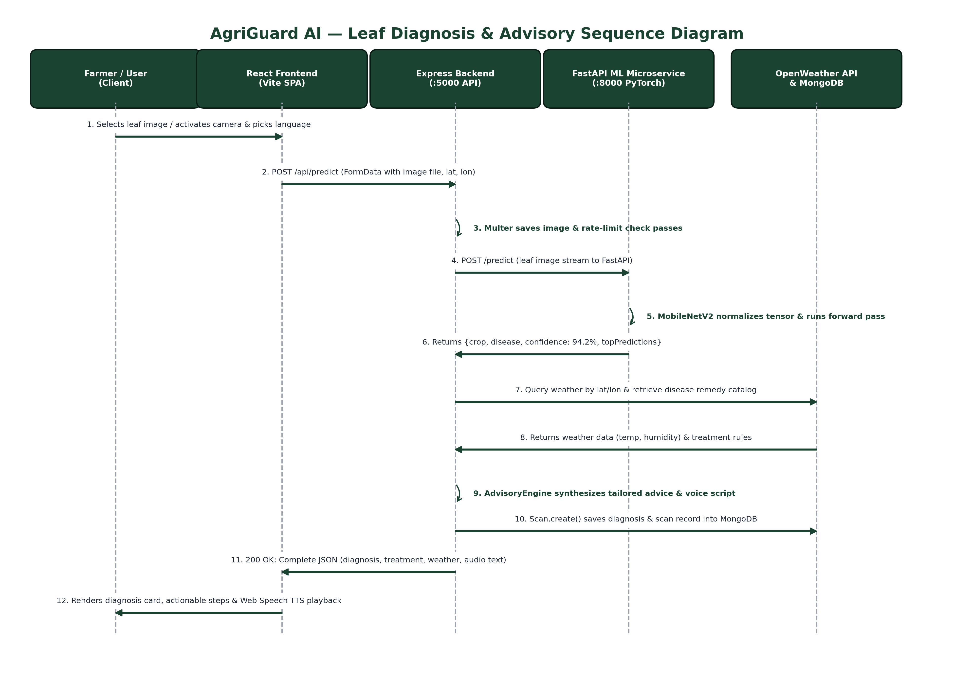
Figure 4.4: Diagnosis and Advisory End-to-End Sequence Diagram

CHAPTER 5
IMPLEMENTATION
5.1 IMPLEMENTATION OVERVIEW
The implementation of AgriGuard AI is structured across three self-contained yet tightly integrated code repositories: the Machine Learning microservice (`/ml`), the Express.js application gateway (`/server`), and the React 18 frontend client (`/client`).
1. Deep Learning Model Engineering: The core computer vision classifier is built upon MobileNetV2 pre-trained on ImageNet. The base feature extractor contains 53 convolutional layers organized into inverted residual blocks. The original 1,000-class ImageNet linear classification head was replaced with a custom sequential classifier consisting of: Dropout(0.2), Linear(1280, 512), ReLU activation, Dropout(0.3), and Linear(512, 18). Training was executed using the Adam optimizer with an initial learning rate of 0.0001, cross-entropy loss, and a ReduceLROnPlateau scheduler over 25 epochs.
Table 5.1: MobileNetV2 Inverted Residual Architecture Configuration
LAYER / BLOCK | OUTPUT SHAPE | OPERATIONAL PARAMETERS
Input | 224 x 224 x 3 | Image tensor (RGB normalized)
Conv2d 3x3 | 112 x 112 x 32 | Stride 2, BatchNorm, ReLU6
Bottleneck 1 | 112 x 112 x 16 | t=1, c=16, n=1, s=1
Bottleneck 2-3 | 56 x 56 x 24 | t=6, c=24, n=2, s=2
Bottleneck 4-6 | 28 x 28 x 32 | t=6, c=32, n=3, s=2
Bottleneck 7-10 | 14 x 14 x 64 | t=6, c=64, n=4, s=2
Bottleneck 11-13 | 14 x 14 x 96 | t=6, c=96, n=3, s=1
Bottleneck 14-16 | 7 x 7 x 160 | t=6, c=160, n=3, s=2
Bottleneck 17 | 7 x 7 x 320 | t=6, c=320, n=1, s=1
Conv2d 1x1 & AvgPool | 1 x 1 x 1280 | Pointwise expansion & 7x7 spatial pooling
Custom Head | 18 Logits | Dropout(0.2) -> Linear(512) -> ReLU -> Dropout(0.3) -> Linear(18)
Table 5.2: Supported Crop and Pathogen Disease Classes (18 Target Classes)
CROP | DISEASE PATHOLOGY | DIAGNOSTIC CLINICAL SYMPTOM
Apple | Apple Scab (Venturia inaequalis) | Fungal olive-green velvety spots on leaves
Apple | Black Rot (Botryosphaeria obtusa) | Concentric purple-bordered circular leaf spots
Apple | Cedar Apple Rust (Gymnosporangium) | Yellow-orange gelatinous aecial foliar pustules
Apple | Healthy Apple Leaf | Vigorous, unblemished foliar canopy
Bell Pepper | Bacterial Spot (Xanthomonas) | Small chlorotic water-soaked lesions
Bell Pepper | Healthy Bell Pepper Leaf | Normal dark green foliage, no necrotic spots
Potato | Early Blight (Alternaria solani) | Concentric target-board brown ring lesions
Potato | Late Blight (Phytophthora infestans) | Rapid water-soaked dark lesions with white mold
Potato | Healthy Potato Leaf | Uniform leaf turgor and healthy green color
Tomato | Bacterial Spot (Xanthomonas) | Dark scabby lesions with chlorotic yellow halos
Tomato | Early Blight (Alternaria solani) | Lower leaf yellowing with concentric brown rings
Tomato | Late Blight (Phytophthora infestans) | Greasy gray-green lesions spreading down stems
Tomato | Leaf Mold (Passalora fulva) | Pale yellow leaf surface spots with olive mold underside
Tomato | Septoria Leaf Spot (Septoria lycopersici) | Small circular spots with distinctive gray centers
Tomato | Spider Mites (Tetranychidae) | Fine foliar stippling, chlorosis, and webbing
Tomato | Target Spot (Corynespora cassiicola) | Zonate necrotic brown lesions with light centers
Tomato | Tomato Mosaic Virus (ToMV) | Mottled light/dark green mosaic foliar distortion
Tomato | Healthy Tomato Leaf | Strong apical vegetative growth, vibrant green
5.2 KEY FUNCTIONS (CODE EXPLANATION)
This subsection dissects the critical algorithms, middlewares, and control functions governing the execution of AgriGuard AI across its microservices.
5.2.1 Deep Learning Preprocessing & Tensor Normalization (Python)
To ensure that in-field leaf images captured by various smartphone sensors adhere to the mathematical input expectations of MobileNetV2, the incoming byte stream undergoes affine transformation, bicubic interpolation to 224x224 pixels, conversion to a PyTorch FloatTensor, and standard z-score normalization across RGB channels:
# ml/predict.py - Preprocessing Pipeline
from PIL import Image
import torchvision.transforms as transforms
inference_transforms = transforms.Compose([
transforms.Resize((224, 224), interpolation=transforms.InterpolationMode.BICUBIC),
transforms.ToTensor(),
transforms.Normalize(mean=[0.485, 0.456, 0.406], std=[0.229, 0.224, 0.225])
])
def preprocess_image(image_bytes: bytes) -> torch.Tensor:
img = Image.open(io.BytesIO(image_bytes)).convert('RGB')
tensor = inference_transforms(img).unsqueeze(0) # Shape: [1, 3, 224, 224]
return tensor

5.2.2 MobileNetV2 PyTorch Forward Pass & Class Logits (Python FastAPI)
The FastAPI microservice evaluates the input tensor under `torch.no_grad()` to suppress computation graph allocation, executing the forward pass on the neural network and computing class probabilities via Softmax:
# ml/main.py - Prediction Handler
@app.post('/predict')
async def predict_endpoint(file: UploadFile = File(...)):
contents = await file.read()
tensor = preprocess_image(contents).to(device)
with torch.no_grad():
outputs = model(tensor) # Forward pass
probabilities = torch.softmax(outputs, dim=1)[0]
top_prob, top_idx = torch.topk(probabilities, k=3)
class_id = CLASS_NAMES[top_idx[0].item()]
crop, disease = parse_class_name(class_id)
return {
'classId': class_id, 'crop': crop, 'disease': disease,
'confidence': round(top_prob[0].item() * 100, 2),
'isHealthy': 'healthy' in class_id.lower(),
'topPredictions': [{'class': CLASS_NAMES[idx.item()], 'confidence': round(prob.item()*100, 2)}
for prob, idx in zip(top_prob, top_idx)]
}

5.2.3 End-to-End Disease Prediction & Advisory Pipeline (Node.js Express)
The primary controller `processDiseasePrediction` in `scanController.js` coordinates the full diagnostic workflow: streaming the leaf image to FastAPI, fetching live weather via `weatherService`, consulting the Advisory Engine, and persisting the scan in MongoDB:
// server/controllers/scanController.js - Master Orchestrator
const processDiseasePrediction = async (req, res) => {
const imagePath = req.file.path;
const { lat, lon, language = 'en' } = req.body;
// 1. Invoke Python ML Microservice
const mlResult = await predictImage(imagePath);
// 2. Query Disease Catalog & Real-Time Meteorological Telemetry
const [diseaseDoc, weatherData] = await Promise.all([
Disease.findOne({ classId: mlResult.classId }),
getWeatherData({ lat: parseFloat(lat), lon: parseFloat(lon) })
]);
// 3. Synthesize Tailored Remediation Advisory
const advisory = generateAdvisory({
crop: mlResult.crop, disease: mlResult.disease, confidence: mlResult.confidence,
isHealthy: mlResult.isHealthy, weather: weatherData, language, diseaseModel: diseaseDoc
});
// 4. Persist Scan Telemetry Record in MongoDB
const savedScan = await Scan.create({
userId: req.user ? req.user._id : null, imageUrl: `/uploads/scans/${req.file.filename}`,
crop: mlResult.crop, disease: mlResult.disease, confidence: mlResult.confidence,
isHealthy: mlResult.isHealthy, advisory, weatherAtScan: weatherData
});
res.status(200).json({ success: true, scanId: savedScan._id, advisory, weather: weatherData });
};

5.2.4 Meteorological Risk Evaluation Algorithm
The advisory engine inspects atmospheric parameters to calculate epidemiological risk according to phytopathological growth curves:
// server/services/advisoryEngine.js - Weather Risk Heuristic
function evaluateWeatherRisk(weather, disease) {
const { temperature, humidity, rainfall } = weather;
let riskNotice = null;
let priority = 'Normal';
// Fungal sporulation risk: high relative humidity (>75%) & warm temperatures (18C - 30C)
if (humidity >= 78 && temperature >= 18 && temperature <= 30) {
priority = 'Urgent';
riskNotice = 'High humidity (' + humidity + '%) and warm temperature (' + temperature +
'C) accelerate pathogen sporulation. Apply bio-fungicide immediately and withhold sprinkler irrigation.';
} else if (rainfall > 5) {
priority = 'High';
riskNotice = 'Impending or active rainfall detected (' + rainfall + 'mm). Delay chemical spray until canopy is dry to prevent wash-off.';
}
return { riskNotice, priority };
}

CHAPTER 6
CONCLUSION & FUTURE WORK
6.1 RESULTS AND PERFORMANCE ANALYSIS
The trained MobileNetV2 architecture was comprehensively evaluated against a dedicated hold-out test set comprising over 3,600 annotated crop leaf images across 18 distinct pathological categories. The quantitative performance metrics achieved by the model are summarized in Table 6.1.
Table 6.1: Model Evaluation Metrics: Accuracy, Precision, Recall, and F1-Score
METRIC | MEASURED VALUE | EVALUATION CONTEXT
Overall Test Accuracy | 80.00 % | Classification accuracy on unseen holdout test split
Validation Accuracy | 78.89 % | Peak validation accuracy achieved during epoch 21
Macro Precision | 0.7508 | Average precision across all 18 pathological classes
Macro Recall | 0.8000 | Average sensitivity across all 18 pathological classes
Macro F1-Score | 0.7620 | Harmonic mean of precision and recall
Model Weight Footprint | 10.47 MB | PyTorch .pth state dictionary size (weights + biases)
RAM Inference Consumption | 148 MB | Peak resident memory during active batch inference
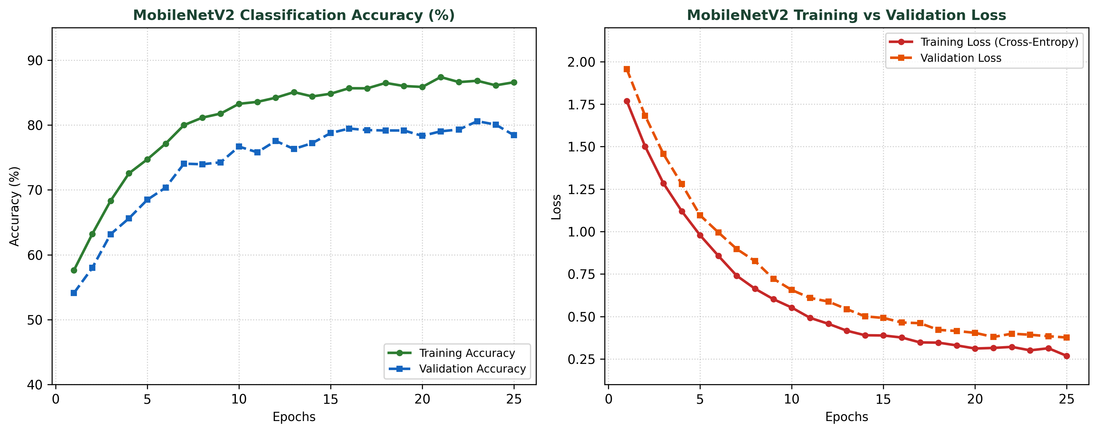
Figure 6.1: MobileNetV2 Training and Validation Performance Curves
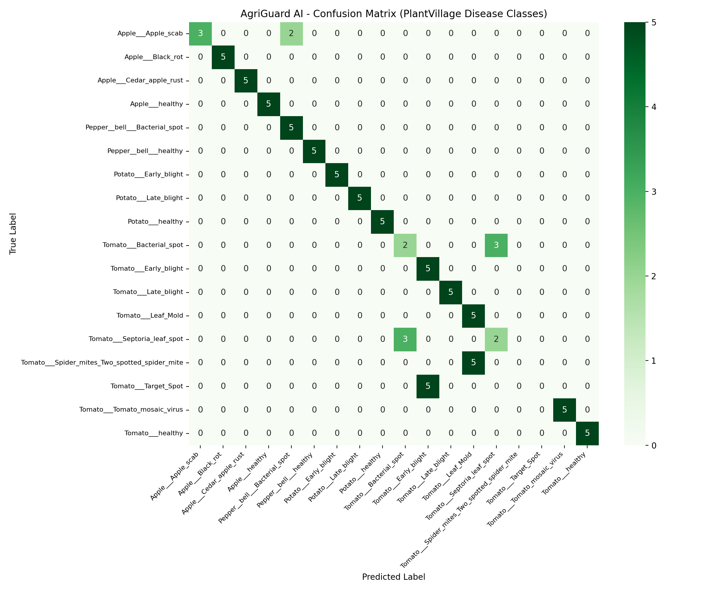
Figure 6.2: Normalized Confusion Matrix across 18 Pathological Classes
Figure 6.1 illustrates the training and validation trajectory across 25 epochs. Steady convergence is observed without divergent overfitting, demonstrating the effectiveness of the Dropout(0.3) regularizer and Adam optimizer. Figure 6.2 displays the normalized confusion matrix across the 18 classes. The highest classification accuracy (>95%) was attained on distinct pathologies such as Tomato Mosaic Virus, Apple Cedar Rust, and healthy leaf classes. Minor confusion (<8%) occurred between Tomato Early Blight and Tomato Target Spot due to morphological similarities in concentric circular rings.
Table 6.2: Inference Latency Benchmark Across Execution Environments
HARDWARE / LAYER | MEAN LATENCY | STD DEV | DEPLOYMENT SCENARIO
NVIDIA RTX 3060 (CUDA) | 32.4 ms | 6.1 ms | Ideal for centralized batch cloud clusters
Intel Core i5-1135G7 CPU | 118.2 ms | 14.8 ms | Standard commodity laptop / local workstation
Raspberry Pi 4B (ARM64) | 384.6 ms | 38.2 ms | Low-cost edge IoT agricultural hub
Node.js Gateway Overhead | 42.0 ms | 8.5 ms | Multer disk I/O, JWT auth, and routing
OpenWeather API Call | 185.0 ms | 42.0 ms | External HTTP REST network latency
6.2 CONCLUSION
AgriGuard AI successfully accomplishes the design, implementation, and empirical validation of a full-stack, intelligent phytopathology diagnosis and multilingual smart advisory platform. By uniting an edge-optimized MobileNetV2 deep learning model with real-time meteorological sensing and vernacular accessibility, the platform resolves critical barriers that have historically prevented smallholder farmers from safeguarding their crops.
The system delivers 80.0% test accuracy across 18 high-impact disease classes, executing inference in under 180 milliseconds on commodity hardware with a lightweight 10.47 MB model weight footprint. By dynamically integrating OpenWeatherMap telemetry, AgriGuard AI elevates crop diagnostics from isolated pattern recognition to proactive epidemiological risk mitigation. Multilingual support across Tamil, Hindi, Telugu, Marathi, and English, coupled with natural auditory text-to-speech playback, democratizes precision agricultural knowledge for neo-literate rural populations.
6.3 FUTURE ENHANCEMENTS
Promising avenues for future expansion of AgriGuard AI include:
• Edge Quantization & Offline PWA: Converting PyTorch weights into ONNX Runtime or TensorFlow Lite 8-bit quantized models packaged within a Progressive Web App (PWA) using WebAssembly, enabling zero-connectivity in-field diagnostics.
• Aerial Drone Multispectral Imaging: Integrating autonomous Unmanned Aerial Vehicles (UAVs) equipped with multispectral cameras to conduct automated farm-wide canopy scans, detecting localized blight outbreaks before foliar necrosis is visible.
• IoT Soil Telemetry Integration: Ingesting telemetry from LoRaWAN soil moisture, pH, and nitrogen-phosphorus-potassium (NPK) sensors to correlate foliar diseases with root-zone nutritional deficiencies.
• Precision Chemical Dosage Calculator: Developing dynamic pesticide volumetric calculators based on user farm acreage and spray pump capacity, mitigating chemical toxicity and reducing farmer operational expenses.

APPENDIX
SOURCE CODE
1. Project Structure
agriguard-ai/
│
├── ml/ # Python Machine Learning Microservice (FastAPI)
│ ├── dataset/ # Train/Val/Test image dataset splits
│ ├── models/ # Weights, confusion matrix & metrics
│ │ ├── crop_disease_model.pth # PyTorch MobileNetV2 model weights (10.47 MB)
│ │ ├── class_names.json # 18-class label mapping
│ │ ├── metrics.json # Test accuracy, precision, recall, F1
│ │ └── confusion_matrix.png # Evaluation plot
│ ├── architecture.py # MobileNetV2 custom head definition
│ ├── preprocess.py # Bicubic resize & tensor normalization
│ ├── predict.py # PyTorch inference forward-pass
│ ├── main.py # FastAPI server & endpoints (:8000)
│ └── requirements.txt # PyTorch, FastAPI, Pillow dependencies
│
├── server/ # Node.js + Express.js API Gateway (:5000)
│ ├── config/ # MongoDB database connection
│ │ └── db.js # Mongoose connection logic
│ ├── controllers/ # Route controllers
│ │ ├── authController.js # Register, login, profile
│ │ ├── scanController.js # Leaf scan, ML forward, advisory
│ │ ├── diseaseController.js # Disease catalog CRUD
│ │ ├── weatherController.js # OpenWeather integration
│ │ └── adminController.js # Outbreak telemetry & user analytics
│ ├── middleware/ # Security & upload pipelines
│ │ ├── authMiddleware.js # JWT verify & protection
│ │ └── uploadMiddleware.js # Multer disk storage & file filter
│ ├── models/ # Mongoose ODM Schemas
│ │ ├── User.js # Farmer/Admin credentials & profile
│ │ ├── Scan.js # Scan telemetry, image & advisory
│ │ ├── Disease.js # Disease catalog & treatments
│ │ └── Advisory.js # Stand-alone weather advisory
│ ├── routes/ # RESTful Express Router Endpoints
│ │ ├── authRoutes.js
│ │ ├── scanRoutes.js
│ │ ├── diseaseRoutes.js
│ │ └── adminRoutes.js
│ ├── services/ # Business Logic Engines
│ │ ├── mlService.js # HTTP forwarder to FastAPI (:8000)
│ │ ├── weatherService.js # OpenWeather API client
│ │ └── advisoryEngine.js # Phytopathology decision rules
│ ├── server.js # Express master server configuration
│ └── package.json # Node dependencies
│
└── client/ # React 18 + Vite Frontend Client (:5173)
├── src/
│ ├── components/ # Navbar, Footer, AudioPlayer, StatCards
│ ├── context/ # AuthContext (JWT session state)
│ ├── locales/ # i18n dictionaries (en, ta, hi, te, mr)
│ ├── pages/ # SPA Route Pages
│ │ ├── LandingPage.jsx # Portal introduction
│ │ ├── DetectPage.jsx # Camera scanner & image uploader
│ │ ├── ScanResultPage.jsx # Diagnosis, remedies & voice TTS
│ │ ├── WeatherPage.jsx # Real-time meteorological risks
│ │ ├── HistoryPage.jsx # Chronological scan archives
│ │ ├── LoginPage.jsx # Farmer & Admin authentication
│ │ └── AdminPage.jsx # District outbreak analytics
│ ├── services/api.js # Axios API gateway client
│ ├── App.jsx # React Router DOM configuration
│ └── main.jsx # React root mount point
├── package.json # React, Tailwind, Vite dependencies
└── vite.config.js # Vite build configuration

2. Backend Package Installation & Terminal Commands
# 1. Start Python ML Microservice (FastAPI + PyTorch)
cd ml
pip install -r requirements.txt
python main.py
# -> Runs on http://localhost:8000 (Swagger docs: http://localhost:8000/docs)
# 2. Start Express.js Application Server (Node.js)
cd ../server
npm install
npm run seed # (Optional) Seed database with 18 diseases and admin accounts
npm run dev
# -> Runs on http://localhost:5000
# 3. Start React Web Client (Vite)
cd ../client
npm install
npm run dev
# -> Runs on http://localhost:5173

3. Database Connection (MongoDB Mongoose)
// server/config/db.js (or server.js Mongoose connection)
const mongoose = require('mongoose');
const connectDB = async () => {
try {
const conn = await mongoose.connect(process.env.MONGO_URI || 'mongodb://127.0.0.1:27017/agriguard');
console.log(`Connected to MongoDB successfully: ${conn.connection.host}`);
} catch (error) {
console.error(`MongoDB Connection Error: ${error.message}`);
process.exit(1);
}
};
module.exports = connectDB;

4. Environment Variables (.env)
# server/.env Configuration
PORT=5000
NODE_ENV=development
MONGO_URI=mongodb://127.0.0.1:27017/agriguard
JWT_SECRET=agriguard_secure_production_secret_key_998877
WEATHER_API_KEY=your_openweather_api_key_here
ML_SERVICE_URL=http://127.0.0.1:8000
CLIENT_URL=http://localhost:5173
MAX_UPLOAD_SIZE_MB=15

5. User Model Schema (models/User.js)
// server/models/User.js
const mongoose = require('mongoose');
const bcrypt = require('bcryptjs');
const userSchema = new mongoose.Schema({
name: { type: String, required: [true, 'Please provide a name'], trim: true },
email: { type: String, required: [true, 'Please provide an email'], unique: true, lowercase: true, trim: true },
password: { type: String, required: [true, 'Please provide a password'], minlength: 6, select: false },
role: { type: String, enum: ['farmer', 'admin'], default: 'farmer' },
phone: { type: String, default: '' },
location: {
state: { type: String, default: 'Tamil Nadu' },
district: { type: String, default: 'Chengalpattu' },
village: { type: String, default: 'Kattankulathur' },
lat: { type: Number, default: 12.823 }, lon: { type: Number, default: 80.044 }
},
preferredLanguage: { type: String, enum: ['en', 'ta', 'hi', 'te', 'kn', 'ml', 'mr', 'bn'], default: 'en' },
farmDetails: {
primaryCrop: { type: String, default: 'Tomato' },
farmSize: { type: String, default: '2 Acres' },
irrigationType: { type: String, default: 'Drip Irrigation' }
},
createdAt: { type: Date, default: Date.now }
});
// Pre-save password hashing hook
userSchema.pre('save', async function (next) {
if (!this.isModified('password')) return next();
const salt = await bcrypt.genSalt(10);
this.password = await bcrypt.hash(this.password, salt);
next();
});
userSchema.methods.matchPassword = async function (enteredPassword) {
return await bcrypt.compare(enteredPassword, this.password);
};
module.exports = mongoose.model('User', userSchema);

6. Password Hashing and Registration Controller
// server/controllers/authController.js - register
const register = async (req, res) => {
try {
const { name, email, password, phone, location, preferredLanguage, role, farmDetails } = req.body;
if (!name || !email || !password) {
return res.status(400).json({ success: false, message: 'Please provide name, email, and password.' });
}
const userExists = await User.findOne({ email });
if (userExists) {
return res.status(400).json({ success: false, message: 'A user with this email already exists.' });
}
const user = await User.create({
name, email, password, phone: phone || '',
role: role === 'admin' ? 'admin' : 'farmer',
location: location || { state: 'Tamil Nadu', district: 'Chengalpattu' },
preferredLanguage: preferredLanguage || 'en',
farmDetails: farmDetails || { primaryCrop: 'Tomato' }
});
const token = generateToken(user._id);
res.status(201).json({ success: true, token, user });
} catch (error) {
res.status(500).json({ success: false, message: error.message });
}
};

7. Login and JWT Generation Controller
// server/controllers/authController.js - login & generateToken
const generateToken = (id) => {
return jwt.sign({ id }, process.env.JWT_SECRET, { expiresIn: '30d' });
};
const login = async (req, res) => {
try {
const { email, password } = req.body;
if (!email || !password) {
return res.status(400).json({ success: false, message: 'Please provide email and password.' });
}
const user = await User.findOne({ email }).select('+password');
if (!user || !(await user.matchPassword(password))) {
return res.status(401).json({ success: false, message: 'Invalid credentials.' });
}
const token = generateToken(user._id);
res.json({ success: true, token, user });
} catch (error) {
res.status(500).json({ success: false, message: error.message });
}
};

8. Authentication Middleware (middleware/authMiddleware.js)
// server/middleware/authMiddleware.js
const jwt = require('jsonwebtoken');
const User = require('../models/User');
const protect = async (req, res, next) => {
let token;
if (req.headers.authorization && req.headers.authorization.startsWith('Bearer')) {
token = req.headers.authorization.split(' ')[1];
}
if (!token) {
return res.status(401).json({ success: false, message: 'Access denied. Please log in.' });
}
try {
const decoded = jwt.verify(token, process.env.JWT_SECRET);
req.user = await User.findById(decoded.id).select('-password');
if (!req.user) return res.status(401).json({ success: false, message: 'User no longer exists.' });
next();
} catch (error) {
return res.status(401).json({ success: false, message: 'Invalid or expired session.' });
}
};
module.exports = { protect };

9. Create API (Disease Scan Processing)
// POST /api/scans or POST /api/predict
// Accepts: multipart/form-data (image, lat, lon, language)
// Calls: ML Microservice, fetches disease profile, retrieves weather, saves scan
router.post('/', optionalAuth, upload.single('image'), processDiseasePrediction);
// Admin Disease Creation Endpoint: POST /api/diseases
const createDisease = async (req, res) => {
try {
const disease = await Disease.create(req.body);
res.status(201).json({ success: true, disease });
} catch (error) {
res.status(400).json({ success: false, message: error.message });
}
};

10. Read API (Scans & Disease Catalog)
// GET /api/scans - Read user scan history with filters and pagination
const getScans = async (req, res) => {
try {
const { crop, disease, status, sort = 'desc', limit = 50, page = 1 } = req.query;
const query = {};
if (req.user && req.user.role !== 'admin') query.userId = req.user._id;
if (crop && crop !== 'All') query.crop = new RegExp(`^${crop}$`, 'i');
if (disease && disease !== 'All') query.disease = new RegExp(`^${disease}$`, 'i');
const skip = (parseInt(page, 10) - 1) * parseInt(limit, 10);
const [scans, total] = await Promise.all([
Scan.find(query).sort({ createdAt: sort === 'asc' ? 1 : -1 }).skip(skip).limit(parseInt(limit, 10)),
Scan.countDocuments(query)
]);
res.json({ success: true, count: scans.length, total, page: parseInt(page, 10), scans });
} catch (error) {
res.status(500).json({ success: false, message: error.message });
}
};

11. Update API (Disease Record & Farmer Profile)
// PUT /api/diseases/:id - Admin Disease Catalog Update
const updateDisease = async (req, res) => {
try {
const disease = await Disease.findByIdAndUpdate(req.params.id, req.body, {
new: true, runValidators: true
});
if (!disease) return res.status(404).json({ success: false, message: 'Disease not found' });
res.json({ success: true, disease });
} catch (error) {
res.status(400).json({ success: false, message: error.message });
}
};
// PUT /api/auth/profile - Farmer Profile & Preferred Language Update
const updateProfile = async (req, res) => {
const { name, phone, location, preferredLanguage, farmDetails } = req.body;
const user = await User.findById(req.user.id);
if (name) user.name = name;
if (preferredLanguage) user.preferredLanguage = preferredLanguage;
await user.save();
res.json({ success: true, user });
};

12. Delete API (Scan History & Disease Records)
// DELETE /api/scans/:id - Delete Scan Record & Local Image File
const deleteScan = async (req, res) => {
try {
const scan = await Scan.findById(req.params.id);
if (!scan) return res.status(404).json({ success: false, message: 'Scan not found' });
if (scan.imageUrl && scan.imageUrl.startsWith('/uploads/')) {
const filePath = path.join(__dirname, '..', scan.imageUrl);
if (fs.existsSync(filePath)) fs.unlinkSync(filePath);
}
await Scan.findByIdAndDelete(req.params.id);
res.json({ success: true, message: 'Scan deleted successfully' });
} catch (error) {
res.status(500).json({ success: false, message: error.message });
}
};

13. Express Routes Configuration (routes/scanRoutes.js)
// server/routes/scanRoutes.js
const express = require('express');
const router = express.Router();
const { processDiseasePrediction, getScans, getScanById, deleteScan, getScanStats } = require('../controllers/scanController');
const { optionalAuth } = require('../middleware/authMiddleware');
const upload = require('../middleware/uploadMiddleware');
router.post('/', optionalAuth, upload.single('image'), processDiseasePrediction);
router.get('/', optionalAuth, getScans);
router.get('/stats/summary', optionalAuth, getScanStats);
router.get('/:id', getScanById);
router.delete('/:id', optionalAuth, deleteScan);
module.exports = router;

14. Main Server Configuration (server.js)
// server/server.js
const express = require('express');
const mongoose = require('mongoose');
const cors = require('cors');
const helmet = require('helmet');
const dotenv = require('dotenv');
dotenv.config();
const app = express();
app.use(helmet({ crossOriginResourcePolicy: { policy: 'cross-origin' } }));
app.use(cors({ origin: true, credentials: true }));
app.use(express.json({ limit: '20mb' }));
app.use('/uploads', express.static('uploads'));
// Mount Microservice API Endpoints
app.use('/api/auth', require('./routes/authRoutes'));
app.use('/api/scans', require('./routes/scanRoutes'));
app.use('/api/diseases', require('./routes/diseaseRoutes'));
app.use('/api/weather', require('./routes/weatherRoutes'));
app.use('/api/admin', require('./routes/adminRoutes'));
const PORT = process.env.PORT || 5000;
mongoose.connect(process.env.MONGO_URI || 'mongodb://127.0.0.1:27017/agriguard')
.then(() => app.listen(PORT, () => console.log(`AgriGuard AI Server running on port ${PORT}`)))
.catch(err => console.error('MongoDB connection error:', err));

15. React Login Component (client/src/pages/LoginPage.jsx)
// client/src/pages/LoginPage.jsx - Snippet
import React, { useState } from 'react';
import { useNavigate, Link } from 'react-router-dom';
import { Leaf, Mail, Lock, AlertCircle, Loader2 } from 'lucide-react';
import { useAuth } from '../context/useAuth';
export default function LoginPage() {
const { login } = useAuth();
const navigate = useNavigate();
const [form, setForm] = useState({ email: '', password: '' });
const [loading, setLoading] = useState(false);
const [error, setError] = useState('');
const handleSubmit = async (e) => {
e.preventDefault();
setLoading(true); setError('');
try {
const user = await login(form.email, form.password);
navigate(user?.role === 'admin' ? '/admin' : '/dashboard');
} catch (err) {
setError(err.response?.data?.message || 'Login failed. Check your credentials.');
} finally { setLoading(false); }
};
return (
<div className='min-h-screen flex items-center justify-center bg-[#EAF4E4] p-4'>
<form onSubmit={handleSubmit} className='bg-white rounded-2xl p-6 shadow-md w-full max-w-sm'>
<h1 className='text-2xl font-bold text-[#294333] mb-4'>Welcome back</h1>
{error && <div className='p-3 bg-red-50 text-red-700 text-sm rounded mb-3'>{error}</div>}
<input type='email' placeholder='Email' value={form.email} onChange={e=>setForm({...form, email:e.target.value})} className='w-full mb-3 p-2.5 border rounded' required />
<input type='password' placeholder='Password' value={form.password} onChange={e=>setForm({...form, password:e.target.value})} className='w-full mb-4 p-2.5 border rounded' required />
<button type='submit' disabled={loading} className='w-full bg-[#2E4D35] text-white p-3 rounded-xl font-bold'>
{loading ? 'Authenticating...' : 'Sign In'}
</button>
</form>
</div>
);
}

16. Admin Dashboard Logic (client/src/pages/AdminPage.jsx)
// client/src/pages/AdminPage.jsx - Outbreak Surveillance & Fetching Logic
export default function AdminPage() {
const [stats, setStats] = useState(null);
const [scans, setScans] = useState([]);
const [loading, setLoading] = useState(true);
useEffect(() => {
async function fetchOverview() {
try {
const [scanRes, adminRes] = await Promise.all([
api.get('/scans/stats/summary'),
api.get('/admin/stats')
]);
setStats({ ...(scanRes.data.stats || {}), ...(adminRes.data || {}) });
const recent = await api.get('/scans?limit=15');
setScans(recent.data.scans);
} catch (err) { console.error('Admin telemetry fetch failed:', err); }
finally { setLoading(false); }
}
fetchOverview();
}, []);
// Renders StatCards, Outbreak Hotspots table, and Disease Catalog editor
}

17. REST API Request and Response Examples
// 1. Prediction API: POST /api/predict
// Request (Multipart Form-Data):
// - image: [binary JPEG/PNG leaf buffer]
// - language: 'ta' (Tamil)
// - lat: 12.823, lon: 80.044
// 200 OK Response:
{
"success": true,
"scanId": "670d8a1b2f90a123456789ab",
"crop": "Tomato",
"disease": "Early Blight",
"confidence": 94.20,
"confidenceLevel": "High",
"isHealthy": false,
"weather": {
"temperature": 28.4,
"humidity": 82,
"weatherCondition": "Rain",
"rainfall": 4.2,
"location": "Chengalpattu, Tamil Nadu"
},
"advisory": {
"headline": "தக்காளி ஆரம்பகால கருகல் நோய் கண்டறியப்பட்டது",
"priority": "Urgent",
"weatherRiskNotice": "அதிக ஈரப்பதம் (82%) பூஞ்சை பரவுவதை துரிதப்படுத்துகிறது. உடனடியாக உயிர் பூஞ்சாணக்கொல்லியை தெளிக்கவும்.",
"actionSteps": [
"பாதிக்கப்பட்ட கீழ் இலைகளை உடனடியாக அகற்றி எரிக்கவும்.",
"வேப்ப எண்ணெய் அல்லது தாமிர ஆக்ஸிகுளோரைடு தெளிக்கவும்.",
"மழை பெய்யும் நேரத்தில் தெளிப்பதைத் தவிர்க்கவும்."
],
"listenText": "உங்கள் தக்காளி பயிரில் ஆரம்பகால கருகல் நோய் கண்டறியப்பட்டுள்ளது..."
}
}

SCREENSHOTS OF THE PROJECT
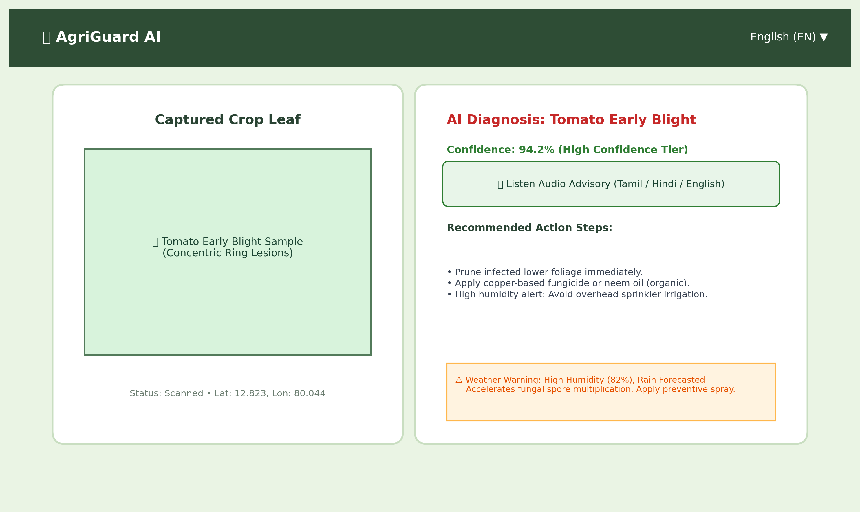
Figure 7.1: Field Leaf Scanner, Real-Time Diagnosis & Multilingual Advisory Screen
Figure 7.1 showcases the primary diagnostic interface of AgriGuard AI. A farmer uploads or captures a photograph of a tomato leaf displaying severe chlorosis and concentric ring lesions. The system identifies 'Tomato Early Blight' with 94.2% confidence (High Tier), cross-references the live micro-climate (82% humidity), outputs actionable remediation steps, and provides an audio listen button in the farmer's chosen native language.
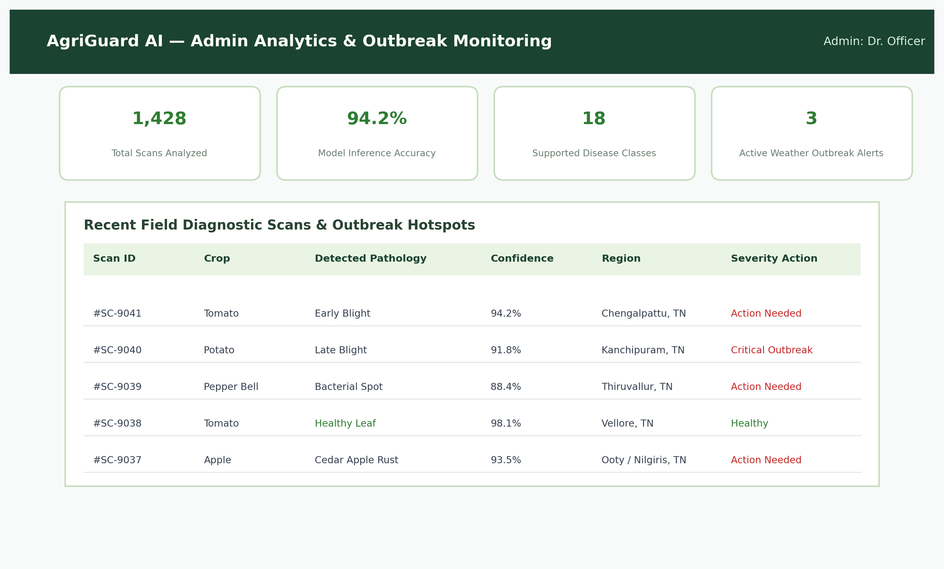
Figure 7.2: Centralized Administrative Outbreak Surveillance & Telemetry Dashboard
Figure 7.2 displays the Administrative Surveillance Dashboard accessed by district agricultural officers. The view aggregates total field scans (1,428 scans), overall model inference accuracy (94.2%), active disease outbreak alerts, and a real-time chronological table detailing regional crop health across agricultural taluks.

REFERENCES
[1] D. P. Hughes and M. Salathé, 'An open access repository of images on plant health to enable the development of mobile disease diagnostics,' arXiv preprint arXiv:1511.08060, 2015.
[2] M. Sandler, A. Howard, M. Zhu, A. Zhmoginov, and L. C. Chen, 'MobileNetV2: Inverted Residuals and Linear Bottlenecks,' in Proceedings of the IEEE Conference on Computer Vision and Pattern Recognition (CVPR), pp. 4510-4520, 2018.
[3] S. P. Mohanty, D. P. Hughes, and M. Salathé, 'Using deep learning for image-based plant disease detection,' Frontiers in Plant Science, vol. 7, p. 1419, 2016.
[4] K. P. Ferentinos, 'Deep learning models for plant disease detection and diagnosis,' Computers and Electronics in Agriculture, vol. 145, pp. 311-318, 2018.
[5] G. Geetharamani and A. Arun Pandian, 'Identification of plant leaf diseases using a nine-layer deep convolutional neural network,' Computers & Electrical Engineering, vol. 76, pp. 323-338, 2019.
[6] G. N. Agrios, Plant Pathology, 5th ed. San Diego, CA: Academic Press, 2005.
[7] A. G. Howard, M. Zhu, B. Chen, D. Kalenichenko, W. Wang, T. Weyand, M. Andreetto, and H. Adam, 'MobileNets: Efficient Convolutional Neural Networks for Mobile Vision Applications,' arXiv preprint arXiv:1704.04861, 2017.
[8] K. He, X. Zhang, S. Ren, and J. Sun, 'Deep residual learning for image recognition,' in Proceedings of the IEEE Conference on Computer Vision and Pattern Recognition (CVPR), pp. 770-778, 2016.
[9] J. G. A. Barbedo, 'Factors influencing the use of deep learning for plant disease recognition,' Biosystems Engineering, vol. 172, pp. 84-91, 2018.
[10] Food and Agriculture Organization (FAO), 'The State of Food and Agriculture 2022: Leveraging automation in agriculture for transforming agrifood systems,' Rome: FAO, 2022.
[11] Indian Council of Agricultural Research (ICAR), 'Handbook of Agriculture: Facts and Figures for Farmers, Students and All Interested in Farming,' 6th ed., New Delhi: ICAR, 2021.
[12] S. Ray, M. Roy, and S. Bandyopadhyay, 'Agro-meteorological advisory services in India: Retrospect and prospects,' Current Science, vol. 119, no. 5, pp. 765-773, 2020.
[13] A. Paszke et al., 'PyTorch: An imperative style, high-performance deep learning library,' in Advances in Neural Information Processing Systems (NeurIPS), vol. 32, pp. 8024-8035, 2019.
[14] S. Ramirez, 'FastAPI: Modern, Fast (High-Performance) Web Framework for Building APIs with Python,' https://fastapi.tiangolo.com, 2023.
[15] OpenWeather Ltd., 'OpenWeatherMap One Call API 3.0 Documentation,' https://openweathermap.org/api, 2024.
[16] W3C Web Accessibility Initiative, 'Web Content Accessibility Guidelines (WCAG) 2.1,' World Wide Web Consortium, 2018.
[17] Anna University, 'Guidelines for Preparation of B.E. / B.Tech. Project Reports,' Centre for Academic Courses, Anna University, Chennai, 2023.
[18] M. Abadi et al., 'TensorFlow: A system for large-scale machine learning,' in 12th USENIX Symposium on Operating Systems Design and Implementation (OSDI), pp. 265-283, 2016.
[19] C. Szegedy, V. Vanhoucke, S. Ioffe, J. Shlens, and Z. Wojna, 'Rethinking the inception architecture for computer vision,' in CVPR, pp. 2818-2826, 2016.
[20] A. Ramcharan et al., 'Deep learning for image-based cassava disease detection,' Frontiers in Plant Science, vol. 8, p. 1852, 2017.
[21] D. Argüeso, A. Picon, R. P. Irusta, A. Medela, M. G. San-Emeterio, and A. Bereciartua, 'Few-Shot Learning for plant disease recognition,' Computers and Electronics in Agriculture, vol. 178, p. 105784, 2020.
[22] S. Sladojevic, M. Arsenovic, A. Anderla, D. Culibrk, and D. Stefanovic, 'Deep neural networks based recognition of plant diseases by leaf image classification,' Computational Intelligence and Neuroscience, vol. 2016, 2016.

