

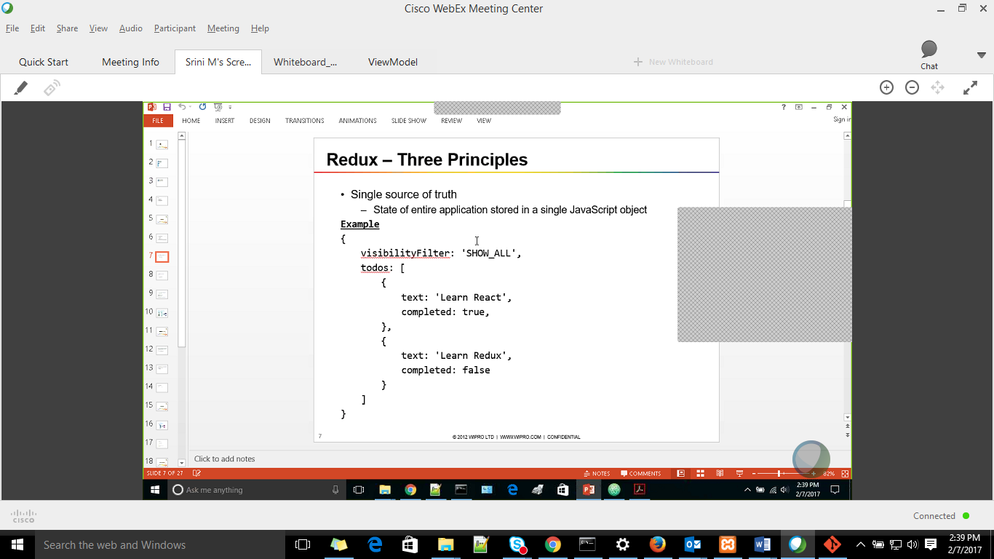

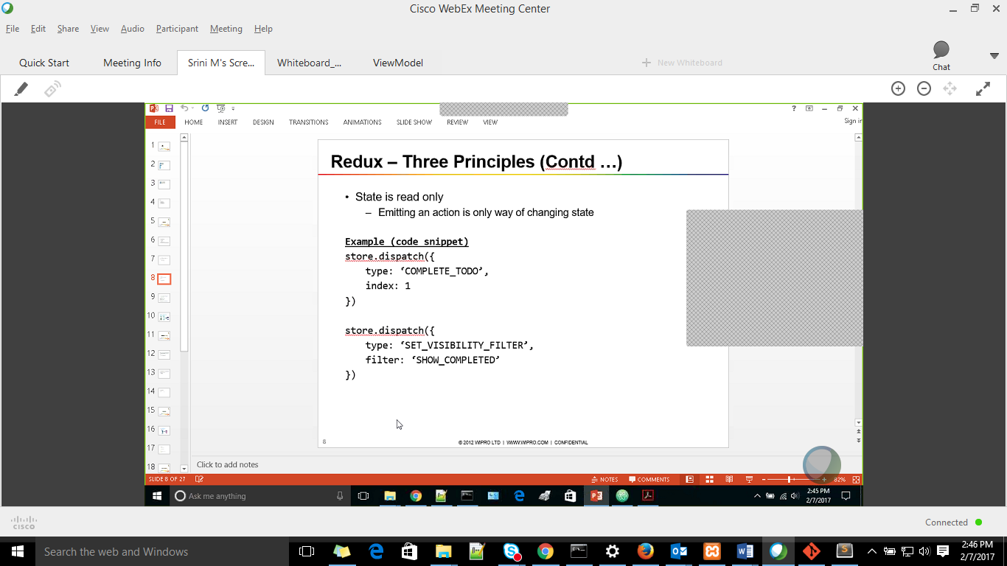

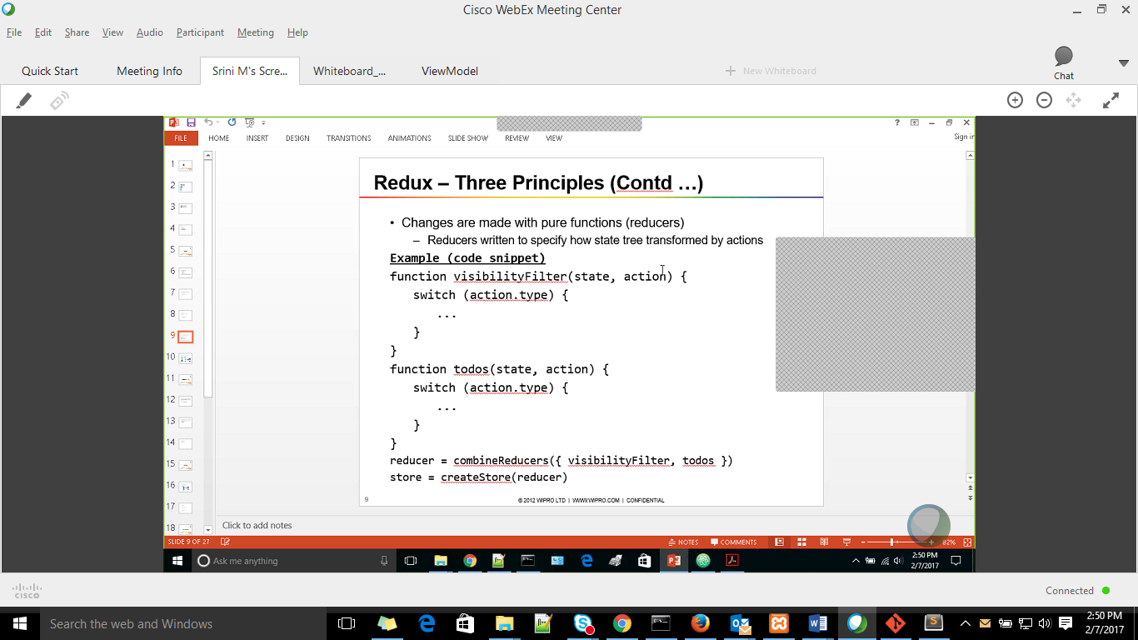

Pure function – out put of a function is determent on state of input passed. It wil return same result always for the given input

Reducers should always be pure functions

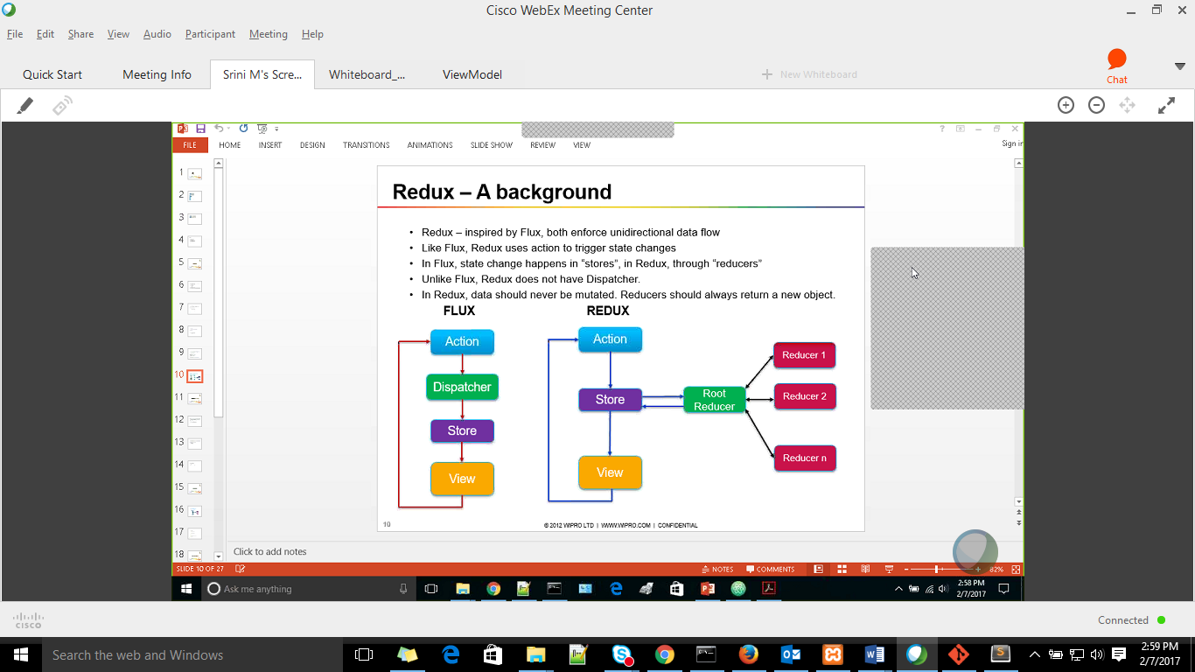

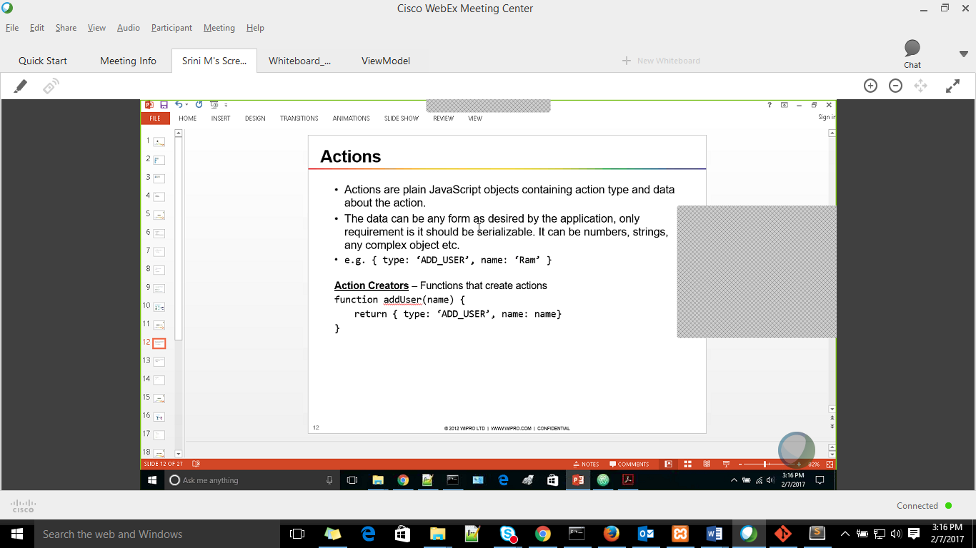

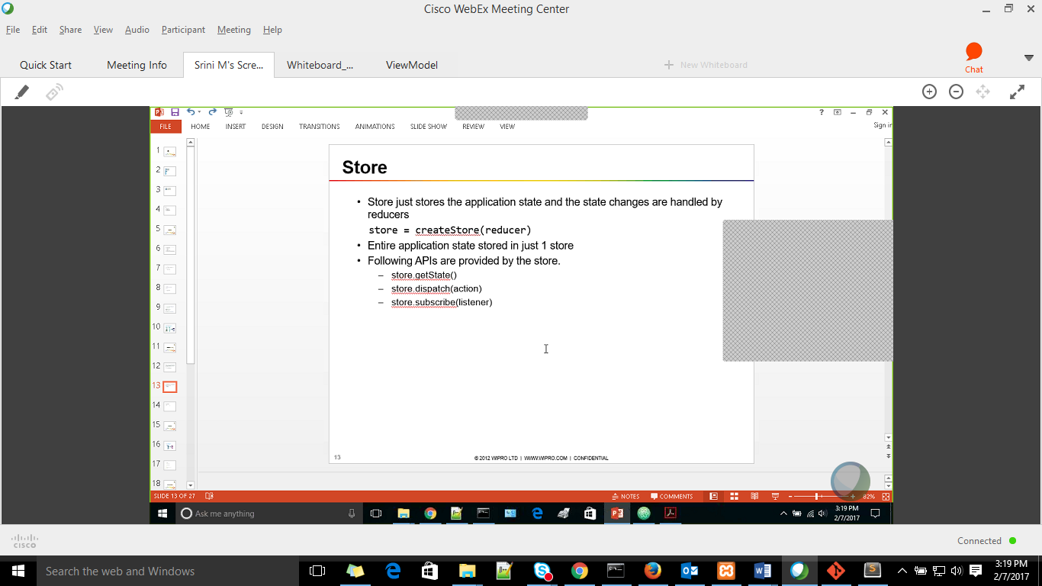



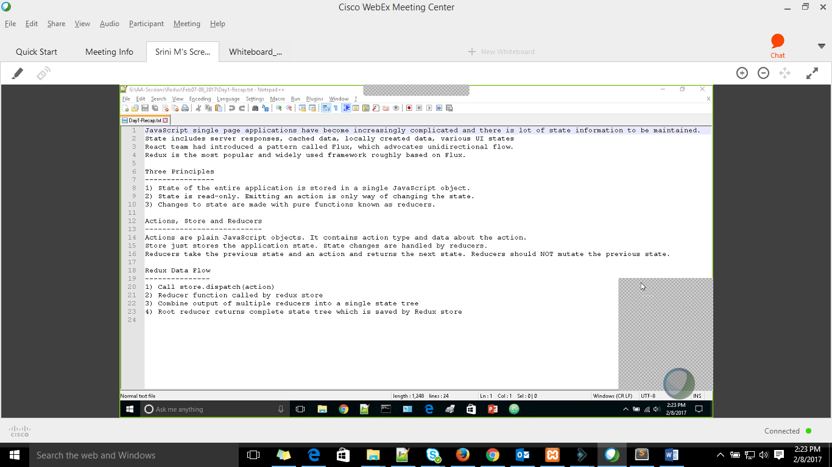

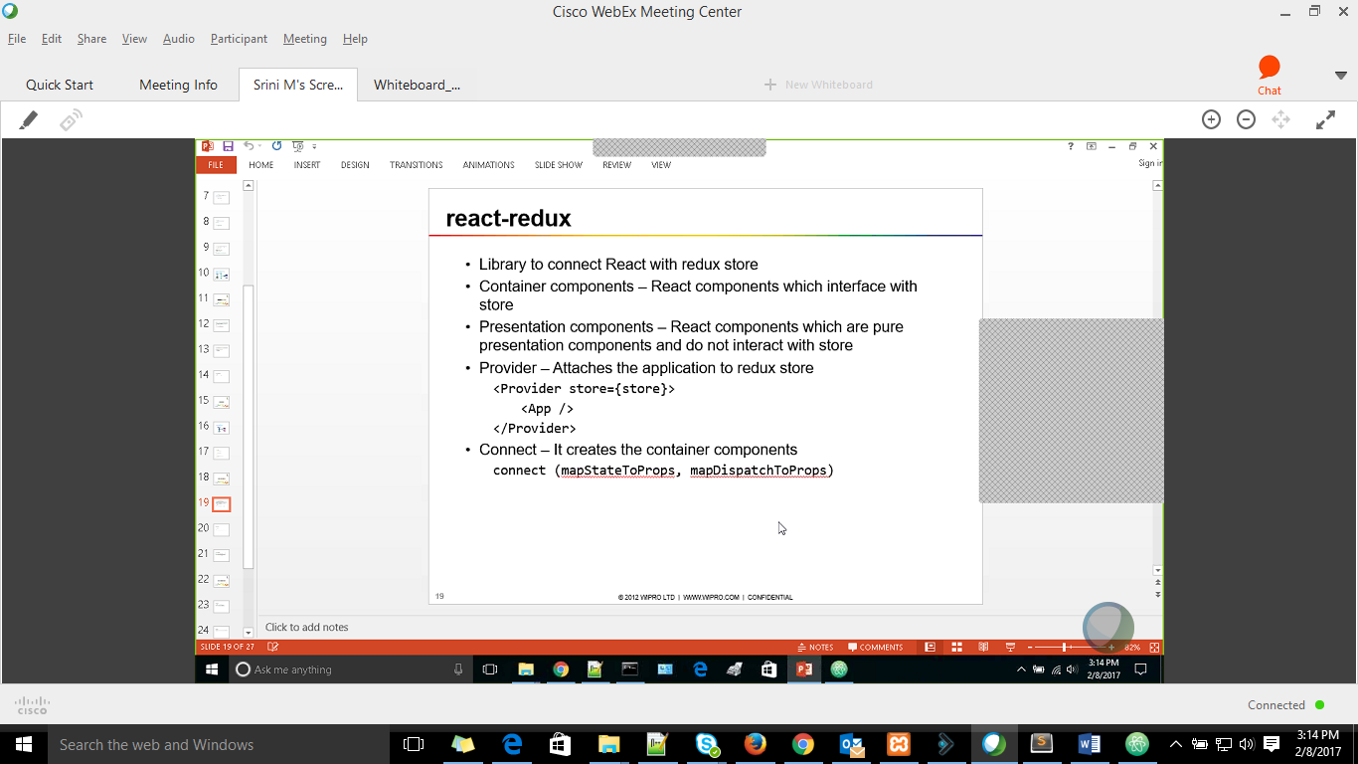

Instead of passing the store data to each child component, provider gives a option to connect once

Connect –

**mapStateToProps**

* State is maintained by redux and not react
* So redux takes care of connecting state to props.
* The react component uses this props only

mapDispatchToProps

* Same as above all dispatch actions is connected as props

Redux reducers are mainly for synchronous

Action comes for async

Redux-thunk is used to implement asynch behavior

ES6 promises—used to simulate the asynchronous behavior.. by introducing the delay

### Axios -[Promise based HTTP client for the browser ...](https://github.com/mzabriskie/axios)