FloodWise
Warn locally. Verify together. Route around known hazards.
A low-cost flood hazard beacon for risky manholes, with a crowd-verified live map
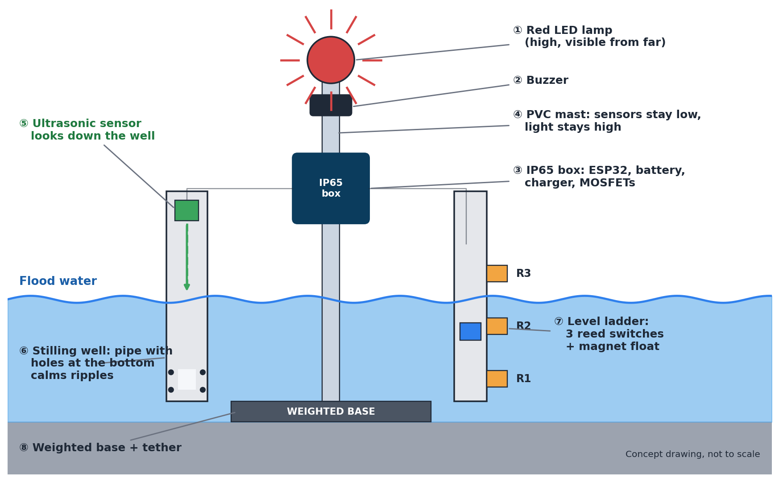
Presented by: Shruthi | B.E. CSE, Rajalakshmi Institute of Technology
Mentor: [add name] Project stage: design complete, prototype planned
This Word file is a slide-by-slide version of the deck. Each page is one slide. See Appendix B for how to move it into PowerPoint.

2 · The problem
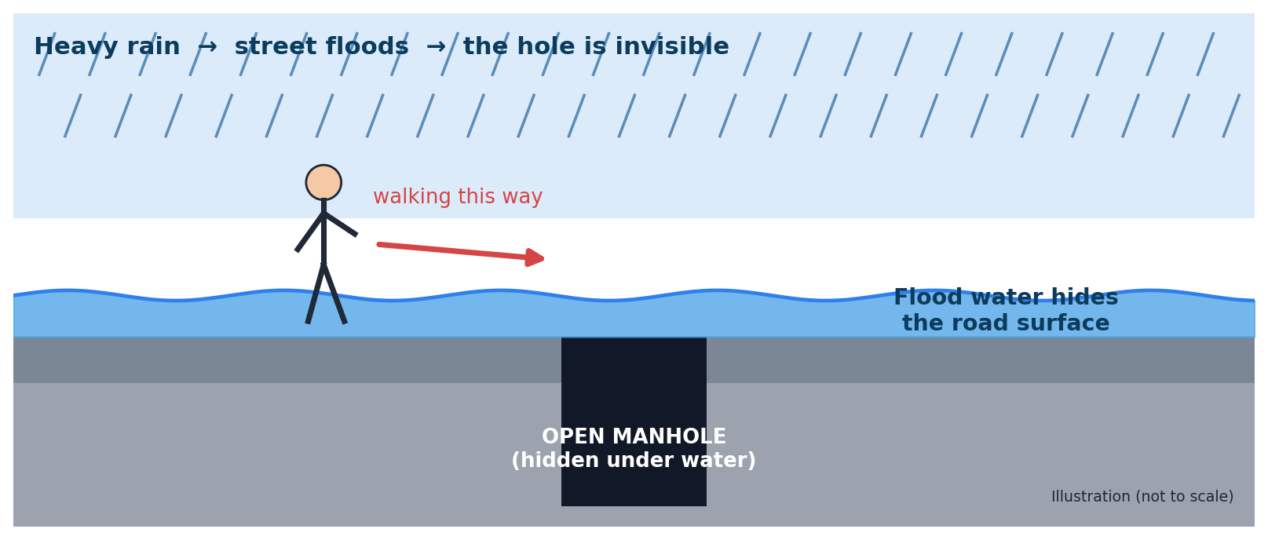
- Heavy rain floods city streets, and the water hides the road surface.
- If a manhole cover is missing, the hole becomes invisible, and people can fall in.
- Wiring electronics into every manhole is too costly for a danger that is worst only on a few days each year.
- We need something cheap, quick to place before monsoon, and useful to the person standing right there.
Say this: When a street floods, nobody can see where the road ends and the hole begins. We want a small device that shouts a warning right at that spot.
Before presenting: add one statistic about manhole or pit accidents with its official source. Do not quote numbers from memory.

3 · What exists today
Work reviewed | What it does | What is still missing for our problem
Sewer monitoring (Utepov et al., 2023) | Low-power sensors for water level and cover presence, mapped in a GIS | Alerts go to a monitoring system, not to people at the hazard
Manhole monitoring with LoRa (Narayana, 2026) | Gas, water level and tilt sensors, with cloud dashboard and WhatsApp alerts | Aimed at authorities; needs a gateway; no local street warning
Campus flood detection + QGIS (Capila, 2025) | Water-level sensing, GPS and a map of affected areas | No crowd input; no local warning
GSM flood monitor (Kaphungkui, 2024) | Ultrasonic sensor, SMS alerts and risk-level LEDs | Warns a monitoring point, not people at the spot
Smart flood detection + impact mapping (Patil et al., 2026) | IoT sensing, SMS alerts that work without internet, impact maps | No crowd verification; no local street warning
Flood Alert Mapper (Vicera et al., 2026) | Citizen reports with AI scoring and community votes | Does not describe protection against fake or repeated votes; no sensors
Based on abstracts and summaries; read the full papers before quoting details. Also add the two IJRASET manhole papers you uploaded, with full citation details.
Say this: Many good systems exist, but almost all of them send alerts to officials. We found none that also warns the person standing next to the hazard, in the papers we reviewed.

4 · Our idea: a beacon and a map
- 1. Warn on the spot. A beacon wakes when water arrives, flashes a bright light and sounds a buzzer. It works with no internet.
- 2. Verify together. Nearby beacons check each other, and citizens can report a missing cover. Fake reports have a hard limit on what they can do.
- 3. Plan around it. The live map shows hazards, and a route avoids the hazards the system knows about.
Who uses FloodWise
User | What they get
Person walking or driving nearby | An instant light and sound warning at the hazard
Nearby resident | Map and phone alerts before leaving home
Volunteer or ward worker | A simple way to place beacons and check reports
Municipal staff | Where to send a guard, beacon health, and a history of floods
What FloodWise is not: it does not detect a missing cover by itself (citizen and volunteer reports do that), and it is a research prototype, not a certified safety device.

5 · How it works
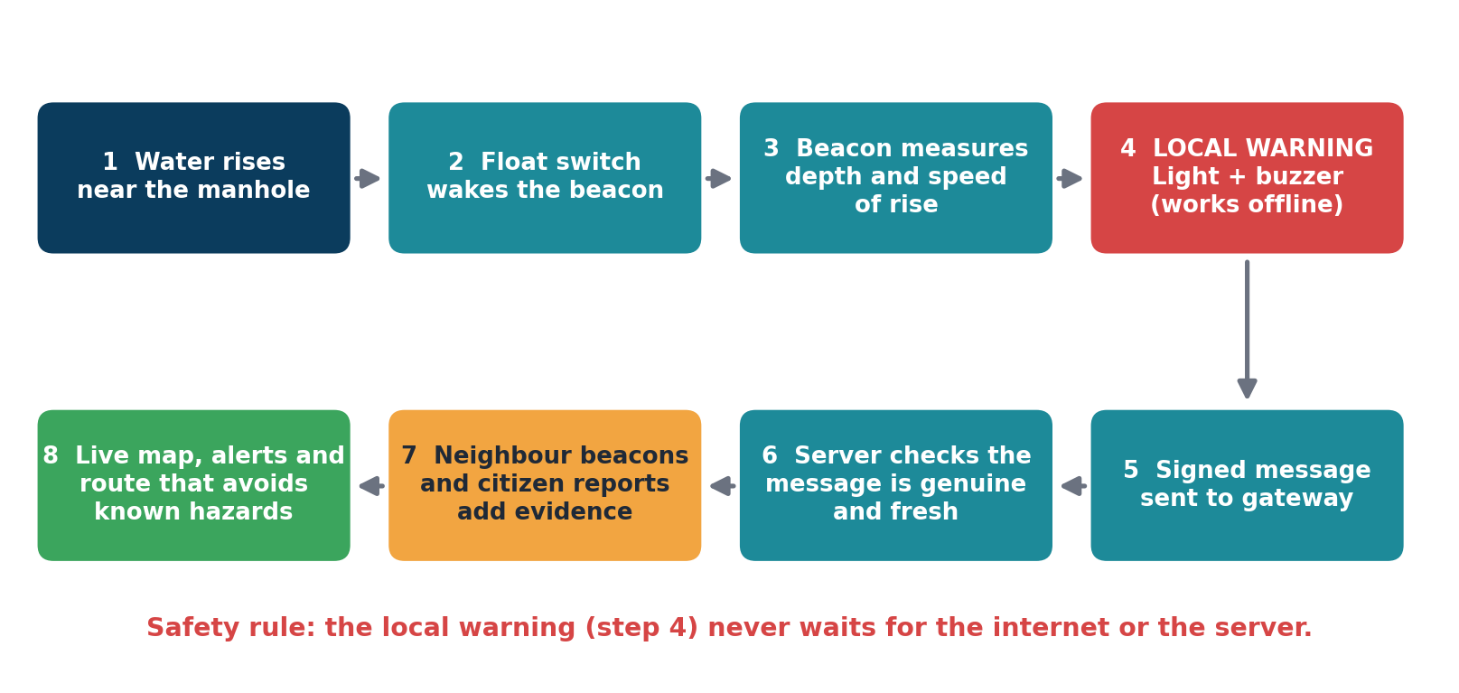
Say this: Water lifts a float. The beacon wakes up, measures how deep and how fast the water is rising, and warns people straight away. After that it tells the server, which double-checks everything before showing it on the map.

6 · System architecture
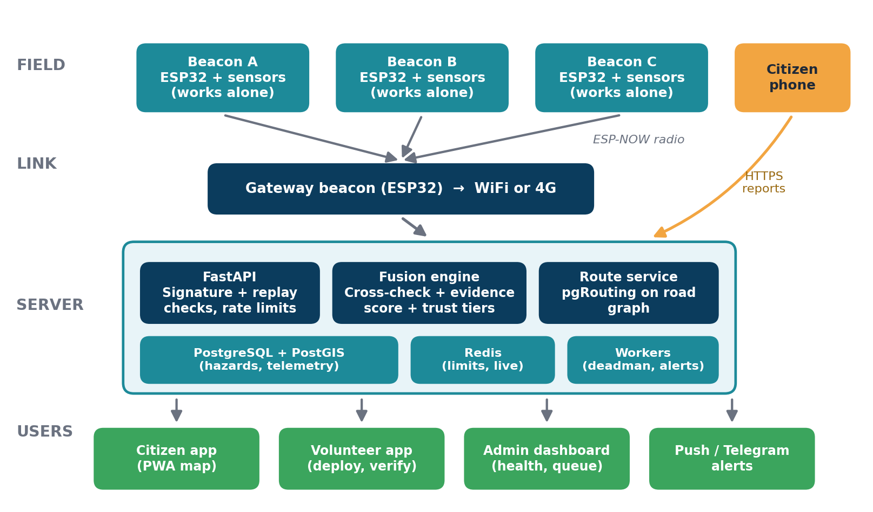
Say this: Beacons talk to one gateway by radio. The server checks every message, combines evidence, stores it, and updates the apps. If the gateway or the internet fails, the beacons still warn people locally.

7 · Hardware: what the beacon looks like
Concept drawing. Replace it with photos of your real prototype once it is built.
Say this: The light and buzzer sit high on a tall mast so people can see them. The sensors sit low, near the water. A weighted base and a tether stop the beacon from drifting away.

8 · Hardware: inside the box
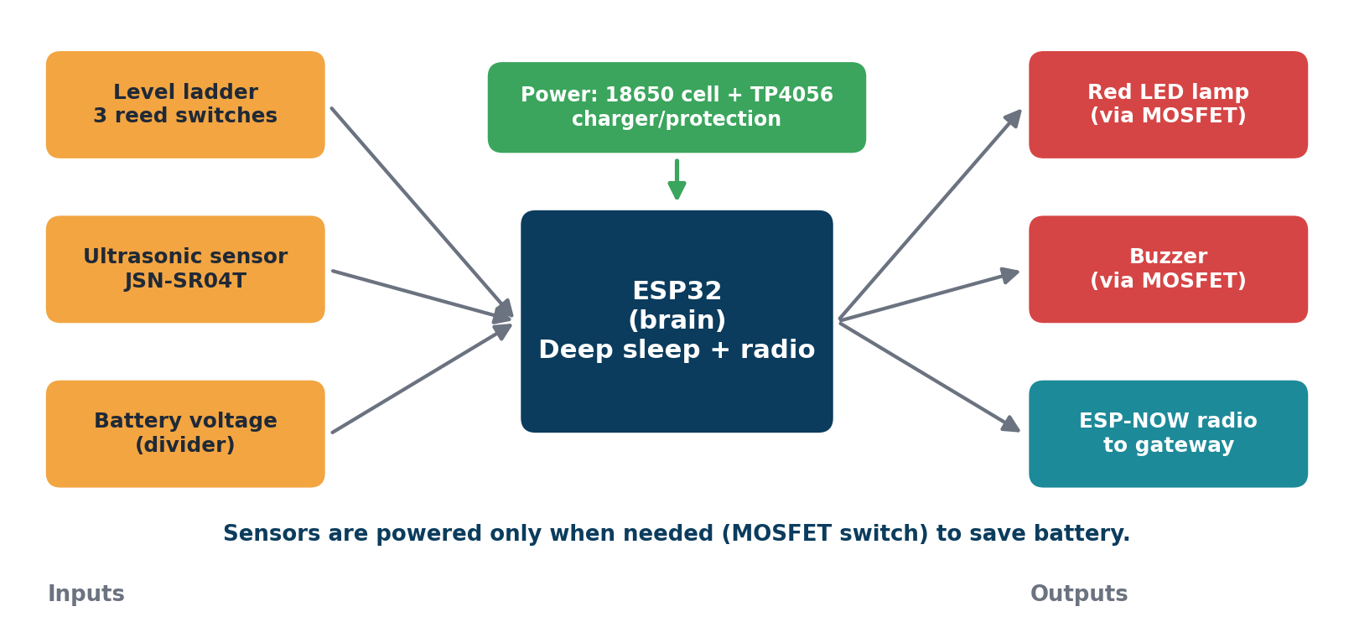
- ESP32 is the brain. It sleeps almost all the time and wakes when the float moves.
- Sensors are switched off until needed, which saves battery.
- A protected 18650 battery with a charging board powers everything. Real battery life will be measured, not guessed.
- The LED and buzzer are driven through small transistor switches (MOSFETs) so the ESP32 pins are not overloaded.
Say this: Think of the ESP32 as a night guard who sleeps until the float rings the bell.

9 · Hardware: parts and estimated cost
Part (per beacon) | Why we need it | Est. cost (₹)
ESP32 DevKit | Controller with radio and deep sleep | 450
JSN-SR04T waterproof ultrasonic sensor | Measures water depth from above | 600
Level ladder: 3 reed switches, magnet float, guide tube | Reliable depth steps and wake trigger | 400
Stilling-well pipe and fittings | Calms ripples for the ultrasonic sensor | 100
High-brightness red LED lamp | Visible warning | 150
Active buzzer | Audible warning | 80
MOSFETs, resistors, diodes, capacitor | Safe switching of lamp, buzzer and sensor power | 60
Protected 18650 cell + holder | Power | 150
TP4056 charging module | Charging and protection | 80
IP65 enclosure, cable glands, sealant | Keeps water out | 400
PVC mast and weighted base | Light stays high; unit stays put | 200
Total per beacon (approx.) |  | about 2,700
- Lean build (2 beacons, WiFi): about ₹7,000 to 7,500
- Core build (3 beacons + spares + test gear): about ₹10,500
- With a 4G module on the gateway: add about ₹2,600
All prices are estimates from earlier planning. Re-check current prices before ordering. GPS is not used; location is set once with a phone when a beacon is placed.

10 · Smart sensing: two methods that fail differently
Method | Strength | Weakness
Level ladder (3 reed switches + float) | Simple and robust; gives clear steps and the speed of rise | Only a few fixed heights
Ultrasonic sensor inside a stilling well | Continuous depth reading; the pipe calms ripples and shields from rain | Sound reflects poorly off rough water, so it must be tested in ripples and rain
Both together | If they disagree, the beacon flags a sensor problem and trusts the ladder | Slightly more parts to build and test

- Working range: from the first inches of water up to about knee height. The exact range will be fixed from tests.
- Deeper than that: the beacon says “saturated” (deeper than I can measure) and keeps flashing.
- Height trick: sensing is low and the light is high, so deep water cannot blind the sensor and the light stays visible.
Say this: We do not trust one sensor. Two different methods check each other, and the simple float ladder is the backup.

11 · Beacon brain: firmware flow
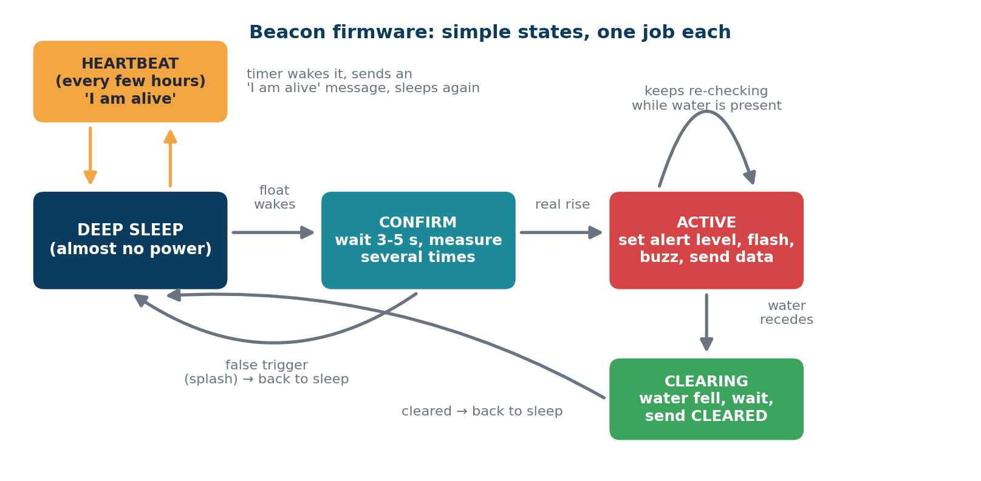
- The confirm step filters out splashes and false triggers.
- A regular “I am alive” message tells the server the beacon is healthy; silence is shown as offline, never as safe.
- Every message is signed so the server can tell it is genuine.

12 · What the beacon shows on the street
Level | When | Light | Sound
1 Watch | Water has reached the first step of the ladder | Slow blink | Off
2 Warning | Water is above a low depth threshold | Fast blink | Intermittent beeps
3 Critical | Water is deeper, or rising fast | Solid flashing | Louder pattern
Saturated | Deeper than the sensors can measure | Keeps flashing | Keeps sounding

- Thresholds are starting values that we will tune from our own tests. They are not officially certified.
- The warning is decided inside the beacon, so it never waits for the internet or the server.
- No light does not mean safe. The beacon might be off, damaged or out of range.
Say this: Light is the main warning because rain and traffic can drown out sound.

13 · Multi-beacon cross-verification
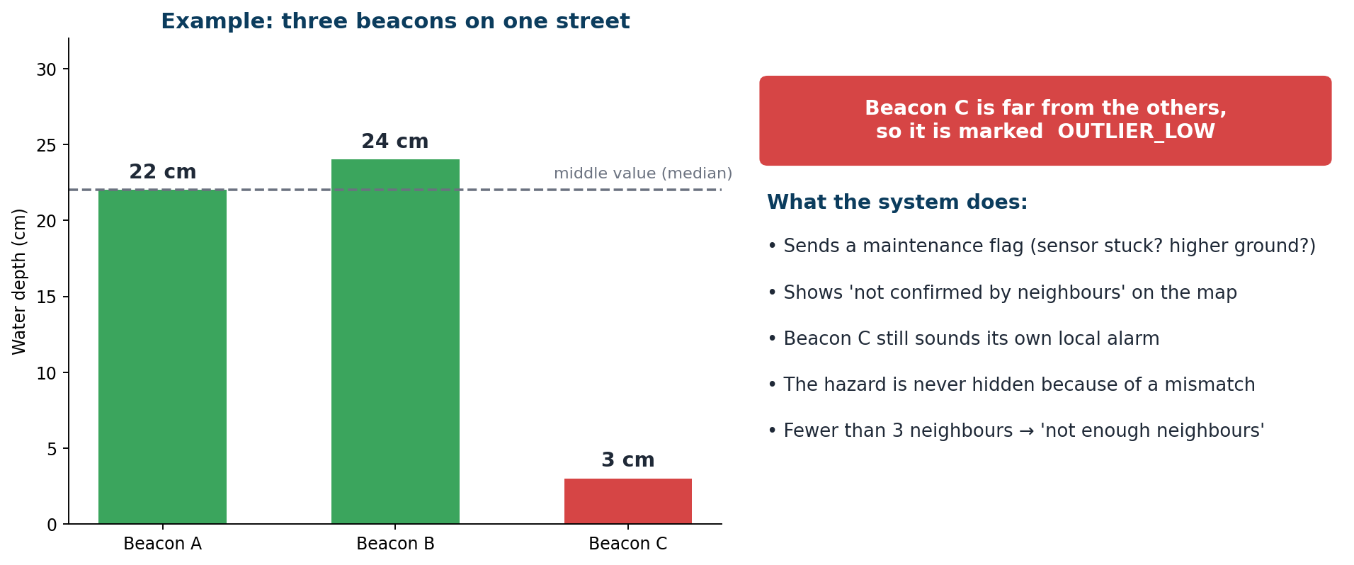
- Simple idea: three friends measure the same puddle. If one gives a very different answer, we ask whether the ruler is broken or that friend stands on higher ground.
- Needs at least 3 beacons in one area. With fewer, the system says “not enough neighbours”.
- Safety rule: a mismatch lowers our confidence, but it never hides a hazard and never switches off a beacon’s own alarm.
Say this: Neighbours checking each other helps us find broken sensors early, and it gives us stronger evidence when they agree.

14 · Hazard evidence: how sure are we?
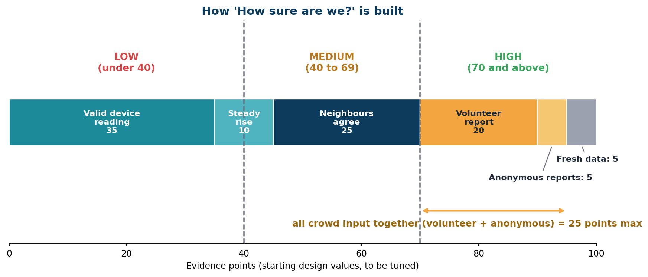
Two separate questions | Answer shown
How dangerous is it? | Severity: No hazard reported, Caution or High hazard (from the beacon readings)
How sure are we? | Evidence: Low, Medium or High, with a list of reasons. It is a score, not a probability.
All points and bands are starting values to be tuned with simulations and expert review. Crowd input alone can never reach High.
Say this: We never show a fake-looking 94 percent. We show Low, Medium or High and tell you why.

15 · Citizen reports and protection from fake data
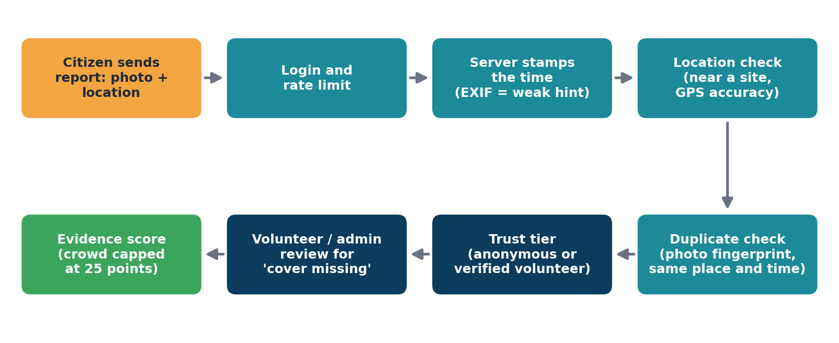
Who | Can do | Cannot do
Anonymous citizen | Send an unverified report; add a small, rate-limited vote | Trigger a public critical alert
Verified volunteer | Verify or reject reports; place beacons | Override beacon data
Signed beacon | Set hazard levels | Be overruled by the crowd
Say this: Fake accounts can clutter the unverified list, but they cannot raise a real alarm. We limit the damage instead of promising to stop every attacker.

16 · Live map and route that avoids known hazards
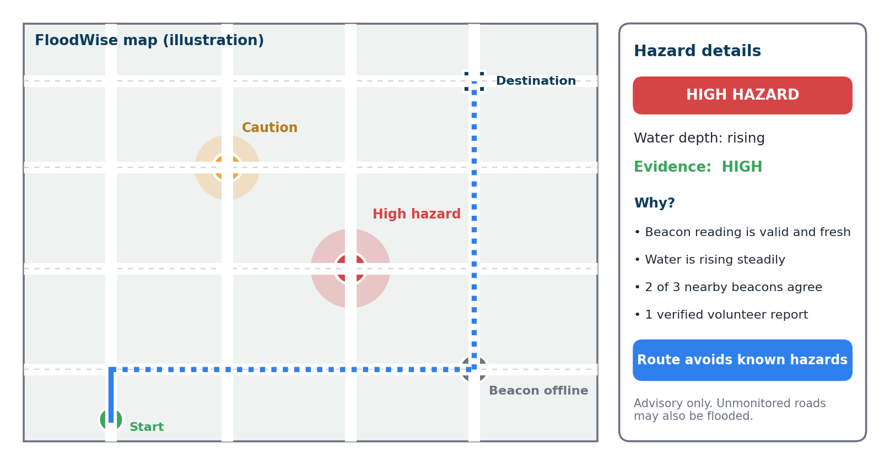
- Clear labels: No hazard reported, Caution, High hazard, Beacon offline, Not monitored. We never use the word “safe”.
- Routing uses road data from OpenStreetMap, with a database tool that adds a high cost to roads near active hazards.
- If no hazard-free route exists, the app says so instead of hiding the problem.
Advisory only. The route avoids hazards known to FloodWise. Unmonitored roads may also be flooded.

17 · Technology stack
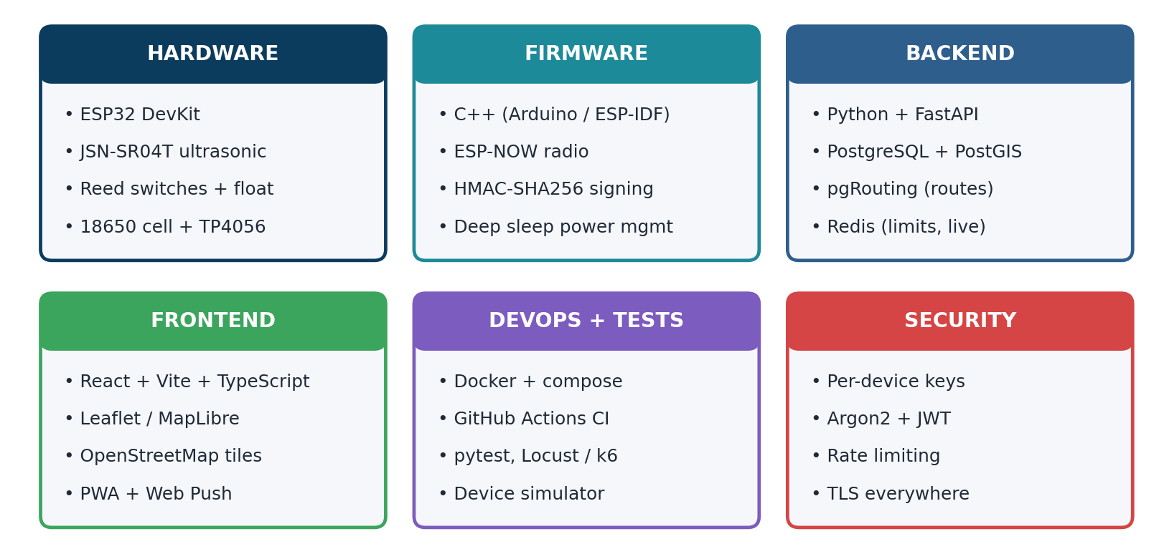
Say this: We picked common, well-documented tools so a team can build, test and maintain the project.

18 · Security: thinking like an attacker
Attack | What could go wrong | Our defence
Forged beacon messages | Fake hazards on the map | Each beacon signs its messages with its own secret key
Replaying an old message | A false hazard stays | Counters and a freshness window; old messages are rejected
Magnet near the float switch | False trigger | Depth confirmation and server sanity checks
Fake accounts voting | Fake reports look real | Distance checks, one vote per user, rate limits, and caps on crowd evidence
Spoofed phone location | Fake nearby votes | Cannot be fully stopped, so crowd input can never trigger a critical alert alone
Flooding the server | Service goes down | Rate limits per device, user and address
Stolen beacon | Attacker copies its key | Per-device keys, revocation, protected key storage; damage limited to one site
Malicious photo upload | Malware or leaked data | Check type and size, re-encode, strip hidden metadata

19 · Feasibility
Area | Assessment | Notes
Technical | Feasible with senior help | Waterproofing and sensing in rain are the main unknowns; each has a planned test
Cost | Affordable | About ₹7,000 to 13,000 depending on build (estimates)
Skills | Stretch for a student team | Firmware and mechanical design need experienced guidance
Software | Standard open-source tools | FastAPI, PostGIS, React and Docker are widely used and well documented
Time | Built in stages | Each stage ends with a test gate; no fixed deadline
Legal and permission | Needs care | Pilot only on permitted property; label it a research prototype
Users | To be validated | Interviews with municipal staff, workers, residents and volunteers come first
Honest status: the design is complete; the prototype is planned and has not been built yet. All performance numbers will come from our own tests.

20 · Risks and how we handle them
Risk | How we handle it
Ultrasonic sensor struggles on rippled, rainy water | Stilling well, level ladder as the main sensor, and a ripple and rain test first
Waterproofing leaks | Early soak tests, silica gel, sealed cable glands, repeated cycles
Beacon drifts or is knocked over | Weighted base, tether, optional motion sensor
No network at the site | Local warning works alone; data is stored and sent later
Fake reports and spoofed locations | Tiered trust, caps on crowd evidence, moderators
Silent failure makes people think a spot is safe | Heartbeat, offline status on the map, and “no light does not mean safe” messaging
Battery heat and theft or damage | Protected cells, shade and ventilation, anchored low-value hardware
Scope grows too big | Stages with gates; advanced features are built last

21 · How we will prove it works
What we measure | How | Result
Depth accuracy | Tub tests at known depths, including ripples and simulated rain | [to be measured]
Time from water to warning | Timestamps for float trigger, light on, and map update | [to be measured]
False triggers | Splash, spray, humidity and magnet tests | [to be measured]
Sleep current and battery life | Meter on the real board | [to be measured]
Radio range and packet loss | Walk tests at set distances | [to be measured]
Fault detection (cross-check) | Block or unplug a sensor and time the flag | [to be measured]
Attack resistance | Scripted fake packets, replays and fake votes | [to be measured]
Offline behaviour | Cut the network and confirm local alarms still work | [to be measured]
We will report only numbers we measure ourselves, with the method and the raw data.

22 · Roadmap: stages with gates
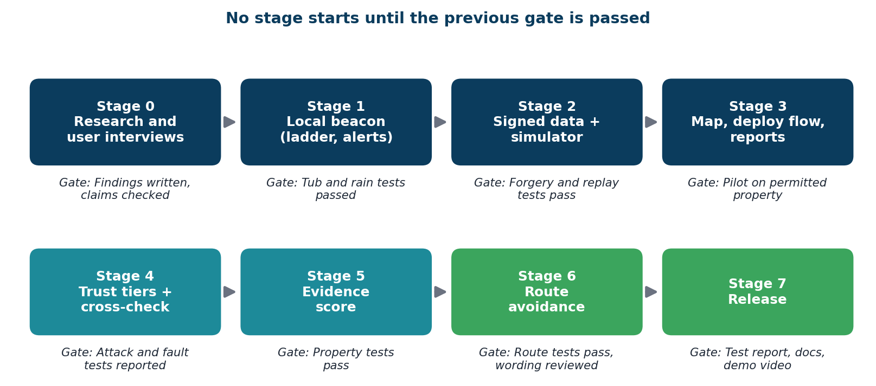
Say this: There are no calendar deadlines. A stage ends when its test passes. If it fails, we redesign or cut scope and write down why.

23 · Team and what we need
Role | Owns
Project lead | Scope, gates, user interviews, pitch, evidence record
Embedded lead (senior) | Firmware, power, sensing
Hardware and mechanical | Enclosure, mast, waterproofing, field tests
Backend and security | Signed ingest, trust and evidence logic, simulator
Frontend and UX | Map, report flow, volunteer deploy flow
Test and reliability | Test rig, attack scripts, test report
What we are asking the mentor for
- A senior team for firmware, mechanical design and backend review.
- Introductions for user interviews and a permitted pilot site.
- Guidance on the biggest open questions: sensing in rain, location spoofing, and the right scope.

24 · Future enhancements
Enhancement | Why it helps | When
MQTT messaging over secure connections | Handles many more beacons than plain web requests | After the core is stable
Over-the-air firmware updates | Fix beacons without visiting each one | After the core is stable
Solar-assisted charging | Longer life with less maintenance | Field pilot
Motion sensor (accelerometer) | Detects a beacon that was moved or swept away | Field pilot
Peer awareness over radio | A dry beacon could warn “flooding nearby”; needs a measured false-alarm rate | Research
Photo assistant for moderators | Suggests whether a photo shows a hazard; needs our own labelled data | Research
Rain-forecast pre-alert | Early warning using a free weather source, as a simple rule | Research
Long-range radio (LoRa or NB-IoT) | Covers areas where WiFi is weak | City scale
Flood history analytics and open data export | Shows which spots flood most, to plan where to place beacons | City scale

25 · Impact and adoption path
- People near the hazard get a warning at the moment it matters, even with no phone signal.
- Residents and volunteers get a shared, verified picture of where streets are dangerous.
- Municipal staff get early notice, beacon health and flood history for planning.
Adoption path
Step | What happens
1 Pilot | A few beacons on permitted property, with user interviews
2 Partnership | Work with a ward office or civic group to place beacons before monsoon
3 Evidence | Publish measured results and lessons from the pilot
4 Scale | More clusters, stronger gateways, municipal dashboard use
Business potential is modest: the buyer would be a municipality, and those sales take time. The main value of this project is real impact and strong engineering proof.

26 · FloodWise vs the work we reviewed
Feature | Typical in the papers we reviewed | FloodWise
Warns people at the hazard (light + buzzer) | Not seen; alerts go to authorities or monitoring points | Yes
Works with no network for the warning | Mostly depends on a network or cloud dashboard | Yes
Depth and speed of rise | Often one sensor type | Ladder + ultrasonic, cross-checked
Neighbour beacons check each other | Not described | Yes, with safety rules
Citizen reports | One paper has them | Yes, tiered and capped
Protection against fake reports | Not described | Designed in; tested with simulations
Evidence strength with reasons | Not described | Yes
Route that avoids known hazards | Not described | Yes, advisory
Measured results reported | Some papers; many give none | Planned; to be filled after testing
Based on summaries of the papers we reviewed, not an exhaustive survey. Search for other products and projects before claiming novelty.

27 · Limits and responsible use
- FloodWise is a research prototype, not a certified safety device.
- Place beacons only with permission, and make sure the beacon itself is not a trip or collision hazard.
- A missing light does not mean a place is safe. The map shows offline and unmonitored areas clearly.
- Phone locations can be faked. For that reason, crowd reports can never raise a critical public alert alone.
- Thresholds and scores are tuned starting values, not certified or calibrated probabilities.
- Keep reporter data minimal: no public names, a stated retention period, and a way to delete accounts. Check the current Indian data-protection rules with your mentor.
- Beacons need regular checks: batteries, fouled sensors and moved units.

28 · References
[1] Utepov, Y., Neftissov, A., Mkilima, T., Mukhamejanova, A., Zharassov, S., Kazkeyev, A., & Biloshchytskyi, A. (2023). Prototyping an integrated IoT-based real-time sewer monitoring system using low-power sensors. https://doi.org/10.15587/1729-4061.2023.283393
[2] Capila, J. A. P. (2025). Development of an IoT-based system for early detection of flooding and QGIS mapping of affected areas in Batangas State University–Pablo Borbon Campus. https://doi.org/10.22214/ijraset.2025.76263
[3] Narayana, K. (2026). Real-time urban manhole monitoring using IoT and LoRa. https://doi.org/10.22214/ijraset.2026.79186
[4] Vicera, L. K. P., Biacan, J. K. D., & Listangco, J. L. S. (2026). Flood Alert Mapper: A community-powered real-time flood reporting and rescue location system. IJRSI, Vol. XIII, Issue VI. https://doi.org/10.51244/IJRSI.2026.1306000067
[5] Patil, M. V., et al. (2026). Smart flood detection and impact mapping system: An IoT-driven framework for real-time early warning and spatial risk visualisation. https://doi.org/10.17148/ijarcce.2026.155235
[6] Nuhu, B., Arulogun, O. T., Adeyanju, I., & Abdullahi, I. (2016). Wireless sensor network for real-time flood monitoring based on 6LoWPAN communication standard. https://doi.org/10.11591/APTIKOM.J.CSIT.97
[7] Kaphungkui, N. K. (2024). Smart flood monitoring and alert system using IoT with GSM communication. https://doi.org/10.52783/jes.8830
[8] Venkanna, P. (2024). FLOODGUARD: An IoT-powered real-time flash flood monitoring and forecasting system. https://doi.org/10.22214/ijraset.2024.60174
[9] Choosumrong, S., et al. (2025). Development of an IoT-based flood monitoring system integrated with GIS for lowland agricultural areas. Sensors, 25(17), 5477. https://doi.org/10.3390/s25175477
[10] Nguyen, H. T., et al. (2020). Development of a spatial decision support system for real-time flood early warning in the Vu Gia–Thu Bon River Basin, Quang Nam Province, Vietnam. Sensors, 20(6), 1667. https://doi.org/10.3390/s20061667
[11] Wilson, E. B. (1927). Probable inference, the law of succession, and statistical inference. Journal of the American Statistical Association, 22(158), 209–212.
[12] Espressif Systems. ESP32 and ESP-NOW documentation. https://docs.espressif.com
[13] FastAPI documentation. https://fastapi.tiangolo.com | PostGIS documentation. https://postgis.net | pgRouting. https://pgrouting.org
[14] OpenStreetMap. https://www.openstreetmap.org/copyright | Leaflet. https://leafletjs.com | OWASP API Security Project. https://owasp.org/API-Security/
Two further 2026 IJRASET manhole-monitoring papers supplied by the team should be added here with full citation details. Check every link and any statistic or legal statement against the original source before presenting.

29 · Thank you
FloodWise
Warn locally. Verify together. Route around known hazards.
- Questions and feedback welcome.
- The three biggest open questions we want help with: sensing in rain, location spoofing in crowd reports, and the right scope for the first pilot.
Contact: [name, email]

A · Likely questions and short answers
Question | Short answer
How is this different from smart-manhole research? | In the papers we reviewed, alerts go to authorities. FloodWise warns people at the spot, works offline, and handles crowd data safely.
Does it detect open manholes? | No. It detects floodwater. Missing covers come from citizen and volunteer reports. Beacons go beside known risky manholes.
What if the internet or gateway fails? | The beacon still flashes and sounds. Data is stored and sent when the link returns.
What if fake reports flood the system? | Anonymous input is capped and cannot raise a critical alert alone. Only beacons and verified volunteers can.
Will the ultrasonic sensor work in rain? | We do not assume so. The ladder is the main sensor and the stilling well is tested with ripples and rain.
Is the confidence score a probability? | No. It is an evidence score with reasons. We would need real event data to calibrate it.
Who would deploy and maintain it? | A ward office, civic group or volunteers, after a pilot. This still needs interviews to confirm.
What is built so far? | The design is complete and documented. The prototype is planned; all results are still to be measured.

B · How to turn this document into PowerPoint
- Each page is one slide. Copy the bullet text onto a slide and use the “Say this” line as the speaker note.
- Right-click each diagram in Word and choose Save as Picture, then insert it on the slide.
- Replace the concept drawings with photos of your real prototype once it exists.
- Fill every item in [brackets], especially the results column on slide 21 and the mentor name on the cover.
- Keep slide text short. Say the longer explanations aloud.
- Check every statistic, legal statement and link before presenting.

