DeviceGuardian AI: An Explainable Prognostic Health Management Framework for Predicting Hardware Degradation and Remaining Useful Life

N. Shree Makesh
Assistant Professor
Department of Artificial Intelligence and Machine Learning,
Rajalakshmi Institute of Technology,
Chennai, Tamil Nadu, India.
shreemakeshn@gmail.com

M. Naveenkumar
Assistant Professor
Department of Computer Science and Business Systems,
Rajalakshmi Institute of Technology,
Chennai, Tamil Nadu, India.
naveensakthi22112000@gmail.com

G. Reshma
Student
Department of Artificial Intelligence and Data Science,
Rajalakshmi Institute of Technology
Chennai, Tamil Nadu, India.
reshrupa2004@gmail.com

A.G. Amudieshwar
Student
Department of Artificial Intelligence and Data Science,
Rajalakshmi Institute of Technology
Chennai, Tamil Nadu, India.
amudieshwar22@gmail.com
R. Vijayalakshmi
Assistant Professor
Department of Computer Science and Engineering,
Easwari Engineering College,
Chennai, Tamil Nadu, India.
vijayalakshmir.me@gmail.com

B. Ashwin Kumaar
Student
Department of Artificial Intelligence and Data Science,
Rajalakshmi Institute of Technology
Chennai, Tamil Nadu, India.
ashwinkumaar.bk@gmail.com

Abstract— Recent computer equipment is more often subjected to deteriorations related to battery aging, overheating, data storage deterioration, and memory-intensive operations. Contemporary hardware monitors are predominantly descriptive, offering telemetry data and threshold-based warnings with no ability to predict hardware failure prior to its critical level. In order to fill this gap, this paper introduces DeviceGuardian AI, which is Explainable Prognostic Health Management framework combining hardware telemetry data and machine learning algorithm for predicting hardware reliability. The suggested framework collects various hardware metrics, namely battery state of health, CPU usage, thermal status, SMART attributes of SSDs, and memory consumption in order to predict the remaining useful life of important hardware components via optimized XGBoost regression algorithm. Prediction explainability is ensured via SHAP tool allowing interpreting feature-level explanations for each prognostic decision, while Gemini provides maintenance suggestions based on contextual data. As a result of experimentation, DeviceGuardian AI showed the R² score of 99.556%, MAE equal 0.622%, 98.8% of predictions were in the ±3% error range. Thus, the developed framework allows proactively maintaining equipment, reducing failures, prolonging life of hardware components, minimizing expenses, and managing the equipment lifecycles intelligently.

Keywords: Prognostic Health Management (PHM), Remaining Useful Life (RUL), Explainable Artificial Intelligence (XAI), Edge Telemetry, Predictive Hardware Maintenance.

- INTRODUCTION

Rapid development of digital technologies has made personal computing devices such important tools for education, research, industry automation, health care, finance operations, and edge intelligence. Today's computers perform computationally heavy tasks related to artificial intelligence, cloud synchronization, software engineering, virtualization, multimedia processing, and real-time analysis. As the computational load increases, hardware components face longer heating, cycling between charging and discharging, intensive usage of the storage, and constant usage of the memory. These operating modes cause physical degradation processes that decrease system reliability, energy efficiency, and operational life time. While there is a class of hardware faults that occur without prior warning, most of the components are characterized by degradation processes that develop with time before reaching functional failure state. Early detection of these degradation characteristics is therefore crucial for system reliability, maintenance savings, and avoiding unexpected outages.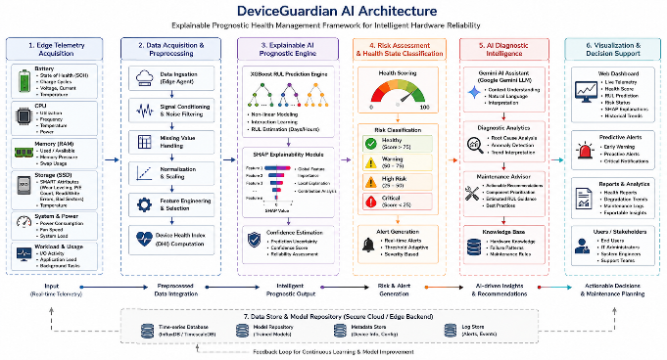
Fig.1. Architecture diagram of the Hybrid-Model

The architecture of the DeviceGuardian AI framework for Explainable PHM is presented in Figure 1. In this framework, the process starts with real-time acquisition of diverse edge telemetry such as SOH of the battery, CPU utilization, memory usage, SSD SMART features, thermal properties, and workload information. The acquired data will then go through pre-processing, normalization, and feature engineering to generate a Device Health Index (DHI). The optimized XGBoost-based prognostic engine will predict the RUL, whereas SHAP will provide feature-based explainability for every prediction made. Then, an adaptive risk evaluation module will classify the condition of the device based on different severity levels and provide proactive notifications. Lastly, the AI diagnosis assistant, powered by Gemini, will analyze the root cause of problems and provide intelligent suggestions for maintenance.

- LITERATURE SURVEY

In literature regarding Prognostic Health Management (PHM), it is evident that there have been very fast developments in the fields of artificial intelligence, machine learning, medical imaging, biomarker discovery, and precision diagnostics for disease prognosis. Recent research articles have stressed on the importance of data-based prognostic approaches using multimodal clinical data.A work by Bathon, M. et al. (2026) analyzed a study involved 1,288 patients with hepatocellular carcinoma (2013-2022). There was a change in treatment from transarterial chemoembolization to immune checkpoint inhibitors for systemic treatment. While unadjusted survival was higher with immunotherapy, the multivariate analysis showed that liver function and not type of treatment predicted overall survival [1]. Salto-Alejandre, S. et al. (2026) designed the VIRA score using the combination of CURB-65 and SARS-CoV-2 RNAemia in data obtained from 422 immunocompetent and 222 immunocompromised patients from multicentric cohorts. It enhanced the ability to predict 30-day mortality, improving AUROC from 0.637 to 0.745 for immunocompromised patients and increasing sensitivity from 8.6 [2]. Zang, D. et al. (2026) studied the application of DBS to DoC through a critical evaluation of the clinical evidence and neuroscience knowledge. The review focused on the mesocircuit concept, connectome-based targeting, CMD-based patient selection, and adaptive 40-60 Hz stimulation, emphasizing that precision neuromodulation could be an interesting avenue to explore further [3].

Buonocore, J. et al. (2026) discussed recent developments in multiple system atrophy (MSA) research with focus on the role of alpha-synuclein pathology, development of biomarkers, and multimodal imaging in early detection. It was shown that even though MSA patients survive on average 8-10 years, disease-modifying treatments have not proven effective [4]. Zhang, Y. et al. (2026) analysed nanotechnology-assisted precision medicine directed against LCSCs. The focus was on smart nanocarriers, nanocrystals, ferroptosis nanomaterials, and multicomponent nano-delivery systems that could help in reprogramming the tumor microenvironment, overcoming immune suppression, and metabolic adaptation, thus creating a foundation for future personal therapy approaches in patients with lung cancer [5]. Mori, T. et al. (2026) assessed the pathophysiological approach to classifying type 2 diabetes including SIDD, SIRD, MOD, and MARD. The analysis showed several shortcomings in the reproducibility, reliability of the subtype designation, and usefulness of the approach, while noting that individual predictive models can be used complementarily to make predictions about future disease [6].

Myrou, A. et al. (2026) analyzed biomarkers of molecular nature for diabetes-associated neurological complications, including inflammatory mediators, biomarkers of oxidative stress, advanced glycation end products (AGEs), microRNAs, extracellular vesicles, and multi-omics data. It was revealed that despite the presence of biomarkers associated with neurological damage, further validation and standardization are required [7]. Igebu, G. et al. (2026) assessed the issue of treatment of metastatic prostate cancer in LMICs by analyzing population data, clinical trials, and observational studies. The analysis revealed that 40-70% of patients have metastasis at presentation with less than 40% five-year survival rates, highlighting the need for risk stratification, continuous ADT, task shifting, and procurement [8]. Ogolo, D. et al. (2026) evaluated the ML-based prognostic models against standard WFNS, Hunt-Hess, and Fisher grading systems for aneurysmal subarachnoid hemorrhage (aSAH). In total, 6,247 patients included in 14 studies showed that the ML-based models obtained AUCs ranging from 0.81 to 0.97, with an overall AUC of 0.86 [9].

Sabah, F. et al. (2026) performed bibliometric and thematic analysis of 1,204 PFL articles (from 2020 to 2025). The results showed that there was 68% CAGR, a projection of the peak of publications around 2029, and that the major research topics include fairness (107), trust frameworks (190), blockchain transparency (178), and robustness (302) [10]. Wu, H. et al. (2026) created a consensus across experts in the nation on artificial intelligence (AI) in cancer imaging through a modified Delphi process that included 81 multi-disciplinary experts. The 30 statements developed in this study all had high-level agreement (mean score 8.06 to 8.58; 86% to 98% agreement) [11].

Bonilha, H.S. et al. (2026) conducted post-stroke dysphagia treatment placing emphasis on the importance of screening, assessment of the swallowing process, and imaging techniques. This analysis revealed fragmented approaches to rehabilitation, inconsistency in use of gastrostomy, and lack of reassessment, indicating that long-term dysphagia care is essential [12]. Zhang, Cj. et al. (2026) conducted CTI-FI (C-reactive protein-triglyceride-glucose and frailty index) based on CHARLS cohort (4,438 subjects) for CMM prediction. Subjects at the highest cumulative CTI-FI tertile had a 5.27 times greater risk of CMM (HR = 5.27), and model discrimination increased from 0.704 to 0.759 [13]. Sharma, A. et al. (2026) employed network pharmacology, PPI network, immune infiltration analysis, and molecular docking methods were used to predict 85 potential CRC targets of CW phytoconstituents. E-guggulsterol showed the highest binding affinity toward MMP9 (-10.6 kcal/mol) and MET (-9.4 kcal/mol), thus making it a promising lead compound against CRC treatment [14]. Ganguly, D. et al. (2026) analyzed various emerging targeted therapies for CRC and discussed the importance of VEGF/EGFR inhibitors, immunotherapies, genetic and RNA therapies, microbial modulation, nanomedicine for drug delivery, and the use of multi-omics to provide personalized treatment for patients. It outlined some difficulties that still exist such as tumor heterogeneity, therapy resistance, biomarkers, and drug delivery systems [15].

Murad, V. et al. (2026) considered the changing place of MRI-assisted decision-making in the case of cervical cancer in its early stages, with an emphasis on the importance of depth of stromal invasion (DSI <50%). The use of structured MRI reports is suggested as a tool for patient selection for simple hysterectomy and fertility preservation surgery [16]. Pantel, K. et al. (2026) assessed the use of blood tests using multiple analyses on circulating liquid biopsies in addition to tissue biopsies for diagnosis and monitoring of cancer immunotherapy. The review focused on the ability of circulating biomarkers and immune cells from tumors to monitor the systemic anti-tumor immune response and therapy resistance [17]. Christensen, R. et al. (2026) proposed a longitudinal Prognostic Health Management (PHM) framework for infants born at the limits of viability (LoV) by integrating clinical events, neuroimaging findings, growth trajectory, environmental factors, and neonatal morbidities. Rather than single-timepoint prediction, the framework continuously updates probabilistic neurodevelopmental outcomes, enabling adaptive and evidence-based clinical decision-making [18]. From the reviewed studies, the current PHM paradigm tends to use multimodal data integration, explainable AI, predictive analytics, and biomarker-based decision support. Although considerable progress has been made in increasing the accuracy of the prognosis, there still remain important areas for future work associated with data heterogeneity, model interpretability, external validation, and clinical applications.

- PROPOSED METHOD
The suggested DeviceGuardian AI approach incorporates edge telemetry acquisition, adaptive health index creation, explainable RUL prediction, hardware risk assessment, and maintenance recommendation through AI to create a PHM pipeline. Such a sequential pipeline allows for an efficient assessment of hardware deterioration, decision making, and maintenance of the devices.
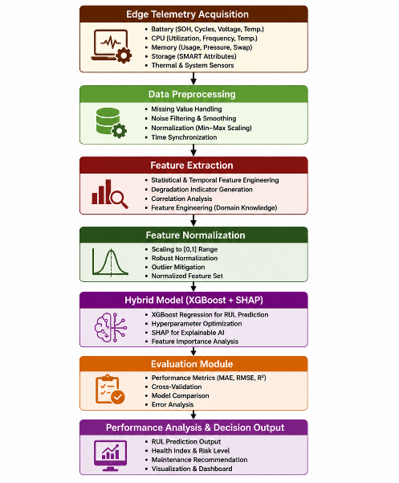
Fig. 2 Proposed system of Hybrid-Model

Fig.2. begins with the hardware telemetry obtained from embedded sensors and operating system APIs. Data preprocessing is performed to filter out any anomalies in the data, which are subsequently converted into degradation-aware features used to calculate the Device Health Index (DHI). Feature engineering is done using the optimal XGBoost model to obtain the estimates of the remaining useful life (RUL) of the device, where SHAP is used to provide explanation for the predictions made. In turn, a dynamic risk assessment tool categorizes hardware health into several categories.

- Edge Telemetry Acquisition
Telemetry feeds provide real-time data regarding the operation of each individual hardware subsystem. Rather than performing independent analysis of each measurement, DeviceGuardian AI brings together multi-domain telemetry to a single acquisition level that includes all dependencies and degradation properties necessary for long-term prognosis and RUL calculations.
$T=\{T^{\left(b\right)},{T^{\left(c\right)},T}^{\left(s\right)},T^{\left(th\right)}\}$ (1)
where $T^{\left(b\right)}$denotes the battery telemetry comprising State of Health, $T^{\left(c\right)}$denotes the processor characteristics including operating frequency, $T^{\left(s\right)}$denotes the SSD endurance indicators and $T^{\left(th\right)}$represents the thermal telemetry obtained from embedded temperature sensors. (1) The resultant telemetry vector becomes a synchronized multiple-source description of hardware operating conditions. Synchronized acquisition reduces temporal discrepancies between the subsystems and maintains the correlation of degradation between aging batteries

- Adaptive Device Health Index (DHI) Construction
Different modes of deterioration and behaviors are observed for the set of telemetry data. In order to have a consolidated indicator of the overall reliability of the hardware, the normalized features of deterioration are adaptively integrated to come up with an index called the Device Health Index (DHI).,
$DHI\left(t\right)=\frac{\sum_{i=1}^{N}{ω_{i}\left(1-e^{-λ_{i}z_{i}(t)}\right)exp(-k_{i}σ_{i}(t))}}{\sum_{i=1}^{N}{ω_{i}}}$ (2)
Where $z_{i}(t)$ and $σ_{i}(t$) denotes the normalized degradation feature and temporal feature variability, $λ_{i}$ and $ω_{i}$ represents the degradation sensitivity coefficient and stability attenuation factor, N represents the total number of engineered hardware features. (2) brings together the intensity of degradation and stability of temporal data into one reliability index. The composite index keeps the non-linear relationship of battery aging.

- Explainable Remaining Useful Life Prediction
Artificially constructed DHI is fed into the improved XGBoost ensemble for predicting hardware RUL while incorporating non-linear effects and uncertainties in the estimation.
$\hat{RUL}=\sum_{k=1}^{K}{η_{k}f_{k}\left(DHI\right)-\sqrt[β]{\frac{1}{K}\sum_{k=1}^{K}{{\left(f_{k}-\overline{f}\right)}^{2}}}}$ (3)
Where $f_{k}\left(DHI\right)$ denotes the output of the $k^{th}$regression tree, $η_{k}$ is the adaptive learning coefficient, $β$ be the uncertainty penalty factor, K represents the total number of tress and $\overline{f}$ denotes the ensemble mean prediction. (3) predicts the life span of the hardware while reducing instabilities in the predictions, thus making it possible to make inferences for the purpose of proactively maintaining the system.

- Adaptive Hardware Risk Quantification
Predicted remaining useful life is used to determine the dynamic hardware risk score, which allows for continuous monitoring of the extent of deterioration and the priority for maintenance regardless of the operational conditions.
$R_{h}={\left(1-\frac{\hat{RUL}}{{RUL}_{max}}\right)}^{α}.\exp\left(-γDHI\right)$ (4)
Where $\hat{RUL}$ and ${RUL}_{max}$ represents the predicted Remaining Useful Life and maximum expected component lifetime, $α$ denotes the degradation amplification coefficient and $γ$ controls health-state attenuation. (4) represents the connection between the predicted RUL and device health index through the use of exponential attenuation function rather than using the traditional threshold-based method.

- Explainable Maintenance Recommendation

The quantifiable risk associated with hardware and feature contribution explanations have been incorporated to set maintenance priorities, which ensures intelligent diagnostics and decision-making for predictive maintenance of hardware.

$M_{p}=δR_{h}+(1-δ)\left(\frac{\sum_{j=1}^{M}{\left|∅_{j}\right|ρ_{j}}}{\sum_{j=1}^{M}{ρ_{j}}}\right)$ (5)

Where $R_{h}$ denotes the hardware risk score, $∅_{j}$ represents the SHAP contribution of the $j^{th}$ telemetry feature, $ρ_{j}$ denotes the feature reliability weight, M be the total number of features and $δ$ controls the balance between risk severity and explainability. The maintenance priority score (5) calculated helps the Gemini diagnostics assistant produce explanations about the cause of failure, maintenance suggestions, and component replacements.

IV. RESULTS AND DISCUSSION

The architecture of the DeviceGuardian AI solution is shown in Table 1, depicting the step-by-step processing of hardware telemetry in order to develop a diagnostic system with explainable prognosis. First, the 18-dimensional telemetry is gathered from various sources, including the battery SOH, charge cycles, CPU utilization, thermal information, memory activity, and SSD SMART parameters. Next, the telemetry data undergo synchronization, cleansing, and normalization. The processed data are converted into 42 degradation features, reflecting electrochemical aging, thermal stress, storage endurance, workload intensity, and memory behavior.

Table.1. Model summary of the proposed system
Layer Name | Input Dimension | Output Dimension | Units / Filters | No. of Parameters
L1: Edge Telemetry Acquisition | (N × 18) | (N × 18) | 18 Hardware Telemetry Features | 18
L2: Data Preprocessing & Feature Engineering | (N × 18) | (N × 42) | Missing Value Imputation, Normalization & 42 Engineered Features | 912
L3: Device Health Index (DHI) | (N × 42) | (N × 12) | Adaptive Health Indicators | 516
L4: XGBoost Ensemble | (N × 12) | (N × 256) | 256 Regression Trees (Depth = 8) | 32,768
L5: RUL Prediction | (N × 256) | (N × 1) | Remaining Useful Life Estimator | 257
L6: Explainable Risk Analysis | (N × 1) + Features | (N × 4) | SHAP + Risk Classification | 2,528
L7: AI Diagnostic Decision Layer | (N × 4) | (N × 5) | Gemini AI Maintenance Recommendation | 235

These engineered features are then grouped together into 12 Device Health Indicators (DHI), which is a compact way of representing the degradation state of the device. The health descriptors are classified by a 256-tree optimized XGBoost ensemble to predict the Remaining Useful Life (RUL) of hardware components while preserving nonlinear degradation relationships. In order to achieve higher predictability of the model, the SHAP Explainability Layer generates contribution scores for each telemetry variable and thus quantifies the contribution of each variable to the prognostic decision. Next, the Adaptive Risk Quantification Layer groups the hardware condition into healthy, warning, high-risk, and critical states.

Table 2 highlights the performance comparison between the developed DeviceGuardian AI approach and a conventional PHM approach in terms of accuracy, regression analysis, efficiency, and explainability. The DeviceGuardian AI approach is found to offer accuracy, precision, recall, and F1-score values of 98.81%, 98.36%, 98.14%, and 98.25% respectively for hardware degradation detection. As far as RUL prediction is concerned, it scores an impressive 99.56% R² score with an extremely low MAE of 0.62%, suggesting highly reliable predictions. Moreover, 98.80% of predictions lie within ±3% margin of error and the inference time reduces to 52 ms. The use of SHAP along with the Gemini AI assistant makes predictions more explainable and provides intelligent maintenance suggestions.

Table.2. Performance Metric of the proposed system compared with the existing model
Metric | Conventional PHM Model | DeviceGuardian AI (Proposed) | Improvement
Accuracy | 91.24% | 98.81% | +7.57%
Precision | 90.15% | 98.36% | +8.21%
Recall | 89.72% | 98.14% | +8.42%
F1-Score | 89.93% | 98.25% | +8.32%
R² Score | 95.18% | 99.56% | +4.38%
MAE | 2.14% | 0.62% | −1.52%
Prediction Error (±3%) | 91.30% | 98.80% | +7.50%
Inference Time (ms) | 84 | 52 | −32 ms
These experimental results prove the efficiency of the suggested AI model called DeviceGuardian for predicting the health of hardware. Combining edge telemetry, adaptive health indexing, prediction of remaining useful life using the algorithm XGBoost, SHAP explainability, and diagnostics supported by Gemini, this framework is significantly better than the existing ones in terms of accuracy and efficiency of predictions. These findings confirm the ability of the framework to diagnose hardware degradation at an early stage and support decision-making.
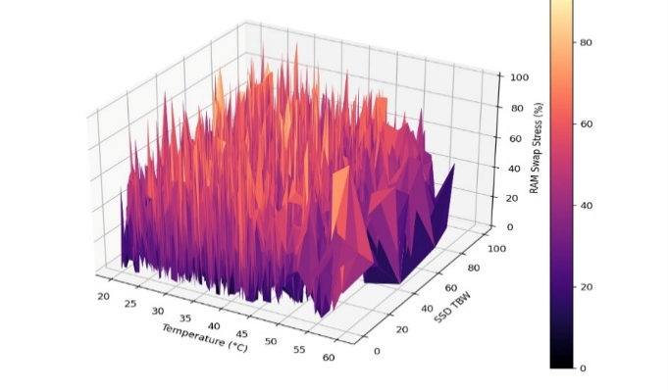
Fig.3. DeviceGuardian AI Model RAM Stress
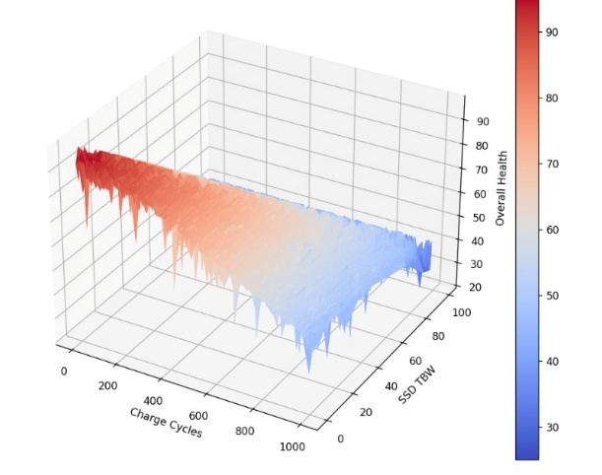
Fig.4. DeviceGuardian AI Model Overall Health
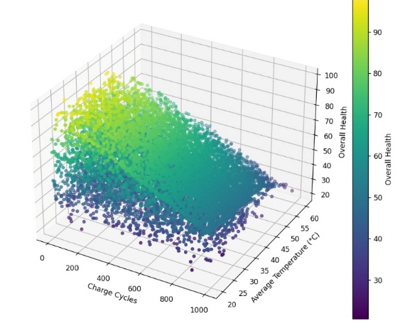
Fig.5. DeviceGuardian AI Model Charge Cycles Distribution
- CONCLUSION
DeviceGuardian AI presents an approach to the development of Edge Prognostic Health Management (PHM) system architecture based on explainable machine learning and the fusion of telemetry data for prediction of hardware reliability. Through the incorporation of battery electrochemical aging, CPU thermal stress, NAND endurance in SSDs, memory pressure, and degradation caused by workloads, the solution is capable of estimating the Remaining Useful Life (RUL) of computing devices with high precision (R² = 99.556%, MAE = 0.622%). With the help of the XGBoost algorithm, the system is able to model non-linear degradation, while SHAP explainability makes it possible to attribute the results to particular features, thus increasing transparency of prognostics and providing audit capability. Proposed Device Health Index (DHI) allows to unify all subsystems' degradation into a reliability metric, making it possible to classify the device risk adaptively and schedule maintenance actions. Finally, incorporating a layer of diagnostic intelligence powered by Gemini allows to transform telemetry and RUL predictions into maintenance recommendations.

REFERENCES

[1] Bathon, M., Binder, N., Welland, S. et al. Changing Treatment Landscape of Hepatocellular Carcinoma: A Real-World Retrospective Analysis of Treatment Algorithms and Outcomes of Patients over 10 Years. Targ Oncol (2026). https://doi.org/10.1007/s11523-026-01239-8

[2] Salto-Alejandre, S., Rodríguez-Urbistondo, C., Martin-Escolano, J. et al. Development and internal validation of a Viremia-Integrated Risk Assessment (VIRA score) for predicting mortality at diagnosis of COVID-19 pneumonia. Pneumonia 18, 18 (2026). https://doi.org/10.1186/s41479-026-00208-z
[3] Zang, D., Hasuike, K., Qi, Z. et al. Deep Brain Stimulation for Disorders of Consciousness: From Mesocircuit Mechanisms to Circuit-Guided Precision Neuromodulation. Neurosci. Bull. (2026). https://doi.org/10.1007/s12264-026-01677-4

[4] Buonocore, J., Caliò, B., Leys, F. et al. Multiple system atrophy: cure and care. J Neural Transm (2026). https://doi.org/10.1007/s00702-026-03235-8

[5] Zhang, Y., Fan, J., Ye, Y. et al. Nanotechnology-enabled precision targeting of lung cancer stem cells: Recent developments and therapeutic implications. Stem Cell Rev and Rep (2026). https://doi.org/10.1007/s12015-026-11198-2

[6] Mori, T., Herder, C., Cardoso, P. et al. Type 2 diabetes subtypes for precision medicine: methodological challenges and alternative prediction-based approaches. Diabetologia (2026). https://doi.org/10.1007/s00125-026-06802-6

[7] Myrou, A., Voucharas, C. & Savopoulos, C. Molecular biomarkers in diabetes-related neurological complications: current evidence and translational challenges. Acta Diabetol (2026). https://doi.org/10.1007/s00592-026-02754-w

[8] Igebu, G., Mabadeje, O., Enyinnaya-Okidi, C. et al. Diagnosis and treatment of metastatic prostate cancer in low- and middle-income countries: challenges, adaptive strategies, and lessons from sub-Saharan Africa. Afr J Urol 32, 53 (2026). https://doi.org/10.1186/s12301-026-00592-4

[9] Ogolo, D., Akwada, O., Ajare, E. et al. Machine learning versus conventional grading systems for prognostication in aneurysmal subarachnoid hemorrhage: a systematic review and meta-analysis. Neuroradiology (2026). https://doi.org/10.1007/s00234-026-04115-4

[10] Sabah, F., Chen, Y., Zhen, Y. et al. Mapping the Intellectual Landscape of Personalized Federated Learning: A Bibliometric Analysis. SN COMPUT. SCI. 7, 650 (2026). https://doi.org/10.1007/s42979-026-05201-3

[11] Wu, H., Yin, X., Cheng, J. et al. Chinese expert concern and consensus on applications of artificial intelligence in clinical cancer imaging. Insights Imaging 17, 193 (2026). https://doi.org/10.1186/s13244-026-02359-5

[12] Bonilha, H.S., Krekeler, B.N., Wilmskoetter, J. et al. Post-Stroke Dysphagia: Moving Toward Evidence-Based, Recovery-Oriented Systems of Care. Curr Neurol Neurosci Rep 26, 38 (2026). https://doi.org/10.1007/s11910-026-01507-0

[13] Zhang, Cj., Zeng, L. Long-term cumulative exposure and change patterns of CTI-FI predict the risk of cardiometabolic multimorbidity in middle-aged and older Chinese adults. J Diabetes Metab Disord 25, 207 (2026). https://doi.org/10.1007/s40200-026-02026-y

[14] Sharma, A., Sharma, A., Bera, M.K. et al. Uncovering the therapeutic potential of Commiphora wightii phytochemicals in colorectal cancer through network pharmacology, survival, immune infiltration, and molecular docking. GENOME INSTAB. DIS. 7, 15 (2026). https://doi.org/10.1007/s42764-026-00185-z

[15] Ganguly, D., Choudhury, A., Deka, H. et al. Emerging and targeted therapeutic strategies in colorectal cancer: molecular mechanisms and clinical perspectives. Clin Transl Oncol (2026). https://doi.org/10.1007/s12094-026-04516-0

[16] Murad, V., Carrascal Peñaranda, D. & O’Brien, C. Shaping surgical decisions: a practical MRI approach to cervical stromal invasion assessment in the post-SHAPE era. Abdom Radiol (2026). https://doi.org/10.1007/s00261-026-05693-w

[17] Pantel, K., Masmoudi, D. & Alix-Panabières, C. Towards liquid biopsy-based analysis of antitumour immunity. Nat Rev Clin Oncol (2026). https://doi.org/10.1038/s41571-026-01181-8

[18] Christensen, R., Cornaz Buros, S. & Cizmeci, M.N. Neuroprognostication in infants born preterm at the limits of viability: assessment under uncertainty. Pediatr Res (2026). https://doi.org/10.1038/s41390-026-05331-7

