Tutorial/In-Class-Programming1

Introduction and Installation of Tools

a.GitHub desktop and Gitshell

b.Zen Hub Plugin

c.Creatly account

d.Web storm

e.Android studio

f.Brackets

g.Ionic CLI

h.Node and NPM

1. GitHub desktop and Gitshell

Github Desktop

* Downloaded GitHub desktop and logged in with GitHub account
* Created repository
* Added sample file “Sample.txt” in the documentation folder
* Pushed the changes to remote repository

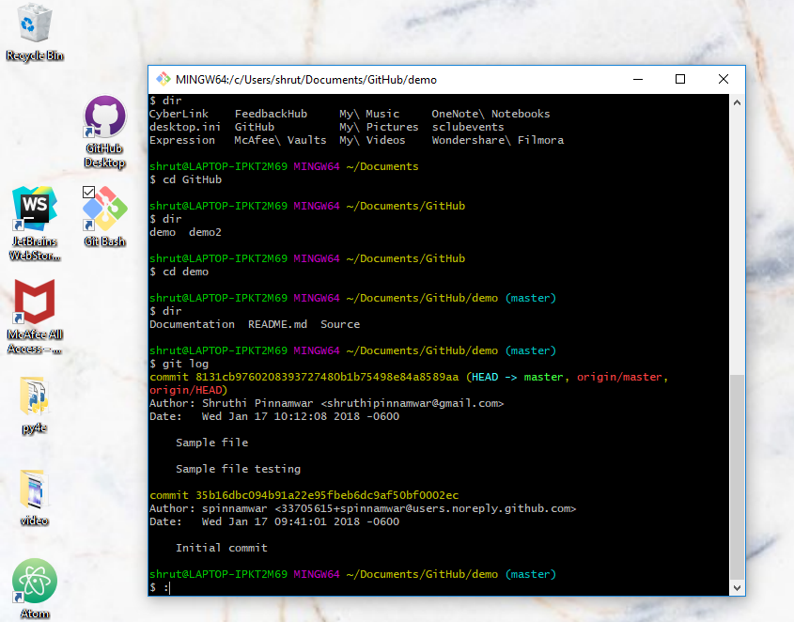

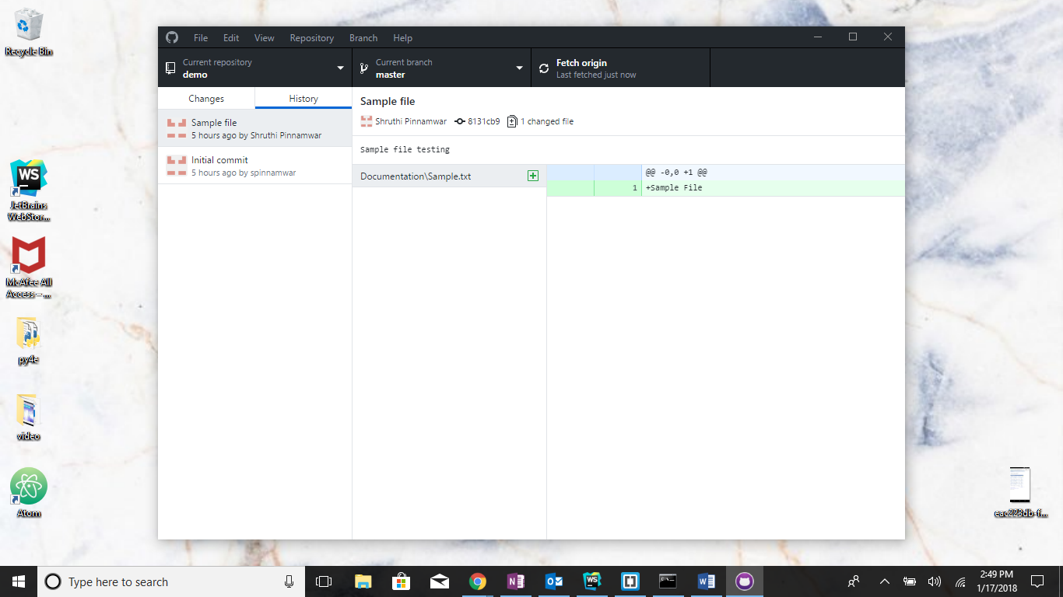

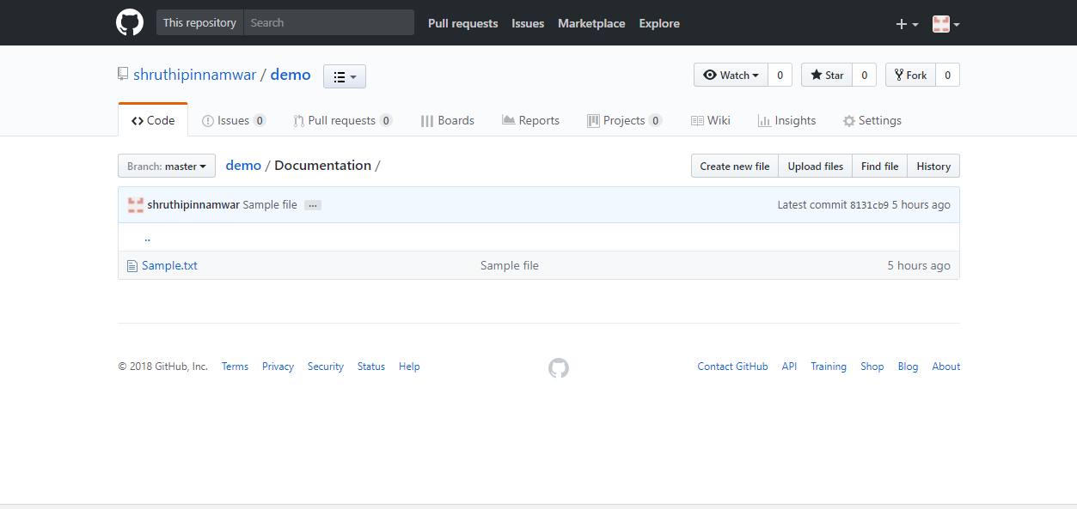

Gitshell/bash

Created another repository demo2

* Added text file to local repository
* Added file, Checked status, Committed and then pushed to remote repository
* Created Branch A, Renamed it BranchB,Checkout/switched to BranchB.

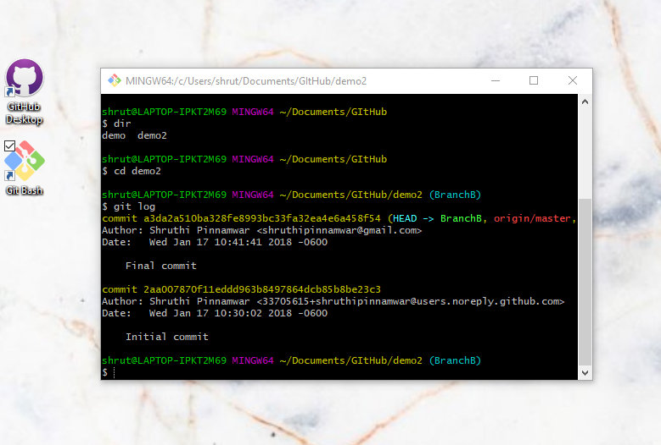

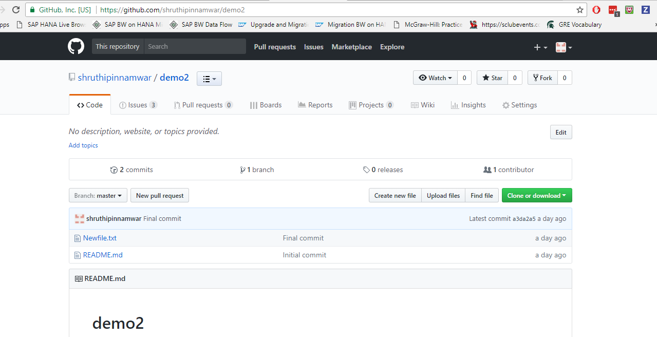

1. Zen Hub Plugin

Added Zen Hub to GitHub.

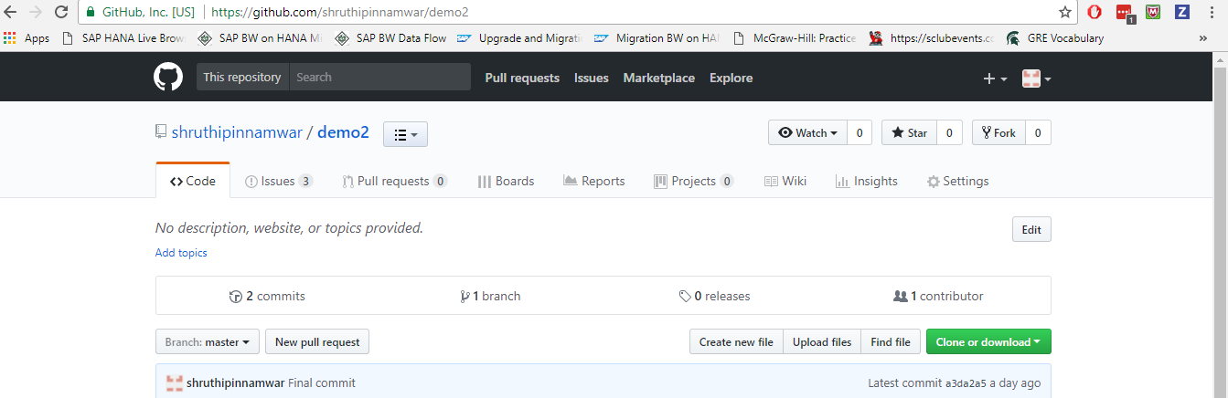

Added Issues

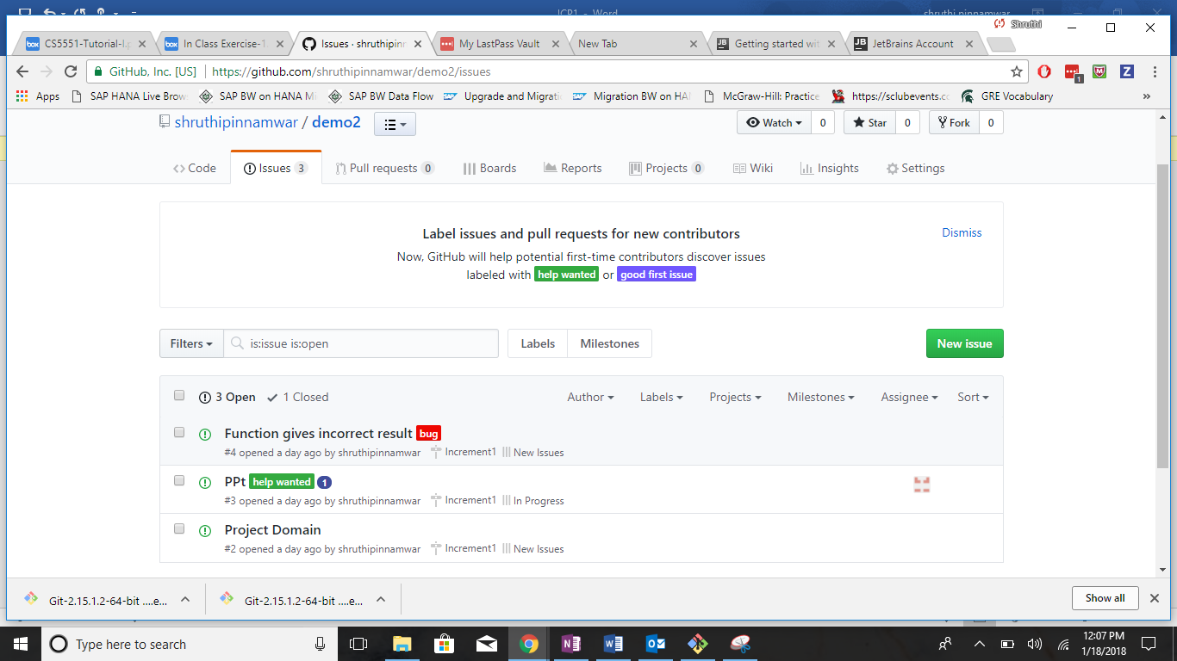

Created burndowns

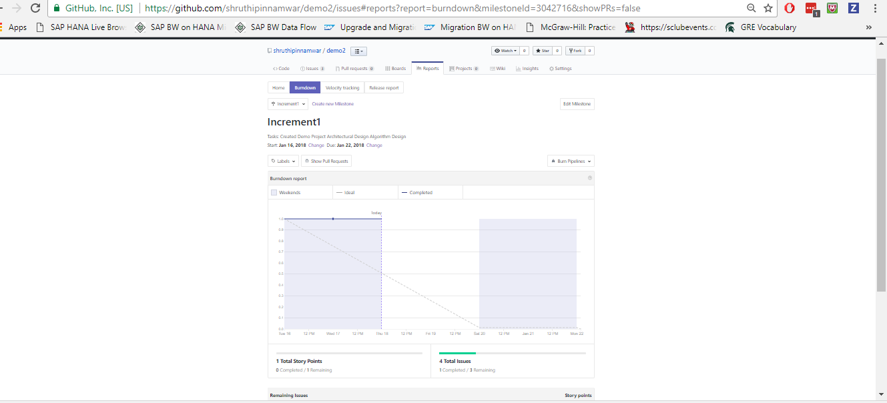

Created Milestones

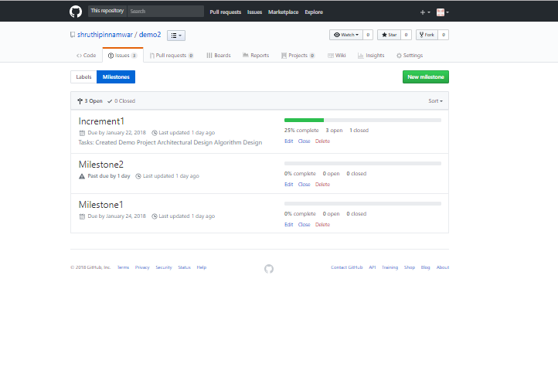

Updated Milestones

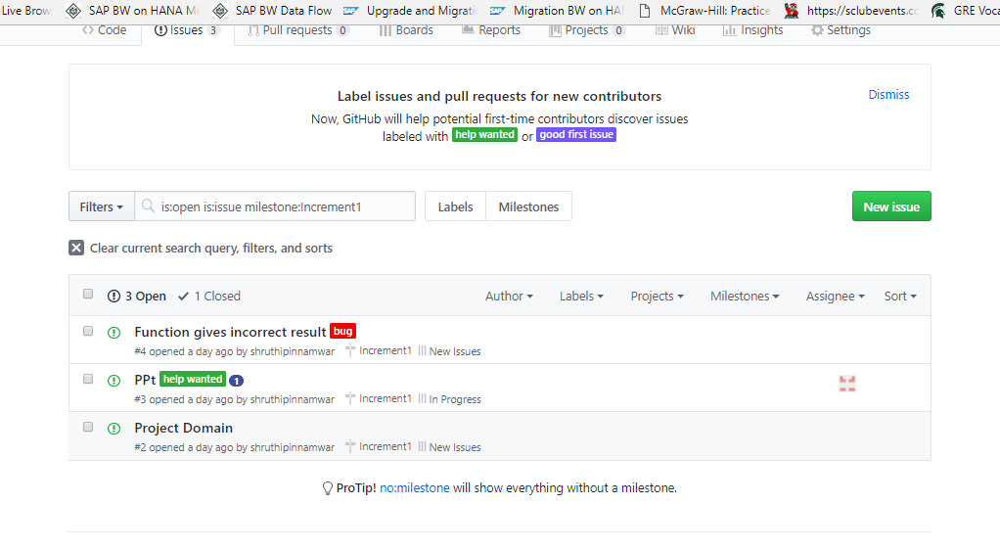

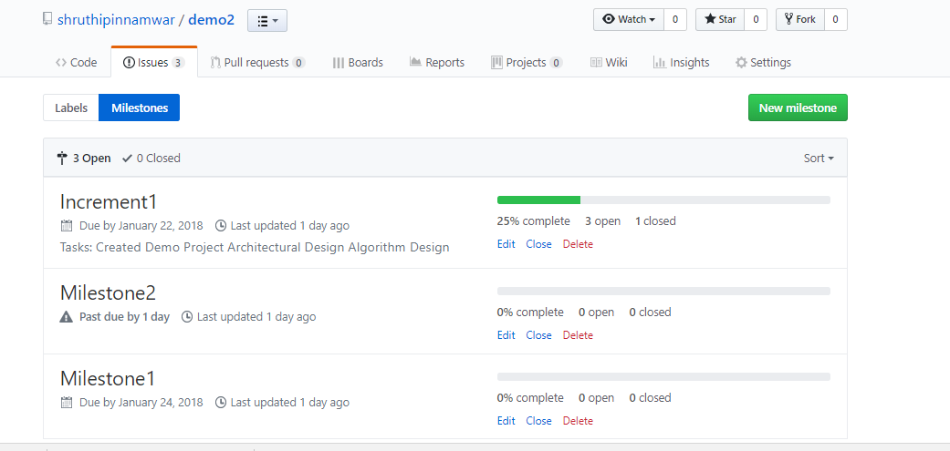

Added Wiki

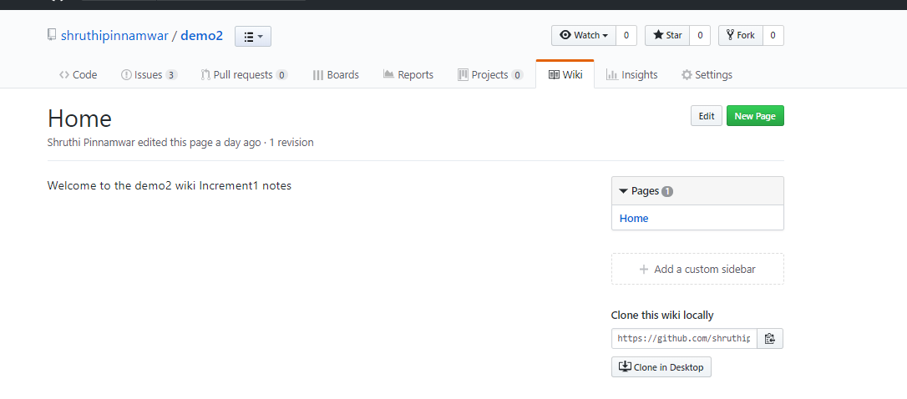

C. Creatly Account

* Created Creatly Account
* Created new project Test
* Created Collaboration, Sequence, Use case and Class diagrams

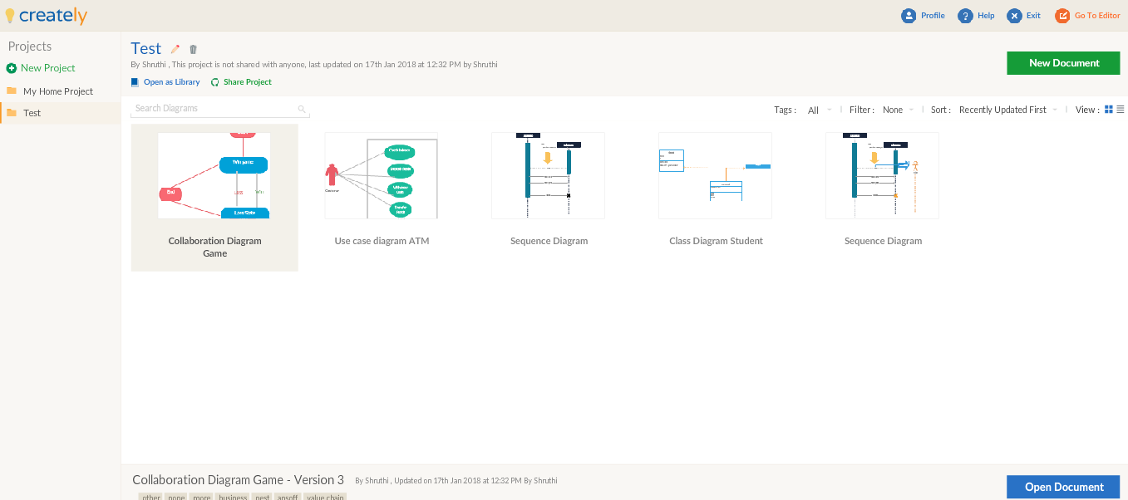

d. WEBSTORM

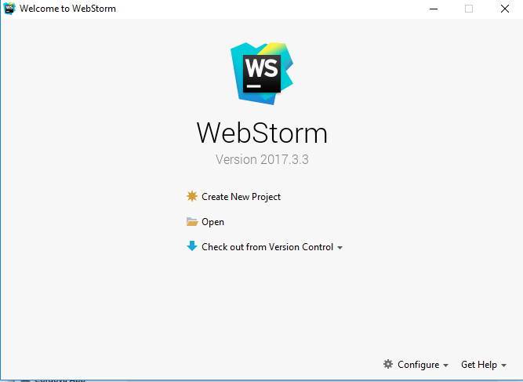

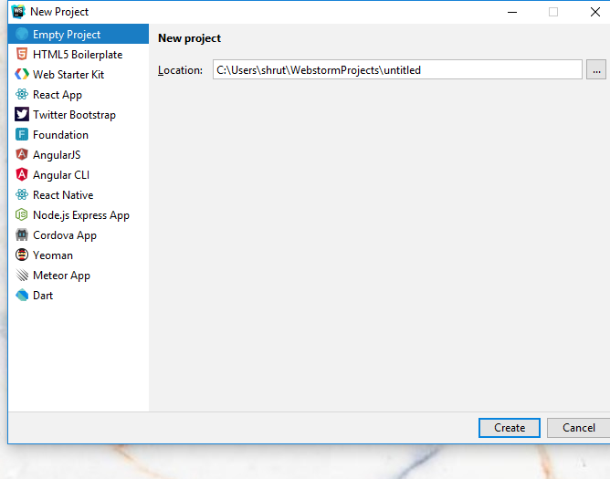

e. Android Studio

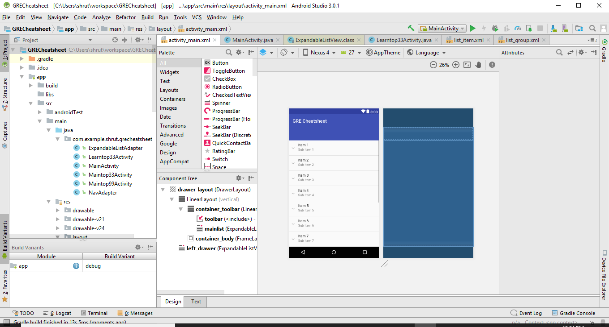

f. Brackets

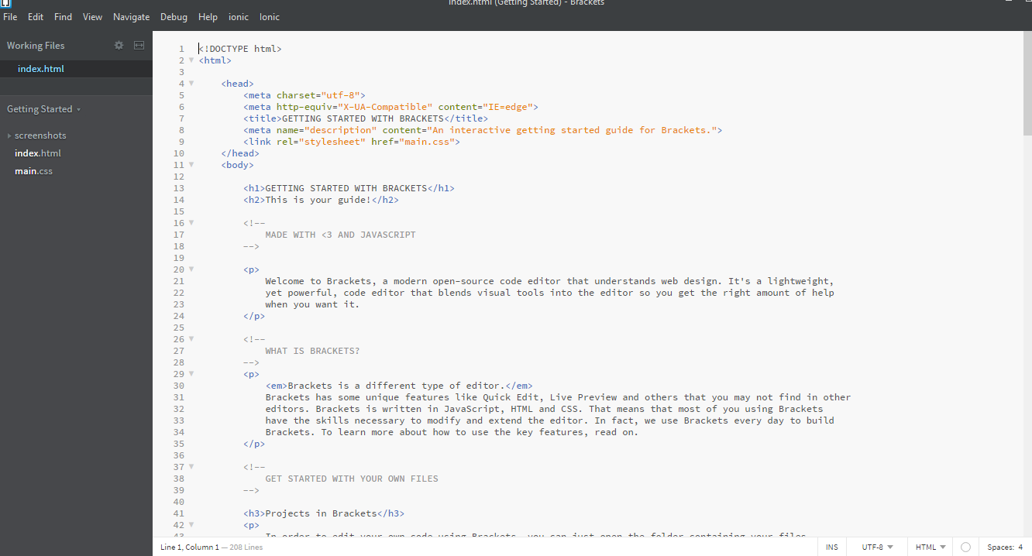

Installed:

AngularJS Code Hints

Angular JS for Brackets

Ionic brackets

Ionic Framework Code Hinting

Simple JS Code Hints

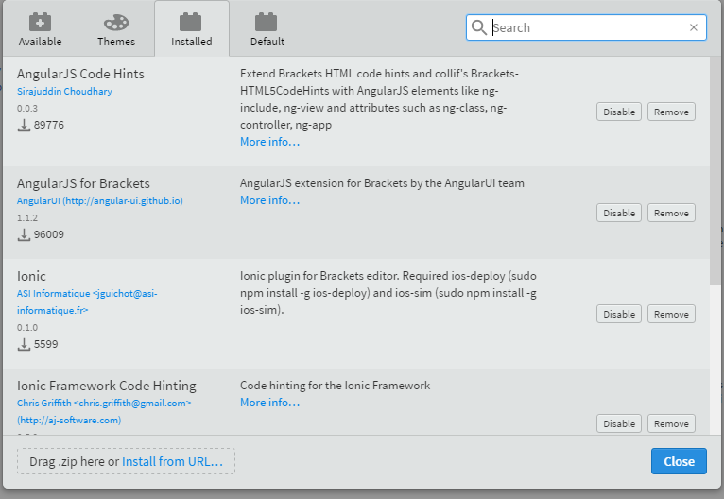

g. Ionic CLI

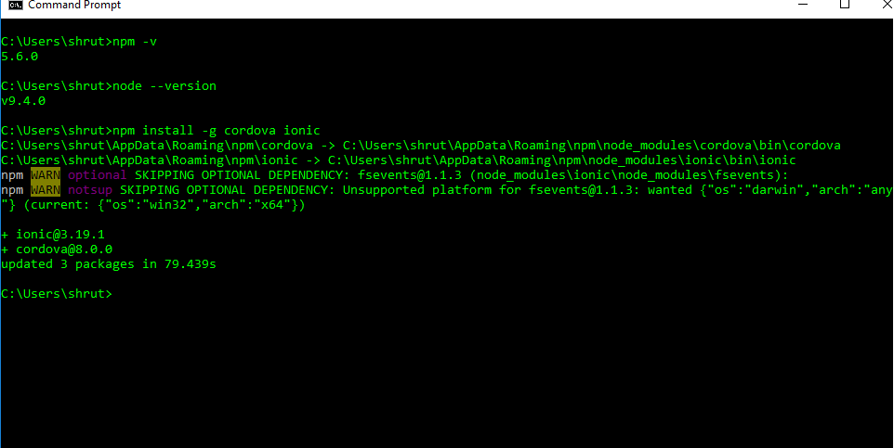

h. Node and NPM

