**Target Rate Notify System**

Software Design Document

|  |  |  |
| --- | --- | --- |
| **TABLE OF CONTENTS** | |  |
| **1.** | **INTRODUCTION** | **3** |
| 1.1 | Purpose | 3 |
| 1.2 | Scope | 4 |
| 1.3 | Objective | 4 |
| 1.4 | Product Benefits | 4 |
| 1.5 | Overview | 4 |
| **2.** | **SYSTEM OVERVIEW** | **5** |
| **3.** | **SYSTEM ARCHITECTURE** | **6** |
| 3.1 | Architectural Design | 6 |
| 3.2 | Decomposition Description | 7 |
| 3.3 | Design Rationale | 7 |
| **4.** | **COMPONENT DESIGN** | **7** |
| **5.** | **User INTERFACE DESIGN** | **8** |
| 5.1 | Overview of User Interface | 8 |
| 5.2 | Screen Images | 9 |
| 5.3 | Screen Objects and Actions | 10 |
| **6.** | **REQUIREMENTS MATRIX** | **11** |
| **7.** | **TEST CASES** | **12** |

**1. INTRODUCTION**

**1.1 Purpose**

The software design document describes the architecture and system design “Target Rate Notified System”. The main purpose of the design document is to offer details of the Target Rate Notified System’s design, requirements, architect diagram. The document helps you to get familiar with the system design concepts.

**1.2 Scope**

**Description of the Product**

The main objective of this project is to make a system that notifies customers when a currency pair rate reaches the target rate which is set by user. User configures the currency pair and target rate. System will periodically check the rates and display it on the screen if target has been reached.

**Goals**

Succeeding are the commercial and technical objectives of the projected ecommerce-based online currency broker application system.:

1. **System functions:**

The principal objective of the Currency broker company is to improve sales dealings by improving the online application system for their customers. Display of target reached alerts will provides the real-time information about bid rates to customers. This helps customers to buy the currency of their desired target.

1. **System development and background:**

Project has user interface depending upon user. User configures the currency pair and target rate. Later, the user interface and the program setting or the program itself may be enhanced on future needs that may occur.

**1.3 Objectives**

The main purpose of this project is to build an advance and deploy a general information alerts in online platform. The objective of this project is to make a system that notifies customers when a currency pair rate reaches the target rate which is set by the user. User configures the currency pair and target rate. System will periodically check the rates and display it on the screen if target has been reached.

**1.4 Product Benefits**

* This project on the “Target Rate notify system” will improve the currency buying capabilities.
* Time-saving.
* Information is accessible in internet and customer support.
* Reliable and easy to use system

**1.5 Overview**

The design document is organized into number of sections comprising of details about the Target rate notify system. It broadly categorized to main chapters which in turn is subdivided into sub-sections. The introduction of the document consists of purpose of SDD, its scope, Objective. It also has architecture design, component design and User interface design.

**2. SYSTEM OVERVIEW**

In Stock market and currency broker company, knowing the currency value plays important role for buyer to buy stock or exchange currency. So, it is crucial for the user to be updated with the changing currency rate. To fill in this requirement, a Target rate Notify system is developed.

The project purpose is to develop, design and test a Target rate notify system for currency broker company. In the Landing page, enter rates within the range it is guided by the rates.fxcm.com/RatesXML. The currency and target are the required fields to be filled by the user. If the inputs are valid then he/she will be navigated to the results page else, error will be displayed to enter valid data. Using the scheduler, the target value is matched with rate in rates.fxcm.com/RatesXML every 5 seconds.

We are using the following technologies to develop:

* PHP
* Java script
* Jquery(library)
* Bootstrap

Tools/server used:

* Xampp – Apache server.

**3. SYSTEM ARCHITECTURE**

**3.1 Architectural Design**

The user enters the value in the landing page and it is made sure that the values entered by the user is valid. The target values of a currency pair is then compared with the current rate from the url rates.fxcm.com/RatesXML which in cloud server.

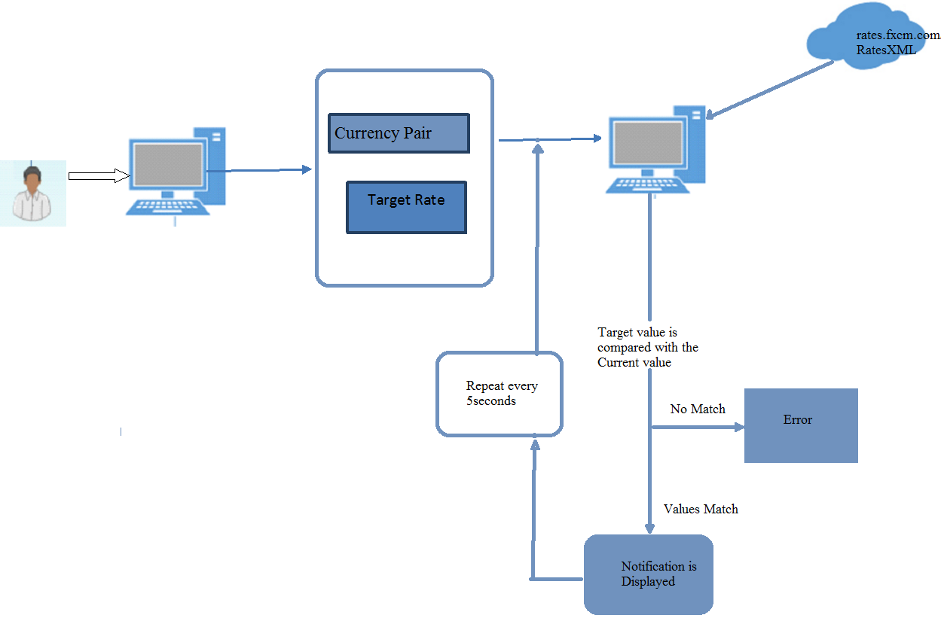

*Architecture sequence diagram*

**3.2 Decomposition Description**

The architecture can be divided into below subsystems:

1. User form – In the lading page, a user form is included which takes care of getting correct values from user. In the case if the values entered by the user is not valid, user is notified with appropriate message and the user is not taken to the next screen.
2. The data entered is accepted and the system connects to the server and fetches the current rates. The current that is fetched from the server is then compared with the data entered. If the data matches, the user is notified that the target is reached. If the data does not match after certain interval of checking, the user is notified that the target is not reached.
3. Scheduler enables to notify the user whenever the rate is reached as it keeps performing the action at interval of 5seconds.

**4. COMPONENT DESIGN**

These are the components of target rate notify system that are involved in the operation of the system respectively.

|  |  |
| --- | --- |
|  |  |
| Components | **Description (pseudo code)** |
| “Target set up details” | The user need to enter the currency pair and the target rate. |
| “Clearing the data” | The user can clear the data entered. |
| “Notification” | The user will view the notification of the target value. |
| “Home” | The user can navigate back to the home screen. |
| “Scheduler” | The target value will be checked with the xml data every 5 seconds. |
| “Get current rate” | This fetches the rate value from the xml for the required currency pair. |

**5. User INTERFACE DESIGN**

**5.1 Overview of User Interface**

The Target rate notify system is a simple system where the user has to enter their desired currency pair value and the target value for which they want to receive a notification. On entering the values and clicking on “set up” button, the system show the notification when the desired target value is reached. The user can then again set a new target value for which they need notification.

**5.2 Screen Images**

These are the screen images for the Online Shopping Website:

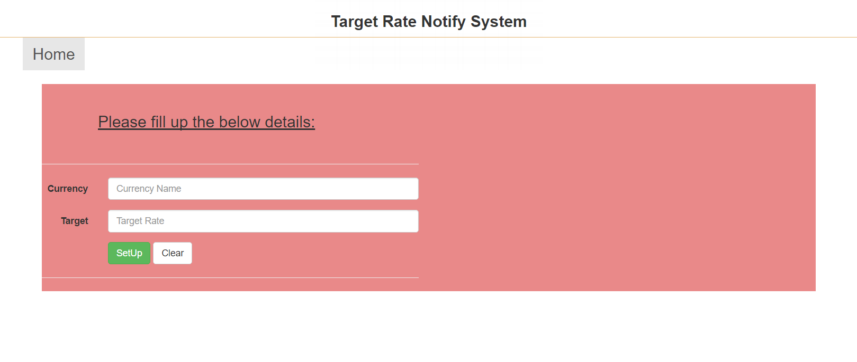*(a). Home screen*

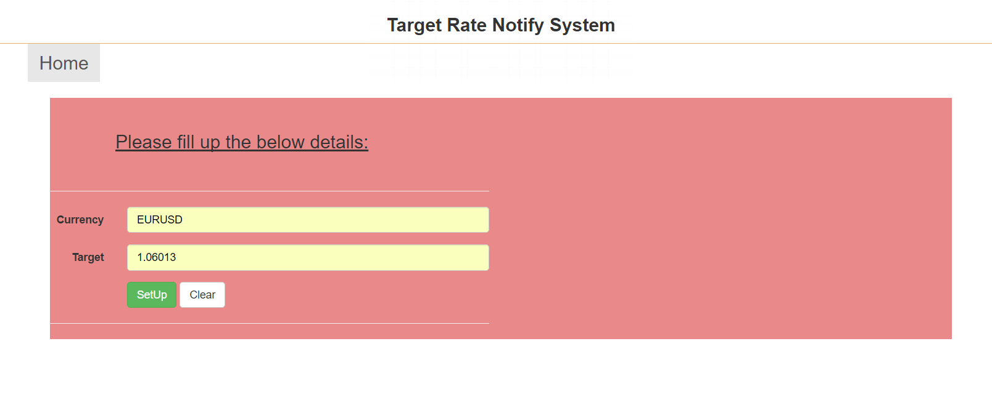

*(b) On entering the data in the fields*

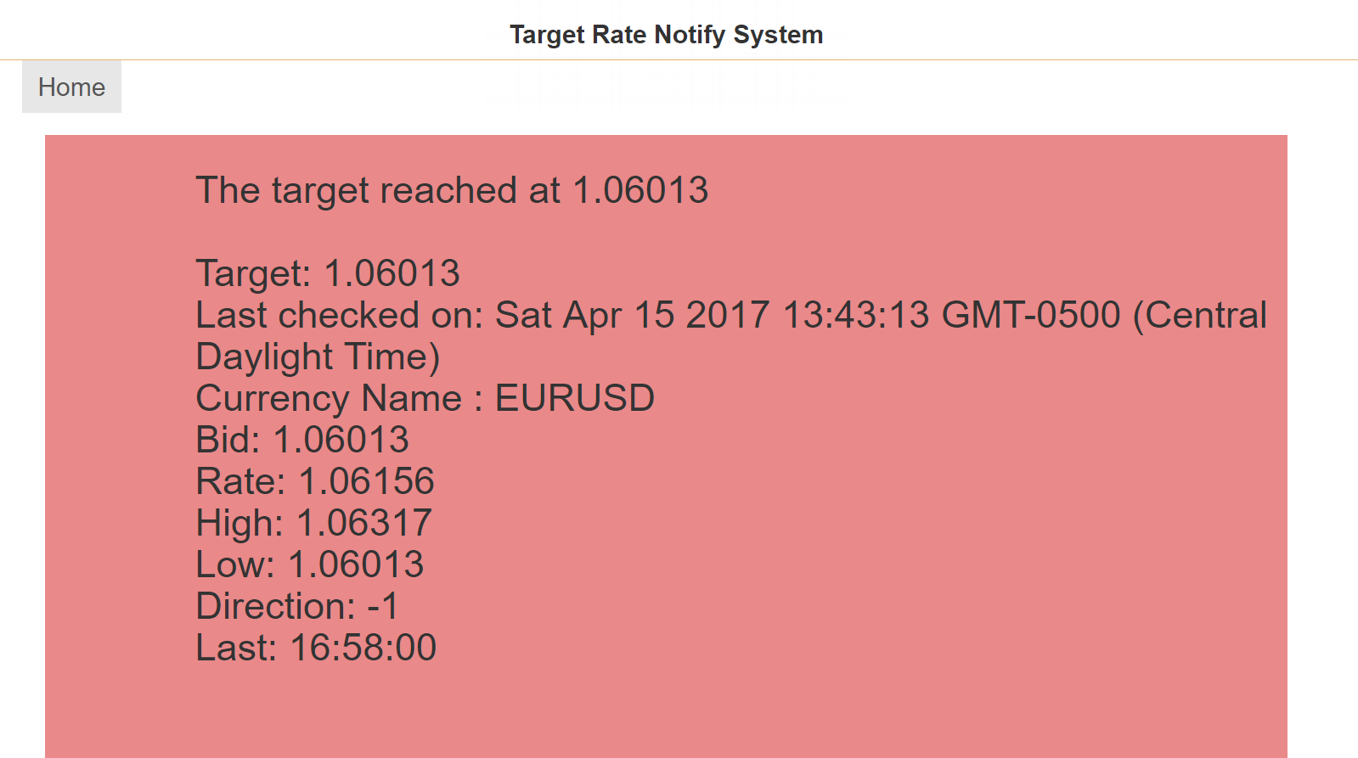

*(c) Notification screen when target value is reached*

**5.3 Screen Objects and Actions**

Below are the screen objects and actions associated with those objects:

* Currency Name – This is a text field, where the user enters the currency pair of which they want the target rate.
* Target rate – This is a text field, where the user enters the target value for which they want notification.
* Set up – This is a button. The user clicks on ‘Set Up’ button to get notification.
* Clear – This is a button. The user clicks on ‘Clear’ button to clear the data entered in text fields.
* Home – This is a button. The user clicks on ‘Home button to navigate to the home screen.

**6. Requirement Matrix**

|  |  |
| --- | --- |
|  |  |
| Req No | **Requirement** |
| 1. | The user should be able to enter the currency pair. |
| 2. | The user should be able to enter and set the Target value. |
| 3. | The user should be notified when the target is reached. |
| 4. | The user should be notified if the target is not reached. |
| 5. | The Currency pair field should be mandatory. |
| 6. | The Target field should be made mandatory. |
| 7. | The user should be able to clear/reset the text fields. |
| 8. | Error message should be displayed if the user enters a value which is not in range. |
| 9. | The target value should be periodically checked with the value in xml. |
| 10. | The User should be able to view the notification. |

**7. Test Cases**

|  |  |  |  |  |
| --- | --- | --- | --- | --- |
| Test case # | Test description | Steps | Test Step | Expected Result |
| 1 | Verify the “Target” fields must be Mandatory | Step 1 | Navigate to the Home page. | Home page should be displayed. |
|  |  | Step 2 | Enter Currency pair in “Currency” field. | The user should be able to enter value. |
|  |  | Step 3 | Leave the Target field blank and tap on “Setup” button. | Error message should be displayed as “Required Target”. |
| 2 | Verify the “Currency” fields must be Mandatory | Step 1 | Navigate to the Home page. | Home page should be displayed. |
|  |  | Step 2 | Enter Currency pair field empty. | The Currency pair field is blank. |
|  |  | Step 3 | Enter in the Target field blank and. | The user should be able to enter value. |
|  |  | Step 4 | Tap on “Setup” button | Error message should be displayed as “Required Currency pair”. |
| 3 | Verify the user is notified when the target is reached | Step 1 | Navigate to the Home page. | Home page should be displayed. |
|  |  | Step 2 | Enter Currency pair in “Currency” field. | The user should be able to enter value. |
|  |  | Step 3 | Enter in the Target field. | The user should be able to enter value. |
|  |  | Step 4 | Tap on “Setup” button. | The target value will be set. |
|  |  | Step 5 | Verify a notification is displayed when the target rate is reached. | Notification should be displayed when the target rate is reached. |
| 4 | Verify when the target is not reached the user should is notified. | Step 1 | Navigate to the Home page. | Home page should be displayed. |
|  | Pre-condition: the target should not reach | Step 2 | Enter Currency pair in “Currency” field. | The user should be able to enter value. |
|  |  | Step 3 | Enter in the Target field. | The user should be able to enter value. |
|  |  | Step 4 | Tap on “Setup” button. | The target value will be set. |
|  |  | Step 5 | Verify an error message is displayed when the target rate is not reached. | Error message should be displayed as “The target rate has not reached”. |
| 5 | Verify the user enters the values with in the high and low range. | Step 1 | Navigate to the Home page. | Home page should be displayed. |
|  |  | Step 2 | Enter Currency pair in “Currency” field. | The user should be able to enter value. |
|  |  | Step 3 | Enter a target value that is higher than the high value. | The user should be able to enter value. |
|  |  | Step 4 | Tap on “Setup” button. | The target value will be set. |
|  |  | Step 5 | Verify an error message is displayed. | Error message should be displayed as “The target rate is not in range”. |
| 6 | Verify the user enters a value lesser than the low value. | Step 1 | Navigate to the Home page. | Home page should be displayed. |
|  |  | Step 2 | Enter Currency pair in “Currency” field. | The user should be able to enter value. |
|  |  | Step 3 | Enter a target value that is lesser than the low value. | The user should be able to enter value. |
|  |  | Step 4 | Tap on “Setup” button. | The target value will be set. |
|  |  | Step 5 | Verify an error message is displayed. | Error message should be displayed as “The target rate is not in range”. |
| 7 | Verify the user can clear all the text fields. | Step 1 | Navigate to the Home page. | Home page should be displayed. |
|  |  | Step 2 | Enter Currency pair in “Currency” field. | The user should be able to enter value. |
|  |  | Step 3 | Enter in the Target field. | The user should be able to enter value. |
|  |  | Step 4 | Tap on “Clear” button. | The text fields should be cleared. |