./

Report – Stock Market Fundamental Analyzer

Course Code: <CODE>



Version Number:

Team Members :

Team No:

Module: Model Based System Engineering

|  |  |  |  |  |  |
| --- | --- | --- | --- | --- | --- |
| **Ver. Rel. No.** | **Release Date** | **Prepared. By** | **Reviewed By** | **Approved By** | **Remarks/Revision Details** |
| 1 | 10-10-2020 | Shruthi V Pai |  |  |  |
|  |  |  |  |  |  |
|  |  |  |  |  |  |
|  |  |  |  |  |  |
|  |  |  |  |  |  |

**Document History**

**TABLE OF CONTENTS**

|  |  |  |
| --- | --- | --- |
| **Sl. No.** | **Contents** | **Page No.** |
| 1 | Introduction | 4 |
| 2 | Aim and Objective | 5 |
| 3 | Requirements | 6-7 |
| 4 | Design | 8-9 |
| 5 | Test Plan and Test Cases | 10 |
| 6 | Expected Result | 11 |
| 7 | Conclusion | 12 |
| 8 | References | 13 |

# 

1. **INTRODUCTION**

**1.1 Problem Statement:**

Stock investing requires careful analysis of financial data to find out the company's true worth. This is generally done by examining the company's profit and loss account, balance sheet and cash flow statement. This can be time-consuming and cumbersome.A lot of people who are new to the stock market are incurring losses due to lack of knowledge in deciding which company to invest in.

An easier way to find out about a company's performance is to look at its financial ratios. This system helps newbies to get the basic financial ratios like dividend yield ratio, debt-to-equity ratio, price-to-earnings ratio and many more. Thus, they can decide which the suitable company to invest in is.

**1.2 Description:**

Here are six things you should know about a company before you decide to invest:

1. Net Income of the company
2. Earnings Per Share (EPS)
3. Stability
4. Debt-to-Equity Ratio
5. Price-to-Earnings Ratio
6. Dividends.

This application helps to calculate all of the above mentioned with a few inputs needed to calculate them.

**2. AIM and OBJECTIVE**

**2.1 Aim:**

The main aim of this project is to help newbies to get the basic financial ratios like dividend yield ratio, debt-to-equity ratio, price-to-earnings ratio and many more. Thus, they can decide which is the suitable company to invest in and earn profit from the share market.

**2.2 Objective:**

* The objective is to help the users by calculating dividends and dividend yield ratio of the company provided the user must give basic details such as cash dividend per share and face value of the share.
* Similarly, the second objective is to help users by calculating earnings per share of any company provided the user must give details available in the balance sheet such as net income, preferred dividends and outstanding common shares.
* The third objective is to help users by calculating debt-to-equity ratio by getting details such as total liabilities and shareholders’ equity.
* The fourth objective is to help users by calculating price-to-earnings ratio by getting details such as market value per share and earnings per share.
* The fifth objective is to find if the user has incurred profit or loss by taking inputs such as buy price, sell price and quantity.

**3. REQUIREMENTS**

**3.1 Requirements:**

* Operating system: Windows XP, 7, 8 or 10
* Editor: Code::Blocks version 20.3
* Programming language: C
* Compiler: MinGW compiler
* Memory: 256 MB

**3.2 Functions Required:**

* Float dividendYieldRatio() is required to calculate the dividend yield ratio in percentage.
* Float EPS() is required to calculate the Earnings Per Share.
* Float debtEquity() is required to calculate debt-to-equity ratio.
* Float priceEarnings() is required to calculate price-to-earnings ratio.
* Float profitOrLoss() is required to calculate the profit or loss incurred.

# 3.3 Functional Requirements:

-Requires inputs to be taken from balance sheet provided by the company.

-It should perform mainly five tasks giving output as

-Dividend Yield Ratio,

-Earnings per Share,

-Debt-to-Equity Ratio,

-Price-to-Equity Ratio,

-Profit or Loss.

**3.4 Non-functional requirements:**

-scalability

-efficiency

-extensibility

-Flexibility

-Modifiability

-Response time

-Readability

-Resource constraints

-Usability

**4. DESIGN**

**4.1 Design Description**

Stock market fundamental analyzer is a type of application which calculates the fundamental financial ratios based on the basic information such as net income of the company, market value of the share, etc. which is easily available in the balance sheet provided by the company.

There are five important things to be considered before deciding to invest in any company:

1. Dividend Yield Ratio
2. Earnings Per Share (EPS)
3. Debt-to-Equity Ratio
4. Price-to-Earnings Ratio
5. Profit or Loss

The proposed system will make use of basic information to calculate the above given important financial ratios to help newbies gain knowledge and profit in the share market.

The basic information needed are:

1. Cash dividend per share and face value of the share to find the Dividend Yield Ratio.
2. Net income and outstanding common shares of the company to find the Earnings per Share.
3. Total liabilities and total shareholders’ equity to calculate the Debt-to-Equity Ratio.
4. Market value and the EPS are required to find the Price-to-Earnings Ratio.
5. Buy price, sell price and quantity are required to calculate the Profit or Loss incurred by the users.

**4.2 UML Diagram**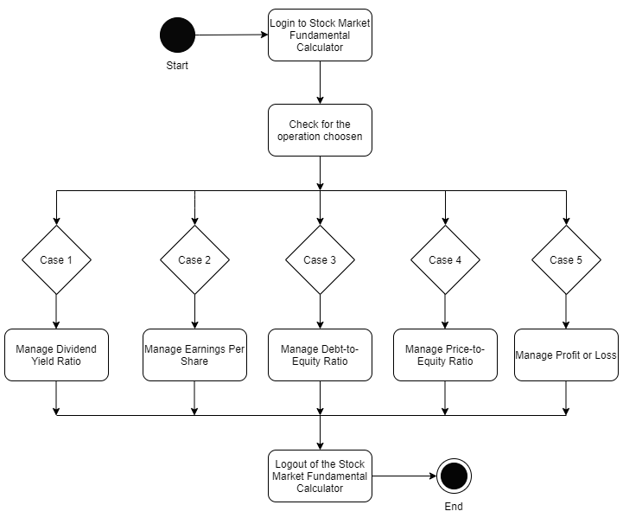

**Figure 1:** Activity diagram of Stock Market Fundamental Analyzer

**5. TEST PLAN and TEST CASES**

**5.1 Functions to be tested:**

* Float dividendYieldRatio()
* Float EPS()
* Float debtEquity()
* Float priceEarnings()
* Float profitOrLoss()

|  |  |  |  |
| --- | --- | --- | --- |
| **Test Cases** | **Test Scenario** | **Steps** | **Expected Output** |
| **01** | Check for Dividend Yield Ratio | Input Cash dividend per share.  Input Face value of the share  **Dividend(%)**=(Cash dividend per share/Face value of the share)*100  **Dividend Yield(%)=** (Cash dividend per share/Dividend)*100 | **Ex. XYZ company**  Cash dividend per share = 18 Rs.  Face value = 2 Rs.  Dividend = (18/2)*100=900%  Dividend yield ratio=(18/900)*100=2% |
| **02** | Check for Earnings per Share | Input net income  Input preferred dividends per share  Input outstanding common share  **EPS**=(net income - preferred dividends per share)/outstanding common share | Net income=$7.6  Preferred dividends=$0  Outstanding common shares=$3.98  EPS=$7.6/$3.98 = $1.91 |
| **03** | Check for Debt-to-Equity Ratio | Input total liabilities  Input total shareholders’ equity  **D/E**=total liabilities/total shareholders’  equity | Total liabilities=$50,000  Total shareholders’ equity=$100,000  D/E=$50,000/$100,000=$0.5 |
| **04** | Check for Price-to-Earnings Ratio | Input market value of the share  Input Earnings per share  **P/E**=market value of the share/EPS | Market value of the share=900.04 Rs.  EPS=47.5  P/E=900.05/47.5=18.94 Rs. |
| **05** | Check for Profit or Loss Ratio | Input buy price  Input sell price  Input Quantity  **Profit/Loss**=(sell price-buy price)*quantity | Buy price=1000 Rs.  Sell price=1100 Rs.  Quantity=400  Profit=(1100 - 1000)*400=40,000 Rs. |

**6. EXPECTED OUTPUT**

The Stock market fundamental analyzer is expected to calculate the following financial ratios and help the users to gain profit by making them decide which company to invest in.

The below given are the financial ratios that need to considered while investing in any company,

1. Dividend Yield Ratio
2. Earnings Per Share
3. Debt-to-Equity Ratio
4. Price-to-Earnings Ratio
5. Profit or Loss incurred

**7. CONCLUSION**

Stock Market Fundamental Analyzer is a project which helps the investors to get the financial ratios of the company without memorizing the required formulae to calculate them as they are important factors while deciding which company to invest in.

Thus, investors can earn profit in the share market and gain knowledge on fundamental analysis of the same.

**REFERENCES**

* <https://money.usnews.com/money/blogs/the-smarter-mutual-fund-investor/2013/02/22/stock-picking-7-things-you-must-know-about-a-company>
* [https://www.tradingacademy.com/financial-education-center/fundamental-analysis.aspx](https://www.tradingacademy.com/financial-education-center/fundamental-analysis.aspx#:~:text=Price%20to%20Earnings%20in%20Fundamental%20Analysis&text=To%20find%20the%20price%2Dearnings,35%2F7%3D5).
* https://www.fool.com/knowledge-center/the-relationship-between-pe-ratio-and-stock-price.aspx